**Why Spring Boot over Spring**?

Easy to use-remove boiler plate code

Production ready application

Rapid development -Autoconfiguration enables developers to quickly develop apps

Embedded server- provide tomcat server by default

---------------------------------------------------------------------------------------------------------------------------

**Working Of Spring Boot?**

Spring boot Starts by Scanning Starter dependencies for Pom.xml

Then download and auto configure module as you included in pom.xml

2. Suppose we are building Spring boot web application then at the time of project creation we select starter web automatically dependency will add in pom like (Spring-boot -Strater-web)

When we We start the project Spring boot Automatically configure required things to run web Application

---------------------------------------------------------------------------------------------------------------------------

**How Spring boot Starts?**

Spring boot Starts from main() method of our main class

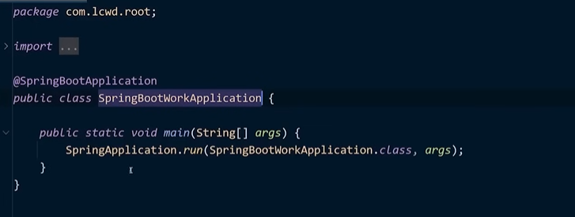

The Run() method is Start Sprig Boot Application. This method Starts the application by creating an Application context(contains beans ) and initialize it

Once application context is initialized the run () method Start the application embedded web server

---------------------------------------------------------------------------------------------------------------------------

**top Spring Boot Annotations?**

1. @SpringBootAppliaction- its combinations of three

@configuration, @enableAutoConfiguration, @componentScan

2. @component //it’s used to mark class as Spring Bean that will manage by Spring container

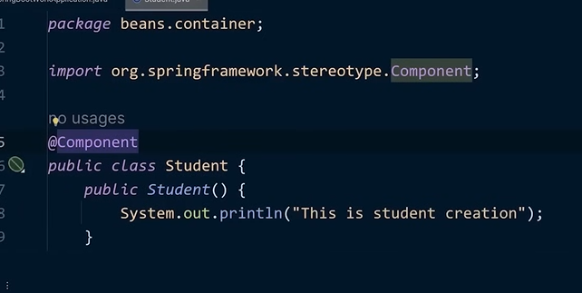With help of Component scan. scan the component from bean class

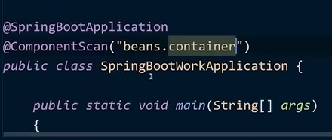--------here is bean class object call

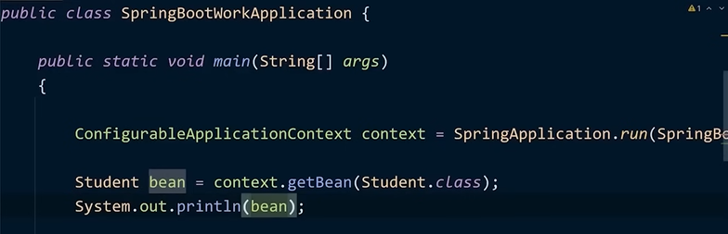

If you remove @component, application context didn’t get any bean and Thow error like



3.@Autowired – this annotation is used to add automatically inject dependencies into a Spring Managed bean (copy different class object into our class)

4. @Service : its used to annotate class that contains buiseness logic

Class is represented as service component in application

5. @RestController- marks class as REST controller. its specialized version of

Always use with each other

@controller || @responseBody // control the request and in response whatever you write in class share as response through response body class will be automatically converted to JSON or XML

6. Request Mapping: Used to map HTTP requests to specific methods in a controller.

Specifies the path and HTTP method for the endpoint (e.g., GET, POST)

[7. @Repository](mailto:7.@Repository): Marks Class As Dao mostly used on class if logic is database related

---------------------------------------------------------------------------------------------------------------------------

**What are springBoot Starters**

Spring Boot Starter is collection of pre-configure dependencies that make it easy to develop particular application like below These include dependencies ,version control, configuration

---------------------------------------------------------------------------------------------------------------

**What are the key dependencies of Spring Boot?**

1.Spring-Boot-Starter-Parent

2. Spring -Boot-Maven-plugin

3.Spring-Boot-Starter-test

4. Spring-Boot-Starter-security

5. Spring-Boot-Starter-actuator

6. Spring-Boot-Starter-web

7…………..

---------------------------------------------------------------------------------------------------------------------------

**What is Spring-Boot-Starter-Parent**

Its starter project that provides the default configuration for Spring-Boot application

-The dependency management

-provide default compiler

-Provide default configuration for maven plugins such as maven-surefire-pluggins,maven-jar-pluggin,and maven-failsafe-plugin

-Resoource Filtering

-everything is managed by parent like version and all

---------------------------------------------------------------------------------------------------------------------------

**Can we use only Spring Boot Dependency feature and configure maven pluggin manually**

Ans. Yes

We can do manually dependency management section but first we should remove parent

And then add versions, pom, import

**--------------------------------------------------------------------------------------------------------------**

**What is Spring Boot CLI what are its benefits**

Its cli to create run and manage SpringBoot Application

Commands

* Spring
* Spring help init
* Spring version
* Spring-Init - - dependencies =web,data-jpa MyProject_Name /// using command line to create project

But we should set path first

* Spring path= here you paste downloaded path of Cli

---------------------------------------------------------------------------------------------------------------------

**What is thymeleaf?**

Java based server side templating Engine used in java web Appliaction to render dynamic web pages

-----------------------------------------------------------------------------------------------------------------

**What is IOC or Inversion Of Controller**

* Inverting the control of creating object using new keyword to container or framework

No need to create manually object like upper we give to Inversion container framework to create object and manage it

inversion of control

**IOC Container[its Framework]**

**Note- DI And IOC is heart of Spring**

**-----------------------------------------------------------------------------------------------------------------------------------------------------**

**Explain the Spring Bean-Lifecycle**

**🡪Bean—**its simple plane java object

Lifecycle-

**Spring bean life cycle is maintained by IOC Container**

1.Container gets Started

2.container creates and object

3.it will go in pom.xml to create dependencies

4.dependancies is injected

5.destroyed when container closed

**• @PostConstruct** runs after the object is created and initialized.

**• @PreDestroy** runs before the object or bean is destroyed.

**Or if you want to using java without annotation**

**Using java --**

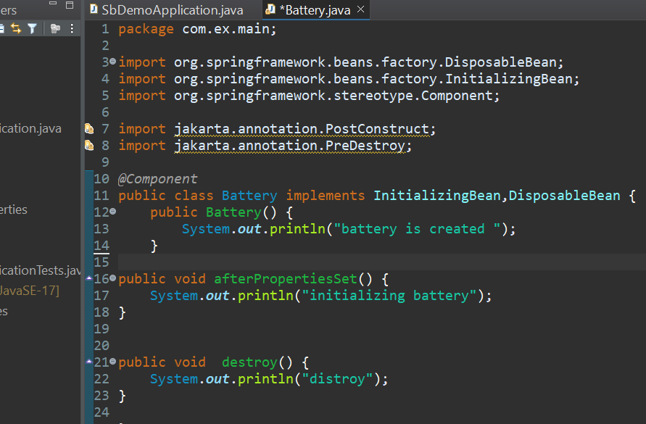**To just implement**

**Initializing_Bean**

After properties set

**Disposable_Bean**

Destroy

**Note-**

**using XML Also we can create**

**-------------------------------------------------------------------------------------------------------------------**

**What is Bean Factory ,Have you used XMLBeanFactory?**

**Ans🡪**

1. This is root interface for Accessing a Spring bean Container
2. ClassPathXmlApplicationContext loads the bean definitions from an XML file located in the class path

XMLBeanFactory was primarily used in older versions of Spring and is not recommended for use today.

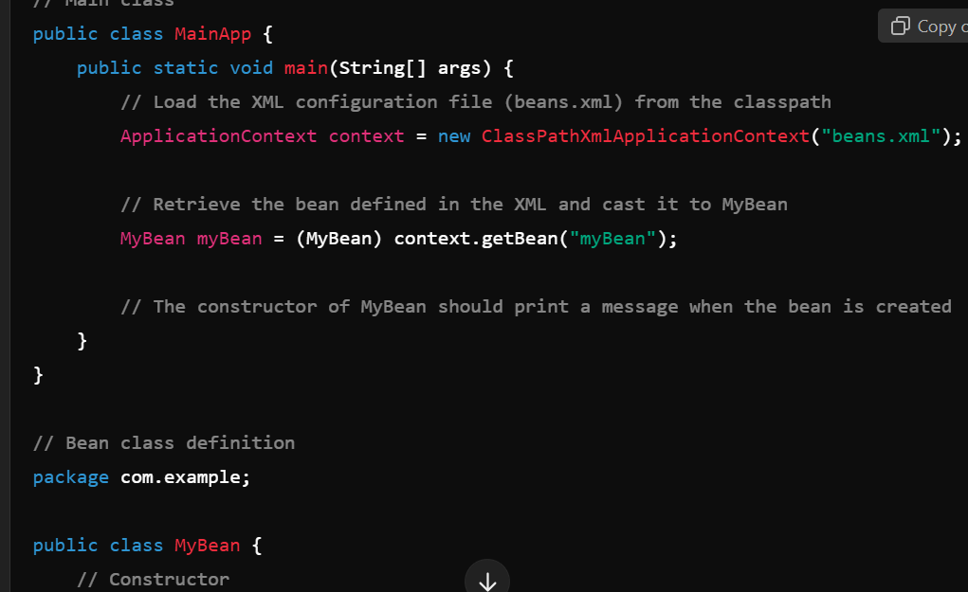

-----------------------------------------------------------------------------------------------------------------------------

**What the difference between Bean-factory AND applicationContext in Spring**?

--------------------------------------------------------------------------------------------------------------------------

**Difference between the setter and constructor in Spring?**

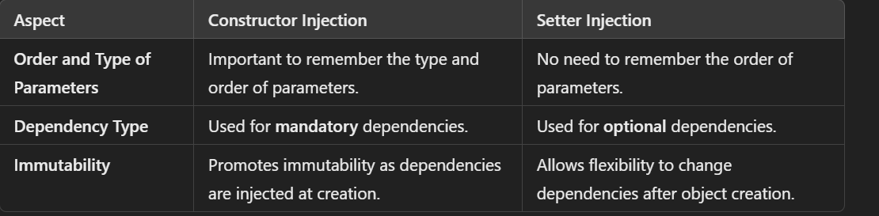In constructor injection is imp to remember the type and order of parameter

Note- Constructor injection is typically used for mandatory dependencies, which must be provided at the time of object creation. If a required dependency is not provided, the Spring container will throw an error.

-------------------------------------------------------------------------------------------------------------------------

**What are different modules in Spring?**

Spring has Seven core module

1. The core container module
2. Application Context module
3. AOP module (Aspect Oriented Programming)
4. Jdbc abstraction and dao module
5. Orm Module
6. Test

---------------------------------------------------------------------------------------------------------------------------

**Difference between @Autowired and @inject**

1. @Autowired is used in Spring to automatically inject dependencies.
2. @Inject is a standard Java annotation (JSR-330) for dependency injection, similar to @Autowired, but not specific to Spring.

----------------------------------------------------------------------------------------------------------------------------

**What is difference between @Bean and @component in Spring?**

* In the @Bean, we manually define the bean inside a configuration class.

In the @Component, Spring automatically detects the bean by ComponentScan, so we don’t need to define it explicitly.

----------------------------------------------------------------------------------------------------------------------------

**What is Auto wiring in Spring? What are auto wiring modes?**

Ans🡪

Inject the beans automatically. We don’t need to write explicitly

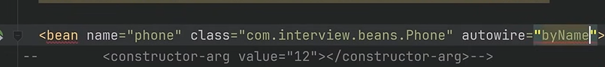

-----------------------------------------------------------------------------------------------------

What Are different bean Scopes in Spring?

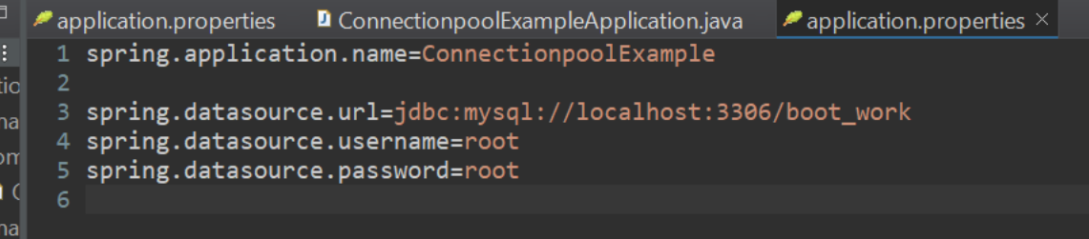

**Connection Pool**

**A connection pool is a cache of database connections maintained in memory, so they can be reused instead of creating new connections each time a database request is made**

**What is jdbc Client ?how it is different from jdbcTemplate?perform Crud Operation Using jdbcClient**

**Added to Spring 6.1 we can be accessible in SB 3.2**

**It simplifies jdbc operations// easy to understand**

**Task-suppose you want all data from database + you want extra so Create your own user without changing in main code or Componey code to add Database operations?**

* **Just create User**
* **Mention details you want to insert or see**
* **Then create Service to write compony logic**
* A computer screen with many colorful text

  Description automatically generated**And at last go in Test and test your application**

**How to create web Application using Eclipse**

1. **Simple servlet?**
2. **Test on latest tomcat server?**
3. **How to configure Spring MVC And create Simple Controller Using XML Configuration?**



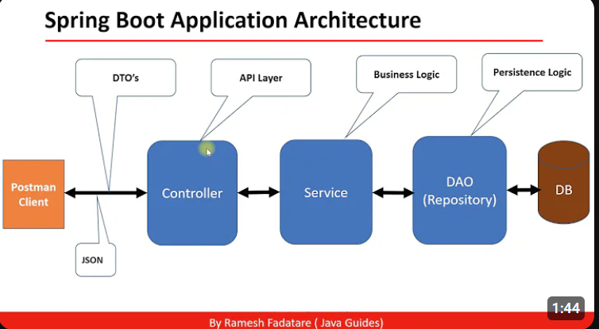

**Questions And Answers**

**Difference between RestController and Controller**

**Difference between request mapping and get mapping**

**Can we check environment properties**

**How to test Spring Boot Application**

**POM.xml explain**

**What server spring boot provides**

**Explain component scan and Bean**

**How to Enable debugging log**

**What is purpose of Spring Boot Starter**

**What are the rest Api for best Practices**

**Few best practices when you apply collection in project what things you consider**

**Have you used design pattern in your project**

**Rest API**

