**Array-**

* Array is a collection of similar type of elements which has contiguous memory location.
* Java array is an object which contains elements of a similar data type.
* We can store only a fixed set of elements in a Java array.
* Array in Java is index-based, the first element of the array is stored at the 0th index, and 2nd element is stored on 1st index and so on.

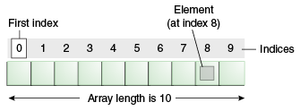

* **Advantages**
* **Code Optimization:** It makes the code optimized, we can retrieve or sort the data efficiently.
* **Random access:** We can get any data located at an index position.
* **Disadvantages:**
* **Size Limit:** We can store only the fixed size of elements in the array. It doesn't grow its size at runtime. To solve this problem, collection framework is used in Java which grows automatically.
* Readymade or predefined method support is not available. We have to write the code for it.
* It is homogenous in nature means can store only one type of data.
* **There are two types of array as:**
* Single Dimensional Array
* Multidimensional Array
* **Syntax to Declare an Array in Java**
* dataType[] arr;
* **Instantiation of an Array in Java**
* arr = new datatype[size];

**Syntax for Multidimensional Array as:**

**data_type**[1st dimension][2nd dimension][]..[Nth dimension] **array_name** = **new data_type**[size1][size2]….[sizeN];

**where:**

* **data_type**: Type of data to be stored in the array. For example: int, char, etc.
* **dimension**: The dimension of the array created. For example: 1D, 2D, etc.
* **array_name**: Name of the array
* **size1, size2, …, sizeN**: Sizes of the dimensions respectively.

Two dimensional array:

int[][] twoD_arr = new int[10][20];

Three dimensional array:

int[][][] threeD_arr = new int[10][20][30];

* **Java Program to illustrate how to declare, instantiate, initialize and traverse the Java array.**

**public** **class** ArrayTest {

// Collection of homogenous data type is called an array

**public** **static** **void** main(String[] args) {

**int** [] intarray = **new** **int** [5]; //declaration and instantiation

intarray [0]=5; //initialization

intarray [1]=10;

intarray [2]=15;

intarray [3]=20;

intarray [4]=25;

**int** intsize = intarray.length;//length is the property of array

System.***out***.println(intsize);

//traversing array

**for** (**int** i=0; i<intsize; i++) {

System.***out***.println(intarray[i]);

}

}

}

**Output:**

5

5

10

15

20

25

* We can declare, instantiate and initialize the java array together by:
* int a[]={10,20,30};//declaration, instantiation and initialization

**public** **class** AverageOfElements {

**public** **static** **void** main(String[] args) {

**int** a [] = {10 , 26 , 29 , 34, 76, 49 , 53};

**int** sum =0 ;

**for** (**int** i=0 ; i<a.length ; i++) //declaration, instantiation and initialization

{

sum = sum + a[i];

}

System.***out***.println("Sum of all elements as :" + sum);

}

}

**Output:**

**Sum of all elements as :277**

## For-each Loop for Java Array

* We can also print the Java array using [for-each loop](https://www.javatpoint.com/for-each-loop). The Java for-each loop prints the array elements one by one. It holds an array element in a variable, then executes the body of the loop.
* The syntax of the for-each loop is given below:

for(data_type variable:array){

//body of the loop

}

* **//Java Program to print the array elements using for-each loop:**

**public** **class** Test3 {

**public** **static** **void** main(String[] args) {

**int** [] a = **new** **int** [7];

a [0]=10;

a [1]=20;

a [2]=30;

a [3]=40;

a [4]=50;

a [5]=60;

a [6]=70;

**int** size =a.length;

**for** (**int** aa:a) {

System.***out***.println("Iterate value are: "+ aa);

}

}

}

**Output:**

Iterate value are: 10

Iterate value are: 20

Iterate value are: 30

Iterate value are: 40

Iterate value are: 50

Iterate value are: 60

Iterate value are: 70

* **//Java Program to Sort the array elements using for-each loop:**

**public** **class** ArrayOrder {

**public** **static** **void** main(String[] args) {

**int** [] jk = **new** **int** [5] ;

jk [0]=3;

jk [1]=8;

jk [2]=5;

jk [3]=11;

jk [4]=15;

System.***out***.println("**********Before Sorting of array********");

**int** size = jk.length;

System.***out***.println(size);

**for** (**int** bb:jk) {

System.***out***.println(bb);

}

System.***out***.println("**********AfterSortingOfArray************");

Arrays.*sort*(jk);

**for** (**int** cx:jk) {

System.***out***.println(cx);

}

}

}

**Output:**

**********Before Sorting of array********

5

3

8

5

11

15

**********AfterSortingOfArray************

3

5

8

11

15

* **If we initialize data beyond size of array then it will throws an exceptions.**

**public** **class** ArrayTest {

**public** **static** **void** main(String[] args) {

**int** [] intarray = **new** **int** [5]; //declaration and instantiation

intarray [0]=5; //initialization

intarray [1]=10;

intarray [2]=15;

intarray [3]=20;

intarray [5]=25; //trying to initialize 5th index value

**int** intsize = intarray.length; //length is the property of array

System.***out***.println(intsize);

//traversing array

**for** (**int** i=0; i<intsize; i++) {

System.***out***.println(intarray[i]);

}

}

}

**Output :**

Exception in thread "main" java.lang.ArrayIndexOutOfBoundsException: Index 5 out of bounds for length 5

at Array.ArrayTest.main(ArrayTest.java:16)

* **Need of collection:**
  + Array are fixed in size, once it is created we cannot change its size based on requirements.
  + Array can hold homogenous data elements.
  + There is no readymade method support available in array.
  + **Collection:**
  + Collection is a group of individual objects which are represented by single entity.
* **To overcome the above limitations of Array we should go for collections concept.** 
  + Collections are growable in nature that is based on our requirement we can increase (or) decrease the size hence memory point of view collections concept is recommended to use.
  + Collections can hold both homogeneous and heterogeneous objects.
  + Every collection class is implemented based on some standard data structure.
  + hence for every requirement ready-made method support is available being a programmer we can use these methods directly without writing the functionality on our own.
* **Explain the different between the Array and Collection?**

|  |  |
| --- | --- |
| **Arrays** | **Collection** |
| Arrays are fixed in size. | Collections are growable in nature. |
| Memory point of view arrays are not recommended to use. | Memory point of view collections are highly recommended to use |
| Performance point of view arrays are recommended to use. | Performance point of view collections are not recommended to use. |
| Arrays can hold only homogeneous data type elements. | Collections can hold both homogeneous and heterogeneous elements. |
| There is no underlying data structure for arrays and hence there is no readymade method support. | Every collection class is implemented based on some standard data structure and hence readymade method support is available |
| Arrays can hold both primitives and object types. | Collections can hold only objects but not primitives. |

* **Difference between Collection and Collections?**
  + Collection is an "interface" which can be used to represent a group of objects as a single entity.
  + Whereas "Collections is a utility class" present in java.util package to define several utility methods for Collection objects.

**Collection--------------------interface**

**Collections------------------class**

* **Collection Framework-**
  + Why it is called as framework because it contain the collection of classes and interface that work together.
  + **9(Nine) key interfaces of collection framework:**
    - Collection
    - List
    - Set
    - SortedSet
    - Navigable Set
    - Queue
    - Map
    - Sorted Map
    - Navigable Map

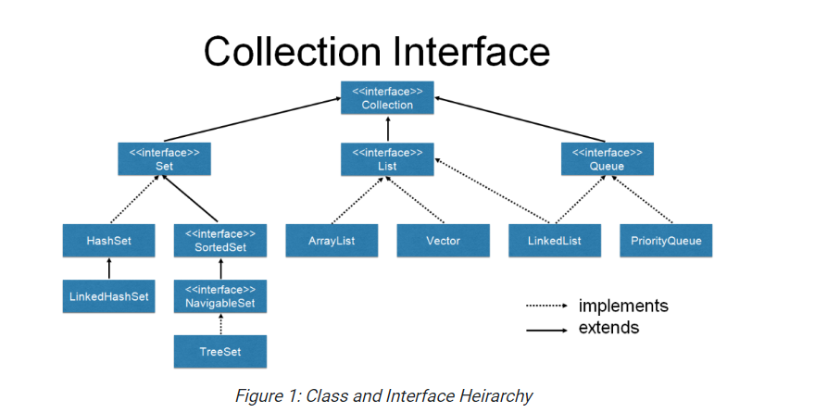

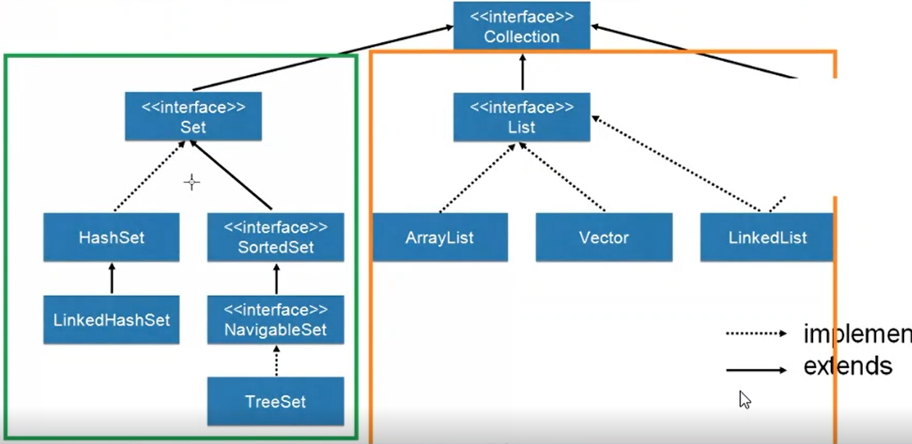

* **List**
  + It is child interface of collection.
  + It is present in Java.util.Package.
  + If we want to represent group of individual objects as single entity where duplicates are allowed and insertion order is preserved then we should go for list.
  + We can differentiates by using index.
  + We can preserve insertion order by using index. Hence index plays important role. It will get the same sequence of element while retrieving the elements.
  + It has three subclasses in java such as- **Array List, Linked List, Vector, etc.**

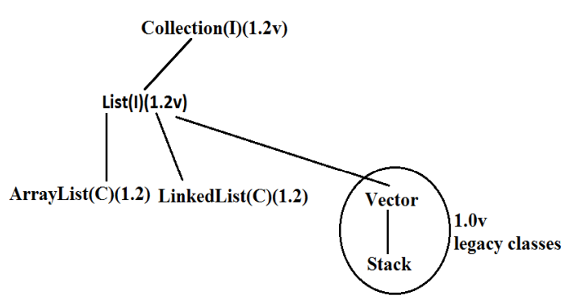

* Vector and Stack classes are re-engineered in 1.2 versions to implement List interface.
* **Array List**
* The Array List extends implements the List interface.
* Duplicates are allowed.
* Insertion order is preserved.
* Heterogeneous objects are allowed.
* Null insertion is possible. (We can add n number of null values in array list).
* Incremental Capacity = (current capacity * 3/2) +1
* Manipulation with Array list is slow because it internally uses an array. If any element is removed or added in the array, all the other bits are shifted in the memory. So it’s a worst choice for manipulation operation.
* Best choice for retrieval operation.
* **Constructor-**

**ArrayList al= new ArrayList();**

* Create the empty array list with default initial capacity 10. Once array list reaches its max capacity then new array list will be created with its new capacity.
* Incremental Capacity = (current capacity * 3/2) +1

**ArrayList a=new ArrayList(int initialcapacity);**

* Creates an empty ArrayList object with the specified initial capacity.

**ArrayList a=new ArrayList(collection c);**

* Here we are passing **the objects.**
* **Java program on ArrayList with use of predefine Methods**

**package** collectionInterface;

**import** java.util.ArrayList;

**public** **class** ArrayList2 {

**public** **static** **void** main(String[] args) {

ArrayList jk = **new** ArrayList();

//Add elements in arraylist.

jk.add("Tanvir");

jk.add("Shinde");

jk.add(27);

jk.add("Pune");

jk.add(**null**);

jk.add("Software tester");

jk.add(**null**);

System.***out***.println(jk); //To print all the elements in arraylist

System.***out***.println(jk.size()); //get the size

System.***out***.println(jk.get(5)); //printing value at a particular index

jk.set(4, "XYZ");

System.***out***.println(jk); //set a value at a particular index

jk.remove(6); //remove a value at a particular index

System.***out***.println(jk);

System.***out***.println(jk.contains("XYZ")); //to check a value

System.***out***.println(jk.isEmpty()); //to check if arraylit it is empty for not

jk.clear(); // to delete all records

System.***out***.println(jk);

}

}

**Output on console:**

[Tanvir, Shinde, 27, Pune, null, Software tester, null]

7

Software tester

[Tanvir, Shinde, 27, Pune, XYZ, Software tester, null]

[Tanvir, Shinde, 27, Pune, XYZ, Software tester]

true

false

[]

**This is allowed but not recommended in Java. We are using Arraylist with Generics:**

**public** **class** ArrayListDemo1 {

**public** **static** **void** main(String[] args) {

ArrayList<Integer> jk = **new** ArrayList<Integer>();

jk.add(10); // add element

jk.add(20);

jk.add(30);

ArrayList<Integer> jk2 = **new** ArrayList<Integer>();

jk2.add(20);

jk2.add(35);

jk.addAll(jk2); //add elements of other arraylist

System.***out***.println(jk);

Iterator<Integer> ub = jk.iterator();

// using iterator interface hasNext method we iterate values

**while** (ub.hasNext()) {

System.***out***.println(ub.next());

}

}

}

**Output on Console:**

[10, 20, 30, 20, 35]

10

20

30

20

35

**Arraylist java program using for each loop:**

**import** java.util.ArrayList;

**public** **class** ArrayListDemo2 {

**public** **static** **void** main(String[] args) {

ArrayList<Integer> jk = **new** ArrayList<Integer>();

jk.add(10);

jk.add(20);

jk.add(30);

**for** ( Integer js : jk) {

System.***out***.println(js);

}

System.***out***.println(jk);

}

}

**Output on Console:**

10

20

30

[10, 20, 30]

**Arraylist if we are using with Generics such as Integer, String and so on …This is recommended here only same type of Data.**

* ArrayList is the best choice if our frequent operation is retrieval operation. It implements the random access interface.
* ArrayList is the worst choice if our frequent operation is insertion or deletion (because several shift operation are required for this).
* **To convert Array into Arraylist (Collection) and to convert the collection (Arraylist) into the Array.**

**package** collectionInterface;

**import** java.util.ArrayList;

**import** java.util.Arrays;

**public** **class** ArrayToCollection {

**public** **static** **void** main(String[] args) {

String [] jk = **new** String [4];

jk[0] = "Tanvir";

jk[1]= "Atul";

jk[2]="Shinde";

jk[3]="Mishra";

ArrayList<String> rt = **new** ArrayList<String>(Arrays.*asList*(jk));

System.***out***.println(rt);

//to convert collection to array

rt.add("123");

rt.add("456");

rt.add("789");

System.***out***.println(rt.size());

String [] str = **new** String [rt.size()];

rt.toArray(str);

**for** (String ss : str) {

System.***out***.println(ss);

}

}

}

**Output on Console:**

[Tanvir, Atul, Shinde, Mishra]

7

Tanvir

Atul

Shinde

Mishra

123

456

* **LinkedList**
* It is child of collection.
* It is present in Java.util.Package.
* Insertion order is preserved.
* Underlying data structure is double linked list.
* Duplicates are allowed.
* Heterogeneous objects are allowed.
* Null insertion is possible.
* LinkedList will implements serializable and clonable interface but not random access interface.
* LinkedList is best choice if our frequent operation is insertion and deletion in middle.
* LinkedList is worst choice if our frequent operation is retrieval.

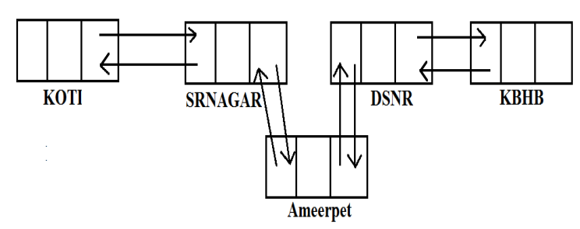

* Usually we can use LinkedList to implement Stacks and Queues.
* To provide support for this requirement LinkedList class defines the following 6 specific methods.
* We can apply these methods only on LinkedList object.
  + void addFirst ();
  + void addLast();
  + object getFirst();
  + object getLast();
  + object removeFirst();
  + Object removeLast ();

**Constructor:**

* **LinkedList l= new LinkedList();**

Create the empty linked list object.

* **LinkedList ll= new LinkedList(Collection c);**

Create the object for given collection.

* **Java Program on Linkedlist with some predefined methods of LinkList:**

**package** collectionInterface;

**import** java.util.LinkedList;

**public** **class** LinkedListDemo {

**public** **static** **void** main(String[] args) {

LinkedList linkedList = **new** LinkedList();

linkedList.add(50);

linkedList.add("Jeevan");

linkedList.add(10);

linkedList.add(**null**);

System.***out***.println(linkedList);

linkedList.addFirst("Pune");

System.***out***.println(linkedList);

linkedList.addLast("SoftwareTester");

System.***out***.println(linkedList);

System.***out***.println(linkedList.getFirst());

System.***out***.println(linkedList.getLast());

linkedList.removeFirst();

System.***out***.println(linkedList);

linkedList.removeLast();

System.***out***.println(linkedList);

}

}

**Output on Console:**

[50, Jeevan, 10, null]

[Pune, 50, Jeevan, 10, null]

[Pune, 50, Jeevan, 10, null, SoftwareTester]

Pune

SoftwareTester

[50, Jeevan, 10, null, SoftwareTester]

[50, Jeevan, 10, null]

**public** **class** LinkedListDemo2 {

**public** **static** **void** main(String[] args) {

LinkedList<Integer> linkedList = **new** LinkedList<Integer>();

linkedList.add(10);

linkedList.add(40);

linkedList.add(30);

linkedList.add(20);

linkedList.addFirst(70);

linkedList.addLast(80);

System.***out***.println(linkedList);

Iterator<Integer> ub = linkedList.iterator();

**while** ( ub.hasNext()) {

System.***out***.println(ub.next());

}

**for** ( Integer df: linkedList )

System.***out***.println(df);

}

}

**Output on Console:**

[70, 10, 40, 30, 20, 80]

70

10

40

30

20

80

70

10

40

30

20

80

* **Difference between ArrayList and LinkedList:**

|  |  |
| --- | --- |
| **ArrayList** | **LinkedList** |
| Duplicates are allowed. | Duplicates are allowed. |
| Underlying data structure for arraylist is resizable or growable array. | Underlying data structure is double linked list. |
| It is worst choice if our frequent operation is insertion and deletion. | It is the worst choice if our frequent operation is retrieval. |
| Default capacity of arraylist is 10. | **Does not have a default capacity**. |
| Best choice for retrieval operation. | For retrieval of data Linked list is the worst choice |
| Allows any number of null values. | Allows any number of null values. |
| Order of insertion is maintained. | Order of insertion is maintained. |
| Arraylist is resizable. Incremental Capacity = (current capacity * 3/2 ) +1 | **Does not have a default capacity** |
| Manipulation with Arraylist is slow because it internally uses an array. If any element is removed or added in the array, all the other bits are shifted in the memory. So it’s a worst choice for manipulation operation. | For manipulation of data Linked list is the best choice as there is no Shifting of elements. |

* **Vector:**
* The underlying data structure is resizable array (or) growable array.
* Duplicate objects are allowed.
* Insertion order is preserved.
* Heterogeneous objects are allowed.
* Null insertion is possible.
* Implements Serializable, Cloneable and Random-access interfaces.
* Every method present in Vector is synchronized and hence Vector is Thread safe

**Vector specific methods:**

**To add objects:**

* add(Object o); -----Collection
* add(int index,Object o);-----List
* addElement(Object o);-----Vector

**To remove elements:**

* remove(Object o);--------Collection
* remove(int index);--------------List
* removeElement(Object o);----Vector
* removeElementAt(int index);-----Vector
* removeAllElements();-----Vector
* clear();-------Collection

**To get objects:**

* Object get(int index);---------------List
* Object elementAt(int index);-----Vector
* Object firstElement();--------------Vector
* Object lastElement();---------------Vector

**Other methods:**

* Int size(); //How many objects are added
* Int capacity(); //Total capacity
* Enumeration elements ();

**Constructors:**

* Vector v=new Vector();
* Creates an empty Vector object with default initial capacity 10.
* Once Vector reaches its maximum capacity then a new Vector object will be created with double capacity. That is "newcapacity=currentcapacity*2".
* Vector v=new Vector(int initialcapacity);
* Vector v=new Vector(int initialcapacity, int incrementalcapacity);
* Vector v=new Vector(Collection c);

**Java Program on Vector:**

**import** java.util.Vector;

**public** **class** VectorDemo {

**public** **static** **void** main(String[] args) {

Vector vector = **new** Vector();

System.***out***.println(vector.capacity());

**for** (**int** i = 1; i <= 10; i++) {

vector.addElement(i);

}

System.***out***.println(vector.capacity());

vector.addElement("J");

System.***out***.println(vector.capacity());

System.***out***.println(vector);

}

}

**Output on Console:**

10

10

20

[1, 2, 3, 4, 5, 6, 7, 8, 9, 10, J]

**Java Program on Vector with generics as String:**

**import** java.util.Vector;

**public** **class** VectorDemo2 {

**public** **static** **void** main(String[] args) {

Vector<String> vector = **new** Vector<String>();

vector.add("sohan");

vector.add("velocity");

vector.add("Pune");

vector.add("Pune");

**while** (vector.contains("Pune"))

{

vector.remove("Pune");

System.***out***.println("new vector is=" + vector);

}

}

}

**Output on Console:**

new vector is=[sohan, velocity, Pune]

new vector is=[sohan, velocity]

**Differences between ArrayList and Vector?**

|  |  |
| --- | --- |
| **ArrayList** | **Vector** |
| No method is synchronized | Every method is synchronized |
| At a time multiple Threads are allow to operate on ArrayList object and hence ArrayList object is not Thread safe. | At a time only one Thread is allow to operate on Vector object and hence Vector object is Thread safe. |
| Relatively performance is high because Threads are not required to wait. | Relatively performance is low because Threads are required to wait |
| It is non legacy and introduced in 1.2v | It is legacy and introduced in 1.0v |

**Stack:**

It is the child class of vector.

It is specially design the class for Last in First Out (LIFO or FILO).

**Constructor**

Stack s= new Stack ();

**Methods**

1. **Object push(Object obj);**

For inserting an object to stack.

1. **Object pop();**

To remove the return top of stack.

1. **Object peak();**

To return the top of stack without removal of object.

1. **int Search(Object obj);**

If specified object is available it returns its offset from top of stack. If object is not available then it return -1.

**Java Program on stack:**

**import** java.util.Stack;

**public** **class** StackList {

**public** **static** **void** main(String[] args) {

Stack stack = **new** Stack();

stack.push("J");

stack.push("M");

stack.push("K");

System.***out***.println(stack);

System.***out***.println(stack.search("X"));

// if element not found then return -1

stack.pop(); //remove first element

System.***out***.println(stack);

stack.peek();

System.***out***.println(stack);

}

}

**Output on Console:**

[J, M, K]

-1

[J, M]

[J, M]

* **Set Interface:**
* It is the child interface of collection.
* If we want to represent a group of individual objects as a single entity where duplicates are not allow and insertion order is not preserved then we should go for set interface.
* Set interface does not contain any new method we have to use only collection interface methods.

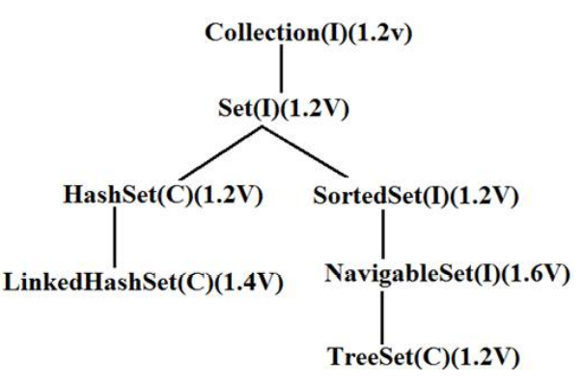

**HashSet:**

* The underlying data structure is Hashtable.
* Insertion order is not preserved and it is based on hash code of the objects.
* Duplicate objects are not allowed.
* If we are trying to insert duplicate objects we won't get compile time error and runtime error add() method simply returns false.
* Heterogeneous objects are allowed.
* Null insertion is possible.(only once)
* Implements Serializable and Cloneable interfaces but not RandomAccess.
* HashSet is best suitable, if our frequent operation is "Search".

**Constructors:**

HashSet h=new HashSet ();

Creates an empty HashSet object with default initial capacity 16 and default fill ratio 0.75(fill ratio is also known as load factor).

HashSet h=new HashSet (int initialcapacity);

Creates an empty HashSet object with the specified initial capacity and default fill ratio 0.75.

HashSet h=new HashSet (int initialcapacity, float fill ratio);

HashSet h=new HashSet (Collection c);

Note : After filling how much ratio new HashSet object will be created, the ratio is called "FillRatio" or "LoadFactor".

**Java Program on Hash_Set:**

**public** **class** HashDemo {

**public** **static** **void** main(String[] args) {

HashSet<String> jk = **new** HashSet<String> () ;

jk.add("Tanvir");

jk.add("Shinde");

jk.add("Kusumba");

//Duplicate all are not allowded.

jk.add("Tanvir");

System.***out***.println(jk);

}

}

**Output on Console:**

[Kusumba, Shinde, Tanvir]

**LinkedHashSet:**

* It is the child class of HashSet.
* Introduced in 1.2 version.
* It is exactly same as hashset but except the following difference.

|  |  |
| --- | --- |
| **HashSet** | **LinkedHashSet** |
| The underlying data structure is hashtable. | The underlying data structure is hashtable + LinkedList (that is hybrid data structure). |
| Insertion order is not preserved. | Insertion order is preserved. |
| Introduced in 1.2 version. | Introduced in 1.4 version. |

**Java Program on Link_Hash_Set:**

**import** java.util.LinkedHashSet;

**public** **class** LinkedHashSetDemo {

**public** **static** **void** main(String[] args) {

LinkedHashSet<String> jk = **new** LinkedHashSet<String> () ;

jk.add("Rupesh");

jk.add("Shinde");

jk.add("Tanvir");

jk.add("Shinde");

//Duplicate are not allowded...Inertion order preserved.

System.***out***.println(jk);

}

}

**Output on Console:**

[Rupesh, Shinde, Tanvir]

**TreeSet-**

* Underlying data structure is balanced tree.
* Duplicates objects are not allowed.
* Insertion order is not preserved.
* All the objects will be inserted according to some sorting order.
* Heterogenous objects are not allowed.
* If we are trying to insert the heterogenous objects then will get run time exception saying classcastexception.
* Null insertion is not allowed, if we are trying to insert it then will get run time error as NullPointerException.

**Constructor-**

TreeSet ts= new TreeSet();

Create the empty treeset object where elements will be inserted according to default natural sorting order.

TreeSet ts= new TreeSet(Comparator c);

Create empty treeset object where elements will be inserted according to customized sorting order.

TreeSet t= new TreeSet(SortedSet s);

TreeSet t= new TreeSet(Collection c);

**Java Program on Tree_Set:**

**import** java.util.TreeSet;

**public** **class** TreeSetDemo {

**public** **static** **void** main(String[] args) {

TreeSet treeSet = **new** TreeSet();

treeSet.add("Jay");

treeSet.add("ram");

treeSet.add("Shyam");

System.***out***.println(treeSet); //dictionary insertion order

}

}

**Output on Console:**

[Jay, Shyam, ram]

**Comparison between Set Implemented classes-**

|  |  |  |  |
| --- | --- | --- | --- |
| **Property** | **HashSet** | **LinkedHashSet** | **TreeSet** |
| Underlying data structure | Hashtable | Hashtable+ LinkedList | Balanced Tree |
| Insertion order | Not preserved | Preserved | Not Applicable |
| Sorting order | Not applicable | Not applicable | Applicable |
| Heterogeneous objects | allowed | allowed | Not allowed |
| Duplicates objects | Not allowed | Not allowed | Not allowed |
| Null acceptance | Allowed(only once) | Allowed(only once) | We will get nullpointer exception. |

**The 3 cursors of java:**

* If we want to get objects one by one from the collection then we should go for cursor. There are 3 types of cursors available in java. They are:
* Enumeration
* Iterator
* List Iterator

**Enumeration:**

* We can use Enumeration to get objects one by one from the legacy collection objects.
* We can create Enumeration object by using elements() method.

public Enumeration elements();

Enumeration e=v.elements();

using Vector Object

Enumeration interface defines the following two methods

public boolean hasMoreElements();

public Object nextElement()

**Java program on enumeration cursor:**

**import** java.util.Enumeration;

**import** java.util.Vector;

**public** **class** EneumerationDemo {

**public** **static** **void** main(String[] args) {

Vector v=**new** Vector();

**for**(**int** i=0;i<=10;i++){

v.addElement(i);

}

System.***out***.println(v);//[0, 1, 2, 3, 4, 5, 6, 7, 8, 9, 10]

Enumeration e=v.elements();

**while**(e.hasMoreElements()){

Integer i=(Integer)e.nextElement();

**if**(i%2==0)

System.***out***.println(i); //0 2 4 6 8 10

}

System.***out***.print(v); //[0, 1, 2, 3, 4, 5, 6, 7, 8,9, 10]

}

}

**Output on Console:**

[0, 1, 2, 3, 4, 5, 6, 7, 8, 9, 10]

0

2

4

6

8

10

[0, 1, 2, 3, 4, 5, 6, 7, 8, 9, 10]

**Limitations of Enumeration:**

* We can apply Enumeration concept only for legacy classes and it is not a universal cursor.
* By using Enumeration we can get only read access and we can't perform remove operations.
* To overcome these limitations sun people introduced Iterator concept in 1.2v.

**Iterator:**

* We can use Iterator to get objects one by one from any collection object.
* We can apply Iterator concept for any collection object and it is a universal cursor.
* While iterating the objects by Iterator we can perform both read and remove operations.

We can get Iterator object by using iterator () method of Collection interface.

public Iterator iterator();

Iterator itr=c.iterator();

* Iterator interface defines the following 3 methods.

public boolean hasNext();

public object next();

public void remove();

**Java program on Iterator cursor:**

**import** java.util.ArrayList;

**import** java.util.Iterator;

**public** **class** IteratorDemo {

**public** **static** **void** main(String[] args) {

ArrayList a=**new** ArrayList();

**for**(**int** i=0;i<=10;i++){

a.add(i);

}

System.***out***.println(a);//[0, 1, 2, 3, 4, 5, 6, 7, 8, 9, 10]

Iterator itr=a.iterator();

**while**(itr.hasNext()){

Integer i=(Integer)itr.next();

**if**(i%2==0)

System.***out***.println(i);//0, 2, 4, 6, 8, 10

**else**

itr.remove();

}

System.***out***.println(a);//[0, 2, 4, 6, 8, 10]

}

}

**Output on Console:**

[0, 1, 2, 3, 4, 5, 6, 7, 8, 9, 10]

0

2

4

6

8

10

[0, 2, 4, 6, 8, 10]

**Limitations of Iterator:**

* Both enumeration and Iterator are single direction cursors only. That is we can always move only forward direction and we can't move to the backward direction.
* While iterating by Iterator we can perform only read and remove operations and we can't perform replacement and addition of new objects.
* To overcome these limitations sun people introduced listIterator concept.

**ListIterator:**

* ListIterator is the child interface of Iterator.
* By using listIterator we can move either to the forward direction (or) to the backward direction that is it is a bi-directional cursor.
* While iterating by listIterator we can perform replacement and addition of new objects in addition to read and remove operations.

By using listIterator method we can create listIterator object.

public ListIterator listIterator();

ListIterator itr=l.listIterator();

(l is any List object)

ListIterator interface defines the following 9 methods.

public boolean hasNext();

public Object next(); forward

public int nextIndex();

public boolean hasPrevious();

public Object previous(); backward

public int previousIndex();

public void remove();

public void set(Object new);

public void add(Object new)

**Java program on List_Iterator cursor:**

**package** collectionInterface;

**import** java.util.LinkedList;

**public** **class** ListIteratorDemo {

**public** **static** **void** main(String[] args) {

LinkedList l=**new** LinkedList();

l.add("balakrishna");

l.add("venki");

l.add("chiru");

l.add("nag");

System.***out***.println(l);//[balakrishna, venki, chiru, nag]

java.util.ListIterator itr=l.listIterator();

**while**(itr.hasNext()) {

String s=(String)itr.next();

**if**(s.equals("venki")){

itr.remove();

}

}

System.***out***.println(l); //[balakrishna, chiru, nag]

}

}

**Output on Console:**

[balakrishna, venki, chiru, nag]

[balakrishna, chiru, nag]

**Comparison of Enumeration, Iterator and ListIterator?**

|  |  |  |  |
| --- | --- | --- | --- |
| **Property** | **Enumeration** | **Iterator** | **ListIterator** |
| **Is it legacy?** | **Yes** | **No** | **No** |
| **It is applicable for?** | **Only legacy classes.** | **Applicable for any collection object.** | **Applicable for only list objects.** |
| **Movement?** | **Single direction cursor(forward)** | **Single direction cursor(forward)** | **Bi-directional** |
| **How to get it?** | **By using elements() method.** | **By using iterator()method.** | **By using listIterator() method.** |
| **Accessibility?** | **Only read.** | **Both read and remove.** | **Read/remove/replace/add.** |
| **Methods** | **hasMoreElement() nextElement()** | **hasNext() next() remove()** | **9 methods.** |

**Comparable interface:**

* Comparable interface present in java.lang package and contains only one method.

compareTo() method.

public int compareTo(Object obj);

**Example: obj1.compareTo(obj2);**

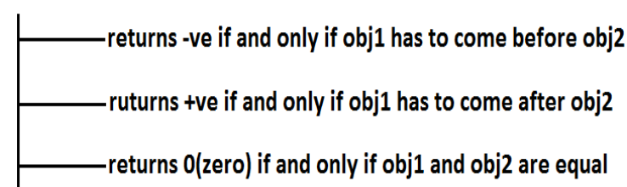

**Java Program on comparable interface:**

**package** collectionInterface;

**public** **class** Test {

**public** **static** **void** main(String[] args) {

System.***out***.println("A".compareTo("Z")); //Output -25

System.***out***.println("B".compareTo("B")); //output 0

System.***out***.println("T".compareTo("S")); // output 1

System.***out***.println("T".compareTo("U")); //output -1

}

}

**Output on Console:**

-25

0

-1

**Comparator interface:**

* Comparator interface present in java.util package this interface defines the following 2 methods.

public int compare(Object obj1,Object Obj2);

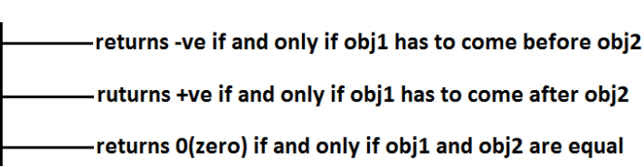

public boolean equals(Object obj);

* Whenever we are implementing Comparator interface we have to provide implementation only for compare() method.
* Implementing equals() method is optional because it is already available from Object class through inheritance.

**Requirement: Write a program to insert integer objects into the TreeSet where the sorting order is descending order**

**package** collectionInterface;

**import** java.util.TreeSet;

**public** **class** TreeTestDemo {

**public** **static** **void** main(String[] args) {

TreeSet t = **new** TreeSet(**new** MyComparator());

t.add(10);

t.add(5);

t.add(20);

t.add(8);

System.***out***.println(t);

}

}

**Output on Console:**

[20, 10, 8, 5]

**package** collectionInterface;

**import** java.util.Comparator;

**public** **class** MyComparator **implements** Comparator<Integer> {

@Override

**public** **int** compare(Integer o1, Integer o2) {

**return** -o1.compareTo(o2); // to sort object in decending order

//return o1.compareTo(o2); // to sort object in Ascending order

}

}

**Difference between Comparable and Comparator ?**

|  |  |
| --- | --- |
| **Comparable** | **Comparator** |
| Comparable meant for default natural sorting order | Comparator meant for customized sorting order |
| Present in java.lang package. | Present in java.util package |
| Contains only one method. **compareTo()** method | Contains 2 methods. **Compare() method**. **Equals() method** |
| String class and all wrapper Classes implements Comparable interface. | The only implemented classes of Comparator are Collator and RuleBasedCollator. (used in GUI) |

**What is Synchronization ?**

* It is a process by which we control the accessibility of multiple threads to a particular shared resource.

**Problem Without synchronization?**

* Final outcome is not deterministic.
* Thread interference.

**Advantages of synchronization?**

* Final outcome is deterministic.
* No Thread interference.

**Disadvantage of synchronization?**

* Increase the waiting time period of thread.
* Create performance issue.
* **Map Interface:**
* If we want to represent a group of objects as "key-value" pair then we should go for Map interface.
* Both key and value are objects only.
* Duplicate keys are not allowed but values can be duplicated 4. Each key-value pair is called "one entry".

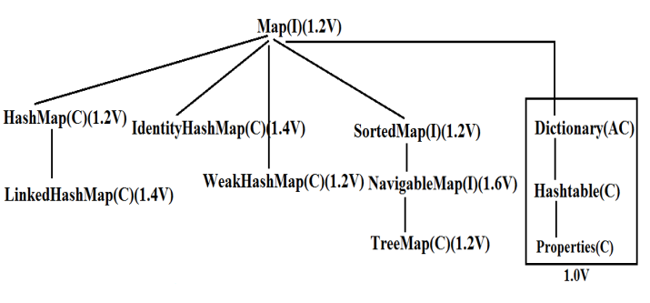

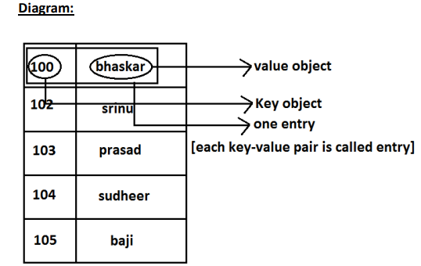

* Map interface is not child interface of Collection and hence we can't apply Collection interface methods here.
* **HashMap:**
  + A HashMap is class which implements the Map interface
  + It stores values based on key.
  + It has 16 size and internally it will increase the size by double, so new size will be 32,64,128.
  + It is unordered, which means that the key must be unique
  + It may have null key-null value
  + For adding elements in HashMap we use the put method.
  + Return type of put method is Object.
  + **Java Program on HashMap:**

**import** java.util.HashMap;

**public** **class** HashMapDemo {

**public** **static** **void** main(String[] args) {

HashMap hashMap = **new** HashMap();

hashMap.put(10, "ashok");

hashMap.put(11, "ram");

System.***out***.println(hashMap);

}

}

**Output on Console:**

{10=ashok, 11=ram}

**LinkedHashMap-**

* A LinkedHashMap is a ‘hashtable and linked list implementation of the map interface with a predictable iteration order.
* It is the same as HashMap except it maintains an insertion order i.e. ordered

**import** java.util.LinkedHashMap;

**public** **class** HashMapDemo2 {

**public** **static** **void** main(String[] args) {

LinkedHashMap linkedHashMap = **new** LinkedHashMap();

linkedHashMap.put(10, "ajay");

linkedHashMap.put(11, "ram");

linkedHashMap.put(12, "shyam");

System.***out***.println(linkedHashMap);

}

}

**Output on Console:**

{10=ajay, 11=ram, 12=shyam}

**TreeMap-**

* The TreeMap is a class which implements NavigableMap interface which is the sub- interface of SortedMap.
* It stores values based on key
* It is ordered but in an Ascending manner
* Keys should be unique
* It cannot have null key at run time but can have null values because the interpreter will not understand how to sort null with other values.

**package** collectionInterface;

**import** java.util.TreeMap;

**public** **class** HashMapDemo3 {

**public** **static** **void** main(String[] args) {

TreeMap treeMap = **new** TreeMap();

treeMap.put(10, "Ajay");

treeMap.put(11, "ram");

treeMap.put(12, "shyam");

System.***out***.println(treeMap);

}

}

**Output on Console:**

{10=ajay, 11=ram, 12=shyam}

**Hashtable-**

* Hashtable is a class which implements Map interface and extends Dictionary class.
* It stores values based on key
* It is unordered and the key should be unique
* It cannot have null keys or null values. It gives runtime error if we try to add any null keys or values but will not show an error at compile time.
* It has synchronised methods and slower than hashmap.

**package** com.test;

**import** java.util.Hashtable;

**public** **class** HashTableDemo {

**public** **static** **void** main(String[] args) {

Hashtable hashTable = **new** Hashtable();

hashTable.put(10, "ram");

hashTable.put(11, "sohan");

System.***out***.println(hashTable);

}

}

Output-

{10=ram, 11=sohan}

**Comparison between HashMap, LinkedHashMap, TreeMap and HashTable:**

|  |  |  |  |  |
| --- | --- | --- | --- | --- |
| Topic | HashMap | LinkedHashMap | TreeMap | HashTable |
| Duplicate Key | Not Allowed | Not Allowed | Not Allowed | Not Allowed |
| Ordering | Unordered | Maintains insertion order | Maintains in Accessing order | Unordered |
| Null (Key Value) | Allow | Allow | key Not allowed but value is Iterator | Not Allowed |
| Accessing Elements | Iterator | Iterator | Iterator | Iterator |
| Thread Safety | No | No | No | Yes |

**package** collectionInterface;

**import** java.util.HashMap;

**import** java.util.Set;

**public** **class** HashMapDemo4 {

**public** **static** **void** main(String[] args) {

HashMap<Integer, String> map = **new** HashMap<Integer, String>();

map.put(10, "Ram");

map.put(20, "yogesh");

map.put(30, "sohan");

Set<Integer> s = map.keySet(); // s contain all the keys only.

**for** (**int** i : s) {

System.***out***.println("Key==" + i);

System.***out***.println("value=" + map.get(i));

/*

* get method used to get the respective value of key.

*/

}

}

}

**Output on Console:**

Key==20

value=yogesh

Key==10

value=Ram

Key==30

value=sohan

**import** java.util.HashMap;

**import** java.util.Iterator;

**import** java.util.Set;

**public** **class** HashMapDemo5 {

**public** **static** **void** main(String[] args) {

HashMap<Integer, String> map = **new** HashMap<Integer, String>();

map.put(10, "Ram");

map.put(20, "yogesh");

map.put(30, "sohan");

Set<Integer> s = map.keySet();

Iterator<Integer> itr = s.iterator();

**while** (itr.hasNext()) {

**int** i = itr.next();

System.***out***.println("key=" + i);

System.***out***.println("value=" + map.get(i));

}

}

}

**Output on Console:**

key=20

value=yogesh

key=10

value=Ram

key=30

value=sohan

**Differences between HashMap and Hashtable ?**

|  |  |
| --- | --- |
| **HashMap** | **Hashtable** |
| No method is synchronized. | Every method is synchronized. |
| Multiple Threads can operate simultaneously on HashMap object and hence it is not Thread safe. | Multiple Threads can't operate simultaneously on Hashtable object and hence Hashtable object is Thread safe. |
| Relatively performance is high. | Relatively performance is low. |
| Null is allowed for both key and value. | Null is not allowed for both key and value otherwise we will get NullPointerException |
| It is non legacy and introduced in 1.2v | It is legacy and introduced in 1.0v |

**Exception Handling :**

**Exception:**

* An Exception is an unwanted or unexpected condition which disturbs our normal flow of execution.
* Once Exception occured remaining part of program will not be executed.
* So, it is our responsibility to handle the exception.
* Exception handling doesn't means, we are resolving an exception it is just like providing an alternate solution so that even though exception happens our program should work properly.

**Exception handling:**

* **Definition:-** Exception handling is nothing but to handle the abnormal termination of a program into normal termination. And make the program to execute completely even though there is an exception caused during the execution.

**Exception Hierarchy:**

• Object class is a super class to all the predefine and user define classes of java.

• Throwable class is a super class to "Exception" class and "Error" class.

• Exception class is a super class to RuntimeException class and other Exception classes.

• All the Exception classes belongs to java.lang package.

**Depending on Hierarchy, Exceptions are divided into 2 types**

* Checked Exception (Compile time Exceptions)
* Unchecked Exception (Run time Exceptions)

**Checked Exception**

• Exception which are checked(identified or found out) during compile time by compiler, such type of exception are called as Checked Exceptions.

(Or)

* Exception classes which are directly inheriting Exceptionclass except RuntimeExceptionclass is called as checked exception.
* Checked Exceptions are also called as Compile time Exception.
* Examples(Classes) of Checked Exceptions are: **- -InterruptedException -ClassNotFoundException -SQLException -FileNotFoundException etc.**

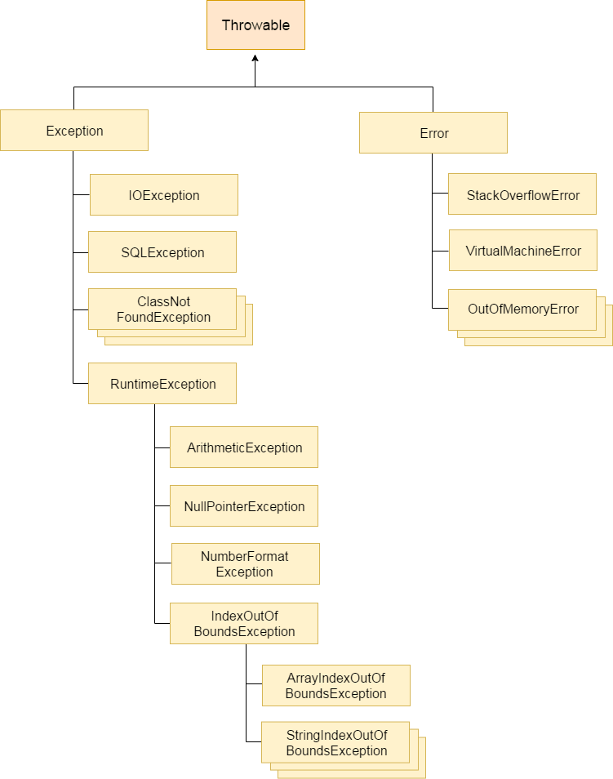

**Unchecked Exception**

* + Exception which are checked(identified or found out) during Runtime or execution time, such type of exception are called as Unchecked Exceptions.
  + Incase of Unchecked Exception our program will atleast compiles successfully.
  + Unchecked Exceptions are also called as Runtime Exceptions.
  + RuntimeExceptionclass is a super class to all UncheckedException classes.
  + **Examples(Classes) of Unchecked Exceptions are :-** 
    - ArithmeticException
    - ArrayIndexOutOfBoundsException
    - NullPointerException
    - StringIndexOutofBoundsException
    - ClassCastException
    - NumberFormatException

**Error :**

• An Error is an irrecoverable Condition i.e, if error occured it is not under programmers control to get over it.

• For Ex: if we develop any program whose size is 4gb but our system's storage is 3gb so such condition is not in programmers control and such situation is referred as Error.

• **Examples(Classes) of Error are :**

* StackoverFlowError
* VirtualMemoryError
* 404pagenotfound

**Differences between Error and Exception?**

|  |  |
| --- | --- |
| **Error** | **Exception** |
| An error is caused due to lack of system resources. | An exception is caused because of some problem in code. |
| An error is irrecoverable i.e, an error is a critical condition cannot be handled by code of program. | An Exception is recoverable i.e, we can have some alternate code to handle exception. |
| There is no ways to handle error. | We can handle exception by means of try and catch block. |
| As error is detected program is terminated abnormally. | As Exception is occurred it can be thrown and caught by catch block. |
| There is no classification for Error. | Exceptions are classified as checked and unchecked. |
| Errors are define in java.lang.Error package | Exceptions are define in java.lang.Exception package. |

**Valid Combinations -**

* try{} catch{} finally{}
* try{} finally{}
* try{} catch{} catch{} finally{}
* try{} catch{} finally{} try{} catch{} finally{}

**Invalid Combinations**

* try{} catch{} finally{} finally{}
* catch{} finally{}
* finally{} try{} catch{}

**There are two ways to handle the exception:**

* try-catch-finally
* throws keyword
* **try-catch- finally:**
  + Inside try block we generally writes the risky code which can cause an exception
  + In the catch block we writes the code which can tell us to bypass the situation on which we got an exception. Only that particular catch will get execute which has written for that particular exception.
  + For example if in try block we gets Arithmetic exception then there should be a catch block with Arithmetic exception otherwise program will get terminate abnormally.
  + Finally block executes every time whether we gets an exception or not. It is basically to perform cleanup activities.

**Java Program On try-catch-finally based exception Handling:**

**public** **class** Test3 {

**public** **static** **void** main(String[] args) {

**int** i =10;

**int** j=0;

System.***out***.println("Before arrival of exception");

**try** {

**int** k=i/j;

System.***out***.println(k);

}

**catch** (Exception e) {

System.***out***.println("exception handled in catch block" + e.getMessage());

}

**finally** {

System.***out***.println("Finally block is running");

}

System.***out***.println("After handling of exception");

}

}

**Output on Console:**

Before arrival of exception

exception handled in catch block/ by zero

Finally block is running

After handling of exception

* If the type of exception which is inside the try block is covered by catch block then the exception will get **handle and the program gets terminate in a normal way.**
* If the type of exception inside try block **is not been covered by any of the catch blocks** **then the program would get terminate abnormally.**
* **throws keyword**
* By using throws keyword we can handle the compile time error for exception handling but if there is an exception caused during runtime then it cannot protect from abnormal termination of program.
* It is recommended to use throws keyword for checked exception.

**Java Program On throws keyword based exception Handling:**

**public** **class** Test {

**public** **static** **void** main(String[] args) **throws** InterruptedException {

**int** i=10;

**int** j=0;

Thread.*sleep*(2000);

System.***out***.println("Exception handled for thread by Throws");

}

}

**Output on Console:**

Exception handled for thread by Throws.

**Throw Keyword:**

* By using throw keyword we can throw the exception at a particular situation in the program.
* It is generally used for throwing **customize exception** **(Exceptions which are defined by** **user).**

**Java Program On throw keyword based exception Handling:**

**public** **class** ThrowKeyword {

**public** **static** **void** main(String[] args) {

**int** i=8;

**int** j=20;

**if** (i>5) {

**throw** **new** ArithmeticException ("Exception occur at particular point ");

}

**if** (j>20) {

System.***out***.println("No any exception");

}

System.***out***.println("normal run of the program");

}

}

**Output on Console:**

Exception in thread "main" java.lang.ArithmeticException: Exception occur at particular point

at exception.ThrowKeyword.main(ThrowKeyword.java:12)

**Differences between throw and throws?**

|  |  |
| --- | --- |
| **throw** | **throws** |
| throw keyword is used to create Exception object explicitly | throws is used to declare the Exception |
| throw keyword is used inside the method | throws keyword is used with method declaration |
| Syntax: throw new ExceptionName(Excp description); Ex: throw new ArithmeticException("MyExcept"); | Ex: method declaration Exceptionname public void fly() throws InterruptedException |
| throw keyword is mainly used for Userdefine exception | throws keyword is mainly used for checked exception |
| Using throw keyword, we can throw only one exception at a time. | one exception at a time Using throws keyword, we can declare multiple exceptions at a time. |
| throw new MinBalException("Zero"); | public void check() throws InterruptedException,SQLException |

**Basically, "finally" is used to keep an important code which should not be skipped at any condition like closing of data base connection or closing of opened file etc.**

* **Difference between final , finally and finalize?**
* **Final :**
* Final is used to apply restrictions on class, method and variables.
* Final class can’t be inherited.
* Final method can’t be overridden.
* Final variable cannot be changed.
* Final is keyword.

**Finally:**

* Finally is used to place important code, it will be executed whether the exception is handled or not.
* **Basically, "finally" is used to keep an important code which should not be skipped at any condition like closing of data base connection or closing of opened file etc.**
* Finally is a block.

**Finalize:**

* Finalize is used to perform clean up activity just before object garbage collected.
* Finalize is a method.
* Finalize ( ) is a method which generally called by garbage collector or JVM to cut off the remaining connections of the unused object and destroy the same for memory optimization.
* **Finally and Close() :**
* close () statement is used to close all the open streams in a program.
* It’s a good practice to use close() inside finally block.
* Since finally block executes even if exception occurs so you can be sure that all input and output streams are closed properly regardless of whether the exception occurs or not.
* **Finally block and System.exit()**
* System.exit(0) gets called without any exception then finally won’t execute. However if any exception occurs while calling System.exit (0) then finally block will be executed.

**Can we write any statement between try and catch block ?**

* No, we cannot write any statement between try and catch block. Immediately after try block there should be catch or finally block.

**Can we write only try block without catch block ?**

* No, a try block should always followed by either catch or finally block.

**If we don't know exception type, what type should we mention in catch block?**

* When we do not know Exception type, we can mention it as ExceptionClass type or Throwable type. Because, Exception is a super class to all the class and during up casting we studied that superclass can hold reference of subclass object.

Ex: Exception e=new ArithmeticException()

Ex: Throwable e1=new ArithmeticException ()