PPHL Attendance Android App - Client Development Plan
Table of Contents

PPHL Attendance Android App — Client Development Plan
Document version: 1.0
Date: July 7, 2026
Audience: Business stakeholders and technical teams
App version: 2.1.0+ (continued development)

Executive Summary
The PPHL Attendance Android App is a mobile employee self-service application for Peoples Paper & Packaging. It connects to two backend systems:
- HRM (hrm-production) — employee login, leave, holidays, face registration, payroll-related data
- ZKTeco (zkteco-production) — attendance punches, device status, geo tracking, and central API configuration for the mobile app
The app is built on an existing Flutter codebase (not a rewrite). New work adds dashboard-driven API mapping, strict geo tracking, enhanced face attendance reporting, and placeholder Sales/Payment modules until their backends are finalized.

1. Outside Dependencies
System | Docker stack | Local URL | Production URL | Data provided
HRM / pphl_erp | hrm-production | http://127.0.0.1:8020 | https://hrm.peoplesitsolution.com | Auth, profile, leave, holidays, face templates
ZKTeco | zkteco-production | http://127.0.0.1:8095 | https://zkteco.peoplesitsolution.online | Attendance, devices, geo pings, app config
Sales system | TBD | — | — | Placeholder UI only
Payment system | TBD | — | — | Placeholder UI only
Firebase (optional) | — | — | — | FCM wake for geo (future)

Architecture diagram
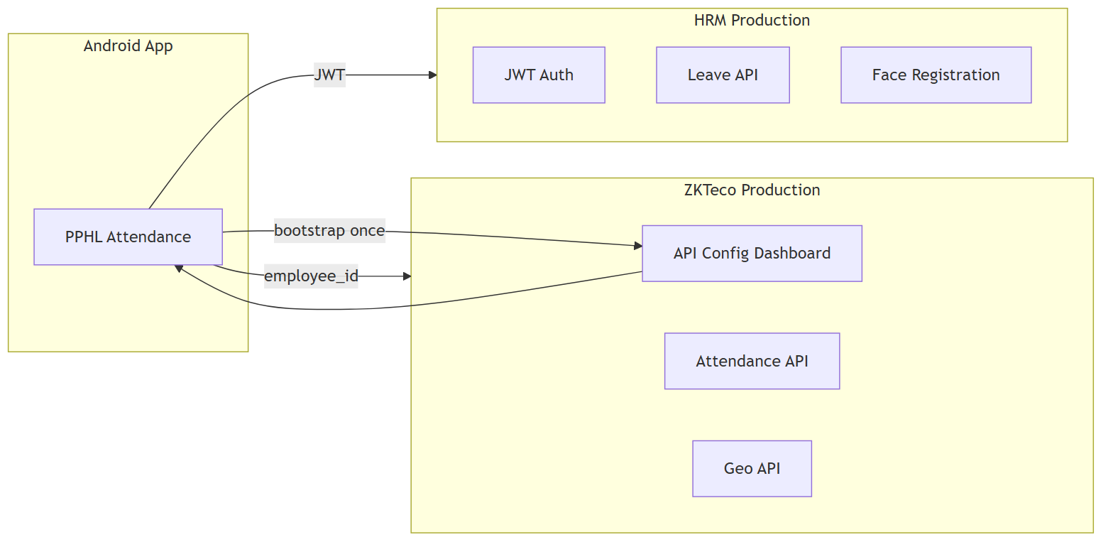
System architecture — Android app, HRM, and ZKTeco
Figure 1: The app bootstraps from ZKTeco, then calls HRM (JWT) and ZKTeco (attendance/geo).
For business users: The phone app talks to two company servers. HR data (leave, login) comes from the HRM server. Attendance and location data goes to the ZKTeco server. Administrators configure all API addresses from the ZKTeco web dashboard — no app update needed when URLs change.

2. Technology Stack

Persisting from current app
Layer | Technology
Framework | Flutter 3.x, Dart 3.11+
HTTP | http package
Local storage | shared_preferences
Face recognition | Google ML Kit + TensorFlow Lite (MobileFaceNet)
Camera | camera, image_picker
Location | geolocator, geocoding, permission_handler
UI | google_fonts, fl_chart, lottie, shimmer, animate_do
Device ID | android_id

New additions
Technology | Purpose
workmanager | Background geo capture (15-min OS minimum)
flutter_local_notifications | Foreground service notifications (geo)
Dynamic endpoint config | Fetched from ZKTeco dashboard

Backend technologies
Stack | Tech
HRM | Laravel, MySQL, JWT auth
ZKTeco | Laravel 13, PostgreSQL, Redis, Livewire dashboard

3. Endpoint Mapping Feature

How it works
- First launch: User enters ZKTeco server URL once (e.g. http://192.168.1.10:8095)
- App fetches: GET /api/v1/mobile/app-config (public, no login)
- Response includes: Base URLs, all feature endpoints, feature flags
- Cached locally and refreshed on login / app resume

Admin configuration
ZKTeco Dashboard → Settings → Mobile App API
- Set HRM and ZKTeco base URLs
- Edit each API path (login, leave, attendance punch, geo upload, etc.)
- Toggle feature flags: Sales, Payment, Geo tracking
- Set geo interval (default: 5 minutes)

Middlewareless principle
All API calls are direct HTTP — no extra middleware layer:
- HRM: Authorization: Bearer <JWT>
- ZKTeco mobile routes: employee_id parameter (existing pattern)

Config flow diagram
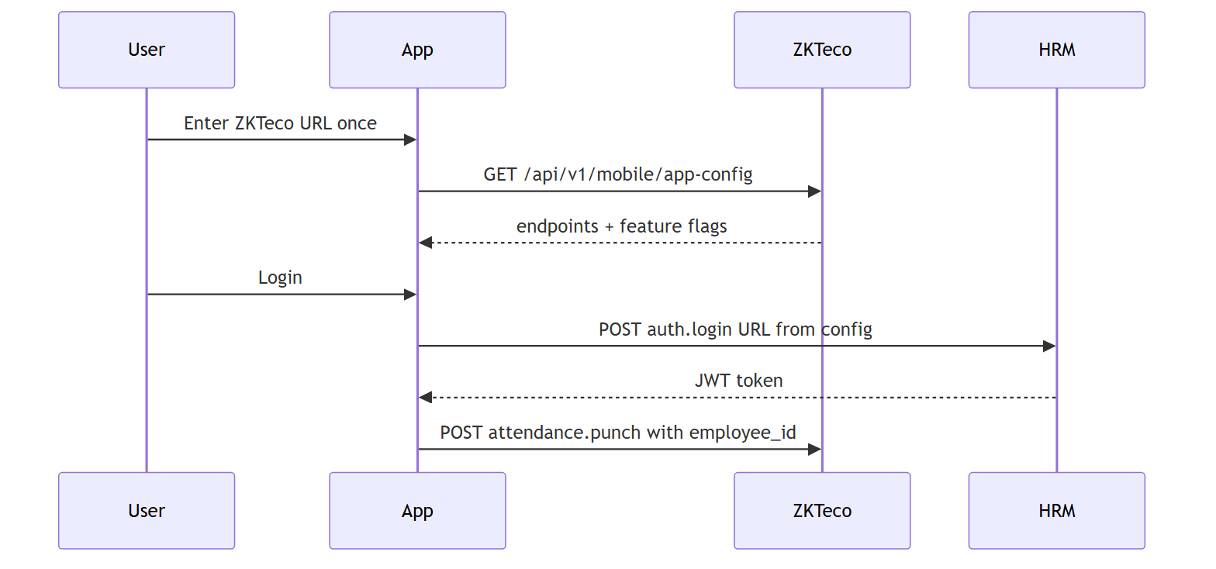
Endpoint configuration and login flow
Figure 2: First launch downloads all API URLs from ZKTeco; login and attendance use those mapped endpoints.

4. App Sections and Pages

4.1 Authentication & Setup
Screen | Function | Technology
Server Bootstrap | Enter ZKTeco URL, download config | HTTP, SharedPreferences
Login | Email/password against HRM | JWT, dynamic auth.login URL

4.2 Home & Face Attendance
Screen | Function | Technology
Home | Dashboard, check-in/out buttons | Profile from HRM
Check-in / Check-out | Face liveness + GPS punch | ML Kit, TFLite, Geolocator, ZKTeco punch API
Face Registration | 5-angle capture, server sync | Camera, TFLite, HRM face API
Face attendance report enhancements:
- Punch timeline with in/out times
- Face verified badge per punch
- GPS address on each record
- Summary cards: Present, Leave, Absent, Holiday

4.3 Leave Module
Screen | Function | Backend
Leave Hub | Balance snapshot + upcoming holidays | HRM
Leave Balance | Full balance list | leave.balance
Leave History | Past applications | leave.history
Apply Leave | Submit new request | leave.apply

4.4 Geo Tracking
Capability | Detail
Interval | 5 minutes (configurable in dashboard)
Storage | ZKTeco mobile_location_pings table
Upload API | POST /api/v1/mobile/geo-location
Background | Foreground timer + WorkManager + FCM (planned)
Permissions | Foreground + background location
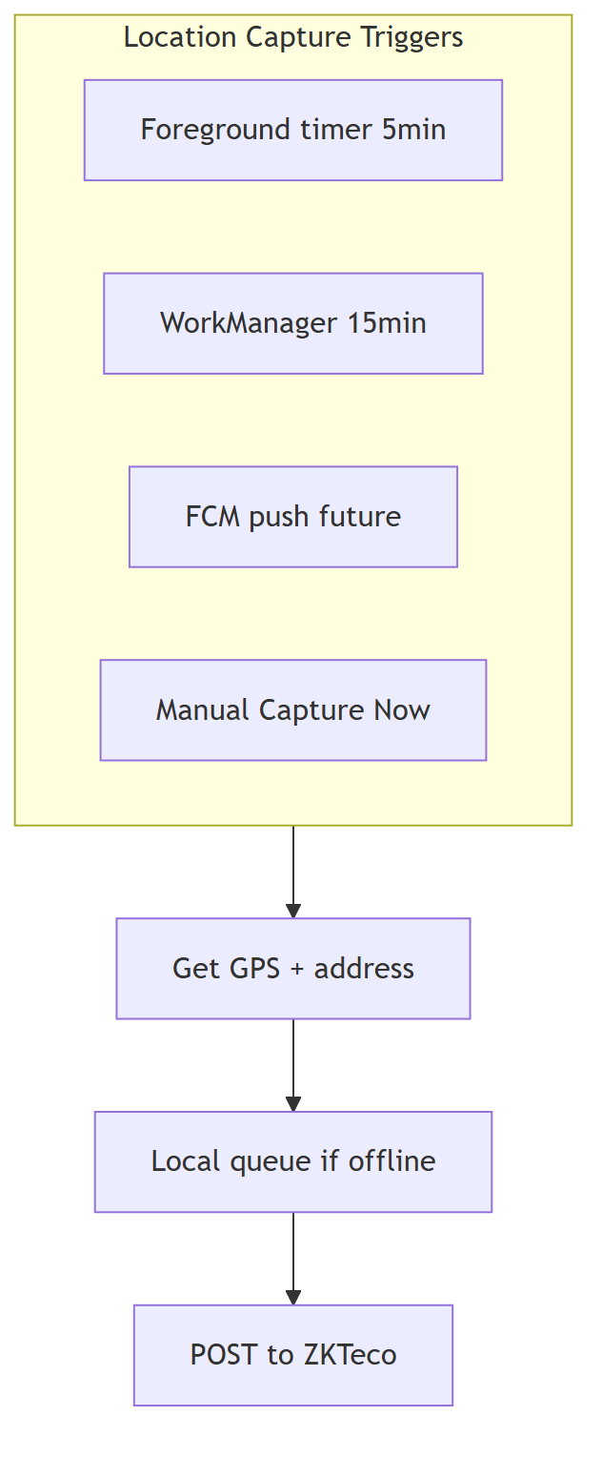
Geo location capture and upload flow
Figure 3: Location is captured on a schedule or manually, queued offline if needed, then posted to ZKTeco.

4.5 Sales Info (Placeholder)
- Visible only when feature.sales.enabled is true and user is in sales employee list
- Shows dummy metrics: Target, Orders, Revenue, Conversion
- Coming Soon when feature flag is off

4.6 Payment (Placeholder)
- Default: disabled (feature.payment.enabled: false)
- Shows polished “Coming Soon” UI with sample rows
- Live HRM loan APIs preserved behind flag for future activation

4.7 Profile & Services Hub
- Employee Services hub links to all modules
- Profile shows user info from HRM get-my-info
- Settings include geo tracking toggle

5. Navigation Map
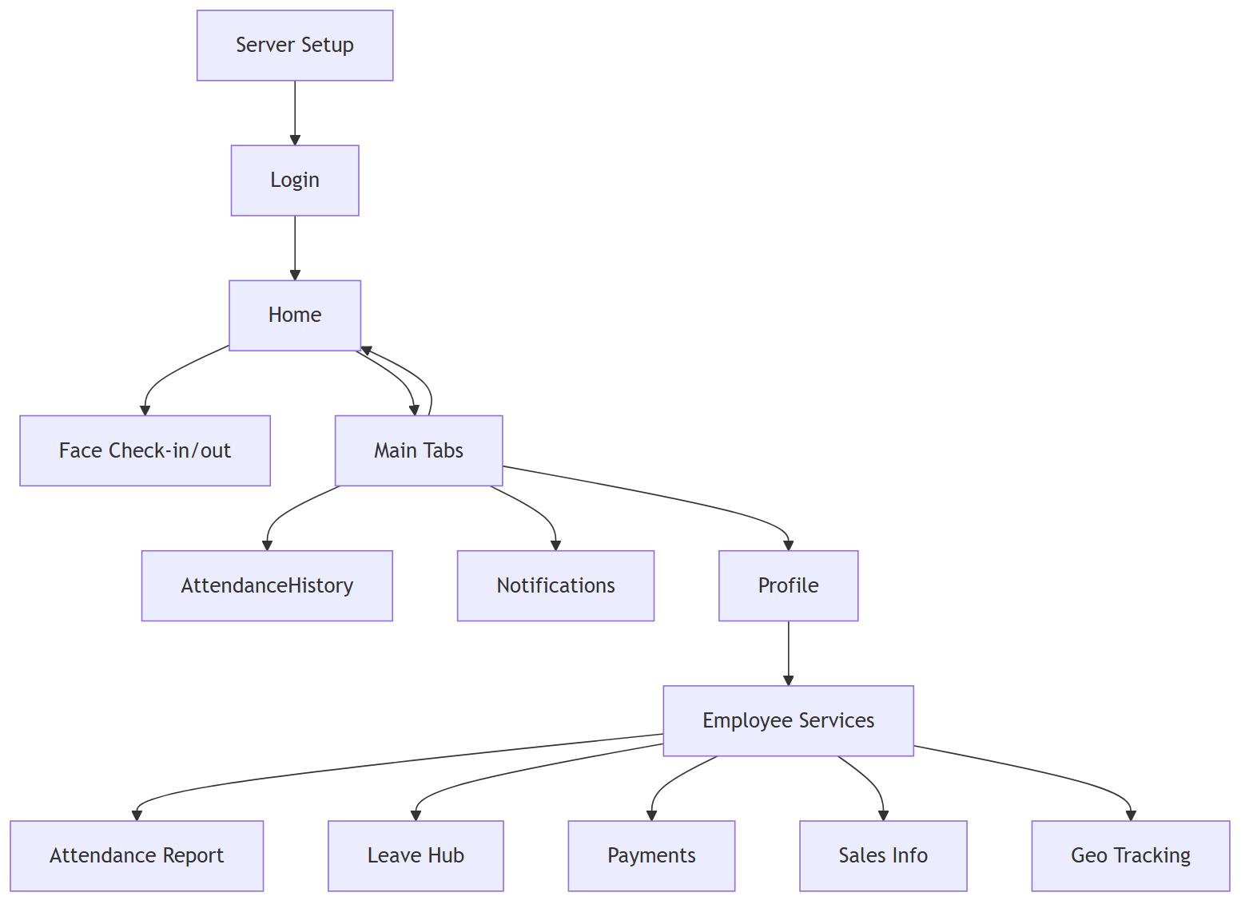
App screen navigation map
Figure 4: Main user journey from server setup through login, home, tabs, and employee services.

6. Development Phases (Completed)
Phase | Deliverable | Status
1 | ZKTeco mobile API config dashboard + public API | Done
2 | Geo location APIs on ZKTeco | Done
3 | HRM mobile holidays + leave security + token refresh | Done
4 | Android dynamic endpoint system | Done
5 | Face attendance detailed report | Done
6 | Geo 5-min + background worker | Done
7 | Sales/Payment dummy modules | Done

7. Local Development Setup

Start Docker stacks
# HRM (hrm-production)
cd hrm_deployment\docker
powershell -ExecutionPolicy Bypass -File .\scripts\up.ps1 -Build
# ZKTeco (zkteco-production)
cd zkteco_deployment\docker-bundle
docker compose --env-file .env up -d

Configure endpoints
- Open ZKTeco dashboard: http://127.0.0.1:8095
- Go to Settings → Mobile App API
- Set HRM base: http://127.0.0.1:8020 (or LAN IP for physical device)
- Set ZKTeco base: http://YOUR_LAN_IP:8095
- Save and use Preview App Config JSON

Physical device testing
Target | URL
Emulator → host HRM | http://10.0.2.2:8020
Emulator → host ZKTeco | http://10.0.2.2:8095
Phone on same Wi-Fi | http://PC_LAN_IP:8020 / :8095

Build APK
cd Attandance_App
flutter pub get
flutter build apk --release

8. Security & Privacy
Topic | Approach
Authentication | JWT on HRM; short-lived tokens with refresh endpoint
Attendance on ZKTeco | employee_id binding (existing public mobile pattern)
Leave data | Employees can only access own employeeId (server enforced)
Face data | Embeddings on device + encrypted template on HRM
Geo data | Stored in ZKTeco DB; 90-day retention (configurable)
API config | Public read endpoint; admin write requires dashboard login

9. Glossary
Term | Plain-language meaning
JWT | Secure login token used for HRM APIs
Bootstrap URL | The one ZKTeco address entered on first app launch
Endpoint mapping | List of API addresses managed in ZKTeco dashboard
Face liveness | Checks that a real person (blink, smile) is in front of the camera
hrm-production | Docker deployment of the HRM backend
zkteco-production | Docker deployment of attendance/device backend
Middlewareless | Direct API calls without an extra processing layer
Feature flag | On/off switch for app modules (Sales, Payment, Geo)

10. Importing to Google Docs

Recommended: use the .docx file (diagrams embedded)
- Upload CLIENT_ANDROID_APP_DEVELOPMENT_PLAN.docx to Google Drive
- Right-click → Open with → Google Docs
- All four architecture diagrams appear as images (not code)
- Apply styles if needed: Heading 1 for main sections, Heading 2 for subsections
- Recommended fonts: Open Sans or Arial

Alternative: re-import the markdown
- Run diagram render (if PNGs are missing):
- powershell -ExecutionPolicy Bypass -File .\scripts\render-client-doc-diagrams.ps1
- Import CLIENT_ANDROID_APP_DEVELOPMENT_PLAN.md via Google Docs → File → Import
- If images do not appear, drag PNGs from docs/images/client-plan/ into the document

Regenerate exports locally
powershell -ExecutionPolicy Bypass -File .\scripts\render-client-doc-diagrams.ps1
powershell -ExecutionPolicy Bypass -File .\scripts\export-client-doc-docx.ps1
Requires Node.js (npx) and Pandoc (winget install JohnMacFarlane.Pandoc).

Prepared for PPHL / Peoples IT Solution — Attendance App Development Program

