NASA SPACE APP CHALLENGE 2019

Project Name: A Jacket from future

# Main Features:

### Introducing TEX-JACK



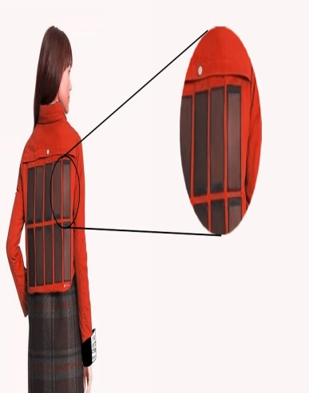

Lilly with normal jacket Solar panel on the back of Lilly

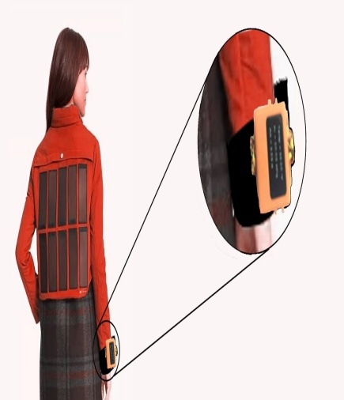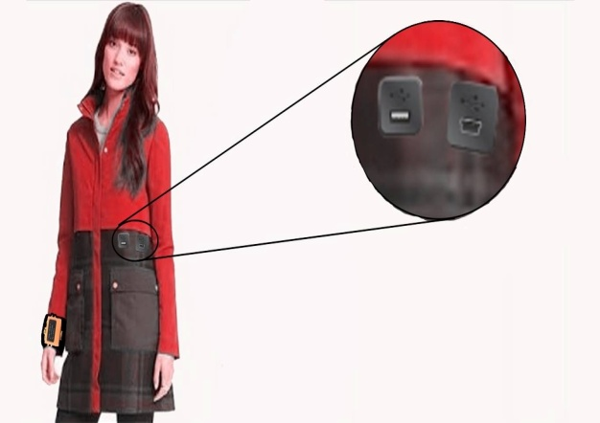

Usb port LCD display



**Lilly with Tex-Jack**

**Main Components :**

# Additional Features:

Headphone jack

Led strip

Waterproof

Multifunctional

Stylish

Both for man and woman

Lightweight

Easy to wash

Flexible

Time

Pressure

Pedometer

Notification

# Description:

As technological advancement is seen everywhere in the world and can be felt in every sphere of our life. Economist said that the more supply means the more demands. So with the advancement of technology people expect of demand more comfort or more features the make the life easier.

Our project name is A JACKET FROM FUTURE: A stylish jacket for smart people.

We simply call it TEX-JACK I and it s a jacket which can be perfect choice for them who want to make his life more comfortable. It is a jacket which is capable of being self heated using the coil inside the jacket by simply pressing the switch. It has built in solar panel to charge its 4000mah lithium ion battery with very light weight. The jacket contains sufficient insulation layers to prevent the body from any heat issue, besides the heat is not that much that it will harm the human body.

If the jacket is wetted by rain then nothing to worry because the jacket has self drying features to dye the whole jacket within 5 minutes.

The jacket has multiple pockets that allow the users to carry more components. The jacket has the facility to charge any Smartphone.

The mains parts of the jacket is the LCD screen the right hand which will show the steps ,time, temperature, pressure ,notifications and etc .

The jacket has a headphone jack for music lovers.

### Benefits:

1. Don’t have to carry watch.
2. Don’t have to worry about cold weather.
3. Don’t have to worry about the rain as the jacket is waterproof.
4. Can carry a lot of things and has many safety pocket.
5. Don’t have to worry about charging the battery as the jacket has solar cell to charge the battery.
6. Stylish.
7. You will get the pedometer.
8. Easy to wash and Dry.
9. Can charge the Smartphone.
10. Not harmful to human body as it has proper insulation layer.
11. Supports fast charging through wall charger.