**NAME - TANWEERUL HAQUE**

**COLLEGE - BIT MESRA**

**YEAR - 3rd**

**WE DIVIDE THE TASK INTO MULTIPLE STAGES IN ORDER TO SUCCESSFULLY ANALYZE EACH STEP AND MODE -**

**1) CONSTRUCTING A SIMPLE MODEL -**

AS WE SEE THROUGH THE METADATA OF THE DATASET DOWNLOADED FROM HERE - [https://github.com/ieee8023/covid-chestxray-dataset](https://github.com/ieee8023/covid-chestxray-dataset" \t "https://colab.research.google.com/drive/_blank) . IT CONTAINS IMAGE FILENAMES OF ALL THE COLUMN NAMES - "finding" AND "RT_PCR_POSITIVE" WHICH CONTAINS ENTRIES AS - "Pneumonia[/Viral/COVID-19](https://colab.research.google.com/drive/1sfRnM6w9svUSj9GCJJn5ZUkNi4FPgFfv)" AND "Y" RESPECTIVELY, THEREBY ABSOLUTELY CONFIRMING THE PRESENCE OF COVID-19.

RESULTS -

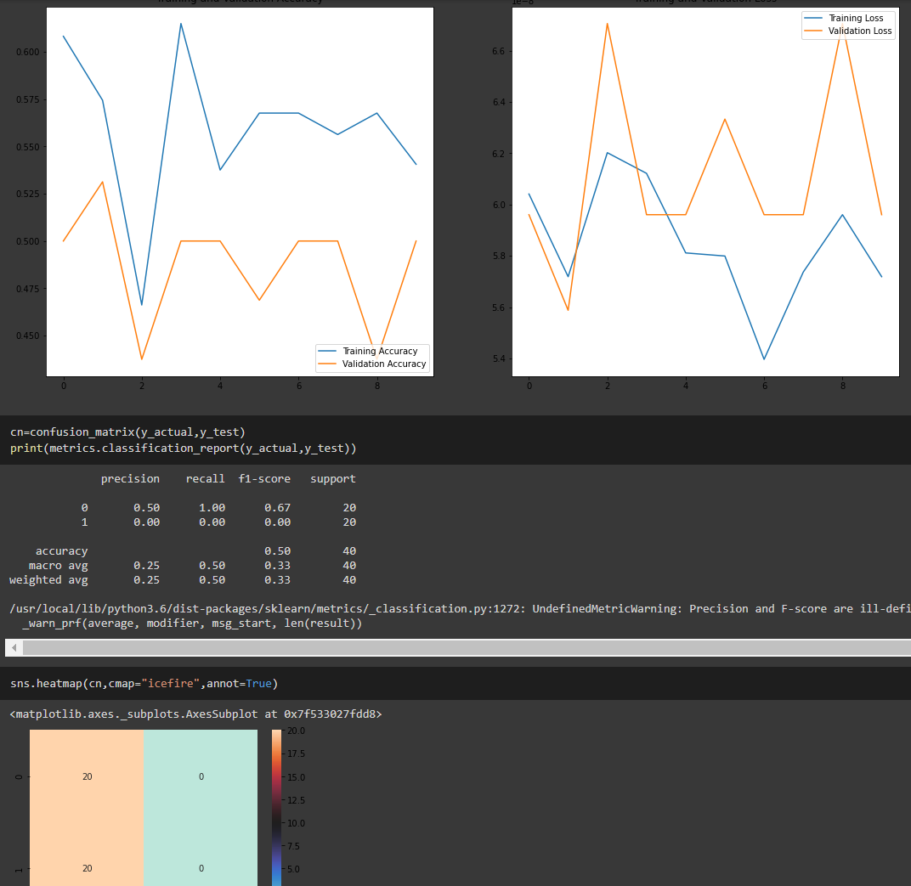

1. WE BUILD OUR SECOND TYPE OF COMPLEX MODEL -

RESULTS -

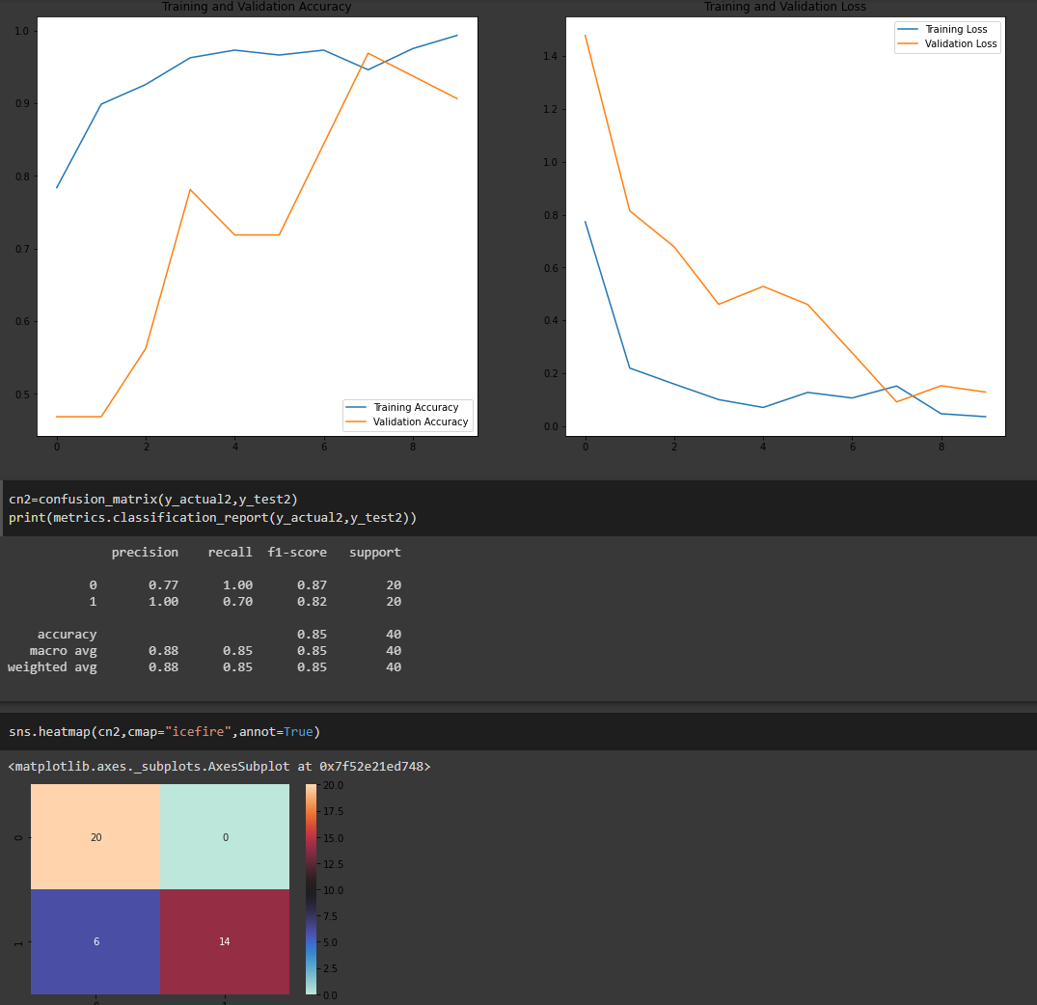

3) TRANSFER LEARNING - USING RESNET50V2 (GOOGLE'S STATE OF THE ART ARCHITECHTURE

We know that the number of COVID-19 x-ray scans available to us is just 110. In real life, there are thousands of x-ray images of normal,viral and bacterial pneumonia which have very resembling scans and symptoms as of COVID-19. So we use transfer learning method and leverage the power of ResNet50V2 to tackle these imbalanced classes using class weights and correctly setting the initial bias to train our model

We proceed in the same way as before. We make folders to store our our images

We'll force our model to tackle class imbalance by putting only +ve covid images in the test folder

RESULTS -

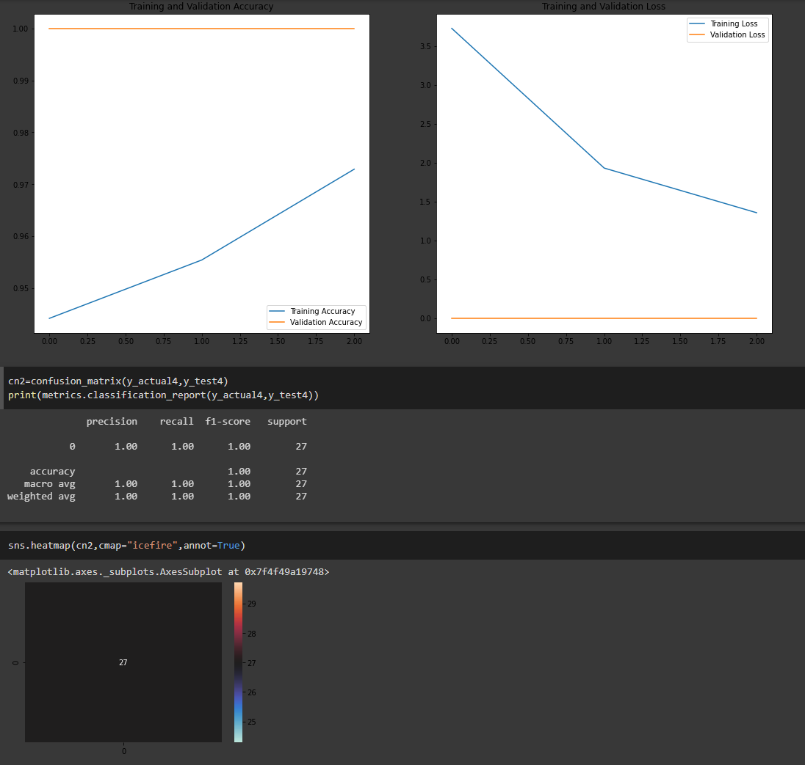

4) IMPLEMENTING A BASIC SKELETON THAT POWERS COVXNET (NETWORK-128) USING THE SAME METHOD OF TRANSFER LEARNING. WE FIRST TRAIN OUR MODEL ON NORMAL/PNEUMONIA X-RAY SCANS. THEN BY TRANSFER LEARNING, WE TRAIN IT ON COVID IMAGES ALSO. COVXNET SURPASSES THE PERFORMANCE OF ALL THE MODELS AVAILABLE TO US

WE'LL IMPLEMEMT TRANSFER LEARNING IN THIS MODEL IN THE SAME WAY AS WE IMPLEMENTED IN THE RESNET50V2

RESULTS -

