1. IoT Monitoring System
○ Real-time monitoring of soil moisture, temperature, and humidity.
○ Data sent to a mobile app or web dashboard using NodeMCU.
○ Alerts when thresholds are crossed (e.g., low moisture or high temperature).

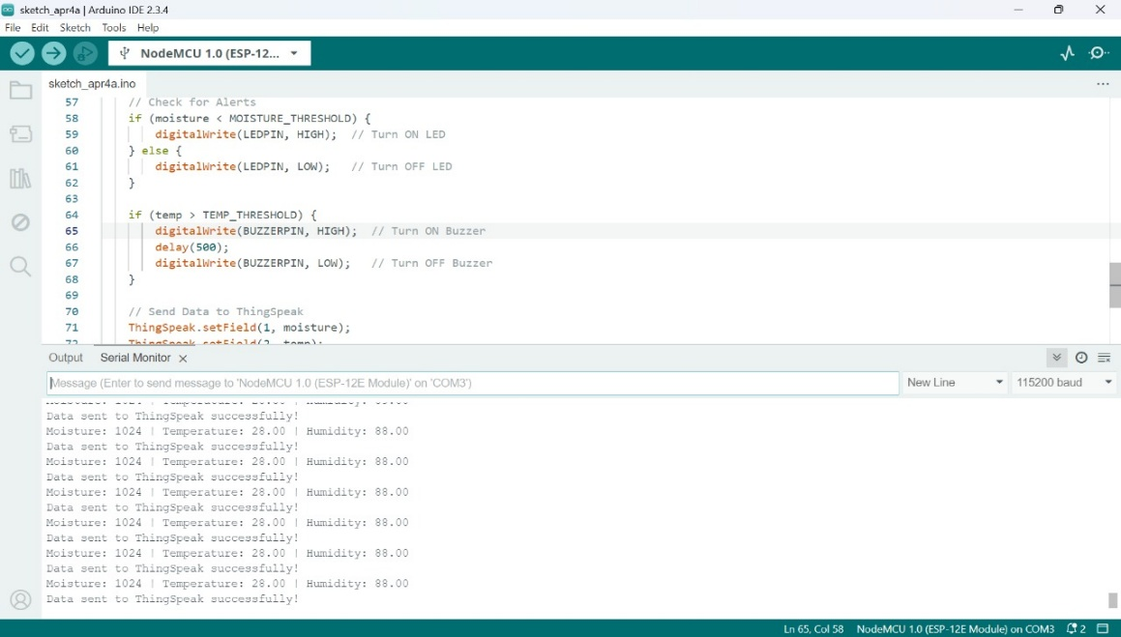
Functional IoT dashboard or serial output:

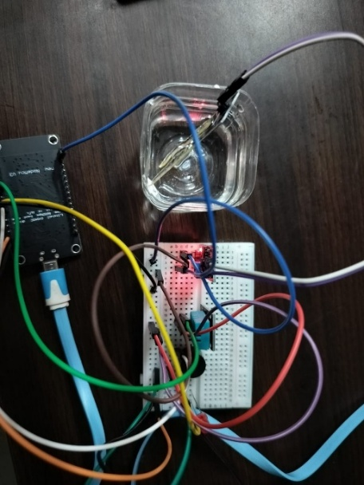
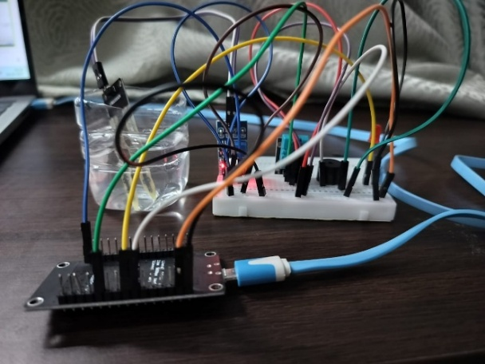
When the moisture sensor is dipped in water

When the moisture sensor is not dipped in water
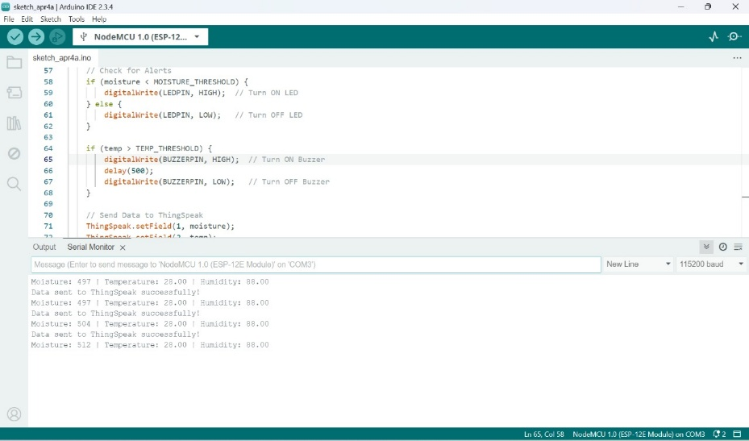

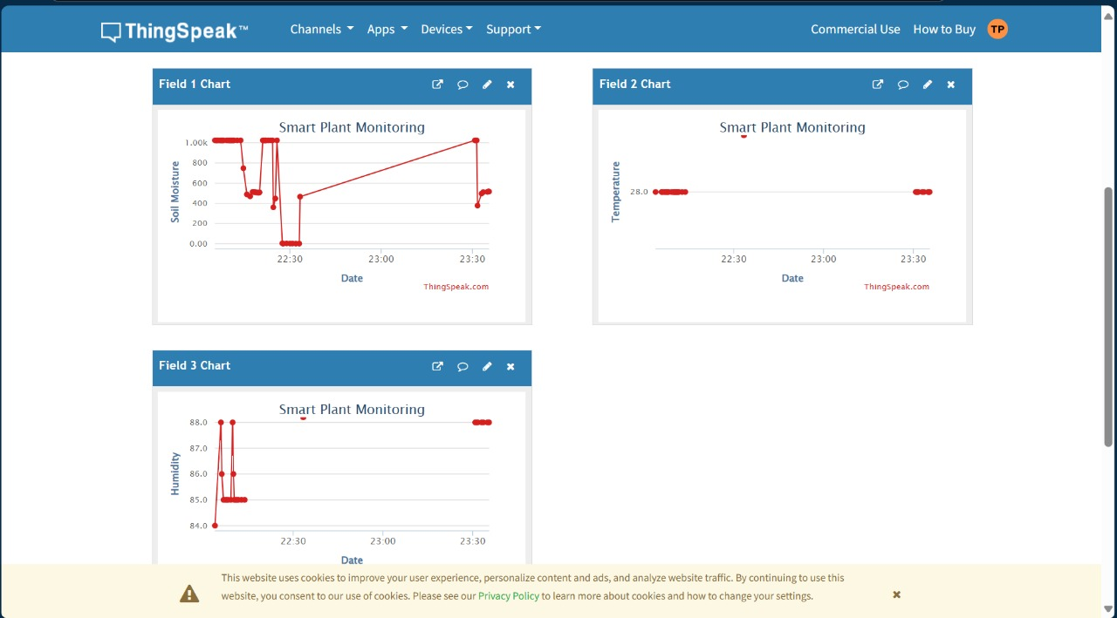

Sensors used:
Node MCU ESP8266
Moisture Sensor
DHT11 Sensor (Temperature & Humidity)
LED
Buzzer
System logic:
- NodeMCU reads soil moisture, temperature, and humidity from sensors in real-time.
- Compares the values with predefined thresholds and sends alerts if limits are crossed.
- Continuously updates data to a mobile app or web dashboard via Wi-Fi for live monitoring.

IOT integration:
Platform used- ThingSpeak
- NodeMCU ESP8266 sends sensor data to IoT Cloud using Wi-Fi. (Soil Moisture Value, Temperature Value, Humidity Value)
- We get graphical representation of the data and alerts.
Robotic actuation mechanism:
To perform automatic actions based on sensor readings using actuators controlled by NodeMCU.
Moisture value increases when soil is dry while it decreases when soil is wet.
- When Moisture > 700 (Soil Dry)- LED ON + Buzzer Beep
- Moisture < 300 (Soil Wet)- LED OFF + Buzzer OFF
- Temp > 35°C or Humidity < 30% or > 80% - LED ON + Buzzer Beep

CODE:
#include <ESP8266WiFi.h>
#include <DHT.h>
#include <ThingSpeak.h>
const char* ssid = "vivo Y200e 5G";
const char* password = "autumn1108";
unsigned long channelID = 2906049;
const char* apiKey = "73JNX7NDRWA4NR46";
#define DHTPIN D4 // DHT11 sensor pin
#define DHTTYPE DHT11 // DHT type
#define MOISTUREPIN A0 // Soil Moisture Sensor pin
#define LEDPIN D5 // LED pin for moisture alert
#define BUZZERPIN D6 // Buzzer pin for temperature alert
#define MOISTURE_THRESHOLD 400 // Adjust based on soil condition
#define TEMP_THRESHOLD 30 // High temperature alert (in °C)
DHT dht(DHTPIN, DHTTYPE);
WiFiClient client;
void setup() {
Serial.begin(115200);
dht.begin();
pinMode(LEDPIN, OUTPUT);
pinMode(BUZZERPIN, OUTPUT);
WiFi.begin(ssid, password);
Serial.print("Connecting to Wi-Fi");
while (WiFi.status() != WL_CONNECTED) {
delay(500);
Serial.print(".");
}
Serial.println("\nConnected to Wi-Fi");

ThingSpeak.begin(client);
}
void loop() {
// Read Sensor Data
int moisture = analogRead(MOISTUREPIN);
float temp = dht.readTemperature();
float humidity = dht.readHumidity();
Serial.print("Moisture: "); Serial.print(moisture);
Serial.print(" | Temperature: "); Serial.print(temp);
if (moisture < MOISTURE_THRESHOLD) {
digitalWrite(LEDPIN, HIGH); // Turn ON LED
} else {
digitalWrite(LEDPIN, LOW); // Turn OFF LED
}
if (temp > TEMP_THRESHOLD) {
digitalWrite(BUZZERPIN, HIGH); // Turn ON Buzzer
delay(500);
digitalWrite(BUZZERPIN, LOW); // Turn OFF Buzzer
}
ThingSpeak.setField(1, moisture);
ThingSpeak.setField(2, temp);
ThingSpeak.setField(3, humidity);
int status = ThingSpeak.writeFields(channelID, apiKey);
if (status == 200) {
Serial.println("Data sent to ThingSpeak successfully!");
} else {
Serial.println("Failed to send data to ThingSpeak.");
}
delay(15000); // Wait for 15 seconds before next reading
}

2. Robotic Plant Guardian
○ IR sensor detects nearby motion (intruders).
○ Servo motor triggers a mechanical response (e.g., waving arm or closing lid).
○ Buzzer and LED provide audio-visual alerts.

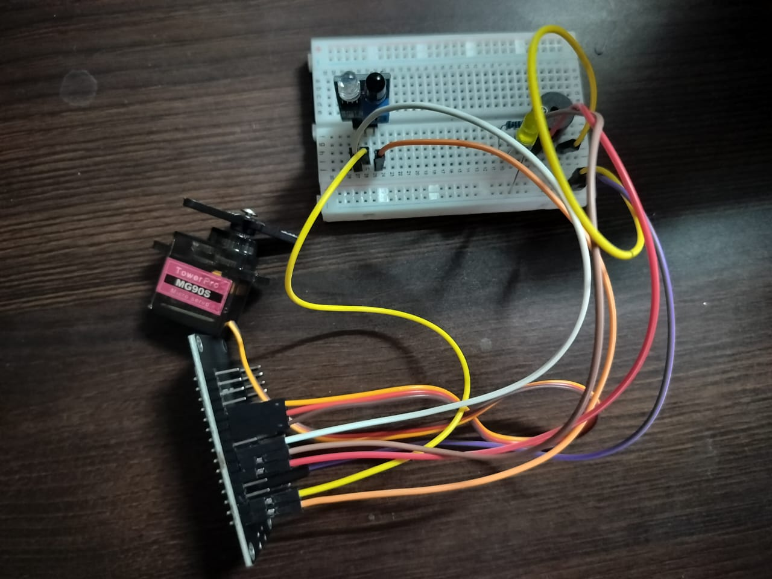
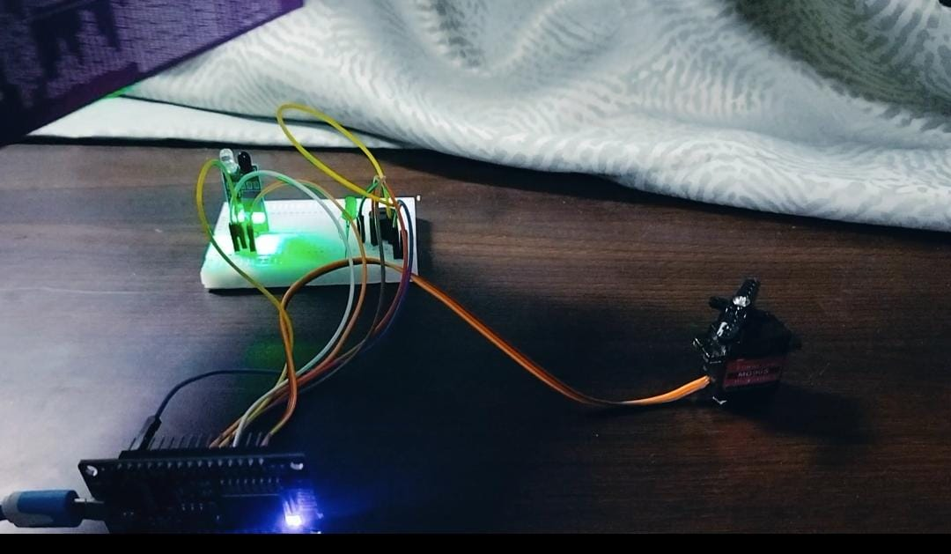
When intruder is not detected.(Normal condition)
When intruder is detected. (LED glows and buzzer beeps)
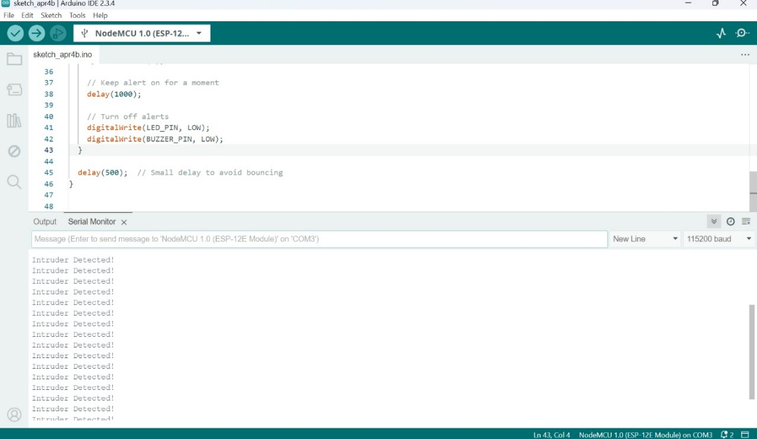

CODE:
#include <Servo.h>
Servo myservo;
const int servoPin = D4; // Servo connected to D4
const int irSensorPin = D6; // IR Sensor connected to D6
const int ledPin = D7; // LED connected to D7
const int buzzerPin = D8; // Buzzer connected to D8
int irValue = 0;
void setup() {
myservo.attach(servoPin);
pinMode(irSensorPin, INPUT);
pinMode(ledPin, OUTPUT);
pinMode(buzzerPin, OUTPUT);
myservo.write(0); // Initial Servo Position
Serial.begin(9600);
}
void loop() {
irValue = digitalRead(irSensorPin);
if (irValue == HIGH) { // Motion Detected
Serial.println("Intruder Detected!");
myservo.write(90); // Servo Movement
digitalWrite(ledPin, HIGH); // LED ON
digitalWrite(buzzerPin, HIGH); // Buzzer ON
delay(1000); // Delay 1 sec
}
else { // No Motion
myservo.write(0); // Servo back to initial position
digitalWrite(ledPin, LOW); // LED OFF
digitalWrite(buzzerPin, LOW); // Buzzer OFF

}
delay(200); // Small Delay
}

Sensors Used:
- IR Sensor → Detects motion/intruder near the plant.
System Logic:
- IR Sensor continuously monitors for motion.
- If motion is detected → Alert and Action triggered.(buzzer and led)
- If no motion → System stays idle.
Robotic Actuation Mechanism:
- Servo Motor moves (like waving arm or closing lid) when motion detected.
- LED glows and Buzzer beeps for visual and sound alert.
- When no motion → Servo returns to initial position, LED & Buzzer OFF.

3. Automated Watering System
○ Relay simulates or controls a water pump.
○ System checks soil moisture and automatically waters when necessary.
○ Moisture threshold adjustable using the potentiometer.
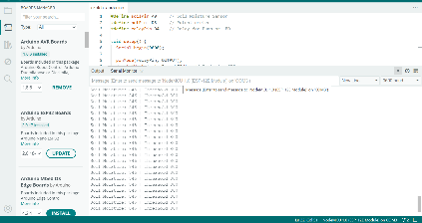

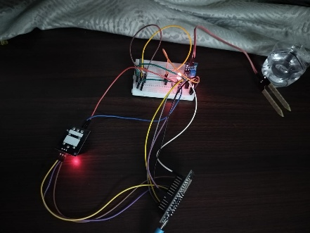

When the moisture sensor is not dipped in the water i.e soil is dry

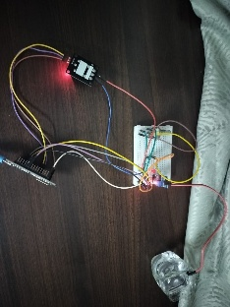
When the moisture sensor is dipped in the water i.e soil is wet.

Sensors used:
Potentiometer- To set/change moisture threshold manually
Soil Moisture Sensor- To read soil moisture level
System logic :
Read Potentiometer → Set Threshold
Read Soil Moisture → Compare
If Soil Moisture < Threshold → Turns Relay ON (Pump ON (here LED))
Robotic Actuation Mechanism:
Relay Module- Acts as a switch between Arduino & Pump
LED-Turns ON/OFF based on relay

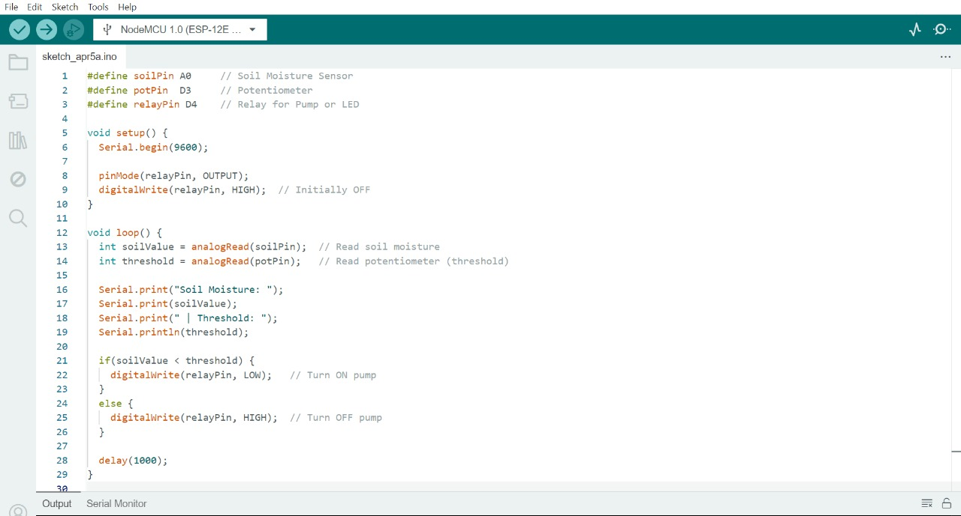
CODE:

\

