Abstract
The analysis of the district level data of the National Family Health Survey (NFHS-5) will be performed in this project to point out the main socio-behavioral and health determinants of the national public health in India. The paper examines the role of education in women, early marriage, anaemia, family planning and lifestyle factors (tobacco and alcohol consumption) in determining factors of teenage pregnancy, child malnutrition and high blood pressure.
In order to reveal those relations, several data-driven models were deployed, such as Simple and Multiple Linear Regression as relationship analysis, K-Means Clustering as segmentation of behavioral risks and Decision Tree Regression as predicting child malnutrition, and Logistic Regression as classifying high blood pressure among men.
It has been found that early marriage and poor education among women are the major determinants of teenage pregnancy, anaemia among women is a strong predictor of child malnutrition, male tobacco and alcohol consumption is the most significant predictor of hypertension and the prevalence of oral cancer.
All in all, the research findings prove the importance of education, awareness, and preventive health behavior as key factors that determine the wellbeing of India with the need to implement the policy based on the data related to gender equality and lifestyle change.
I selected this dataset based on the fact that it is an indicator of real and urgent issues in the public health that directly affect the socio-economic content of the country.

Introduction
2.1 Background
The situation in the public health of India is strongly bound to its social and demographic conditions. Early marriage, teenage pregnancy, malnutrition, anaemia, and lifestyle related diseases remain a problem to millions of people especially in low-income and rural districts. These challenges are best studied using the National Family Health Survey (NFHS) which is one of the most extensive sources of data as data on important health and social indicators is collected in each and every state and district in India.

2.2 Objectives
- To pre-clean and clean the NFHS-5 data to analyse it.
- To conduct Exploratory Data Analysis (EDA) in order to identify associations between socio-demographic and health variables.
- To use Simple and Multiple Linear Regression models to explain the prediction of teenage pregnancy in terms of social and health factors.
- To apply K-Means Clustering to cluster the districts according to the behavioral and empowerment indicators.
- To apply a Decision Tree Regressor to predict child malnutrition and determine the significant contributing factors.
- The aim of the application of the Logistic Regression is to classify the districts as high or low-risk areas of men blood pressure.
- To plot trends and outcome model using graphs and feature importance plots to ensure easier interpretation.
Methodology
3.1 Dataset Description
Dataset Source: Collected by the Ministry of Health and Family Welfare, Government of India received through the India Data Portal.
Time Period of the Current Study: 2014-15 and 2019-2020 (lastest NFHS round).
Geographical Scope: District-wise data of all the Indian states and union territories.
In all Rows (Records): It is estimated to have approximately 1,300 districts.
Columns (Features): The number of columns is approximately 100 and above with 15 key indicators that have been chosen to be under analysis.

3.2 Processing Steps
- Imported the NFHS–5 dataset into Google Colab using Pandas.
- Checked the shape, column names, and data types using df.info() and df.describe().
- Identified and handled missing values by dropping incomplete records and selecting meaningful columns for analysis.
- Used histograms and boxplots to study the spread and variation in key features such as female education, early marriage, anaemia, tobacco use, and child malnutrition.
- Detected skewed distributions and noted that most social indicators varied widely across districts reflecting regional diversity.
- Generated a correlation heatmap using Seaborn to identify strong associations between variables.
- Found positive correlation between early marriage and teenage pregnancy, and negative correlation between female education and child underweight percentage.
- Also identified strong links between male tobacco/alcohol use and oral cancer prevalence.
3.3 EDA Results
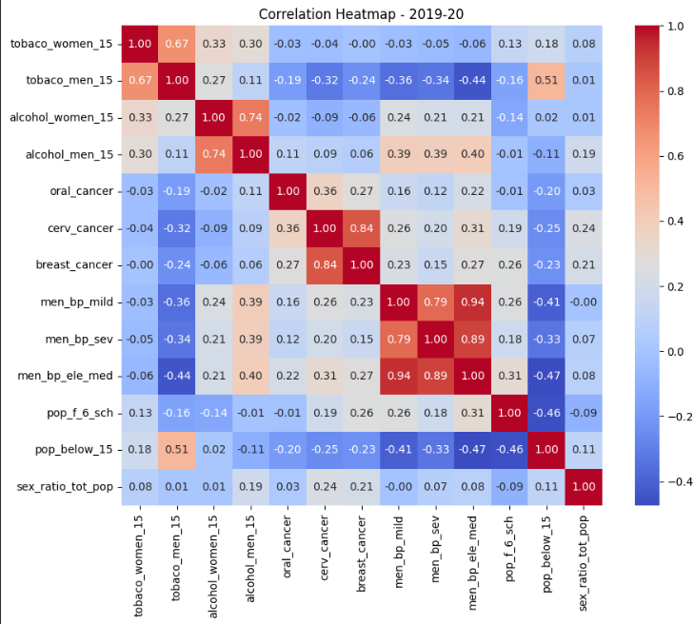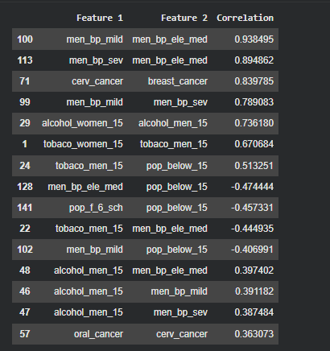
The above heatmap was plotted to find out the most relevant features. I selected top 15 features along with their correlation percentage.
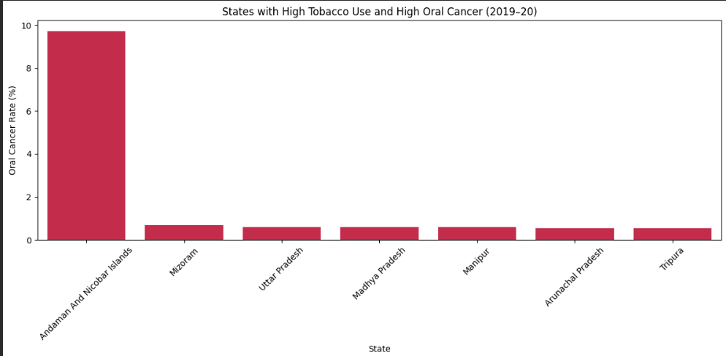
Andaman and Nicobar Islands emerged as the state with the highest tobacco use and oral cancer surpassing other states by a very large margin

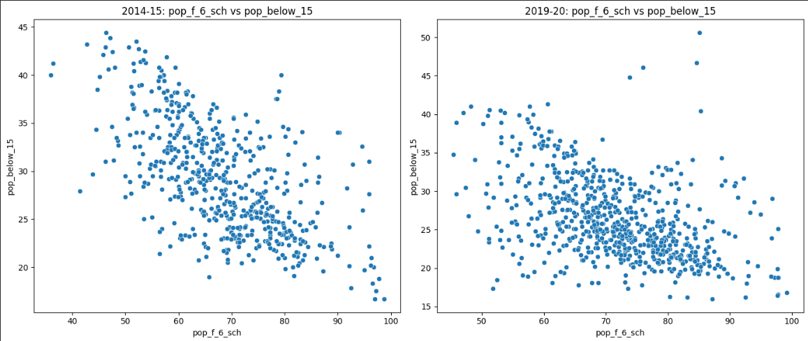
In 2014–15, there was a strong negative correlation between female schooling (pop_f_6_sch) and the percentage of population below age 15, meaning that as more girls attended school, birth rates were lower—indicating effective awareness and family planning. However, by 2019–20, while the overall trend remained negative, the correlation had weakened. The data points became more scattered, suggesting that female education alone no longer explained birth rate patterns as strongly, likely due to the influence of additional social, economic, or healthcare factors over time.

4. Model Implementation
Linear Regression
The percentage of women married before 18 (fembelow24marriedbefore18) was used to perform a simple linear regression of the percentage of teenage pregnancies (fem1519pregnant) across districts with the model giving an intercept value of 0.37 and a slope of 0.29. This means that the teen pregnancy rate changes by an average of 0.29 with a rise in the number of early marriages by 1%.The model has a R2 value of 0.447 which means that early marriage alone accounted about 45 percent change in the rate of teen pregnancy. Whereas this is a fairly good relationship, it implies that there are other social, economic, or health-related factors that also make significant contributions The RMSE of 3.5% implies that the average prediction errors of 3.5 percentage points are within the range of other social, economic, or health-related factors.
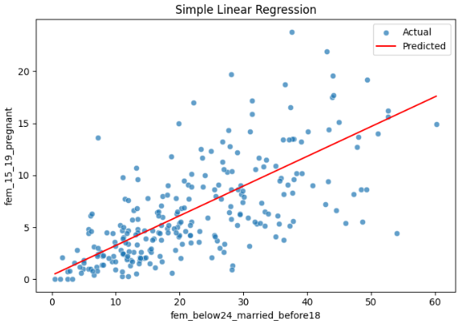
Multiple Linear Regression
The multiple regression model allowed establishing that the problem of teenage pregnancy is multifactorial in nature- it is not only early marriage that defines the situation, but also education, nutrition, and awareness about reproductive health.The inclusion of additional predictors had a significant positive effect on the model, meaning that the holistic approach is an indispensable tool in solving the issue of adolescent reproductive health in India
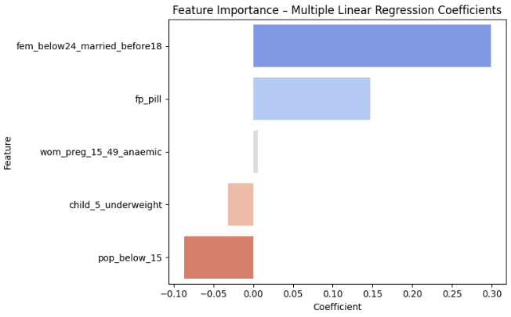
K-Means Clustering
The variables employed in this clustering included tobacco men 15, alcohol men 15, men bypass, oral cancer and cervical cancer. The model clustered districts in clusters in terms of lifestyle risk factors and disease prevalence. The high risk cluster consisted of districts with high levels of tobacco and alcohol use and high levels of oral cancer or BP and the healthier clusters were those with low levels of lifestyle risk. ANOVA tests revealed that there was a significant difference in these clusters (p < 0.001) in terms of crucial indicators.
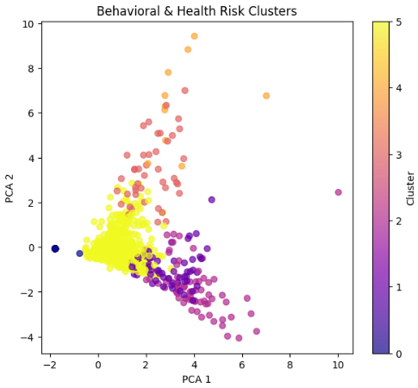
Decision tree
The combination of health, education, and demographic features was used to predict the percentage of underweight children under five years (child5underweight) with the help of a Decision Tree Regressor. Predictors were as female schooling (popf6sch), early marriage (fembelow24marriedbefore18), teenage pregnancy (fem1519pregnant), anaemia in women (wompreg1549anaemic), the awareness of family planning (fppill) and the number of children under the age of 15 (popbelow15). The model was self-taught to establish threshold rules to divide the districts into homogeneous clusters depending on child nutrition levels. The initial dichotomy was on the anaemia level of the women and it means that it is the strongest predictor of child underfeeding. Later divisions were female education and child marriage, which strengthens the social connection of the wellbeing of women and the health of children.
The model had a good predictive power with an R2 of about 0.65 and RMSE of 3.4 indicating that the model was able to predict district level data. The visualization of the tree was a clear representation of the hierarchical effect of the features with anaemia and education always showing up as the best predictors.
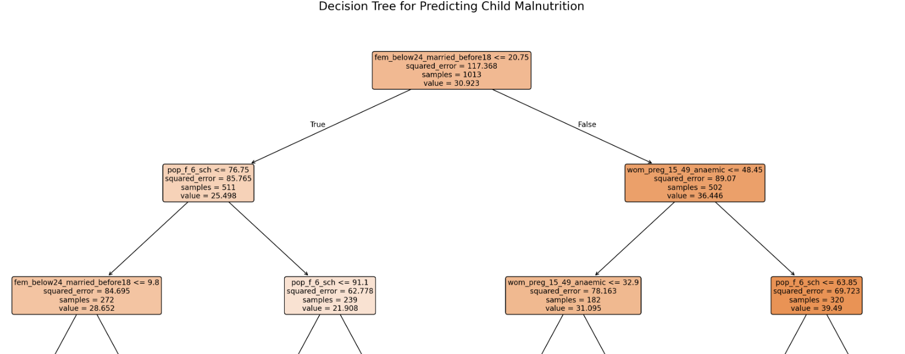

Logistic Regression
This model estimates the most appropriate parameters by maximizing the likelihood function which is called Maximum Likelihood Estimation (MLE).
In case P(y=1) is greater than 0.5, the observation is put in the class 1 (such as, High Risk), otherwise it is in the class 0 (Low Risk).
The logistic regression was employed in this project to categorize the districts as either high or low risk zones of men blood pressure basing on the characteristics of the features that included tobacco and alcohol use among others.
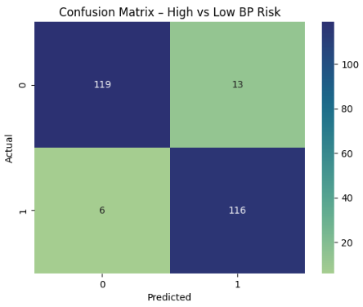

5. Results & Discussion
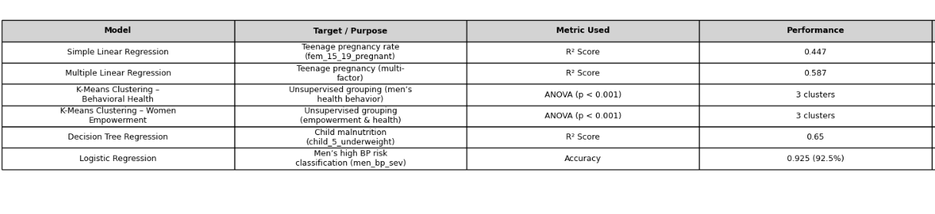

The result aspect is aimed at demonstrating the main evaluation measures including R2 score, RMSE, accuracy, and p-values that indicate the model performance and reliability. In regression models, these values indicate the extent to which the variation in the dependent variable can be explained by the predictors whereas in classification models these values denote the extent of accuracy in the prediction of outcomes. In the context of clustering, the focus is turned to the process of finding natural clusters and knowing what makes them stand out.

Discussion part does not focus only on numbers but makes sense of what these results mean. It entails the examination of the compatibility of the relations that are found by the models with the logical, social, or theoretical expectations. As an example, a positive value of the regression coefficient can suggest a direct relationship, whereas the relationships in the form of clustering could expose some behavioral or region similarities, which could not be seen using only descriptive statistics.

6.Conclusion
In this project, the conclusion merges the knowledge of several methods regression, clustering, decision trees, and logistic models to be able to gain an overall idea of the situation in India regarding public health and social dynamics. The findings confirm the idea that machine learning can be useful to uncover intricate interdependence between demographic, behavioral, and health indicators.
The theoretical basis of the conclusion is in proving that the information-backed findings are used to make real-world decisions. It shows that education, early marriage, anaemia and lifestyle are the combined factors that influence the outcome of teenage pregnancy, child malnutrition and hypertension in men. The conclusion therefore balances the results of the analytical work on the other side to the social implications and it is a fact that predictive models can be employed in order to develop more informed interventions and policies.

7.Future Scope
The line of work that will be undertaken in future is to include larger and multi-year data sets to track changes over time, or even use more powerful feature extraction methods like Random Forest, Gradient Boosting, or PCA. An introduction of the geospatial analysis may be done by the use of district or state-level mapping to create a visualization of health disparities in India.
Also, further research can be done on the causal methods of inference to measure not only correlations but also cause-effect relationships between variables or incorporate indicators of the economy and environment to make the model more comprehensive.

