COMPUTER PROJECT ON


‘VIDEO LIBRARY MANAGEMENT’

BY

TANYA SHARMA

INDEX
- Certificate……………………………………..
- Acknowledgement………………………….
- Overview of C++……………………………..
- Synopsis …………………………………………..
- Header Files…………………………………….
- Global Classes ………………………………….
- Source Code………………………………….….
- Compilation Report …………………………
- Output………………………………………………..
- Bibliography………………………………………
CERTIFICATE

This is to certify that
TANYA SHARMA of CLASS XII C
has done this project on
“VIDEO LIBRARY MANAGEMENT”
under my supervision
and to my complete satisfaction.

MS. NITI ARORA
(PGT Computer Science)

ACKNOWLEDGEMENT It is my solemn duty to place on record my sincere thanks and deep sense of gratitude to my respected teacher, Ms.Niti Arora , for her invaluable guidance, keen interest and constant encouragement for fulfillment of this project.

Overview of C++
C++ is an "object oriented" programming language created by Bjarne Stroustrup and released in 1985. It implements "data abstraction" using a concept called "classes", along with other features to allow object-oriented programming.
Parts of the C++ program are easily reusable and extensible; existing code is easily modifiable without actually having to change the code. C++ adds a concept called "operator overloading" not seen in the earlier OOP languages and it makes the creation of libraries much cleaner.
C++ maintains aspects of the C programming language, yet has features which simplify memory management. Additionally, some of the features of C++ allow low-level access to memory but also contain high level features.
C++ could be considered a superset of C. C programs will run in C++ compilers. C uses structured programming concepts and techniques while C++ uses object oriented programming and classes which focus on data. C++ is a general purpose programming language with a bias towards systems programming that
- is a better C
- supports object-oriented programming
Some of the important object oriented features are namely:

Objects:
Object is the basic unit of object-oriented programming. Objects are identified by its unique name. An object represents a particular instance of a class. There can be more than one instance of an object. Each instance of an object can hold its own relevant data.

Classes :
Classes are data types based on which objects are created. Objects with similar properties and methods are grouped together to form a Class. Thus a Class represents a set of individual objects. Characteristics of an object are represented in a class as Properties. The actions that can be performed by objects become functions of the class and are referred to as Methods.

Inheritance :
Inheritance is the process of forming a new class from an existing class or base class. The base class is also known as parent class or super class, the new class that is formed is called derived class. Derived class is also known as a child class or sub class. Inheritance helps in reducing the overall code size of the program, which is an important concept in object-oriented programming.

Data Abstraction :

Data Abstraction increases the power of programming language by creating user defined data types. Data Abstraction also represents the needed information in

the program without presenting the details.

Data Encapsulation :
Data Encapsulation combines data and functions into a single unit called class. When using Data Encapsulation, data is not accessed directly; it is only accessible through the functions present inside the class. Data Encapsulation enables the important concept of data hiding possible.

Polymorphism :
Polymorphism allows routines to use variables of different types at different times. An operator or function can be given different meanings or functions. Polymorphism refers to a single function or multi-functioning operator performing in different ways.

Overloading :
Overloading is one type of Polymorphism. It allows an object to have different meanings, depending on its context. When an exiting operator or function begins to operate on new data type, or class, it is understood to be overloaded.

Reusability :
This term refers to the ability for multiple programmers to use the same written and debugged existing class of data. This is a time saving device and adds code efficiency to the language. Additionally, the programmer can incorporate new features to the existing class, further developing the application and allowing users to achieve increased performance. This time saving feature optimizes code, helps in gaining secured applications and facilitates easier maintenance on the application.

SYNOPSIS
Project Category : Management System
Project Members : Tanya Sharma
Pratishtha Gupta
- DESCRIPTION :

The objectives of this project are to provide a software to maintain the record of members and CD/DVDs in a library.

The librarian will consume less time in generating correct record of transactions and calculating fines using this automated system thus increasing efficiency.

The data will be stored in binary files and will be easily restored whenever required as the system is made very user friendly.This system will reduce manual work , calculations and will also provide periodic reports at anytime.

Header Files
In computer programming, particularly in the C and C++ programming languages, a header file or include file is a file usually in the form of source code that is automatically included in another source file by the compiler. Typically, header files are included via compiler directives at the beginning (or head) of the other source file.
In the C and C++ programming languages, standard library functions are traditionally declared in header files. Header files used in the program are :-
- #include <fstream.h> : read(),write(),open(),seekg(), seekp(),cout ,cin
- #include <stdio.h> : gets(),remove,rename
- #include <conio.h> : getch(), clrscr(),gotoxy()
- #include<dos.h> : getdate();
- #include <process.h> : exit()

DATA FILES

- Member.dat : binary file for storing data of member
- Videos.dat : binary file for storing data of CD/DVD
- Trans.dat : binary file for storing information regarding issue
and return of CD/DVD
Global Classes

class CDDVD
{
int CDDVD_no;
char Title[20],Singer[30],Movie[30],Type;
float Price;
int no_of_copies,no_issued;
public:
void VGetdata();
void VDisplaydata();
int Return_CDDVDno();
char *Return_Title();
int Check_CDDVD();
void Update_CDDVD();
void Update_CDDVD2();
};

class Member
{
int Member_no;
char Name[20],Address[30],phone[11],pincode[10];
int CDDVD_allowed,CDDVD_issued;
public:
void MGetdata();
void MDisplaydate();
int Return_Memberno();
int Check_CDDVD();
void Update_CDDVDI();
void Update_CDDVDR();
};

class Issued
{
int CDDVD_no,Member_no;
date Issue_date,Return_date,Due_date;
float fine_amt;
public:
void IGetdata();
void IDisplaydata();
int Check_issuet(int ,int);
int check_date(date);
};

FlowChart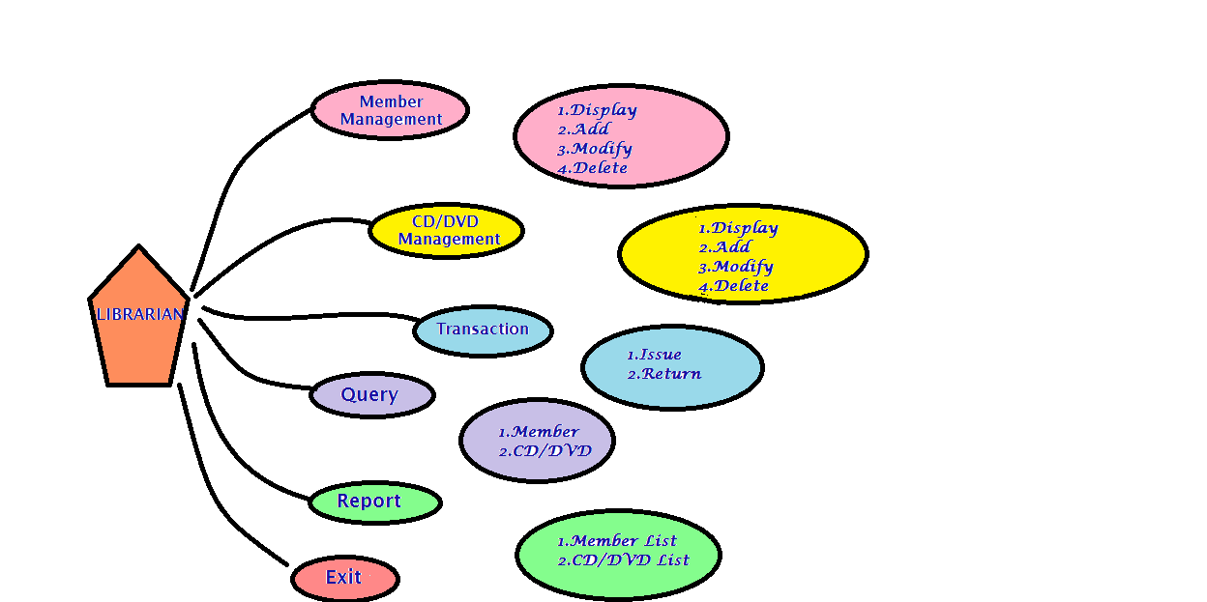

COMPILATION
REPORT
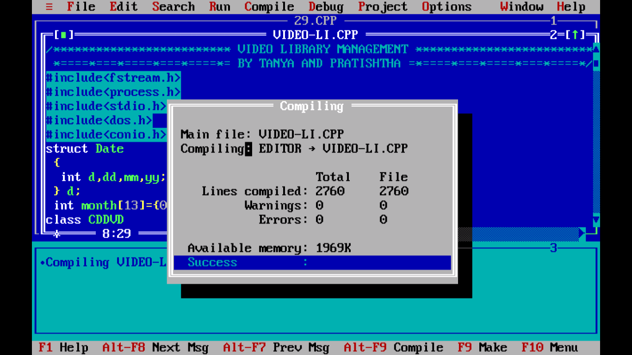

Output Snapshots
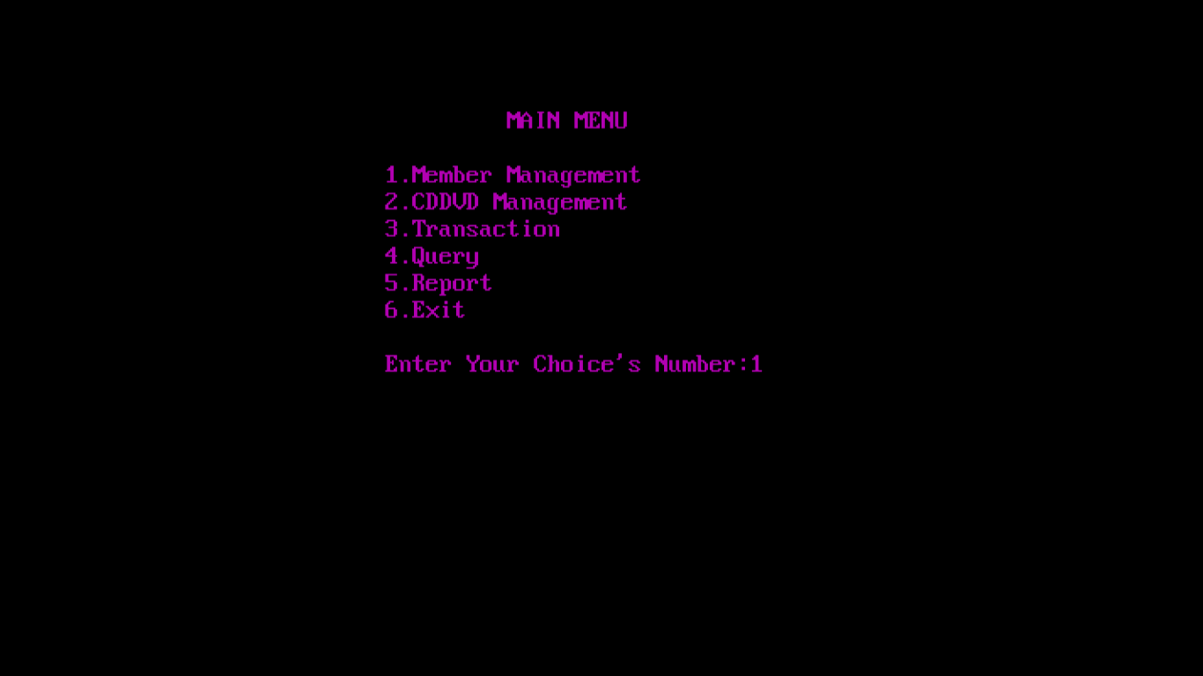

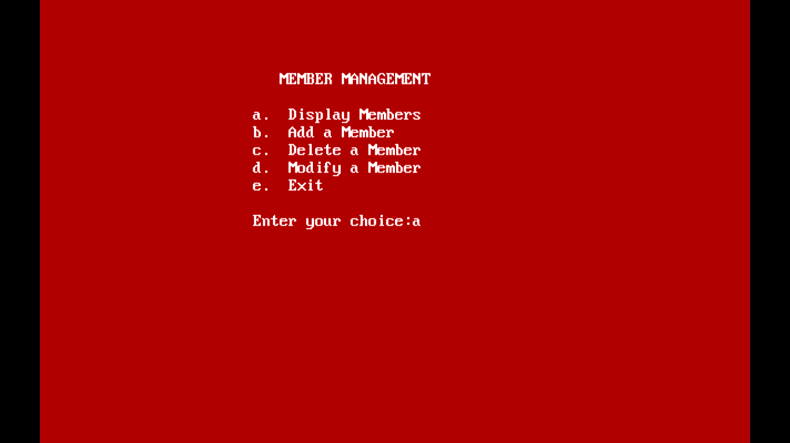

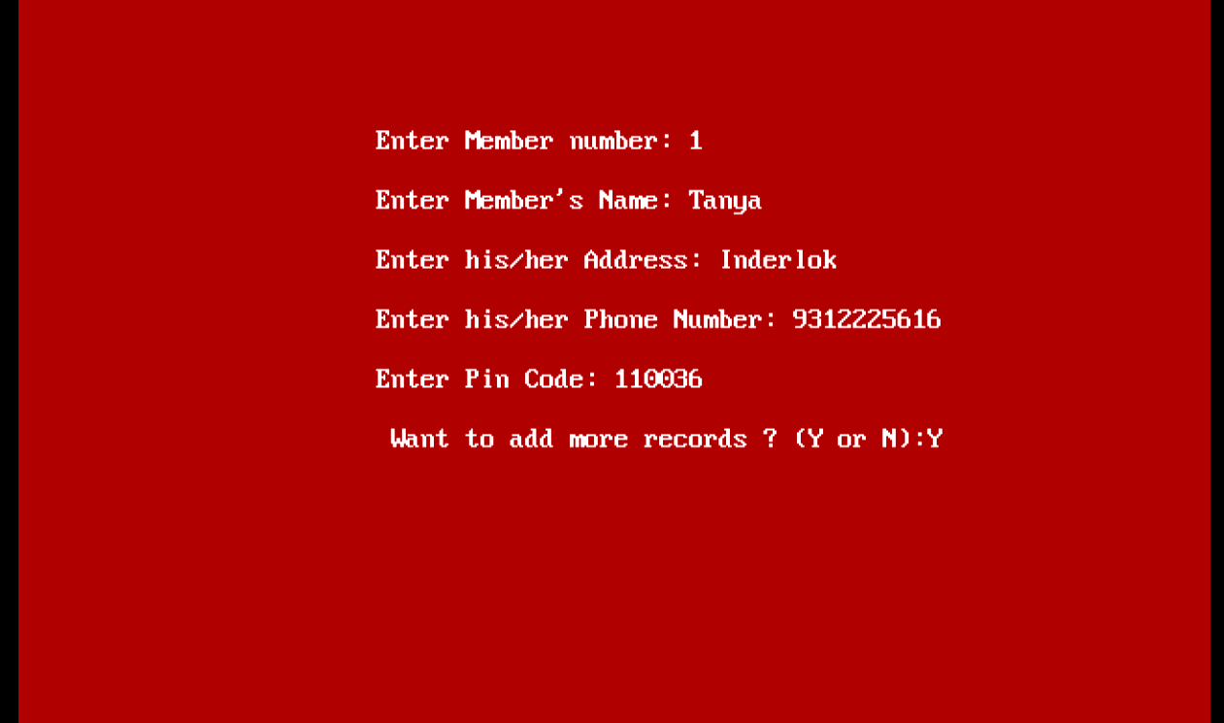

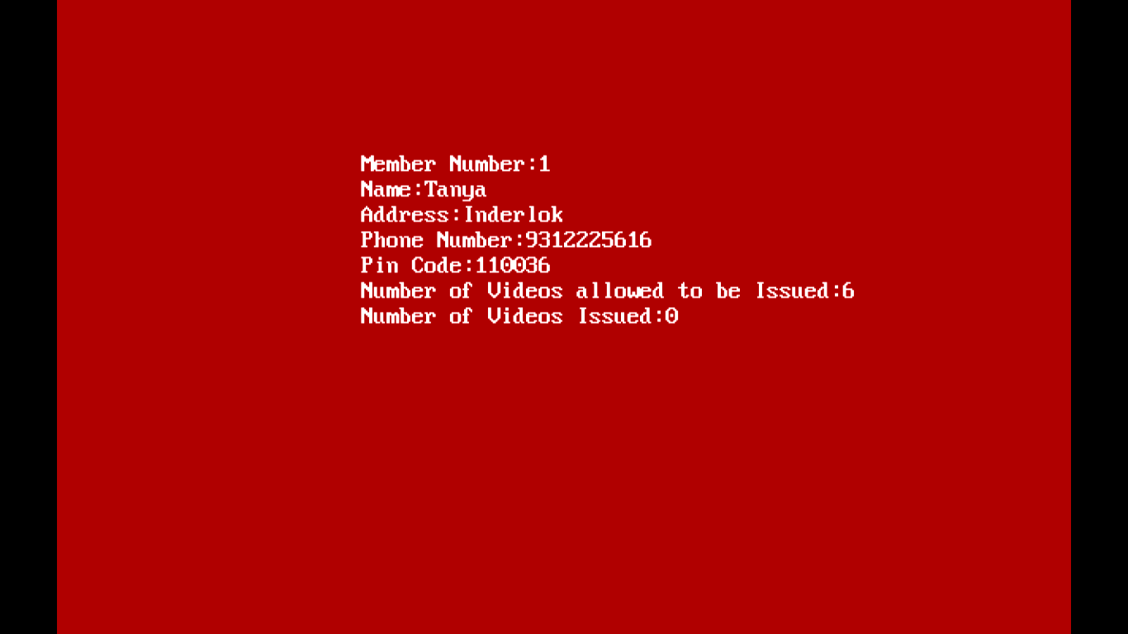

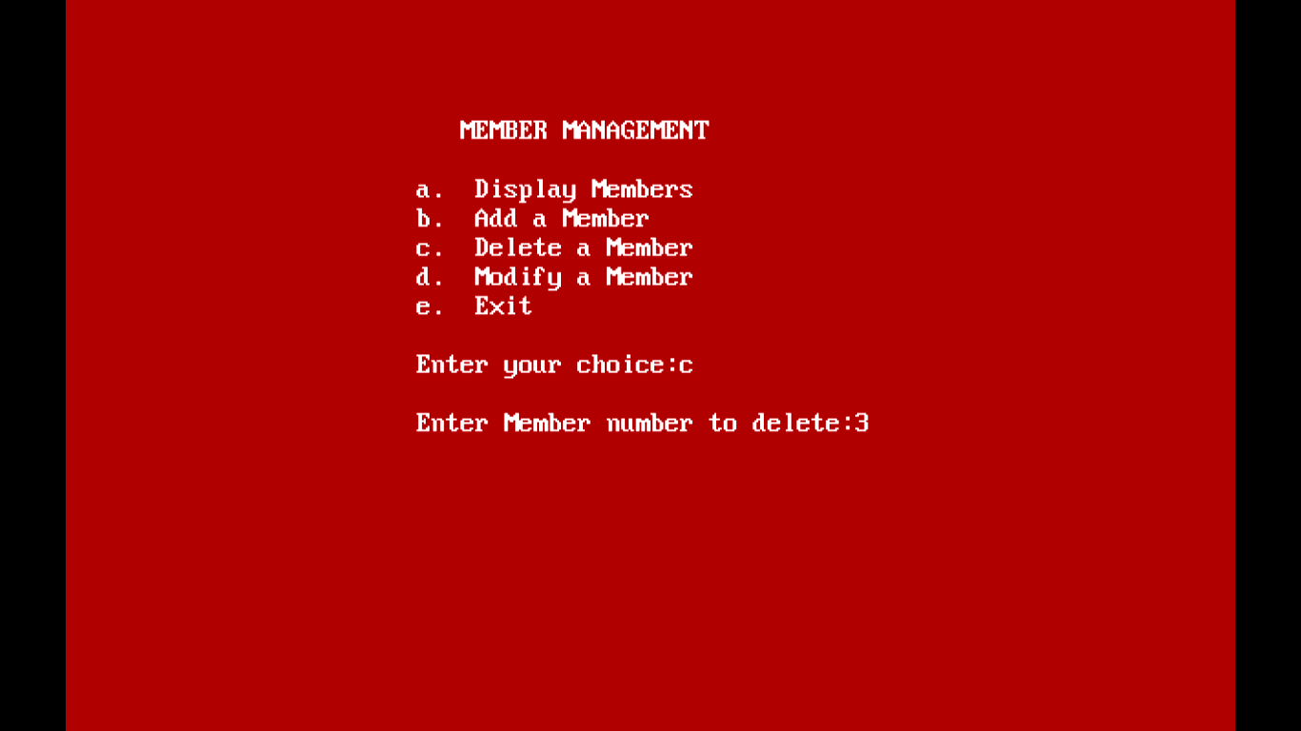

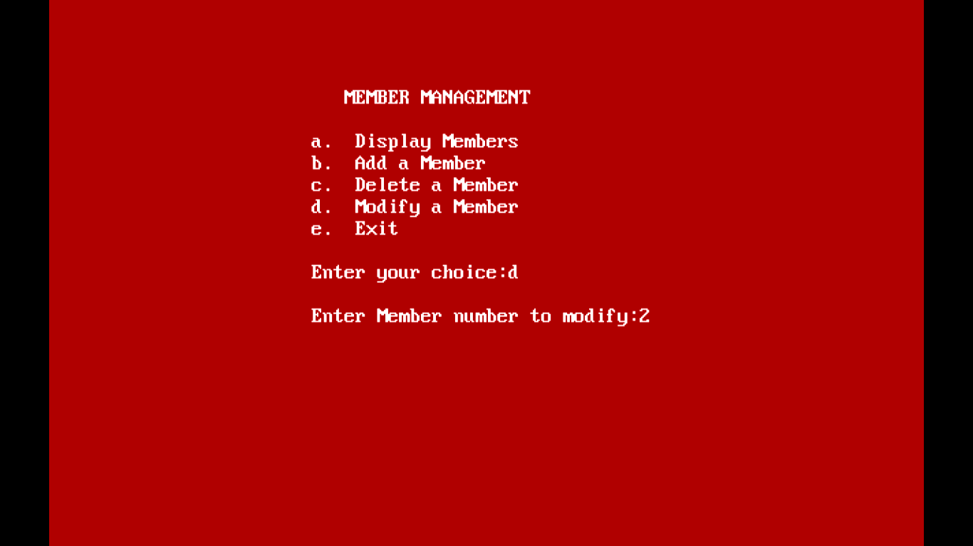

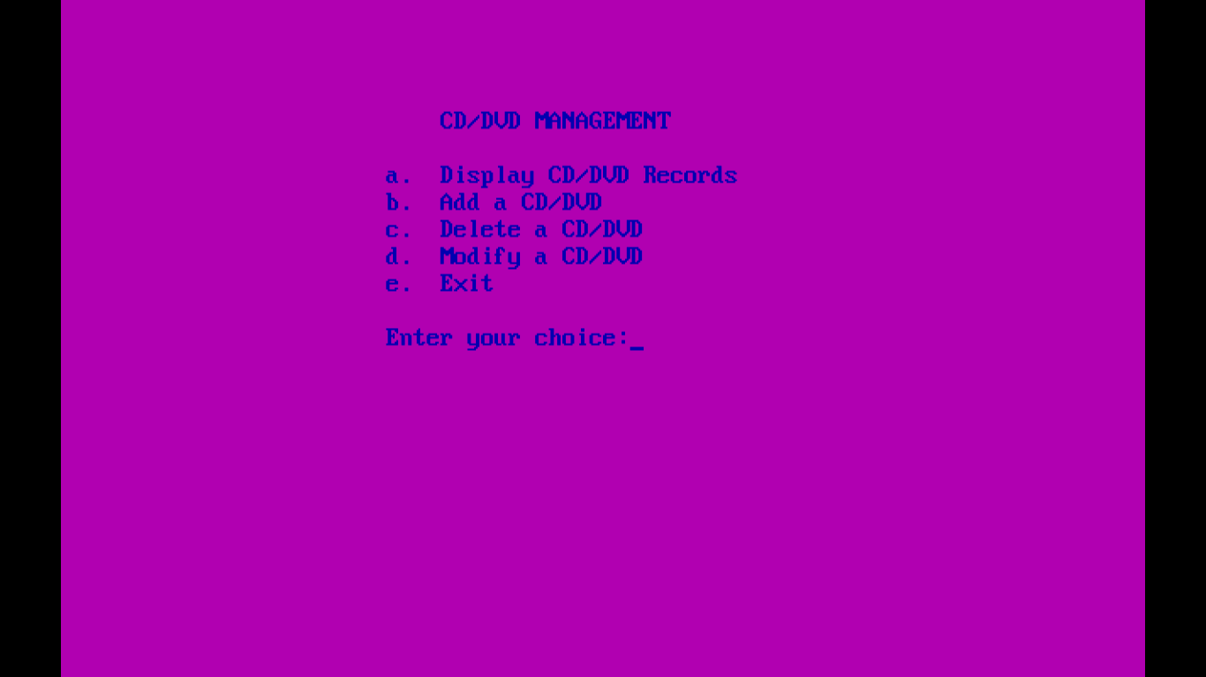

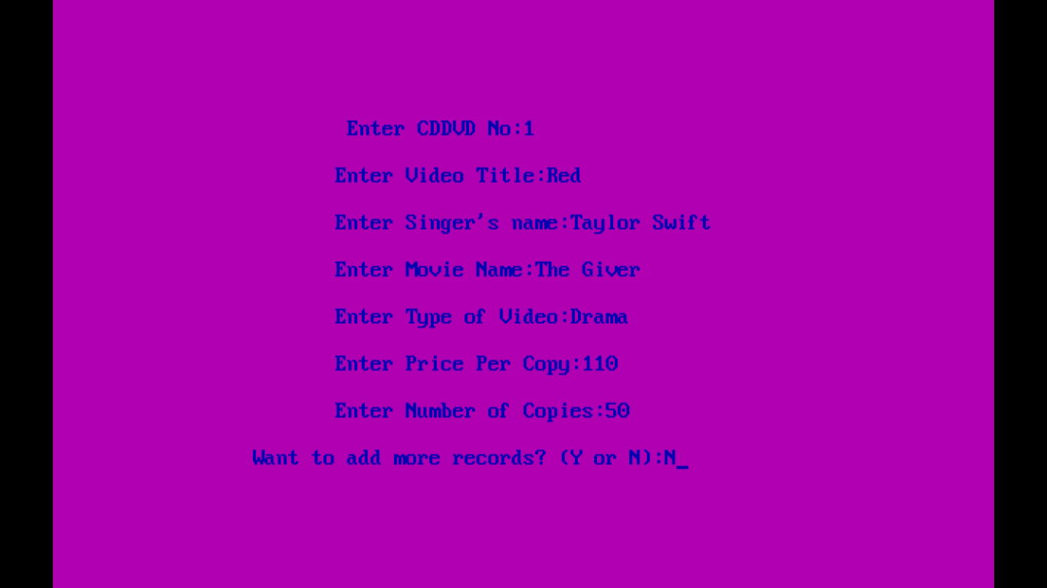

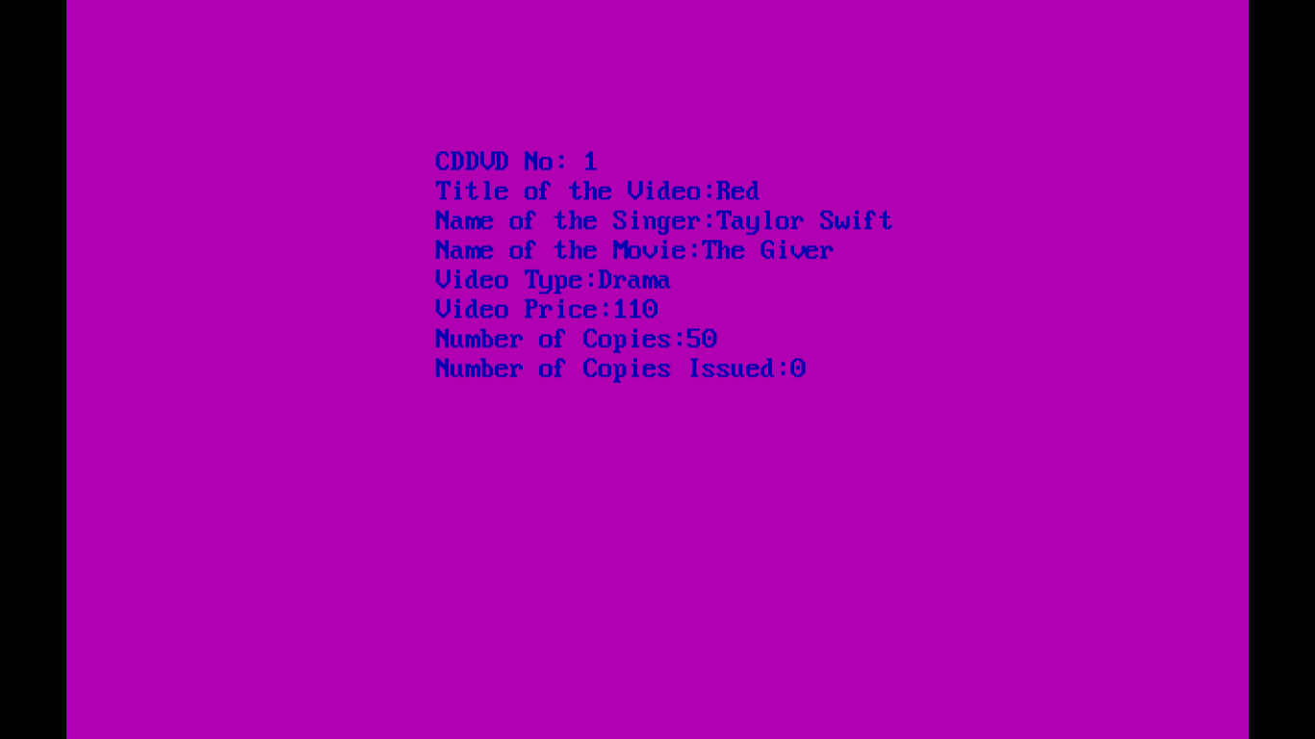

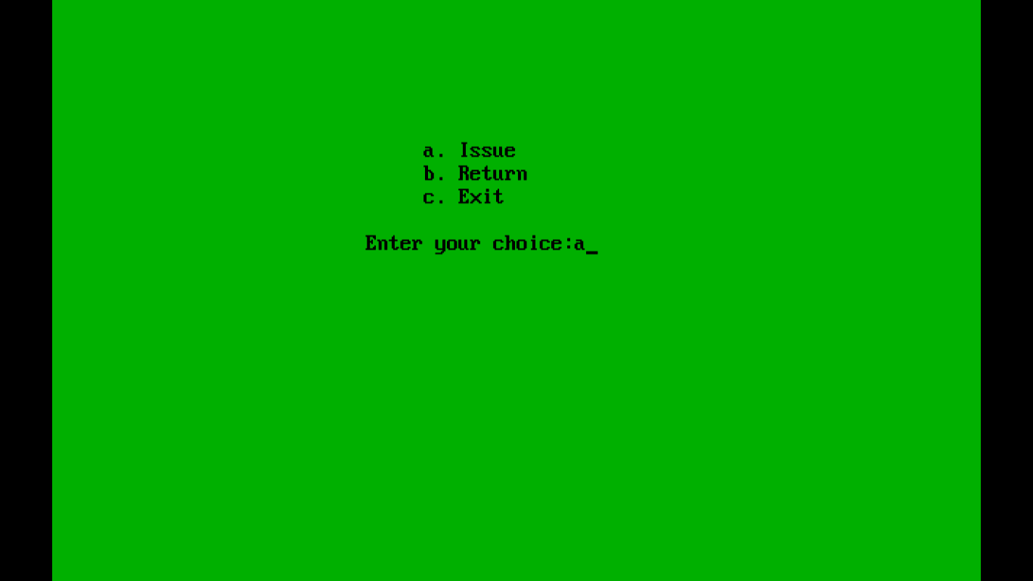

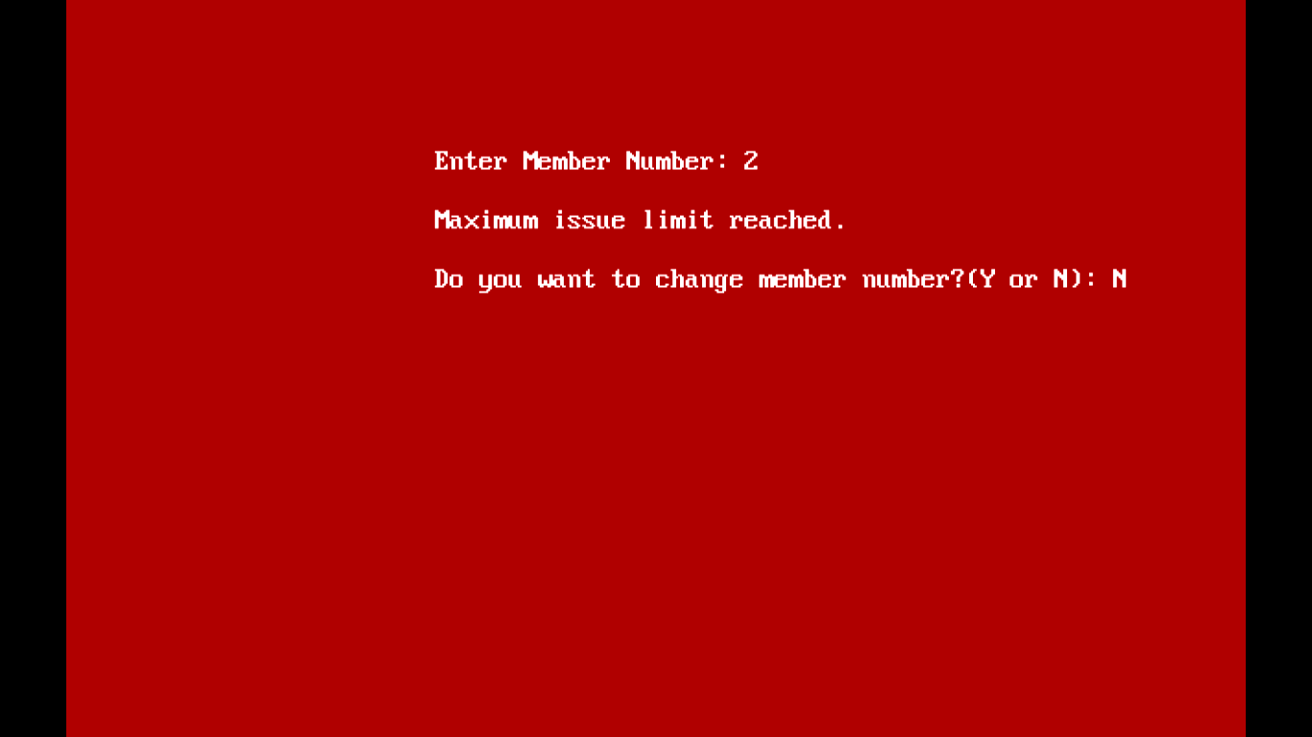

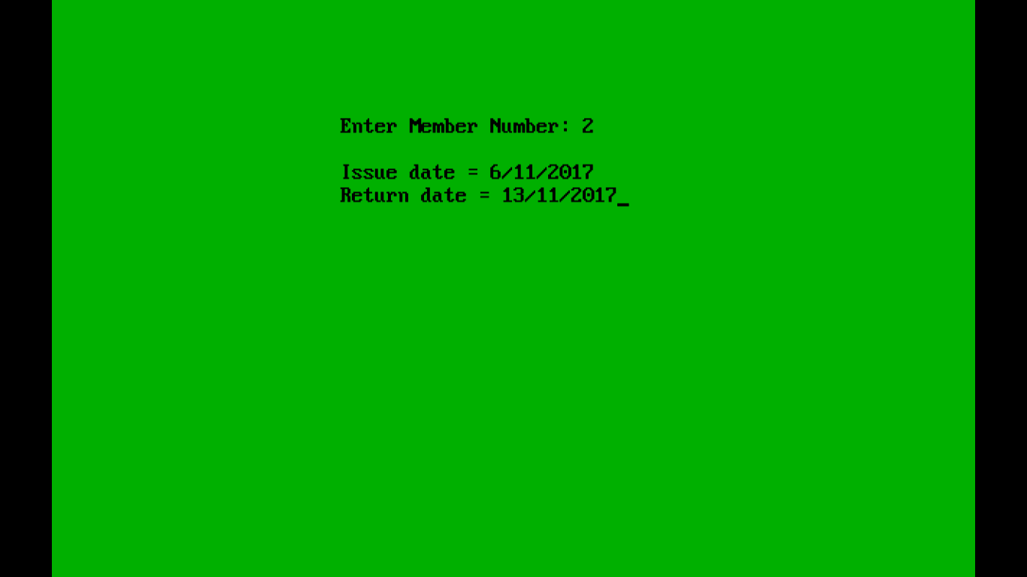

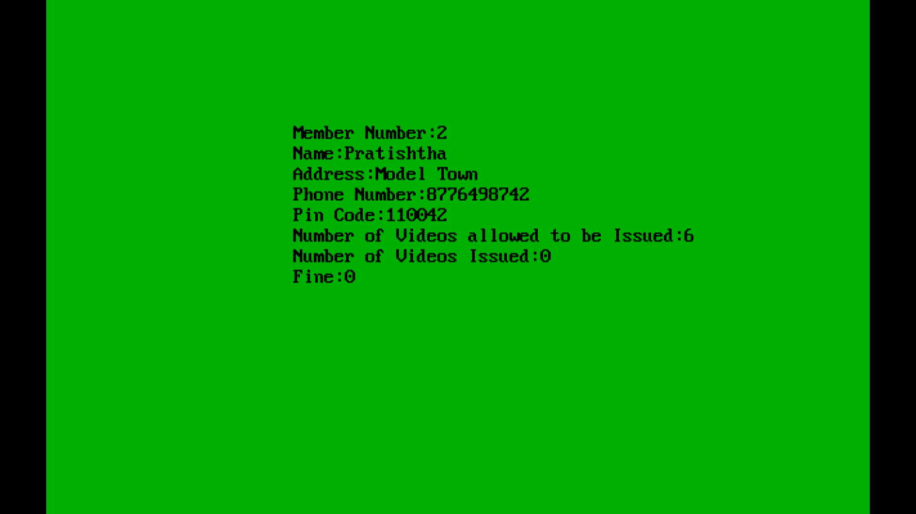

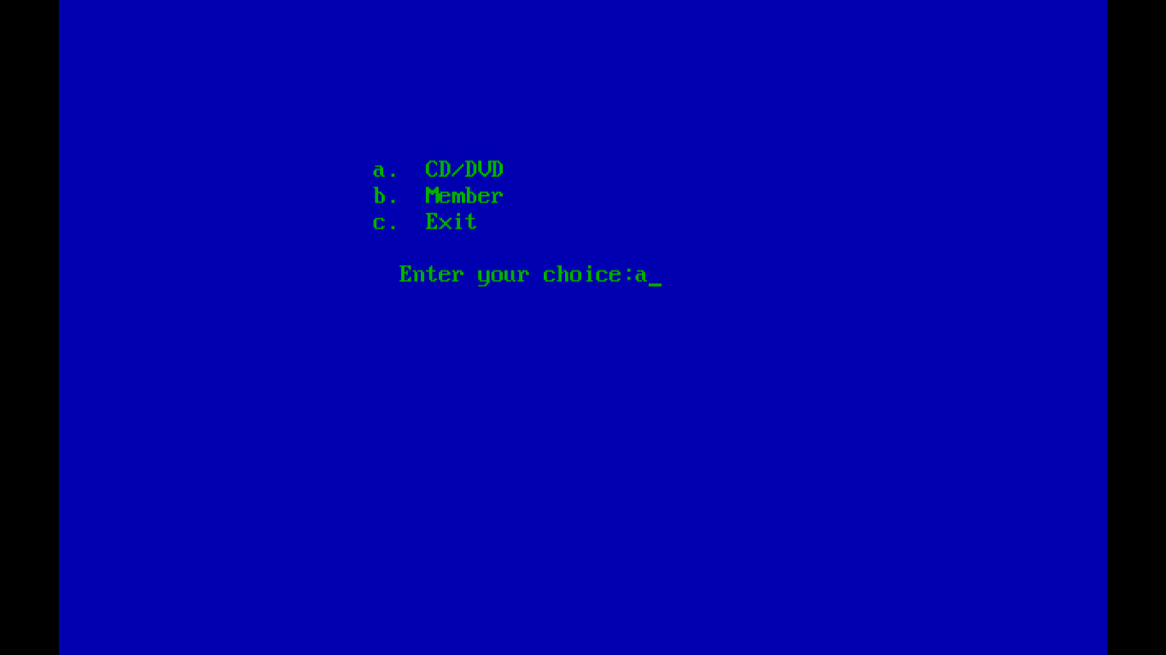

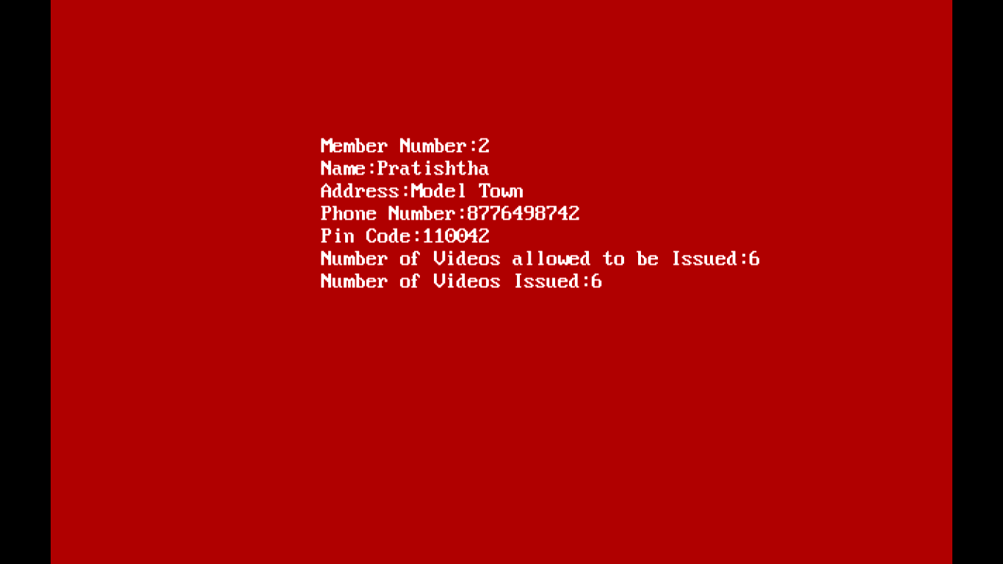

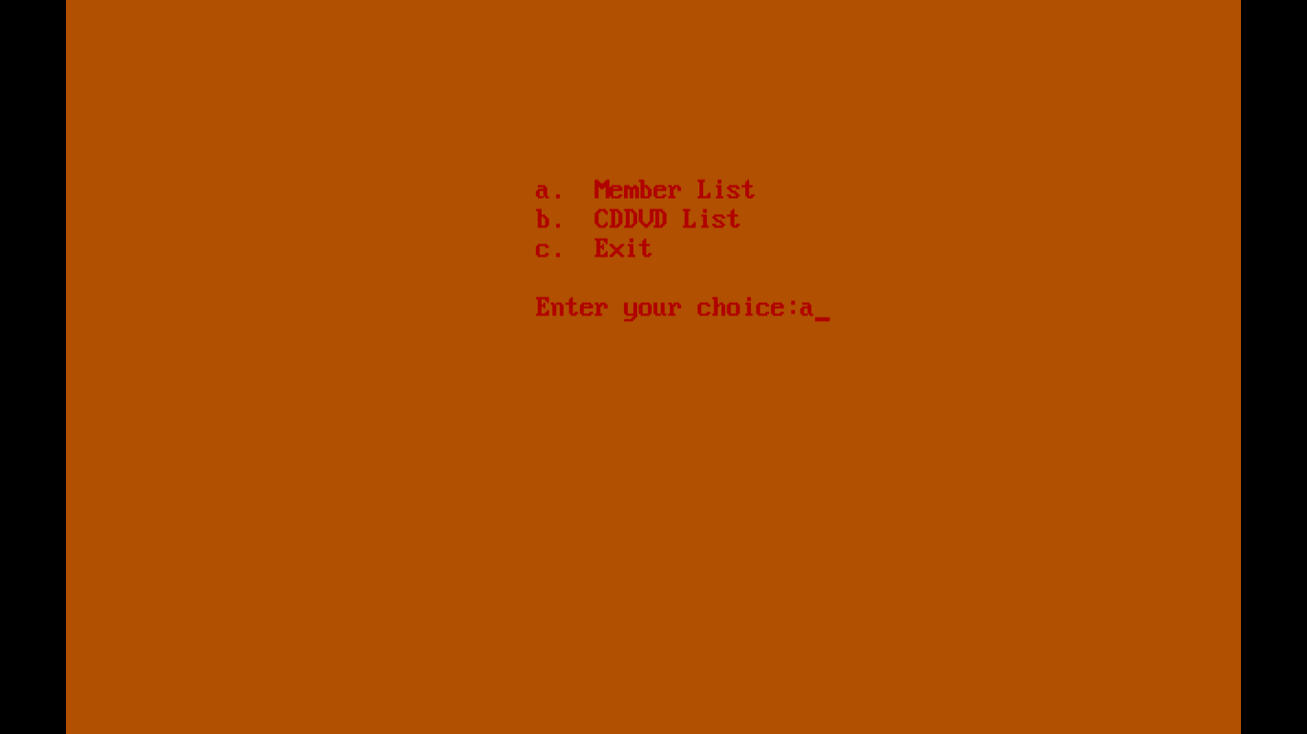

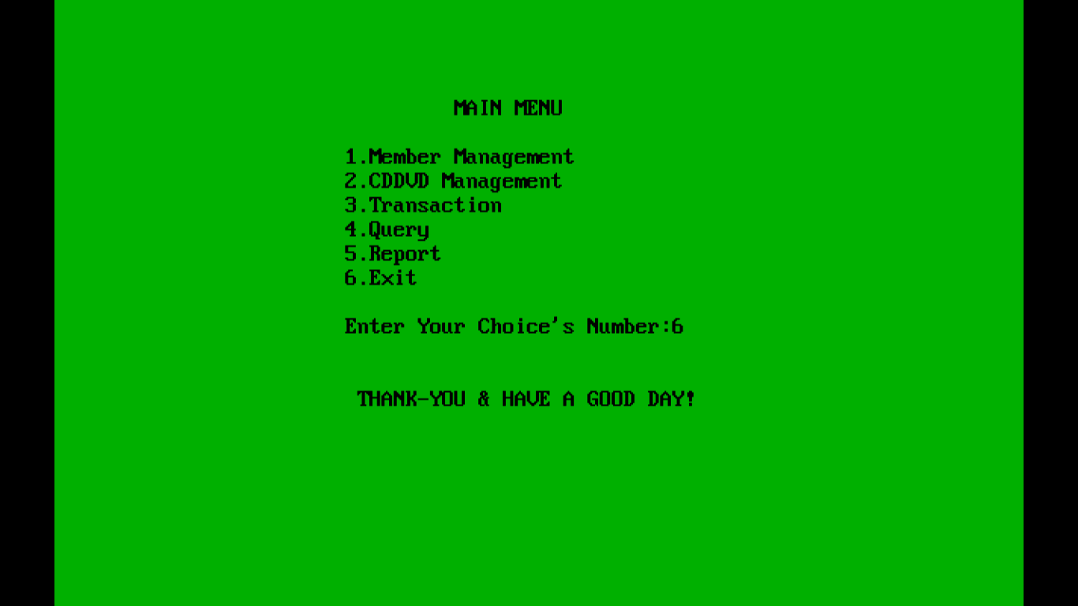

BIBLIOGRAPHY

1. Computer Science by Sumita Arora
2. Internet

3. Object Oriented Programming With C++ by Balagurusamy

