1.This is my database table I made using mysql:

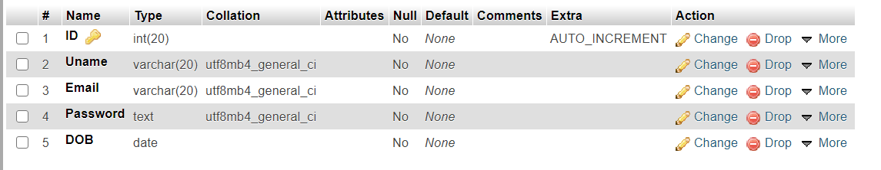

2. I made a html form for registration:

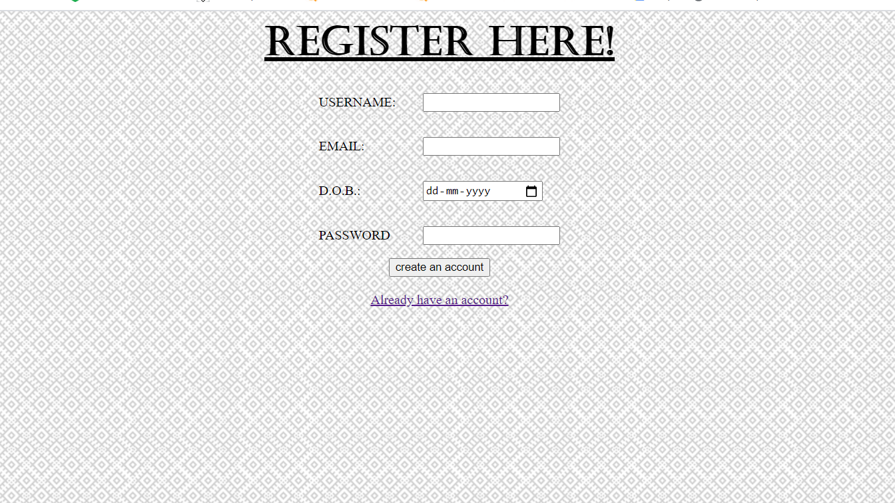

3. Entered details of random user for demonstration:

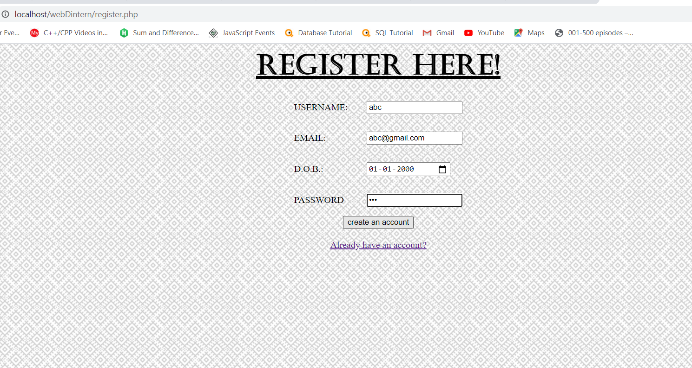

4. webpage when registration is done properly:

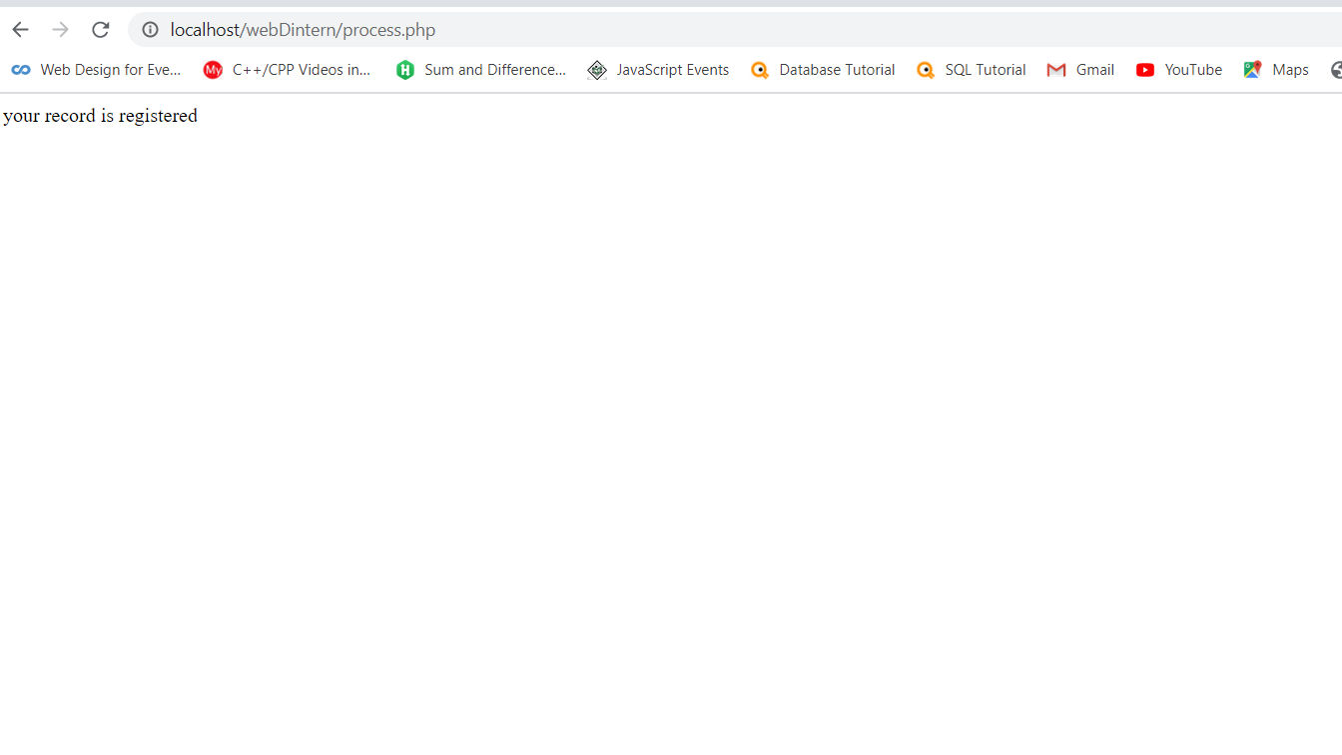

5.Login page :

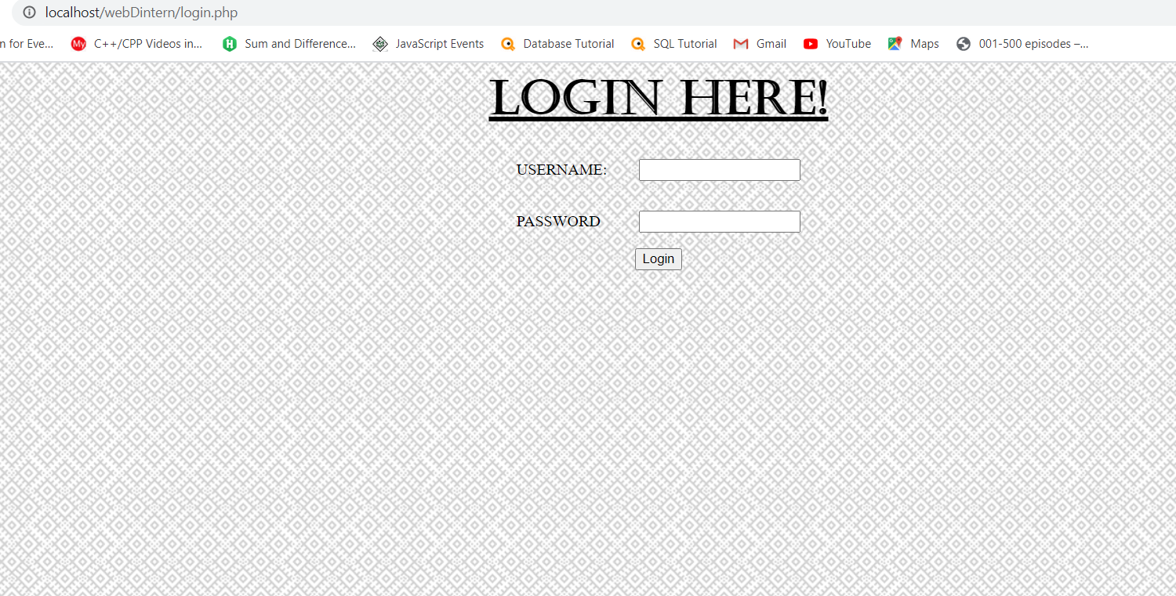

6.Details I previously entered:

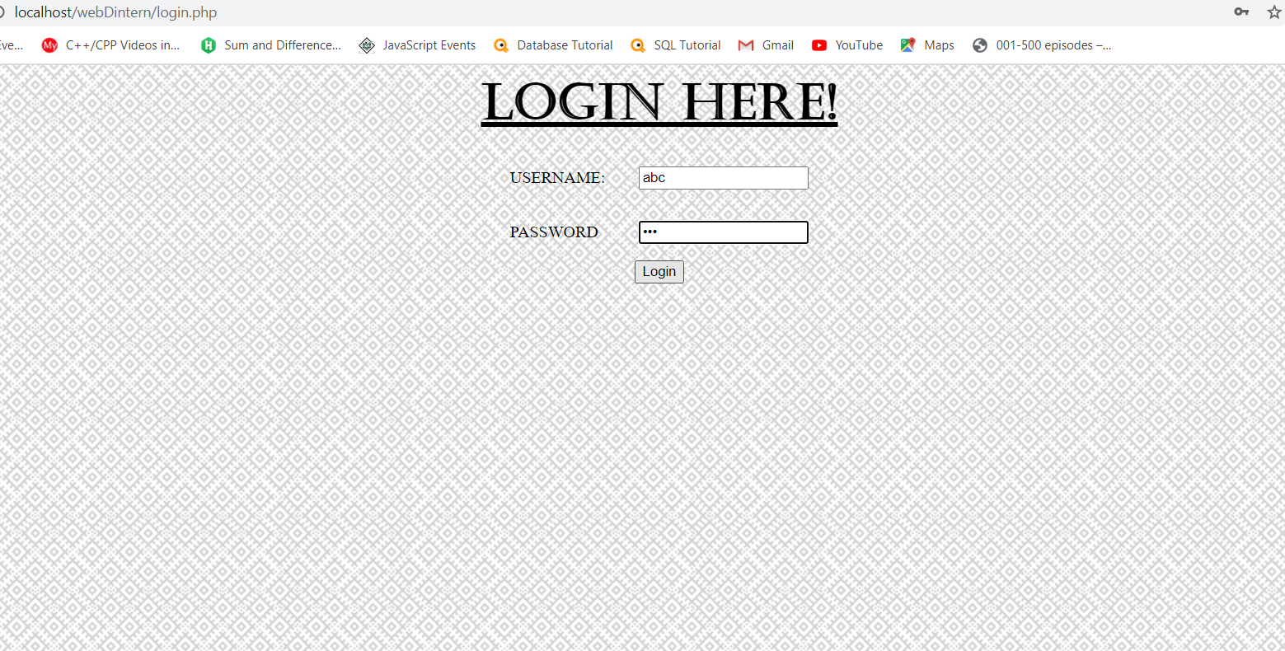

7. The details of an existing user with a message displayed:

