## Bring It On

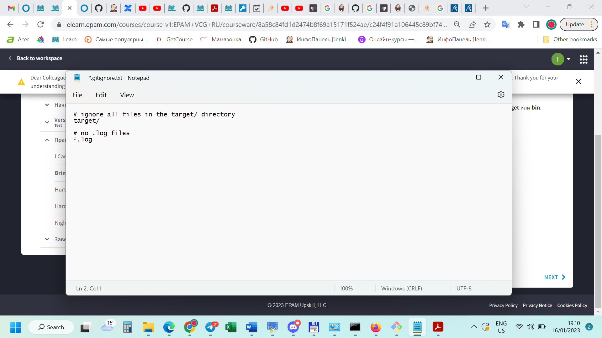

**Hurt Me Plenty**

