Confluence

Confluence – Overview and Purpose
Confluence is an enterprise documentation and collaboration tool used to create, manage, and maintain project and validation-related documents.
It is commonly used to:
- Capture business and system requirements
- Maintain validation documentation
- Store SOPs and controlled documents
- Maintain test evidence
- Support audits and compliance activities (GxP environments)

Usage in Regulated Projects
Confluence is typically used by:
- QA and Validation teams
- Business Analysts
- Product Owners
- Compliance teams
- Developers (for design and technical documentation)

Note:
Confluence is used as a controlled documentation repository to support traceability, collaboration, and compliance.

Confluence Architecture Core Structure
Confluence follows a hierarchical model:
- Confluence
  - Space
    - Pages
      - Child Pages

Space
- Logical container for documentation
- Represents a project, team, or application

- Has its own permission configuration

Page
- Actual document created inside a space
- Fully version-controlled
- Maintains complete edit history and audit trail

Note:
Spaces provide logical segregation of documentation, while pages maintain versioned content with full history.

Spaces in Confluence Types of Spaces
- Team Space
- Project Space
- Knowledge Base Space
In validation-driven environments, separate spaces are usually created per application or validation scope.

Note:
Maintaining separate spaces helps with access control and audit clarity.

Pages and Page Hierarchy
Pages are organized in a parent–child hierarchy to reflect the documentation lifecycle.

Example Documentation Structure
- Validation Master Plan
  - User Requirements (URS)
  - Functional Specifications (FS)
  - Risk Assessment
  - Test Strategy
  - Test Evidence
  - Release Notes

Note:
A clear page hierarchy aligns documentation with SDLC phases and simplifies audits.

Page Editing and Formatting

Confluence provides rich formatting features to structure documents clearly. Commonly used features:
- Headings (H1–H6)
- Tables
- Panels for notes or warnings
- Expand sections for optional details
- Status macros
Structured formatting improves readability and consistency across documents.

Note:
Well-structured formatting supports controlled documentation practices.

Templates
Templates are predefined page structures used to standardize documentation. Common templates include:
- Requirements templates
- Test plan templates
- SOP templates
- Meeting notes templates
Templates help ensure uniformity across teams and documents.

Note:
Using templates enforces consistency and reduces documentation gaps.

Permissions and Access Control
Permissions control who can view or edit content.

Permission Levels
- Space-level permissions
- Page-level restrictions

Common Roles
- Admin
- Editor
- Viewer
Typical access setup:

- QA and validation teams have edit access
- Stakeholders have view-only access

Note:
Role-based access helps maintain data integrity and compliance.

Version History and Audit Trail
Confluence automatically tracks every page modification. Version history captures:
- Who made the change
- What was changed
- When the change occurred
Previous versions can be viewed and compared.

Note:
Version history supports auditability and traceability requirements.

Comments and Collaboration
Collaboration is supported through comments without changing approved content. Types of comments:
- Inline comments
- Page-level comments Common uses:
- Review feedback
- Clarifications
- Approval discussions

Note:
Comments allow collaboration while preserving document integrity.

Attachments and Evidence Management
Confluence supports attaching supporting files such as:
- PDFs
- Excel files
- Images

- Screenshots
Attachments are version-controlled and can be previewed or downloaded.

Note:
Attachments act as supporting evidence within documentation.

Jira Integration
Confluence integrates with Jira to maintain traceability. Integration capabilities include:
- Linking Jira issues within pages
- Displaying live issue status

Note:
Integration helps connect requirements, execution, and evidence.

Search, Labels, and Organization Labels act as metadata for pages. They are used for:
- Improved searchability
- Content organization
- Reporting and filtering Common labels:
- validation
- qa
- compliance

Note:
Labels improve discoverability and structured organization.

Page Restrictions
Page restrictions limit who can view or edit a specific page. Common use cases:
- Approved documents
- Sensitive or controlled content

Note:
Restrictions ensure only authorized users can modify validated documents.

Export and Sharing
Confluence pages can be exported as:
- PDF
- Word documents
Exports are commonly used for:
- Audits
- Regulatory submissions
- External reviews

Note:
Export functionality supports documentation sharing and compliance needs.

Best Practices
- Maintain one space per application
- Use templates for all controlled documents
- Restrict edits after approval
- Maintain a clear page hierarchy
- Link Jira and test management tools for traceability
- Avoid deleting approved documentation

Summary Note
Confluence serves as a controlled documentation platform that supports collaboration, traceability, version control, and compliance in regulated environments.

Hands-On Practice:

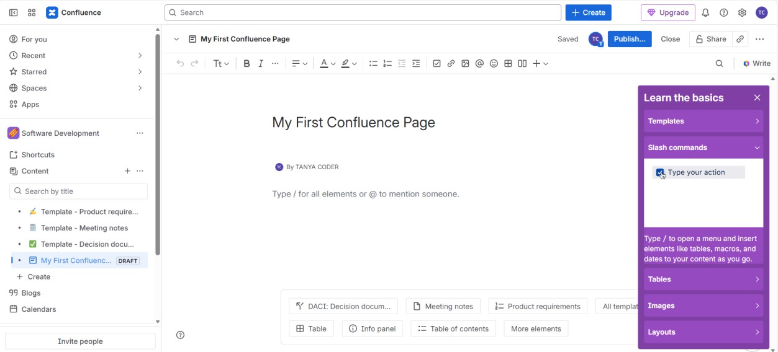

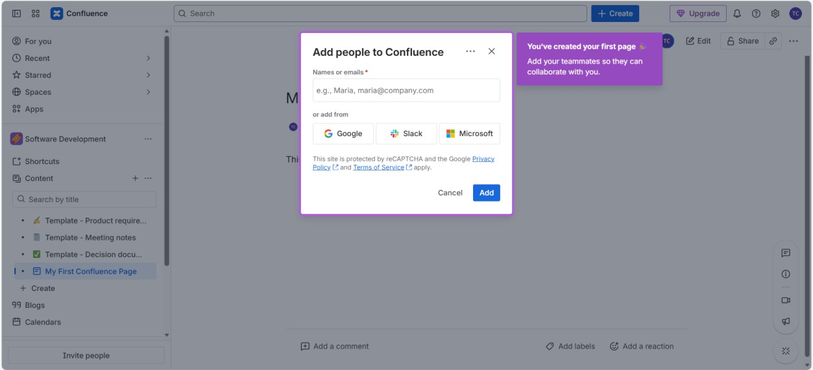

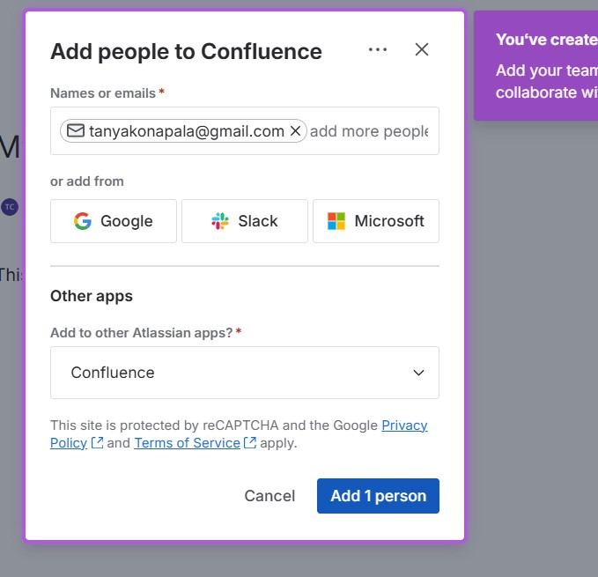

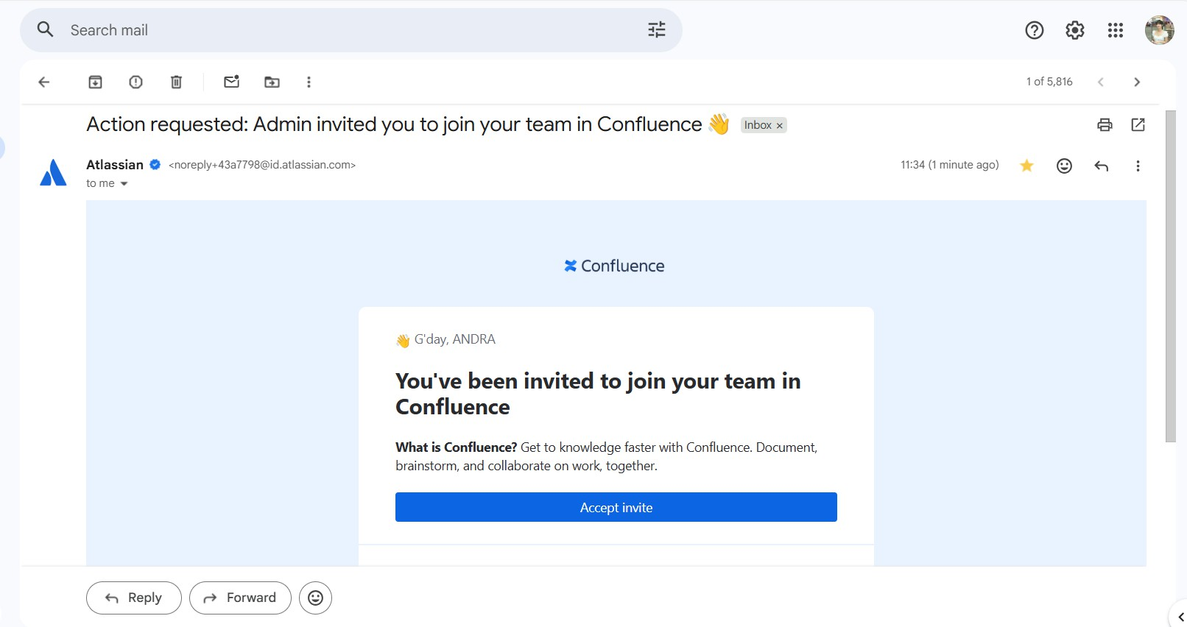

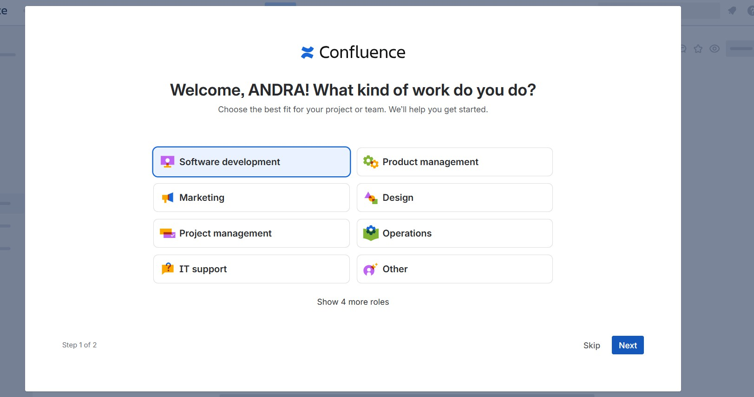

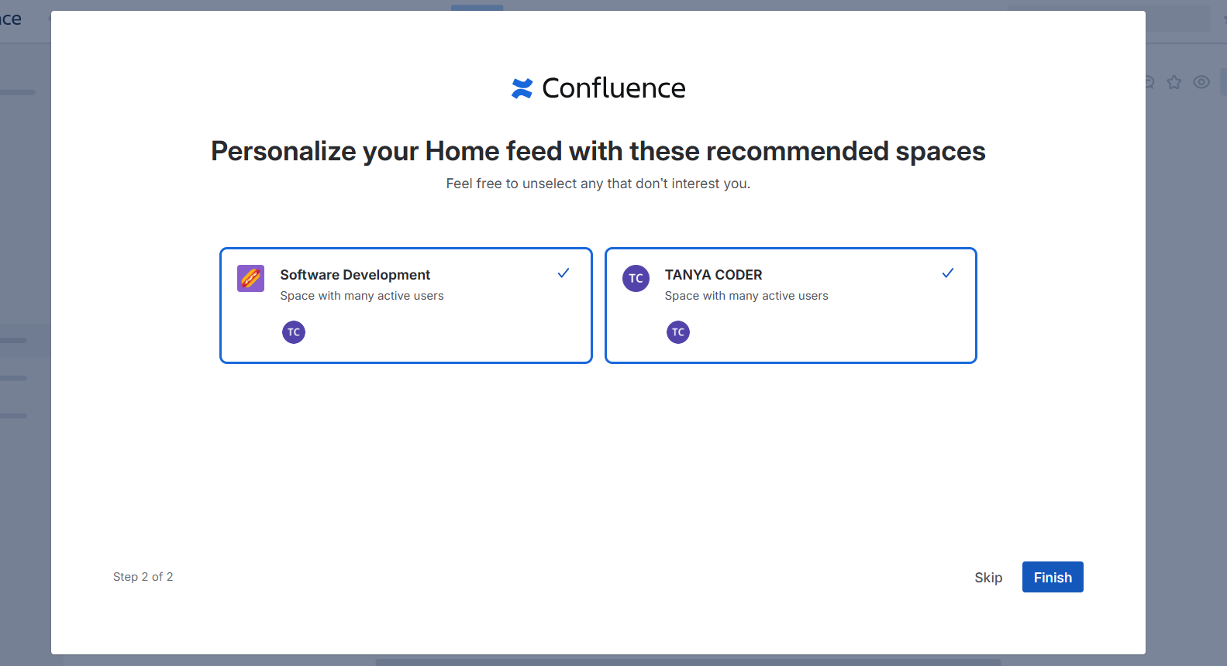

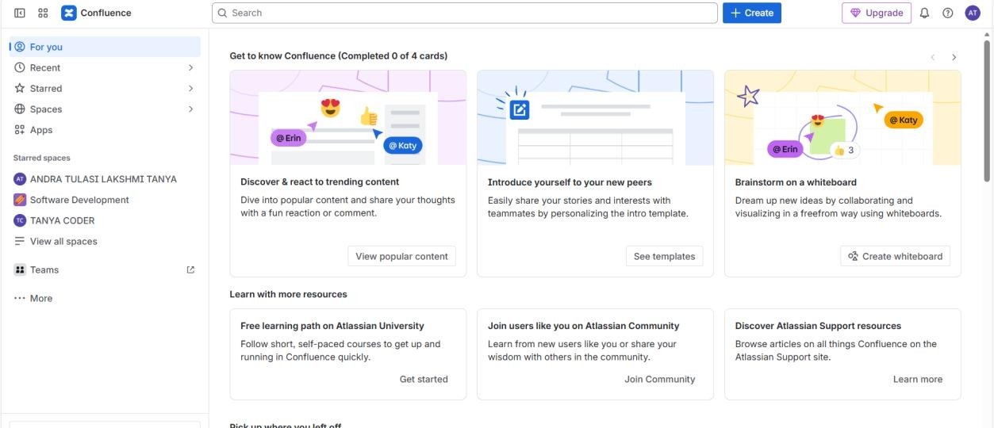

x

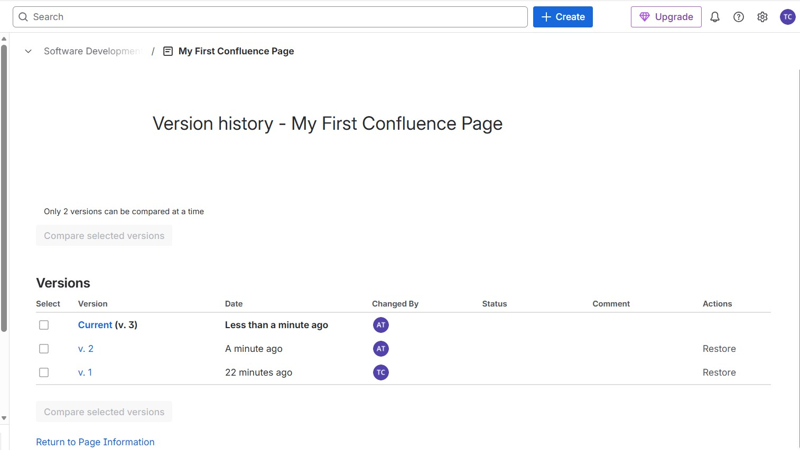

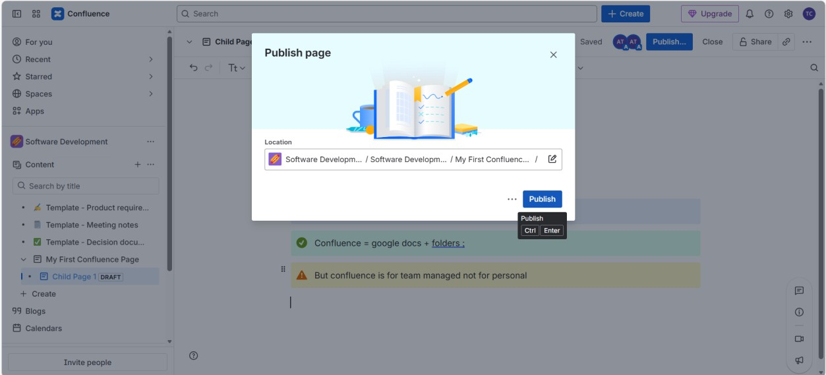

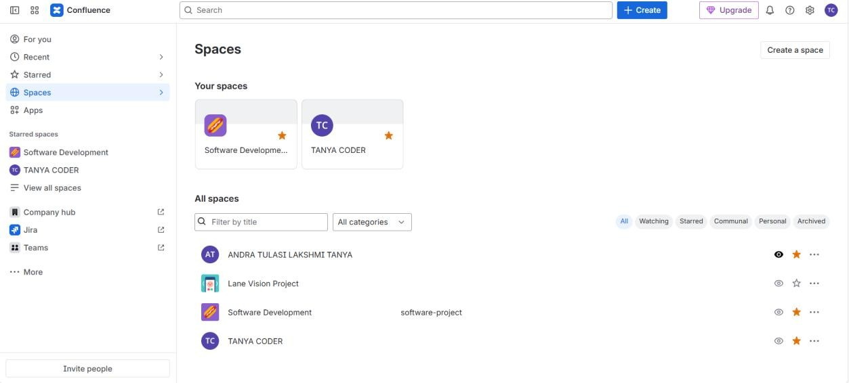

TEMPLATES (FAST & USEFUL)
- Click Create
- Choose Meeting Notes
- Don’t change structure
- Publish
Templates save time + standardize pages

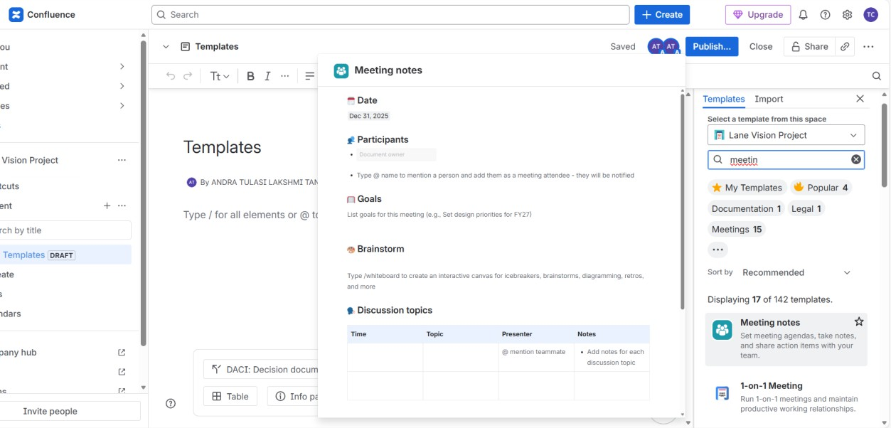

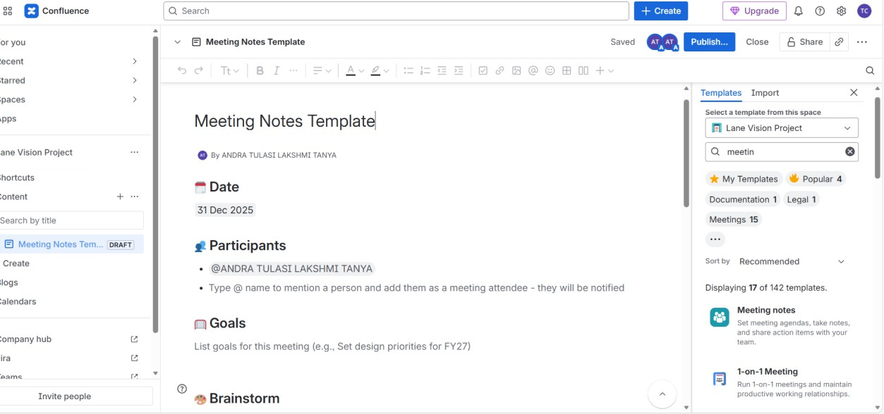

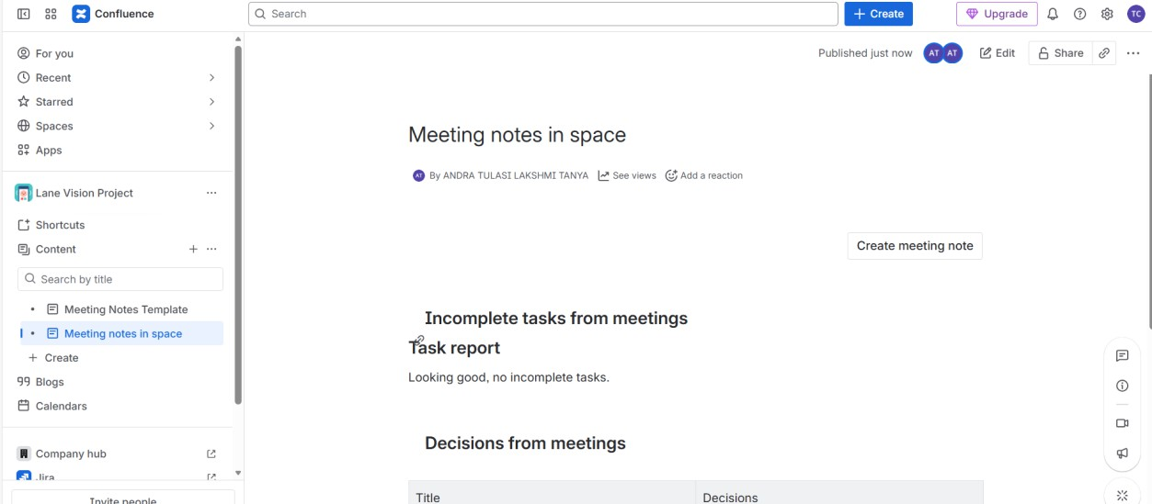

Above image is the default created page (Meeting notes in space) which contains summary of the space ●•^-

COMMENTS (COLLABORATION)

Inline Comment
- Edit a page
- Select a word
- Click Comment
- Type:
Please review this.

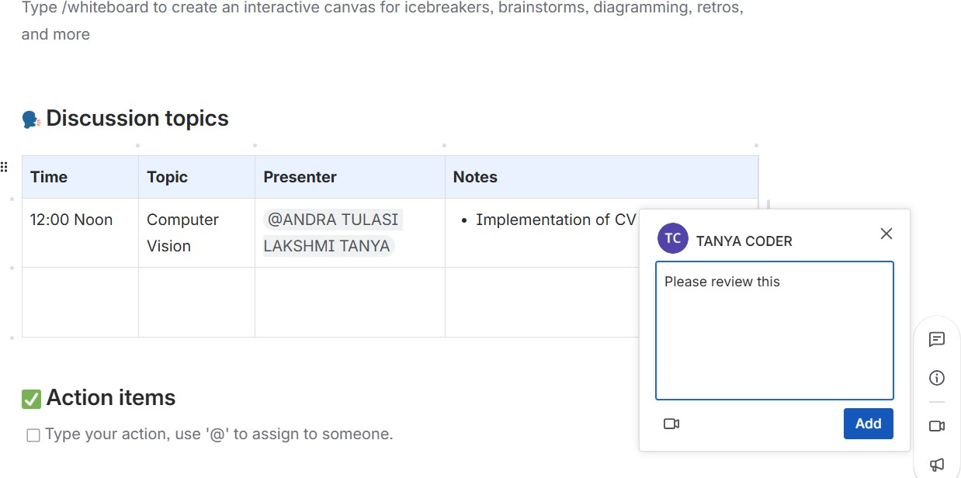

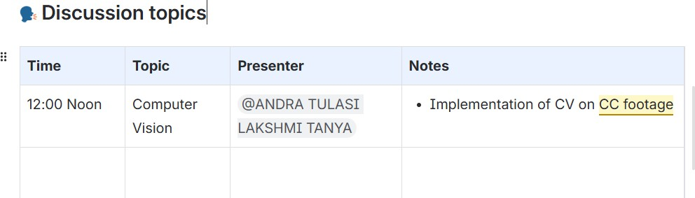

ATTACHMENTS
- Edit page
- Click + → Files
- Upload any file
Files are stored with the page.



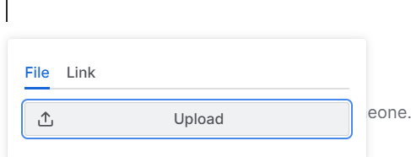



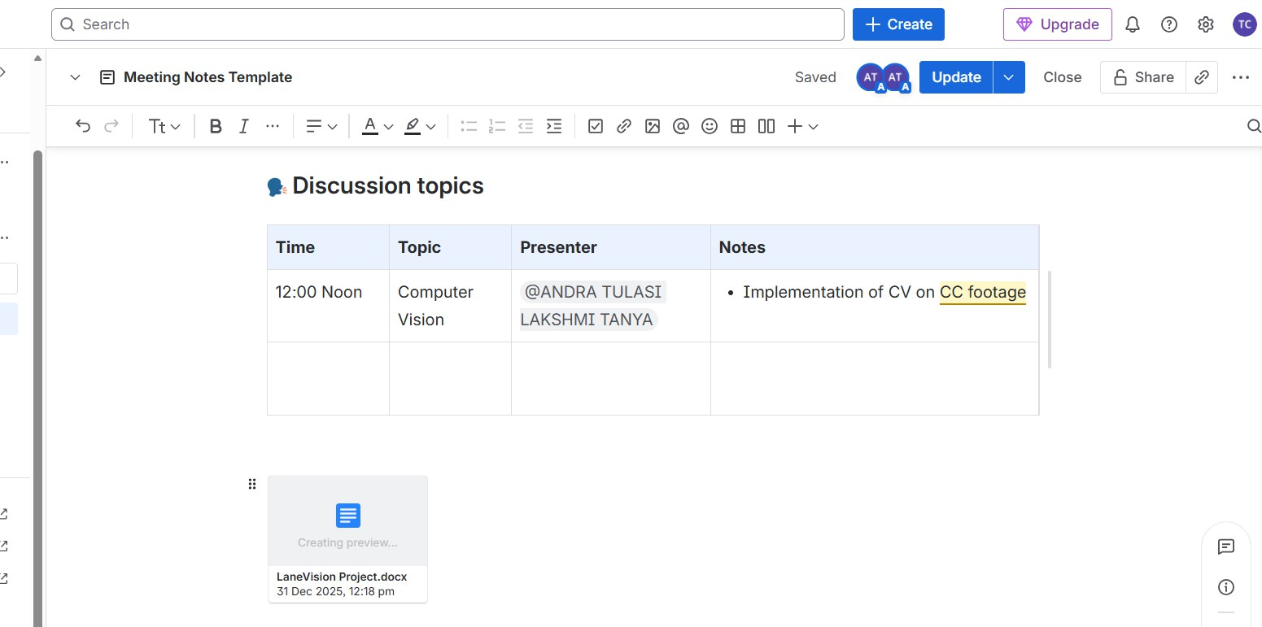

SEARCH & LABELS
Labels are tags added to pages to improve search and organization.

Space permissions
  - Decide who can see and edit the whole space
  - Usually set by admins

Page restrictions
  - Decide who can edit or view one page
  - Used for important pages Note:
You don’t change permissions unless you’re an admin.

Space and pages creation:

Project Alpha
├── Project Overview
├── Meeting Notes
├── Action Items
├── Status Reports

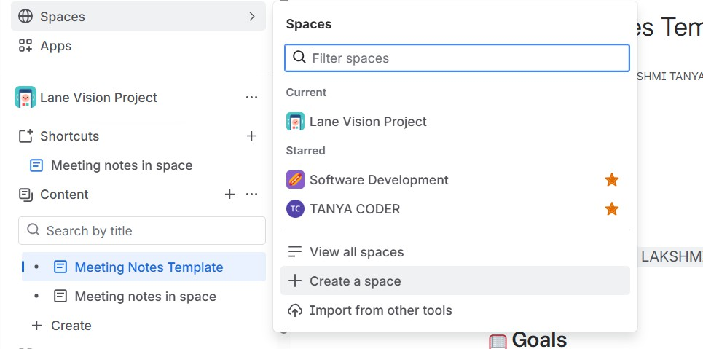

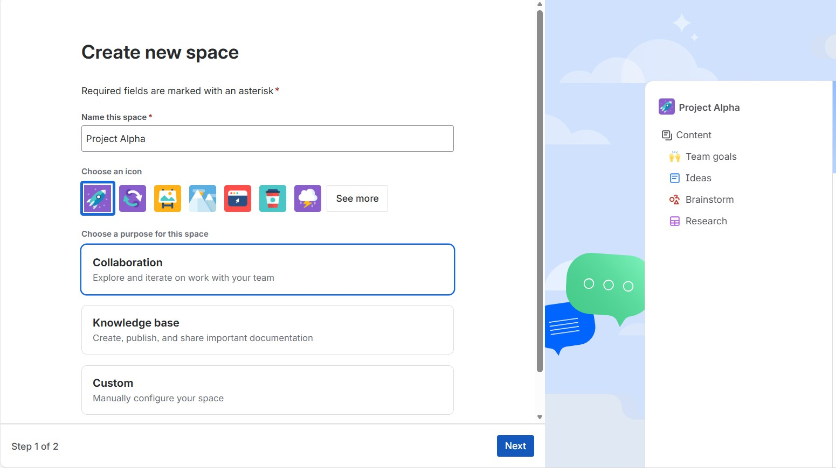

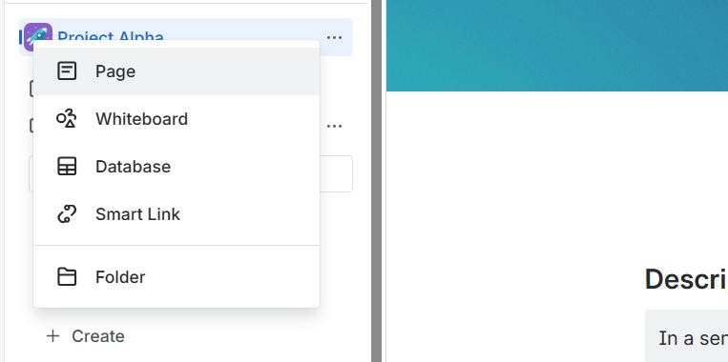

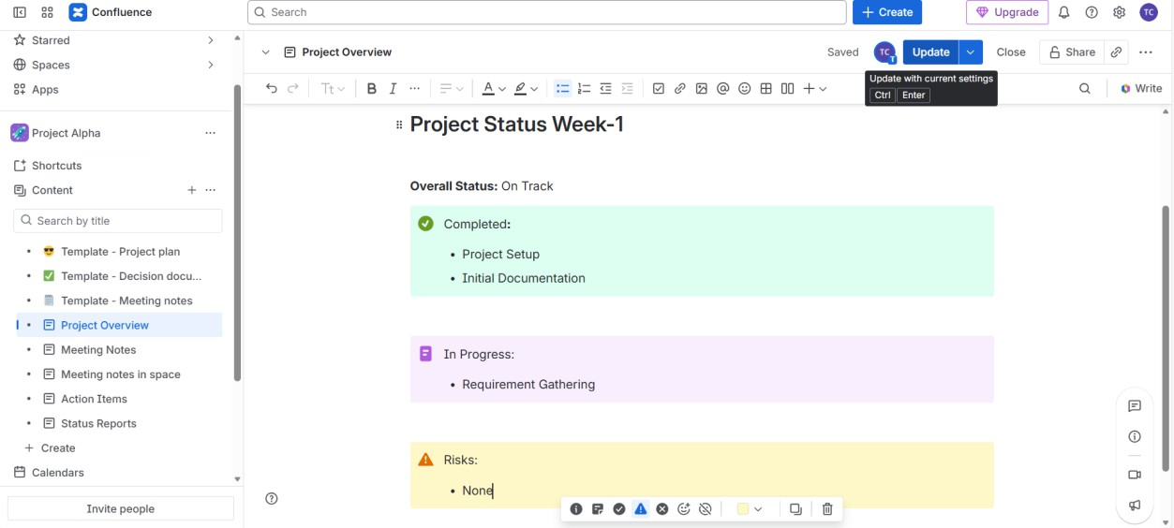
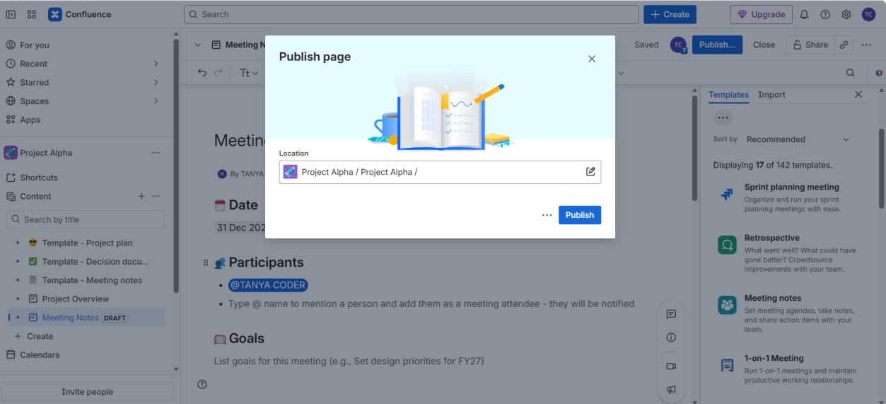

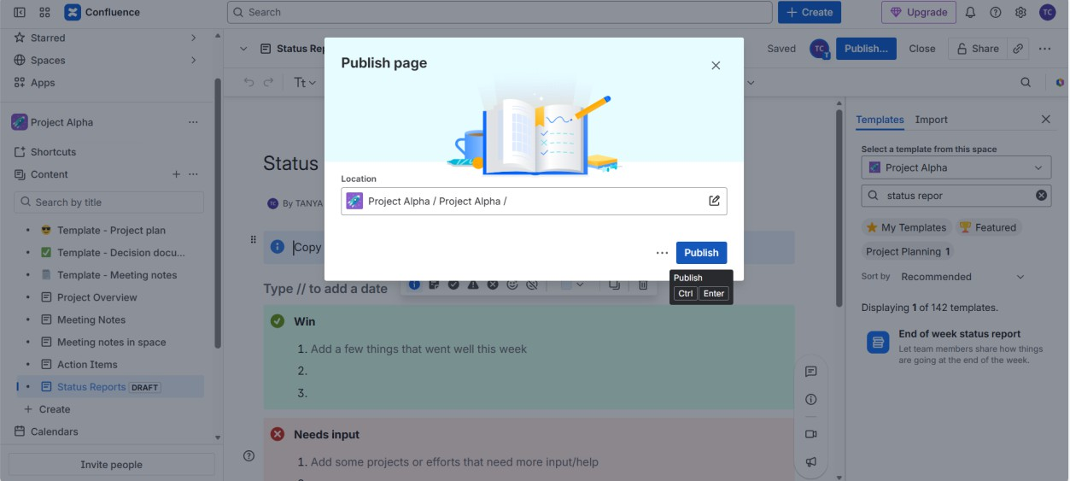

Created some pages by custom and some by templates above^-^•●

JIRA LINKING :
Confluence pages can display live Jira issues.

Link a Jira issue:
- Edit any page
- Type:
/jira
- Click Jira Work Items

- After clicking Jira Work Items:
  - A search/input box will appear
  - Click inside that box
  - Type your issue key:
  - FKP-4
  - Press Enter

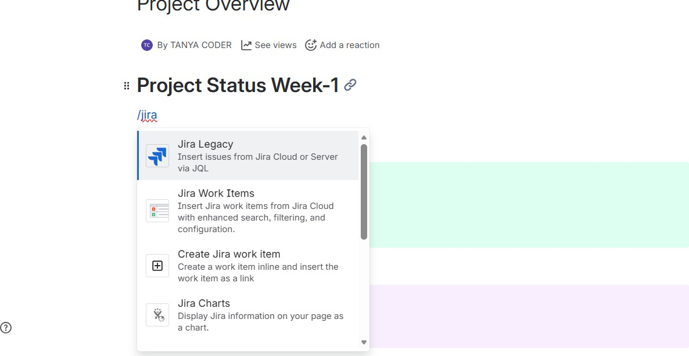

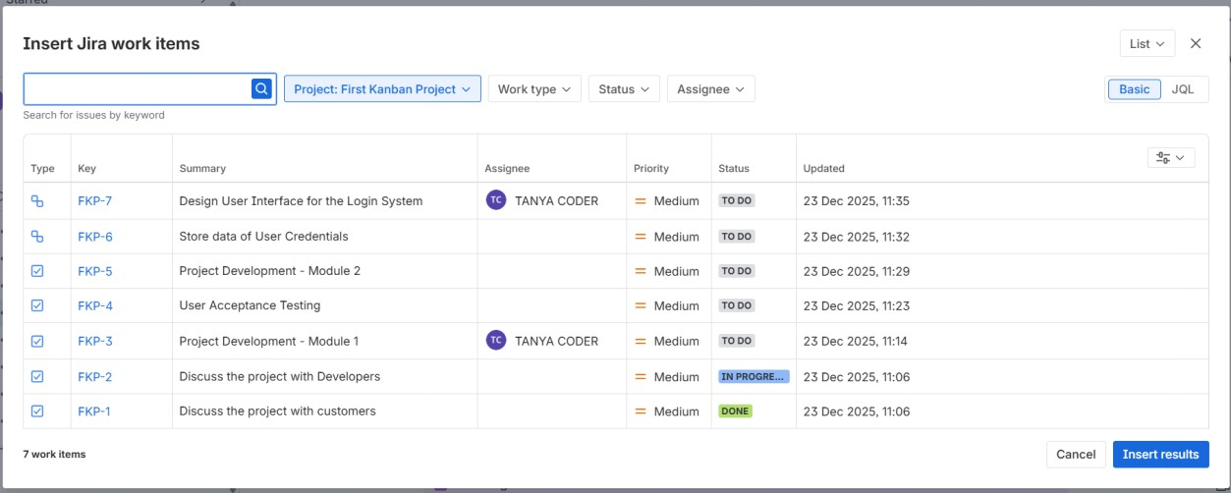

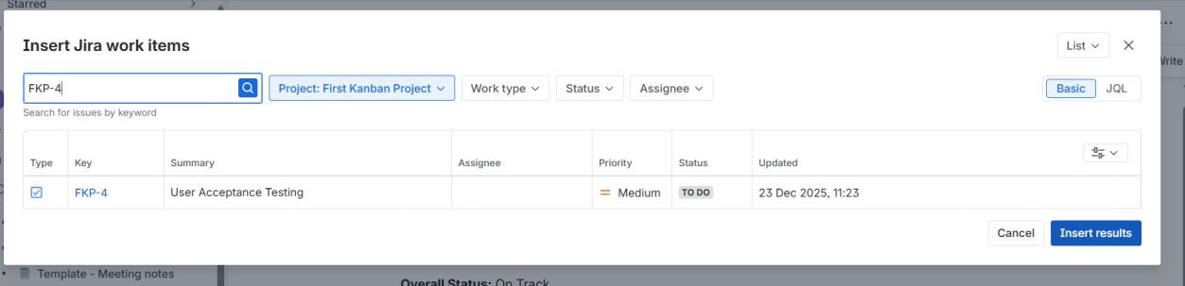

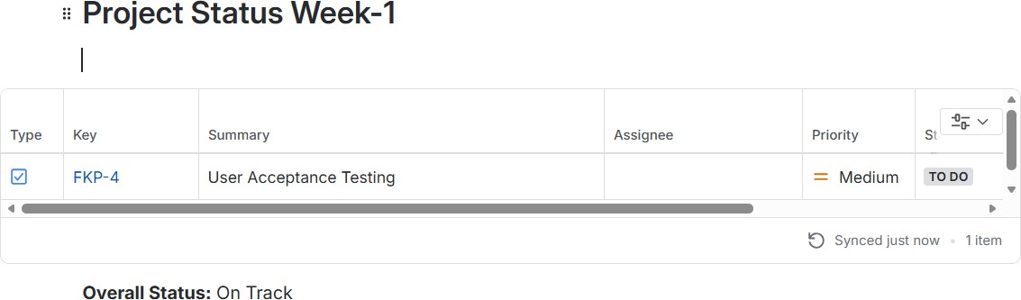

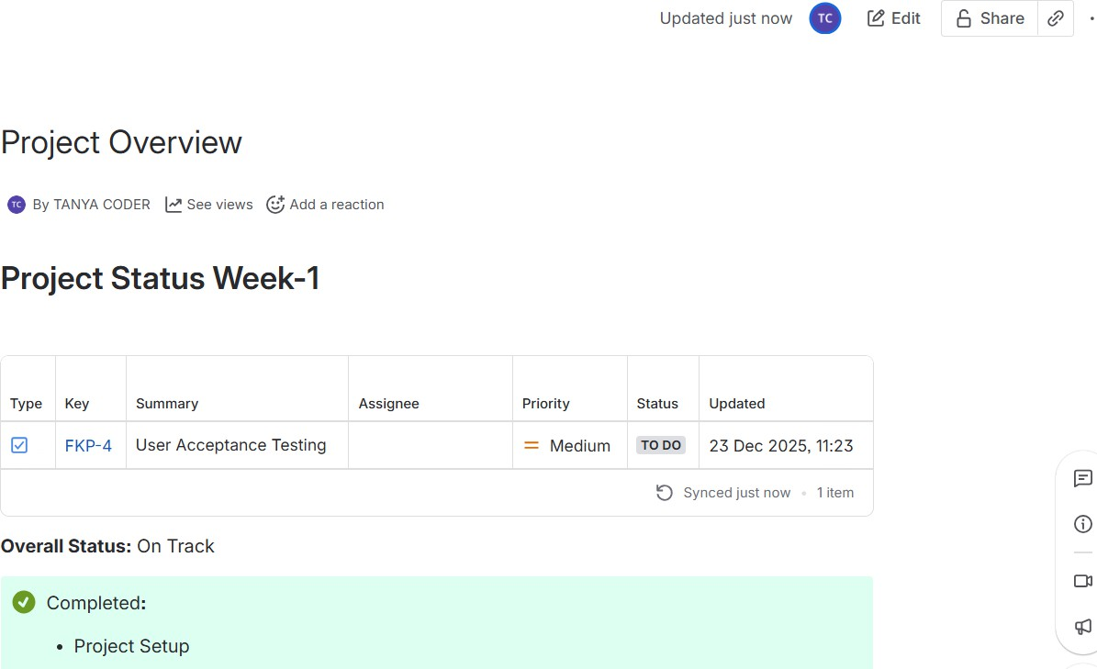

✔ Inserted a Jira Work Item macro
✔ Linked FKP-4 into Confluence
✔ Displayed it as a live table/card
✔ Embedded it inside a Status Report page
✔ Synced Jira → Confluence in real time

