Selenium

Getting Started with Selenium:

1)By adding Selenium jar files to Java Project (Manual process): -- Not recomended

Go to : Downloads | Selenium
Download : Java Stable: 4.39.0 (December 06, 2025)

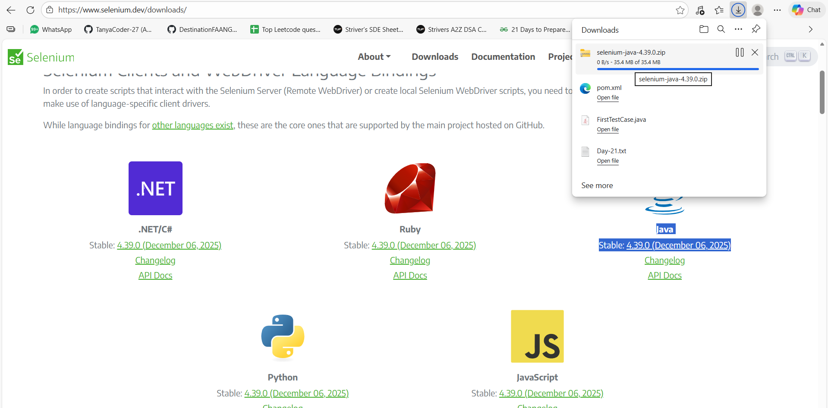

Extract the zip folder:
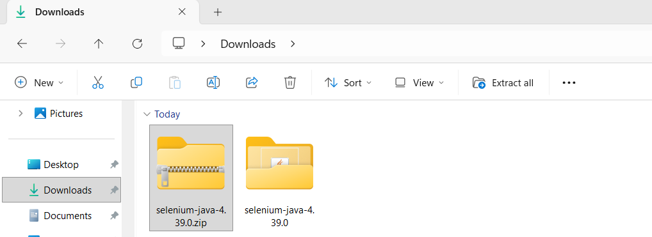

In this manual process of adding the jar files to java project, we have to keep it as updated i.e., whenever a new Selenium version gets released, we have to delete the previous attached jar files and add the newer version jar files to the project.

Create a new java project or use the existing java project:

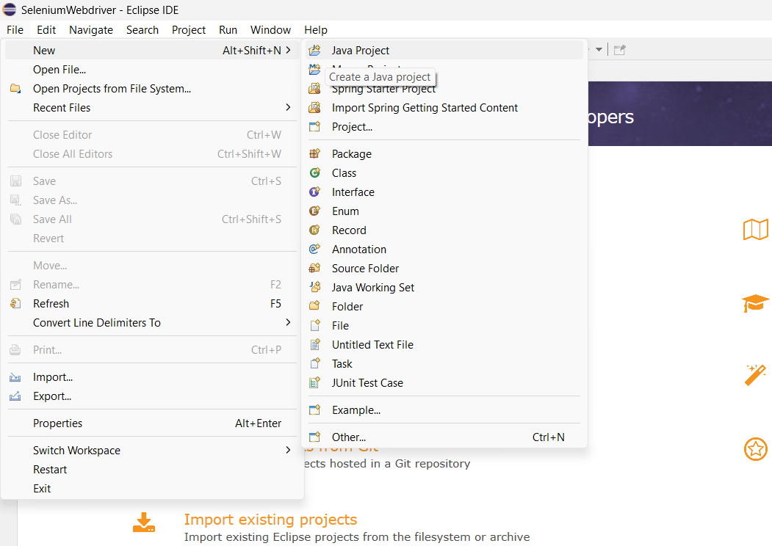

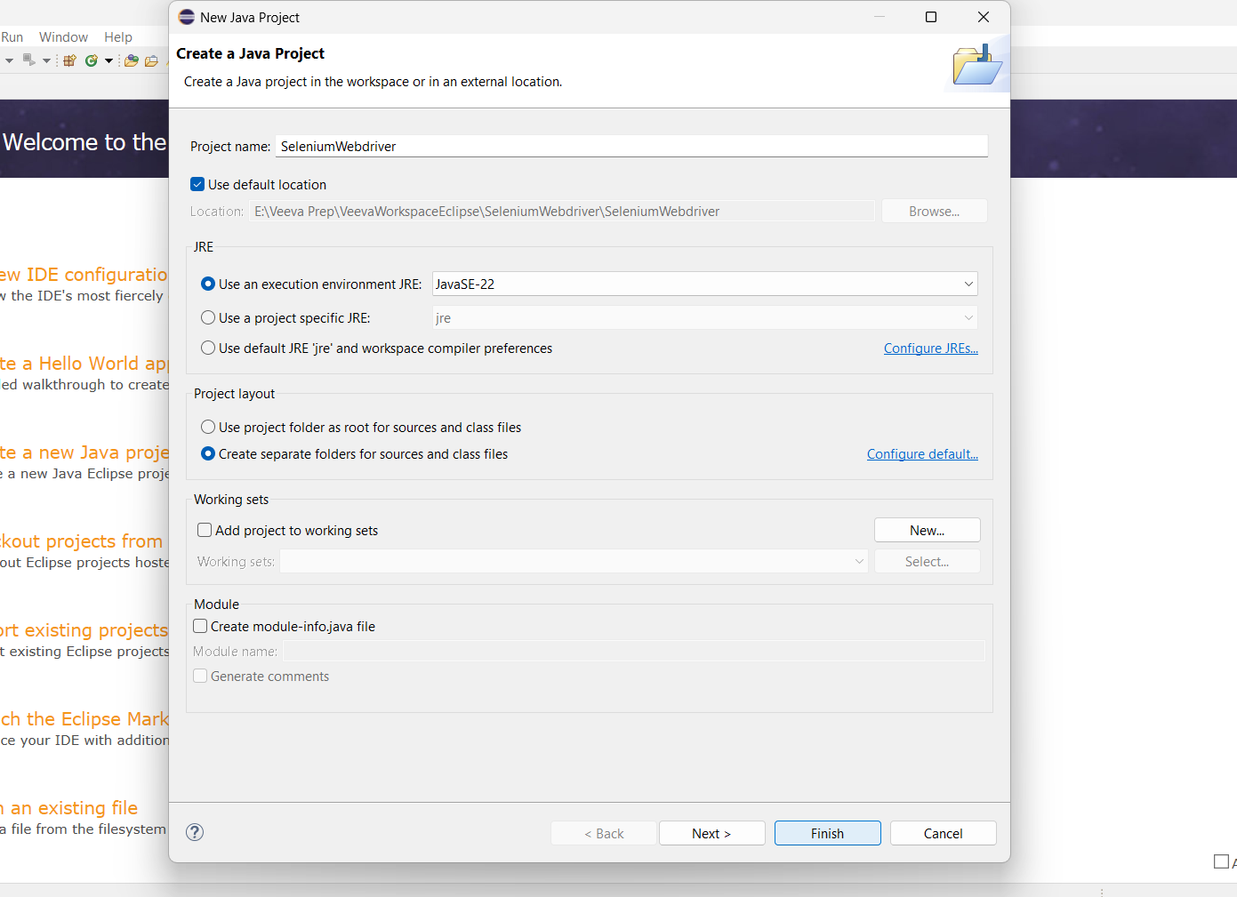

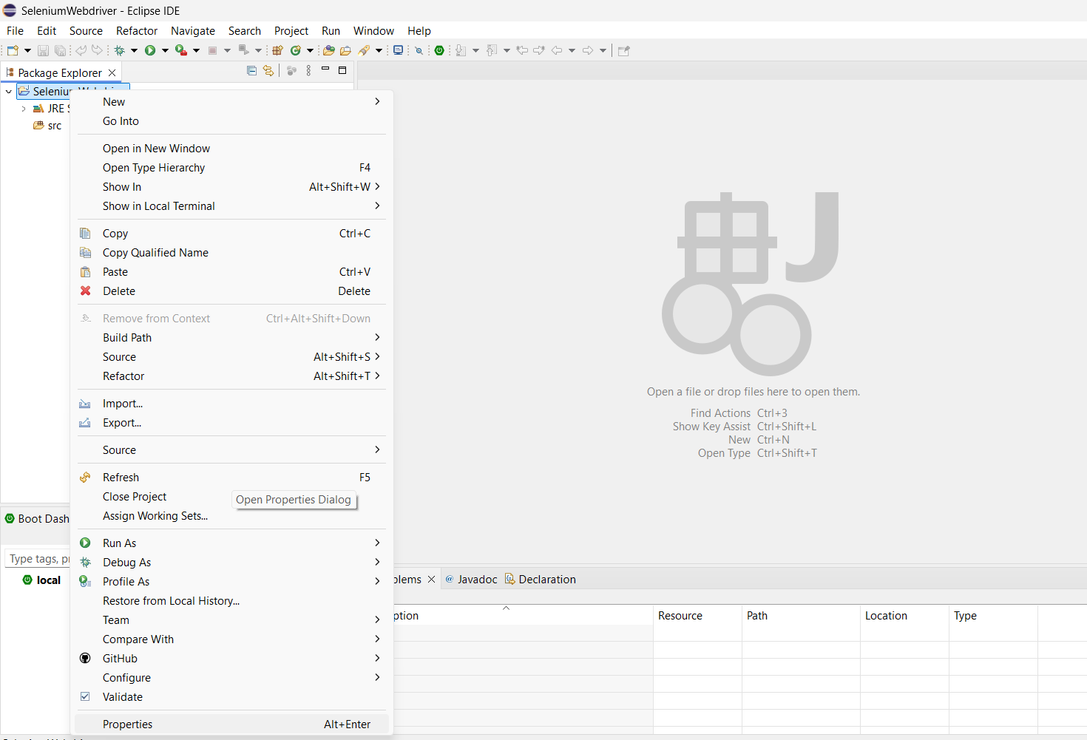
After clicking on Properties, select the below buttons:
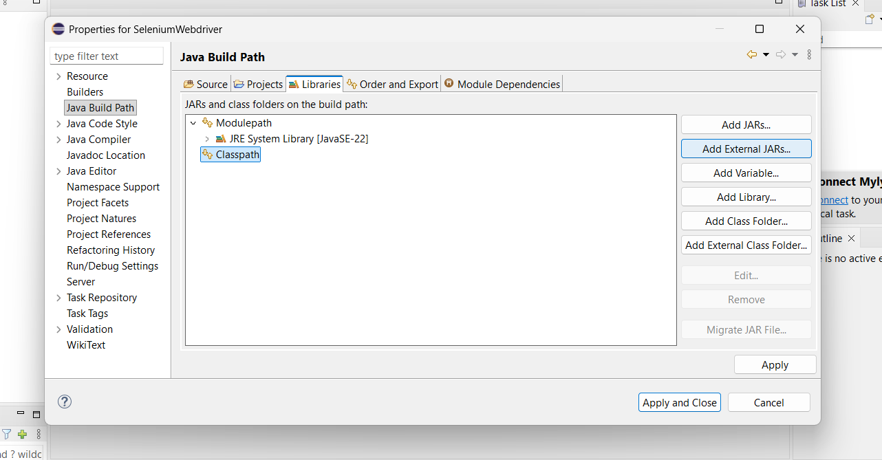

After selecting Add External JARs, make sure to add all jar files outside of lib folder and as well as inside the lib folder too to the Classpath:
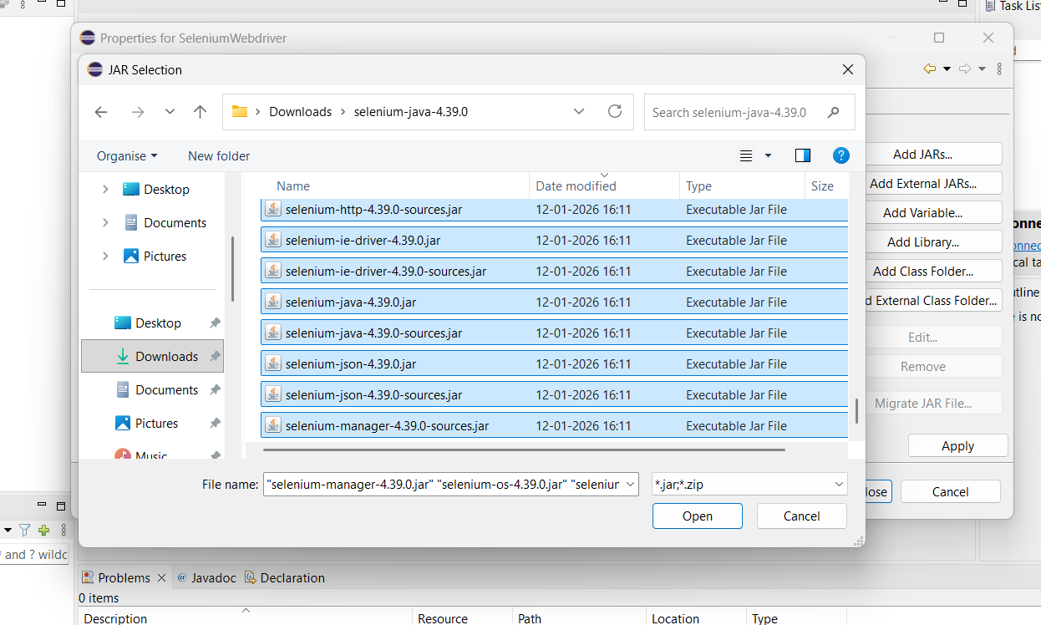

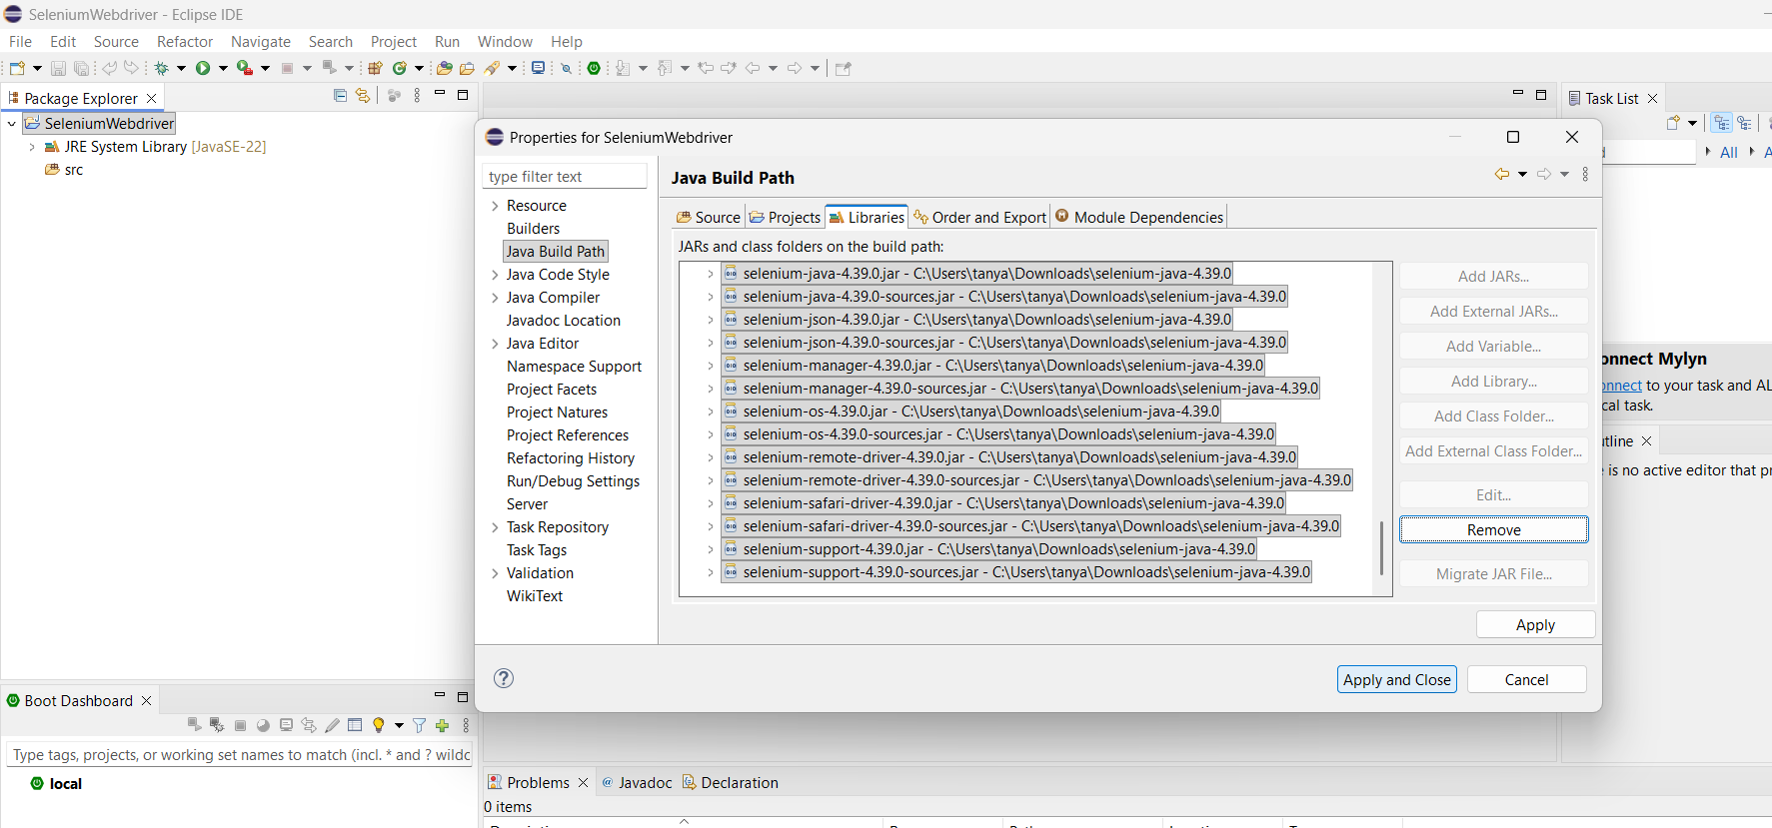

Once you have done it, you can see the referenced libraries:

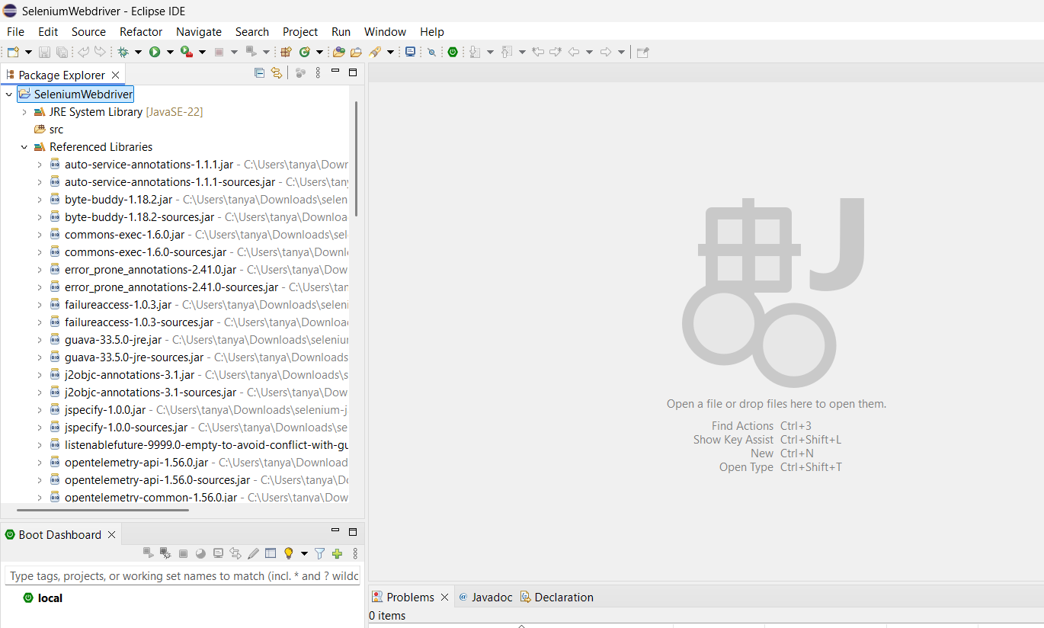

2) By Creating Maven Project

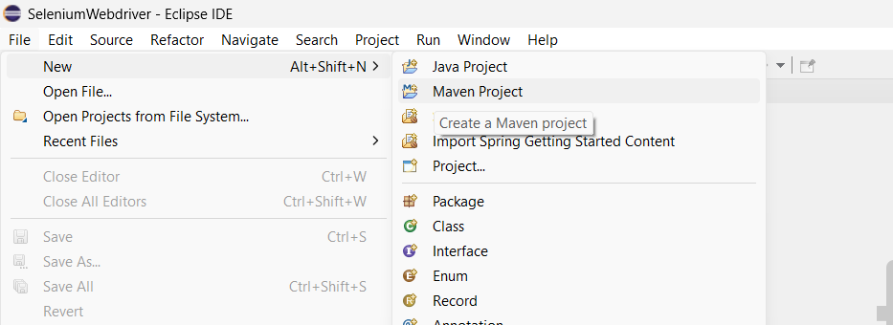

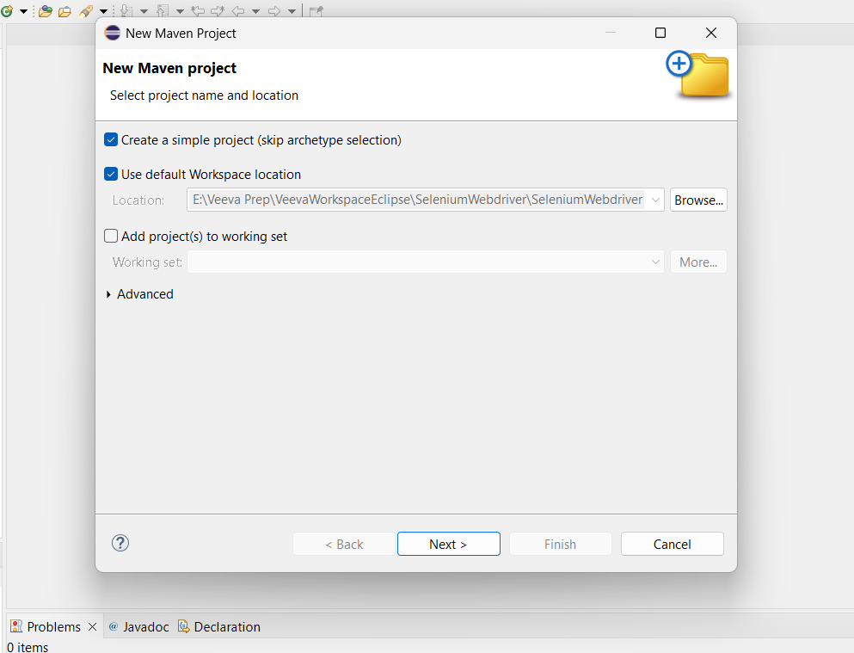

Enter the groupid which is the project name and click on Finish:
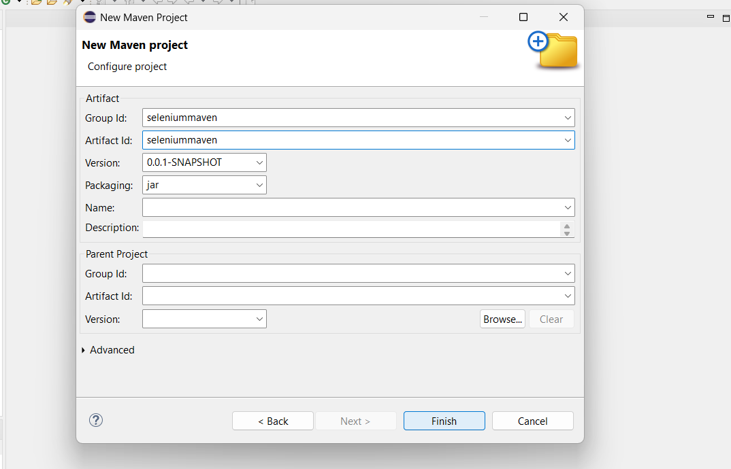

Every dependency needed is available in Maven Central Repository. Just search for what you want and copy the latest version maven xml code from there and paste it on pom.xml.

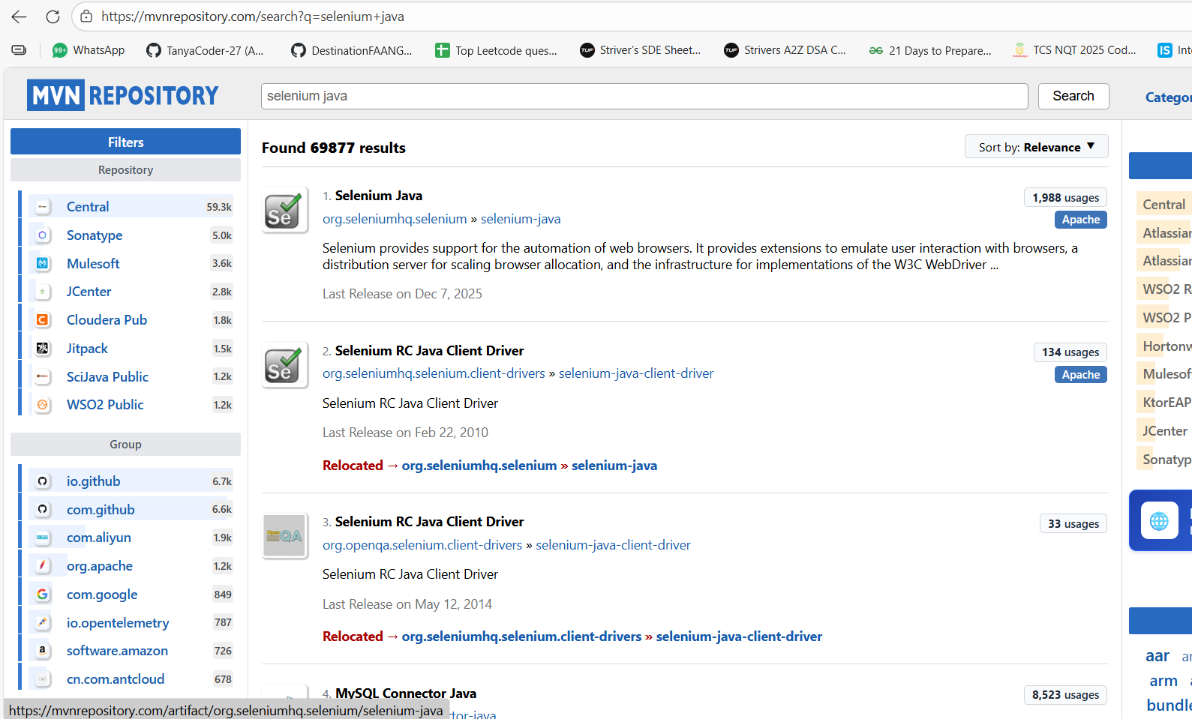

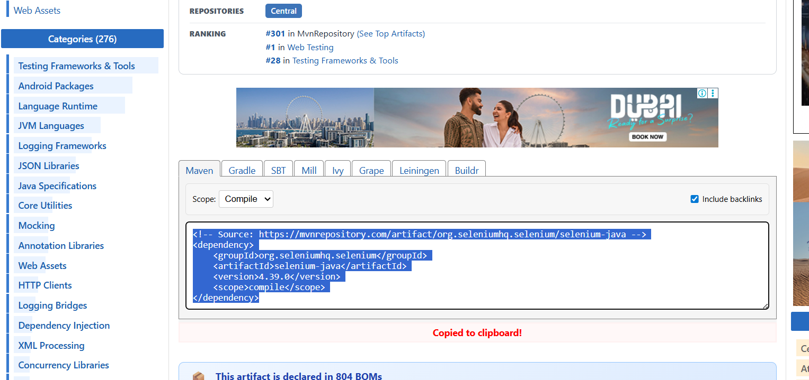

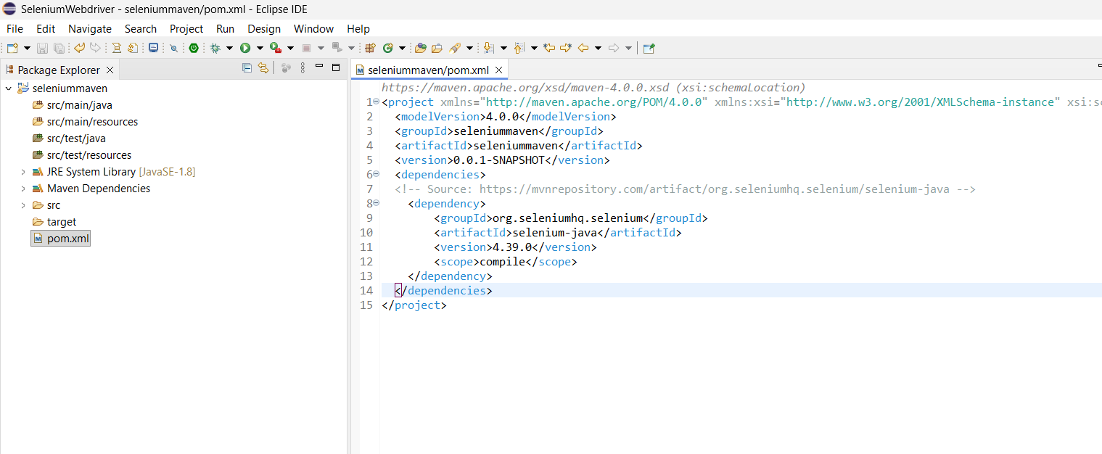

Whenever a change is made in pom.xml, simply update the maven project.
When a dependency is added in pom.xml (saved), you will see the corresponding version’s jar files getting added.

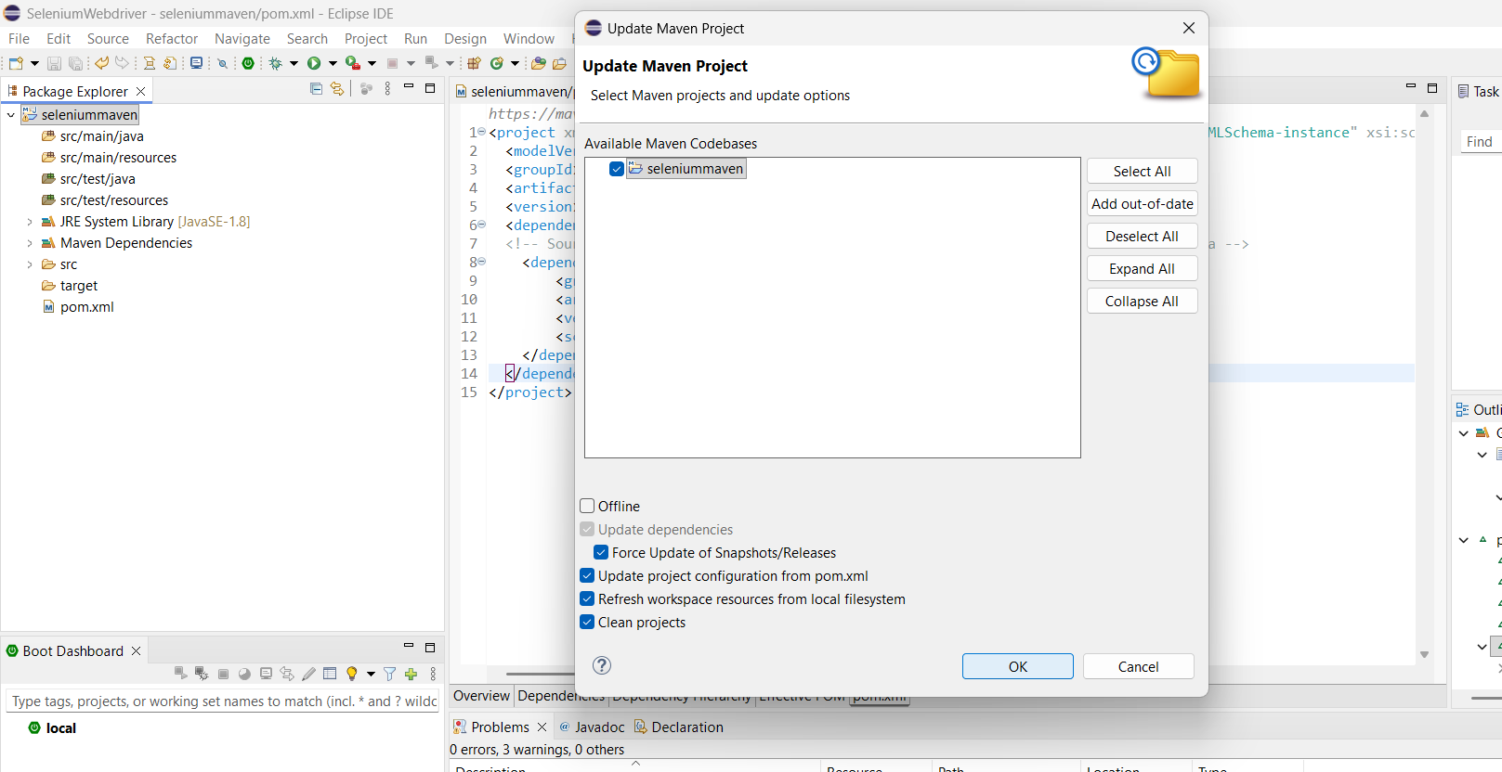

Make sure to check Force Update of Snapshots/Releases as sometimes those won’t get updated.
You can see a folder called Maven Dependencies, where there contains jar files related to Selenium now
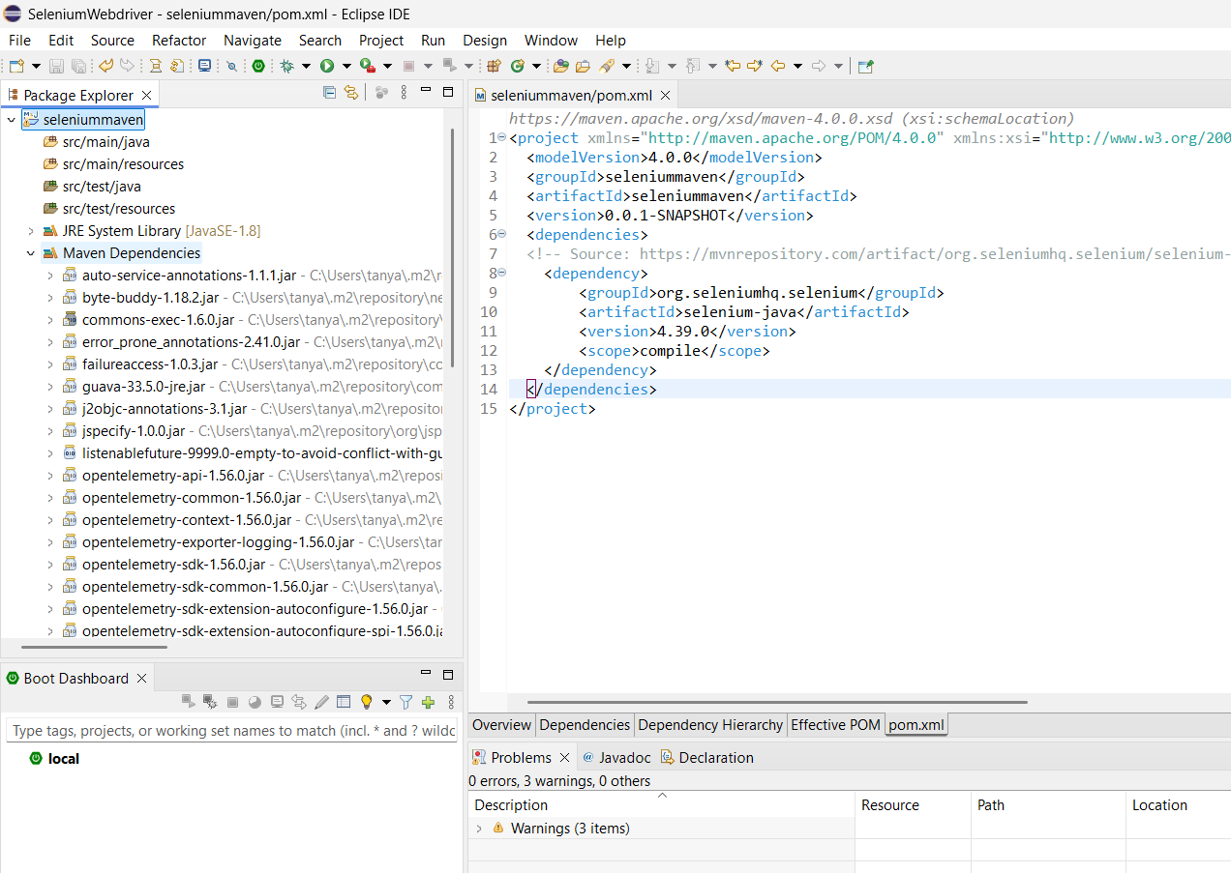
Maven project won’t work without pom.xml, as it holds all the necessary dependencies and configurations related to the Maven project.

If a new version comes tomorrow, simply change the version number and update the maven project.

From now on, we focus on src/test/java only where testing related work happens. Create a package (sub-folder)and then class as usual under src/test/java

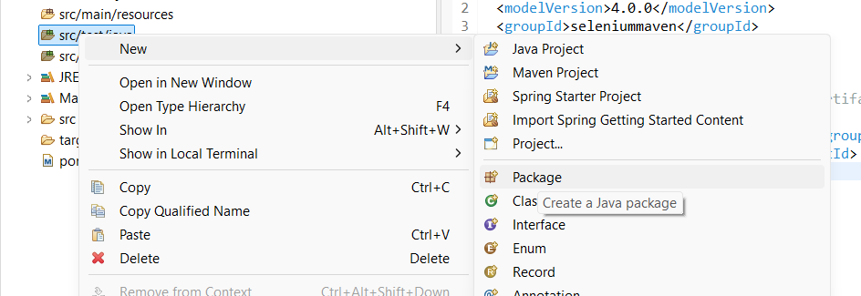

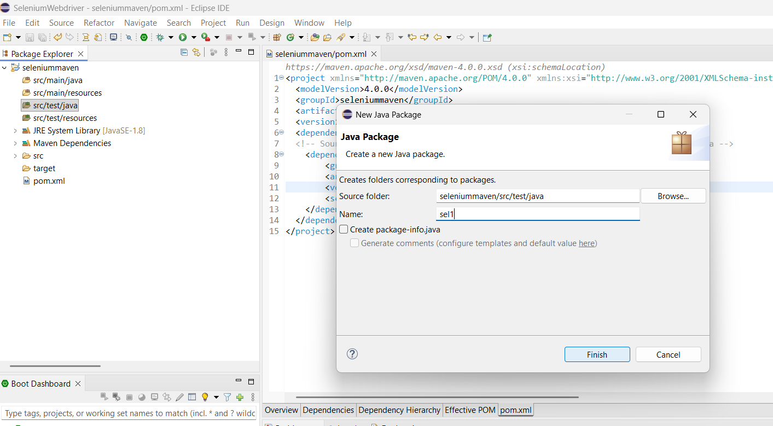

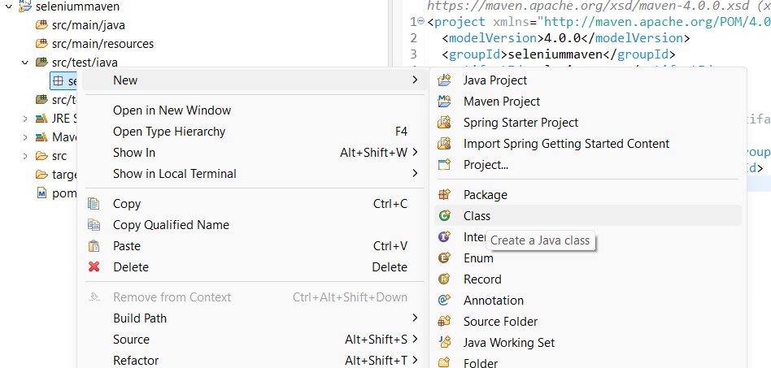

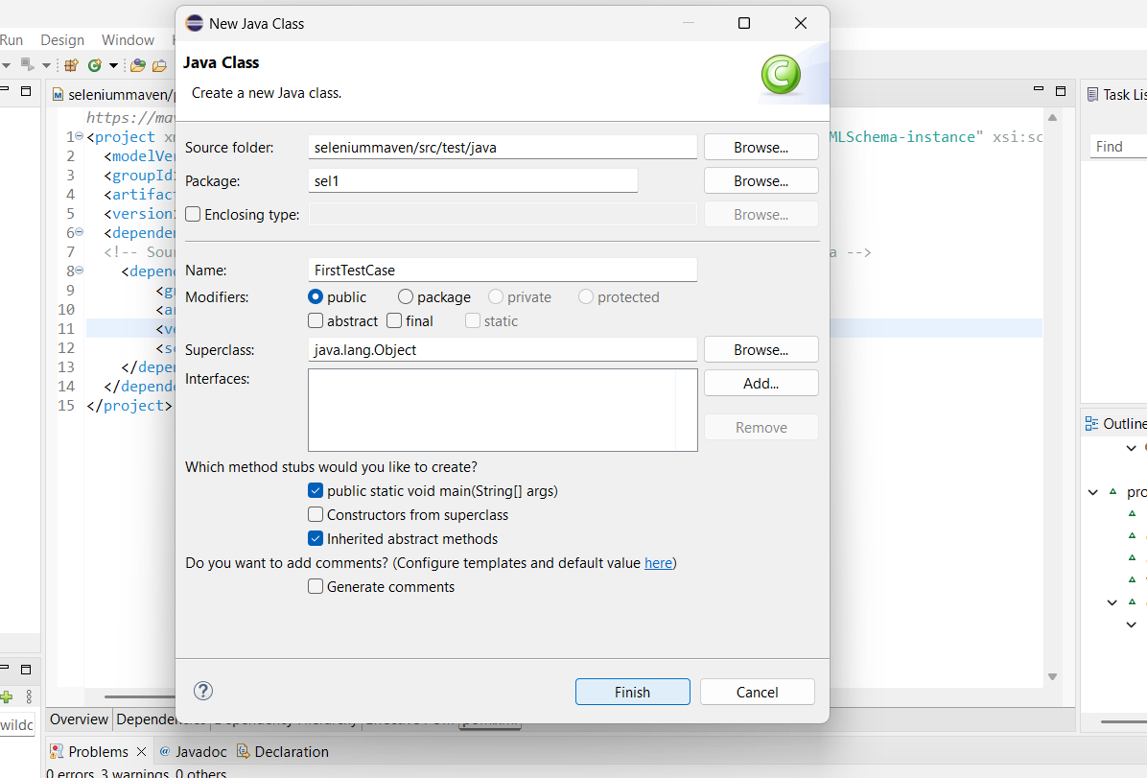

Chrome broswer is automatically launched via the constructer of the ChromeDriver class once it’s object has been created:

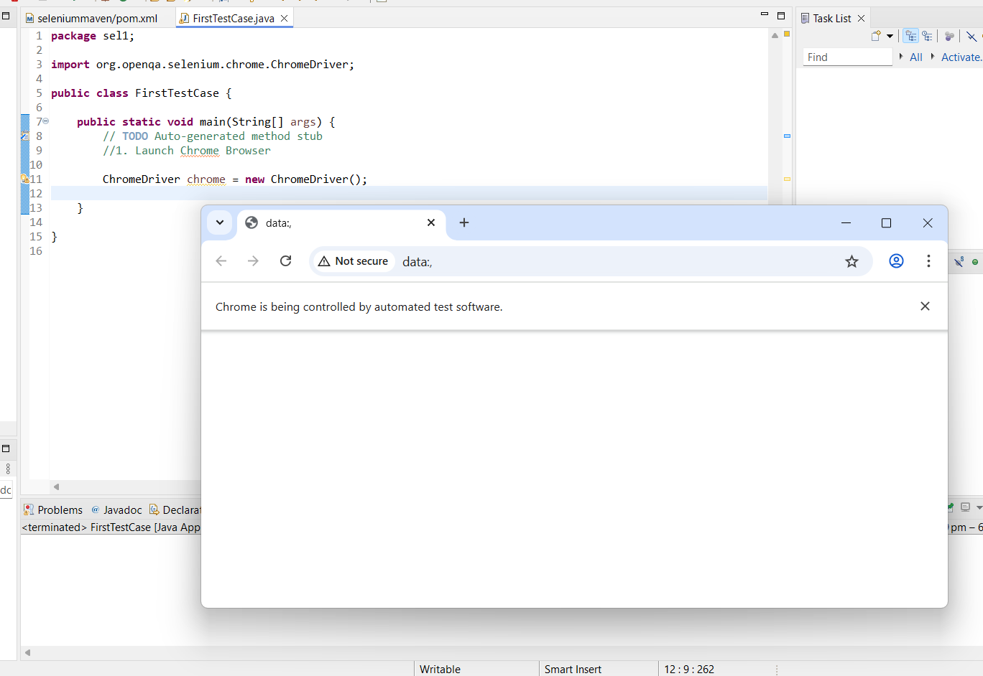

Now let’s write automation script for: launching the browser, going to a specific url page, then validating the title with our expected title, and close the browser:

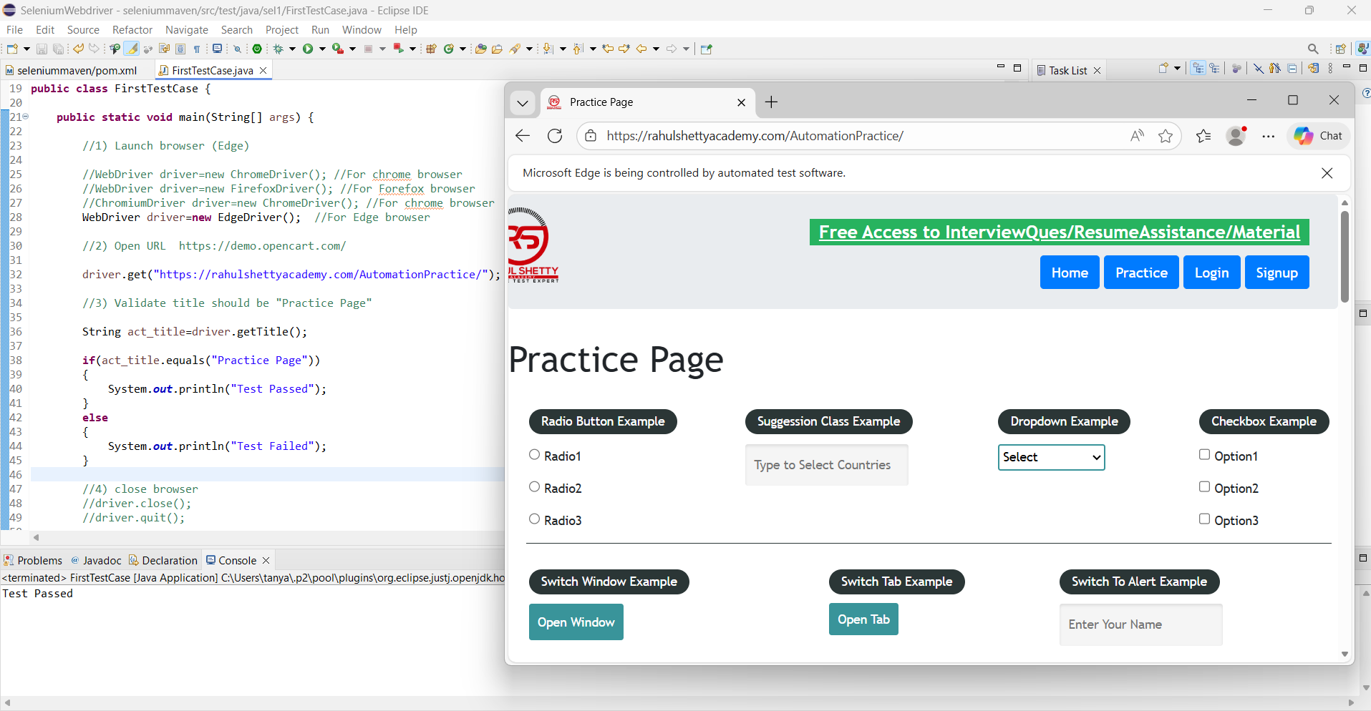
WebDriver is the interface, it is implemented by RemoteWebDriver class, it is extended by child classes such as ChromiumDriver, FirefoxDriver,EdgeDriver etc., ChromiumDriver is again extended by ChromeDriver and EdgeDriver.

