Q4) 1.Create a rule to automatically assign a bug to a developer when the prioirty is set to highest.

- Project settings Automation
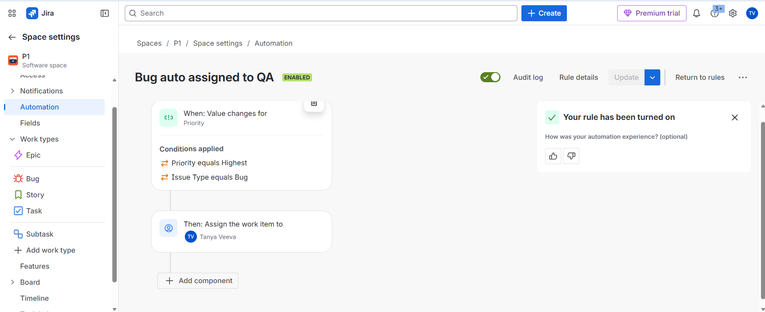

- The rule is triggered whenever the Priority field changes. It checks two conditions:
Priority equals Highest
Issue Type equals Bug
If both conditions are true, the action automatically assigns the bug to Tanya Veeva (say developer).

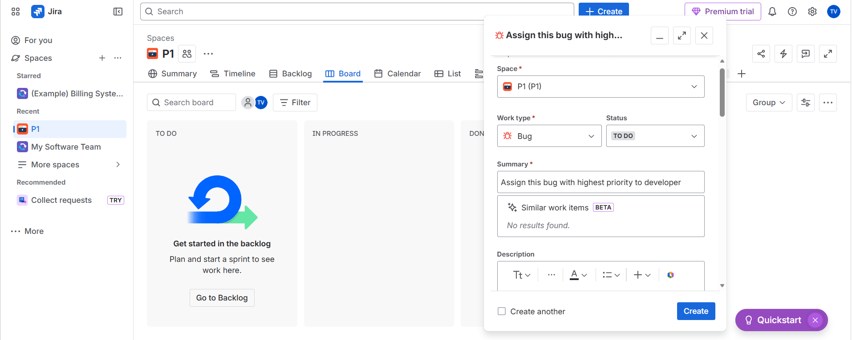

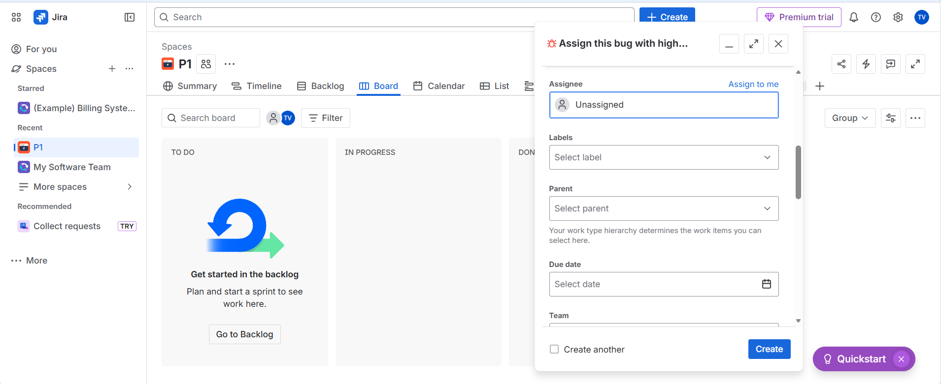

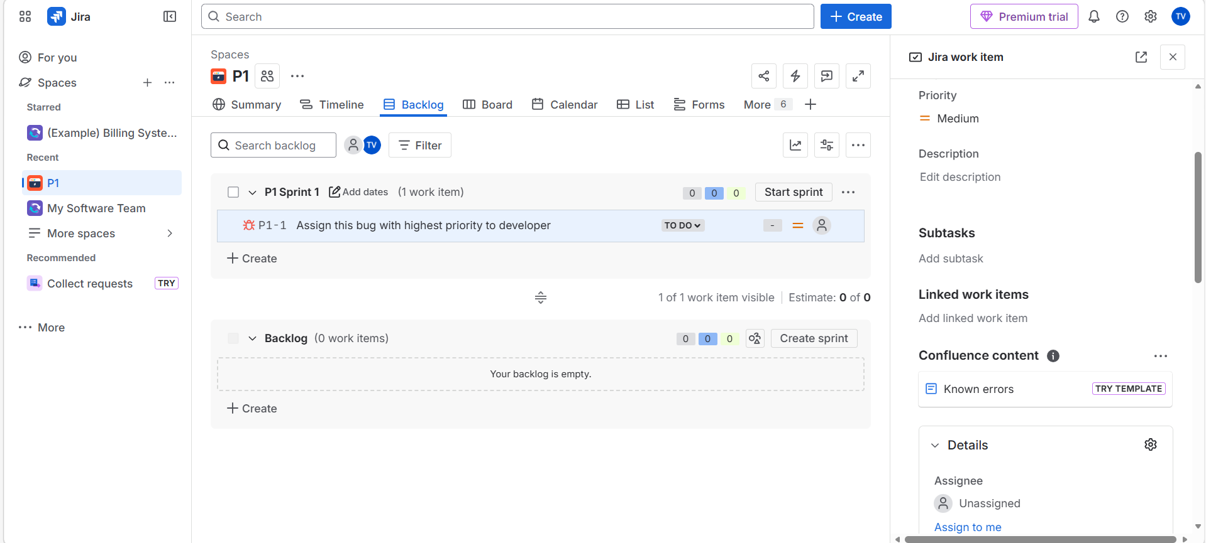

- Bug is unassigned initially with medium prioirty

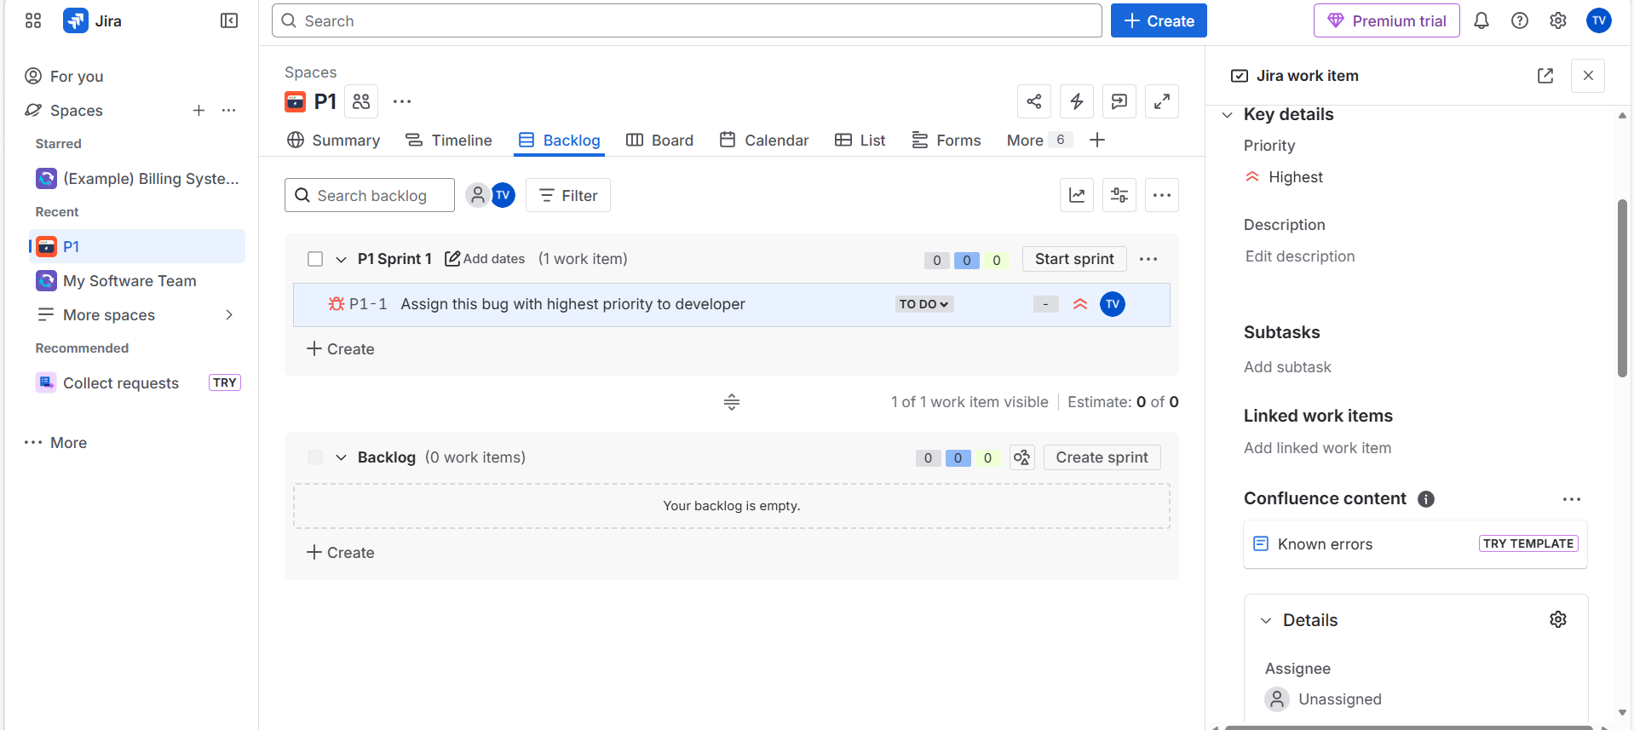

- Prioirty changed to highest
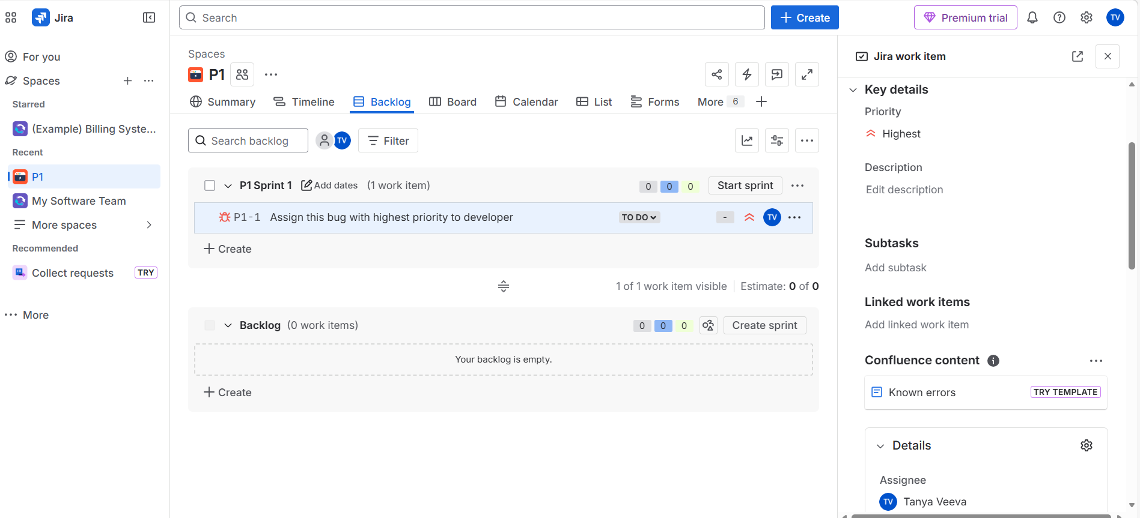

- Automatically it got assigned to Tanya Veeva (Say Developer)

