Q5.3)

- Created Test Execution Work item
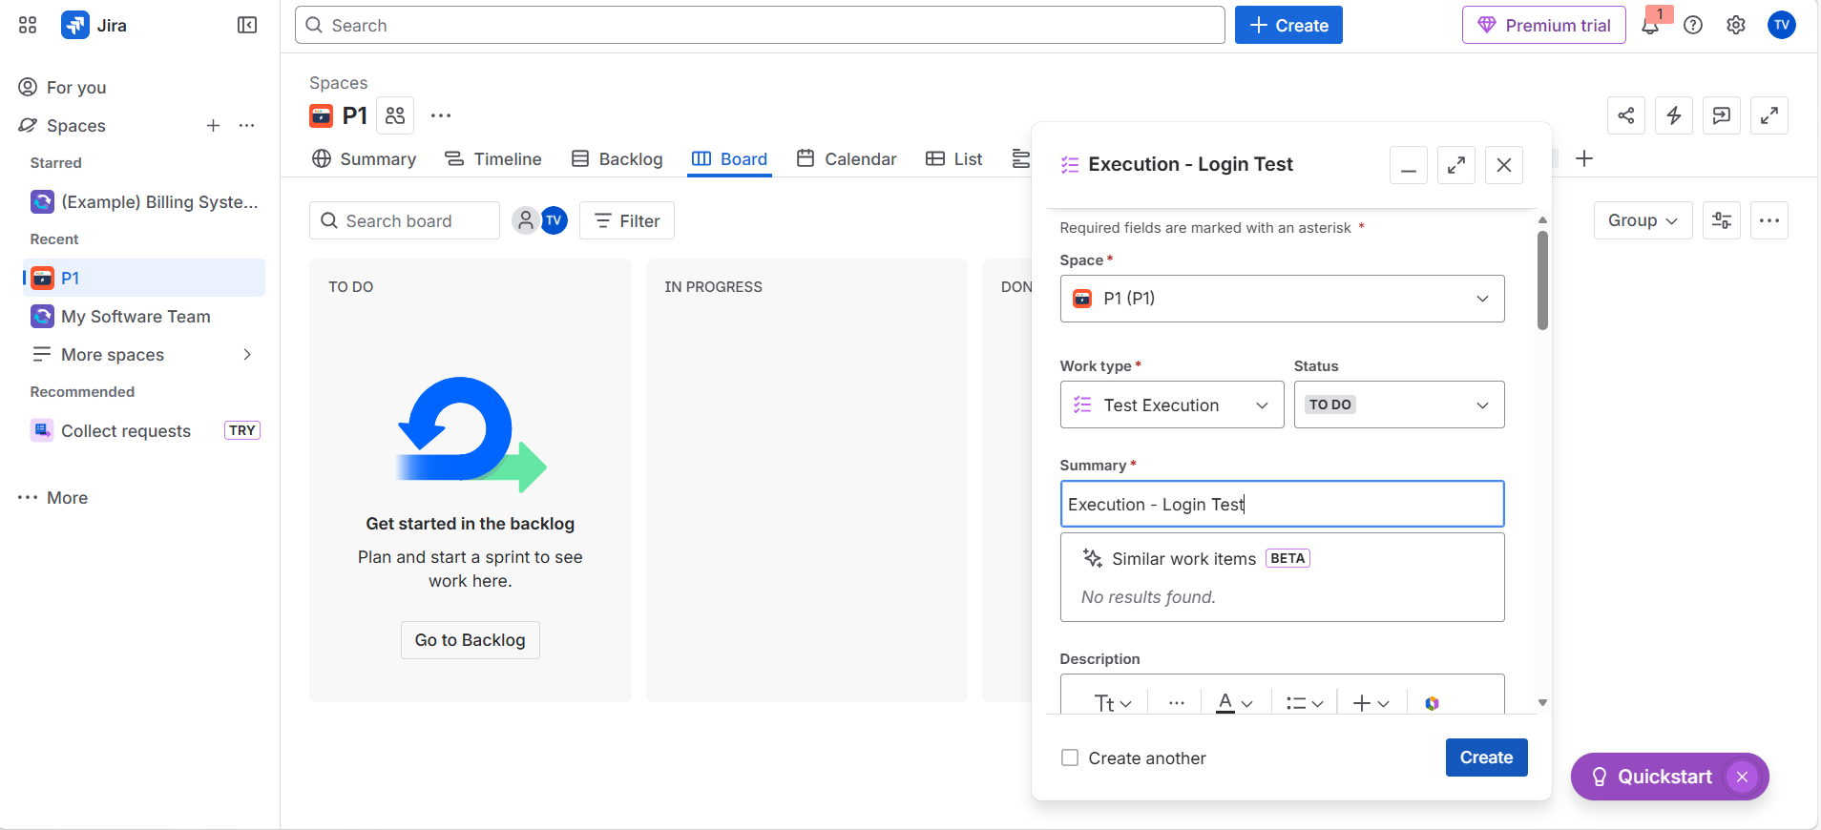

- Added Test in the Test Execution

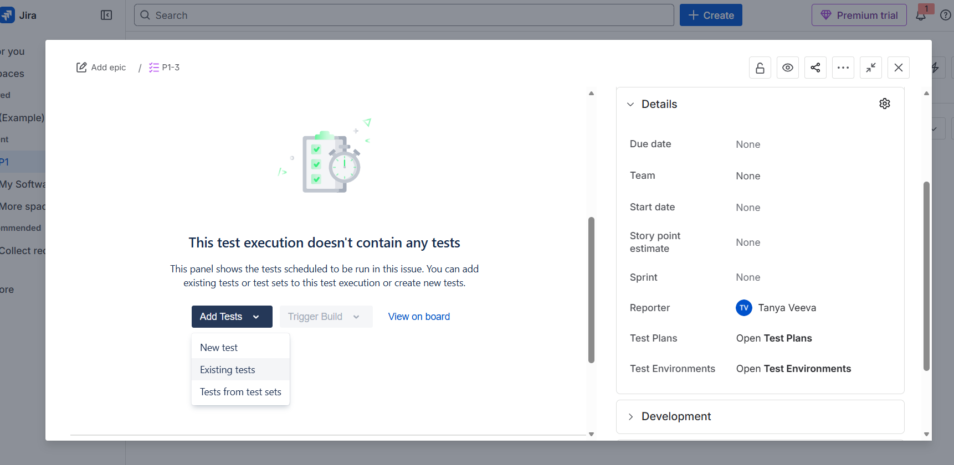

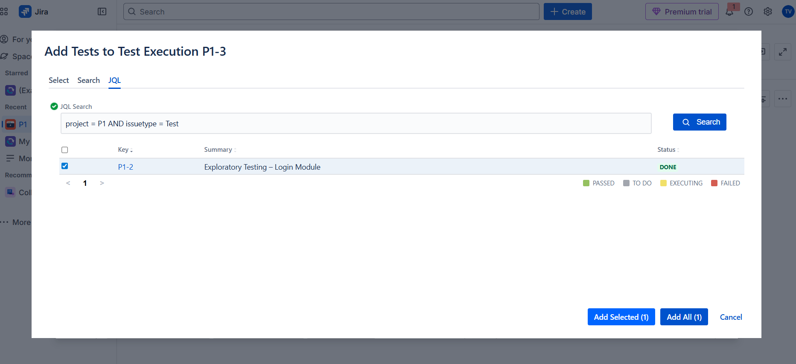

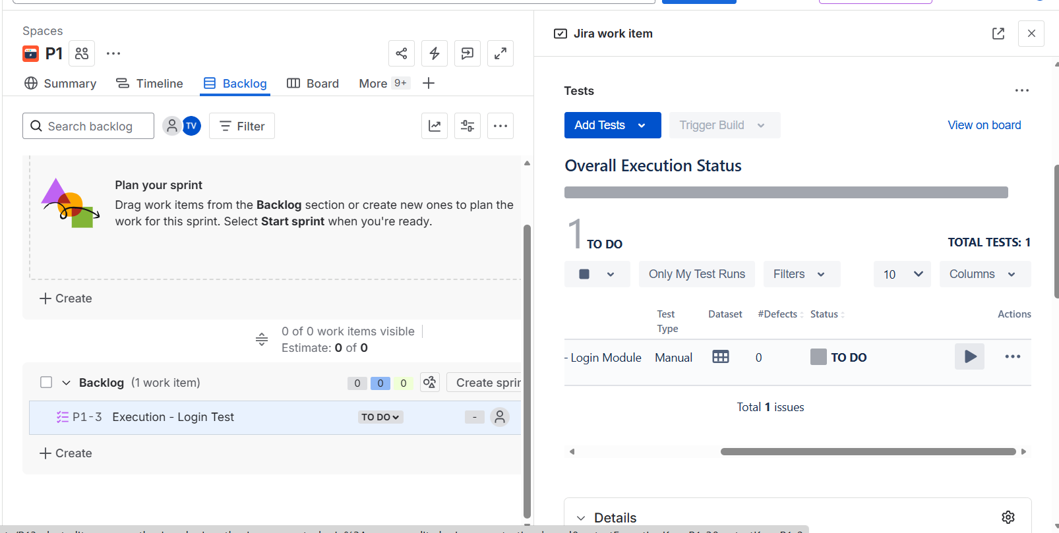

- Executed the Test and marked it as failed as it got failed at Step 3

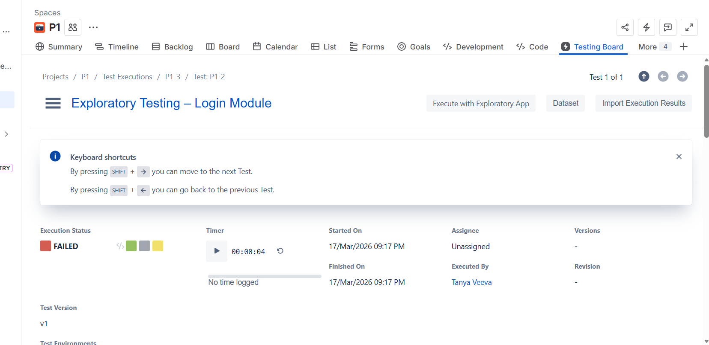

- Created Defect (Bug) where the test got failed

Defect is creted below: (bug)
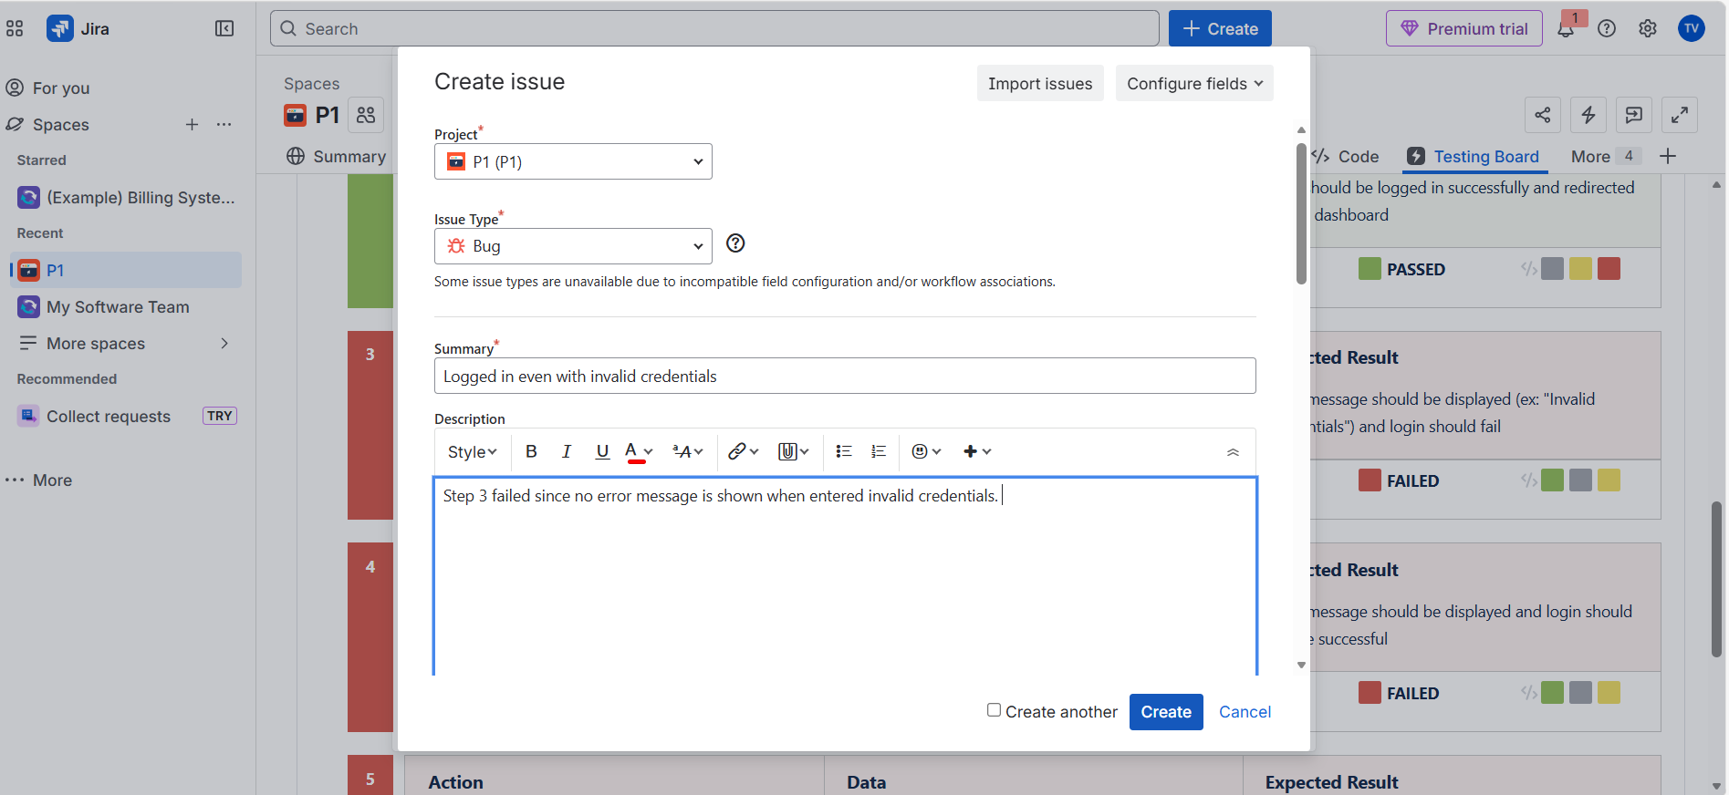

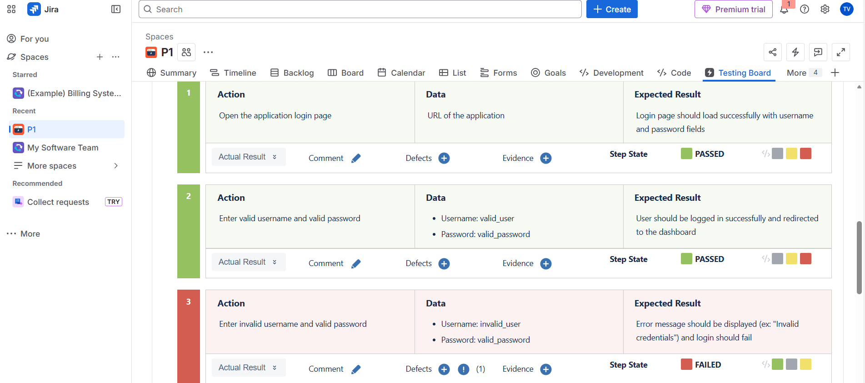
- Created new test execution (on the same login test) after the developer fixed the bug identified above:
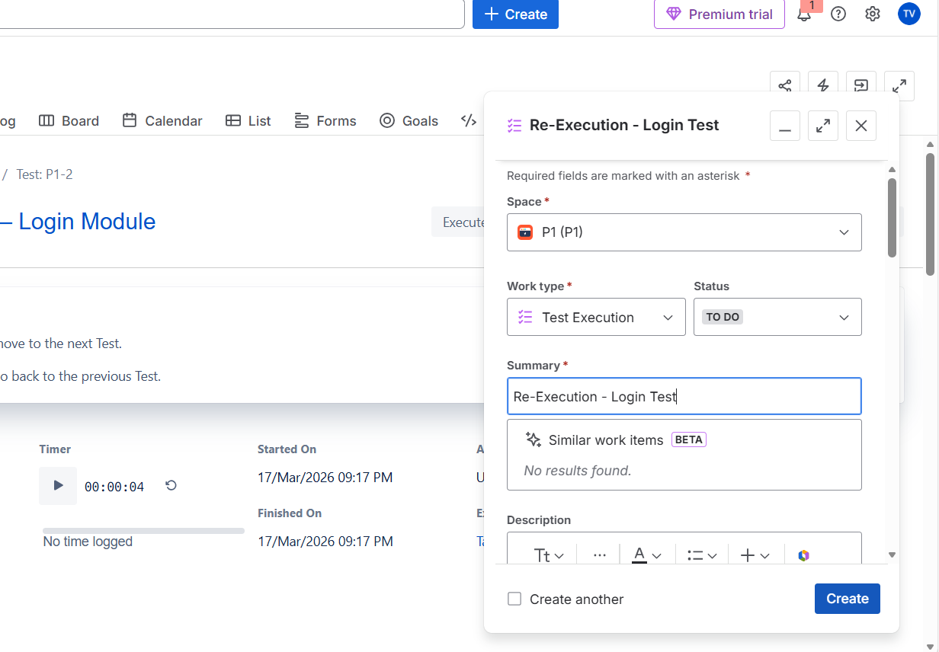

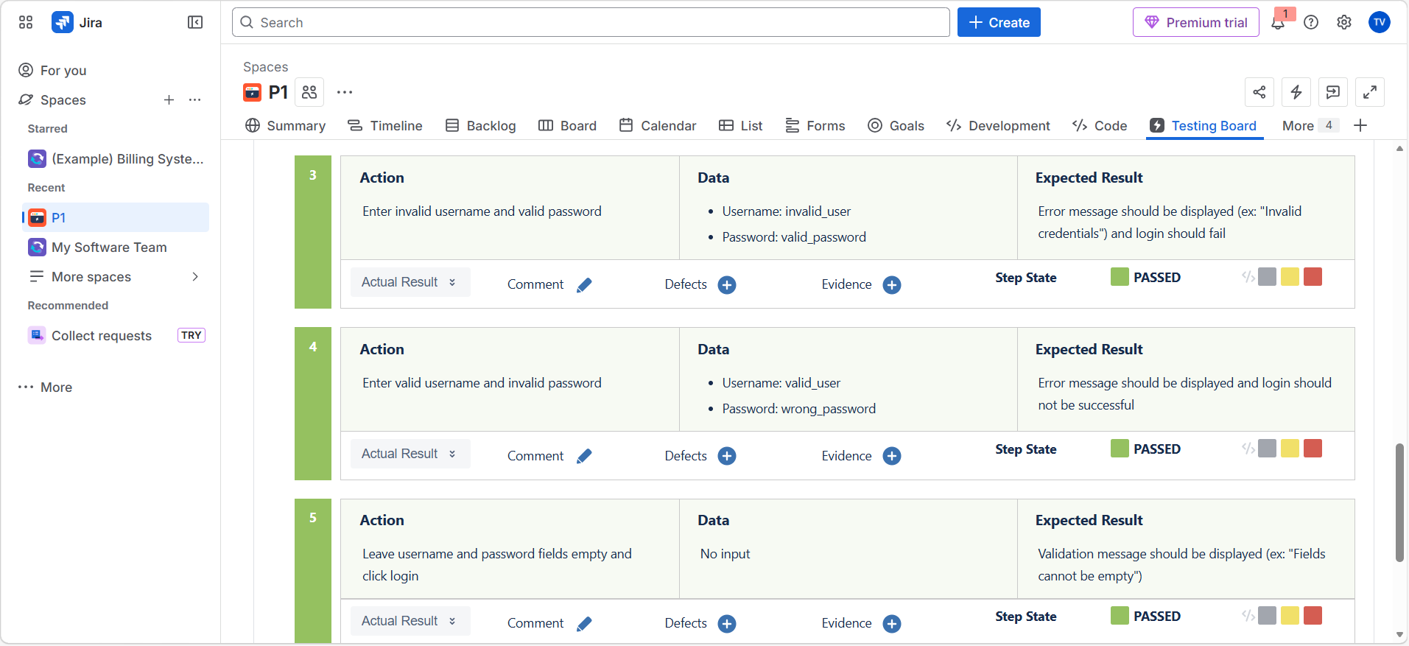

- Test got passed now

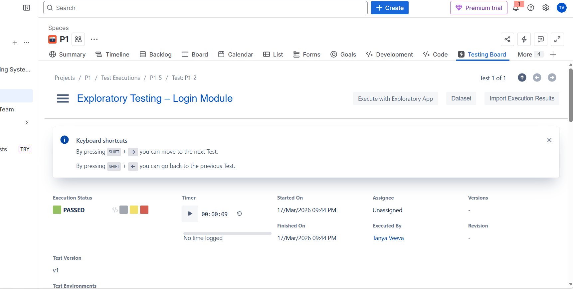

- By creating Defect, it’s easy to re-execute the failed tests as developers get to look at where the test got failed , what went wrong and also modifies that code.

