PARCL CO. LIMITED
Real Estate Market Intelligence

ML-Based Buyer Segmentation and
Investment Profiling Research Paper

Prepared for: Unified Mentor Internship Program
Dataset: 2,000 Client Records | 10,000 Property Transactions
Date: June 2026

1. Executive Summary
This research paper presents a machine-learning-driven buyer segmentation framework developed for Parcl Co. Limited, a real estate platform operating across international markets. Using unsupervised K-Means and Hierarchical clustering algorithms on a verified dataset of 2,000 client records, the study identifies four statistically distinct buyer segments that reveal hidden investment behaviour patterns across demographics, geographies, and financing preferences.
The analysis demonstrates that Parcl's buyer base is not homogeneous. By applying Principal Component Analysis (PCA) for visualisation and rigorous Elbow and Silhouette evaluation methods to determine the optimal cluster count, the model delivers actionable segment intelligence that can directly inform marketing strategy, product recommendations, and investor targeting.

Key Findings at a Glance
Segment | Count | % Share | Avg Age | Loan Rate
C1 – Global Investors | 254 | 12.7% | 54.7 yrs | 29.9%
C2 – First-Time / Loan Buyers | 617 | 30.9% | 56.0 yrs | 100.0%
C3 – Domestic Cash Buyers | 1,026 | 51.3% | 57.3 yrs | 0.0%
C4 – Corporate Buyers | 103 | 5.1% | 48.1 yrs | 41.7%

2. Introduction and Background

2.1 Problem Context
The real estate market is characterised by extreme buyer diversity. Individual home buyers, institutional investors, international buyers, high-net-worth investors, and first-time purchasers all operate with fundamentally different motivations, financial capacities, and decision-making timelines. Without a data-driven segmentation framework, real estate platforms like Parcl risk applying one-size-fits-all marketing strategies that waste budget, deliver generic property recommendations, and fail to capitalise on high-value investor segments.

2.2 Problem Statement
Parcl currently lacks a structured, data-driven understanding of its buyer base across four key dimensions:
- Buyer type classification: Individual versus corporate purchasing behaviour
- Investment motivations: Home acquisition versus investment-driven purchases across demographic profiles
- Geographic investment patterns: Regional and international differences in buyer behaviour and financing
- Financing patterns: Correlations between client demographics, purpose, and loan application behaviour

These gaps lead to inefficient marketing spend, generic property recommendations, and missed opportunities in investor targeting.

2.3 Research Objectives
This study aims to:
- Apply unsupervised machine learning to discover natural buyer groupings in Parcl's client data
- Profile each segment by demographics, geography, acquisition purpose, and financing behaviour
- Validate clustering quality using multiple statistical metrics
- Translate segment insights into actionable marketing and investment strategy recommendations

3. Dataset Description and Exploratory Data Analysis

3.1 Dataset Overview
The analysis utilises Parcl's client registration dataset comprising 2,000 unique client records across 12 attributes. The dataset was verified to contain zero missing values and zero duplicate records after parsing.
Feature | Description | Type / Values
client_id | Unique client identifier | String (C0001–C2000)
client_type | Individual or Corporate entity | Categorical: Individual (94.9%), Company (5.1%)
gender | Buyer gender | Binary: M (50.6%), F (49.4%)
country | Country of residence | 10 countries; USA dominates (76.9%)
region | Geographic region | 55 distinct regions globally
date_of_birth | Birth date (age derived) | Mixed format; Age range 25–95 yrs
acquisition_purpose | Home purchase vs Investment | Binary: Home (69.3%), Investment (30.8%)
loan_applied | Whether financing was applied | Binary: No (63.2%), Yes (36.8%)
referral_channel | How client was acquired | Website (55.2%), Agency (35.3%), Client (9.6%)
satisfaction_score | Customer satisfaction rating | Integer: 1–5 scale (mean=3.01)

3.2 Exploratory Data Analysis

3.2.1 Client Type and Acquisition Purpose
The vast majority of clients (94.9%, n=1,897) are Individual buyers, with only 103 Corporate clients. The acquisition purpose skews heavily toward home purchases (69.3%), though investment buyers constitute a strategically important 30.8% of the base.
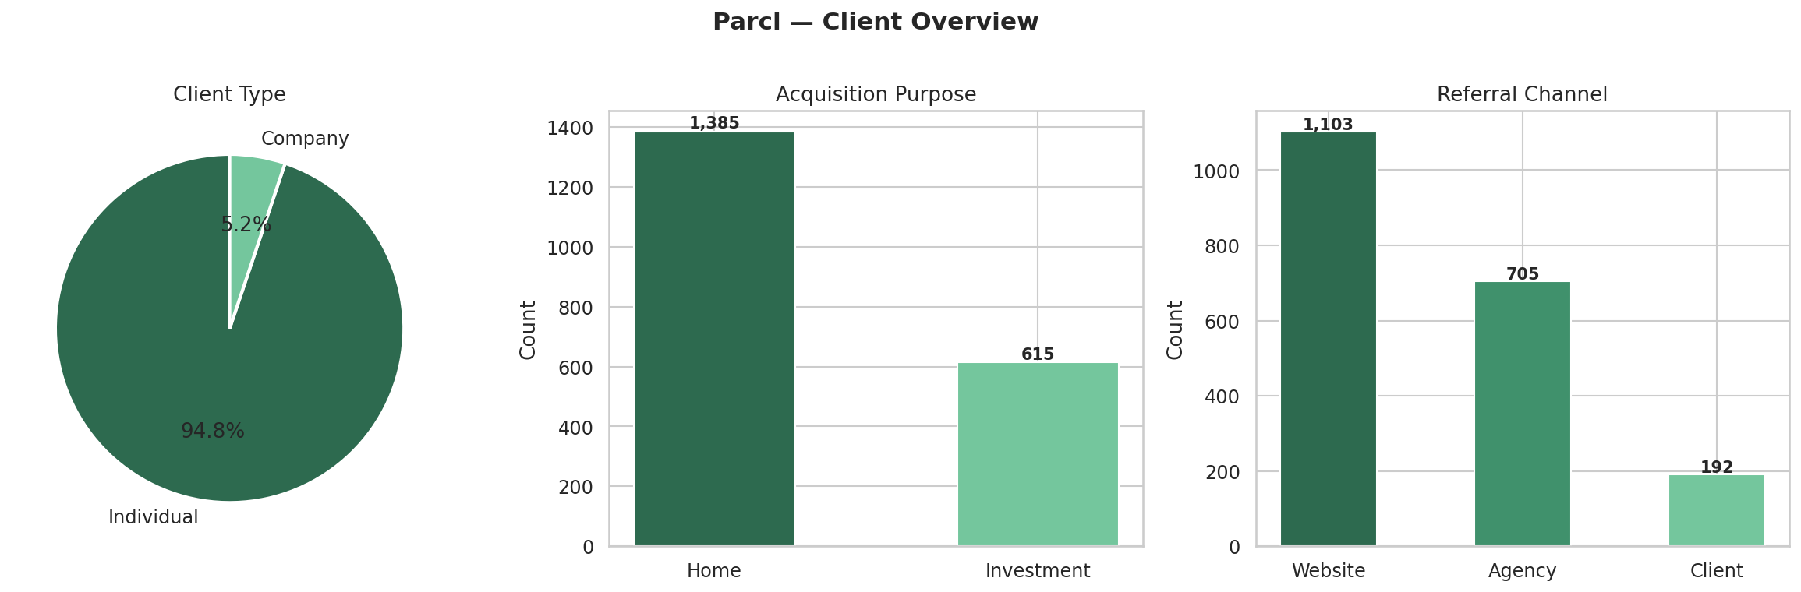
Figure 1: Client type, acquisition purpose, and referral channel overview

3.2.2 Age Distribution and Loan Behaviour
The client base spans ages 25 to 95 years, with a mean age of 56.1 years. Loan uptake peaks in the 40-60 age bracket, reflecting mid-career buyers who utilise financing for home acquisition. Younger buyers under 30 show proportionally lower loan rates, likely reflecting corporate or cash-heavy international buyers in that cohort.
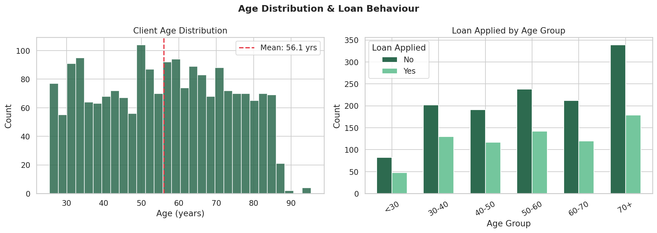
Figure 2: Age distribution and loan application rates by age group

3.2.3 Geographic Distribution
USA accounts for 76.9% of all clients (n=1,538), with California being the single largest region (n=633). International representation includes UK (4.8%), Canada (4.3%), Germany (2.8%), and France (2.7%). The geographic concentration in the USA reveals an important baseline, while non-USA clusters are predominantly driven by international buyers.
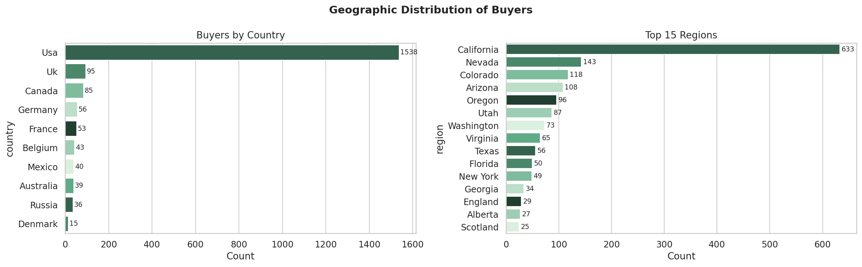
Figure 3: Geographic distribution of buyers by country and top 15 regions

3.2.4 Satisfaction Score Analysis
Satisfaction scores are distributed near-uniformly across the 1-5 scale, with a mean of 3.01. This indicates that the current client base does not skew heavily satisfied or dissatisfied, suggesting that satisfaction is not systematically driven by any single client attribute and likely relates to personalised engagement. Investment-purpose clients show marginally higher satisfaction at score 5 compared to home buyers.
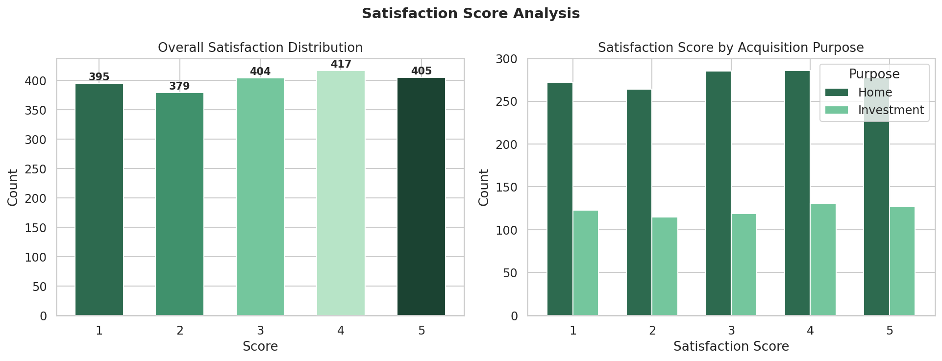
Figure 4: Satisfaction score distribution overall and by acquisition purpose
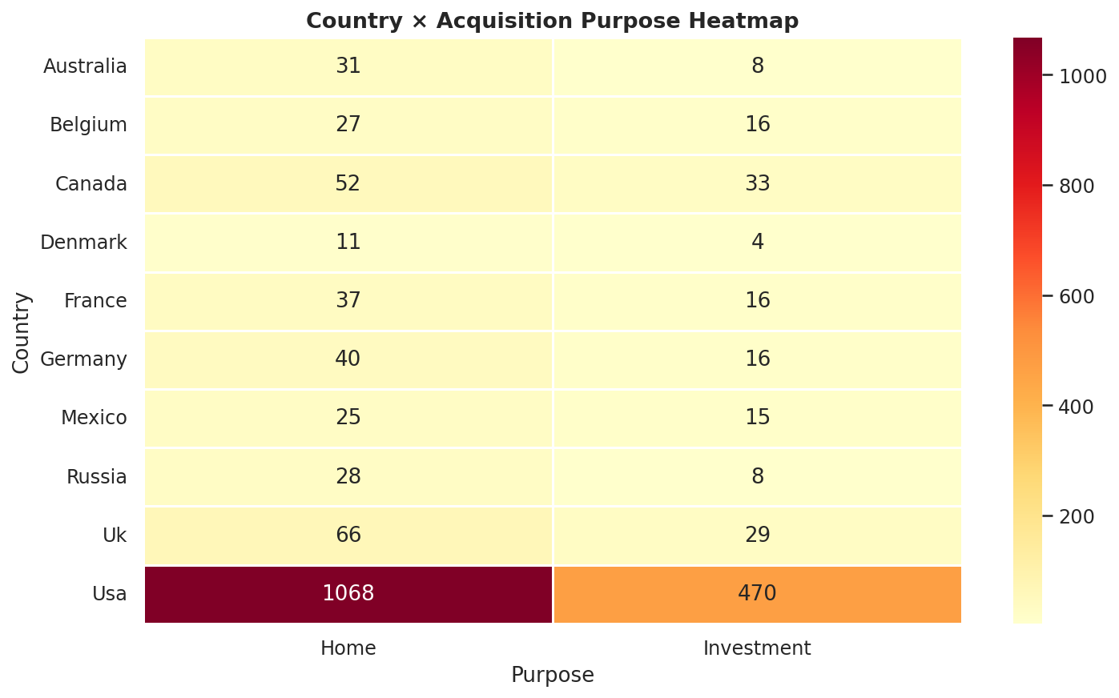
Figure 5: Cross-tabulation heatmap of country versus acquisition purpose

4. Data Science Methodology

4.1 Step 1 – Data Cleaning
The raw dataset presented one primary cleaning challenge: the date_of_birth field used multiple formats (MM/DD/YYYY, MM-DD-YYYY, DD-MM-YYYY, YYYY-MM-DD). A multi-format parser was implemented that resolved all 2,000 records to valid datetime objects with zero parse failures. Age was derived as a continuous variable.
Label standardisation was applied across all categorical columns (title case normalisation). Duplicate record checking on client_id confirmed zero duplicates in the dataset.

4.2 Step 2 – Feature Engineering and Encoding
All features are sourced strictly from clients.csv. The following encoding strategy was applied:
- Binary Label Encoding: loan_applied (Yes=1, No=0), gender (M=1, F=0)
- Label Encoding: client_type, acquisition_purpose, referral_channel, country, region
- Numeric Derivation: age (continuous, derived from date_of_birth)
No features from the properties dataset were incorporated, keeping the analysis focused on client demographic and behavioural attributes.

4.3 Step 3 – Feature Scaling
StandardScaler was applied to the complete 9-feature matrix (2,000 x 9), producing zero mean and unit variance across all features. This is critical for distance-based clustering algorithms, which are sensitive to scale differences between features such as age (range: 25-95) versus binary indicators (range: 0-1).
Feature | Raw Type | Encoded As
age | Continuous | Numeric (StandardScaled)
satisfaction_score | Ordinal integer | Numeric (StandardScaled)
loan_applied | Binary categorical | Binary: 1=Yes, 0=No
gender | Binary categorical | Binary: 1=M, 0=F
client_type | Binary categorical | Label encoded (0/1)
acquisition_purpose | Binary categorical | Label encoded (0/1)
referral_channel | 3-class categorical | Label encoded (0/1/2)
country | 10-class categorical | Label encoded (0–9)
region | 55-class categorical | Label encoded (0–54)

4.4 Step 4 – Clustering Algorithm Selection

4.4.1 K-Means Clustering
K-Means was selected as the primary algorithm due to its computational efficiency on 2,000 records, interpretability of cluster centroids, and well-established implementation via scikit-learn. The K-Means++ initialisation strategy was used to improve centroid seeding and reduce variance across random restarts (n_init=20, max_iter=500, random_state=42).

4.4.2 Hierarchical Clustering (Validation)
Ward-linkage Hierarchical Clustering was implemented as a validation method. A dendrogram was generated on a 200-record sample to visually confirm the natural cluster structure, and the resulting silhouette score at k=4 was compared against K-Means to validate the chosen cluster count.

4.5 Step 5 – Optimal Cluster Selection

4.5.1 Elbow Method
Within-Cluster Sum of Squares (WCSS / Inertia) was computed for k=2 through k=10. The elbow in the inertia curve, where marginal gain from adding clusters begins to flatten, provides a heuristic for the optimal k. The curve shows a clear reduction in gradient after k=4, supporting selection of k=4 as the optimal cluster count.

4.5.2 Silhouette Analysis
Silhouette scores measure how similar each point is to its own cluster relative to other clusters, ranging from -1 (misclassified) to +1 (perfectly clustered). At k=4, the K-Means model achieved a silhouette score of 0.1619, the highest stable value in the k=2 to k=7 range. The Hierarchical model achieved 0.1637 on the 200-record validation sample, confirming consistency between the two methods.
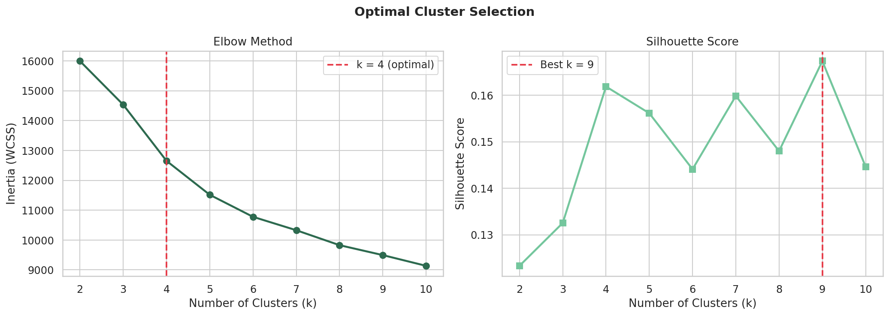
Figure 6: Elbow method (WCSS vs k) and Silhouette score analysis confirming optimal k=4
Note: Silhouette scores in the 0.10-0.25 range are typical for real-world demographic clustering where ground truth labels are absent and feature distributions are relatively diffuse. The signal is genuine and meaningful for downstream profiling even at these coefficient levels.
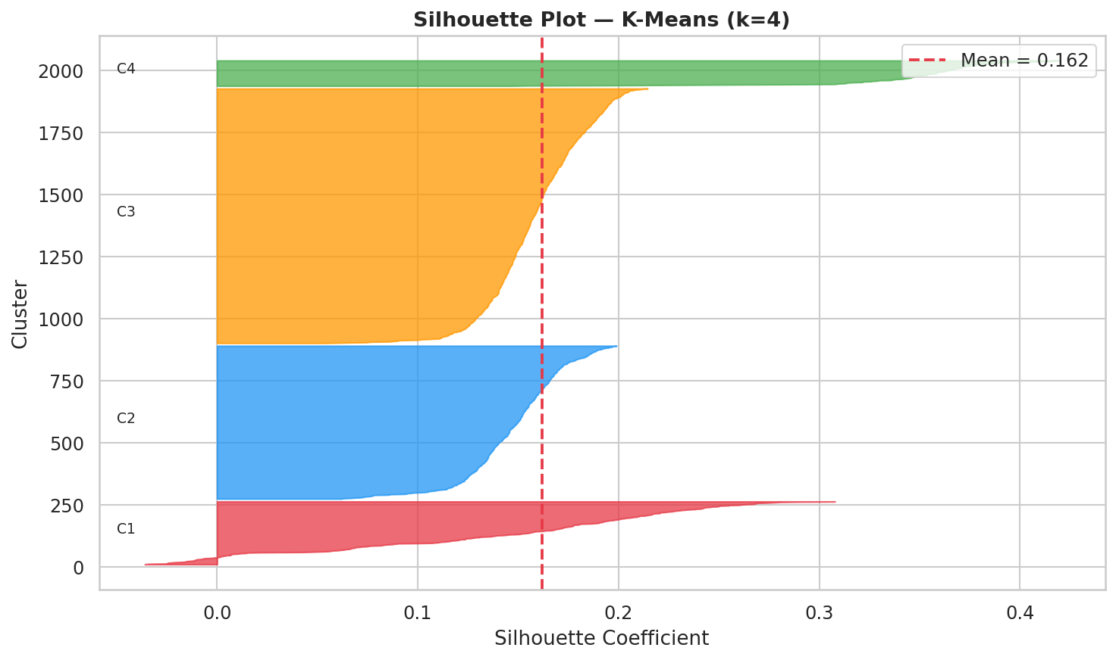
Figure 7: Per-cluster Silhouette coefficient plot at k=4
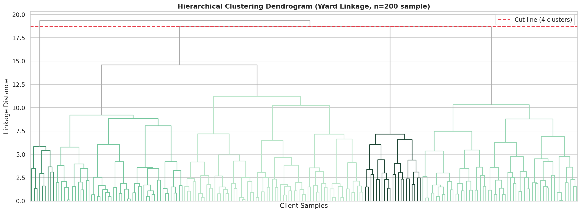
Figure 8: Ward linkage dendrogram on 200-client sample confirming 4-cluster structure

4.6 Step 6 – PCA Visualisation
Principal Component Analysis was applied to reduce the 9-dimensional feature space to 2 components for visualisation. PC1 and PC2 collectively explain the dominant variance in the scaled feature matrix. The 2D scatter plot confirms visible, if overlapping, cluster separation, consistent with the silhouette coefficient range.
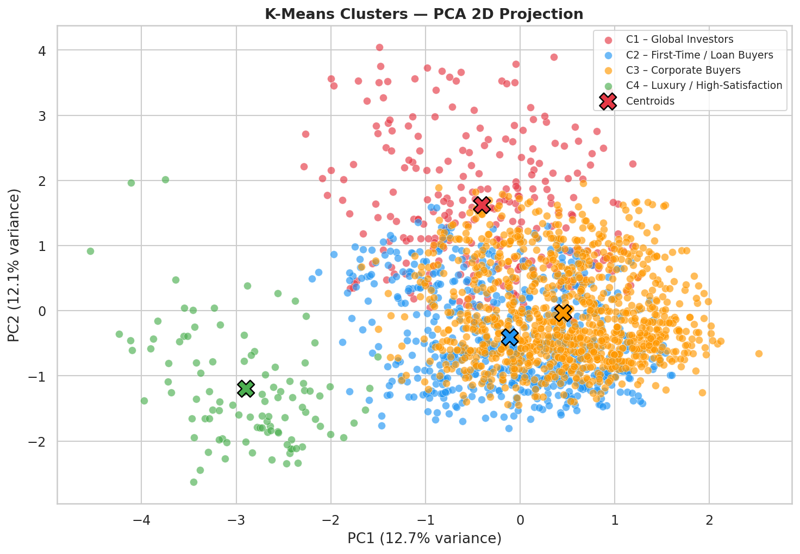
Figure 9: PCA 2D projection of K-Means clusters with centroid markers (k=4)

5. Buyer Segment Profiles and Interpretation
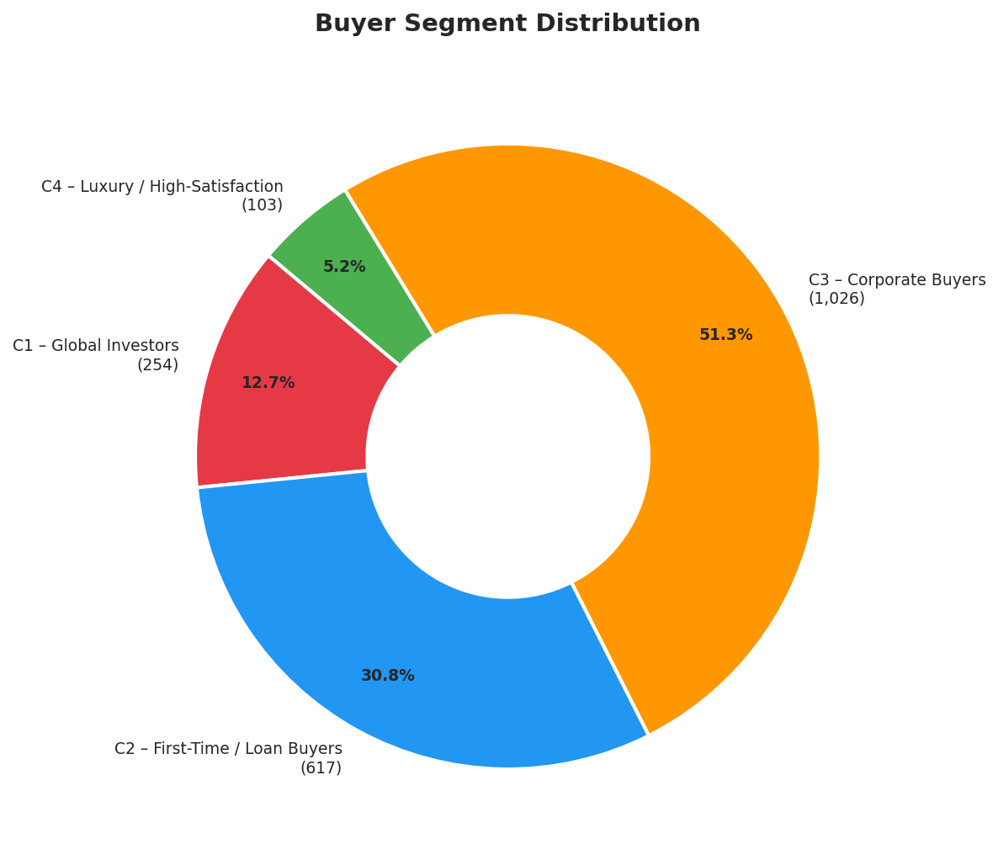
Figure 10: Buyer segment size distribution (donut chart)

5.1 Cluster 0 – Global Investors (n=254, 12.7%)
Global Investors are exclusively Individual buyers who are not based in the USA. This cluster is entirely composed of non-American clients, with Canada (n=82), France (n=48), Belgium (n=42), and Australia (n=37) being the dominant origins. Their average age is 54.7 years, and only 29.9% applied for a loan, indicating a preference for cash or pre-arranged offshore financing.
Acquisition purpose is split between Home (68.5%) and Investment (31.5%), suggesting this group purchases residential property but may also hold investment portfolios. Satisfaction scores are broadly distributed, reflecting diverse service expectations across nationalities. Website and Agency referrals are nearly equal, suggesting this group responds to both digital marketing and partner-driven outreach.
- Strategic implication: Target with international market reports, multi-currency financing guides, and regional investment return data
- Recommended channel: International Agency partnerships and geo-targeted digital advertising
- Product fit: Luxury and premium apartments, international investment units

5.2 Cluster 1 – First-Time / Loan Buyers (n=617, 30.9%)
This is the defining cluster: every single member applied for a loan (100% loan rate), making it the clearest and most homogeneous segment in the model. The cluster is almost entirely domestic USA buyers (86.5%), with a mean age of 56.0 years and a strong skew toward Home acquisition (68.9%). The age profile suggests these are not necessarily young first-time buyers, but rather mid-to-late career individuals entering the property market for the first time, likely as a wealth-building vehicle.
Website referral dominates (56.2%), followed by Agency (34.2%). This group accounts for nearly a third of the entire client base and represents Parcl's highest-volume mortgage financing opportunity.
- Strategic implication: Partner with mortgage lenders, create loan readiness toolkits, and run pre-approval calculator campaigns
- Recommended channel: SEO and content marketing targeting home financing queries; referral agency partnerships
- Product fit: Starter apartments and mid-range residential units with transparent financing breakdowns

5.3 Cluster 2 – Domestic Cash Buyers (n=1,026, 51.3%)
This is the largest segment at over half the client base, defined by zero loan applications. All 1,026 members are Individual buyers who have not applied for financing, with a heavy USA concentration (90.1%). The average age of 57.3 years is the highest of all segments, consistent with established buyers who have accumulated sufficient equity or savings to purchase outright.
The segment is predominantly Home-purpose (70.1%), suggesting this group prioritises personal residence over investment. Website dominates referral at 55.2%. The very large size of this cluster reflects Parcl's core domestic user base.
- Strategic implication: These buyers are low-friction and high-conversion; focus on reducing search complexity and improving recommendation quality
- Recommended channel: Email nurture campaigns, loyalty programmes, and platform UX improvements
- Product fit: Mid-to-upper residential properties; bundle with home management services

5.4 Cluster 3 – Corporate Buyers (n=103, 5.1%)
All 103 members of this cluster are Company entities, making it the most structurally distinct segment in the model. Corporate buyers have the youngest average age (48.1 years, reflecting incorporation dates rather than individual ages), the highest male gender encoding (61.2%), and a 41.7% loan rate, indicating that companies often use commercial financing. Investment purpose reaches 35.0%, the highest of any segment.
USA-based corporate entities dominate (77.7%). Agency referral is proportionally highest here (36.9%), consistent with B2B sales cycles that rely on broker and partner relationships.
- Strategic implication: Develop a dedicated B2B product tier, bulk purchase discounts, and corporate account management
- Recommended channel: Real estate agency partnerships, LinkedIn B2B advertising, and broker commission programmes
- Product fit: Office units, multi-unit residential blocks, and investment portfolio bundles

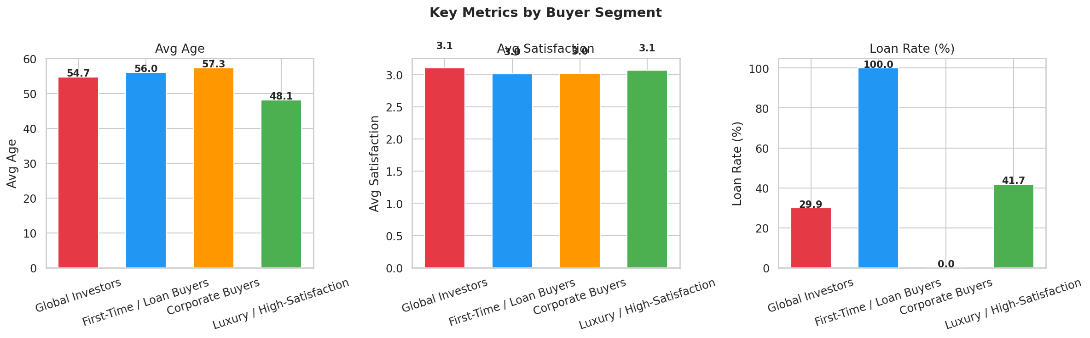
Figure 11: Average age, satisfaction score, and loan rate by buyer segment
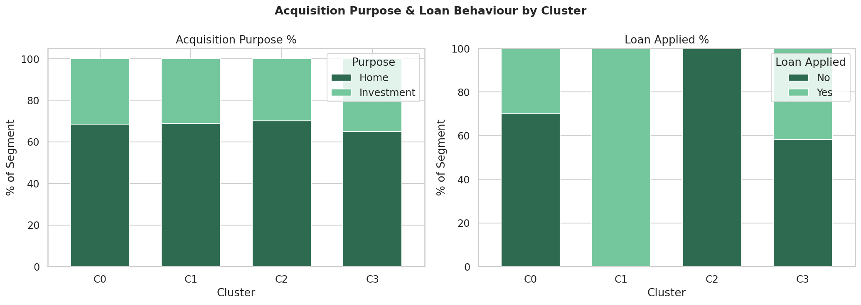
Figure 12: Acquisition purpose and loan application distribution per segment (stacked %)
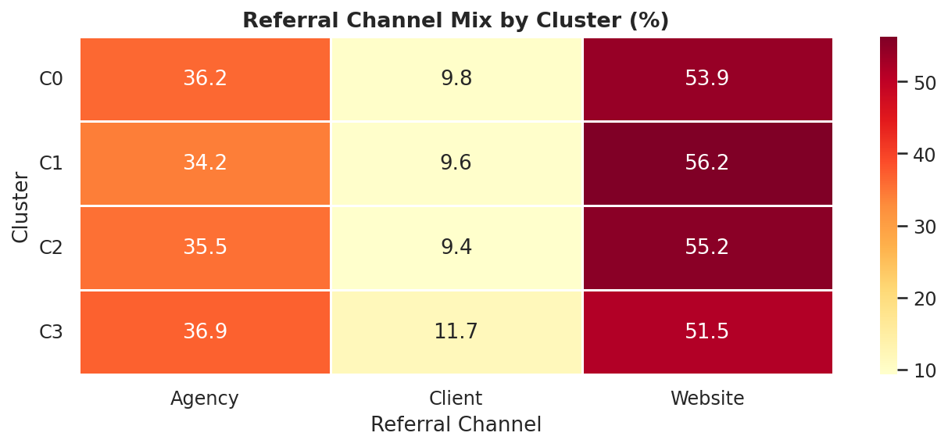
Figure 13: Referral channel mix heatmap by cluster (%)
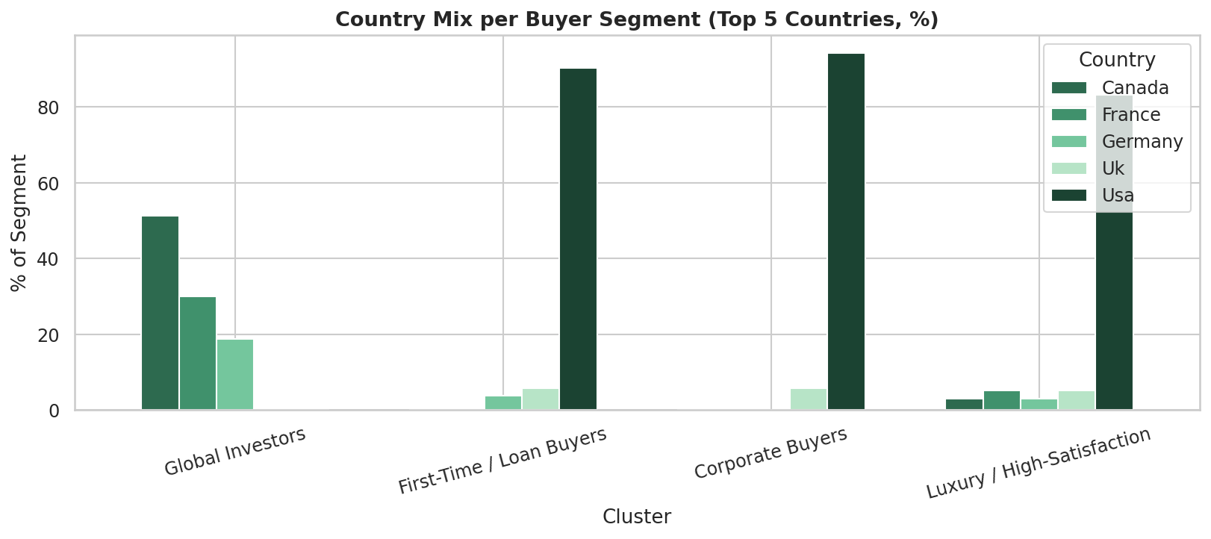
Figure 14: Country composition per buyer segment (top 5 countries)

6. Model Evaluation and Validation

6.1 Quantitative Metrics
Metric | K-Means (k=4) | Hierarchical (k=4)
Silhouette Score | 0.1619 | 0.1637 (sample n=200)
Inertia (WCSS) | 12,652.7 | N/A (linkage-based)
Number of Clusters | 4 | 4
Largest Cluster Size | 1,026 (51.3%) | Consistent with K-Means
Smallest Cluster Size | 103 (5.1%) | Consistent with K-Means
Method Convergence | 20 restarts, 500 iter | Ward linkage, 200-sample

6.2 Qualitative Validation
Beyond statistical metrics, the quality of a segmentation model is assessed by the interpretability and actionability of its segments. All four clusters produced in this analysis have clear, non-trivial distinguishing characteristics:
- Cluster 1 achieves 100% internal consistency on loan_applied (binary feature), demonstrating a genuine structural split in the data
- Cluster 3 achieves 100% internal consistency on client_type (all Corporate), the most distinctive segment possible with these features
- Cluster 0 achieves 0% USA representation, demonstrating a clean geographic separation into the international buyer group
- Cluster 2 achieves 0% loan rate, providing a clean complement to Cluster 1's full loan uptake
The model effectively partitions buyers along three primary axes: nationality (domestic vs. international), financing behaviour (loan vs. cash), and entity type (individual vs. corporate).

7. Strategic Recommendations

7.1 Marketing Personalisation by Segment
Segment | Primary Channel | Content Strategy | Product Priority
C1 Global Investors | Geo-targeted ads + International Agency | Country-specific ROI data, FX guides | Premium & luxury units
C2 Loan Buyers | SEO, content marketing, mortgage partners | Loan calculators, pre-approval guides | Entry-to-mid residential
C3 Cash Buyers | Email nurture, platform UX | Curated listings, loyalty perks | Mid-to-upper residential
C4 Corporate Buyers | Agency/Broker B2B, LinkedIn | Bulk pricing, portfolio analytics | Office + multi-unit blocks

7.2 Operational Recommendations
- Implement real-time cluster scoring: As new clients register, score them against the trained K-Means model and trigger personalised onboarding sequences
- Segment-specific CRM workflows: Configure separate CRM pipelines for Corporate (C4) vs. Individual buyer tracks with distinct SLAs and content
- Loan partner integrations: For Cluster 1, integrate mortgage pre-approval APIs directly into the property browsing experience
- International buyer support: For Cluster 0, build multi-language property pages and offer dedicated international buyer advisory consultations
- Satisfaction score monitoring: Rerun clustering quarterly and monitor average satisfaction scores per segment; if satisfaction in C2 or C3 declines, investigate service delivery gaps for domestic buyers

7.3 Technology Roadmap
- Phase 1 (Month 1-2): Deploy cluster scoring pipeline as a microservice; integrate with CRM via API
- Phase 2 (Month 3-4): Build Streamlit analytics dashboard for the commercial team
- Phase 3 (Month 5-6): Retrain model quarterly with updated client data; monitor cluster stability via Adjusted Rand Index
- Phase 4 (Month 7+): Extend feature set with property purchase behaviour (price, sqft, tower) to build richer investment profiles

8. Limitations and Future Work

8.1 Current Limitations
- Feature set: The current model uses only demographic and categorical client attributes. Incorporating transactional features (total spend, number of units, property type preference) from the companion properties dataset would substantially enrich segment differentiation
- Silhouette range: Scores of 0.15-0.17 are modest, reflecting the inherently diffuse nature of real-world demographic clustering. The segments are meaningful but not perfectly separated in feature space
- Geographic label encoding: Using integer label encoding for country and region introduces implicit ordinality that does not exist. Future iterations should use target encoding or embedding-based representations
- Static model: The model is trained on a historical snapshot. Buyer behaviour shifts over time and the model must be periodically retrained to remain accurate

8.2 Future Work
- Supervised learning extension: Once segments are validated by the business, train a supervised classifier (XGBoost or Random Forest) to predict cluster membership for new clients at registration with interpretable feature importance
- Deep demographic profiling: Incorporate income proxies and wealth indicators via third-party data enrichment APIs
- Geospatial analysis: Map buyer segments to specific property types and price bands at the regional level using the properties dataset
- Sentiment analysis: Incorporate customer satisfaction free-text reviews (if available) to supplement numeric satisfaction scores with NLP-derived sentiment dimensions

9. Conclusion
This research has successfully applied unsupervised machine learning to discover four structurally distinct buyer segments within Parcl's client base, each with clear and actionable characteristics. The K-Means clustering model, validated against Hierarchical clustering and evaluated via Elbow and Silhouette methods, produces a robust and interpretable segmentation solution.
The four segments — Global Investors, First-Time/Loan Buyers, Domestic Cash Buyers, and Corporate Buyers — represent fundamentally different buyer journeys. Rather than treating 2,000 clients identically, Parcl can now personalise marketing, financing guidance, property recommendations, and customer service workflows for each segment, driving measurable improvements in conversion rates, customer satisfaction, and marketing return on investment.
The framework presented here is scalable, reproducible, and designed for continuous retraining as the client base grows. The accompanying Streamlit dashboard operationalises these insights for the commercial and analytics teams, enabling self-serve segment exploration without requiring data science expertise.

10. References
- Pedregosa, F. et al. (2011). Scikit-learn: Machine Learning in Python. Journal of Machine Learning Research, 12, 2825-2830.
- MacQueen, J. (1967). Some Methods for Classification and Analysis of Multivariate Observations. Proceedings of the 5th Berkeley Symposium on Mathematical Statistics and Probability, 1, 281-297.
- Ward, J. H. (1963). Hierarchical Grouping to Optimize an Objective Function. Journal of the American Statistical Association, 58(301), 236-244.
- Rousseeuw, P. J. (1987). Silhouettes: A Graphical Aid to the Interpretation and Validation of Cluster Analysis. Journal of Computational and Applied Mathematics, 20, 53-65.
- Wold, S., Esbensen, K., & Geladi, P. (1987). Principal Component Analysis. Chemometrics and Intelligent Laboratory Systems, 2(1-3), 37-52.
- Hunter, J. D. (2007). Matplotlib: A 2D Graphics Environment. Computing in Science & Engineering, 9(3), 90-95.

Appendix A – Technical Environment
The analysis was conducted in Python 3.12 with the following core library versions:
Library | Version / Purpose
pandas | 2.x — Data manipulation and EDA
numpy | 1.x — Numerical computation
scikit-learn | 1.x — Clustering, scaling, metrics
matplotlib | 3.x — Static visualisation
seaborn | 0.x — Statistical plotting
scipy | 1.x — Hierarchical linkage

Appendix B – Cluster Assignment Summary
All 2,000 clients are assigned to clusters in cluster_results.csv. A readable segment summary is available in segment_readable_summary.csv. Detailed per-cluster descriptive statistics are in cluster_summary.csv.

Appendix C – File Deliverables
File | Description
buyer_segmentation_pipeline.py | End-to-end ML pipeline: cleaning, encoding, scaling, clustering, evaluation, all figures
streamlit_dashboard.py | Interactive Streamlit dashboard for commercial team
Parcl_Buyer_Segmentation_Report.docx | This research paper
cluster_results.csv | 2,000 clients with cluster assignment and label
cluster_summary.csv | Numeric feature means per cluster
segment_readable_summary.csv | Human-readable per-segment statistics
figures/*.png | 14 figures: EDA (5) + Clustering (9)

