Project 2
Extracting Elevation Values from Google Earth Engine
Using a Python Toolbox

1. Introduction
Google Earth Engine (GEE) provides access to a wide range of large-scale geospatial datasets and cloud-based computational resources that support efficient spatial analysis. One such dataset is the USGS 3D Elevation Program (3DEP), which provides seamless national elevation models at multiple spatial resolutions. While Earth Engine is powerful, its direct integration with desktop GIS software such as ArcGIS Pro requires custom scripting and workflow design.
This project develops a complete Python-based workflow to extract elevation values from the USGS 3DEP 10-meter Digital Elevation Model using Google Earth Engine and integrate the results into ArcGIS Pro. The input data consist of a CSV file containing point coordinates derived from a flood classification raster. These coordinates are converted into a shapefile, projected appropriately for Earth Engine compatibility, and used to sample elevation values from the 3DEP dataset. The extracted elevation values are written back to the shapefile as a new attribute field.
To support usability and reproducibility, the workflow is encapsulated into a Python script and implemented within an ArcGIS Python Toolbox (.pyt), providing a graphical user interface for execution within ArcGIS Pro. The final output is visualized through a map layout, which is exported to a PDF document. This report follows the structure outlined in the instructor’s Guided Project 2 instructions, including code development in a Jupyter Notebook, script refactoring, toolbox development, data visualization, and final documentation.
2. Data Description
The primary input dataset for this project is a CSV file containing point locations extracted from a classified flood raster (flood_2class.tif). The CSV file includes four columns: row, column, X, and Y. The X and Y coordinates represent the spatial locations of flood boundary points and are defined in the same coordinate system as the raster dataset from which they were derived.
The reference raster, flood_2class.tif, is used to obtain the correct spatial reference information for converting the CSV coordinates into spatial features. Elevation data are obtained from Google Earth Engine using the USGS 3DEP 10m National Map Seamless dataset, which provides nationwide elevation coverage suitable for regional and local-scale analysis.
3. Jupyter Notebook Code Development
The initial development and testing of the elevation-extraction workflow were conducted in a Jupyter Notebook environment. This approach allowed individual processing steps to be executed incrementally and verified before integration into a standalone Python script.
3.1. Initializing Google Earth Engine
The elevation extraction workflow was developed and tested in a Jupyter Notebook environment. The first step in the notebook initializes access to Google Earth Engine (GEE), which is required to retrieve elevation data from cloud-hosted datasets. Before any Earth Engine operations can be performed, authentication and initialization must be completed.
The following code cell imports the Earth Engine Python API and establishes a connection to the user’s Earth Engine project:
The import ee statement loads the Google Earth Engine Python library, which provides programmatic access to Earth Engine datasets, image collections, and geospatial analysis functions. This library enables interaction between local Python environments and Earth Engine’s cloud-based processing system.
The ee.Authenticate() function initiates the authentication process for Google Earth Engine. When executed for the first time, this command prompts the user to log in with their Google account and grant permission for Earth Engine access. Authentication is required to verify the user’s identity and authorize access to Earth Engine resources. Once authentication is completed successfully, credentials are stored locally and do not need to be re-entered for subsequent sessions in the same environment.
The ee.Initialize() function completes the setup by initializing the Earth Engine API for use within the current Python session. The project argument specifies the Earth Engine project under which computations are executed. Associating Earth Engine operations with a project is required for managing resource usage and permissions. Without this initialization step, Earth Engine objects such as images, feature collections, and sampling functions cannot be accessed.
By the end of this step, the Jupyter Notebook environment is fully connected to Google Earth Engine, enabling subsequent cells to load the USGS 3DEP elevation dataset and perform spatial sampling operations.
3.2. Exploring the USGS 3DEP Elevation Dataset in Google Earth Engine
Before extracting elevation values for the full set of flood boundary points, a preliminary test was conducted to verify access to the elevation dataset and confirm that Google Earth Engine was returning valid results. This exploratory step ensures that the Earth Engine environment is properly configured and that the selected dataset behaves as expected.
The following code cell loads the USGS 3DEP 10-meter Digital Elevation Model and samples elevation at a single test location:
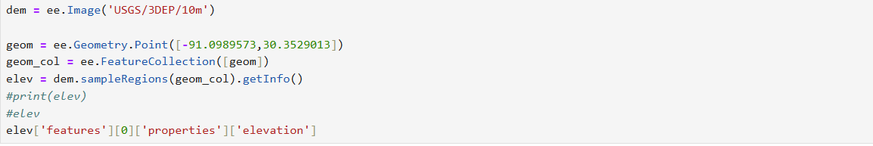
The first line loads the USGS 3DEP 10-meter elevation dataset from Google Earth Engine as an ee.Image object. This dataset provides seamless national elevation coverage and is suitable for point-based elevation sampling. Assigning the dataset to the variable dem allows it to be reused in later processing steps.
Next, a test point geometry is created using ee.Geometry.Point. The coordinates are specified in longitude and latitude order, consistent with the WGS 84 geographic coordinate system required by Earth Engine. This point represents a known location and serves as a simple test case for verifying elevation retrieval.
The point geometry is then wrapped inside an ee.FeatureCollection. Although only a single point is used in this example, Earth Engine’s sampleRegions() function requires a feature collection as input. This structure also mirrors the approach used later when sampling elevation values for multiple points simultaneously.
The sampleRegions() function is applied to the elevation image using the feature collection as input. This function extracts pixel values from the elevation raster at the specified point locations. The getInfo() method is then called to transfer the results from Earth Engine’s server-side environment to the local Python environment as a standard Python dictionary.
To access the elevation value directly, the following line retrieves the elevation attribute from the returned data structure:
The output returned by sampleRegions() is organized as a list of features, each containing a dictionary of properties. Because only one point was sampled, the elevation value is located in the first feature’s properties dictionary under the key elevation. Evaluating this expression confirms that a valid numeric elevation value is returned.
This exploratory step verifies that the USGS 3DEP dataset is accessible, the Earth Engine API is functioning correctly, and elevation values can be successfully extracted. With this confirmation, the workflow can proceed to processing the full set of point locations derived from the CSV file.
3.3. Reading and Inspecting the CSV Input Data
After confirming that elevation values could be successfully retrieved from Google Earth Engine, the next step in the workflow involved loading the CSV file containing the flood boundary point locations. This CSV file serves as the primary input dataset for the elevation extraction process.
The following code cell reads the CSV file into a pandas DataFrame:
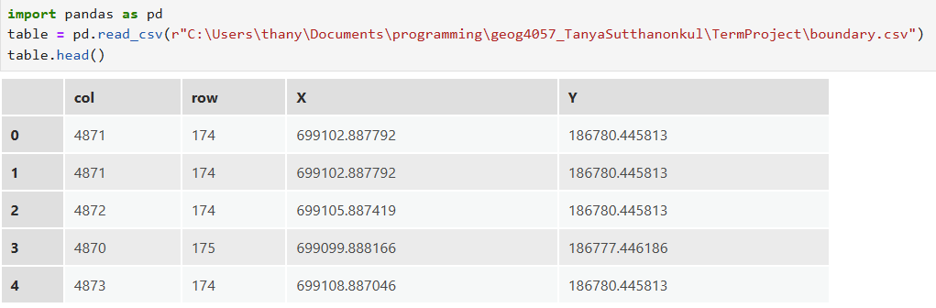
The import pandas as pd statement loads the pandas library, which provides efficient tools for reading, inspecting, and manipulating tabular data. Pandas is particularly well suited for handling CSV files and serves as an intermediate step before converting the tabular data into spatial features.
The pd.read_csv() function reads the boundary CSV file from disk and stores its contents in a DataFrame named table. The CSV file contains four columns: row, column, X, and Y. The X and Y columns represent the spatial coordinates of flood boundary points, while the row and column fields record the original raster cell indices from which these points were derived.
The table.head() command displays the first few rows of the DataFrame. This step is used for data inspection and verification, allowing the structure of the dataset to be confirmed before further processing. Viewing the initial records ensures that the coordinate values were read correctly and that no unexpected formatting or missing values are present.
By loading and inspecting the CSV file at this stage, the workflow establishes a reliable tabular representation of the point locations. This DataFrame provides the foundation for generating spatial point geometries and converting the CSV data into a shapefile in subsequent steps.
3.4. Retrieving the Spatial Reference from the Flood Raster
After loading the CSV data, the workflow next retrieves spatial reference information from the flood classification raster. This step is essential because the coordinate values stored in the CSV file were extracted from the raster and therefore share the same coordinate system. Ensuring that this spatial reference is correctly identified allows the point geometries created later to align accurately with the raster data.
The following code cell loads the flood classification raster and prints its spatial reference identifier:
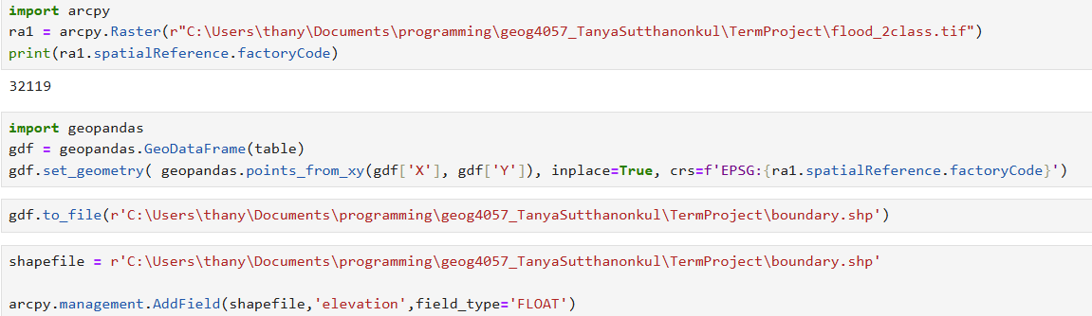
The import arcpy statement loads the ArcPy site package, which provides access to ArcGIS geoprocessing tools and spatial data structures. ArcPy is required to interact with raster datasets and to retrieve metadata such as coordinate systems.
The arcpy.Raster() function reads the flood classification raster file and creates a Raster object. This object provides access to raster properties, including its spatial reference. The raster represents a two-class flood classification, from which the boundary point coordinates in the CSV file were originally derived.
The spatialReference.factoryCode property returns the numeric identifier (WKID) of the raster’s coordinate reference system. Printing this value allows the coordinate system to be explicitly verified and documented. This WKID is later used to assign the correct coordinate reference system to the point geometries created from the CSV coordinates.
3.5. Converting the CSV Data into a Point Shapefile
After reading the CSV data and identifying the appropriate spatial reference from the flood classification raster, the next step in the workflow converts the tabular coordinate data into a spatial dataset. This is accomplished by creating point geometries from the CSV coordinates and exporting them as a shapefile.
The following code cell performs the conversion from a pandas DataFrame to a spatial point shapefile:
The import geopandas statement loads the GeoPandas library, which extends pandas by adding support for spatial data types and geospatial operations. GeoPandas provides a convenient interface for creating spatial geometries directly from tabular coordinate data.
The GeoDataFrame is initialized using the previously loaded pandas DataFrame table. At this stage, the GeoDataFrame contains only attribute data and does not yet include spatial geometry. The geometry column is then defined using the points_from_xy() function, which converts the X and Y coordinate columns into point geometries.
The coordinate reference system (CRS) is explicitly assigned using the factory code obtained from the flood classification raster. This step ensures that the resulting point features are correctly georeferenced and spatially aligned with the raster dataset from which the coordinates were derived. Assigning the CRS at this stage prevents projection inconsistencies during later spatial processing.
Once the geometry and CRS are defined, the GeoDataFrame is written to disk as a shapefile using the to_file() method. The output shapefile serves as the primary spatial dataset for subsequent elevation extraction and attribute updates.
After creating the shapefile, an additional attribute field is added to store elevation values extracted from Google Earth Engine:
The AddField function creates a new floating-point field named elevation in the shapefile. This field is designed to store numeric elevation values returned by the USGS 3DEP dataset. Adding the field at this stage prepares the shapefile schema for attribute updates in later steps of the workflow.
By the end of this section, the CSV coordinate data have been fully converted into a spatial point shapefile with an appropriate coordinate reference system and a dedicated field for elevation values. This shapefile provides the spatial foundation required for integrating Google Earth Engine elevation data into the ArcGIS environment.
3.6. Preparing Shapefile Coordinates for Google Earth Engine and Extracting Elevation Values
After converting the CSV data into a spatial point shapefile and adding the elevation field, the next step prepares the point geometries for use with Google Earth Engine and performs elevation sampling. Because Earth Engine requires geographic coordinates in longitude–latitude format, the point coordinates must be accessed in the WGS 84 coordinate reference system.
The following code cell reads the point coordinates from the shapefile and converts them into Earth Engine geometry objects:
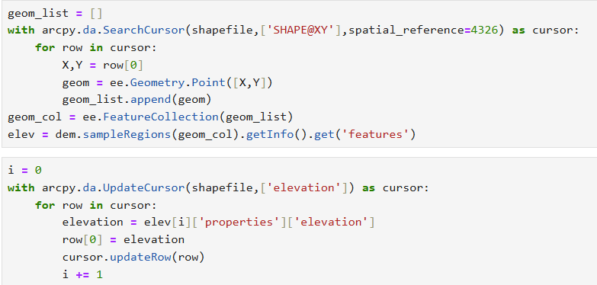
An empty Python list, geom_list, is first created to store Earth Engine point geometries. The SearchCursor is then used to iterate through each feature in the shapefile and retrieve its coordinate values using the SHAPE@XY token. The spatial_reference=4326 argument ensures that the coordinates are read in the WGS 84 geographic coordinate system, which is required for compatibility with Google Earth Engine.
For each feature, the X and Y coordinates are extracted and used to create an ee.Geometry.Point object. These point geometries are appended to the list, preserving the order of features in the shapefile. This step converts local ArcGIS geometries into a format that can be processed by Earth Engine.
Once all point geometries have been created, they are assembled into an Earth Engine FeatureCollection:
The FeatureCollection groups all point geometries into a single object that can be processed efficiently by Earth Engine functions. This structure is required by the sampleRegions() method used for raster sampling.
Elevation values are then extracted from the USGS 3DEP 10-meter Digital Elevation Model using the following code:
The sampleRegions() function samples pixel values from the elevation image at the locations defined by the FeatureCollection. The result is returned as a collection of features, each containing an elevation value corresponding to a point location. The getInfo() method transfers the results from Earth Engine’s server-side environment to the local Python environment, where they are stored as a standard Python data structure. The list of sampled features is accessed through the "features" key.
3.7. Writing Elevation Values Back to the Shapefile
After retrieving elevation values from the USGS 3DEP dataset using Google Earth Engine, the final step in the Jupyter Notebook workflow assigns these values to the corresponding point features in the shapefile. This operation integrates cloud-based elevation data into a local ArcGIS-compatible spatial dataset.
The following code cell updates the shapefile by writing elevation values into the previously created elevation field:
An index variable i is initialized to zero to track the position of each elevation value in the list returned by Earth Engine. The UpdateCursor is then used to iterate through each feature in the shapefile and update its attribute values.
The cursor accesses only the elevation field, which allows efficient modification of the shapefile’s attribute table. For each feature, the corresponding elevation value is retrieved from the Earth Engine results using the index i. The elevation value is stored under the "properties" key in the Earth Engine feature dictionary.
The retrieved elevation value is assigned to the current row of the shapefile, and the updateRow() method writes the updated attribute back to disk. After each update, the index variable is incremented to ensure that the next feature receives the correct elevation value.
By the end of this step, every point feature in the shapefile contains a numeric elevation value derived from the USGS 3DEP 10-meter Digital Elevation Model. This completes the integration of Google Earth Engine data into the ArcGIS environment and finalizes the core data processing workflow developed in the Jupyter Notebook.

4. Transition from Jupyter Notebook to Python Script
The Jupyter Notebook environment was used as the initial development platform for this project because it allows interactive execution and step-by-step verification of code. This environment was particularly useful for testing Google Earth Engine authentication, verifying access to the USGS 3DEP elevation dataset, and validating intermediate outputs such as point geometries and extracted elevation values. However, while effective for exploratory development, the notebook structure is not suitable for deployment as a reusable geoprocessing tool within ArcGIS Pro.
Several limitations of the notebook-based implementation were identified. File paths for the CSV input, raster reference, and output shapefile were hard-coded within individual cells, restricting the workflow to a single dataset and file structure. Additionally, the processing logic was distributed across multiple cells and relied on execution order, making the workflow fragile and difficult to reuse. The notebook also included exploratory commands, such as printing values and inspecting data frames, which are not appropriate for a production-level tool.
To address these limitations, the notebook code was refactored into a standalone Python script. The core elevation extraction workflow was encapsulated within a single function, allowing all processing steps to be executed sequentially and automatically. Input parameters such as the Earth Engine project name, CSV file path, raster file path, and output shapefile path were converted from hard-coded values into function arguments. This transformation allows users to apply the workflow to different datasets without modifying the underlying code.
The refactoring process also involved consolidating repeated logic and removing notebook-specific constructs. Earth Engine initialization, CSV reading, spatial reference handling, shapefile creation, elevation sampling, and attribute updates were reorganized into a structured and modular script. Temporary variables and debugging statements used during exploratory testing were removed to ensure clean execution. As a result, the Python script can be executed independently from a command line, imported as a module, or called directly from an ArcGIS Python Toolbox.
By transitioning from a Jupyter Notebook to a parameter-driven Python script, the workflow became reusable, reproducible, and suitable for integration into ArcGIS Pro. This step represents a critical progression from interactive development to a deployable geoprocessing solution, enabling the elevation extraction process to be executed consistently through a graphical user interface.

Table 1 Hard-coded Elements in the Jupyter Notebook and Their Replacements in the Python Script
Hard-coded Element in Jupyter Notebook | Issue / Limitation | Improved Implementation in Python Script | Benefit
Hard-coded Earth Engine project name (e.g. 'ee-tanyas71lsu') | Tied to a single Earth Engine project; not reusable | Passed as a function parameter (project_name) | Allows execution under different Earth Engine projects
Hard-coded CSV file path | Only works for a specific file location | Converted into a function parameter (csv_path) | Enables user selection of any input CSV file
Hard-coded raster file path (flood_2class.tif) | Limits workflow to one raster dataset | Converted into a function parameter (raster_path) | Supports different reference rasters
Hard-coded output shapefile path | Output location fixed; risk of overwriting | Converted into a function parameter (shapefile_path) | User controls output location and naming
Inline Earth Engine initialization | Must edit code to change project | Wrapped inside main workflow function | Centralized and reusable initialization
Geometry conversion embedded in notebook cells | Dependent on execution order | Encapsulated within a single processing function | Ensures consistent execution sequence
Assumption of WGS 84 coordinate handling inside cursor | Implicit CRS handling may cause confusion | CRS handling explicitly defined in script | Improves clarity and reduces projection errors
Use of index-based elevation assignment (i) | Depends on feature order consistency | Documented and structured inside function | Predictable behavior and easier debugging
Manual execution of notebook cells | Requires user interaction | Converted into automated function calls | Fully automated execution
Notebook-only inspection commands (print, head) | Not suitable for production | Removed from script | Cleaner and professional output

5. Python Toolbox Development
To make the elevation extraction workflow accessible within the ArcGIS Pro graphical user interface, a Python Toolbox (.pyt) was developed. The toolbox provides a structured and reusable interface that allows users to execute the Google Earth Engine–based elevation extraction process without modifying or directly running Python scripts. This design improves usability, reproducibility, and integration with ArcGIS geoprocessing workflows.
5.1. Toolbox Structure
The toolbox contains two classes:
Toolbox – defines the toolbox name, alias, and tool list
Tool – defines the interface, parameters, and execution logic
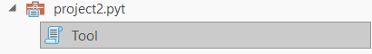
The Toolbox class establishes the identity of the toolbox within ArcGIS Pro, while the Tool class encapsulates the logic required to run the elevation extraction workflow. This structure follows the standard ArcGIS Python Toolbox design pattern and ensures compatibility with ArcGIS Pro’s geoprocessing framework.
5.2 Tool Parameters
User interaction with the Python Toolbox is managed through the getParameterInfo() method, which defines the inputs required to execute the elevation extraction workflow. This method specifies parameter names, data types, directions, and whether each parameter is required, allowing ArcGIS Pro to generate an appropriate graphical interface.
The following code defines the input parameters for the elevation extraction tool:
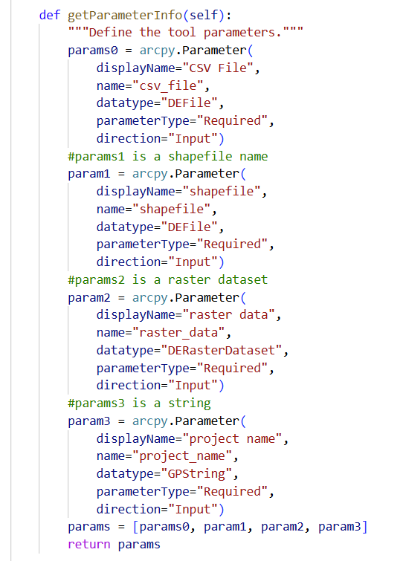
The getParameterInfo() method returns a list of arcpy.Parameter objects, each of which represents a user-defined input in the ArcGIS Pro toolbox interface. These parameters replace the hard-coded values used during Jupyter Notebook development and allow the tool to be reused across different datasets and projects.
The first parameter, CSV File, is defined using the DEFile data type and is marked as a required input. This parameter specifies the CSV file containing the flood boundary point coordinates (X and Y) that serve as the basis for elevation extraction.
The second parameter, shapefile, is also defined as a required DEFile input. This parameter identifies the output shapefile that stores the spatial point features and the extracted elevation values. Allowing the user to specify the shapefile path prevents overwriting existing data and provides flexibility in output management.
The third parameter, raster data, is defined using the DERasterDataset data type. This input represents the flood classification raster (flood_2class.tif) and is used to retrieve spatial reference information. Using a raster dataset parameter ensures that the point geometries derived from the CSV file are assigned the correct coordinate reference system.
The fourth parameter, project name, is defined as a GPString. This parameter specifies the Google Earth Engine project name used during Earth Engine initialization. Making the project name a user-defined input allows the tool to be executed under different Earth Engine projects without modifying the source code.
5.3. Execution Logic
The execution of the Python Toolbox is controlled by the execute() method, which serves as the entry point for the geoprocessing tool when it is run from the ArcGIS Pro interface. This method retrieves user-defined parameters from the toolbox interface and passes them to the Python function that performs the elevation extraction workflow.
The following code defines the execution logic of the tool:
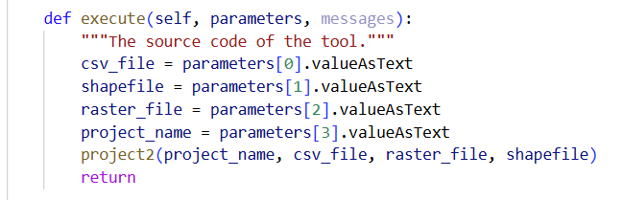
The execute() method accepts two arguments: parameters and messages. The parameters argument contains a list of parameter objects defined in the getParameterInfo() method, while the messages argument provides a mechanism for reporting progress and status messages to the ArcGIS Pro geoprocessing interface.
Each input parameter is accessed using its position in the parameter list and retrieved as a text string using the valueAsText property. This ensures that file paths and string inputs are passed correctly to the processing function regardless of the underlying data type selected by the user.
The retrieved parameter values include the CSV file path, the output shapefile path, the reference raster file path, and the Google Earth Engine project name. These values are passed directly to the project2() function, which encapsulates the full elevation extraction workflow. All core processing, including CSV reading, spatial reference handling, Earth Engine sampling, and attribute updates—occurs within this function.
The execute() method itself does not contain any data processing logic. Instead, it acts as a controller that connects the ArcGIS Pro user interface to the underlying Python script. This separation of interface logic and processing logic improves code readability, simplifies debugging, and allows the core workflow to be reused outside of the toolbox environment if needed.
By implementing the execution logic in this manner, the Python Toolbox provides a clean and modular interface for running the elevation extraction process. Users can execute the workflow directly from ArcGIS Pro by specifying input parameters through the toolbox dialog, without interacting with the underlying Python code.

6. Data Visualization
After completing the elevation extraction workflow using the Python Toolbox, the resulting shapefile was visualized in ArcGIS Pro to verify the correctness of the spatial data and to interpret the extracted elevation values. Visualization serves as a critical validation step, ensuring that point geometries are correctly located and that elevation values have been successfully written to the attribute table.
A new ArcGIS Pro project was created, and a map was added to the project workspace. The output shapefile generated by the Python Toolbox, containing point geometries and the newly populated elevation field, was then added to the map. Displaying the shapefile in the map allowed the spatial distribution of the flood boundary points to be inspected and confirmed.
The attribute table of the shapefile was examined to verify that elevation values were present and correctly populated for all point features. The presence of numeric elevation values in the elevation field confirmed that the Google Earth Engine sampling and attribute update processes were executed successfully.
To enhance visual interpretation, the point layer was symbolized based on elevation values. Graduated color symbology was applied using the elevation field as the classification variable. This symbology visually represents variations in elevation across the study area, making it easier to identify spatial patterns and relative differences among point locations. A suitable color ramp and number of classes were selected to provide clear contrast while maintaining readability.
Through this visualization process, the spatial alignment of the points with the underlying geographic context was confirmed, and the elevation data extracted from the USGS 3DEP dataset were shown to be logically consistent across the study area. This step verifies the success of the overall workflow and prepares the data for presentation in a cartographic layout.
6.1. Layout Creation and Export using python
After symbolizing the elevation point data, a cartographic layout was created programmatically using the arcpy.mp module in ArcGIS Pro. The layout provides a standardized and reproducible presentation of elevation values extracted from the USGS 3DEP dataset and serves as the final visual product of the project.
The active ArcGIS Pro project was accessed using ArcGISProject("CURRENT"), and the map containing the elevation-sampled boundary point layer was selected. Graduated symbol symbology was applied to the point layer using the elevation attribute. Circular point symbols colored red were used to represent elevation values, with symbol sizes varying proportionally according to the magnitude of elevation. This symbology emphasizes relative elevation differences along the flood boundary while maintaining clear visual contrast against the basemap.
A new layout was created using a standard letter-size page format (8.5 × 11 inches). A map frame was added to the layout and linked to the active map, allowing the graduated red symbols to be displayed within the layout environment. The size and position of the map frame were defined using page units to ensure consistent placement and formatting.
Standard cartographic elements were added to enhance map readability and interpretation. A north arrow was included to indicate map orientation, and a scale bar was added to provide spatial reference. A legend was generated automatically based on the graduated symbol symbology, displaying the relationship between symbol size and elevation values. The legend title was customized to clearly describe the elevation units represented in the map.
Once all layout components were finalized, the layout was exported as a high-resolution PDF file (300 dpi). Exporting the layout to PDF produces a portable and publication-quality map suitable for reporting and documentation. The ArcGIS Pro project was then saved to preserve the layout configuration and symbology settings.
The completed layout provides a clear and professional visualization of elevation variation along the flood boundary. This final cartographic output confirms the successful integration of Google Earth Engine elevation data into ArcGIS Pro and concludes the visualization component of the project.
The completed layout is exported as a PDF file. The project is then saved to preserve all automated layout and symbology changes. The final product showed below:
