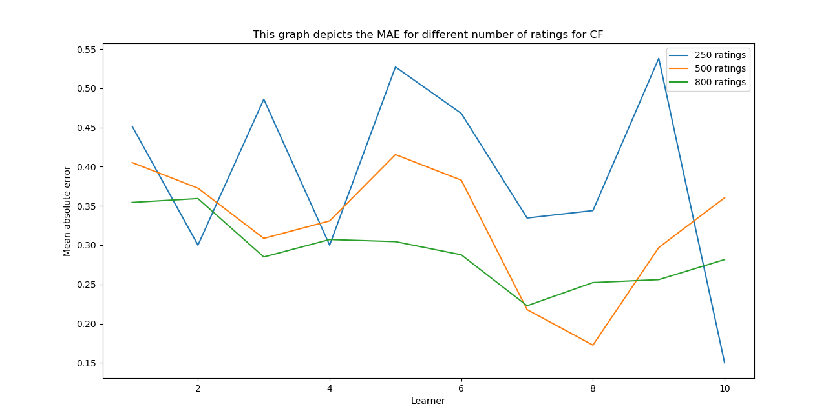
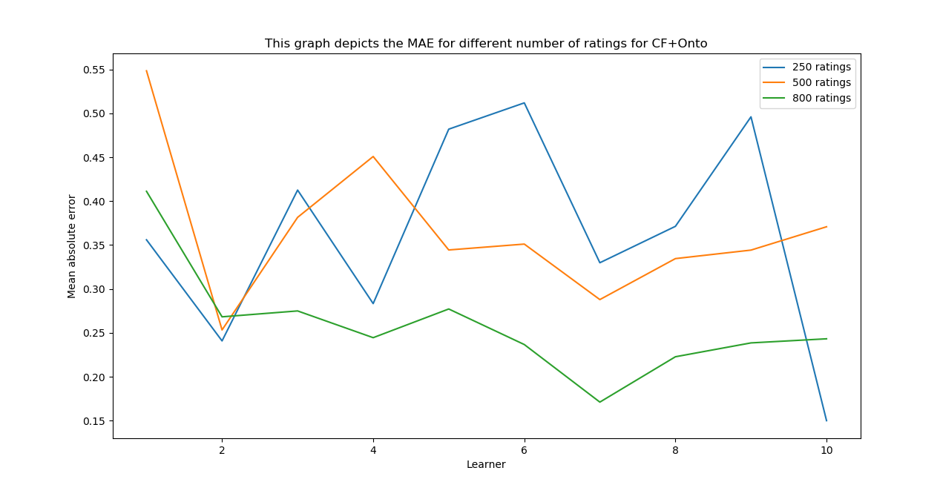

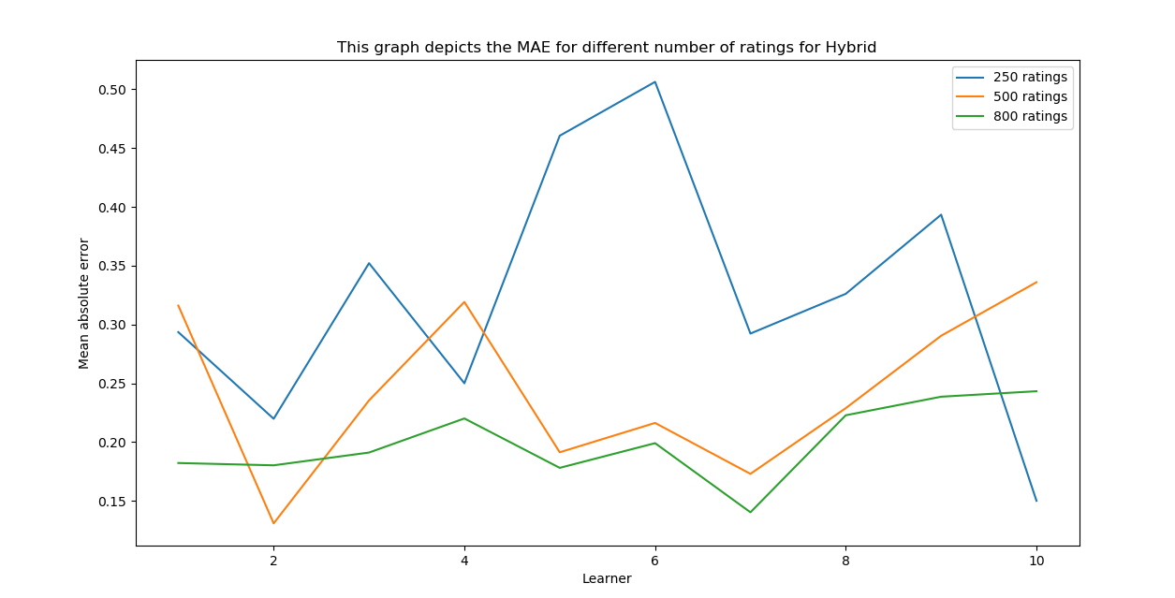

Table depicting reduction in Mean Absolute Error with increase in the number of ratings
No. of Ratings\Model | CF | CF+ONTO | HYBRID
250 | 0.389993046537 | 0.363398203843 | 0.324415815296
500 | 0.326347580439 | 0.317675253193 | 0.243723533537
800 | 0.291070122252 | 0.258855294072 | 0.199543194938

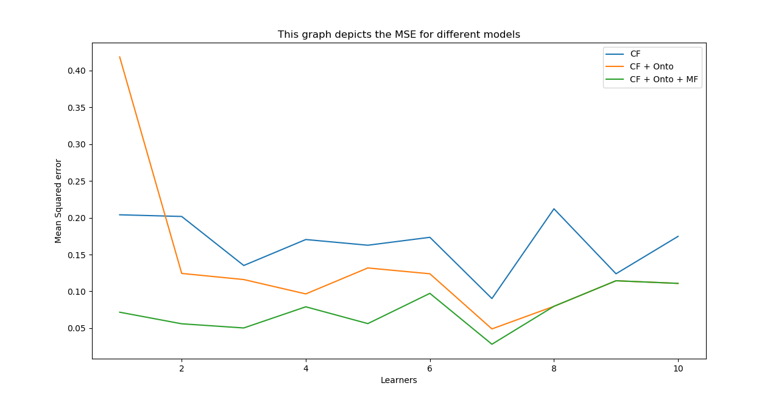

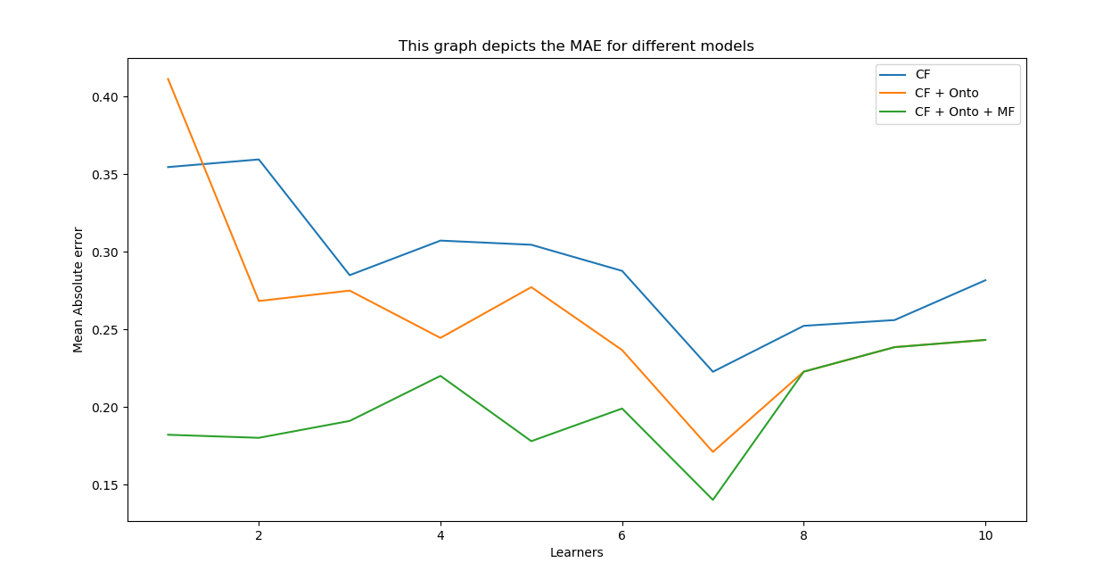

Table showing MAE and MSE for different models
MODEL/MEASURE | MAE | MSE
CF | 0.291070122252 | 0.164849356579
CF+ONTO | 0.258855294072 | 0.136505508937
CF+ONTO+MF | 0.199543194938 | 0.0743384580084

