Intent2Deploy AI — Project Report
29 October 2026
Intent2Deploy AI turns a plain-English change request into reviewed, tested, containerized code delivered through GitHub — with a human approval at every risky step. This report lists every code file in the project and what it contains.

At a glance
The browser talks only to the FastAPI backend; the orchestrator calls each service group in turn, and they use the stores and outside systems below.
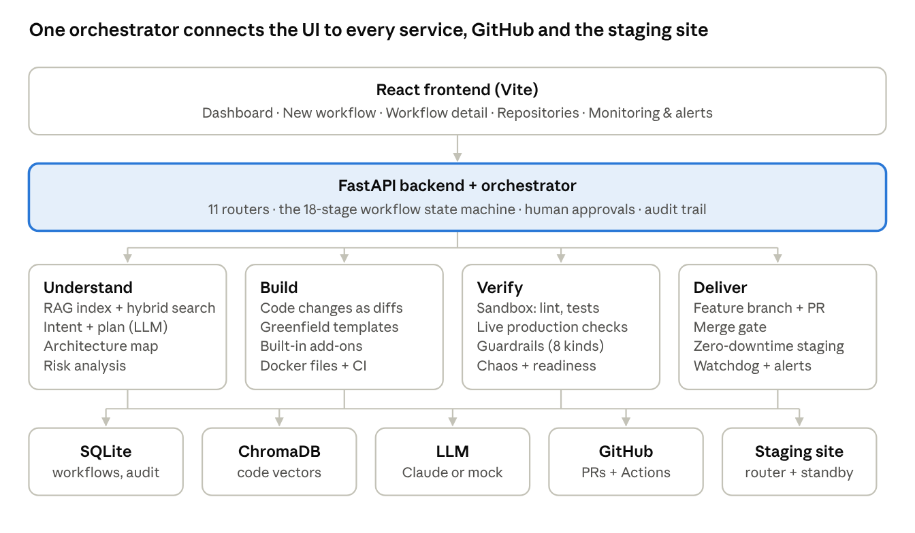

How a request flows
Every request runs through 18 stages. A person approves the plan, the code changes, the commit and the merge; everything else runs automatically.
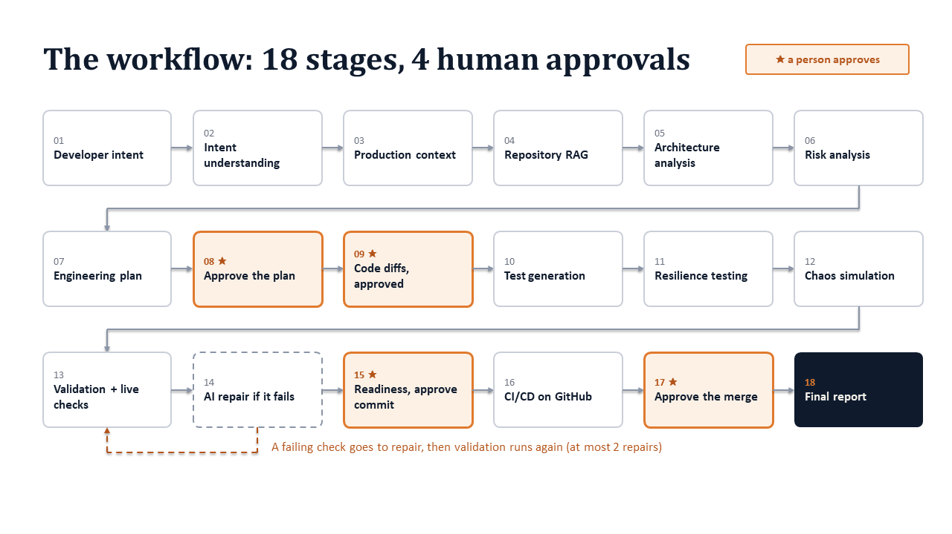
- Developer Intent — The request in plain English; input guardrails refuse unsafe or injection-shaped requests.
- Intent Understanding — The request is classified and normalised into a requirement.
- Production Context — The target environment (sandbox, staging, production-simulation) is recorded and checked.
- Repository RAG — The repository is indexed into ChromaDB; the code most relevant to the request is retrieved.
- Architecture Analysis — Components, dependencies and entry points are mapped; an empty repository switches to greenfield mode.
- Risk Analysis — Risks are scored (security, data, blast radius) with mitigations.
- Engineering Plan — Steps, files, acceptance criteria and test strategy; for a new project, a full design.
- Human Approval — A person approves, edits or rejects the plan.
- Code Generation — Changes are produced as reviewable diffs inside the approved scope; a person approves them.
- Test Generation — Tests are added for the change.
- Resilience Testing — Fault experiments relevant to the architecture.
- Chaos Simulation — Simulated faults on the service graph.
- Validation — In an isolated sandbox: syntax, lint, unit tests, Docker build, security scan, then six live production checks (boot, smoke, API contract, hostile input, load, restart).
- AI Repair — When validation fails, a repair is proposed for approval (at most 2 attempts).
- Production Readiness — READY / READY WITH WARNINGS / NOT READY from every check; a person approves the commit.
- CI/CD — GitHub Actions run lint, tests, the Docker image and the same production checks on the pull request and after each merge.
- GitHub / PR — A feature branch and a pull request into staging; after merge, a zero-downtime staging release, then a release pull request to main.
- Final Report — Written once the work is delivered (merged and released).

Delivery in detail: a release that fails its live checks is never switched to; the old version keeps serving.
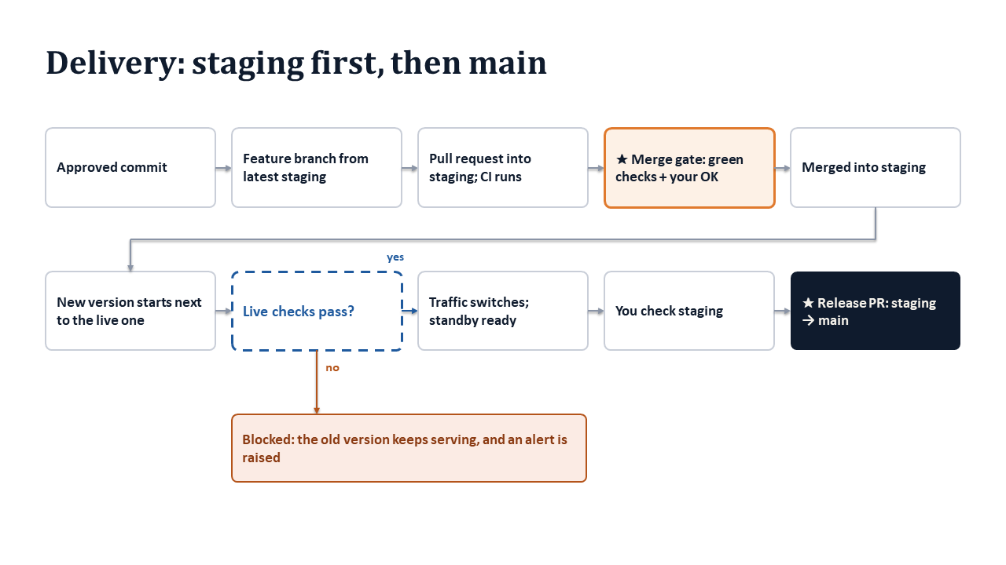

Backend API layer
The FastAPI app (backend/app/main.py) mounts eleven routers; workflows.py (843 lines) carries the whole workflow lifecycle.
File | Lines | What it contains
app/main.py | 62 | Creates the FastAPI app, CORS for any local dev port, startup (database init, recovery of interrupted repository jobs), shutdown (stops running deployments), /api/health, and registers every router.
app/api/workflows.py | 843 | Workflow lifecycle: create, list, delete, resume; indexing, planning, plan edit/approve; code generation and change approval; tests, validation, repair; commit, push, PR publish/status/merge, release PR; staging preview start/stop/rollback; CI status and CI workflow listing; readiness, risks, chaos, report; problem reports (revise, revisions, add-ons, screenshots, revision check) and workflow file reading.
app/api/repo_manager.py | 410 | Repository Manager: create, connect local folder, connect GitHub (public or private with a per-request token), background indexing jobs and their recovery, re-index, sync, disconnect, file tree, file read, text search, insights, a repository's workflows.
app/api/repositories.py | 168 | Index or clone a repository, list/get it, semantic search, and “Ask the repository” (answer + ranked file locations).
app/api/dashboard.py | 193 | Dashboard KPIs and “needs attention” items, computed only from stored rows.
app/api/guardrails.py | 182 | Guardrail catalog, per-workflow checks, summary, timeline, re-evaluation and human approval of a guardrail.
app/api/alerts.py | 43 | Alerts list, acknowledge one/all, and the live deployments list for Monitoring.
app/api/evaluation.py | 70 | Serves evaluation results and baseline comparisons from evaluation/results/.
app/api/risks.py | 70 | Production risk dashboard across all workflows.
app/api/simulation.py | 54 | In-memory simulated service graph: state, fault injection, reset.
app/api/projects.py | 35 | Create, list and get projects.
app/api/deps.py | 18 | Dependency injection: database session and the configured LLM provider.

Backend core, models and schemas
Configuration, security rules and the data model live here; 18 database tables back every workflow.
File | Lines | What it contains
app/core/config.py | 122 | All settings from environment variables: LLM provider and mode, GitHub, safety limits, Docker validation, production-check budgets, zero-downtime deployment and monitoring options, the alert webhook.
app/core/security.py | 175 | Path safety for repositories, the command allowlist (python, pytest, ruff, npm, docker build only), dangerous-token detection, secret patterns and redaction.
app/core/db.py | 86 | SQLite engine, table creation, additive column migrations, retired-table cleanup, session dependency.
app/core/llm_reliability.py | 78 | structured_call(): calls the model, extracts JSON, validates it with Pydantic, retries on bad output.
app/core/prompts.py | 69 | Loads prompt templates with YAML front matter and renders them.
app/models/models.py | 310 | SQLModel tables: Project, Repository, Workflow, AuditEvent, RetrievedDocument, Plan, ProposedChange, ChangeApprovalRecord, GeneratedTest, ValidationResult, RepairAttempt, GitOperation, CIRun, GuardrailCheck, RiskItem, ChaosExperiment, ProductionReadinessAssessment, Alert.
app/models/enums.py | 202 | Workflow states and allowed transitions, audit event types, chunk types, environments, guardrail categories/status/actions, severities, risk, chaos and readiness values.
app/models/__init__.py | 32 | Re-exports the models so the database sees every table.
app/schemas/api.py | 229 | Request/response bodies: projects, repositories, workflows, approvals, search/ask, GitHub actions, revisions (problem, screenshots, add-ons), plan edits, repository manager.
app/schemas/plan.py | 38 | PlanStep, PlanOutput, RetrievalEvidenceItem.
app/schemas/change.py | 18 | ProposedChangeItem (file, operation, diff, confidence, risks) and ChangeSetOutput.
app/schemas/test.py | 17 | GeneratedTestItem and TestSetOutput.
app/schemas/repair.py | 12 | RepairProposal.

Backend services
orchestrator.py (1,913 lines) drives every workflow and calls the services below; the guardrail engine (1,488 lines) checks each step.
File | Lines | What it contains
services/orchestrator.py | 1,913 | The workflow engine: create, index, plan (existing, greenfield or add-on), approve, generate changes, apply them on a feature branch, tests, validation, repair, commit, readiness, risks, chaos, resume after failure, delete, problem-report revisions.
services/state_machine.py | 16 | Enforces the allowed workflow state transitions.
services/audit.py | 29 | Writes audit events for the timeline.
services/pipeline_view.py | 373 | Builds the 18-stage pipeline view from stored rows; the report waits until the PR is merged.
services/reporting.py | 1,177 | Assembles the final report (JSON and Markdown).
services/workflow_evaluation.py | 843 | Scores a workflow against the evaluation framework.
services/rag/indexer.py | 124 | Discovers text files and indexes code-aware chunks into ChromaDB.
services/rag/chunking.py | 217 | Splits Python and JavaScript by function/class, other files by size; detects language.
services/rag/embeddings.py | 79 | Offline deterministic embeddings (no API needed).
services/rag/retriever.py | 189 | Hybrid retrieval: semantic + BM25 keywords + file-path + symbol matching, with a plain reason per result.
services/rag/vectorstore.py | 31 | ChromaDB collection access and reset.
services/rag/formatting.py | 34 | Formats retrieved chunks for prompts and the UI.
services/planner/planner.py | 128 | Requirement analysis, retrieval queries and the engineering plan via the LLM.
services/planner/intent_classifier.py | 64 | Mock-mode intent categories.
services/planner/category_metadata.py | 104 | Mock-mode plan templates per category.
services/codegen/codegen.py | 101 | Proposes code changes within file and patch-size limits.
services/codegen/diffing.py | 133 | Creates unified diffs and applies them strictly (conflicts detected).
services/codegen/mock_strategies.py | 516 | Mock-mode code changes for the bundled demo repository.
services/testing/mock_test_strategies.py | 223 | Mock-mode tests paired with those changes.
services/providers/base.py | 48 | LLM provider interface, usage and errors.
services/providers/factory.py | 25 | Picks the provider from settings.
services/providers/local_provider.py | 231 | Mock provider: answers every prompt deterministically, including greenfield design and generation.
services/providers/anthropic_provider.py | 47 | Live Claude provider (needs ANTHROPIC_API_KEY).
services/providers/openai_provider.py | 42 | Live OpenAI provider (needs OPENAI_API_KEY).
services/validation/sandbox.py | 178 | Isolated workspace per workflow; runs only allowlisted commands with timeouts; Docker availability.
services/validation/pipeline.py | 118 | Validation stages: syntax, lint, unit tests, Docker build, production checks, security scan.
services/validation/production.py | 649 | Boots the app like production and tests it live: boot, smoke, API contract (from OpenAPI), hostile input, load with p95 budget, restart; read-only pre-release checks for deployments.
services/validation/repair.py | 80 | Diagnoses a failure and proposes a bounded repair.
services/guardrails/engine.py | 1,488 | Guardrail control plane: input, AI/LLM, output, security, CI/CD, infrastructure, deployment and cost checks; command classification; approvals.
services/risk/engine.py | 149 | Derives risks and severity from the plan and changes.
services/architecture/engine.py | 102 | Maps components, dependencies and external services.
services/chaos/engine.py | 266 | Resilience lab: experiments relevant to the detected architecture.
services/readiness/engine.py | 114 | The release decision with reasons and a checklist.
services/simulation/engine.py | 98 | Simulated service graph for fault injection.
services/evaluation/baseline_runner.py | 243 | Runs the non-orchestrated baseline for comparison.
services/evaluation/automation_provider.py | 107 | Adapters for local, GitHub Actions and Sweep automation.

Backend delivery services
These files take approved code to GitHub and keep the staging site up: feature branch → pull request into staging → zero-downtime release → release pull request into main.
File | Lines | What it contains
services/git/git_ops.py | 295 | Git: clone and refresh (latest staging), feature-branch names, branch from the latest base, protected branches (main, master, staging), status, diff, commit.
services/github/github_ops.py | 581 | GitHub API: target repository, push (never to a protected branch), initialise an empty repo, pull requests, PR status with every check, update branch, merge, branch CI status, Actions log parsing.
services/github/delivery.py | 518 | The merge flow: publish the PR, merge gate (checks, conflicts, approvals), merge into staging (starts the staging release), release PR staging → main, staging preview start/stop/rollback.
services/preview.py | 633 | Zero-downtime deployments: traffic router on a stable port, blue-green releases that must pass live checks, hot standby with instant failover, watchdog that heals (standby, rollback, restart), monitoring stats.
services/alerts.py | 102 | Stores alerts, de-duplicates them for 10 minutes, optionally posts to a Slack/Teams webhook, acknowledge.
services/containerize.py | 298 | Detects the app type and writes the Dockerfile, .dockerignore, docker-compose.yml, the Docker CI workflow and the README Docker section.
services/ci_assets/production_check.py | 199 | Standard-library script shipped in every project: CI runs it against the container (smoke, API, hostile input, load).
services/greenfield/service.py | 243 | Designs a new project and generates its files; in a revision, updates existing files with diffs.
services/greenfield/schemas.py | 62 | ProjectDesign, components, file specs, generated files.
services/greenfield/templates.py | 286 | Picks the template, names the app from the request, fills placeholders, adds Docker files.
services/greenfield/templates_webapp.py | 710 | General full-stack web app: dashboard, search, filters, create/edit/delete dialog, REST API, tests.
services/greenfield/templates_food.py | 1,202 | Food delivery app: restaurants, menus, cart, coupons, checkout, order tracking.
services/greenfield/templates_login.py | 875 | Sign-in app: sign in, create account, forgot-password flow with 6-digit reset codes.
services/addons/catalog.py | 102 | Add-on catalog: match a request, check status, apply to staging code.
services/addons/database.py | 428 | Add-on: SQLite persistence for accounts or records, Docker volume, persistence tests.
services/addons/dark_mode.py | 109 | Add-on: dark mode with a remembered toggle.
services/addons/login_protection.py | 157 | Add-on: sign-in rate limiting and reset-code request limits.
services/revision_check.py | 194 | Checks whether a reported problem is already handled on staging, with evidence.
services/attachments.py | 96 | Validates and stores screenshots attached to a problem report.
services/repos/manager.py | 418 | Safe repository access: allowed roots, create/clone, file tree, file read (no secrets or binaries), text search, insights.

Prompts and tests
Eleven prompt templates drive the live AI; 283 backend tests across 39 test files (17 integration, 20 unit, 2 security) all pass.

Prompt templates (backend/prompts/)
File | Used for
requirement_analysis.md | Normalising the request, assumptions, open questions
retrieval_query_generation.md | Search queries for retrieving relevant code
implementation_planning.md | The engineering plan
code_modification.md | Code changes as diffs
test_generation.md | Tests for the change
failure_diagnosis.md | Explaining a validation failure
repair_planning.md | A bounded repair patch
code_explanation.md | “Ask the repository” answers
project_design.md | Requirements and architecture for a new project
project_generation.md | Every file of a new project
final_report_generation.md | The report’s executive summary

Integration tests (backend/tests/integration/)
File | What it proves
test_orchestrator_e2e.py | Index → plan → approve → code → tests → validate → commit → report end to end
test_greenfield.py | Empty repositories get a designed, generated, validated project; template choice and naming
test_feature_branch_workflow.py | Changes reach main only through a PR after checks and approval; staging preview
test_github_target.py | Push/PR/CI target the workflow’s own repository; tokens never stored; report waits for the merge
test_containerize.py | Every project is Dockerized; Docker build stage; commit refused without a Dockerfile
test_production_validation.py | Live checks pass healthy apps and catch broken ones; CI script behaves the same
test_zero_downtime.py | Blocked bad release, zero failed requests during release, standby failover, rollback, watchdog, alerts
test_revision.py | Problem reports: fixes, already-there answers, screenshots, add-ons, no failing workflows
test_resume_workflow.py | A failed workflow resumes from where it stopped
test_delete_workflow.py | Deleting removes history and workspace, never the repository
test_repo_manager.py | Path validation, browsing confinement, GitHub clone errors, token hygiene
test_auto_analysis.py | Risk, chaos and readiness run automatically; validation re-runs
test_api_routes.py | Every endpoint the frontend calls exists; “Ask” locations ranking
test_production_control_plane_e2e.py | The payment-timeout scenario through all 8 guardrail categories
test_rag_payment_scenario.py | Semantic search and grounded Q&A on the demo repository
test_report_evidence_classification.py | The report separates fact, inferred, assumption, unknown
test_indexing.py | Indexing produces real chunks; retrieval changes with the query

Unit and security tests
- Guardrails (test_guardrails_*.py, 9 files): input, AI/LLM, output, security, CI/CD, infrastructure, deployment, cost, catalog.
- Engines: test_readiness_engine.py, test_risk_engine.py, test_chaos_engine.py, test_state_machine.py, test_llm_reliability.py, test_prompts.py.
- Code handling: test_chunking.py, test_diffing.py, test_intent_classifier_and_mock_strategies.py, test_baseline_runner.py, test_actions_log_parsing.py.
- Security (tests/security/): path traversal, malicious commands, .env exclusion, prompt injection, oversized patches.
- tests/conftest.py: temporary database, workspaces and alert store per test; Docker and live checks off unless a test turns them on.

Frontend
A React 19 + TypeScript + Vite single-page app; WorkflowDetailPage.tsx (2,699 lines) holds one panel per pipeline stage.
File | Lines | What it contains
src/main.tsx | 14 | Mounts the app with the router.
src/App.tsx | 117 | Sidebar navigation (with the live open-alerts badge) and the page routes.
src/index.css | 2,507 | All styles: layout, cards, tags, pipeline rail, interactive CI/CD flow, code explorer, file viewer, animations.
pages/DashboardPage.tsx | 256 | KPIs and items that need attention.
pages/NewWorkflowPage.tsx | 388 | Pick or connect a repository, type the request, then index and plan automatically.
pages/WorkflowHistoryPage.tsx | 347 | Workflow runs grouped by status; delete one or all.
pages/WorkflowDetailPage.tsx | 2,699 | The workflow screen: stage rail and a panel per stage — intent, code explorer with “Ask the repository”, plan editor, risks, diff review, validation reports, readiness checklist, interactive CI/CD, GitHub PR and merge, staging → main release, problem reports with screenshots and add-ons, resume, final report.
pages/RepositoriesPage.tsx | 306 | Repository cards with status; create, connect local, connect GitHub.
pages/RepositoryWorkspacePage.tsx | 579 | A repository’s files, code view, text search, RAG Q&A and workflows.
pages/MonitoringPage.tsx | 166 | Live deployments (availability, latency, release, standby, failovers, incidents) and alerts.
pages/GuardrailsPage.tsx | 546 | Guardrail catalog and per-workflow results.
pages/EvaluationPage.tsx | 663 | Evaluation results and orchestrated-vs-baseline comparison.
pages/SettingsPage.tsx | 112 | Provider status and configuration reference.
components/DiffReview.tsx | 158 | File list and diff for change approval.
components/EvidencePanel.tsx | 195 | Interactive retrieved-code explorer: search, kind filters, group by file, expandable cards.
components/PlanEditor.tsx | 314 | Edit, add, reorder and remove plan steps before approval.
components/StatusBadge.tsx | 68 | Coloured status labels.
components/DiffViewer.tsx | 23 | Renders a unified diff.
components/PipelineStrip.tsx | 30 | Compact pipeline strip.
components/Timeline.tsx | 20 | Audit event timeline.
components/ApprovalControls.tsx | 32 | Approve/reject buttons with a comment.
components/DataDisplay.tsx | 33 | Small table and expander helpers.
components/RepoStatusBadge.tsx | 13 | Repository status badge.
services/api.ts | 335 | Typed client for every backend endpoint.
services/repoMeta.ts | 51 | Repository status and label helpers.
types/index.ts | 854 | TypeScript types for workflows, plans, changes, validation, guardrails, deployments, alerts, add-ons.
package.json, vite.config.ts, tsconfig*.json, .oxlintrc.json, index.html | — | Dependencies and scripts, Vite build, TypeScript and lint settings, the HTML shell.
Dockerfile, .dockerignore, .env.example | — | Production image of the frontend and the API address setting.

Infrastructure and repository files
The rest of the repository runs, demonstrates and evaluates the platform.

Run and deploy
File | What it contains
docker-compose.yml | Runs the backend and frontend together, with keys passed from the environment.
backend/Dockerfile, frontend/Dockerfile | Production images for the API and the web app.
.dockerignore, .gitignore | Keep secrets, caches and runtime data out of images and Git.
.env.example | Every setting with a safe default; real keys go in an untracked .env.
.github/workflows/ai-devops.yml | The platform’s own CI: lint, tests and build on every push and pull request.
backend/requirements.txt, pyproject.toml, pytest.ini | Python dependencies, lint and test settings.
scripts/setup_demo.sh | Sets up the demo environment.

Demo repository (demo-repository/) — ShopFlow
Area | What it contains
main.py, config.py, database.py, exceptions.py, seed.py | FastAPI app, settings, SQLite layer, domain errors mapped to HTTP codes, demo data.
api/ (9 files) | Registration/login, cart, order lifecycle, payment charge, product catalog, refunds, inventory, users, auth dependencies.
services/ (10 files) | Business logic: auth tokens, cart, orders, payments through the provider client, refunds, inventory without overselling, notifications, audit, products, users.
models/ (7), schemas/ (6) | Data classes and request/response shapes.
integrations/payment_provider.py, utils/ | A stand-in payment provider (timeouts, declines), redacting JSON logs, input validation.
tests/ (11 files) | Auth, cart, inventory, notifications, orders, payments, products, refunds, security, users.

Evaluation
File | What it contains
evaluation/tasks/task_001.json … task_021.json | 21 benchmark change requests with expected outcomes.
evaluation/README.md | How the benchmark is run and scored.
scripts/run_evaluation.py | Runs every task through Intent2Deploy and records results.
scripts/run_baseline_evaluation.py | Runs the same tasks with a plain LLM-assisted baseline.
scripts/compare_evaluation_runs.py | Compares the two runs and analyses failures.

Documentation
File | What it contains
README.md | Overview, setup and usage.
docs/setup.md, architecture.md, demo-script.md | Installation, system design, a 7–10 minute live demo.
docs/rag.md, prompt-engineering.md, sourcegraph.md | Retrieval design, prompt design, semantic code navigation.
docs/github-actions.md, ai-testing-tools.md | CI/CD and AI testing tools.
docs/evaluation.md, EXPERIMENTAL_EVALUATION.md | Evaluation method and baseline-vs-Intent2Deploy results.
docs/responsible-ai.md, AI_DEVOPS_GUARDRAILS.md | Responsible-AI rules and the guardrail catalog.
docs/course-alignment.md, docs/course-evidence/* | Course mapping, project charter, timeline.
PROJECT_PLAN.md, PRODUCTION_CONTROL_PLANE_PLAN.md, master prompt | Project plan, control-plane upgrade plan, the original master specification.
LICENSE | The project licence.

