Final case: Outsourcing, Near-sourcing, and Supply Chain Flexibility in the Apparel Industry

Section #1: Outsourcing business model
How many shirts should Veizenburg order for the upcoming collection?

To answer this question, we trained a regression model based on actual demand.
Take a look at the visualization of sales for LEC:

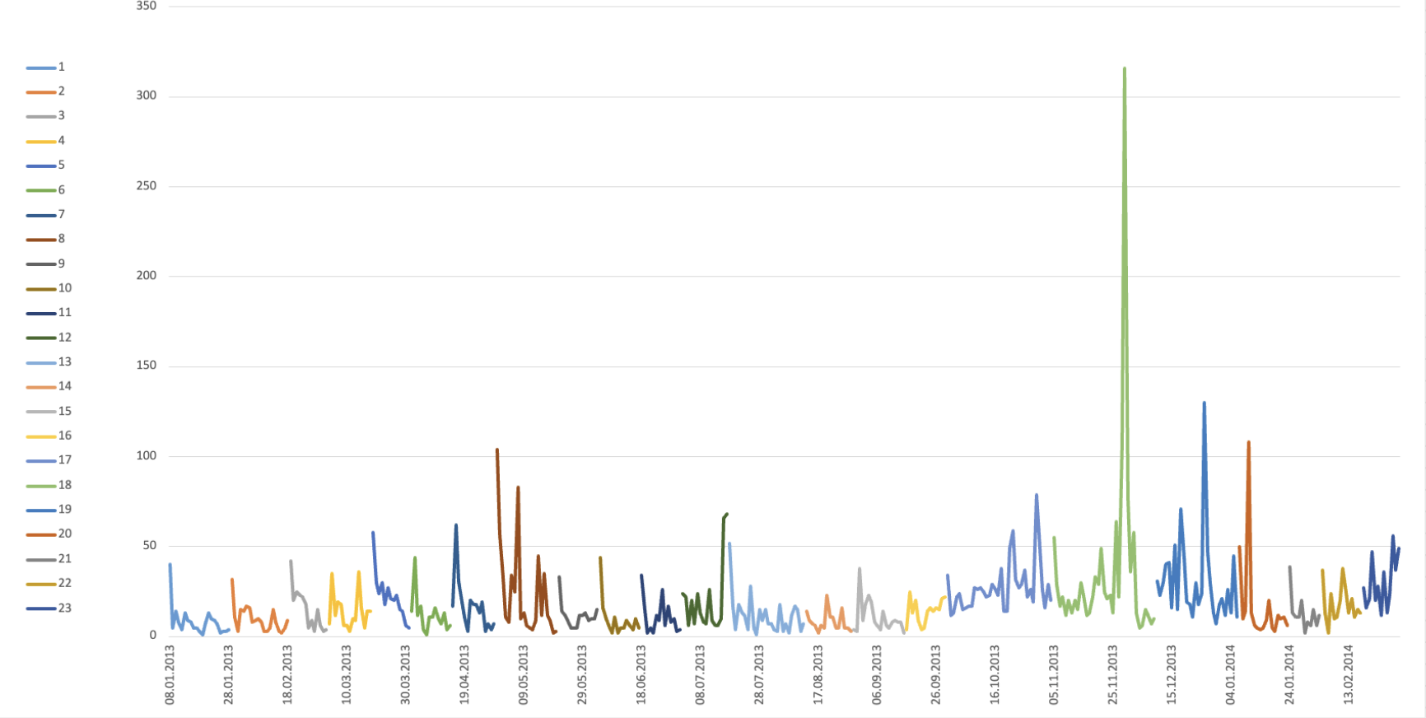

Clear spikes occur at different periods of time, we assume such demand is related to holidays.
The independent variables of our regression model are:
- Normalized Ln(Length) - ln of Length of selling period of LEC
- Contains holiday - Whether the period contains social holiday

The summary of regression model:
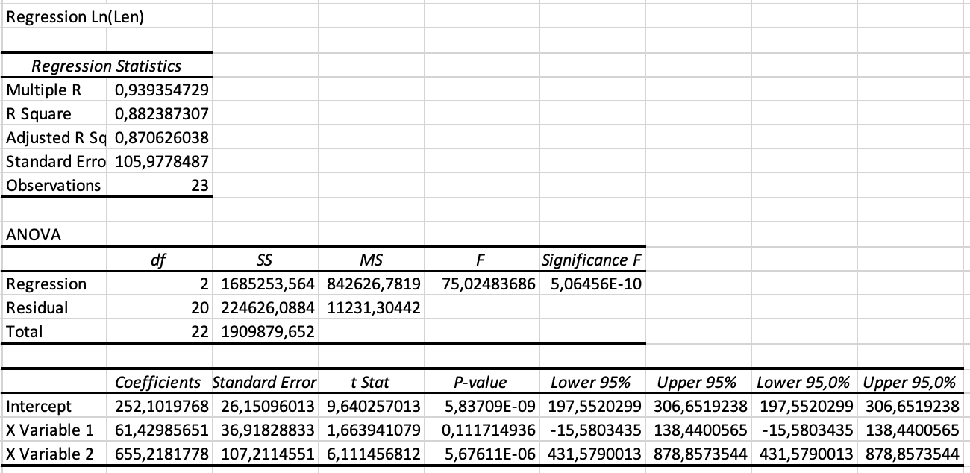

R squared is 0.88, model describes the variance quite well.

Forecasted demand for upcoming LEC
For LEC 24:
- Length = 21 days
- Normalized Ln(Length) = 0.6183
- Holiday = 0
Applying the regression coefficients gives us the prediction of 290 units. (Task 3 sheet in excel file).
To take into account possible error, we performed 1000 Monte Carlo demand simulations for each possible order size in range(100, 500), calculated the profit for each size, chose optimal, which is 292 units for 24 LEC.
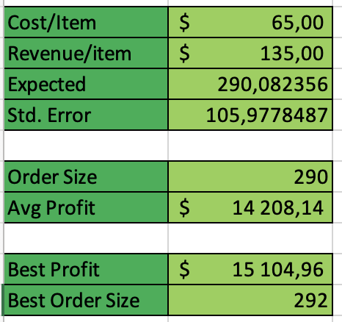

Section #2: Near-sourcing business model
How much benefit can Veizenburg obtain by sourcing from the local production facility?

4. Summary of the outsourcing model:
Under the outsourcing business model, Veizenburg must place a single order from Ukraine three weeks before the LEC begins. To determine the optimal order size, we
- analyzed historical demand,
- constructed a regression-based forecast for LEC 24
- used simulation to evaluate profits for many order quantities.
The regression model provided an expected demand of 290 units with residual variability captured by σ ≈ 106. Using 1,000 simulated demand scenarios, we computed the expected profit for different order sizes and found that the optimal quantity is approximately 292 units.

5. How should Veizenburg optimally use the local production facility for the upcoming LEC? Contrast the result with that of the outsourcing business model.
To determine how Veizenburg should optimally utilize the local production facility, our team extended the simulation-based optimization approach that we previously applied in the outsourcing model.
We generated 1,000 random demand scenarios for the upcoming LEC using the forecast mean and standard deviation obtained from the regression model. (Task 5 sheet in Excel file)
For each simulated demand value, we calculated total profit under the near-sourcing setup.
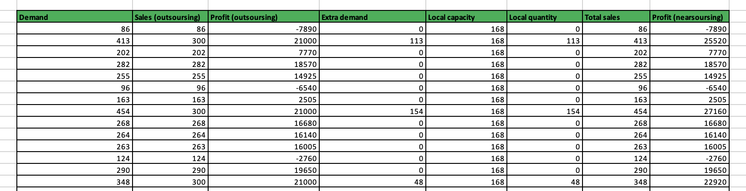...and till 1000 times
Then for different possible sizes of order from Ukraine (from 100 to 700 units with step 10) calculated average profit, using data table. And found optimal order size from Ukraine, where the average profit is highest.
It is 240 units in this exact case, but, in general, order sizes and average profits are obtained from simulations in which demand has approximately normal distribution with mean around 290 and stdev ≈ 106.

6. Evaluate the benefit of the near-sourcing option. For that, compare the profit Veizenburg would have obtained in LECs 11–23 had his firm utilized the outsourcing model only versus the profit they would have obtained from near-sourcing.

To evaluate the benefit of the near-sourcing or to determine at which order size profits for 13-21 collections are highest we created two 2D data tables: First for outsourcing model, second for near-sourcing. We provided an example of the data table (outsourcing) below:

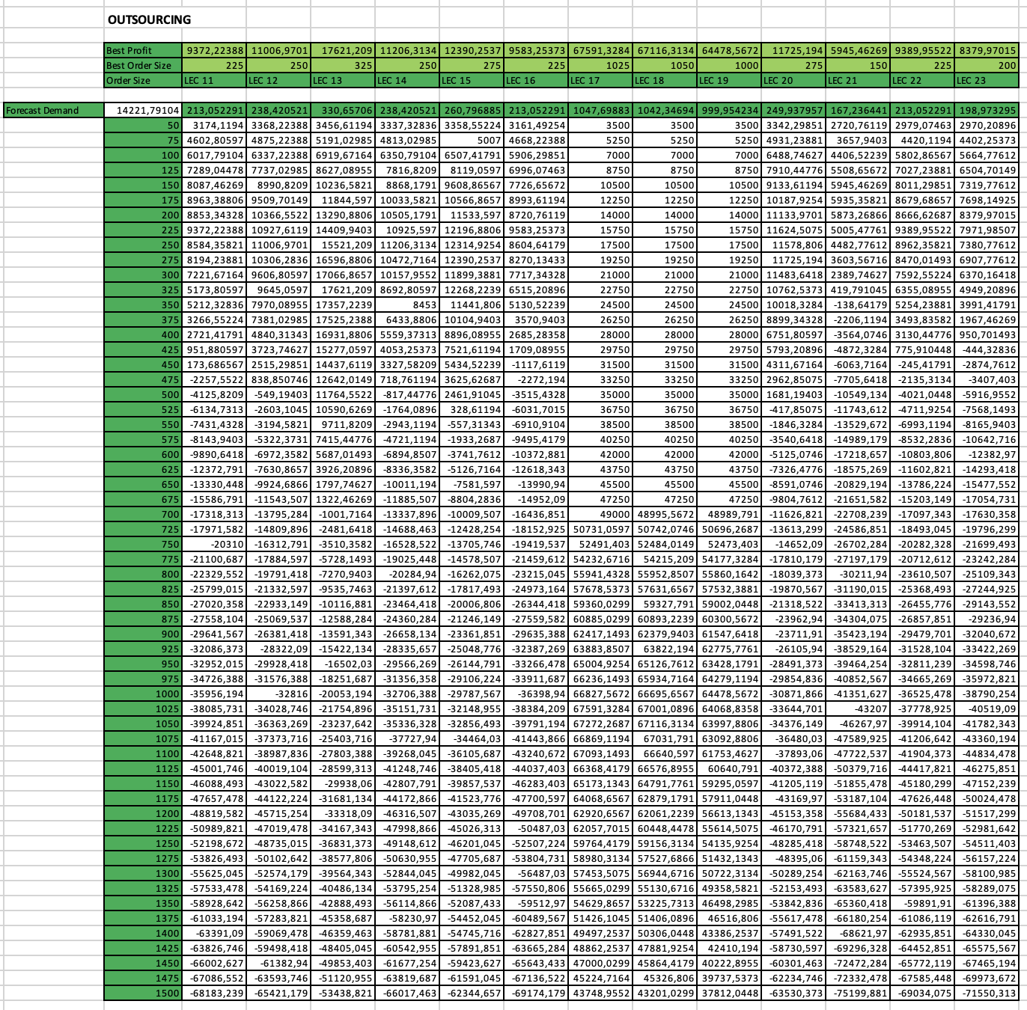
Next, having this data on optimal quantities for LEC 11-23 separately for the outsourcing business model and for the near-sourcing business model, we substitute them into the table to calculate the total profit.

For outsourcing:
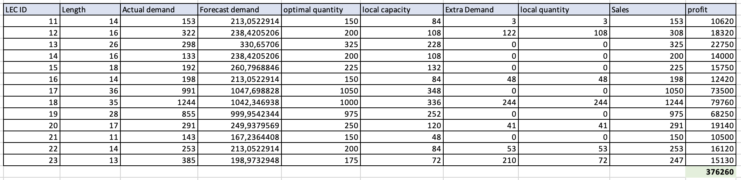
For near-soursing:
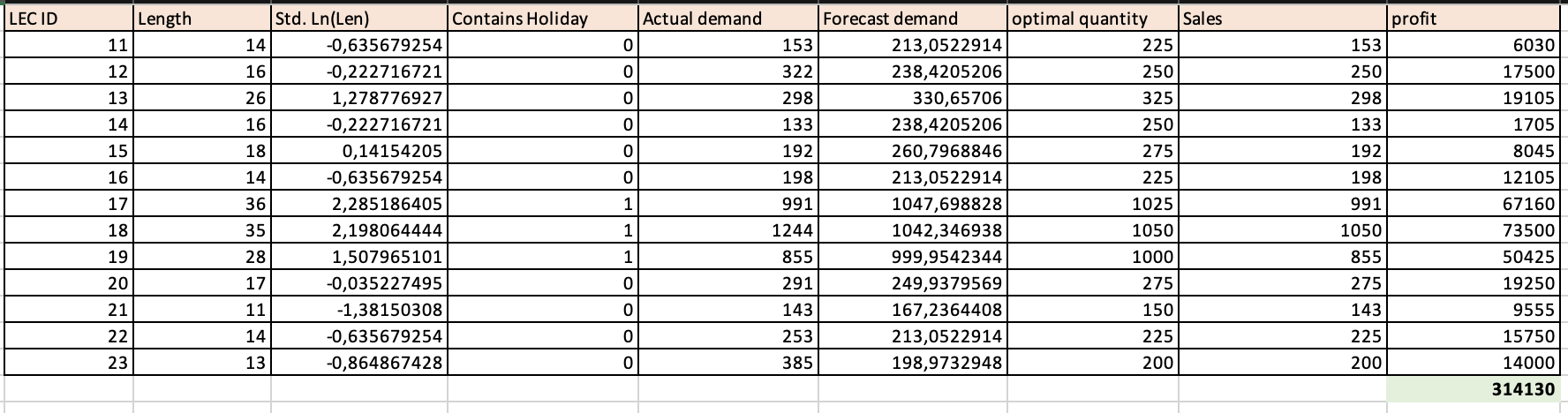Short explanation for tables:
- Actual demand - demand from data
- Forecasted demand - demand evaluated by regression model
- Optimal quantity - values from data tables
For outsourcing:
- Sales = min(Actual demand; Optimal quantity)
- Total profit = Sales*135 - Optimal quantity*65 (our costs is equal to Optimal quantity * 65, because we make our order 3 weeks ahead, when we don’t know our actual demand)
For near soursing:
- Local capacity = 12 * (LEC Length - 7) (the maximum of shirts we can produce for each LEC and such formula because local facility can produce 12 shirts per day for next-day delivery, starting perhaps one week from the LEC launch)
- Extra demand = If(Actual demand > Optimal quantity; Actual demand - Optimal quantity; 0) – 0 or difference between Actual demand and Optimal quantity if Actual demand > Optimal quantity
- Local quantity = min(Local capacity, Extra demand) (local facility can’t produce more than it’s capacity)
- Sales = Local quantity + Optimal quantity
- Profit = Sales*135 - Optimal quantity*65 - Local order *95

And finally, the benefits of using near-sourcing is provided in the table:
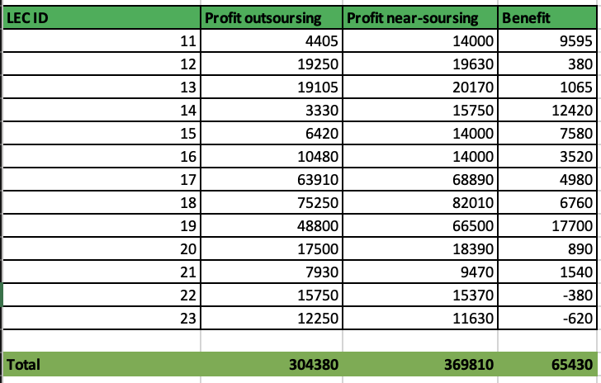
And we see, that near-soursing business model is more profitable than outsourcing

Section #3: Flexibility business model
The higher-level question is: How valuable is this alternative to Veizenburg’s firm?

7. Roadmap
Current Approach: Under the current model, Veizenburg must commit to a single order from Ukraine, placed before the LEC launches. This order takes three weeks to produce and deliver, meaning all inventory decisions must be made with zero market feedback. If you order too many you have unsold inventory, if you order too few you miss sales opportunity.
The Flexibility Alternative: The flexibility option fundamentally changes this approach by splitting procurement into two stages:
Initial Order (Pre-launch): Place initial order from Ukraine before the LEC starts
Reorder Option (Mid-launch): After observing actual customer demand for the first week, place a reorder from Ukraine at the same $65 cost, delivered in one week.
Instead of gambling on total demand with no information, Veizenburg can now use a "test and respond" strategy.

8.“Analyze (i.e., Forecast and Optimize)”:
Unlike the outsourcing model where we forecasted total LEC demand, the flexibility model requires us to forecast two different quantities:
- Week 1 Demand: How many shirts will customers want in the first week?
- Remaining Demand (Weeks 2-3): How many additional shirts we need to order
We analysed historical data from LEC 11-23.
We used a regression model to predict demand after the first 7 days.
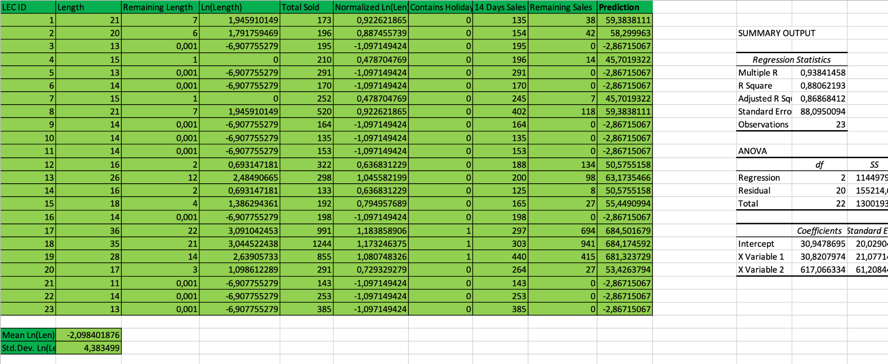
So, we know the first week demand, remaining predicted demand and we should determine how much we need to reorder
To calculate size of additional order we used Monte Carlo simulations
For each candidate reorder quantity:
- Simulate remaining demand thousands of times.
- Compute realized sales + leftovers.
- Compute profit for each simulated scenario.
- Average profit across simulations.
- Select the reorder quantity that maximizes expected profit.

9. Backtest. How Valuable Would Flexibility Have Been in LECs 11–23?

To quantify the value of flexibility, we applied the same framework retrospectively to LECs 11–23:
Forecasting Remaining Demand via Regression

1. Use historical week-1 and week-2 demand2. Forecasting Remaining Demand via Regression
3. Simulate remaining-demand distributions.
4. Optimize reorder quantities for each LEC.
5. Compute realized profit under flexibility.
6. Compare against outsourcing profit and near-sourcing profit

Total profit under flexibility = 314135
Outsourcing total = 309255
Near-sourcing total = 375950

Thus, flexibility performs slightly better than outsourcing but is less profitable than near-sourcing because of very high variance of the prediction for the upcoming demand.
Flexibility adds operational value by replacing forecast risk with real demand observations. But due to high variance in the remaining-demand model, the flexible strategy: provides some improvement over rigid outsourcing, but is outperformed by near-sourcing, because noisy predictions make second-stage additions less reliable.

So, in conclusion, the model demonstrates that flexibility has potential, but its realized value depends critically on the accuracy of remaining-demand forecasting and variance reduction.
In its current form, near-sourcing appears to be the superior operational model for Veizenburg.

260,2

