



**Table of Contents**

1. **Introduction**…………………………………………………………………………
   1. Purpose…………………………………………………………………………...
   2. Scope……………………………………………………………………………..
2. **General Description**....……………………………………………………………...
   1. Product Functions….………………………………………………………….....
   2. User Characteristics………………………………………………………….......
3. **Specific Requirements**……………………………………………………………...
   1. Functional Requirements….……………………………………………………..
   2. Non-Functional Requirements…………………………………………………...
4. **Analysis Models**……………………………………………………………………..
   1. Use Case Diagram………………………………………………………………
   2. Class Diagram…………………………………………………………………...
5. **Screens**………………….………………………………………………………….5
6. **Database (ERD)**…………………………………………………………………....
   1. Database Schema….………………………………………………………….....
7. **Web Calls**………....…….…………………………………………………………..
8. **References**…………………………………………………………………………..
9. **Glossary**……………………………………………………………………………
10. **Introduction**

***To be Done***

* 1. **Purpose**

***To be Done***

* 1. **Scope**

***To be Done***

1. **General Description**

***To be Done***

* 1. **Product Functions**

***To be Done***

* 1. **User Characteristics**

***To be Done***

1. **Specific Requirements**

***To be Done***

* 1. **Functional Requirements**

***To be Done***

**3.2 Non-Functional Requirements**

***To be Done***

1. **Analysis Models**

***To be Done***

**Use case Diagram**

***To be Done***

**Class Diagram**

***To be Done***

* 1. **Use case Diagram**

***To be Done***

* 1. **Class Diagram**

***To be Done***

1. **Screens**

**Screen flow diagram**

***To be Done***

**Screen Design**

We can simulate the screens of the app in this tool and verify how it looks when the App is designed. We use drag and drop widgets, screens to design the screens. We used Justinmind Prototyper 8.7.0 to design the Screens. We can simulate these screens with this tool or we can view on our mobile device by connecting it.

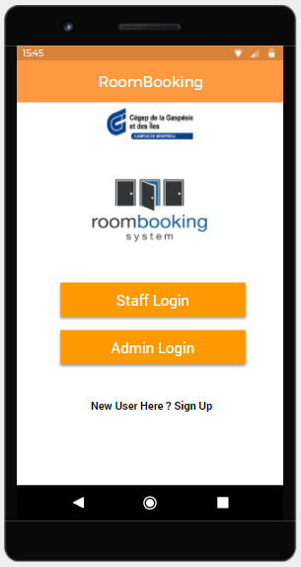

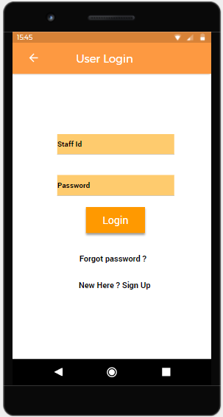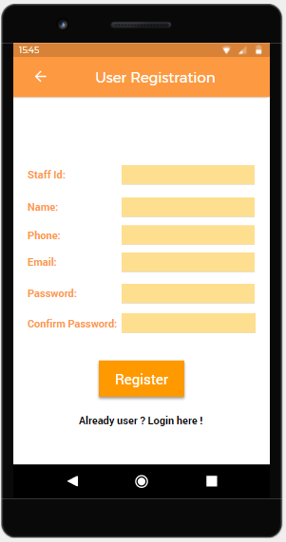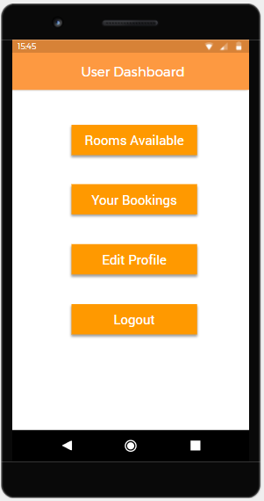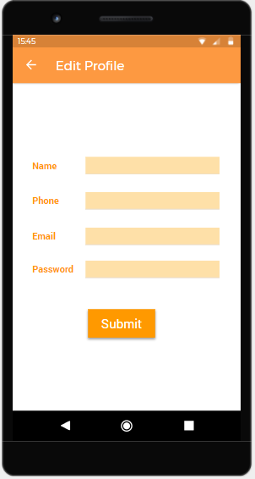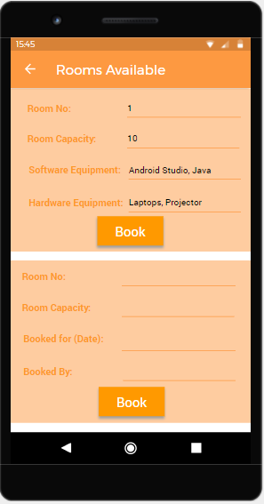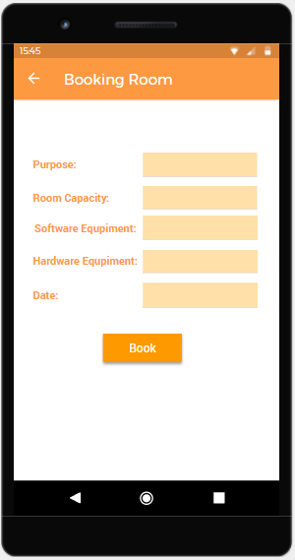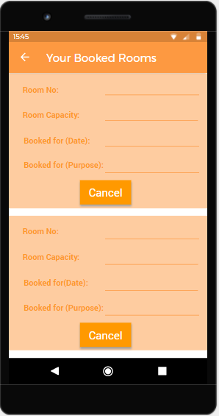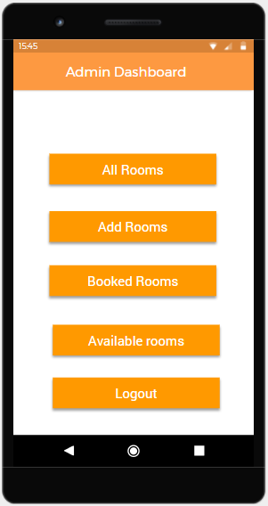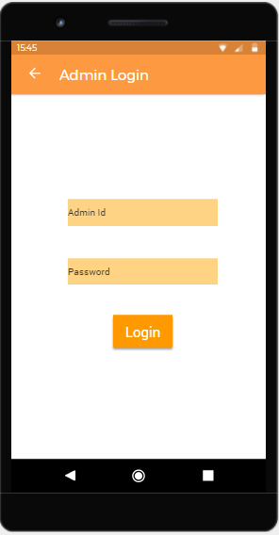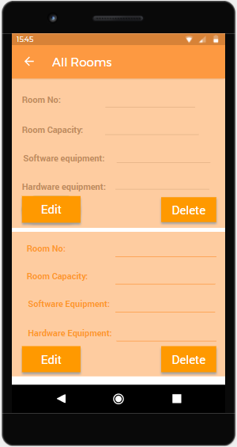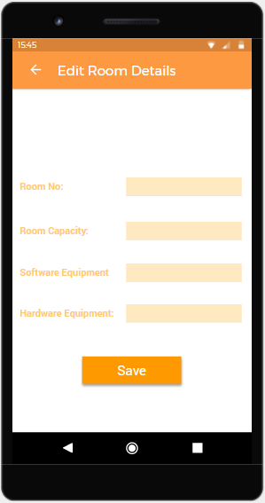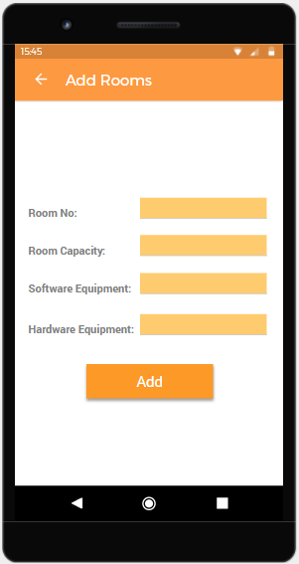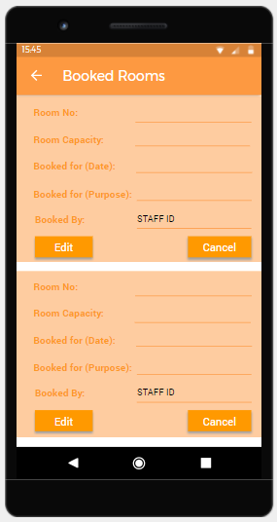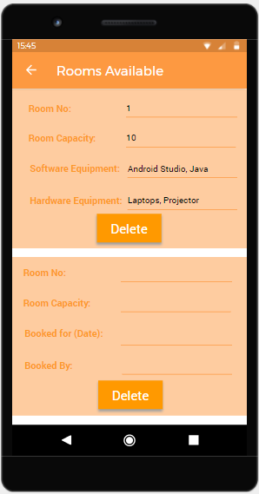

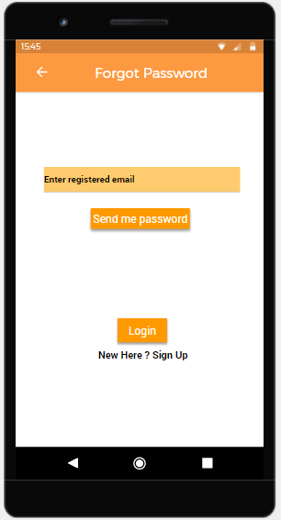

1. **Database (ERD)**

***To be Done***

**ERD Diagram**

***To be Done***

* 1. **Database Schema**

|  |
| --- |
| ***To be Done*** |

1. **Web Calls**

***To be Done***

**Login**

|  |  |  |  |
| --- | --- | --- | --- |
|  | ***To be Done*** | | |
|  |  | | |
|  |  | | |
|  |  | | |
|  |  |  |  |
|  |  |  |
|  |  |  |
|  |  |  |
|  |  |  |

1. **References**

***To be Done***

1. **Glossary**

|  |  |
| --- | --- |
|  |  |
|  |  |

***To be Done***