DoDoo — Database Guide
Editing Firestore for the Rider, Admin & Store apps — and where each change reflects

Overview
This single guide covers editing the database (Google Cloud Firestore, project dodoo-admin-refresh) for all three DoDoo apps. It is organised in three parts:
- Part 1 — Rider database (delete/edit riders, orders, offers, wallet).
- Part 2 — Admin database (approvals, pricing/config, payouts).
- Part 3 — Store / merchant database (store profile, menu, wallet).
Firebase Console: https://console.firebase.google.com/project/dodoo-admin-refresh/firestore

How your edits reach each app
App | How it reads | When your change shows
Rider app | Polls every 10 seconds + pull-to-refresh | Within ~10 seconds
Admin app | Live snapshot stream | Instantly (real-time)
Store app | Menu/wallet live; orders from DoDoo API | Menu/wallet instant; orders on API refresh

[ SCREENSHOT 1 — ADD HERE ]
Capture: The Firestore Console home for project dodoo-admin-refresh, showing the list of collections in the left panel (riders, orders, order_offers, stores, app_settings, …).

Part 1 — Rider Database

1.1 The golden rule
A rider IS their phone number
A rider's document ID is their phone number, digits only. Example: phone 9999999999 -> riders/9999999999. Everything about that rider keys off the same phone number: their tracking doc (rider_tracking/9999999999) and every order/offer/withdrawal/wallet row (rider_id or assigned_rider_id = 9999999999).
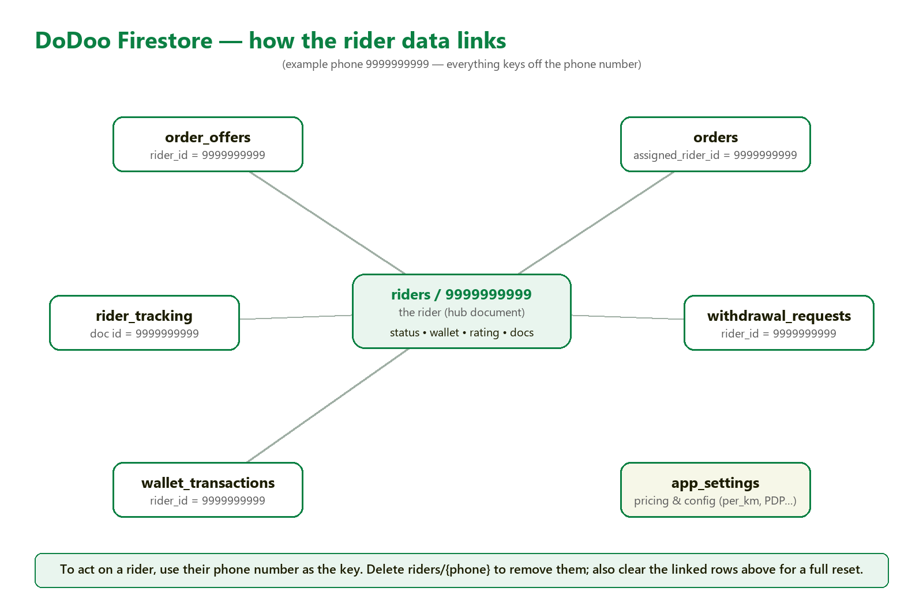
Structure map: the rider (hub) and the collections that link to it by phone number.

1.2 The riders document (fields you can edit)
Field | Type | Controls / where it shows
account_status | string | pending | approved | rejected | suspended. Only "approved" can sign in and take orders.
current_status | string | online | offline | busy (dashboard status card).
wallet_balance | number | Wallet balance (Earnings tab, Profile).
rating | number | Star rating.
total_orders | number | "Total Orders" on the profile.
is_verified / is_document_verified | boolean | Verified flags / green "Verified" badges.
first_name / last_name | string | Name shown on profile.
phone | string | Phone (also equals the document ID).
bank_account_number / bank_ifsc_code | string | Payout bank details.
pending_profile_changes | map | Edits awaiting admin approval.

[ SCREENSHOT 2 — ADD HERE ]
Capture: One rider document open in Firestore (riders/{phone}) so the reader can see the real field names and values.

1.3 Delete a test rider (worked example)
Test rider phone 9999999999.
- Firestore > riders > find document 9999999999 (or query: riders where phone == "9999999999").
- Open it > 3-dot menu > Delete document.
[ SCREENSHOT 3 — ADD HERE ]
Capture: The rider document's 3-dot menu open, showing the "Delete document" option.

Where it reflects: gone from the admin app instantly; the rider is signed out of the rider app.
Also clear the linked rows (for a full reset)
Deleting the rider doc does NOT remove their other data. Also delete: rider_tracking/9999999999; order_offers where rider_id == 9999999999; orders where assigned_rider_id == 9999999999; withdrawal_requests where rider_id == 9999999999; wallet_transactions where rider_id == 9999999999.

1.4 Common rider edits
Goal | Set field | To value
Approve a rider | riders/{phone}.account_status | approved
Suspend / reject | riders/{phone}.account_status | suspended / rejected
Force Online / Offline | riders/{phone}.current_status | online / offline
Set wallet balance | riders/{phone}.wallet_balance | a number
Mark documents verified | riders/{phone}.is_document_verified | true
Change rating | riders/{phone}.rating | e.g. 4.8

1.5 Queries you should know (rider)
[ SCREENSHOT 4 — ADD HERE ]
Capture: The Firestore query/filter builder with a "where" condition added (e.g. phone == 9999999999) so the reader can see how to run a query.

Find… | Firestore query
A rider by phone | riders where phone == "9999999999"
A rider's active deliveries | orders where assigned_rider_id == "9999999999" and status in [accepted, picked_up, in_transit, reached]
Offers sent to a rider | order_offers where rider_id == "9999999999" and is_accepted == false and is_rejected == false
All open orders | orders where status == "pending"
A rider's withdrawals | withdrawal_requests where rider_id == "9999999999"
A rider's live location | rider_tracking (doc id = phone)

Part 2 — Admin Database

2.1 Collections the admin manages
Collection | What it holds | Doc ID
riders | Delivery partners | phone number
orders | Orders (imported from the DoDoo API) | auto-id
order_offers | Offers broadcast to riders | auto-id
stores | Merchants | owner phone number
rider_tracking | Live rider GPS | rider phone
withdrawal_requests | Rider payout requests | auto-id
wallet_transactions | Rider wallet ledger | auto-id
app_settings | Pricing & config | setting name
admins | Admin accounts | auto-id

Admin login password
Stored as a SHA-256 hash at app_settings/admin_password. Change it from the Admin app's settings — do not hand-edit unless you paste a correct hash, or admins get locked out.

2.2 Common admin actions
Goal | Edit | To value
Approve a rider | riders/{phone}.account_status | approved
Approve a store | stores/{phone}.account_status | approved
Approve a payout | withdrawal_requests/{id}.status | approved (then lower rider wallet_balance)
Change pricing | app_settings/… (see 2.3) | the number in its "value" field

[ SCREENSHOT 5 — ADD HERE ]
Capture: A withdrawal_requests document open, showing the status field you flip to "approved".

2.3 Pricing & config (app_settings)
Each app_settings document is named after the setting and holds one "value" field.
Document | value means | Example
price_per_km_ATP (per city code) | ₹ per km for that city | 8
min_delivery_charge | minimum store-order delivery charge | 42
pickdrop_charge | flat charge for PDP orders | 60
rider_base_fare | base fare before per-km | 0
offline_reminder_minutes | minutes before the go-online nudge | 30
admin_password | SHA-256 hash of the admin password | (hash)

[ SCREENSHOT 6 — ADD HERE ]
Capture: The app_settings collection with the pricing documents (price_per_km_ATP, min_delivery_charge, pickdrop_charge, …) and one opened to show its "value" field.

2.4 Queries the admin should know
Find… | Firestore query
Riders awaiting approval | riders where account_status == "pending"
Orders by status | orders where status == "pending" (or accepted/completed/cancelled)
Pending payouts | withdrawal_requests where status == "pending"
Stores awaiting approval | stores where account_status == "pending"

Part 3 — Store (Merchant) Database

3.1 The golden rule
A store IS its owner's phone number
A store's document ID is the owner's phone number. Example: phone 8888888888 -> stores/8888888888. Its menu, wallet and payout requests live in SUBCOLLECTIONS under that document.
[ SCREENSHOT 7 — ADD HERE ]
Capture: A store document (stores/{phone}) open, showing its fields AND its subcollections listed (menu, store_wallet_transactions, withdrawal_requests).

3.2 The stores/{phone} document (fields)
Field | Type | Controls
account_status | string | pending | approved (only approved stores are live).
store_name | string | Merchant name.
phone | string | Owner phone (= document ID).
address | string | Store address.
wallet_balance | number | Store wallet balance.

3.3 Subcollections & menu fields
Path | What it holds
stores/{phone}/menu | Menu items
stores/{phone}/store_wallet_transactions | Wallet ledger
stores/{phone}/withdrawal_requests | Payout requests

Menu item fields (stores/{phone}/menu/{itemId}):
Field | Type | Meaning
name | string | Item name
price | number | Item price
available | boolean | Available / sold-out
is_recommended | boolean | Recommended flag
category | string | Menu section
dodoo_item_id | string | Link to DoDoo item

[ SCREENSHOT 8 — ADD HERE ]
Capture: One menu item document (stores/{phone}/menu/{itemId}) showing its fields.

3.4 Delete a test store (worked example)
Test store owner phone 8888888888.
- Delete the SUBCOLLECTIONS first: menu, store_wallet_transactions, withdrawal_requests.
- Then delete the stores/8888888888 document.
Deleting a document does NOT delete its subcollections
In Firestore, deleting stores/8888888888 leaves its menu/wallet/withdrawal subcollections behind (orphaned). Clear the subcollections first, THEN delete the store document.

3.5 Common store edits & queries
Goal | Edit | To value
Approve the store | stores/{phone}.account_status | approved
Set wallet balance | stores/{phone}.wallet_balance | a number
Mark item sold-out | stores/{phone}/menu/{itemId}.available | false
Change item price | stores/{phone}/menu/{itemId}.price | a number

Store orders are not in Firestore
Store ORDERS come from the DoDoo order API (the store app auto-refreshes them). You cannot hand-create a real store order in Firestore.

Where to add screenshots

Throughout this guide, blue dashed boxes marked "[ SCREENSHOT n — ADD HERE ]" show exactly where to paste a Firestore console screenshot. Capture each from your own console (https://console.firebase.google.com) and drag it into the matching box. Summary:
# | Section | What to capture
1 | Overview | Console home — the collections list (left panel).
2 | 1.2 Rider fields | A rider document open (riders/{phone}).
3 | 1.3 Delete rider | The 3-dot menu with "Delete document".
4 | 1.5 Rider queries | The query/filter builder with a where condition.
5 | 2.2 Admin actions | A withdrawal_requests document (status field).
6 | 2.3 Pricing | app_settings pricing docs + one value field.
7 | 3.1 Store | stores/{phone} with its subcollections listed.
8 | 3.3 Menu | A menu item document.

