DoDoo Rider — Editing the Database
How to add/edit/delete rider data in Firestore, and where it shows up in the app

1. The essentials
The rider app stores its data in Google Cloud Firestore (Firebase project dodoo-admin-refresh). You edit it two ways:
- Firebase Console (easiest): https://console.firebase.google.com/project/dodoo-admin-refresh/firestore
- The DoDoo Admin app — it writes the same collections.

How your edits reach the app
App | How it reads | When your change shows
Rider app | Polls Firestore every 10 seconds + pull-to-refresh | Within ~10 seconds (or instantly on pull-to-refresh)
Admin app | Live snapshot stream | Instantly (real-time)

THE GOLDEN RULE — a rider IS their phone number
A rider's document ID is their phone number, digits only. Example: phone 9315547927 -> document riders/9315547927. Everything about that rider keys off the same phone number: their tracking doc (rider_tracking/9315547927) and every order/offer/withdrawal/wallet row (rider_id or assigned_rider_id = 9315547927). So to act on a rider, you always use their phone number as the key.
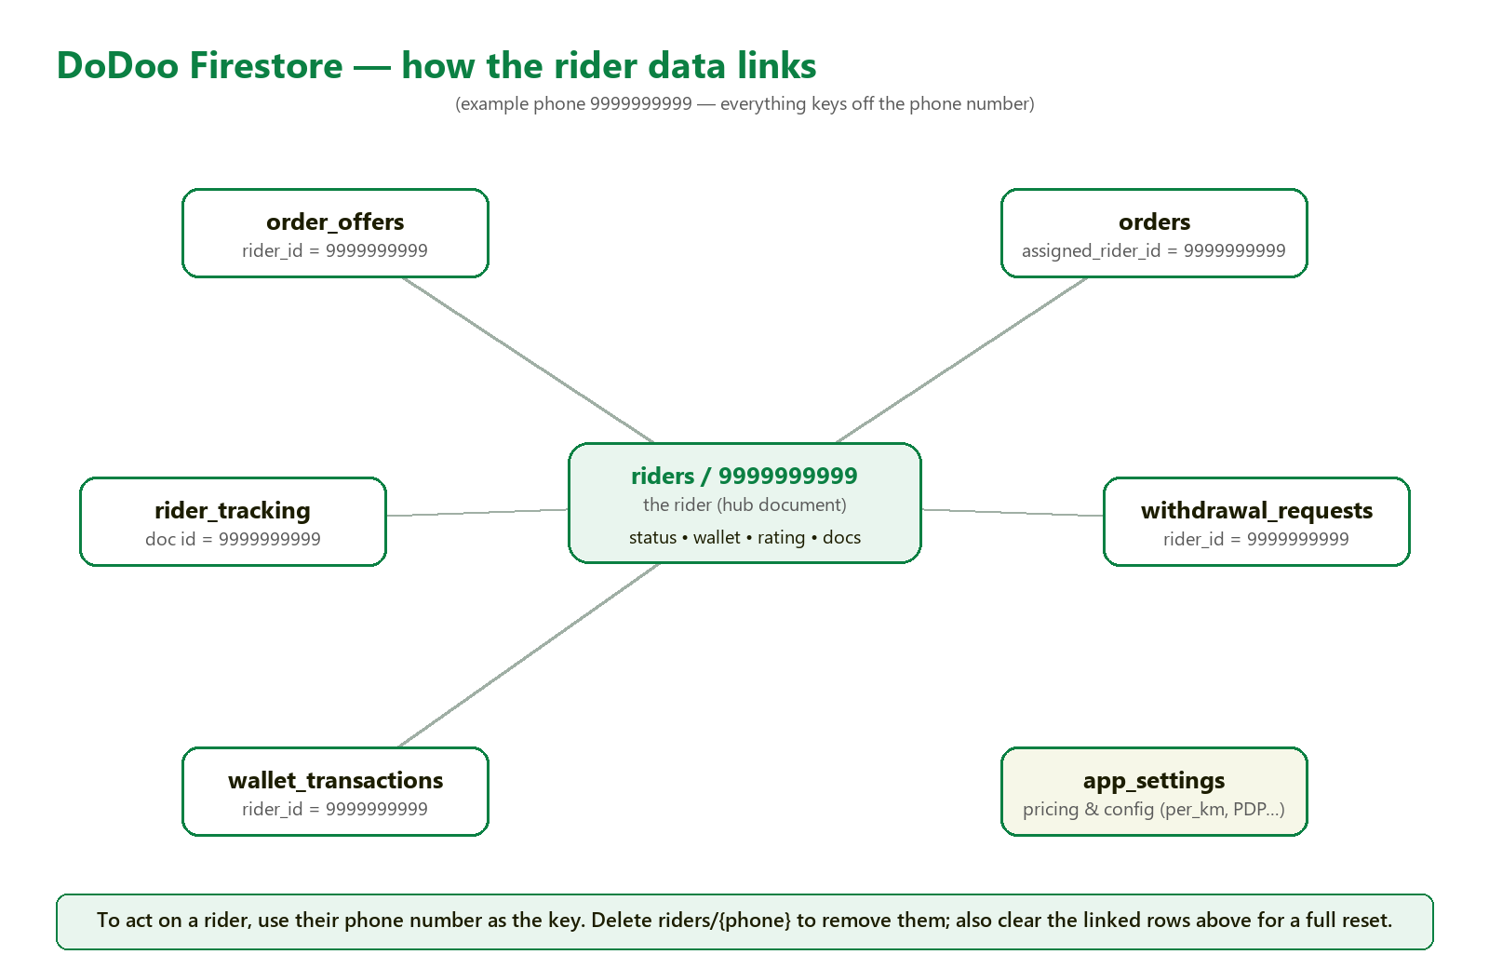
Structure map: the rider (hub) and the collections that link to it by phone number.

2. The riders collection (fields you can edit)
Open Firestore > riders > the document whose ID is the phone number. Key fields:
Field | Type | What it controls / where it shows
account_status | string | pending | approved | rejected | suspended. Only "approved" can sign in and take orders; others land on the "account status" screen.
current_status | string | online | offline | busy. Shows on the dashboard status card.
wallet_balance | number | Wallet balance (Earnings tab, Profile).
rating | number | Star rating on dashboard/profile.
total_orders | number | "Total Orders" on the profile.
is_verified | boolean | Rider verified flag.
is_document_verified | boolean | Documents verified (green "Verified" badges).
first_name / last_name | string | Name shown on profile.
phone | string | Phone (also equals the document ID).
address | string | Used for city matching.
bank_account_number / bank_ifsc_code | string | Payout bank details.
aadhar_front_url / aadhar_back_url / driving_license_image_url | string | Uploaded document images (Cloudinary URLs).
document_status | map | Per-document status, e.g. {aadhar_front: pending}.
pending_profile_changes | map | Edits awaiting admin approval (name/photo etc).

3. Worked example — DELETE a test rider
Say you want to remove a test rider with phone 9999999999.

Step 1 — Delete the rider document
- Firebase Console > Firestore > riders collection.
- Find the document whose ID is the phone number: 9999999999 (or use a query: riders where phone == "9999999999").
- Open it > click the 3-dot menu > Delete document.

Step 2 — Where it reflects
- Admin app: the rider disappears from the riders list immediately (real-time).
- Rider app: on that phone, the next launch/poll can no longer find the rider -> they are effectively signed out (sent back to the login screen). The dashboard shows an empty rider.
Deleting the rider doc does NOT delete their orders
Their old orders/offers still carry assigned_rider_id = 9999999999 (now pointing to a rider that no longer exists). For a clean test reset, also remove the related rows in Step 3.

Step 3 — Full cleanup (remove everything tied to that phone)
Delete these too (each is keyed by the same phone number):
Collection | How to find the rows | Why
rider_tracking | document ID = 9999999999 | GPS pings
order_offers | where rider_id == "9999999999" | pending offers to this rider
orders | where assigned_rider_id == "9999999999" | orders they handled (delete or clear the field to re-open)
withdrawal_requests | where rider_id == "9999999999" | payout requests
wallet_transactions | where rider_id == "9999999999" | wallet ledger

Also (optional): Cloudinary + re-registration
Uploaded ID/photo images live on Cloudinary under rider_documents/9999999999 and profile_pictures/pending_9999999999 — delete there if you want them gone. Note: the same phone can simply sign up again (a fresh riders/9999999999 doc is created on registration), so deleting is safe for testing.

4. Common rider edits (and where they reflect)
Edit the field on riders/{phone}; the rider app reflects it within ~10s, the admin app instantly.
Goal | Set this field | To value
Approve a rider (let them work) | account_status | approved
Suspend / block a rider | account_status | suspended
Reject a rider | account_status | rejected
Force them Online / Offline | current_status | online / offline
Give / set wallet balance | wallet_balance | a number, e.g. 500
Mark documents verified | is_document_verified | true
Mark rider verified | is_verified | true
Change rating | rating | e.g. 4.8
Fix total orders | total_orders | a number

5. Queries you should know
In the Firebase Console, open a collection, click the filter/query icon, and add a "where" condition. These are the queries the app itself uses:
I want to find… | Firestore query
A specific rider | riders (document ID = the phone number)
A rider by phone (search) | riders where phone == "9999999999"
A rider's ACTIVE deliveries | orders where assigned_rider_id == "9999999999" and status in [accepted, picked_up, in_transit, reached]
A rider's completed/cancelled | orders where assigned_rider_id == "9999999999" and status in [completed, cancelled]
Offers sent to a rider | order_offers where rider_id == "9999999999" and is_accepted == false and is_rejected == false
All open/unassigned orders | orders where status == "pending"
A rider's withdrawals | withdrawal_requests where rider_id == "9999999999"
A rider's wallet history | wallet_transactions where rider_id == "9999999999"
A rider's live location | rider_tracking (document ID = the phone number)
All riders | riders (whole collection)

Field types matter
When editing values: numbers (wallet_balance, rating, total_orders) must be number type, not string; is_verified / is_document_verified must be boolean; status values must match exactly (lowercase). A wrong type or spelling means the app ignores it.

6. Add a test rider
- Firestore > riders > Add document.
- Document ID = the phone number (digits only), e.g. 9999999999.
- Add fields: phone (string) = 9999999999, first_name (string), account_status (string) = approved, current_status (string) = offline, wallet_balance (number) = 0, rating (number) = 5, total_orders (number) = 0, is_document_verified (boolean) = true.
- Save. The rider can now sign in with that phone number (OTP still comes via the DoDoo SMS API).

7. Safety & gotchas
- The rider app reflects changes on a 10-second poll — wait or pull-to-refresh; no app restart needed.
- The admin app is real-time, so use it to confirm a change landed instantly.
- Deleting a riders/{phone} document signs that rider out; their historical orders remain unless you also clean them (Section 3).
- A deleted rider can register again with the same phone — a new document is created automatically.
- Editing production riders affects real people. Prefer clearly-fake test phone numbers (e.g. 9999999999).
- Firestore delete is permanent — there is no undo. Double-check the document ID (phone) before deleting.

