DoDoo Rider
Google Play Store — Submission Guide
Version 1.3.9 (build 15) • Package: com.dodoo.delivery.rider

Everything needed to publish DoDoo Rider on the Google Play Store: listing copy, permissions justification, Data safety answers, privacy-policy content, and the build / sign / upload steps.

1. App identity
Field | Value
App name | DoDoo Rider
Package name (applicationId) | com.dodoo.delivery.rider
Version name / code | 1.3.9 / 15
Category | Business (or Maps & Navigation)
Default language | English (India)
Min Android | 7.0 (API 24)
Target Android | API 36
Content rating | Everyone
Pricing | Free
Contains ads | No
In-app purchases | No

Backend / tech: Firebase (Cloud Firestore + Anonymous Auth), Cloudinary (image hosting), and DoDoo order/OTP web services. Login is by phone number + OTP (sent via DoDoo's service — not Firebase Phone Auth).

2. Store listing copy (copy-paste ready)

Short description (max 80 chars)
Deliver orders, track earnings, and get paid — the DoDoo delivery partner app.

Full description (max 4000 chars)
DoDoo Rider is the official delivery-partner app for the DoDoo platform. Accept delivery orders in your city, navigate to pickup and drop-off, update the order status in real time, and track your earnings — all from one simple app.
WHY DODOO RIDER
• 0% commission — you keep 100% of every rupee you earn.
• Simple, fast, and built for Indian delivery partners.
• Get paid to your bank account with easy withdrawal requests.
KEY FEATURES
• Phone + OTP login — no passwords to remember.
• Go Online / Offline with a single tap to control when you receive orders.
• Incoming order offers with details: pickup, drop, distance, and your earning.
• Accept or reject offers; one active delivery at a time so you stay focused.
• Live order status flow: Accepted → Picked Up → Delivered.
• Today's earnings, total orders, and rating on your dashboard.
• Earnings wallet with transaction history and bank withdrawal requests.
• Upload your documents (Aadhaar, driving licence) for verification.
• Order history so you can review every delivery you've completed.
HOW IT WORKS
1. Sign in with your phone number and the OTP we send you.
2. Complete your profile and upload your documents for verification.
3. Go Online to start receiving delivery order offers.
4. Accept an order, pick it up, and mark it delivered.
5. Your earning is added to your wallet — withdraw to your bank anytime.
DoDoo Rider is intended for registered DoDoo delivery partners. You'll need an account approved by the DoDoo team to start delivering.
Questions or support? Reach us from the in-app Help & Support menu.

Other listing assets you must upload
- App icon: 512×512 PNG (32-bit, with alpha) — the DoDoo mascot icon.
- Feature graphic: 1024×500 PNG/JPG (no alpha).
- Phone screenshots: 2–8 images, min 1080px long edge — sign-in / "0% commission", dashboard, incoming offer, active delivery, earnings wallet, profile & documents.
- Contact email + a Privacy Policy URL (mandatory — see section 5).

Ready-made store graphics (already generated — in docs/playstore_assets/)
These finished, correctly-sized assets are included below and saved in the project folder docs/playstore_assets/. Upload them directly in Play Console → Main store listing → Graphics. The screenshots are padded to a Play-compliant ratio, and personal details on the profile screen have been blurred.
App icon — 512 × 512

Upload to: App icon
Feature graphic — 1024 × 500
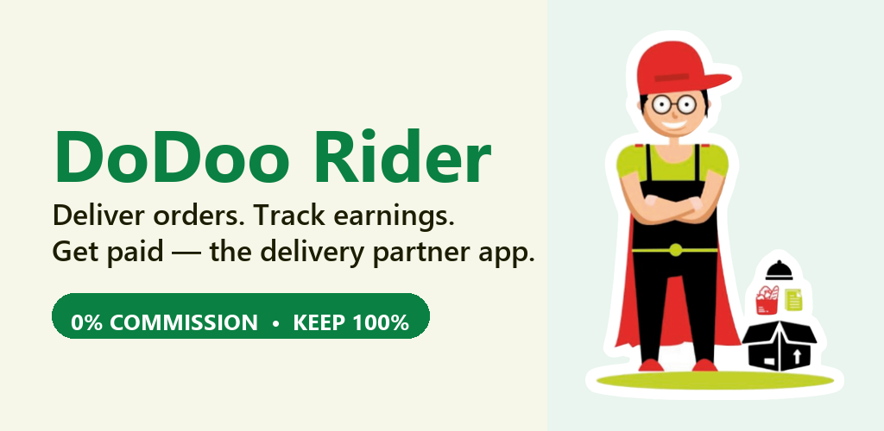
Upload to: Feature graphic
Phone screenshots (6)
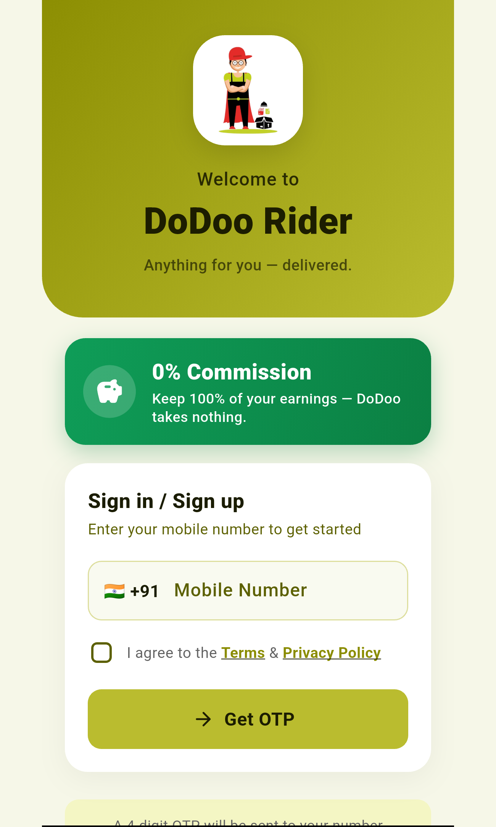  Welcome / 0% commission | 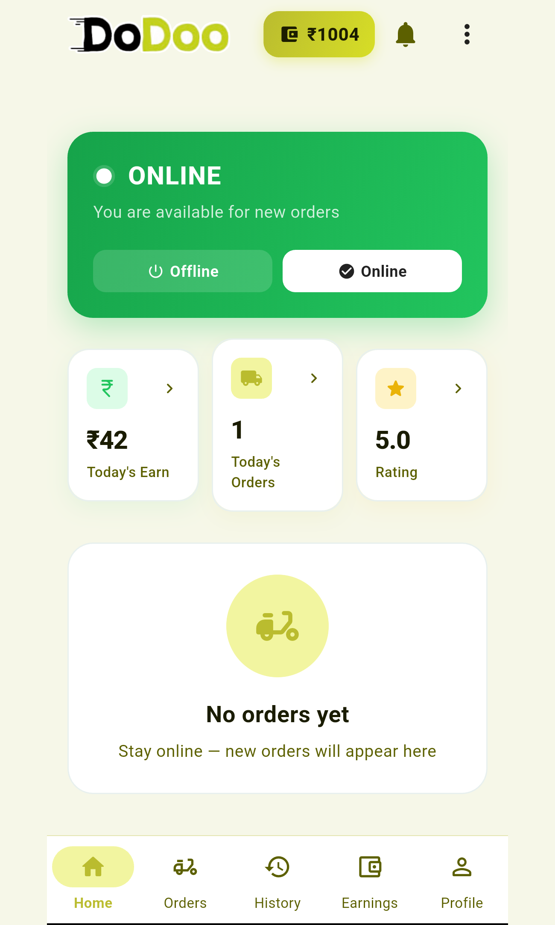  Dashboard | 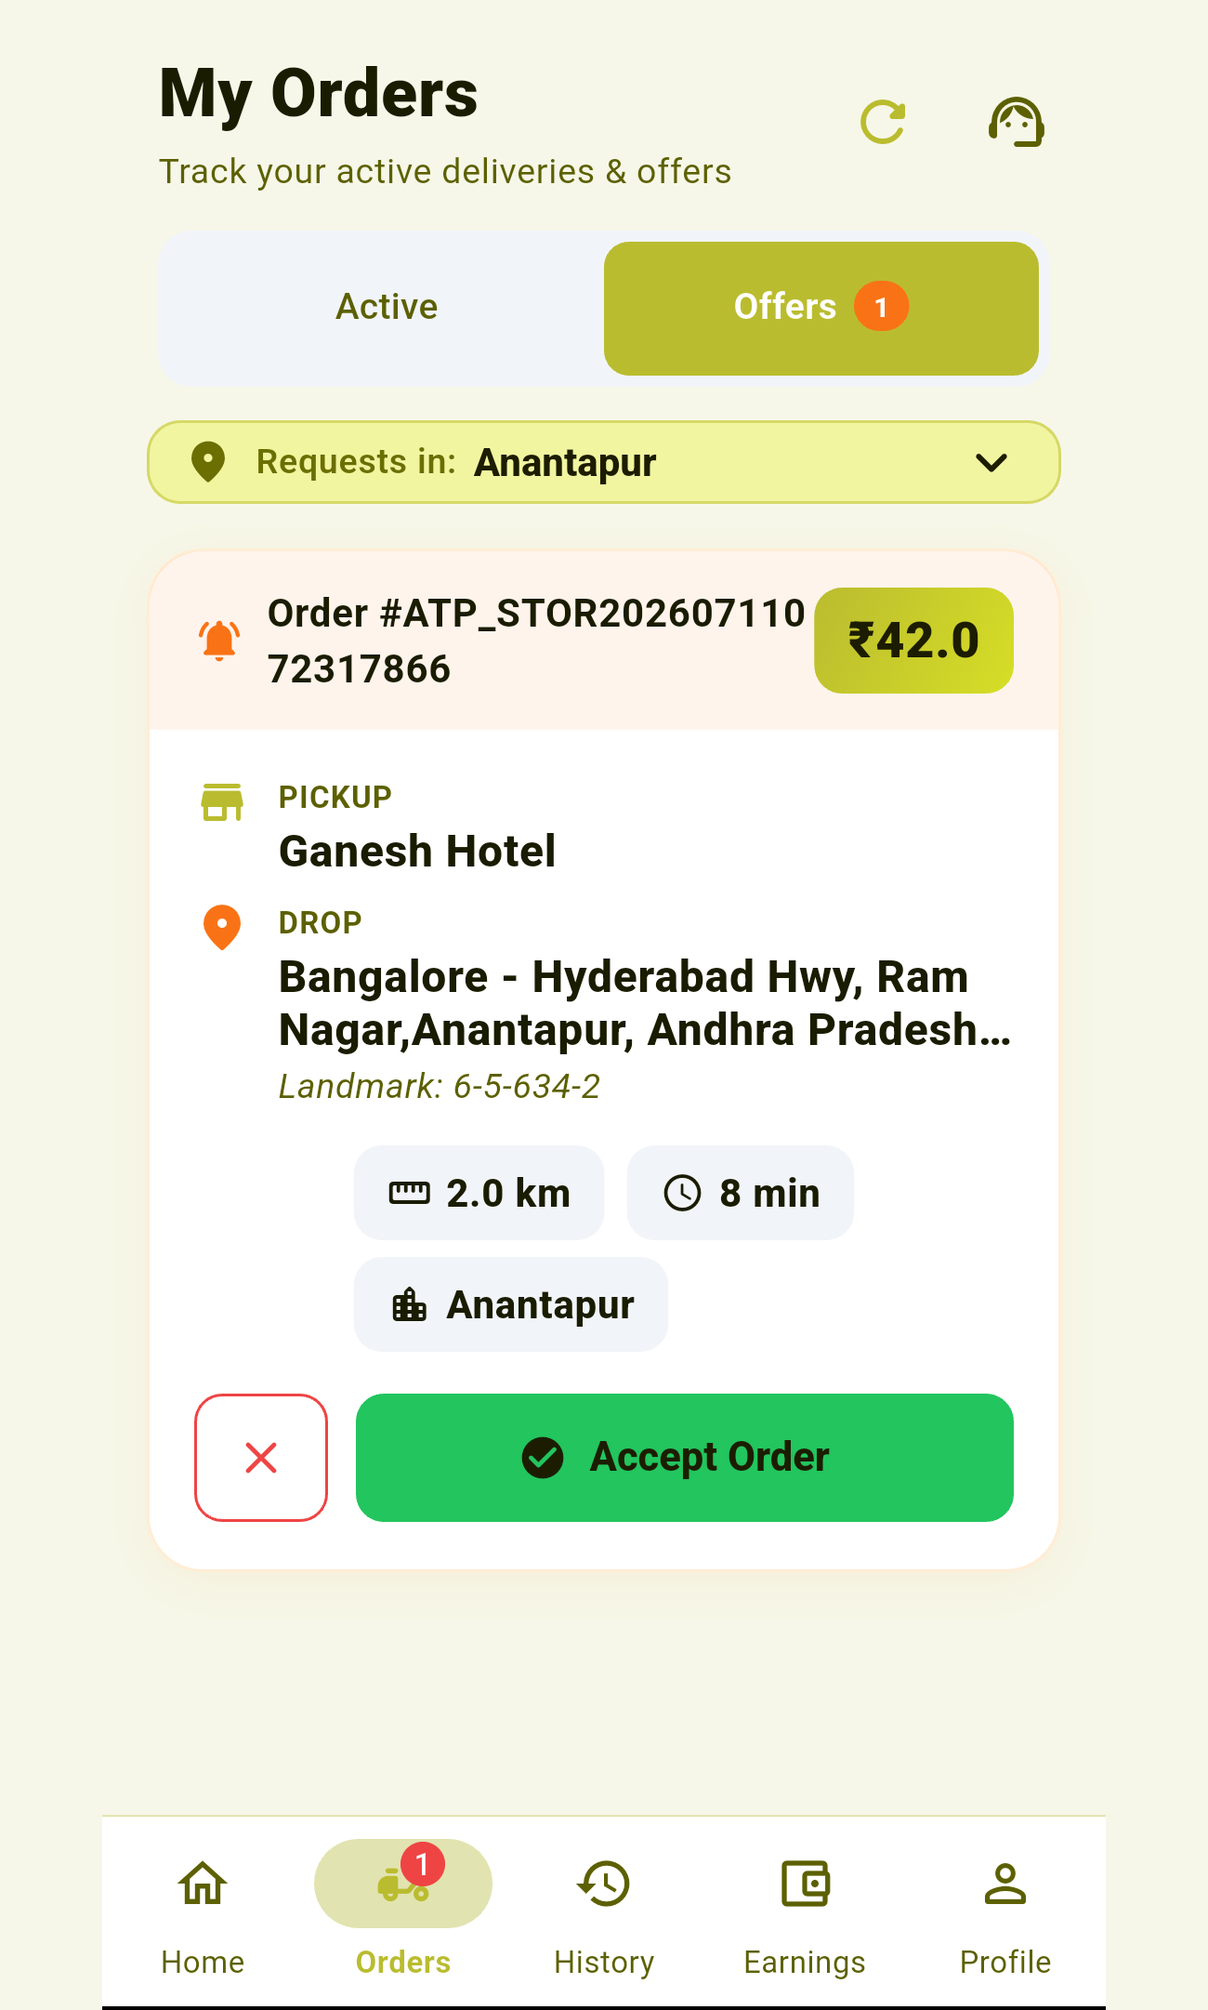  Incoming offer
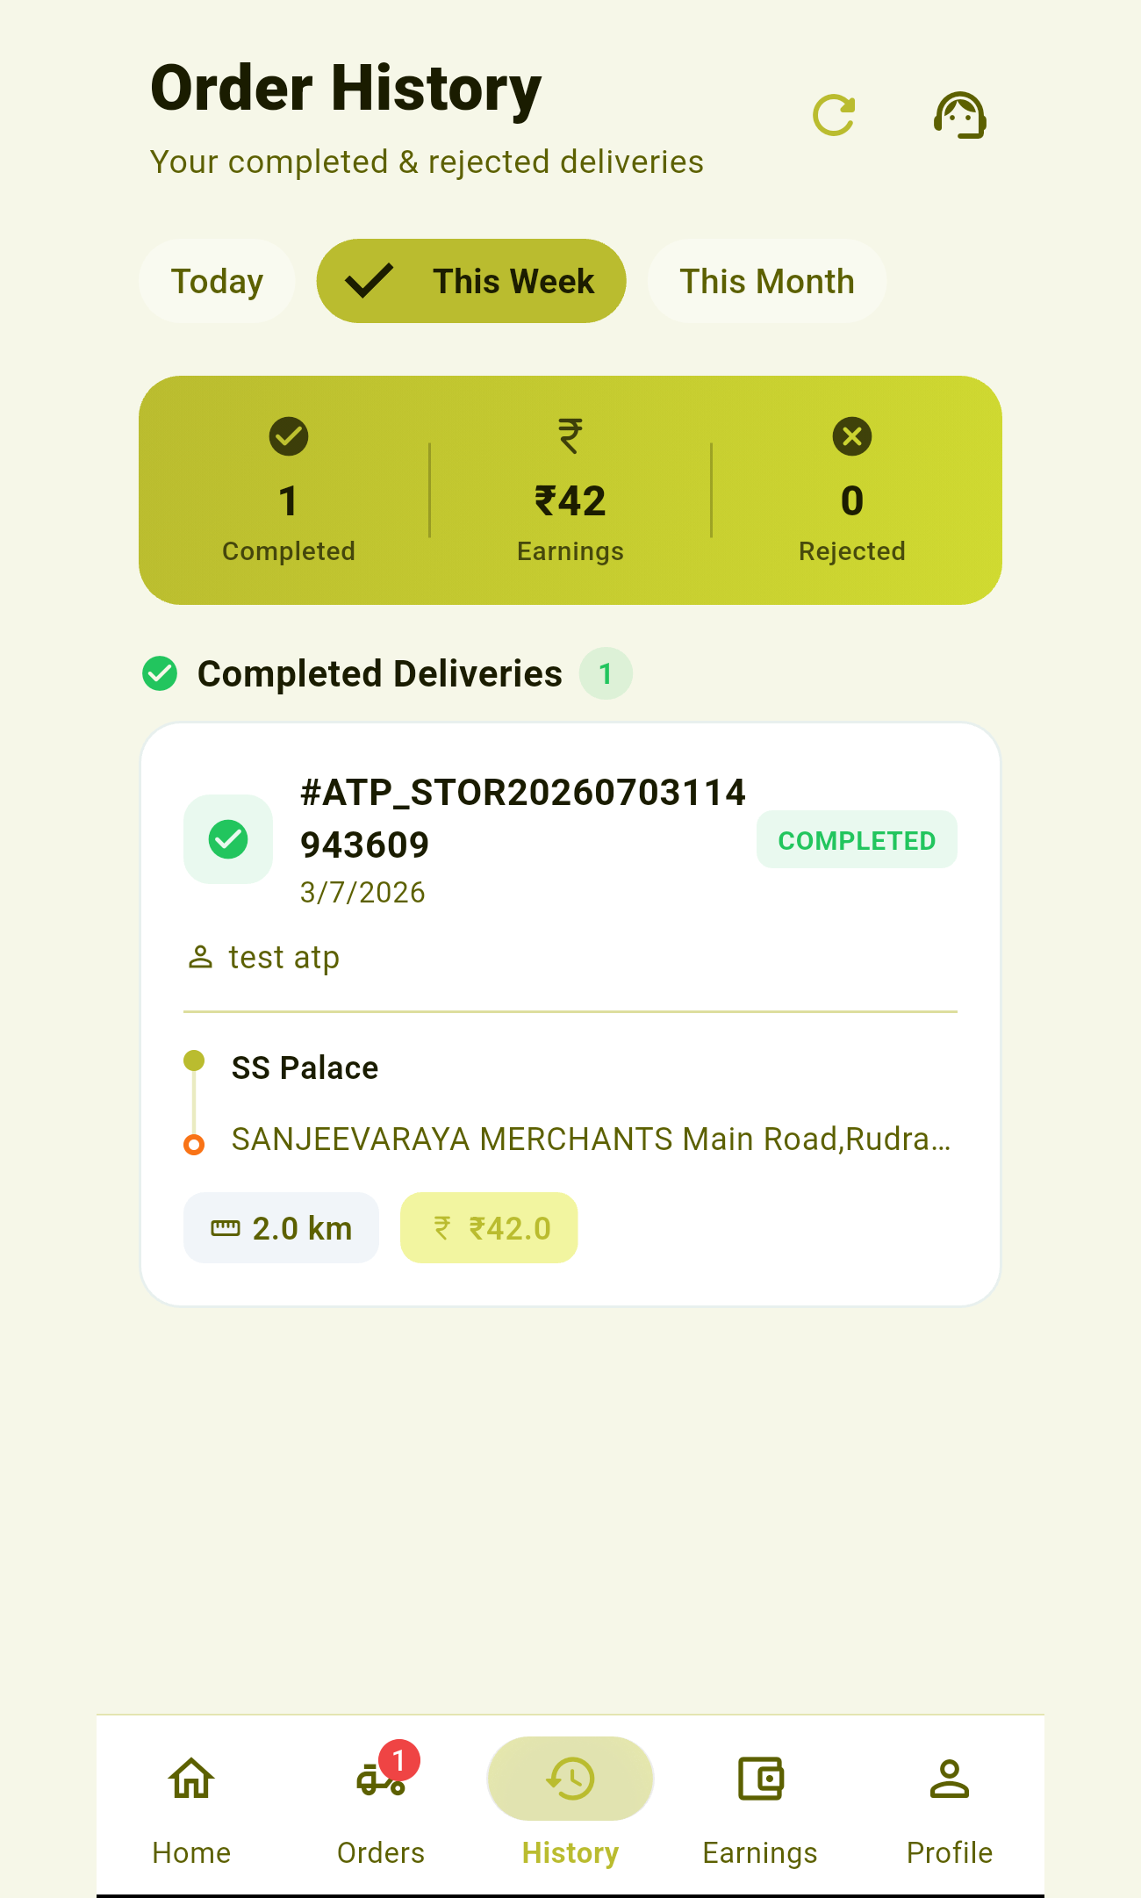  Order history | 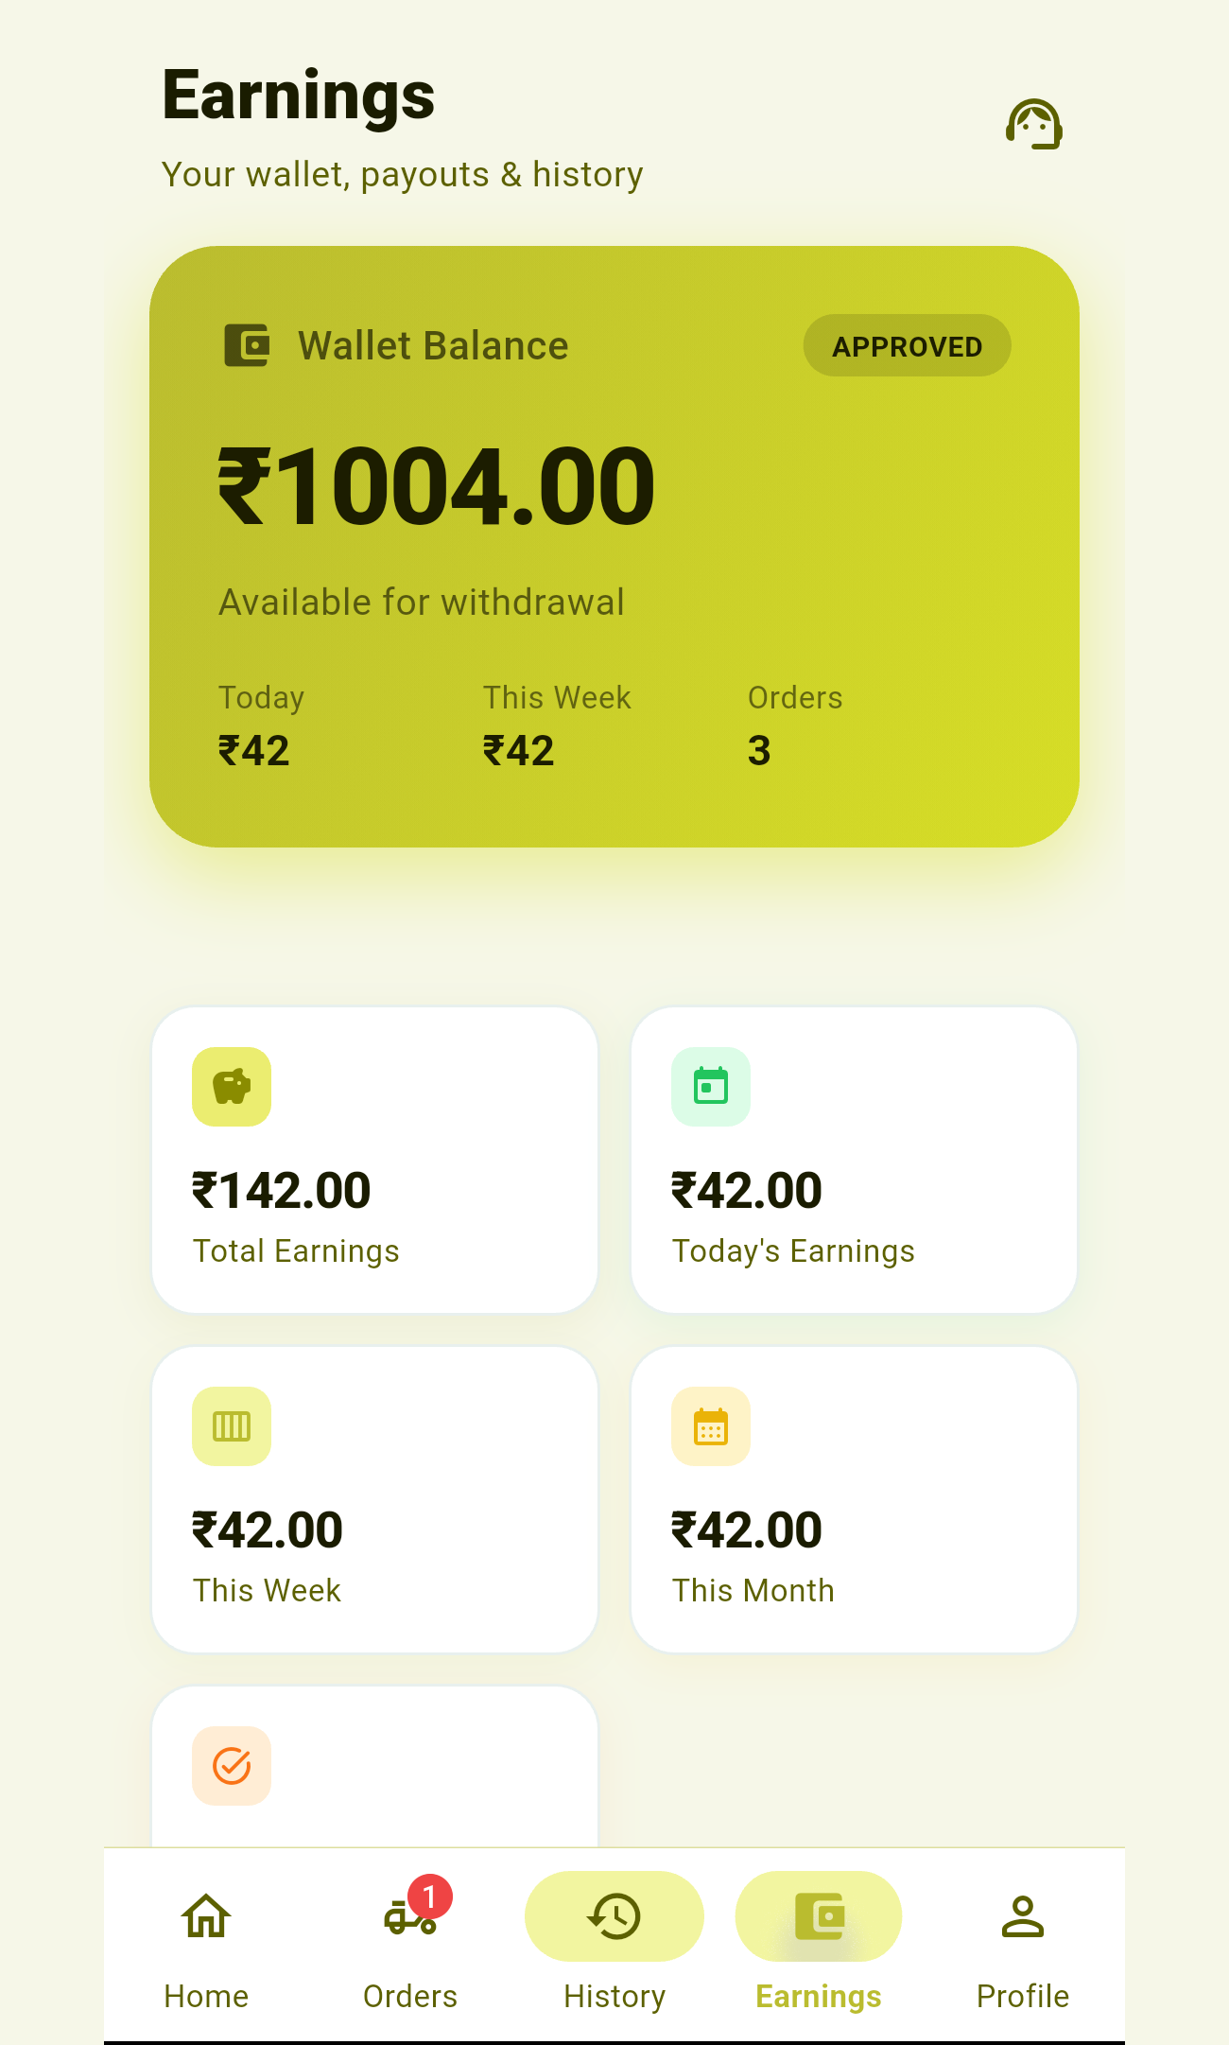  Earnings wallet | 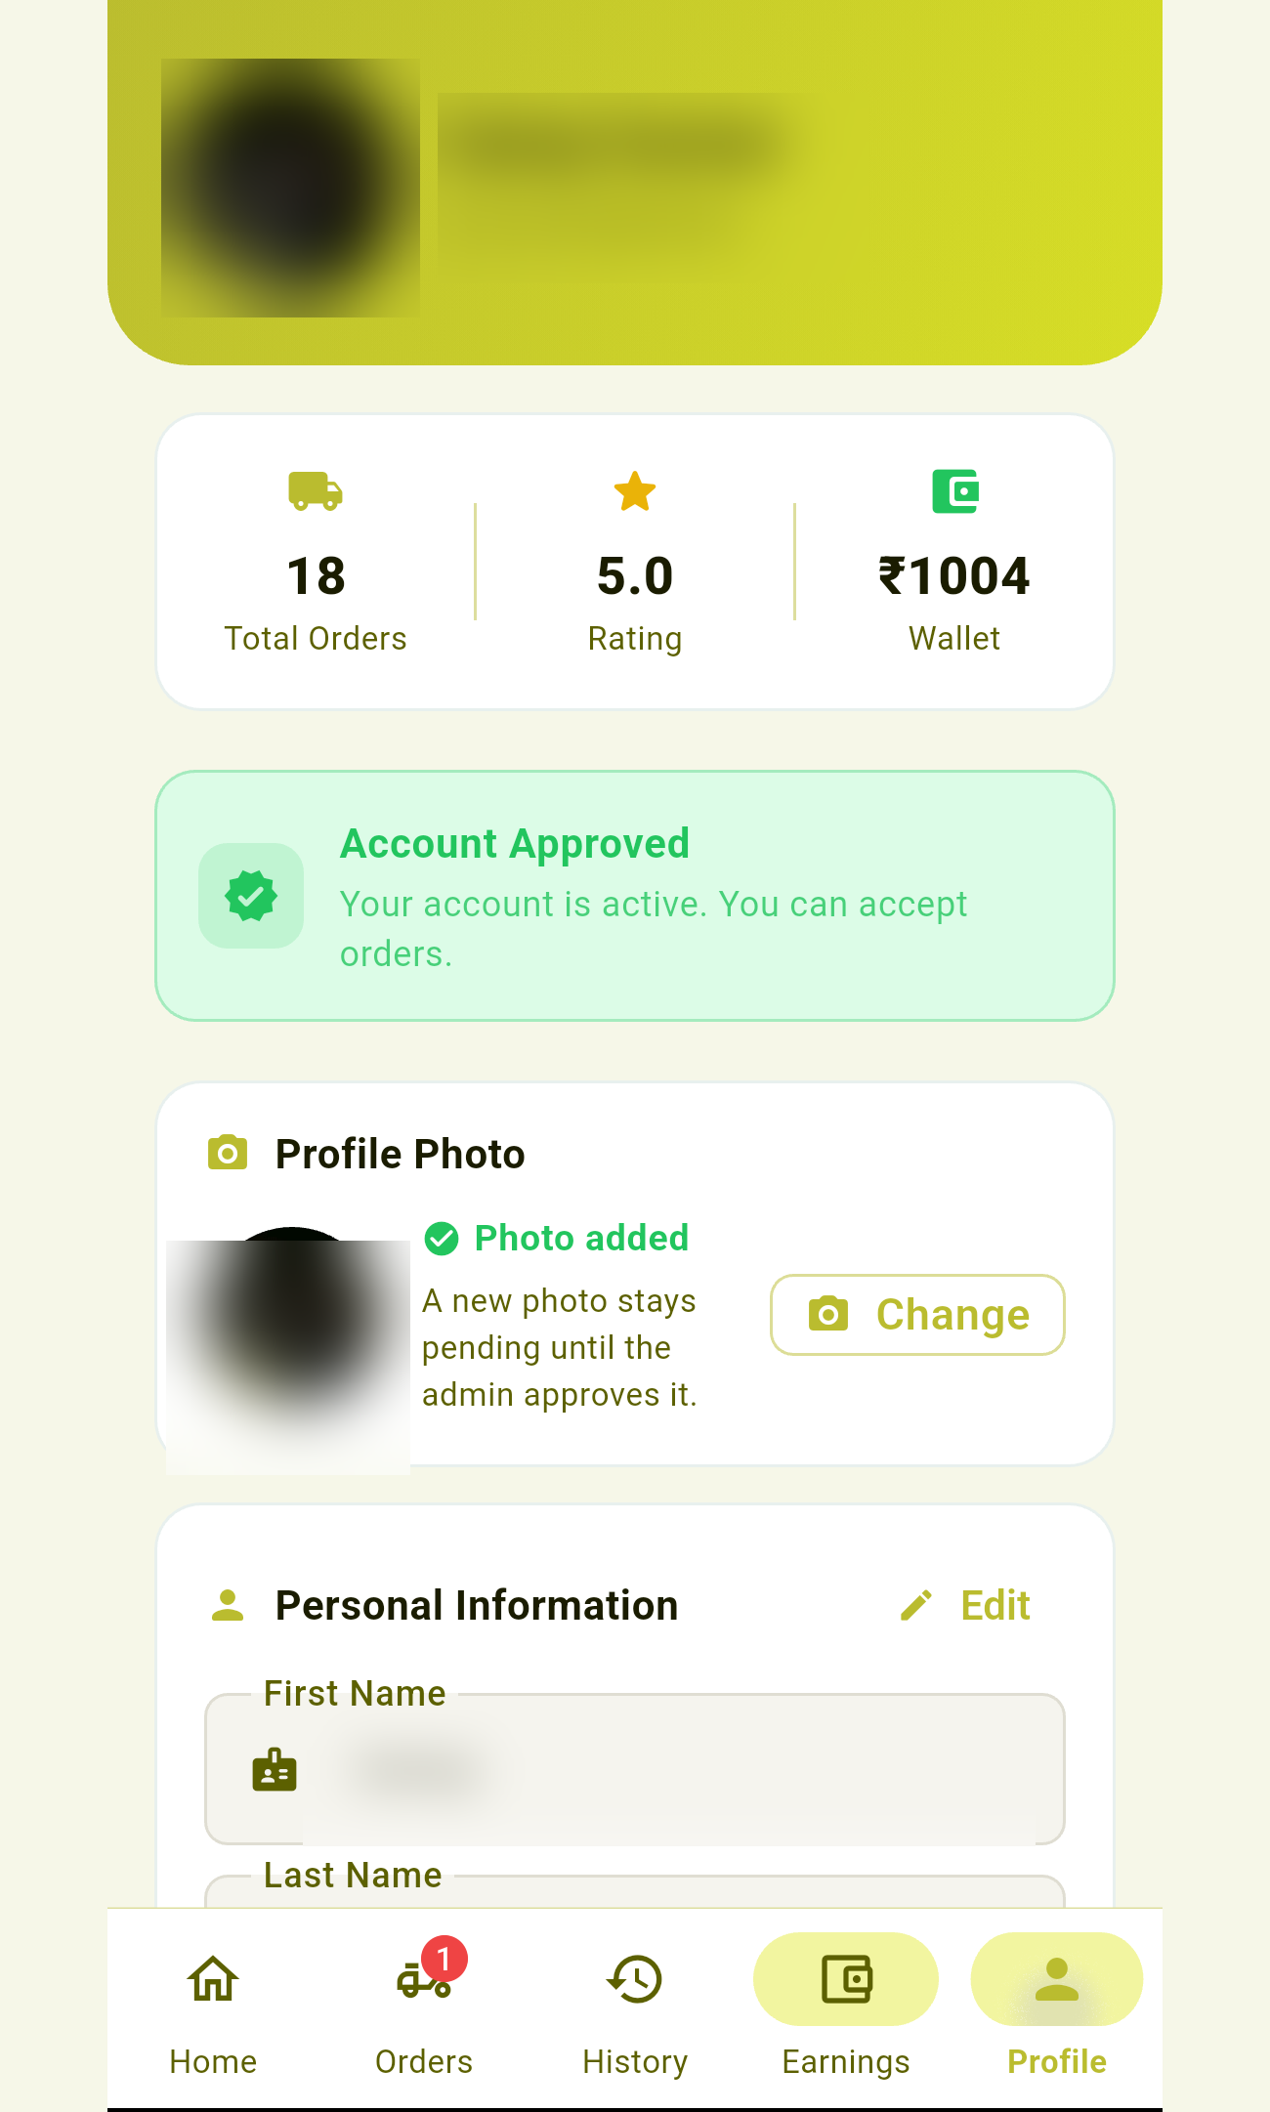  Profile (anonymized)

3. Permissions — and the ONE thing to fix before submitting
Permission | Used for | Play notes
INTERNET | All network calls (Firestore, APIs) | Standard
ACCESS_COARSE_LOCATION | Nearest-city / delivery location | Foreground only
ACCESS_FINE_LOCATION | Precise pickup/drop tracking | Foreground only
POST_NOTIFICATIONS | New-order alerts | Standard (Android 13+)
WAKE_LOCK | Keep alerts working | Standard
ACCESS_BACKGROUND_LOCATION | Declared but NOT used | Triggers strict review — remove
FOREGROUND_SERVICE | Declared, no service exists | Remove unless a service is added
FOREGROUND_SERVICE_LOCATION | Declared, no service exists | Remove unless a service is added

ACTION REQUIRED before first submission
The app requests background-location and foreground-service permissions but the code never uses them — location is only read on-demand (Geolocator.getCurrentPosition), there is no background service and no getPositionStream. Shipping ACCESS_BACKGROUND_LOCATION forces Google's background-location review (written justification + a demo video + weeks of delay) and is a common rejection reason.
Recommendation: remove these three lines from android/app/src/main/AndroidManifest.xml until a real background-tracking feature exists. Foreground fine/coarse location is enough for the current feature set and needs only the standard in-app location disclosure.
<uses-permission android:name="android.permission.ACCESS_BACKGROUND_LOCATION" />
<uses-permission android:name="android.permission.FOREGROUND_SERVICE" />
<uses-permission android:name="android.permission.FOREGROUND_SERVICE_LOCATION" />

4. Data safety form (Play Console answers)
The app collects the following. Answer the Data safety questionnaire accordingly.
Data type | Collected | Purpose | Shared? | Optional?
Phone number | Yes | Account/identity, login (OTP) | No | Required
Name | Yes | Account, delivery assignment | No | Required
Address | Yes | City/area matching | No | Optional
Approx. + precise location | Yes | Delivery pickup/drop | No | Required (in-use)
Photos (profile) | Yes | Profile identity | No | Optional
Government ID (Aadhaar, licence) | Yes | Partner verification (KYC) | No | Required to deliver
Bank account / IFSC | Yes | Earnings payout | No | Optional
App activity (orders, earnings) | Yes | Core app function | No | Required

- Data encrypted in transit? Yes (HTTPS / Firestore TLS).
- Users can request deletion? Yes — provide an in-app or email path.
- Data sold? No.
- Images stored on Cloudinary; order/profile data in Cloud Firestore.
Sensitive data notice
Because you collect government IDs and bank details, your Data safety section and privacy policy must explicitly cover them, with a clear KYC / data-retention statement.

5. Privacy policy (mandatory)
Google requires a hosted privacy-policy URL for any app handling personal or sensitive data. Host a page (e.g. https://dodoo.in/privacy-rider) covering:
- Who you are (DoDoo) and contact email.
- What you collect: phone, name, address, location, profile photo, Aadhaar & driving-licence images, bank account/IFSC, order & earnings activity.
- Why: partner onboarding/verification (KYC), assigning & tracking deliveries, paying earnings, fraud prevention, support.
- Where it's stored: Google Firebase (Firestore) and Cloudinary (images); processed by DoDoo's order services.
- Sharing: not sold; shared only as needed to operate deliveries and payouts.
- Security: TLS in transit, access-controlled Firestore rules.
- Retention & deletion: how long KYC data is kept and how a partner requests account/data deletion (required by Play).
- Users’ rights and how to contact you.

6. Build, sign & upload
Play Store requires an App Bundle (.aab), release-signed. A debug-signed or unsigned build is rejected.

6.1 One-time: create a release keystore
keytool -genkey -v -keystore dodoo-release.jks -keyalg RSA -keysize 2048 \
-validity 10000 -alias dodoo
Back up the keystore forever
Back up dodoo-release.jks and its passwords somewhere safe. If you lose it you can never update the app on Play (you'd have to publish a brand-new listing). Do NOT commit it to git.
Create android/key.properties (also git-ignored):
storeFile=../dodoo-release.jks
storePassword=YOUR_STORE_PASSWORD
keyAlias=dodoo
keyPassword=YOUR_KEY_PASSWORD
The release signingConfig in android/app/build.gradle.kts picks this file up automatically when it exists.

6.2 Build the release App Bundle
flutter clean # always clean first — avoids stale compiled Dart
flutter build appbundle --release --flavor rider -t lib/main.dart
# output: build/app/outputs/bundle/riderRelease/app-rider-release.aab
Always flutter clean before a release build
We hit incremental builds that shipped stale code (an old version string compiled into an otherwise-current build). A clean build is the only reliable cure. After building, verify the version string is inside the binary:
flutter build apk --release --flavor rider -t lib/main.dart --split-per-abi --target-platform android-arm64
unzip -p build/app/outputs/flutter-apk/app-arm64-v8a-rider-release.apk \
lib/arm64-v8a/libapp.so | grep -a -o "v1\.3\.[0-9]" | sort -u # prints current version

6.3 Upload
- Play Console → Create app → name, language, app/game, free.
- Complete App content (privacy policy, ads, data safety, target audience, content rating), then Production → Create release.
- Upload the .aab, add release notes, roll out.
- Google manages the signing key (Play App Signing) — keep your upload key safe.

7. Pre-launch checklist
- ☐ Remove unused background-location / foreground-service permissions (section 3).
- ☐ Bump version in pubspec.yaml and the version string in profile_tab.dart.
- ☐ flutter clean + build .aab; verify the version string inside the build.
- ☐ Release keystore created and BACKED UP; key.properties in place.
- ☐ Privacy-policy URL live and linked in Play Console.
- ☐ Data safety form completed (phone, location, ID, bank).
- ☐ Icon 512×512, feature graphic 1024×500, 2–8 screenshots.
- ☐ Test the signed release build on a real device (login → online → accept → deliver → withdraw).
- ☐ Confirm google-services.json includes com.dodoo.delivery.rider.
- ☐ Admin default password (dodoo@123) is not shipped in a public build.

