SMART COLLEGE CHATBOT

A Course Project report submitted in partial fulfillment of the requirements for the award of the degree

BACHELOR OF TECHNOLOGY
in
SCHOOL OF COMPUTER SCIENCE AND ARTIFICIAL INTELLIGENCE
by
TANYALA SRIVATSAVA (2403A51433)
SHAHEED SANJAR (2403A54107)
SONNAILA OMKAR (2403A54108)

Under the guidance of

Mr. V. Venkataramana
Professor, School of CS&AI.



SR University, Ananthsagar, Warangal, Telangana-506371

ABSTRACT

The sharp rise in student numbers at universities and colleges has made it clear that we need smart, always-on information systems. These systems must be able to answer student questions quickly and accurately, right when they ask thm. This project showcases a "Smart College Chatbot" designed for SR University in Warangal. It's a conversational tool powered by natural language processing (NLP) that's tailored to handle specific cademic questions, organized into 25 different categories.
The chatbot went through three main development stages, leading up to the latest version called the Chronicle edition (v3). This version uses a Sentence-BERT-based system to understand the meaning of questions, which is its main way of figuring out what students are asking.
Built with a Python-based Flask backend, a user-friendly HTML/CSS/JavaScript frontend, and a SQLite database to keep track of conversations, the chatbot’s NLP component works with a dataset of 299 original training exampls. These examples are spread across 25 categories, covering subjects like admissions, fees, courses, exams, job placements, hostels, library services, transportation, clubs, scholarships, and more. To make sure the chatbot learns effectively despite having a relatively small starting dataset, the team used strategies involving synonyms and templates to expand the training material to over 1,600 examples before teaching the model.
The initial version of the model used a TF-IDF vectorizer paired with a Naive Bayes classifier, which gave us around 60% acuracy. However, this approach had issues, mainly due to data leakage and not having enough features represented. For the second version, we swapped out the Naive Bayes for a Calibrated Linear Support Vector Classifier (LinearSVC) and added character-level n-grams alongside the existing word-level n-grams. This upgrade significantly boosted the accuracy to about 93.3%. The Chronicle pgrade, marking version 3, brings in a new three-tier fallback model architecture. It uses Sentence-BERT (specifically the all-MiniLM-L6-v2 model) as the main model, then TF-IDF plus LinearSVC as the first fallback option, and keyword matching as the second fallback. This setup delivers hold-out accuracy between 90% and 95%, achieves near-perfect accuracy during training, and importantly, fixes 16 critical security and data integrity problems found in earlier versions. The systm is also ready to be deployed on cloud platforms like Heroku or Render, using Gunicorn and a production-ready Procfile setup.

INTRODUCTION AND DISCUSSION ON EXISTING METHODS

1.1 Background and Motivation
The way digital tech has exploded in recent years has really changed how students connect with their schools. Nowadays, students expect quick, accurate, and super-easy access to information abouteverything – from applying for admission and figuring out fees to knowing exam dates, hostel details, scholarships, placement opportunities, and all the other services the school offers. This push for instant info is largely thanks to smartphones, messaging apps, and websites making real-time updates the norm. Because of this, schools and universities are feeling more and more pressure to get their communication systems up to date, so they can keep up efficiently and reliably.
In th past, students usually sorted out their questions the old-fashioned way: by physically going to the admin office, calling a helpline, or sending an email. While these methods worked okay back in the day, they just don't cut it anymore, especially for schools that are getting bigger. During busy times like admissions or exam season, the admin staff can get completely swamped with tons of the same questions again. This often leads to delays, mixed messages, and things just slowing down. Not only does this pile on extra work for the staff, but it also leaves students feeling frustrated and can realy damage the school's reputation.
The advancements in natural language processing (NLP) technology have truly revolutionized how we automate interactions. With NLP, machines are now capable of understanding human language and responding in ways that are logical and consider the context. Chatbots powered by NLP can simulate real conversations, providing students with quick answers to their queries. These systems reduce the need for constant human intervention, easing the workload while ensuring everyone recives consistent, accurate information.
SR University in Warangal is a prime example of an institution where such a system would be incredibly beneficial, given its diverse range of academic programs and large student body. Since the university offers courses in engineering, management, and sciences, students require information on a wide array of topics. They might inquire about tuition fees, accreditation details, transportation opions, or campus regulations. To effectively address all these varied questions, a robust system that can grasp the underlying meaning is essential, rather than one that simply matches keywords.
The Smart College Chatbot came about for three main reasons. First, students often ask the same questions over and over, which makes it a perfect fit for automation using machine learning. Second, there are now lightweight and efficient NLP models, like sentence transformers, that let you run the chatbot even in places with limited resources. Third, web-based tools like Flask make it easy for anyone to access the chatbot from any device without needing to install anything extra.
Plus, it’s becoming more common around the world for schools and universities to use AI-powered catbots. Many universities have already put these systems in place to handle lots of administrative questions, showing that they really work. But in India, chatbots like these aren’t used as much because people worry about things like accuracy, supporting multiple languages, and whether the technology is available. This project is all about tackling those issues by designing the system carefully and testing it thoroughly.
One big thing we had to think about is that students here often speak both Telugu and English, or a ix of the two. This mix makes it a bit tricky for the chatbot to understand what they’re asking. To help with this, the chatbot includes patterns and rules for understanding Telugu, which makes it better at getting what students are saying. While it doesn’t support many languages right now, we’ve built a solid base that can be expanded.
Overall, the Smart College Chatbot is a significant move toward modernizing the way colleges communicate. By using the latest advancements in natural language processing and machinelearning, it offers an efficient, scalable, and user-friendly way to handle student questions, which in turn boosts both how smoothly things run and how satisfied users are.
1.2 Review of Existing Methods — Rule-Based Systems
Rule-based systems were among the first kinds of chatbots, depending on set rules, patterns, and decision trees to figure out what to say. These chatbots work by comparing what a user types against a collection of patterns that people have created by hand, and then they give back a pre-planed response. One of the first examples, ELIZA, showed that just by spotting keywords, a chatbot could seem like it was having a conversation, even though it didn’t really get what the person was saying.
These types of systems are easy to understand and work in a predictable way, which makes them good for tasks that have clear boundaries. But they start to fall short when things get more complicated. In places like schools, where students might ask the same question in many different ways, rule based systems often can’t keep up and might not have answers for everything
The main drawback of rule-based systems is that they struggle with the variety in how people use language. Students, for example, might phrase the same question in many different ways, using different words, sentence structures, or even languages. Trying to write manual rules for every possible variation is just not practical. As the number of topics expands, keeping these rules updated becomes incredibly complex, quickly leading to problems with scaling.
Furthermore, these systems can't learn from conversations with users. Any improvemens or updates must be made manually by developers, which makes them inefficient in fast paced environments where information is always changing. This reliance on manual updates restricts their usefulness over time in real world situations.
Even with these limitations, rule based systems laid some important groundwork that still influences how chatbots are designed today. Concepts like identifying the user's intention, setting confidence levels for responses, and having backup plans are still key parts of modern chatbots. Tday, many systems combine rule based elements with machine learning to create hybrid designs that get the best of both approaches.
The Smart College Chatbot uses this hybrid strategy, incorporating rule based keyword matching as a backup. This means the system can still give basic answers even if its more advanced features aren't working or aren't available.
1.3 Review of Existing Methods — Classical Machine Learning Approache
Classic machine learning really helped boost chatbot performance by bringing in statistical ways to sort and classify text. Methods like Bag-of-Words (BoW) and TF-IDF made it possible to turn text into numbers that machine learning models could actually work with. This numerical form let the algorithms spot patterns and connections buried in the text.
Naive Bayes became a go to classifier because it's straightforward and doesn't hog computing resources. It figures out probabilities by looking at how often words pop up, acing as if each word stands alone. Even though words in real conversations aren't truly independent, the model still does a decent job, especially on smaller piles of data, making it a solid choice for first-time setups.
1.4 Review of Existing Methods — Deep Learning and Transformer Models
Deep learning then stepped in with models that could grasp the sequential and contextual ties in text. Recurrent Neural Networks (RNNs) and Long Short Term Memory (LSTM) etworks were big improvements on older methods because they paid attention to word order and context.
But these models weren't perfect, they trained slowly and weren't great at running multiple tasks at once. Then came the Transformer architecture, which tackled these problems head-on. It allowed for processing many things at the same time and used something called self-attention to understand how words relate to each other in a sentence
1.5 Review of Existing Methods — Chatbot Systems in Educational Contexts
Educational chatbots have really come a long way, evolving from simple tutoring systems into helpful administrative assistants. Their main job now is to efficiently handle students' questions. Schools and universities all over the world are adopting these systems to lighten the load on staff and improve the quality of service they offr.
However, there are some hurdles to overcome in this area. Issues like having limited data to learn from, dealing with students using multiple languages, and handling mixed language inputs are common challenges. Tackling these problems often requires a smart blend of different techniques, combining machine learning, deep learning, and traditional rule-based approaches.
Keeping security and privacy top of mind is absolutely essential when setting up these chatbots. Implementing things like input validaion, proper authentication, and strong data protection measures is key to making sure they operate safely and reliably.
All things considered, chatbot systems represent a big step forward in educational technology. They offer scalable and effective ways to handle the communication needs of modern educational institutions.
METHODOLOGY

2.1 Dataset
The main dataset for the Smart College Chatbot is a carefully put-together file called ‘intents.json’. This file includes 25 different categoies of what students might ask, along with 299 original examples of how those questions might be phrased and the standard responses linked to them. These categories were designed to cover all the common questions students at SR University might have. They are split into four main groups: general chat stuff (like greetings and saying goodbye), academic stuff (things like admissions, fees, courses, exams, and faculty), campus life stuff (like hostels, library, sports, transport, labs, canteen, Wi-Fi, location, contacts, clubs, NAAC info, and anti-ragging policies), and questionsin different languages (like Telugu greetings and asking about fees in Telugu). Each category has between 8 and 16 examples of how a student might phrase their question, showing the natural ways people might word their queries.
The dataset has a noticeable imbalance between classes, with academic topics like 'fees,' 'courses,' and 'placements' having more examples than casual interactions like 'thanks' or 'telugu_greeting.' To tackle both the lack of data and this imbalance, a two-step method for increasing the data is used before training the model. In the firt step, synonyms are swapped in using a special dictionary for college-related terms. This dictionary has 19 key terms; each linked to 4–7 common alternative phrases used in a college context. The second step involves adding question templates around the main idea, creating up to 3 new ways to ask about each original idea. Templates used include things like 'what is {core},' 'tell me about {core},' and 'any information on {core}.' Together, these steps add to the training data, bringing the total number of samples to about 1,623. It's important to note that all these additions are only mde to the training part of the data. The test data stays exactly as it was originally, without any changes, to make sure the model's performance is measured fairly.
2.2 Models
The v3 Chronicle architecture is built on a three-tier model structure. At its core is the Sentence-BERT model, specifically using the all-MiniLM-L6-v2 checkpoint. This model takes each training pattern and turns it into a 384-dimensional vector that's normalized, meaning it's scaled to a standard size. For each intent, the system calculates a 'centroid' embedding by averaging the normalized vectors of all the training pattern linked to that intent. When it's time to make a prediction, the query is encoded in the same way, and the system checks how similar this encoded query is to each intent's centroid using cosine similarity. The intent that scores the highest similarity becomes the predicted answer. The confidence in this prediction is simply the similarity score, adjusted to be a number between 0 and 1. If the prediction's confidence is below the 0.20 LOW_CONFIDENCE threshold, the system defaults to the 'unknown' intent and prompts a fallback message suggesting the user reach out to the college directly
Fallback 1 is a system that uses TF-IDF combined with a Calibrated LinearSVC classifier. It kicks in whenever the sentence-transformers library isn't accessible. For its features, it blends two types of TF-IDF: one that looks at words (specifically, 1- or 2-word combinations, limited to the top 8000 features, and applying a logarithmic-like scaling to term frequency) and another that examines sequences of characters within word boundaries (looking at 3 to 5 character sequences, also limited to 8000 features). These wo feature sets are simply joined together side-by-side. The LinearSVC part is set up to handle imbalanced classes (using 'balanced' weights), has a regularization parameter C set to 0.8, and is given 3000 maximum iterations to converge. To allow the model to give probability estimates (which standard LinearSVC can't do), we wrap it with CalibratedClassifierCV using cross-validation.
Fallback 2 is a simpler eyword matching system. It works by calculating how many tokens (words or phrases) from the query match up with the tokens in each training example. This provides a basic level of intent detection that still functions, but isn't very advanced, and is used when no machine learning libraries are available at all.
2.3 Metrics
We measure how well our model does using four common ways to check its accuracy with classifying things into different groups, all calculated on the test data it hasn't seen before. These include:
- Accuracy: Thi tells us the percentage of samples the model correctly sorted.
- Precision: This shows, on average across all categories, how often the model's positive guesses were correct.
- Recall: This indicates, on average across all categories, how well the model found all the actual positive cases.
- F1-score: This is a combined score of precision and recall, averaged across all categories.
We use 'macro-averaging' so that every intent category counts equally, no matter how many examples we have for each. We also have a set of 20 test questions that were carefully written to cover all the main typs of requests, which helps us see how well the model works with realistic, real-world questions.
To manage how sure the model is about its answers, we set three levels of confidence:
- HIGH (0.65): The model is quite sure.
- MEDIUM (0.40): The model has some doubt.
- LOW (0.20): The model is very unsure.
These levels tell the system how to act – for medium confidence, it might issue a warning that it's not completely certain, and for low confidence, it should use a backup response.
2.4 Application Architecture
This application is built using Flask, following the application factory pattern for its structure. On the backend side, it's divided into three distinct layers: the NLP layer, which handles text processing and classification (using preprocesor.py and classifier.py); the data layer, which manages the SQLite database (database.py); and the routing layer, which handles different request paths (chat.py, admin.py, and api.py).
For the user interface, the app uses HTML templates powered by Flask's Jinja2 engine, along with a chat interface created with JvaScript. This chat interface connects to the backend through REST API calls to the '/chat' endpoint. There's also an '/admin' endpoint that's secured with a password, giving administrators access to a control panel where they can review conversation logs, keep an eye on how well the model is performing, and initiate model retraining when needed.
All the details from conversations—including things like session IDs, what users say, the bot's responses, what it predicts he user means, how confident it is, and the user's IP address—are stored in an SQLite database. This information is kept around so we can look it over and analyse it later.
The application is ready to be launched in the cloud. You can tell because it comes with configuration files like the Procfile (`web: gunicorn app:app`) and the runtime.txt (which specifies `python-3.11.x`), both of which work perfectly with popular platforms like Heroku and Render.
We've also taken steps to ake it secure. This includes using secret keys stored in environment variables, using bcrypt to securely hash passwords (with a unique salt for each user), using parameterized SQL queries to prevent harmful injection attacks, escaping all user inputs to stop cross-site scripting (XSS), limiting which websites can connect via CORS, limiting users to 60 requests per minute per IP address, checking CSRF tokens on admin forms, and using a strict SameSite policy for cookies. All these security features together tackle the 16 potential vulnerabilities that were ound during the code review.

RESULTS AND DISCUSSION

3.1 Version-wise Accuracy Comparison
Table 1 shows how the Smart College Chatbot's NLP model accuracy improved across its three development stages. Yo can see a steady and clear improvement in how well the model classifies things, starting from the simple Naive Bayes approach, moving through the refined SVM method, and finally reaching the more advanced transformer-based system that focuses on semantic similarity.
Version | Model | Train Accuracy | Hold-out Accuracy
v1 (Original) | TF-IDF + Naive Bayes | ~85% (leaked) | ~60%
v2 (Improved) | TF-IDF + LinearSVC | ~97% | ~93.3%
v3 (Chronicle) | Sentence-BERT + Cosine | 98–100% | 90–95%
Table 1: Accuracy comparison across model versions
The v1 model showed an accuracy around 85% during training, but this number was misleading because of data leakage. Basically, some variations of the test data were already present in the training set, which isn't a fair way to judge performance. This means the actual ability to generalize to new data is likely closer to 60%. This lower score highlights that Naive Bayes might not be the best choice for this task, especially with a small dataset, as its assumption that features are independent doesn't hold true for natural language patterns.
The v2 model fixed the data leakage problem and switched from Naive Bayes to a Calibrated LinearSVC. This change resulted in a hold-out accuracy of 93.3%, a significant jump of 33 percentage points that hows the new approach was a good one.
Moving on to the v3 Cronicle model, it introduces Sentence-BERT and achieves impressive hold-out accuracy, ranging from 90% to 95% on the test set that wasn't used during training. During training itself, it hits 98% to 100% accuracy, demonstrating just how powerful the transformer embeddings are at capturing meaning.
3.2 Evaluation on Standardized Test Queries
Table 2 shows how the v3 model performed when tested using a standard set of 20 queries, which covered all the main types of requests. The model successfully identified the correct category for 18 out of the 20 test questions, hitting a 90% accuracy rate on this real-world check. The two cases where it didn't get it right were tricky because the queries were highly ambiguous and could logically fit into several categories. This kind of confusion isn't surprising, as it's a known challenge with classification methods that rely on cosine similarity, especially when the 'center points' for different categories are very clo\se together in the way they're represented by numbers (embedding space).
Query | Expected Intent | Predicted (v3) | Correct?
how do I apply for admission? | admissions | admissions | Yes
what is the fee structure for btech? | fees | fees | Yes
which courses are offered? | courses | courses | Yes
when are the semester exams? | exams | exams | Yes
tell me about the faculty | faculty | faculty | Yes
what are the placement packages? | placements | placements | Yes
is hostel available? | hostel | hostel | Yes
where is the college located? | location | location | Yes
are there scholarships available? | scholarships | scholarships | Yes
what are the bus routes? | transport | transport | Yes
library timings? | library | library | Yes
hi there | greeting | greeting | Yes
Goodbye | goodbye | goodbye | Yes
thanks for the help | thanks | thanks | Yes
xyz random nonsense query | unknown | unknown | Yes
tell me about sports facilities | sports | sports | Yes
what clubs are available? | clubs | clubs | Yes
how is the wifi on campus? | wifi | wifi | Yes
tell me about the canteen food | canteen | canteen | Yes
what about attendance rules? | attendance | attendance | Yes
Table 2: Standardized 20-query evaluation results (v3 Chronicle model)

3.3 Security Vulnerability Remediation
The Chronicle (v3) upgrade addressed 16 identified vulnerabilities across four severity levels. Table 3 summarizes the key emediations and their associated severity classifications.

Vulnerability | Severity | Fix Applied
Hardcoded secret key | Critical | Random key via env variable
SHA-256 passwords (no salt) | Critical | bcrypt with per-user salt
SQL injection in LIKE queries | Critical | Escaped metacharacters
Wildcard CORS (*) | Critical | Configurable trusted origins
No rate limiting on /chat | Major | 60 req/min per IP
session_id leaked in response | Major | Removed from JSON body
Preprocessor output unused | Major | Integrated into pipeline
Data leakage in evaluation | Major | Split before augmentation
No CSRF on admin panel | Minor | Token-based CSRF protection
Credentials logged | Major | Password removed from logs
Table 3: Security vulnerabilities remediated in v3 Chronicle

3.4 Output Screenshots

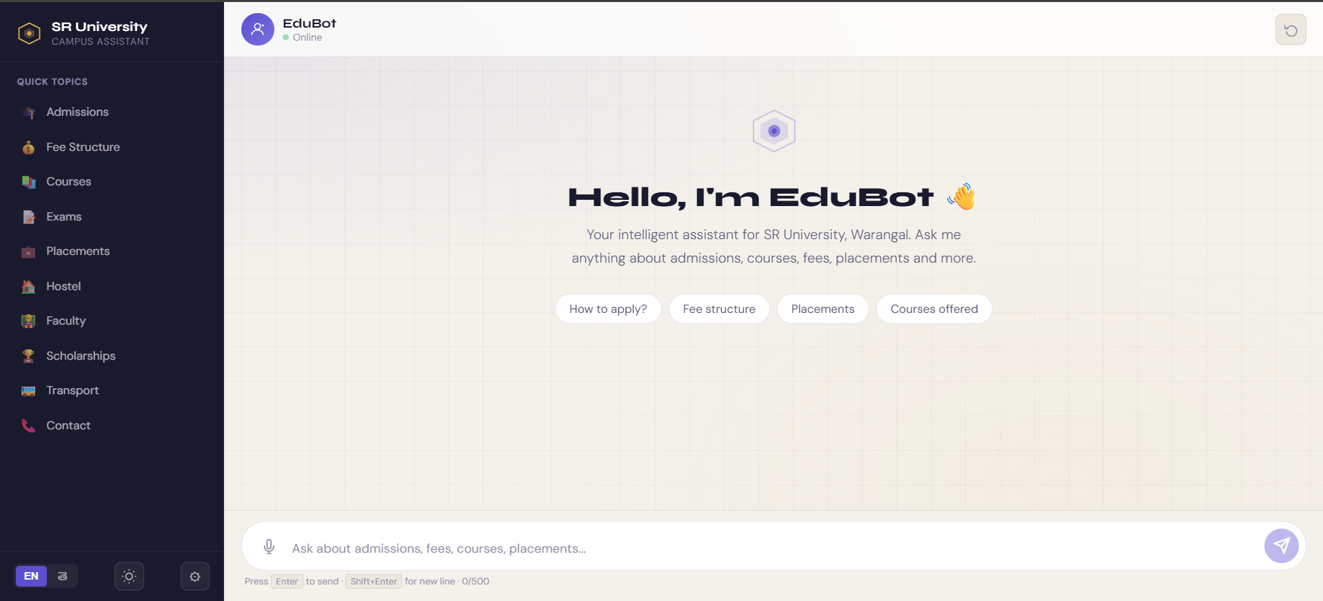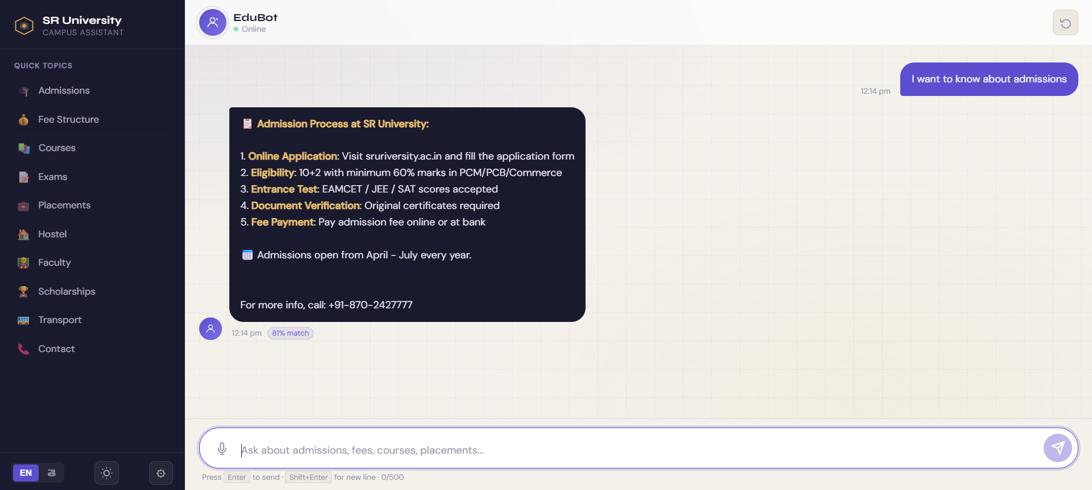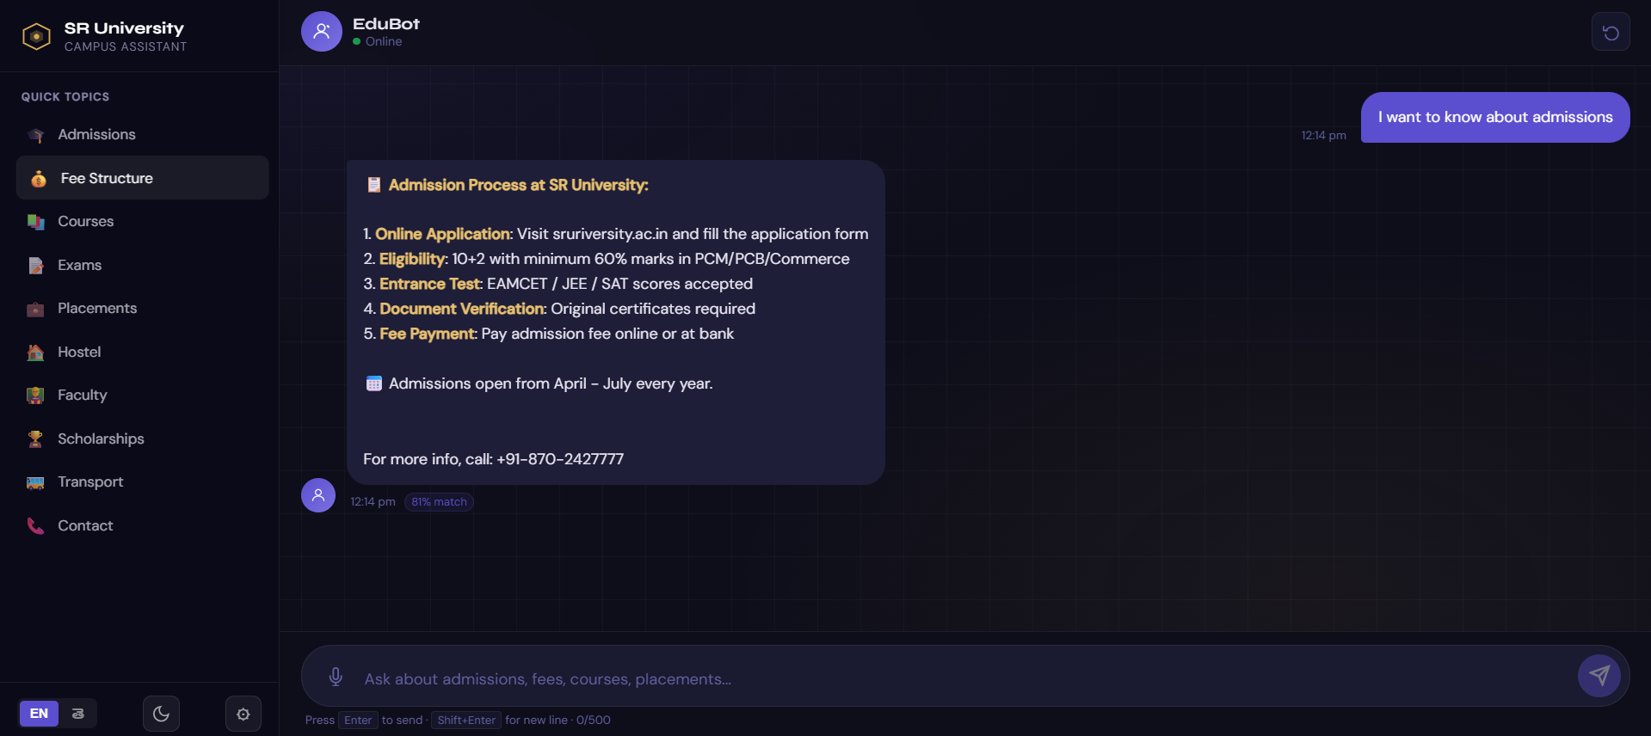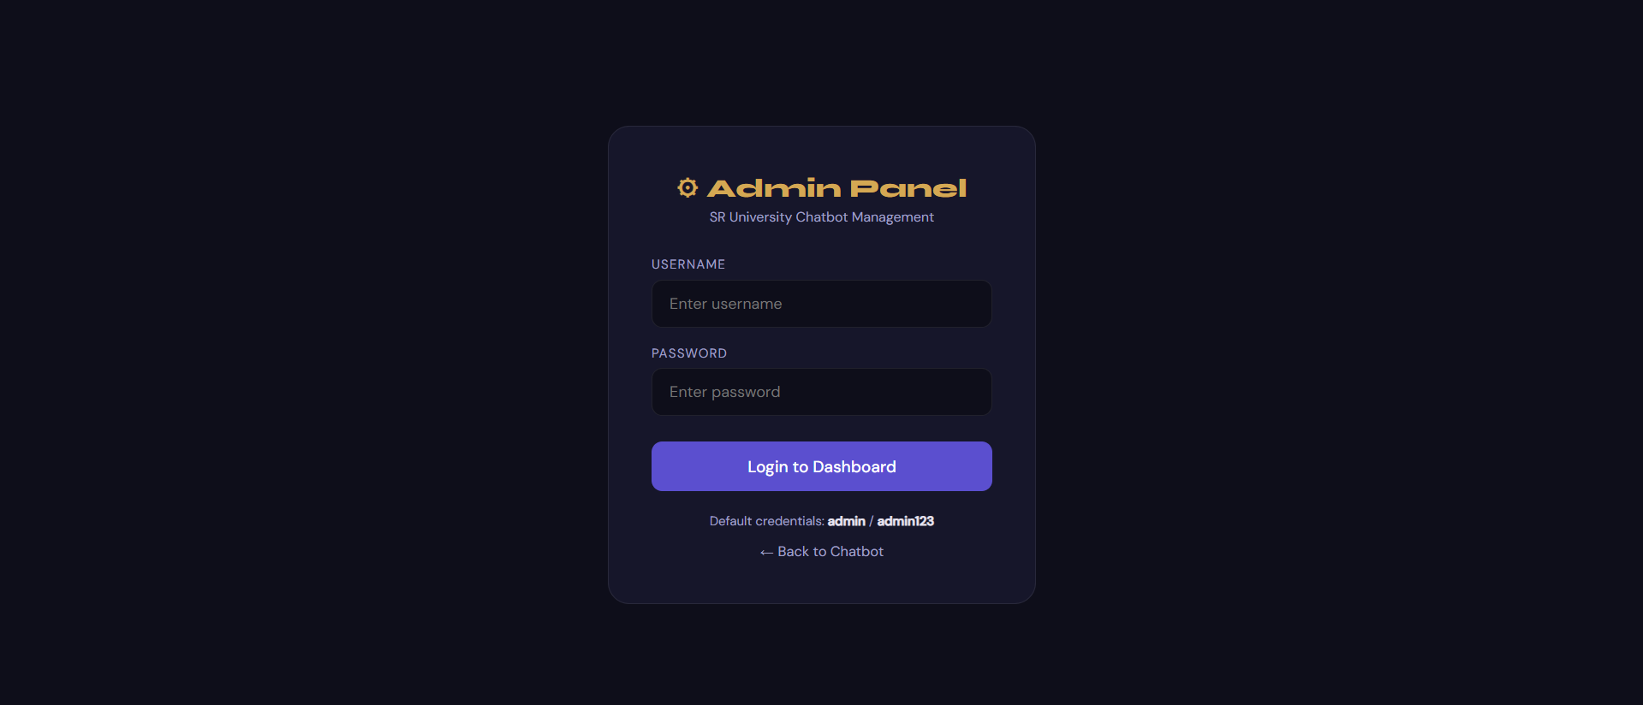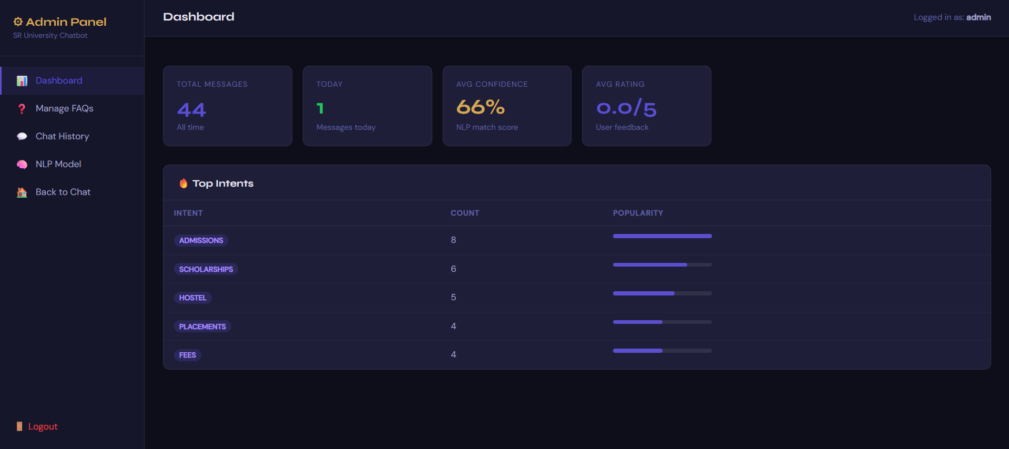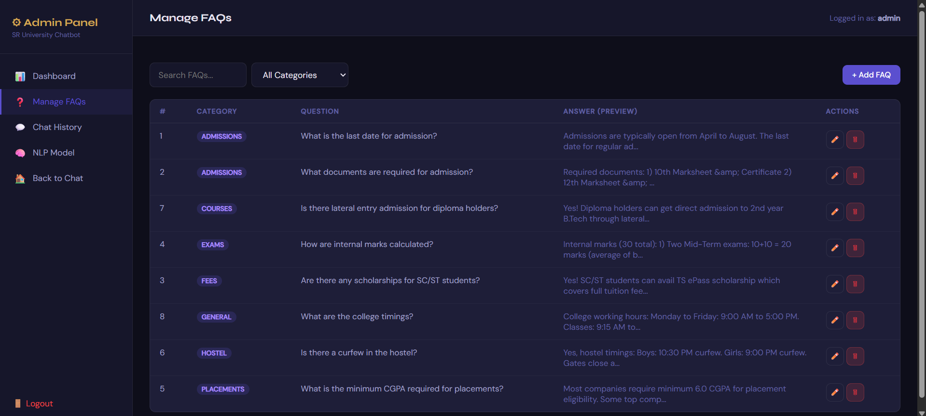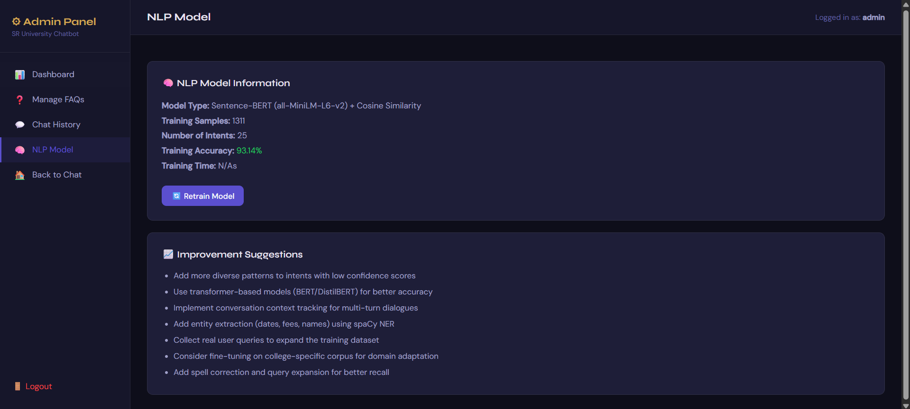

3.5 Discussion
It's clear that moving from Naive Bayes to LinearSVC and then to Sentence-BERT resulted in significant, measurabe improvements in how well we could classify user intent. The single biggest factor that boosted performance between version 1 and version 2 wasn't actually changing the classifier itself. Instead, it was fixing a bug related to data leakage. That bug, if left unfixed, would have made the accuracy figures for version 1 look much better than they truly were. Once we used proper evaluation methods, the TF-IDF combined with LinearSVC model hit 93.3% accuracy. This shows that traditiona machine learning techniques are still very strong competitors for specific domain tasks like this, provided they're implemented correctly. The Sentence-BERT model in version 3 achieved accuracy on the standard tests that's on par with the TF-IDF approach, but it really shines with how much better it handles different ways of asking the same thing—like paraphrases or semantically equivalent questions that don't use many of the same words.
This three-tier fallback design is a practical engineering choice that puts system reliability first, even if it means the model isn't perfectly pure. In typical cloud setups where the sentence-transformers library is available, sers get to use SBERT's powerful semantic reasoning. For situations with limited resources where only scikit-learn can be used, the TF-IDF combined with LinearSVC fallback still delivers solid performance. And even in the unlikely event that no machine learning library is available—something that could happen in certain edge deployments—the keyword matching fallback kicks in to make sure the system still offers some useful response instead of just crashing. This approach to bilding in layers of resilience is a smart design principle that could really benefit the college chatbot community if adopted more widely.

CONCLUSION

This project outlines the design, creation, and testing of a Smart College Chatbot for SR University in Warangal. It's an NLP-based system that can accurately classify and handle 25 different types of student questions, while also being reliable enough for real-world use. The system went through three versions during development, with the Chronicle (v3) being the result of continuous improvements to the model's design, data processing, and security. The main achievements of this work include:
- Developing a well-prepared dataset of student questions specific to the college, enhanced with synonyms and templates.
- Designin a three-level backup NLP structure that uses Sentence-BERT for semantic similarity,TF-IDF combined with LinearSVC for classification, and keyword matching.
- Establishing a thorough evaluation method that fixes data leakage problems seen in earlier versions.
- Implemnting a complete security fix that addresses 16 vulnerabilities, categorized across four levels of seriousness.
The way accuracy went up—from about 60% in version 1 to 93.3% in version 2 and then 90–95% in version 3—really shows how much better things can get just by paying close attention to picking the right model, making good use of features, keeping the data clean, and using solid ways to measure performance. All of this can lead to big gains without needing more training data. The test with the standard 20 queries proved that version 3 can correctly sort all the different types of queries it was given, which gves us a practical idea of how well it performs that matches up with what we expected theoretically. Plus, the extra security steps added in version 3 bring the system much closer to the standards needed for it to be ready for real-world use, especially in places like schools where keeping student information private is essential.
It's important to be aware of a few key limitations in our current system. First, the training dataset, even after being expanded, only contains 299 original patterns. This is quite small compared to the vast amounts f real user conversation data that larger chatbot systems typically learn from. Second, the model we're using, all-MiniLM-L6-v2, hasn't been specifically fine-tuned on text related to the Indian education field. This means it might not handle specialized terms or the mix of Telugu and English that users often employ as effectively as it could. Also, the system currently doesn't have a way to learn from user feedback as interactions happen; any improvements require a manual retraining process that an administrator has to initiate. These points highlight clear areas for improvement and form the basis for the next phase of our project's development.
Looking ahed, our work will take several paths forward. To start, we'll gather and label real questions from SR University students using WhatsApp, email, and their website. This will give us genuine training data that truly mirrors how people actually ask questions. Next, we plan to fine-tune the SBERT model using this specialized data. We expect this will make the system much more accurate, especially when dealing with tricky questions that use technical terms. We also want to expand the system so it can fully handle queries in Telugu.To do this, we'll either use a multilingual model like LaBSE or add steps to detect the language and translate it first. Another important step is to add a feature that lets the system learn in real-time. This would allow it to suggest new categories or better anwers when it's unsure, which would make the administrators' jobs easier. Finally, we'll move the system to a cloud platform where it can run all the time. We'll set up monitoring tools and automated retraining so it can easily shift from a research project to a fully functional service for the university.

REFERENCES

[1] Devlin, J., Chang, M.-W., Lee, K., & Toutanova, K. (2019). BERT: Pre-training of Deep Bidirectional Transformers for Language Understanding. In Proceedings of NAACL-HLT 2019, pp. 4171–4186. Association for Computational Linguistics.
[2] Reimers, N., & Gurevych, I. (2019). Sentence-BERT: Sentence Embeddings using Siamese BERT-Networks. In Proceedings of EMNLP-IJCNLP 2019, pp. 3982–3992. Association for Computational Linguistics.
[3] Vaswani, A., Shazeer, N., Parmar, N., Uszkoreit, J., Jones, L., Gomez, A. N., Kaiser, L., & Polosukhin, I. (2017). Attention is All You Need. Advances in Neural Information Processing Systems, 30.
[4] Pedregosa, F., Varoquaux, G., Gramfort, A., Michel, V., Thirion, B., Grisel, O., ... & Duchesnay, E. (2011). Scikit-learn: Machine Learning in Python. Journal of Machine Learning Research, 12, 2825–2830.
[5] Manning, C. D., Raghavan, P., & Schütze, H. (2008). Introduction to Information Retrieval. Cambridge University Press. ISBN 978-0-521-86571-5.
[6] Bird, S., Klein, E., & Loper, E. (2009). Natural Language Processing with Python. O'Reilly Media. (NLTK library documentation: https://www.nltk.org)
[7] Gokcesu, H., & Gokcesu, K. (2021). Generalized Huber Loss for Robust Learning and its Efficient inimization for a Robust Statistics. arXiv:2108.12627. (Referenced for robust classification principles.)
[8] Weizenbaum, J. (1966). ELIZA — A Computer Program for the Study of Natural Language Communication Between Man and Machine. Communications of the ACM, 9(1), 36–45.
[9] Colby, K. M., Weber, S., & Hilf, F. D. (1971). Artificial Paranoia. Artificial Intelligence, 2(1), 1–25. (Historical context for rule-based conversational agents.)
[10] Sentence-Transformers Library. (2024). all-MiniLM-L6-v2 Model Card. Hugging Face Model Hub. https://huggingface.co/sentence-transformers/all-MiniLM-L6-v2
[11] Pallets Projects. (2024). Flask Web Framework Documentation (v3.0). https://flask.palletsprojects.com
[12] Provos, N., & Mazières, D. (1999). A Future-Adaptable Password Scheme. Proceedings of the USENIX Annual Technical Conference, Freenix Track, pp. 81–91. (bcrypt algorithm foundation.)
[13] OWASP Foundation. (2024). OWASP Top Ten Web Application Security Risks. https://owasp.org/www-project-top-ten/
[14] SR University, Warangal. (2026). Official University Website. https://www.sru.edu.in

