**HomeworkDay15_1**

1.create database library;

2.create table employee(

Id_emp int(13) primary key,

f_name varchar(50),

l_name varchar(50),

age int(2),

date_reg timestamp not null default now()

);

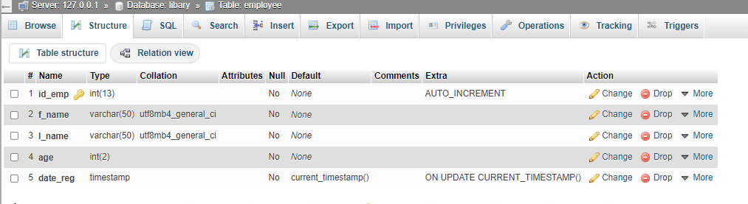

3.create table book(

Isbn bigint(13) primary key,

Title varchar(255),

price int(6),

date_add timestamp not null default now()

);

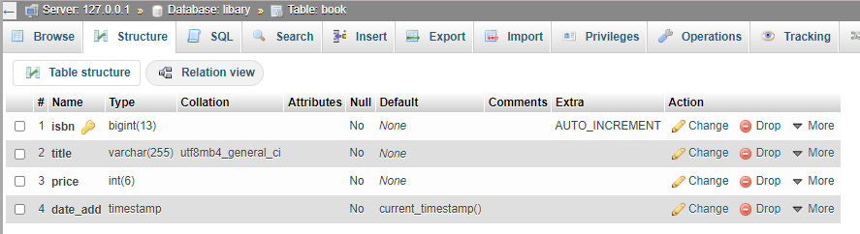

4.create table invoice(

Inv_num bigint(10) primary key,

Isbn_book bigint(13),

Id_emp int(13),

price int(4),

amount_book int(2),

date_buy timestamp not null default now()

);

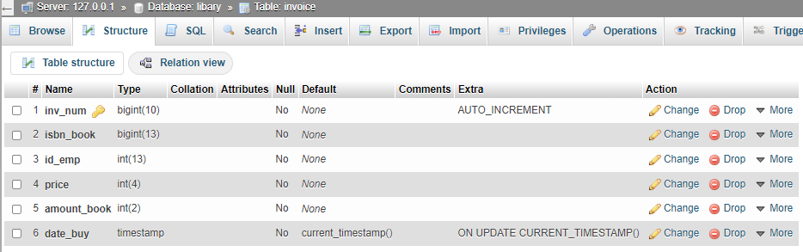

5.[INSERT](http://localhost/phpmyadmin/url.php?url=https://dev.mysql.com/doc/refman/8.0/en/insert.html) INTO

employee(f_name,l_name,age,date_reg)

[VALUES](http://localhost/phpmyadmin/url.php?url=https://dev.mysql.com/doc/refman/8.0/en/miscellaneous-functions.html%23function_values)

('Noah','Armstorn',34,[CURRENT_TIMESTAMP](http://localhost/phpmyadmin/url.php?url=https://dev.mysql.com/doc/refman/8.0/en/date-and-time-functions.html%23function_current_timestamp)),

('Leslie','Ellis',24,[CURRENT_TIMESTAMP](http://localhost/phpmyadmin/url.php?url=https://dev.mysql.com/doc/refman/8.0/en/date-and-time-functions.html%23function_current_timestamp)),

('Sandra','Hoffman',35,[CURRENT_TIMESTAMP](http://localhost/phpmyadmin/url.php?url=https://dev.mysql.com/doc/refman/8.0/en/date-and-time-functions.html%23function_current_timestamp)),

('Cameron','Meyer',19,[CURRENT_TIMESTAMP](http://localhost/phpmyadmin/url.php?url=https://dev.mysql.com/doc/refman/8.0/en/date-and-time-functions.html%23function_current_timestamp)),

('Cameron','Moore',27,[CURRENT_TIMESTAMP](http://localhost/phpmyadmin/url.php?url=https://dev.mysql.com/doc/refman/8.0/en/date-and-time-functions.html%23function_current_timestamp));

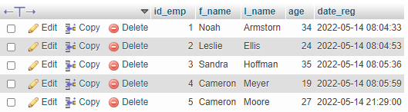

5. [INSERT](http://localhost/phpmyadmin/url.php?url=https://dev.mysql.com/doc/refman/8.0/en/insert.html) INTO

book(isbn,title,price,date_add)

[VALUES](http://localhost/phpmyadmin/url.php?url=https://dev.mysql.com/doc/refman/8.0/en/miscellaneous-functions.html%23function_values)

(9783598215766,'His Toy',289,[CURRENT_TIMESTAMP](http://localhost/phpmyadmin/url.php?url=https://dev.mysql.com/doc/refman/8.0/en/date-and-time-functions.html%23function_current_timestamp)),

(9783598215919,'The Mars Room',199,[CURRENT_TIMESTAMP](http://localhost/phpmyadmin/url.php?url=https://dev.mysql.com/doc/refman/8.0/en/date-and-time-functions.html%23function_current_timestamp)),

(9783598215933,'The Marquis and I',250,[CURRENT_TIMESTAMP](http://localhost/phpmyadmin/url.php?url=https://dev.mysql.com/doc/refman/8.0/en/date-and-time-functions.html%23function_current_timestamp)),

(9783598215957,'Blood on the Tongue',352,[CURRENT_TIMESTAMP](http://localhost/phpmyadmin/url.php?url=https://dev.mysql.com/doc/refman/8.0/en/date-and-time-functions.html%23function_current_timestamp)),

(9783598215995,'A Higher Loyalty',157,[CURRENT_TIMESTAMP](http://localhost/phpmyadmin/url.php?url=https://dev.mysql.com/doc/refman/8.0/en/date-and-time-functions.html%23function_current_timestamp));

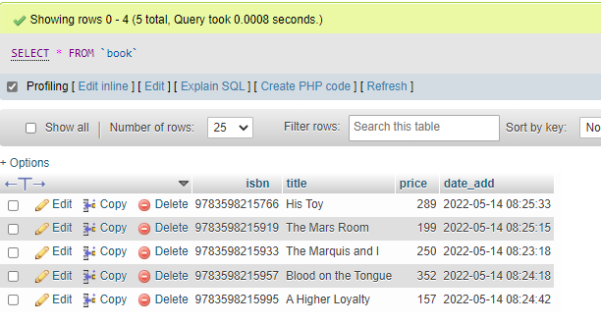

**HomeworkDay15_2**

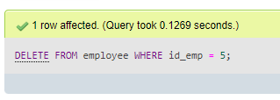

2.

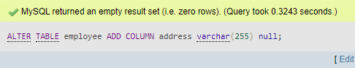

3.

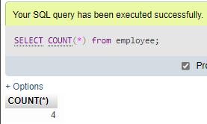

4.

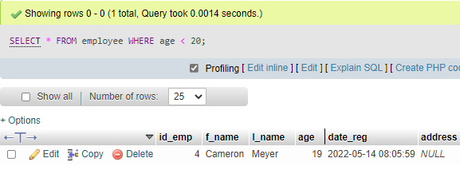

5.

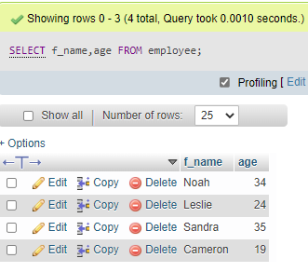

6.

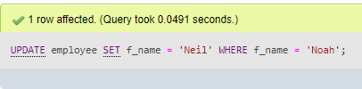

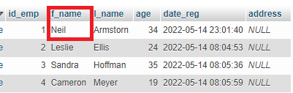

**HomeworkDay15_3**

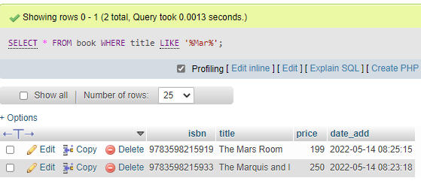

2.

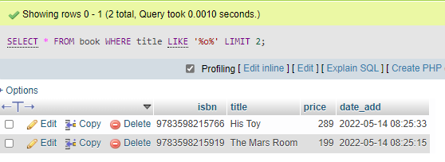

3.

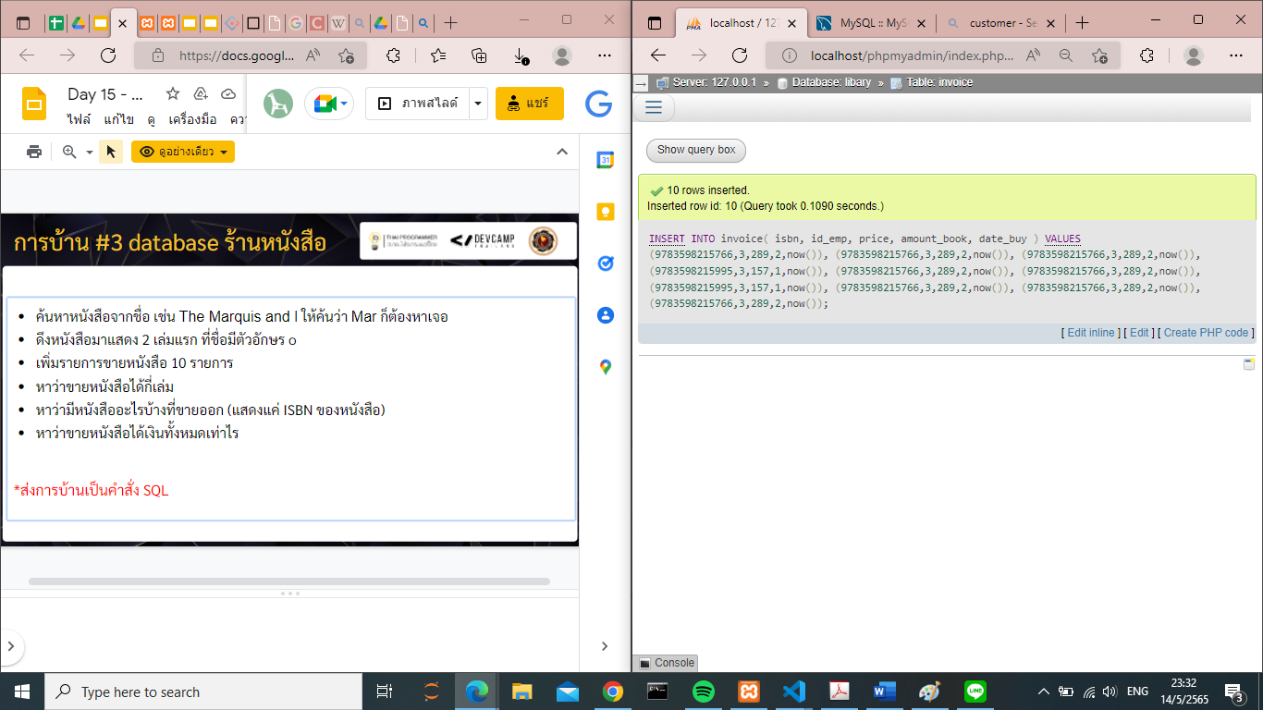

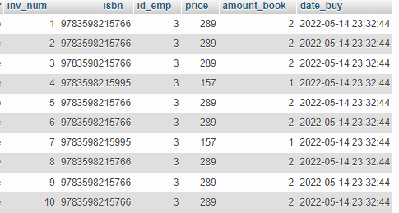

4.

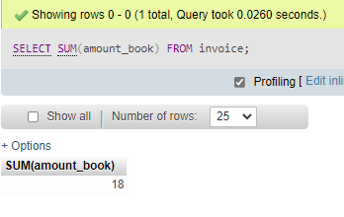

5.

