AADIITYA K JAISAWAL | : 7509125566 / 9028915037 | 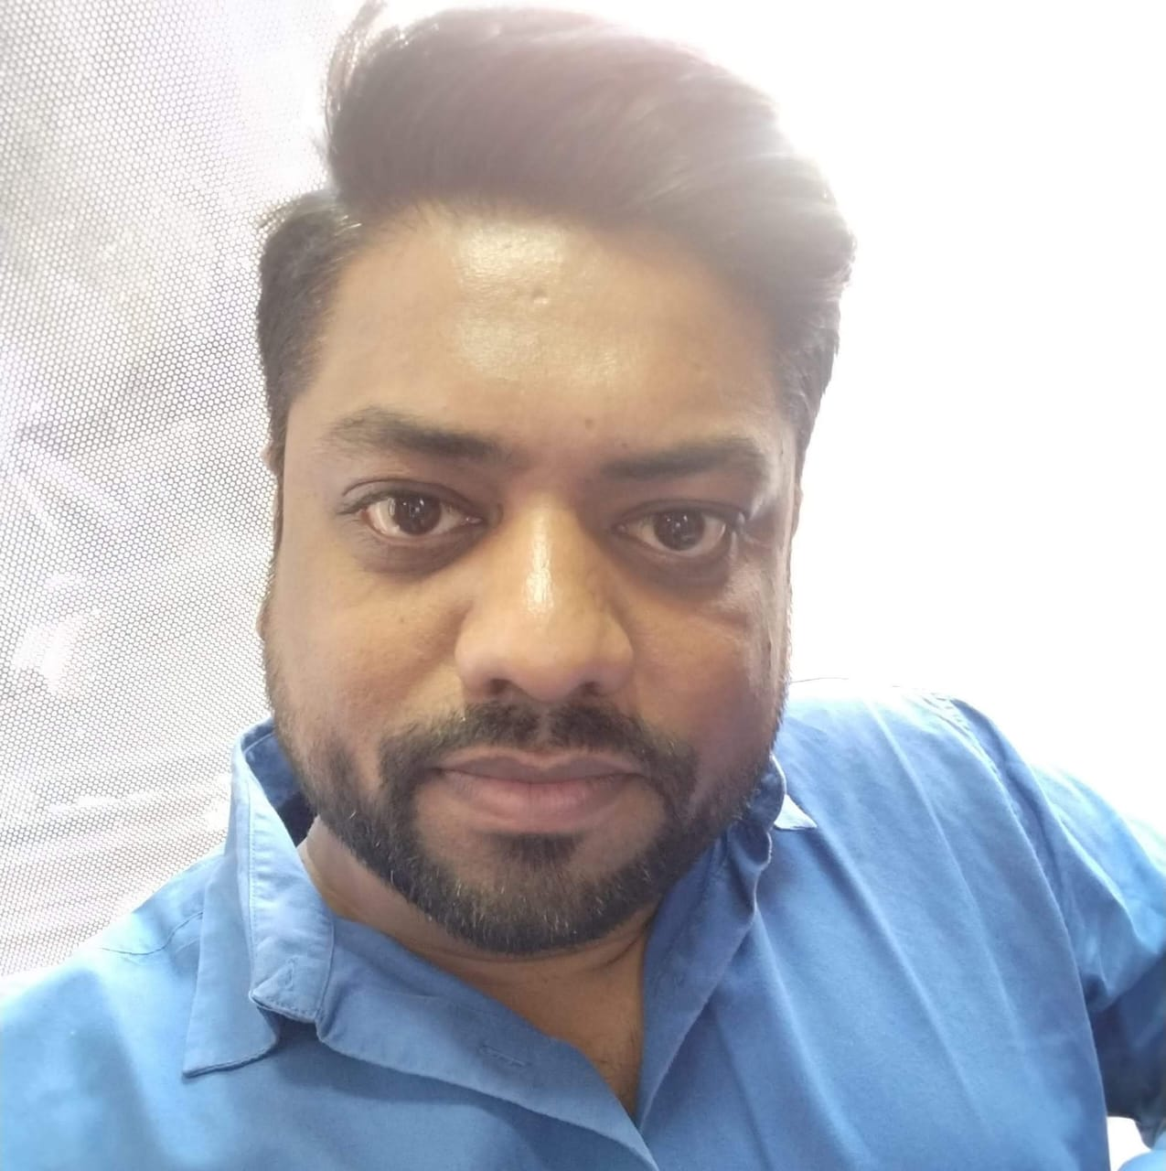
Meghsparsh By Shraddha Alliance | Male (5’11)
B-402, Opp Swami Narayan | 4th September 1988
Temple, Jambulwadi Raod | MBA – Sales & Marketing
Bhumkar Chowk, Narhe- Pune (411046) | Email– aadiitya.aj@gmail.com

Profile: MBA with Twelve Year Experience in Sales & Marketing An astute & result oriented professional with over 14 years of experience in building material ( Architect, Builder, Facade Consultant, PMC, Contractors, Glass Processor, Fabricators Distributors, Dealers & Retails). Expertise in devising/ implementing marketing activities for accelerating business growth. Business savvy management professional with a pioneering career reflecting strong leadership coupled with strong people and team building skills. Works closely with business personnel at all levels during organizational strategic planning, setup, and implementation.

Educational Qualifications:
Degree/Exam | University / Board | Institute | Stream | Class Grade
MBA | ISBM University | ISBM University | Sales & Marketing | A Grade
B. Com | Gorakhpur University | D.D.U University | Marketing | B Grade
HSC | UP Board | M.M.M Inter College | Commerce | B Grade
SSC | UP Board | M.M.M Inter College | Science | A Grade

Professional Experience:
RR Parkon
Sales Manager - Pune & ROM
Division : Multi Leval Parking
From : September 2024 | To: Till Date | Total Duration :

🔹 Roles & Responsibilities

Sales & Business Development
- Spearheaded lead generation and business development across metro and tier-2 cities in West India, including Nagpur, Kolhapur, Nashik, and Goa.
- Targeted and acquired key decision-makers such as builders, architects, consultants, and government agencies to drive market penetration.
- Established and maintained strong client relationships with real estate developers, infrastructure consultants, and facility managers.
- Consistently achieved or exceeded quarterly and annual sales targets by implementing territory-specific growth strategies and nurturing long-term partnerships.

Regional Marketing & Brand Positioning
- Developed and executed localized marketing strategies tailored to the West Indian market, enhancing regional brand visibility and engagement.
- Conducted in-depth market research and competitive analysis to identify emerging trends, optimize pricing strategies, and support product positioning.
- Collaborated with the central marketing team to manage participation in expos, trade shows, and targeted digital campaigns, boosting lead generation and brand recall.

Technical Sales Support & Coordination
- Delivered impact technical presentations and live product demonstrations to key clients, highlighting the functional and commercial benefits of mechanical parking systems.
- Acted as the primary liaison between clients and internal design/engineering teams to ensure alignment on customized layouts and solution design.
- Assisted in preparing detailed techno-commercial proposals and tender documents, supporting successful project bids and conversions.

Project Handover & After-Sales Support
- Ensured seamless post-sales coordination by facilitating the transition from sales closure to installation kickoff, maintaining client satisfaction and alignment.
- Collected client and market feedback post-deployment to identify areas for product enhancement and inform internal R&D and design teams.
- Supported issue resolution and maintained communication loops to ensure high levels of customer service and long-term retention.

Jindal Aluminium Ltd
Deputy Manager - Pune & ROM
Division : B & C ( Aluminum Extrusion )
From : September 2021 | To: October 2024 | Total Duration : 3.2 Yr

Key Achievements:
- Average monthly sales increased from 50 MT in 2021 to 150 MT in 2024 i.e. growth of over 300% .
- Won the big & prestigious order of CIDCO for 400 MT.
- Strong penetration in Architect, Builders, PMC, Façade Consultant Segment, Façade Contractors, Glass Processor, Dealer & Distributor

Responsibilities:
- To work closely with Architects/Builder/Interior Designers/PMC/Facade Consultants Fabricators and Glass Processor establish relationships with them and ensure that Jindal Aluminum is selected for projects and used as the most preferred solution by them.
- Maintain cordial relationship with all key clients by making regular visits, understanding their needs, and anticipating new marketing opportunities, and informing the same to management.
- Maintain the existing accounts, obtain orders, and establish new accounts by planning and organizing a daily work schedule to call on existing or potential customers
- Enrolling & nurturing the exclusive Façade Consultant/ Contactors & fabrication partners for the company.
- Must keep the HOD informed by submitting activity reports, results reports, daily call reports, weekly work plans, and monthly, territory analysis, etc.
- Monitor competition by gathering current marketplace information on pricing, products, new products, delivery schedules, and merchandising techniques.
- Must be actively involved in research and developing marketing opportunities and plans, understanding consumer requirements, identifying market trends, and suggesting system improvements to achieve the organization s marketing goals.
- Must have an eye for details; stay current in the industry, must be good in implementing new sales plans and promotion activities
- Expedite the resolution of customer problems and complaints to maximize satisfaction. Resolve customer complaints by investigating problems, developing solutions, preparing reports, and making recommendations to management.
- Supply management with reports on customer needs, problems, interests, competitive activities, and potential for new products and services.

Vox Building Products Pvt Ltd
Area Sales Manager - Pune & ROM
Division : Soffit Infratop Ceiling
From : May 2018 | To: July 2021 | Total Duration: 3.4 Yr.
Responsibilities:

- Distributor & Dealer in terms of Primary & secondary, schemes, and consumer offers. (Meeting existing Dealers / Distributors on a regular basis for achieving service standards)
- Appointing Dealer & Distributor in Pune & ROM.
- To focus on Secondary Sales through growing projects & retail business in mentioned geography through Developers, Builders, Architects & Channel partners.
- Product Specification gets the products approved by Architects/PMC/Designers including government and other institutions.
- To introduce our company to all above-mentioned concerned persons and explain our product range.
- Identifying new business opportunities and projects and converting them into clients.
- Liasioning with the customer on various issues related to the concerned projects/ assignments.
- To update the customers about all new product releases of the company as soon as they are released.
- Track new infrastructure developments in respective territory and develop a database to aid the achievement of sales targets.
- Develop and execute action plans to fix issues and improve sales processes.
- Responsible for all collection of payments as per the commercial policy

Vista Furnishing Pvt. Ltd.
Territory Manager - Pune
Division: Wooden Flooring
From: March 2013 | To: Nov 2017 | Total Duration : 4.8 Year
Responsibilities:
- Managing the sales and marketing operations for increasing the market share, promoting products and services.
- Generating product specs through architects.
- Professional relationship management with the entities involved in projects, i.e. PMC, contractors, designers, etc
- Identifying new business opportunities and projects and converting them into clients.
- Liasioning with the customer on various issues related to the concerned projects/ assignments.
- To achieve sales target aligned with respective product line.
- Payment Collections as Per Terms agreed with Customer.
- Track new infrastructure developments in respective territory and develop a database to aid the achievement of sales targets.
- To keep track of competitors’ movement in respective accounts.
- Ensure collection efficiency and ensure financial viability. To track Industry, finding right product to provide solution as per customer requirement.
- Account Mapping, follow up and closures.

IT Skills: Microsoft Office (Word, Excel, PowerPoint and Access).

