测试数据1：
read x; { input an integer }

if x>0 then { don't compute if x <= 0 }
fact := 1;
repeat
fact := fact * x;
--x;
until x = 0;
write fact { output factorial of x }
end
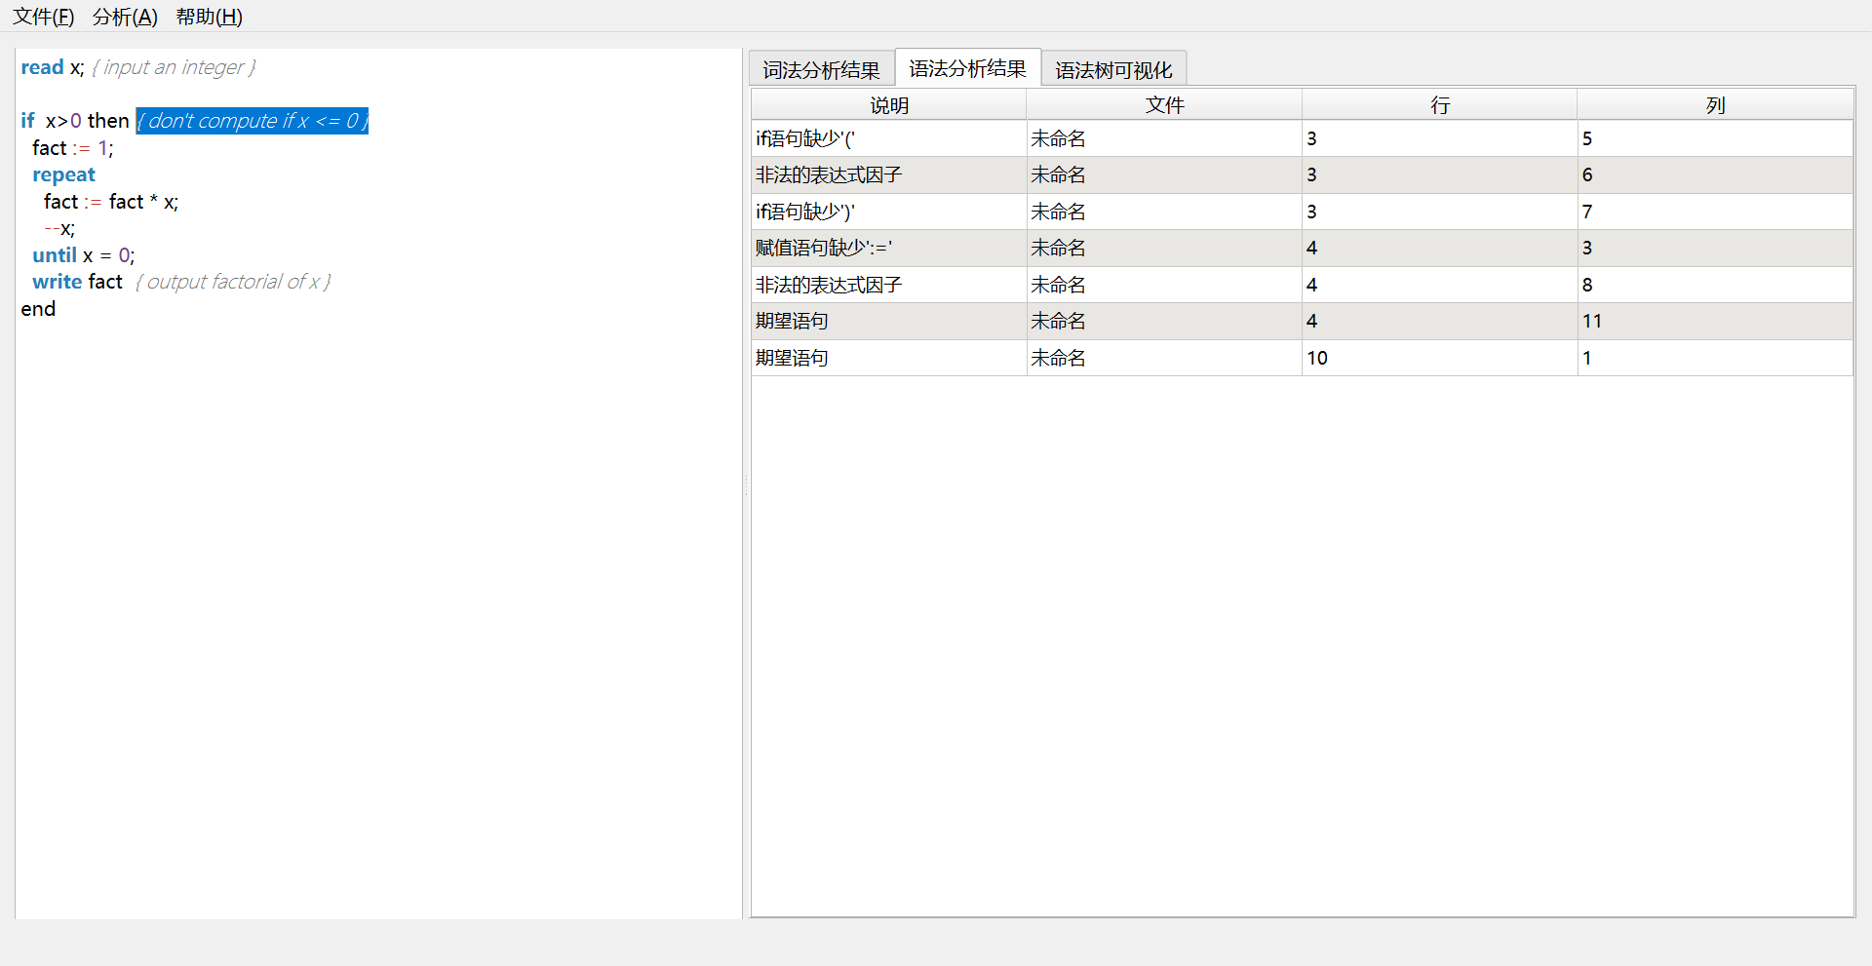
按照规范修改后：
read x; { input an integer }

if (x>0) { don't compute if x <= 0 }
fact := 1;
repeat
fact := fact * x;
--x;
until x = 0;
write fact { output factorial of x }

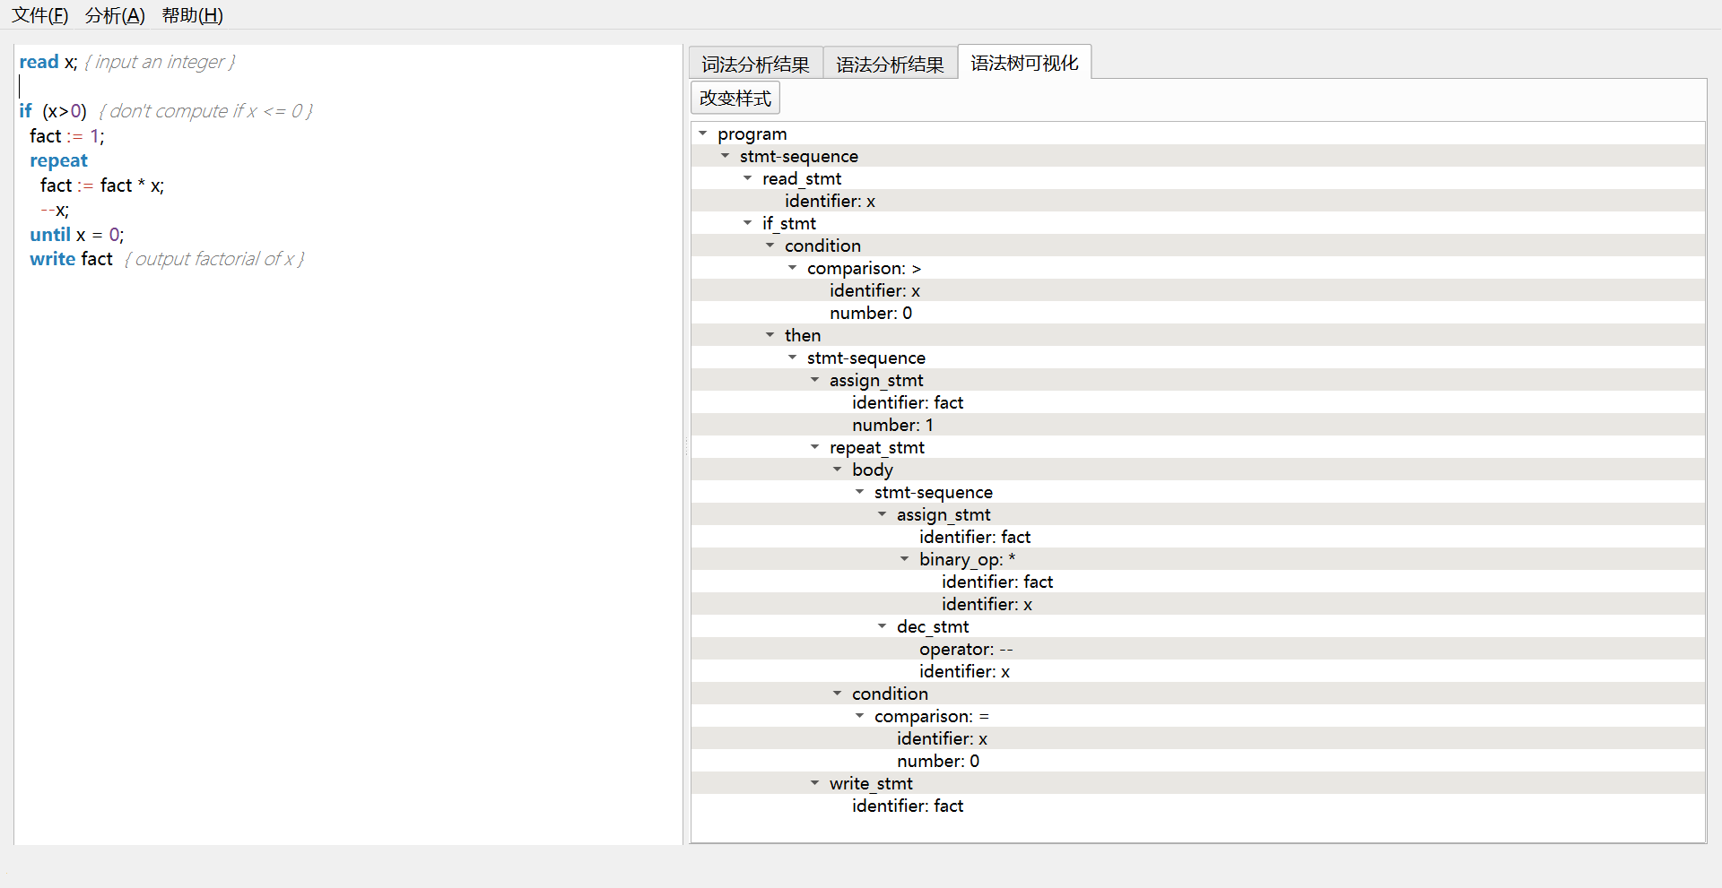
测试数据2:
{ Sample program
in TINY language -
computes factorial
}
read x; { input an integer }
if 0<x then { don't compute if x <= 0 }
for( fact := 1; x>0;--x;)
fact := fact * x;
write fact; { output factorial of x }
end

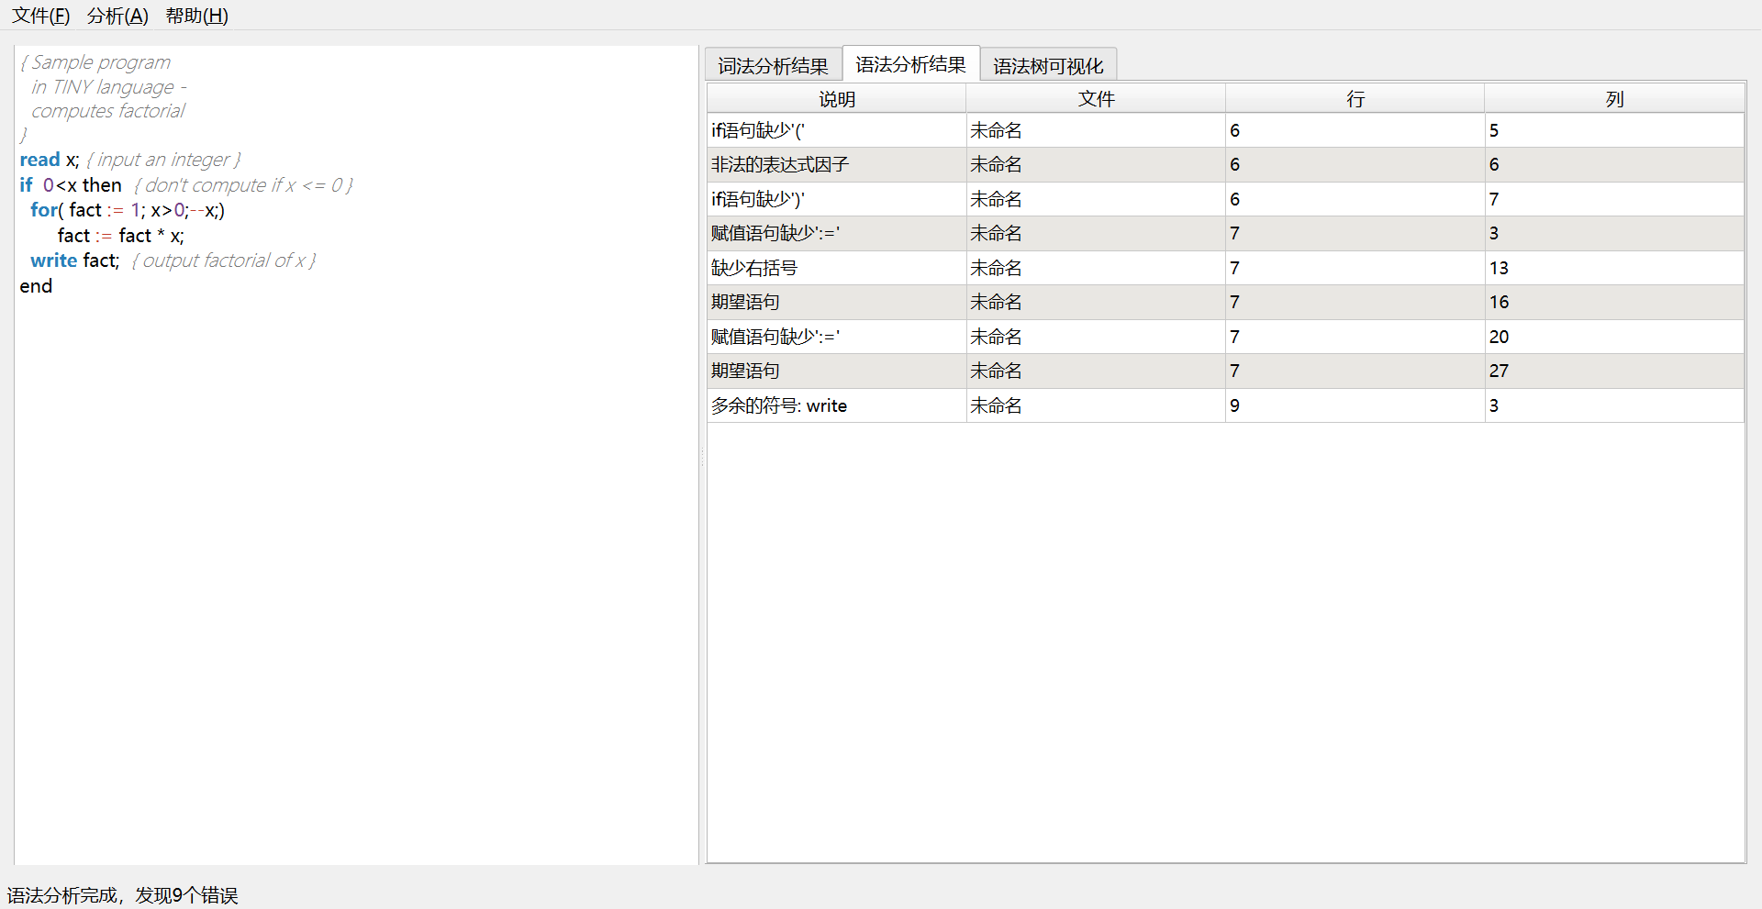
按照规范修改后：
{ Sample program
in TINY language -
computes factorial
}
read x; { input an integer }
if (0<x) { don't compute if x <= 0 }
for( fact := 1; x>0;--x;)
fact := fact * x;
write fact; { output factorial of x }

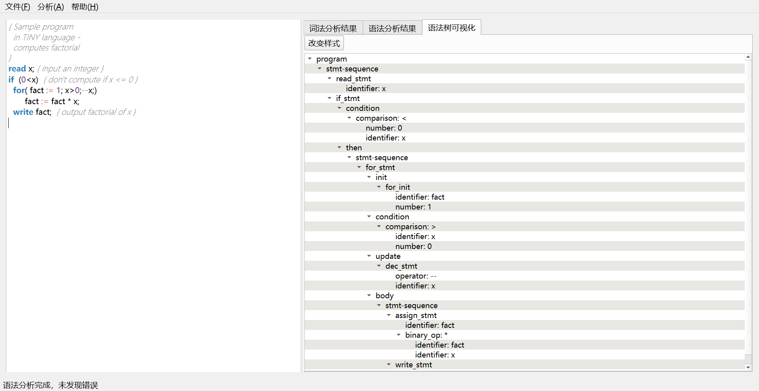
测试数据3：
read count;
result := 1;
pattern ::= (a|b)#;

if(count > 0)
for(i := 1; i <= count; ++i;)
result := result * i;
parity := i % 2;
write result;
else
write 0;
