PROTOTYPE ENGINEERING PASSDOWN | AS-BUILT ELECTRICAL & WIRING HANDOVER (REV J)
GrowTech Wall — Electrical & Electronics Handover Package
Complete as-built power distribution, E-Stop safety boundary, Arduino Nano & Raspberry Pi 5 pinout schedules, DM542 stepper driver settings, 12-pin Molex dosing harness, Hiwonder servo bus architecture, and maintenance/verification guide.

Handover Parameter | As-Built Reference | Power Parameter | As-Built Specification
Schematic Basis | GTW-E01 to GTW-E08 (Rev J) + Connection Schedule Rev J (66 nets) | Main Power Supply | 24V DC / 16.5A (396W nominal capacity) via UK fused 3-pin plug
Active Controllers | Raspberry Pi 5 (PI1) + Gantry Nano (NG1) + Hydroponics Nano (NH1) + Hiwonder Bus Board (ARM1) | Voltage Rails | 24V_RAW (unswitched), 24V_ACT (E-Stop switched), 12V_LOAD (pumps/arm), 5V (Pi/LED/Logic)

CHAPTER 1 | CRITICAL ELECTRICAL SAFETY, E-STOP BEHAVIOR & OPERATING CAUTIONS
Before powering on the prototype, pressing the Emergency Stop (ES1), or probing inside any enclosure, incoming maintainers must understand how power is partitioned across the system and the physical consequences of cutting actuator power.
MANDATORY ELECTRICAL & OPERATIONAL SAFETY WARNINGS
• 1. E-Stop (ES1) Cuts Switched Actuator Power ONLY — And Drops the Vertical Gantry Immediately!: The red E-Stop button at the top of the main electrical enclosure interrupts ONLY the 24V Actuator Branch (24V_ACT), which feeds the three DM542 stepper drivers (DX, DY1, DY2) and the 12V SZBK07 buck converter (DC1, powering all pumps and the robotic arm). CRITICAL HAZARD: Removing 24V power from the DM542 drivers removes stepper holding torque, causing the vertical Y-axis gantry (carrying the X-beam and robotic arm) to DROP STRAIGHT DOWN under gravity! Always command the gantry to Home to the bottom limit switches (or physically prop up the X-beam) BEFORE pressing E-Stop or switching off wall power.
• 2. E-Stop Leaves Pi 5, Both Arduino Nanos, Sensors & 5V Grow Lights Powered ON: Pressing E-Stop does NOT de-energize the whole machine! The raw 24V branches to the Wheeltec P23C 5V/5A board (PD1 -> Raspberry Pi 5 -> USB-powered Nanos NG1 & NH1) and the 5V SZBK07 buck converter (DC2 -> DIM1 -> LED grow lights) remain LIVE when E-Stop is pressed. To completely de-energize the machine for wiring work, switch OFF and unplug the UK 3-pin wall plug.
• 3. Mandatory Restart & GUI Reset Sequence After Releasing E-Stop: To recover after pressing E-Stop: (a) Ensure the gantry is resting safely at the bottom and clear any obstructions, (b) Twist-release the red E-Stop button to restore 24V_ACT and 12V_LOAD power, and (c) Click the 'Reset' button in the Raspberry Pi touchscreen GUI to re-initialize serial communication with both Arduino Nanos.
• 4. Unusual Wire Color Conventions (5V Uses Red/Brown; Signal Ground Uses Black/Brown): Do NOT assume standard industrial color codes! While thick Red/Black pairs carry 24V and 12V DC power, on the 12-pin Molex dosing harness (X1) and LED circuit, thin RED is +5V Logic (LOGIC_5V) and thin BROWN is Logic Ground (LOGIC_GND). On the Gantry side, thin BLACK wires are 5V signal returns (PUL-, DIR-, ENA-) tied together into shared orange lever connectors (SG_GANTRY). Always check the pinout tables before moving wires.
• 5. DM542 Stepper Drivers Are Mounted Upside-Down: Inside the main electrical box, the three DM542 drivers (Top = X, Middle = Y1 Left, Bottom = Y2 Right) are physically mounted upside-down. Read the printed terminal silkscreen on the driver body rather than assuming top-to-bottom pin order, and never unplug motor connectors while 24V power is live.
• 6. Robotic Arm Local Switch & 3.3V Pi UART Caution: The black arm control box beside the arm base has an external red switch that cuts power to the Hiwonder servo controller (ARM1). Support the arm links before switching it OFF. Note that Pi 5 UART pins (Pin 27 TX / Pin 28 RX) use 3.3V logic—never short 5V or 12V power onto the orange/purple UART wires.

CHAPTER 2 | SYSTEM ARCHITECTURE, CONTROLLER ROLES & DC POWER DISTRIBUTION
The GrowTech Wall electrical system is built around a single 24V DC / 16.5A (396W nominal capacity) AC-DC switched-mode power supply (PSU1) fed from a standard UK fused 3-pin wall plug, and a distributed 4-controller architecture coordinated by a Raspberry Pi 5 (PI1). Crucially, the robotic arm is NOT controlled by either Arduino Nano—it is a separate fourth endpoint driven directly by the Pi 5 over native UART.
Controller / Endpoint | Communication Link & Port | Power Source | Verified Electrical & Functional Responsibilities
PI1 — Raspberry Pi 5 (16GB) | Local GUI process + USB Host + Native UART1 (/dev/ttyAMA1, 9600 baud) | Powered via USB-C from Wheeltec P23C (PD1, 5V/5A) | Runs Tkinter touchscreen GUI (DISP1), Logitech C920 webcam (CAM1) & YOLOv8 AI inference; coordinates NG1, NH1, and ARM1.
NG1 — Gantry Arduino Nano | USB-A to USB-C cable from Pi 5 (/dev/arduino_gantry -> /dev/ttyUSB1) | Powered via USB from Pi 5 (no external VIN feed) | Owns X, Y1 (Left), and Y2 (Right) AccelStepper pulse/dir/enable outputs (D2–D7, A0–A2) and 3 homing limit switches (D8–D10).
NH1 — Hydroponics Arduino Nano | USB-A to USB-C cable from Pi 5 (/dev/arduino_hydroponic -> /dev/ttyUSB0) | Powered via USB from Pi 5 (5V pin feeds sensors/relays/RTC) | Owns DS3231 RTC (A4/A5), water-level/EC/pH analog inputs (A0–A2), 4 tank pump relays (D2–D5), LED light relay (D9), and spray relay (D10).
ARM1 — Hiwonder Bus Servo Controller | Direct UART from Pi 5: Pin 27 (GPIO0 TX, Orange) -> RX; Pin 28 (GPIO1 RX, Purple) -> TX; Pin 25 -> GND (Grey) | 12V_LOAD branch from DC1 into Arm Box (via local red switch) | Executes pre-loaded binary Lobot action groups (.rob files) driving 5 servos: 1x HX-12H gripper + 3x HTS-35H joints (daisy-chained) + 1x HX-35M base.

2.1 Three-Branch DC Power Distribution Architecture (24V / 12V / 5V)
From the main 24V / 16.5A PSU (PSU1), thick red (+24V) and black (0V24) wires split into three primary branches inside the left-side electrical enclosure (sheets GTW-E01 and GTW-E04):
1. Unswitched 5V Pi & Fan Branch (PSU1 -> PD1): Raw 24V feeds the Wheeltec P23C 5V/5A power module (PD1). PD1 powers the Raspberry Pi 5 (PI1) via USB-C and powers the enclosure cooling fan(s) via its auxiliary 5V output. The Pi 5 USB host ports then supply 5V power and serial data to both Arduino Nanos (NG1 and NH1) and the C920 webcam (CAM1).
2. Unswitched 5V Grow-Light Branch (PSU1 -> DC2 -> DIM1 -> RLIGHT -> LED1): Raw 24V feeds the bottom SZBK07 step-down buck converter (DC2, adjusted to 5V). The 5V output passes through the rotary PWM dimmer (DIM1) and exits the main enclosure to the rear LED relay box (RLIGHT), which switches power to the four full-spectrum white LED grow-light strips (LED1). (Note: LED load power comes from DC2; NH1 5V supplies only the relay logic coil).
3. E-Stop Switched Actuator Branch (PSU1 -> ES1 -> 2-to-8 Block -> Drivers & DC1 12V): Raw 24V passes through the top-mounted Emergency Stop button (ES1) to a 2-to-8 quick-connector distribution block (24V_ACT / 0V24_ACT):
• Three 24V pairs feed the three DM542 stepper drivers directly: Top Driver (DX), Middle Driver (DY1), and Bottom Driver (DY2).
• One 24V pair feeds the top stacked SZBK07 buck converter (DC1, adjusted to 12V). The 12V_LOAD output from DC1 branches via quick-connectors to: (a) the Dosing Module via the 12-pin Molex connector (X1.+12V / X1.0V12) to power the DP-521 main water pump and three Kamoer peristaltic pumps, and (b) the Robotic Arm Control Box to power the Hiwonder servo controller (ARM1) and the 12V pesticide spray pump (PUMP-S via relay RSPRAY).
Power Unit / Converter | Input Source | Rated Output | Net Name | Physical Location | Connected Loads & Operational Notes
PSU1 (Main AC-DC PSU) | 240V AC (UK 3-pin fused plug) | 24V DC, 16.5A (396W nominal) | 24V_RAW / 0V24_RAW | Main enclosure | Feeds PD1, DC2, and ES1 input.
ES1 (Emergency Stop) | 24V_RAW (Red/Black pair) | 24V_ACT (Switched 24V) | 24V_ACT / 0V24_ACT | Top of main enclosure | Cuts DX, DY1, DY2, and DC1 (12V). Causes immediate Y-gantry gravity drop!
PD1 (Wheeltec P23C) | 24V_RAW from PSU1 | 5V DC, 5A (USB-C + 2-pin 5V) | PI_POWER / 5V_FAN | Main enclosure | Powers Raspberry Pi 5 (and Nanos/Webcam via Pi USB) + Enclosure Fan.
DC2 (Bottom SZBK07 Buck) | 24V_RAW from PSU1 | 5V DC (20A rated buck) | 5V_LIGHT_LOAD | Main enclosure (stacked bottom) | Powers white LED grow lights via PWM dimmer (DIM1) and rear relay (RLIGHT).
DC1 (Top SZBK07 Buck) | 24V_ACT (from ES1 block) | 12V DC (20A rated buck) | 12V_LOAD / 0V12_LOAD | Main enclosure (stacked top) | Powers Dosing Module pumps (via Molex X1) and Arm Control Box (ARM1 + Spray Pump).

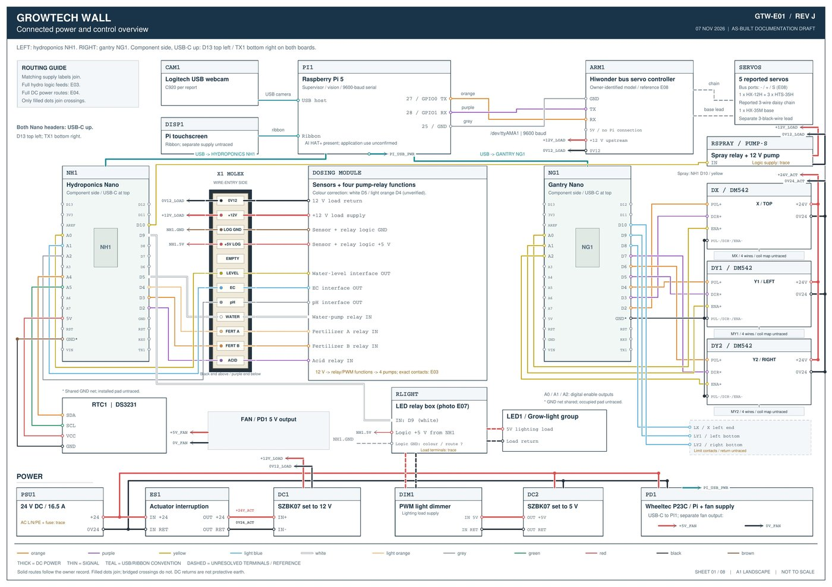
Figure 2.1: Sheet GTW-E01 (Rev J) — Connected Power and Control Overview showing NH1, NG1, Molex X1, DM542 drivers, and power modules.

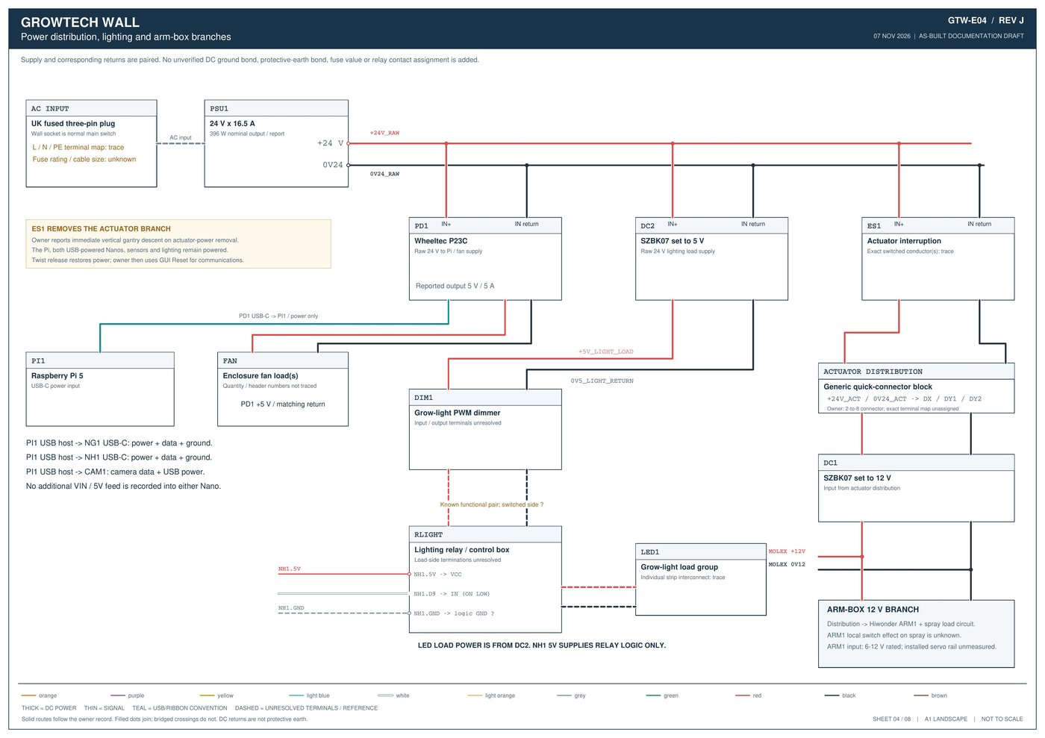
Figure 2.2: Sheet GTW-E04 (Rev J) — Detailed DC Power Distribution, E-Stop (ES1) actuator boundary, LED dimmer/relay path, and Arm-Box 12V branch.

CHAPTER 3 | GANTRY MOTION SUBSYSTEM (GANTRY NANO NG1, DM542 DRIVERS, MOTORS & LIMITS)
The Gantry Arduino Nano (NG1) controls all X and dual-Y stepper motion and reads the three homing limit switches. NG1 is mounted on a screw-terminal expansion shield with its USB-C port facing UP (D13 at top-left, TX1 at bottom-right). Note that analog pins A0, A1, and A2 are configured in firmware as DIGITAL OUTPUTS for the driver Enable (ENA+) lines (Active LOW = Enabled; HIGH = Disabled).
3.1 Gantry Arduino Nano (NG1) Complete Pinout & DM542 Signal Mapping
NG1 Pin | Destination Terminal | Signal Type | Wire Color | Net Name | Functional & Wiring Notes
NG1.D2 | DX.PUL+ (Top Driver — X Axis) | Digital Output (STEP) | Orange | DX_PULSE | X-axis step pulse train
NG1.D3 | DX.DIR+ (Top Driver — X Axis) | Digital Output (DIR) | Purple | DX_DIRECTION | X-axis direction signal
NG1.A0 | DX.ENA+ (Top Driver — X Axis) | Digital Output (ENA) | Yellow | DX_ENABLE | Used as digital output (LOW = Enabled, HIGH = Disabled)
NG1.D4 | DY1.PUL+ (Middle Driver — Y1 Left) | Digital Output (STEP) | Orange | DY1_PULSE | Left vertical Y1-axis step pulse train
NG1.D5 | DY1.DIR+ (Middle Driver — Y1 Left) | Digital Output (DIR) | Purple | DY1_DIRECTION | Left vertical Y1-axis direction signal
NG1.A1 | DY1.ENA+ (Middle Driver — Y1 Left) | Digital Output (ENA) | Yellow | DY1_ENABLE | Used as digital output (LOW = Enabled, HIGH = Disabled)
NG1.D6 | DY2.PUL+ (Bottom Driver — Y2 Right) | Digital Output (STEP) | Orange | DY2_PULSE | Right vertical Y2-axis step pulse train
NG1.D7 | DY2.DIR+ (Bottom Driver — Y2 Right) | Digital Output (DIR) | Purple | DY2_DIRECTION | Right vertical Y2-axis direction signal
NG1.A2 | DY2.ENA+ (Bottom Driver — Y2 Right) | Digital Output (ENA) | Yellow | DY2_ENABLE | Used as digital output (LOW = Enabled, HIGH = Disabled)
NG1.GND | All PUL-, DIR-, ENA- on DX, DY1, DY2 | Common Signal Return | Black | SG_GANTRY | All 9 black return wires join shared orange lever connectors back to NG1.GND
NG1.D8 | LX Signal (X-Axis Left Limit Switch) | Digital Input (Pull-up) | Light Blue | LX_LIMIT | Mounted at Left end of X-beam; triggers LOW when touched
NG1.D9 | LY1 Signal (Y1 Left Bottom Limit) | Digital Input (Pull-up) | Light Blue | LY1_LIMIT | Mounted at Bottom of Left Y1 rail; triggers LOW when touched
NG1.D10 | LY2 Signal (Y2 Right Bottom Limit) | Digital Input (Pull-up) | Light Blue | LY2_LIMIT | Mounted at Bottom of Right Y2 rail; triggers LOW when touched
NG1.USB-C | PI1 USB Host (/dev/arduino_gantry) | USB Power + Serial | USB Cable | USB_GANTRY | Supplies 5V power and serial comms from Raspberry Pi 5

3.2 DM542 Stepper Driver Physical Order, DIP Switches & Motor Wiring
• Physical Driver Stack (Top to Bottom): Inside the enclosure, the three Leadshine DM542 drivers are arranged vertically: TOP = DX (X-Axis, 1.3 N·m NEMA 23), MIDDLE = DY1 (Y1 Left Axis, 1.9 N·m NEMA 23), and BOTTOM = DY2 (Y2 Right Axis, 1.9 N·m NEMA 23).
• As-Built DIP Switch Positions (SW1–SW8): Across the drivers, the physical toggle positions are set to: SW1 = UP, SW2 = DOWN, SW3 = UP, SW4 = DOWN, SW5 = UP, SW6 = UP, SW7 = DOWN, SW8 = DOWN. (Note: Because the DM542 units are mounted upside-down in the enclosure, always check the printed 'ON' arrow on the driver faceplate before changing current or microstep switches).
• Power & Motor Coil Wire Sequence: Following the 8 DIP switches on each driver, the high-voltage terminal block receives: Black (0V24_ACT), Red (+24V_ACT), followed by the 4-wire stepper motor cable in the observed sequence: Black, Green, Blue, Red. Before swapping a motor or driver, verify the exact A+/A-/B+/B- terminal labels printed on the upside-down driver housing.
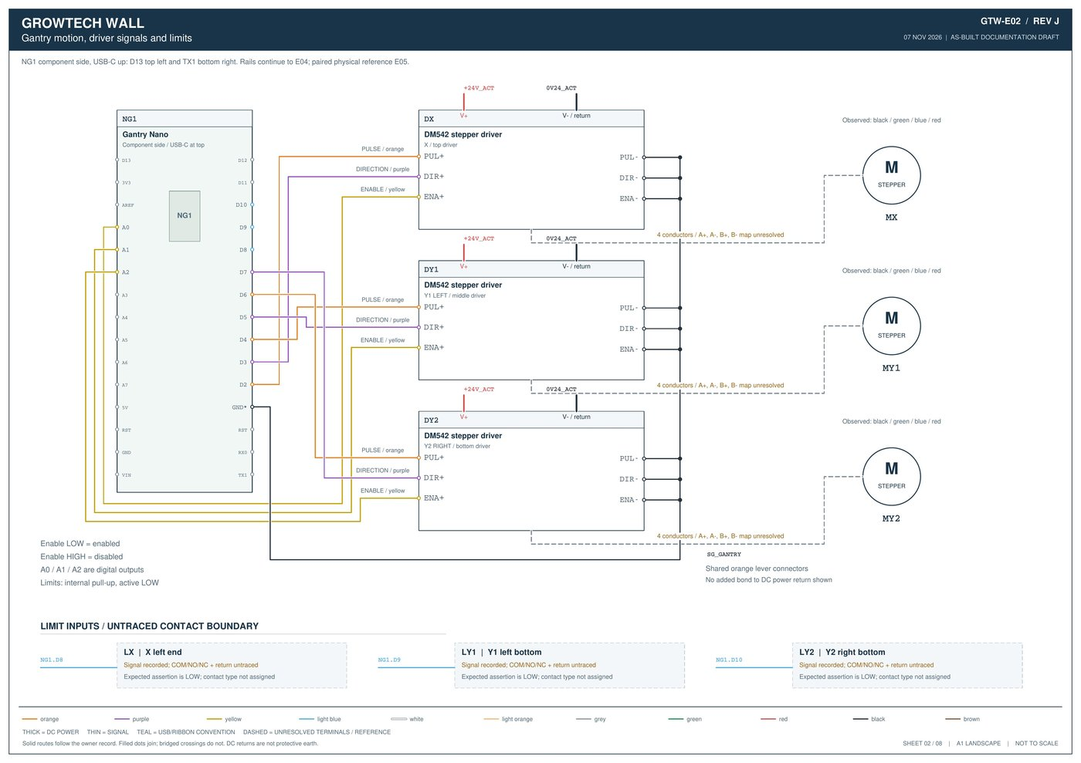
Figure 3.1: Sheet GTW-E02 (Rev J) — Gantry Nano (NG1) to DM542 Stepper Drivers (DX, DY1, DY2), shared SG_GANTRY return block, and Limit Switches.

CHAPTER 4 | HYDROPONICS, DOSING & LIGHTING SUBSYSTEM (NH1 NANO & 12-PIN MOLEX X1)
The Hydroponics Arduino Nano (NH1) manages all reservoir sensing (water level, EC, pH), real-time clock scheduling (DS3231 RTC), the four tank pumps (DP-521 main circulation pump + three Kamoer peristaltic dosing pumps), the white LED grow-light relay (RLIGHT), and the robotic arm's pesticide spray pump relay (RSPRAY). Like NG1, NH1 is mounted with its USB-C port facing UP.
4.1 Hydroponics Arduino Nano (NH1) Complete Pinout Schedule
NH1 Pin | Destination / Endpoint | Signal Type | Wire Color | Net Name | Active Level & Functional Notes
NH1.D2 | X1.ACID -> Acid Pump Relay IN | Relay Control Output | Purple | ACID | Controls Phosphoric Acid Kamoer pump (ON = HIGH)
NH1.D3 | X1.FERT_B -> Fertilizer B Relay IN | Relay Control Output | Orange | FERT_B | Controls Fertilizer B Kamoer pump (ON = HIGH)
NH1.D4 | X1.FERT_A -> Fertilizer A Relay IN | Relay Control Output | Light Orange* | FERT_A | Controls Fertilizer A Kamoer pump (ON = HIGH; *adopted color correction)
NH1.D5 | X1.WATER -> Main Water Pump Relay IN | Relay Control Output | White* | WATER | Controls DP-521 main circulation pump (ON = LOW / NC; *adopted color correction)
NH1.D9 | RLIGHT.IN (Rear LED Relay Box) | Relay Control Output | White | LIGHT_CONTROL | Switches 5V white LED grow lights (Firmware ON = LOW)
NH1.D10 | RSPRAY.IN (Arm Box Spray Relay) | Relay Control Output | Yellow | SPRAY_CONTROL | Triggers 12V neem-oil/pesticide spray pump on arm (ON = HIGH)
NH1.A0 | X1.LEVEL <- Water-Level Sensor OUT | Analog Input | Yellow | LEVEL | Reads reservoir water level sensor inside tank
NH1.A1 | X1.EC <- EC Sensor Interface OUT | Analog Input | Light Blue | EC | Reads electrical conductivity (nutrient concentration) probe
NH1.A2 | X1.PH <- pH Sensor Interface OUT | Analog Input | Grey | PH | Reads PH-4502C pH sensor module
NH1.A4 (SDA) | RTC1.SDA (DS3231 Clock Module) | I2C Data | Orange | RTC_SDA | Direct I2C connection inside main enclosure
NH1.A5 (SCL) | RTC1.SCL (DS3231 Clock Module) | I2C Clock | Green | RTC_SCL | Direct I2C connection inside main enclosure
NH1.5V | X1.+5V_LOG, RTC1.VCC & RLIGHT.VCC | 5V Logic Supply | Red (Thin) | LOGIC_5V / 5V_HYDRO | Supplies 5V logic to dosing sensors/relays, RTC1, and LED relay coil
NH1.GND | X1.LOG_GND (Brown), RTC1.GND (Black) | Logic Return | Brown / Black | LOGIC_GND / SG_HYDRO | Brown thin wire on Molex X1; Black wire to RTC1 GND
NH1.USB-C | PI1 USB Host (/dev/arduino_hydroponic) | USB Power + Serial | USB Cable | USB_HYDRO | Supplies 5V power and serial STAT telemetry to Raspberry Pi 5

4.2 12-Pin Single-Row Molex Connector (X1) Pin-by-Pin Wire-Entry Schedule
All power and signal lines between the main enclosure and the removable Auto-Dosing Module (GTW007A) pass through a single-row 12-pin Molex connector (X1) mounted on the side of the white dosing box (see photograph on Sheet GTW-E07). Viewing X1 from the WIRE-ENTRY SIDE (from the thick Black return wire at Pin 1 to the Purple acid wire at Pin 12), the exact sequence is:
X1 Position | Functional Label | Wire Color | Source Endpoint | Destination Endpoint | Electrical & Servicing Notes
Pin 1 (End) | 0V12 (12V Load Return) | Thick Black | DC1.0V12 (12V Buck Return) | Dosing Module 4-Pump Return | High-current 12V ground return for main & dosing pumps
Pin 2 | +12V (12V Load Supply) | Thick Red | DC1.+12V (12V Buck Output) | 4ch Relay / PWM -> 4 Pumps | Switched by E-Stop (ES1); powers DP-521 & 3x Kamoer pumps
Pin 3 | LOG GND (Logic Ground) | Thin Brown | NH1.GND | Sensors + 4ch Relay Logic GND | IMPORTANT: Thin BROWN is 5V Logic Ground on this harness!
Pin 4 | +5V LOG (Logic +5V Supply) | Thin Red | NH1.5V | Sensors + 4ch Relay Logic VCC | Supplies 5V to pH, EC, water-level boards & optocoupler relay
Pin 5 (Gap) | EMPTY (Unused Pin) | No Wire | — | — | Intentional 1-pin empty gap separating power from signals
Pin 6 | LEVEL (Water Level Signal) | Yellow | Water-Level Sensor OUT | NH1.A0 (Analog Input) | Continuous wire color end-to-end from Nano shield to X1
Pin 7 | EC (Electrical Conductivity) | Light Blue | EC Sensor Interface OUT | NH1.A1 (Analog Input) | Continuous wire color end-to-end from Nano shield to X1
Pin 8 | pH (Acidity Sensor Signal) | Grey | PH-4502C Interface OUT | NH1.A2 (Analog Input) | Continuous wire color end-to-end from Nano shield to X1
Pin 9 | WATER (Main Pump Relay IN) | White* | NH1.D5 (Digital Output) | Main Water Pump Relay Channel | Active LOW (NC arrangement: water pump runs by default when 12V is on)
Pin 10 | FERT A (Fertilizer A Relay IN) | Light Orange* | NH1.D4 (Digital Output) | Fertilizer A Kamoer Relay Ch | Active HIGH (NO arrangement: off by default until dosed)
Pin 11 | FERT B (Fertilizer B Relay IN) | Orange | NH1.D3 (Digital Output) | Fertilizer B Kamoer Relay Ch | Active HIGH (NO arrangement; firmware doses A & B together)
Pin 12 (End) | ACID (Phosphoric Acid Relay) | Purple | NH1.D2 (Digital Output) | Acid (pH Down) Kamoer Relay | Active HIGH (NO arrangement: off by default until dosed)

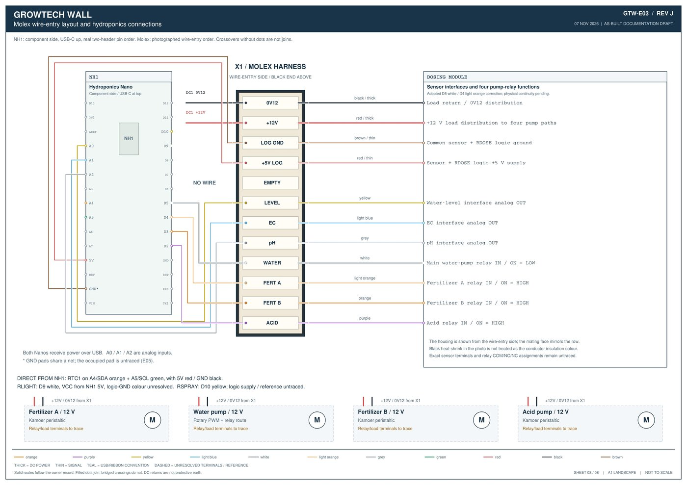
Figure 4.1: Sheet GTW-E03 (Rev J) — Hydroponics Nano (NH1), 12-Pin Molex Harness (X1) wire-entry layout, Dosing Module sensors/relays, and 4 pump loads.

CHAPTER 5 | ROBOTIC ARM CONTROL BOX, HIWONDER BUS SERVO BOARD (ARM1) & SPRAY CIRCUIT
Mounted on the projecting X-carriage platform right beside the robotic arm base is the black Robotic Arm Control Box (CAD part FRA019A, photographed on Sheet GTW-E07). Inside this local enclosure are two sub-circuits fed by a single incoming 12V red/black pair (12V_LOAD / 0V12_LOAD) from the top SZBK07 buck converter (DC1):
1. Hiwonder Serial Bus Servo Controller (ARM1 — SKU 21090003): Receives 12V power through the external red rocker switch mounted on the side of the arm control box (switching this off turns off the entire robotic arm). The board features a 4-pin white UART header (GND, TX, RX, 5V from top to bottom when viewing component side with micro-USB at top), a blue 2-screw power terminal (+ on left, - on right; rated 6–12V input), 'Program' and 'Run' pushbuttons, and white 3-pin serial bus ports (marked - / + / S).
2. 12V Pesticide/Neem-Oil Spray Relay (RSPRAY) & Mini Diaphragm Pump (PUMP-S): Branched off the internal 12V quick-connector inside the arm box. The relay is triggered by a yellow signal wire from Hydroponics Nano pin NH1.D10 (SPRAY_CONTROL, active HIGH) during pest-spraying workflows.
Source Endpoint | Destination on Arm Box / ARM1 | Wire Color | Net Name | Electrical & Functional Details
PI1 Pin 25 (GND) | ARM1 Serial Header: GND (Top Pin) | Grey | UART_GND | Common UART signal ground reference between Pi 5 and ARM1
PI1 Pin 28 (GPIO1 / UART1_RX) | ARM1 Serial Header: TX (2nd Pin) | Purple | UART1_RX | Controller transmits to Pi RX (/dev/ttyAMA1, 9600 baud)
PI1 Pin 27 (GPIO0 / UART1_TX) | ARM1 Serial Header: RX (3rd Pin) | Orange | UART1_TX | Controller receives Lobot binary action-group commands from Pi TX
(Unconnected) | ARM1 Serial Header: 5V (Bottom Pin) | No Wire | — | 5V auxiliary pin MUST remain unconnected (Pi 5 uses 3.3V logic; ARM1 is 12V powered)
Arm-Box 12V Branch (via Red Switch) | ARM1 Blue Screw Terminal (+ Left / - Right) | Red / Black | 12V_ARM | Upstream 12V from DC1 (switched by both main E-Stop ES1 and local arm switch)
ARM1 3-Pin Bus Port (- / + / S) | 1x HX-12H Gripper + 3x HTS-35H Joint Servos | Yellow / Red / Black | SERVO_CHAIN | 4 servos connected in a 3-wire serial daisy chain
ARM1 Base Socket | 1x HX-35M (HX-35HM) 360° Base Servo | 3x Black Wires | BASE_SERVO | Separate 3-black-wire lead driving base turntable rotation
NH1.D10 + Arm-Box 12V Branch | RSPRAY Relay -> 12V Spray Pump (PUMP-S) | Yellow (Sig) + Red/Blk | SPRAY_CONTROL / 12V_SPRAY | Activates foliar spray nozzle beside gripper (Firmware ON = HIGH)

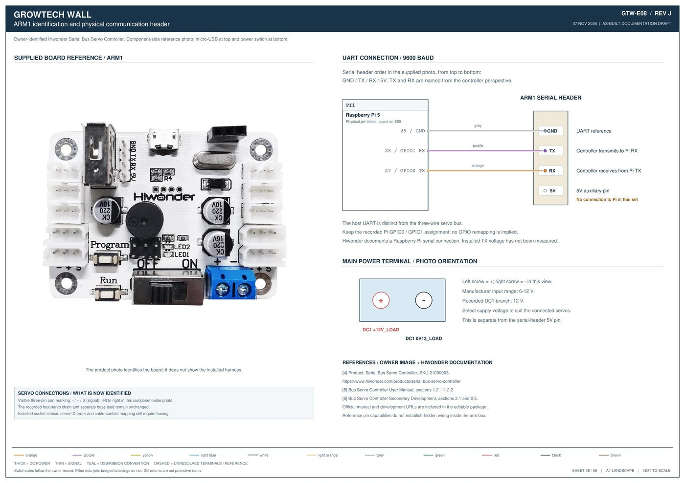
Figure 5.1: Sheet GTW-E08 (Rev J) — Hiwonder Serial Bus Servo Controller (ARM1) physical board layout, Pi 5 UART1 header mapping (Pins 25/27/28), and 12V terminal polarity.

CHAPTER 6 | PHYSICAL HEADER LAYOUTS, FIELD PHOTOS
When troubleshooting with a multimeter or replacing an Arduino Nano or connector harness, use Sheet GTW-E05 (Figure 6.1) for physical pin locations and Sheet GTW-E07 (Figure 6.2) to match field-installed enclosures and wire colors.
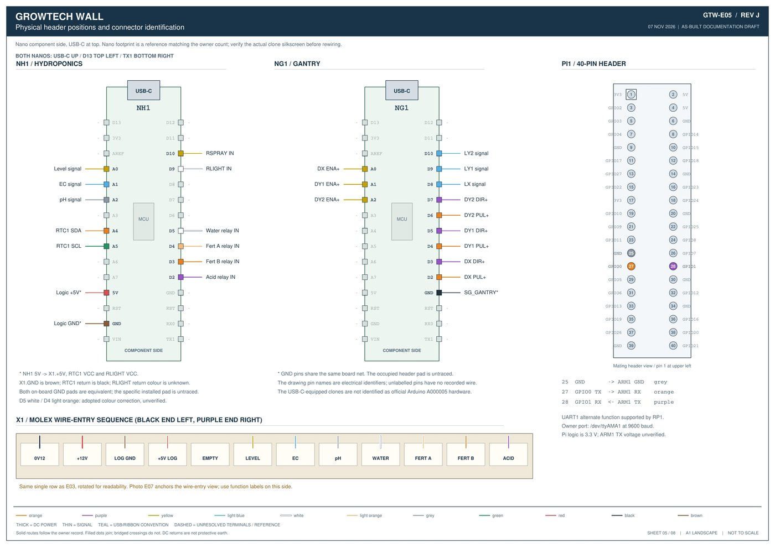
Figure 6.1: Sheet GTW-E05 (Rev J) — Physical component-side pin positions for Hydroponics Nano (NH1), Gantry Nano (NG1), Pi 5 40-pin GPIO header, and Molex X1.

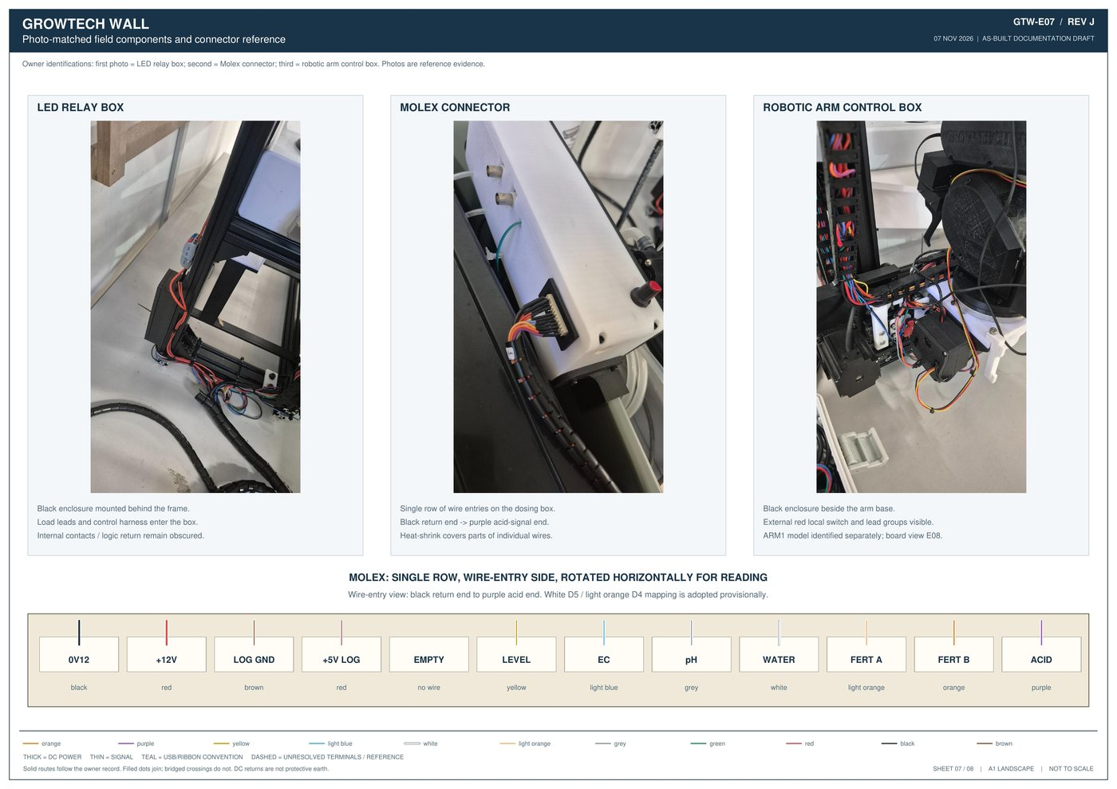
Figure 6.2: Sheet GTW-E07 (Rev J) — Field photographs of the Rear LED Relay Box (RLIGHT), 12-Pin Molex Connector (X1), and Robotic Arm Control Box.

CHAPTER 7 | ELECTRICAL TROUBLESHOOTING, DIAGNOSTICS & ON-SITE VERIFICATION REGISTER
This chapter provides practical multimeter test points, symptom-based electrical diagnostics, and the 10-point On-Site Terminal Verification Register (V01–V10 from Sheet GTW-E06) for any terminal contacts that were obscured inside closed boxes during remote documentation.
7.1 Symptom-to-Fix Electrical & Control Troubleshooting Guide
Observed Electrical / System Symptom | Most Likely Cause | Step-by-Step Diagnostic & Fix
Stepper motors have no holding torque; gantry drops or does not move; pumps & arm dead, but Pi GUI and LEDs are ON | Emergency Stop (ES1) is pressed/latched, or the 2-to-8 actuator distribution block / ES1 contact is open. | 1. Twist-release the red E-Stop button at the top of the main enclosure.  2. Verify 24V DC between +24V_ACT and 0V24_ACT at the DM542 drivers and DC1 input.  3. Click 'Reset' in the Pi GUI to re-initialize Nano serial comms.
After releasing E-Stop, power is back (drivers/arm lit) but Gantry or Dosing Nano does not respond to GUI commands | Serial port state desynchronized or locked when actuator power was interrupted. | 1. Click the 'Reset' button in the Raspberry Pi GUI to reset serial communication to `/dev/arduino_gantry` (`/dev/ttyUSB1`) and `/dev/arduino_hydroponic` (`/dev/ttyUSB0`).  2. Check USB cables between Pi 5 and both Nanos.
One stepper axis (X, Y1, or Y2) does not move, or moves in only one direction | Loose PUL+ (Orange), DIR+ (Purple), or ENA+ (Yellow) wire on NG1 shield / DM542, or disconnected Black return wire in the orange lever connector (SG_GANTRY). | 1. Check that ENA+ (A0/A1/A2) is driven LOW (0V) when enabled.  2. Verify continuity of the Black signal return wire from PUL-/DIR-/ENA- to the shared orange lever block and NG1.GND.  3. Check the 4 motor coil wires (Blk/Grn/Blu/Red) on the DM542.
Gantry crashes into bottom or left frame end during Homing without stopping | Limit switch (LX on D8, LY1 on D9, LY2 on D10) wire detached, or switch lever bent. | 1. With gantry stationary, press each microswitch by hand and verify that NG1 pin D8 (X), D9 (Y1 Left), or D10 (Y2 Right) pulls LOW to 0V.  2. Inspect the light-blue signal wire and return ground path on the microswitch.
Robotic arm does not move or LEDs inside the arm control box are OFF | Local red switch on the arm control box (FRA019A) is switched OFF, 12V feed from DC1 is open, or Pi UART wires (Pins 25/27/28) are loose. | 1. Flick the external red switch on the black arm control box to ON (verify LED1/LED2 light up on the Hiwonder board).  2. Verify 12V DC at the blue screw terminal (+ Left, - Right).  3. Check Orange (Pin 27 -> RX), Purple (Pin 28 -> TX), and Grey (Pin 25 -> GND) UART wires.
Main water pump runs continuously as soon as 12V power is turned on, while dosing pumps stay OFF | Normal as-built relay wiring! Main water pump relay (NH1.D5) is wired Normally Closed / Active LOW (always ON when 12V is present), while dosing pumps (D2/D3/D4) are Active HIGH (normally OFF). | 1. Use the external rotary PWM knob on the dosing module to adjust flow or switch off main pump flow manually, or toggle water pump state via the GUI.  2. Unplug 12-pin Molex (X1) before servicing the tank.
pH, EC, or Water-Level readings in GUI are stuck at 0, erratic, or all dosing relays fail to click | 12-pin Molex connector (X1) is partially unseated, or Pin 3 (Thin Brown = LOGIC_GND) / Pin 4 (Thin Red = +5V_LOG) has lost contact. | 1. Inspect the single-row 12-pin Molex connector (X1) on the side of the dosing box.  2. Measure 5V DC between Pin 4 (Thin Red) and Pin 3 (Thin Brown) from NH1.5V/GND.  3. Keep Molex pins dry and free of nutrient salt crust.
DS3231 RTC clock loses time or Hydroponics Nano halts on startup | Loose I2C wires on NH1 (A4/SDA Orange, A5/SCL Green) or flat CR2032 coin cell on RTC1. | 1. The Hydroponics Nano firmware halts if the DS3231 RTC fails to initialize on I2C.  2. Check Orange (A4/SDA), Green (A5/SCL), Red (5V), and Black (GND) wires on RTC1, and check the coin cell voltage.

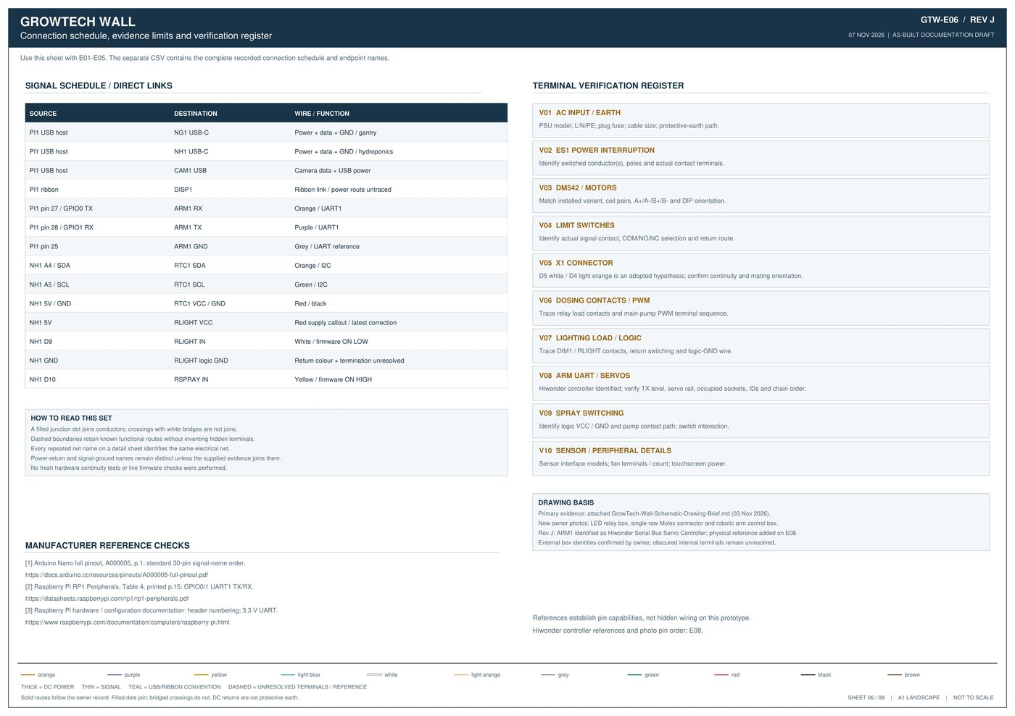
Figure 7.1: Sheet GTW-E06 (Rev J) — Direct Signal Schedule, Terminal Verification Register (V01–V10), Drawing Basis, and Manufacturer Reference Links.

