PROTOTYPE ENGINEERING PASSDOWN | MECHANICAL HARDWARE & MAINTENANCE MANUAL
GrowTech Wall — Mechanical Handover Package
Practical operating precautions, module-by-module mechanical architecture, standard parts sourcing BOM, 3D-printed fabrication reference, and maintenance/troubleshooting manual for incoming researchers.

System Parameter | Specification / As-Built Convention | Mechanical Parameter | As-Built Specification
Full System CAD Root | GTW003C.SLDASM (IDP V2/Assembly) — Revision Rule: Highest letter suffix (A -> B -> C -> D) is latest | Primary Structure | 20x40 mm T-Slot Aluminum Extrusion (1260 mm H x 1080 mm L x 506 mm D)
Active Control Roles | Raspberry Pi 5 (GUI/Vision) + Gantry Nano (NG1) + Hydroponics Nano (NH1) + Hiwonder Bus Servo Board | Workspace & Capacity | XY Gantry: 900 x 1050 mm | 4-DOF Arm Reach: 500 mm | 24 Plant Sites | 12 L Tank

SECTION 1 | CRITICAL SAFETY & OPERATING CAUTIONS (READ BEFORE OPERATING!)
This prototype combines a heavy vertical XY gantry, a cantilevered 4-DOF robotic arm, and a 12 L circulating nutrient system. Before powering up, pressing E-Stop, or unbolting any mechanical bracket, every operator and researcher must understand the physical power-loss behaviors and mechanical tolerances listed below.
MANDATORY PROTOTYPE OPERATING PRECAUTIONS — DO NOT SKIP
• HAZARD 1 — Pressing E-Stop or Cutting Power Drops the Vertical Gantry Immediately: The red Emergency Stop button at the top of the electrical box cuts 24V power to the three DM542 stepper drivers (and the 12V buck converter for pumps/arm). Because the vertical Y-axis uses low-friction V-wheels and GT2 timing belts with no mechanical brake, cutting stepper holding torque causes the horizontal X-beam and robotic arm to DROP STRAIGHT DOWN under gravity! PRECAUTION: Unless preventing an active collision or injury, ALWAYS Home the gantry to the bottom limit switches (or physically prop up the horizontal beam) BEFORE pressing E-Stop or switching off the wall socket.
• HAZARD 2 — E-Stop Recovery & GUI Reset Sequence: When E-Stop is pressed, the Raspberry Pi 5, touchscreen, both Arduino Nanos (powered via Pi USB), sensors, and 5V LED grow lights remain ON. To recover after an E-Stop: (1) Clear any mechanical obstruction and ensure the gantry is resting safely at the bottom, (2) Twist-release the E-Stop button to restore 24V/12V actuator power, and (3) Press the 'Reset' button in the Raspberry Pi GUI to re-initialize serial communication with the Arduino Nanos before commanding any motion.
• HAZARD 3 — GUI 'Stop' Button Does Not Freeze Active Motion Instantaneously: Pressing 'Stop' in the touchscreen GUI cancels the high-level automation queue on the Raspberry Pi, but an already-started Gantry move or Robotic Arm action group will continue until its current command finishes. Furthermore, sending the Gantry Disable command triggers a Y-axis homing routine first. Never put your hands inside the frame until all axes have come to a complete standstill.
• HAZARD 4 — Robotic Arm Local Switch & Gravity Sag: The Hiwonder servo control box mounted beside the arm base has its own external ON/OFF switch. Flicking this switch OFF removes holding torque from the 5 servos, causing the arm links to sag. Always support the arm links by hand before switching the arm box OFF or loosening any servo horn fasteners.
• HAZARD 5 — Never Over-Tighten GT2 Timing Belts (Plate Bowing): The Y-axis and X-axis carriage plates are FDM 3D-printed. If a belt skips, DO NOT blindly crank up belt tension! Excessive belt tension creates lateral bending loads that bow the 3D-printed plates outward, pulling the V-wheels out of the aluminum extrusion grooves and making skipping worse. Check pulley set-screws, 30T pulley alignment, and V-wheel seating instead.
• HAZARD 6 — Tight 1.5 mm Clearance on Hand-Drilled Channel Holes: The 45 mm planting holes in the PVC channels were drilled manually using a jig, and each net pot base is 42 mm in diameter—leaving only 1.5 mm of radial clearance! Because of hand-drilling variations, a theoretical mathematical grid will miss edge/corner holes. Never swap channels between tiers, and always verify physical hole positions when calibrating robot coordinates.

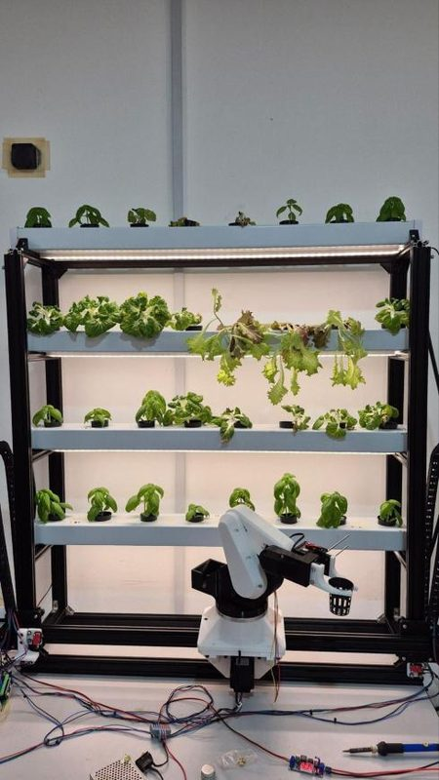 | 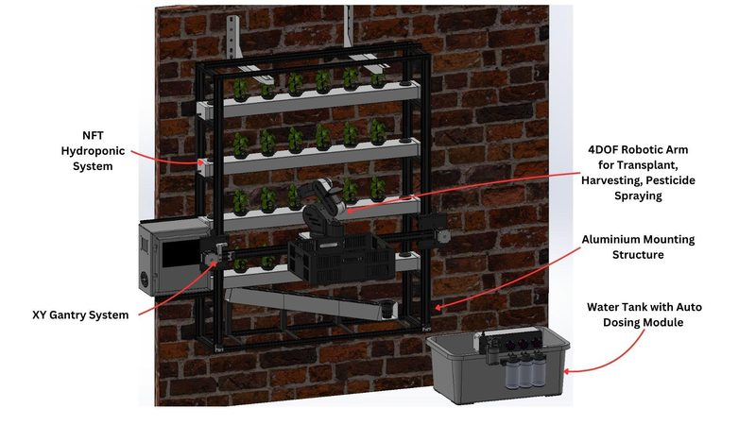
Figure 1.1: As-built GrowTech Wall prototype showing the 4-tier NFT channels, XY gantry, cantilevered 4-DOF arm, and collection basket. | Figure 1.2: Full-system mechanical architecture (GTW003C) identifying the primary functional modules.

SECTION 2 | SYSTEM ARCHITECTURE & MODULE-BY-MODULE MECHANICAL BREAKDOWN
The GrowTech Wall mechanical system is organized around a modular 20x40 mm T-slot aluminum frame (GTW003C). The rear plane supports four horizontal NFT hydroponic channels and an inclined seedling rack, while the front plane carries a dual-motor vertical Y-axis gantry (GTW002B), a horizontal X-axis carriage and cantilevered arm platform (GTW005C), a 4-DOF robotic arm (GTW001E), and a rack-and-pinion gripper (GTW006B). A 12 L reservoir with a snap-fit auto-dosing module (GTW007A) sits at the base, and the main electrical enclosure (GTW004A) mounts on the left side of the frame.
CAD Assembly | Module Name | Key Mechanical Components | Core Mechanical Function & Interfaces
GTW003C | Full System Root & Main Frame (FRAM001D) | 20x40 mm T-slot extrusions (1260 H x 1080 L x 506 D mm), 4 PVC channels, seedling chute (FHA003B), and collection basket. | Main structural reference; sets verticality and parallelism for both Y-axis guide rails.
GTW002B | Vertical Y-Axis Gantry Assembly | Dual NEMA 23 (1.9 N·m) motors (Y1 Left, Y2 Right), 30T GT2 pulleys, stiffened carriage plates (FGA001C), 12 V-wheels (6 per side). | Lifts horizontal beam across 1050 mm vertical stroke; homes to 2 bottom microswitches (D9/D10).
GTW005C | Horizontal X-Axis & Arm Platform | Single NEMA 23 (1.3 N·m) motor, 20T GT2 pulley, 16 V-wheels in 2 planes, side plates (FGA012A), trusses (FGA013B), basket hooks. | Moves arm across 900 mm width; resists heavy cantilever torque from offset arm and basket.
GTW001E | 4-DOF Robotic Arm Assembly | FDM-printed PETG/PLA+ links (FRA001C–FRA005D), turntable base, 1x HX-35M base servo + 3x HTS-35H joint servos (35 kg·cm), C920 camera, sprayer. | 500 mm reach; executes pre-programmed action groups via Hiwonder bus controller.
GTW006B | End-Effector Gripper (Inside GTW001E) | Actuator housing (FRA010A), HX-12H servo (25T horn), central pinion (FRA013A), opposing racks (FRA014A/FRA015B), curved fingers (FRA017C/18C). | Symmetric rack-and-pinion closure around the 3D-printed PETG net-pot socket wall.
GTW007A | Water Tank & Auto-Dosing Module | 12 L reservoir, snap-fit case (FHA004A/005A), DP-521 main pump (3.5 L/min), 3x Kamoer peristaltic pumps, 3x 250 ml bottles, pH/EC/level probes. | Circulates nutrient film (~15 mm depth) via 9.5 mm black PU tubing; disconnects via 12-pin Molex.
GTW004A | Electrical Enclosures & Cable Routing | Main left-side electrical box, 3x DM542 drivers (Top X, Mid Y1, Bot Y2), 24V PSU, buck converters, plus 2x local boxes (FRA019A) & X chain bracket. | Houses power/control hardware; routes moving harnesses safely to X carriage and arm.

2.1 Main Structural Frame & Wall Mounting (GTW003C / FRAM001D)
The structural backbone is constructed from manually cut 20x40 mm T-slot aluminum extrusion profiles (nine 1000 mm lengths and sixteen 200 mm cross-members) joined using cast aluminum L-brackets (Misumi LBSBL6-2028-SET / 2028 gussets) with M5 T-nuts and hex socket cap screws. The overall frame envelope measures 1260 mm high, 1080 mm long, and 506 mm deep (occupying a 0.546 m² footprint, excluding the protruding electrical box, basket, and tank). Total operating weight is approximately 29.2 kg including water in the channels (10.05 kg aluminum frame, 5.3 kg stainless mounting brackets, 3.4 kg PVC channels, 3.35 kg water in channels, 3.0 kg gantry, and 3.5 kg robotic arm).
• Wall Anchoring & Rigidity: The frame is designed to be anchored to a structural wall using two heavy-duty AISI 304 stainless steel sheet-metal L-brackets (the type used for outdoor air-conditioning condensers). Whether mounted to a wall or resting on a lab bench during indoor research, ensure the two vertical outer columns are completely square and parallel—any twist in the main frame directly binds the Y-axis V-wheels.
• Prototype Fabrication Note: Because the 2040 extrusions were cut manually, minor length tolerances exist. Always measure the physical frame bay before cutting replacement extrusions or remaking channel support brackets.
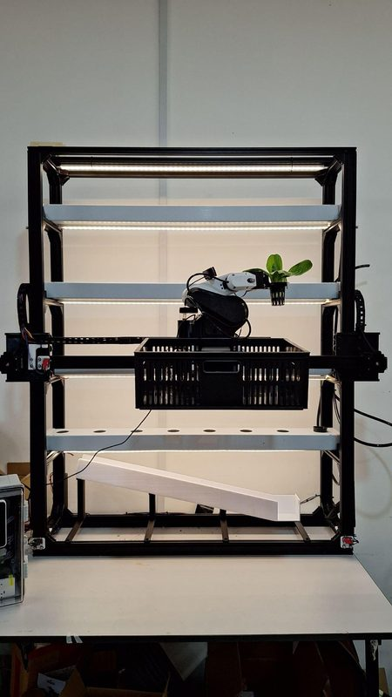 | 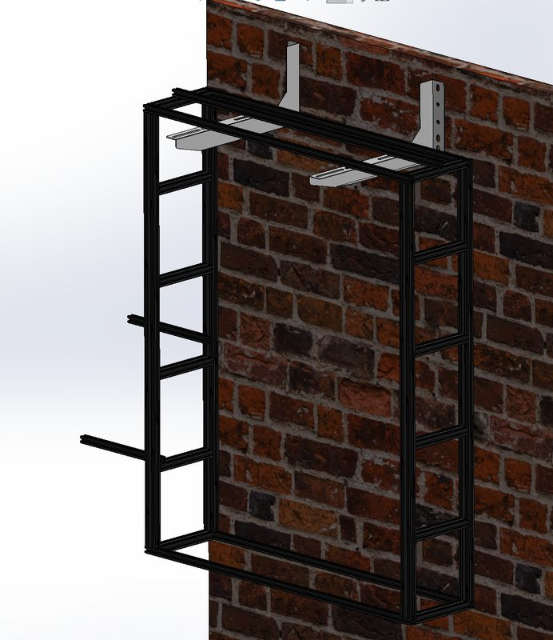
Figure 2.1: As-built 2040 T-slot aluminum structural frame with mounted channels, gantry, arm, and basket. | Figure 2.2: CAD structural frame (FRAM001D) and heavy-duty sheet-metal wall-mounting brackets.

2.2 Vertical Y-Axis Gantry Drive & Carriage System (GTW002B)
The vertical Y-axis lifts and lowers the horizontal X-beam across a 1050 mm vertical stroke so the robotic arm can reach all four growing tiers and the bottom seedling slide. It is driven by two high-torque NEMA 23 stepper motors (1.9 N·m rated torque), one on each side of the frame, coupled to fiberglass-reinforced GT2 timing belts:
• Left vs. Right Orientation (Y1 vs. Y2): When standing in front of the machine facing the wall, Y1 is the LEFT vertical axis and Y2 is the RIGHT vertical axis. Inside the electrical box, the middle DM542 driver powers Y1 (Left) and the bottom DM542 driver powers Y2 (Right).
• Dual Bottom Homing Limit Switches: Two Omron V-155-1C25 microswitches are mounted at the bottom ends of the left and right vertical rails (wired to Gantry Nano pins D9 for Y1-Left and D10 for Y2-Right). During homing, both sides drive down independently until both bottom switches trigger, automatically squaring and leveling the horizontal X-beam.
• Crucial Engineering Upgrades (Preserved in FGA001C): Early prototypes used a 20-tooth GT2 pulley and a 4-wheel carriage plate, which suffered from belt tooth skipping and out-of-plane plate bending under tension. The current build incorporates three critical upgrades that MUST be preserved if remaking parts:
1. 30-Tooth GT2 Pulleys: Upgraded from 20T to 30T to increase pitch diameter and belt wrap angle, eliminating tooth skipping under vertical load.
2. 6-Wheel V-Slot Configuration: Increased from 4 to 6 Delrin V-wheels per side (12 wheels total on Y), including two passive top guide rollers to suppress torsional play.
3. Stiffened Carriage Plates (FGA001C): Increased plate thickness with top and bottom reinforcing edge flanges so belt tension does not bow the plate and unseat the V-wheels.
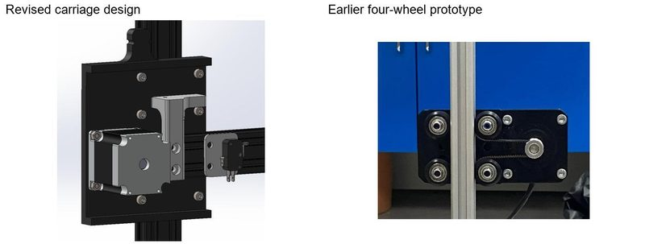 | 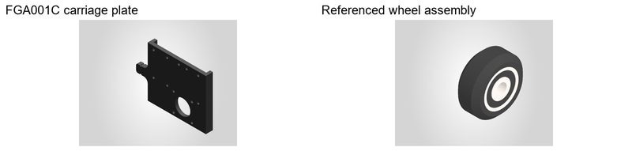
Figure 2.3: Left: Revised 6-wheel Y-axis carriage (FGA001C) with edge stiffening flanges and 30T pulley. Right: Earlier 4-wheel prototype. | Figure 2.4: CAD detail of the FGA001C gantry carriage plate and Delrin Solid V-Wheel assembly (with dual 625-2RS bearings).

2.3 Horizontal X-Axis Carriage & Cantilever Arm Platform (GTW005C)
The X-axis carriage travels 900 mm horizontally along the moving cross-beam (FGA002A), driven by a single NEMA 23 stepper motor (1.3 N·m rated torque, top DM542 driver) with a 20-tooth GT2 pulley. Homing is detected by a single microswitch mounted on the left end of the X-beam (FGA004A limit switch plate, wired to Gantry Nano pin D8).
• Cantilever Load & Dual-Plane 16-Wheel Design: To give the 4-DOF arm enough clearance to articulate in front of the crops, the arm base is offset forward from the X-beam. This offset—combined with the harvesting collection basket hanging on rear hooks (FGA021B / FGA022A)—creates a severe cantilevered twisting moment on the X-carriage. Single-plane rollers twisted off the rail during early trials. To solve this, GTW005C uses 16 Delrin V-wheels arranged across TWO orthogonal planes (8 rollers on the front vertical face and 8 rollers on the top horizontal face of the extrusion), locking the carriage around all four faces of the rail.
• Truss Bracing & Spacer Stack: Two triangular platform trusses (FGA013B) and platform supports (FGA015B) brace the projecting arm mounting plate (FRA001C) back into the X carriage side plates (FGA012A). The wheel axles rely on specific custom spacers—4.5 mm (FGA016A, Qty 8), 9 mm (FGA017A, Qty 4), and 23 mm (FGA018A, Qty 2)—plus aluminum round spacers. Always photograph and label the exact spacer stack order before unbolting any X-carriage wheel axle!
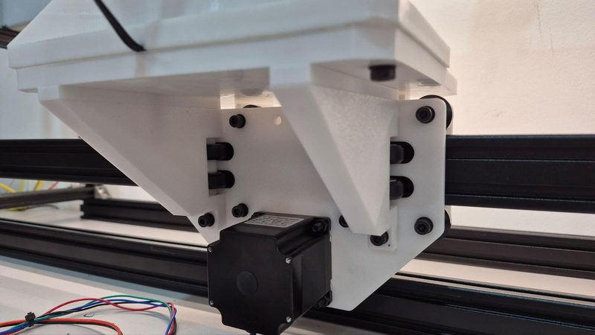 | 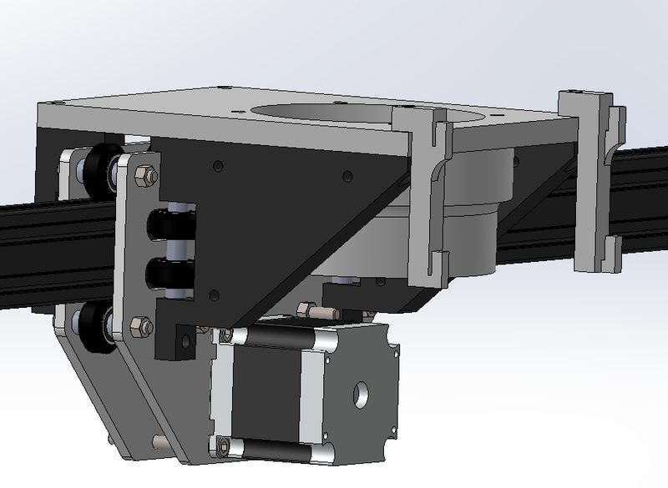
Figure 2.5: Actual 3D-printed X-axis carriage showing the triangular platform trusses (FGA013B), bottom NEMA 23 motor, and dual-plane V-wheels. | Figure 2.6: CAD assembly of GTW005C showing the projecting arm mounting plate (FRA001C) and rear basket hook mounts (FGA021B/022A).

2.4 4-DOF Robotic Arm Assembly & Actuators (GTW001E)
The 4-DOF robotic arm (GTW001E) mounts atop the X-carriage platform and provides a 500 mm maximum reach to handle transplanting, harvesting, AI vision inspection, and foliar pesticide/neem-oil spraying across all four channel tiers. All structural links are FDM 3D-printed in PETG/PLA+ with internal stiffening ribs to minimize deadweight.
• Joint Architecture & Structural Links:
1. Base Rotation (Yaw): Turntable Assembly (Inner/Outer rings) and rotary base plate (FRA002B) mounted on the arm base plate (FRA001C), driven by a Hiwonder HX-35M (or HX-35HM) 360° high-torque servo.
2. Shoulder & Elbow Pitch + Wrist Articulation: Supported by joint housing FRA003C, first link housing FRA004B, and second link housing FRA005D ('Arm 2'). These three articulated joints are powered by three Hiwonder HTS-35H serial bus servos (35 kg·cm stall torque each) coupled via 25T aluminum servo horns.
3. End-Effector Gripper Drive: The gripper actuator housing (FRA010A) carries one Hiwonder HX-12H servo (11 kg·cm torque) that drives the rack-and-pinion fingers.
• Servo Bus Wiring & Local Control Box (FRA019A): A black control enclosure mounted right beside the arm base houses the Hiwonder Serial Bus Servo Controller and a 12V spray-pump relay. The gripper servo (HX-12H) and the three joint servos (HTS-35H) are connected in a 3-wire daisy chain (yellow/red/black wires) to the controller's bus ports, while the base 360° servo (HX-35M) uses a separate 3-black-wire lead. The controller communicates directly with the Raspberry Pi 5 over UART (Pi GPIO0 TX Pin 27, GPIO1 RX Pin 28, GND Pin 25 at 9600 baud)—it does NOT go through either Arduino Nano.
• Load Path & Cantilever Moment: At full 500 mm horizontal extension with a wet net pot and mature plant (~450 g payload), the shoulder joint experiences torque near its continuous holding limit (Segment masses: L6 Base/Link = 85 g, Shoulder Motor = 60 g, L4 Arm+Camera = 227 g, Wrist Motor = 60 g, L2 Gripper = 100 g, L1 Payload = 450 g). Never hang extra weight on the wrist, and inspect 3D-printed servo horn seats regularly for layer delamination or screw loosening.
• Camera & Sprayer Accessories: A Logitech C920 HD webcam is mounted adjacent to the gripper for YOLOv8 plant maturity and pest detection. A quick-connector spray nozzle (with 6 mm pneumatic fittings) is mounted beside the gripper, fed by a 12V diaphragm spray pump and a compact rear reservoir.
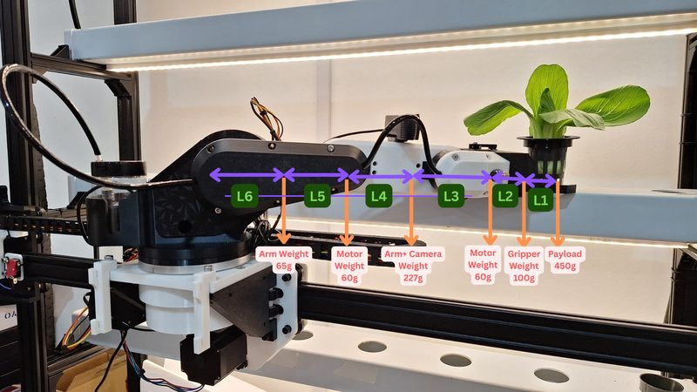 | 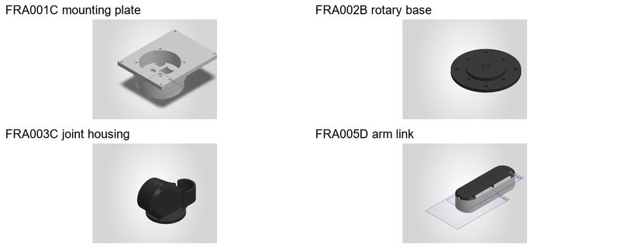
Figure 2.7: As-built 4-DOF robotic arm extended in front of the channels, showing link mass distribution and cantilevered posture. | Figure 2.8: Primary 3D-printed arm structural parts: FRA001C base mount, FRA002B rotary base, FRA003C joint housing, and FRA005D link.

2.5 Rack-and-Pinion End-Effector Gripper Mechanism (GTW006B)
Nested at the distal end of GTW001E, the end-effector assembly (GTW006B) converts rotary servo motion into synchronized, symmetric linear motion of two opposing curved fingers:
• How the Mechanism Works: The gripper servo horn (23.9 mm effective radius) drives the Right Rack (FRA014A) directly. As the right rack slides linearly, its teeth rotate a central passive Gripper Pinion (FRA013A, supported on a miniature 603-ZZ ball bearing, 3 mm ID x 9 mm OD x 3 mm W, and thrust bearing), which drives the opposing Left Rack (FRA015B) in the exact opposite direction. Curved Gripper Finger A (FRA017C) and Finger B (FRA018C) bolt to the two racks and slide along two parallel 3 mm x 80 mm steel guide shafts.
• Maintenance & Replacement Note (Shaft/Bearing Check): In the CAD BOM, the linear bearing is labeled 'LM3UU' in the part title (matching the 3 mm x 80 mm guide shafts) but has 'LM6UU' stored in its configuration field. Before ordering replacement linear bearings, measure the physical guide shaft diameter on the gripper with calipers (3 mm vs. 6 mm).
• Centering on the Socket Adapter: If the two fingers do not meet at the exact centerline of the gripper housing, skip a tooth on the passive pinion (FRA013A) to re-center both racks. Even a 1–2 mm centering error will cause the pot rim to catch on the 45 mm channel hole during transplanting!
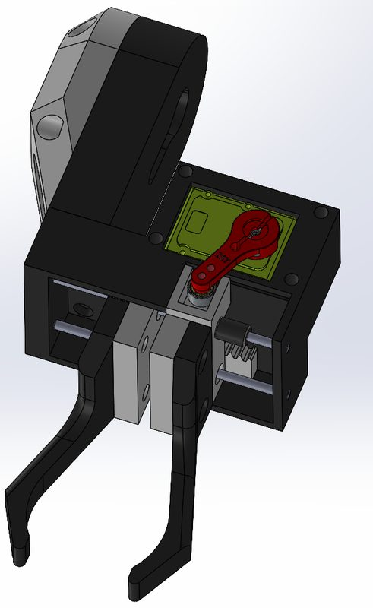 | 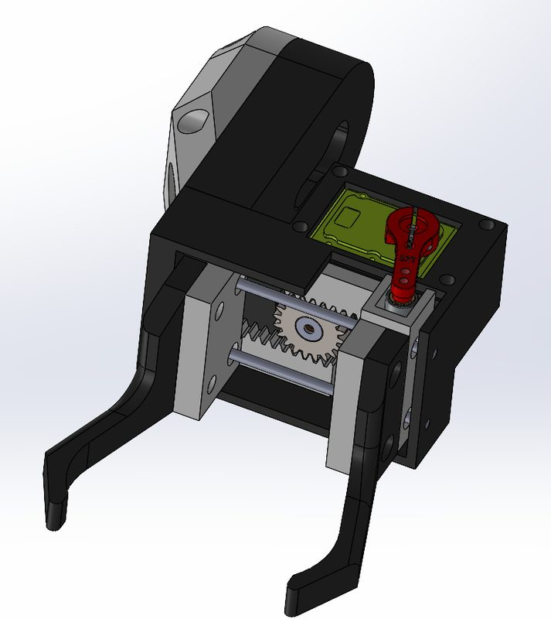
Figure 2.9: Gripper assembly (GTW006B) in Open Pose showing the active right horn/rack, central passive pinion (FRA013A), and opposing left rack. | Figure 2.10: Gripper assembly in Closed Pose showing symmetric finger engagement (FRA017C & FRA018C).

2.6 NFT Hydroponic Channels, PETG Socket Adapters & Seedling Slide
The growing wall uses a 4-tier Nutrient Film Technique (NFT) layout designed specifically around robotic pick-and-place constraints:
• Four Horizontal PVC Channels: Each channel measures 1000 mm long x 109 mm wide x 58 mm high, stacked vertically with 200 mm row-to-row spacing. Each channel has 8 holes drilled at a nominal 127 mm pitch, with 6 active planting sites per channel (24 active plants total) and 8 printed lids (FHA012A) capping unused holes. Channel ends are sealed with 8 PVC end caps (two configured for manual water top-up during power outages).
• Custom 3D-Printed PETG Socket Adapter (FHA002A, Qty 34): Standard slotted net pots have thin, flexible rims and overhanging leaves that a robotic gripper cannot grab reliably. Each net pot is fitted with a custom 3D-printed PETG collar/cup (FHA002A) that sits on the channel opening and provides a rigid vertical contact wall for the curved gripper fingers. Treat the net pot and PETG adapter as a matched pair—never use a bare net pot without its adapter!
• 13° Inclined Seedling Slide Rack (FHA003B): Mounted below the bottom growing tier, the transplant chute is inclined at an experimentally tuned 13° slope. Seedling pots sit in a queue along the chute; when the robotic arm lifts the leading pot from the bottom stop, gravity passively slides the remaining cups forward into the pick position.
• Full-Spectrum White LED Grow Lights: Mounted on the underside of each tier above the plants using industrial double-sided tape. White LEDs (380–780 nm, 5V powered via PWM dimmer and rear relay box) were deliberately chosen instead of purple ('blurple') grow lights so the C920 webcam can run YOLOv8 plant-health and pest-detection models without color distortion.
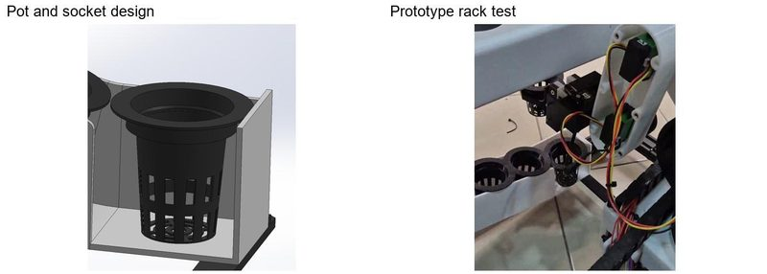 | 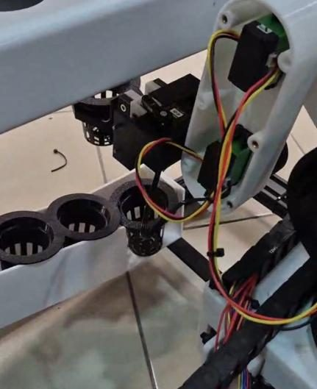
Figure 2.11: Custom PETG socket adapter (FHA002A) fitted onto a standard net pot and tested on the 13° inclined seedling rack (FHA003B). | Figure 2.12: Close-up of the robotic gripper approaching the leading seedling cup on the inclined chute during transplant testing.

2.7 Water Tank & Snap-Fit Auto-Dosing Module (GTW007A)
Positioned on the floor beside the lower right corner of the frame, the Water Tank Assembly (GTW007A) regulates nutrient circulation and automated chemical dosing:
• 12 L Reservoir & Main Circulation Loop: A 12V diaphragm pump (DP-521, rated 3.5 L/min) draws nutrient solution from the 12 L tank through an inlet debris filter and pumps it through a one-way outlet check valve (prevents backflow/siphoning when idle) into 9.5 mm ID opaque black polyurethane (PU) tubing (chosen to block light and prevent algae growth) fitted with stainless push-to-connect fittings. An external rotary PWM speed-controller knob on top of the dosing box lets the operator tune flow rate to maintain an ~15 mm nutrient film depth across all four channels.
• Snap-Fit Dosing Housing (FHA004A) & Bracket (FHA005A): The white 3D-printed dosing enclosure clips directly over the lip of the 12 L tank via custom snap-fit brackets (FHA005A) without permanent screws. Three blue Kamoer KPP peristaltic pumps mounted on the front face draw from three 250 ml reagent bottles held in a lower rack (FHA008A): Left = Fertilizer A, Middle = Fertilizer B, Right = Phosphoric Acid (pH Down).
• Submerged Sensor Holder (FHA009A) & 12-Pin Molex Quick-Disconnect: Mounted inside the tank wall, FHA009A holds the pH sensor (PH-4502C), EC sensor, and water-level sensor at fixed immersion depths. All power (12V pump power, 5V logic) and 7 sensor/relay control lines pass through a single 12-pin Molex connector (1 pin empty) on the side of the dosing box, allowing the entire tank module to be unplugged and carried to a sink for cleaning.
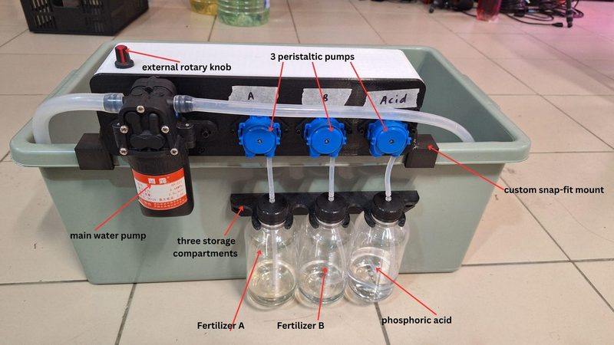 | 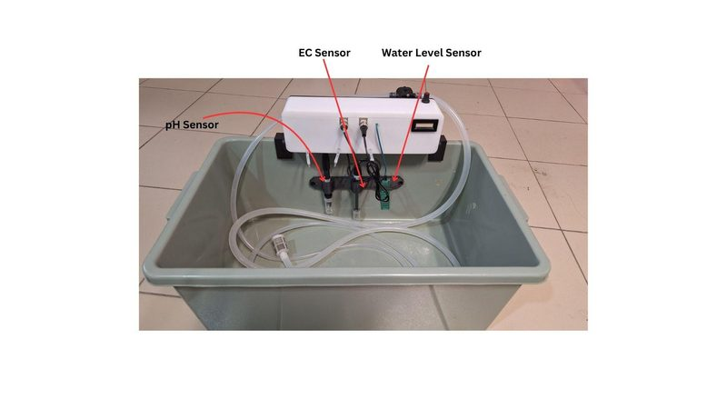
Figure 2.13: Front view of the actual GTW007A dosing module showing the DP-521 main pump, rotary flow knob, 3 Kamoer peristaltic pumps, and 3 reagent bottles. | Figure 2.14: Rear/interior view of the reservoir showing the submerged pH, EC, and water-level sensors in holder FHA009A.

2.8 Electrical Enclosures & Moving Cable Routing (GTW004A & FRA019A)
While electrical schematics are covered in the companion Electrical Handover (GTW-E01 to E08), mechanical maintainers must understand the physical packaging and cable paths when disassembling modules:
• Main Left-Side Electrical Enclosure (GTW004A): Houses the 24V 16.5A (396W) AC-DC PSU, two stacked SZBK07 buck converters (top set to 12V for pumps/arm; bottom set to 5V for LED grow lights), the Wheeltec P23C 5V/5A power board (powering the Raspberry Pi 5 and enclosure cooling fan), both USB-powered Arduino Nanos (Gantry NG1 and Hydroponics NH1), and the three DM542 stepper drivers.
• DM542 Physical Mounting Order: Inside the enclosure, the three stepper drivers are stacked vertically: TOP = X-Axis (DX), MIDDLE = Y1 Left Axis (DY1), BOTTOM = Y2 Right Axis (DY2). Note that the physical DM542 units are mounted upside-down relative to standard text orientation—always verify terminal labels before unplugging motor plugs.
• Local Control Boxes (FRA019A, Qty 2) & Cable Chains (FGA019A): Two smaller 3D-printed boxes (FRA019A) are installed on the machine: one mounted at the rear of the frame housing the LED grow-light relay, and one mounted beside the robotic arm base housing the Hiwonder bus servo controller and spray-pump relay. Moving cables and spray tubing are anchored to the X-carriage via the X Chain Bracket (FGA019A)—always verify full X (900 mm) and Y (1050 mm) travel clearance after re-tying any zip-ties so harnesses cannot snag on the basket hooks or channel ends.
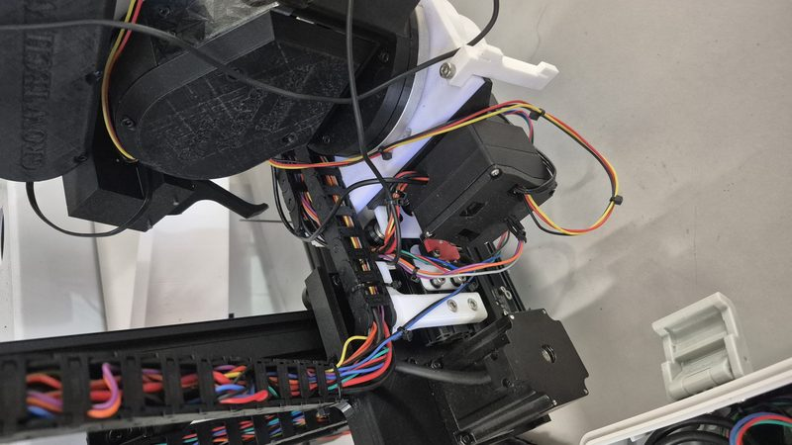 | 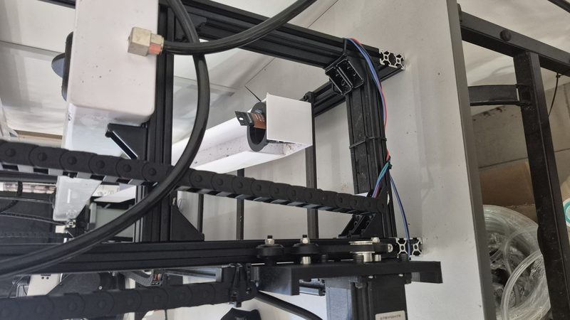
Figure 2.15: Prototype photo showing the X-carriage motor, robotic arm base control box (FRA019A), and moving cable/tubing harness. | Figure 2.16: Prototype photo showing rear frame channel supports, plumbing lines, and rear cable routing.

SECTION 3 | BILL OF MATERIALS (BOM) — STANDARD SOURCING & CUSTOM FABRICATED PARTS
To make replacement sourcing straightforward without wading through raw SolidWorks assembly trees, the Bill of Materials is divided into two practical tables below:
1. Table 3.1 (Standard / Off-the-Shelf Parts Sourcing BOM): Lists all commercial mechanical, structural, fluidic, and actuation hardware with specifications, quantities, and actual suppliers used during prototype construction.
2. Table 3.2 (Custom 3D-Printed & Fabricated Parts Reference): Lists all 33 custom-designed components by their latest SolidWorks revision code (where A -> B -> C -> D -> F denotes successive revisions; always use the highest letter suffix).
3.1 Standard / Off-the-Shelf Parts Sourcing List (For Replacements)
Component / Part Name | Specification & Model Details | System Qty | Subsystem / Mechanical Role | Prototype Supplier & Price Ref
2040 T-Slot Extrusion (1000 mm) | 20x40 mm Aluminum Profile, 1000 mm length | 9 pcs | Main vertical columns & horizontal rails | Focus Aluminium (Shopee) — RM 35.00/pc
2040 T-Slot Extrusion (200 mm) | 20x40 mm Aluminum Profile, 200 mm length | 16 pcs | Front-to-back depth cross-members | Focus Aluminium (Shopee) — RM 7.00/pc
Cast L-Bracket Gusset (2028) | Misumi LBSBL6-2028-SET (with M5 T-nut LNCFM5 & M5x10 screw LTTB6-5-10) | 70–96 sets | Joining 2040 frame extrusions (70 purchased / 96 in CAD) | Taobao (铝型材配件销售) / Misumi — RM 2.15/pc
Sheet-Metal Wall Mounting Bracket | Heavy-duty AISI 304 Stainless L-Bracket (AC outdoor unit type) | 2 pcs | Anchoring main frame to structural wall | Alibaba (创美金属有限公司) — RM 17.50/pc
Mounting L-Bracket (Small) | Standard 90° angle bracket | 1 pc | Auxiliary bracket in CAD root | Standard hardware
NEMA 23 Stepper Motor (1.9 N·m) | 57BYGH56-401A, 1.9 N·m holding torque, 4-lead (Blk/Grn/Blu/Red) | 2 pcs | Vertical Y-Axis Dual Drive (Y1 Left & Y2 Right) | Robotronik (Shopee) — RM 85.00/pc
NEMA 23 Stepper Motor (1.3 N·m) | NEMA 23 bipolar stepper, 1.3 N·m holding torque | 1 pc | Horizontal X-Axis Carriage Drive | Robotronik (Shopee) — RM 73.90/pc
Stepper Motor Driver (DM542) | Leadshine DM542 digital stepper driver (24V supply; DIP: SW1,3,5,6 UP; SW2,4,7,8 DOWN) | 3 pcs | Drives X (Top), Y1 Left (Mid), Y2 Right (Bot) (Note: Report listed TB6600; actual build uses DM542) | Robotic Wholesale Market / Taobao
GT2 Timing Belt (Fiberglass) | GT2 pitch (2 mm), fiberglass-reinforced rubber, ~1030 mm per axis | 3ch (3+ m) | X-axis and dual Y-axis linear belt drives | Smith3D — RM 15.99/pack
GT2 Timing Pulley (30T & 20T) | Aluminum 6063-T1 GT2 pulleys: 2x 30-Tooth (Y-axis upgraded) + 1x 20-Tooth (X-axis) | 3 pcs | Motor shaft belt drive (30T stops Y belt skipping) | Robotronik (Shopee) — RM 5.90/pc
Delrin Solid V-Wheel Assembly | Delrin (POM) Solid V-Slot wheel body + 2x 625-2RS ball bearings per wheel | 28 assys (56 brgs) | 12 wheels on Y-carriages (6/side) + 16 wheels on X-carriage (8 front, 8 top) | Smith3D — RM 3.50/assy
625-2RS Ball Bearing | Metric 625-2RS double-sealed bearing (5 mm ID x 16 mm OD x 5 mm W) | 56 pcs | 2 bearings pressed into each of the 28 Delrin V-wheels | Included with V-Wheel kits (Smith3D)
Aluminum Round Spacer | 5052-H34 Aluminum unthreaded M5 wheel/standoff spacer | 29 pcs | Maintains wheel & motor standoff stack on X/Y carriages | Smith3D / Standard M5 hardware
Limit Switch (Microswitch) | Omron V-155-1C25 SPDT roller lever microswitch | 3 pcs | Homing endstops: Y1 bottom (D9), Y2 bottom (D10), X left (D8) | Robotic Wholesale Market
Hiwonder Joint Servo (HTS-35H) | Hiwonder HTS-35H high-torque serial bus servo (35 kg·cm, 3-wire daisy chain) | 3 pcs | Articulated arm joints (Shoulder, Elbow, Wrist) | Alibaba (一介布衣) / Hiwonder
Hiwonder Base 360° Servo (HX-35M) | Hiwonder HX-35M / HX-35HM 360° rotary servo (separate 3-black-wire lead) | 1 pc | Robotic arm base yaw rotation (Turntable) | Alibaba (一介布衣) / Hiwonder
Hiwonder Gripper Servo (HX-12H) | Hiwonder HX-12H serial bus servo (11 kg·cm; CAD ref 0_DS-LH8A_stp) | 1 pc | Drives rack-and-pinion gripper fingers (daisy-chained with HTS-35H) | Alibaba / Hiwonder
Hiwonder Bus Servo Controller | Hiwonder Serial Bus Servo Controller (SKU 21090003, 6–12V input, UART to Pi) | 1 pc | Mounted inside arm control box; runs .rob action groups | Hiwonder / Taobao
25T Aluminum Servo Arm Horn | 6061 Alloy 25-tooth clamping servo horn (plus 1x Round Servo Horn) | 4 pcs (+1) | Couples servo output splines to 3D-printed arm links & gripper rack | Robotronik — RM 3.69/pc
Gripper Guide Shafts (3x80 mm) | 3 mm diameter x 80 mm length stainless steel linear rod | 2 pcs | Linear guide rails for opposing gripper fingers inside GTW006B | Standard 3 mm linear shaft
Linear Bearing (LM3UU / LM6UU) | Linear ball bushing (Verify physical shaft: CAD title says LM3UU, config says LM6UU) | 1 pc | Guides gripper rack/finger travel | Standard linear bearing
Miniature Ball Bearing (603-ZZ) | Metric 600 series double-shielded bearing, 3 mm ID x 9 mm OD x 3 mm W | 1 pc | Supports central passive pinion (FRA013A) in gripper | Standard metric bearing
Thrust Bearing & Turntable | Axial thrust bearing (1 pc) + Turntable Assembly Inner/Outer rings (1 set) | 1 set | Supports axial & moment loads at rotary arm base | Standard hardware
NFT Hydroponic PVC Channel (1 m) | Food-grade white PVC channel, 1000 x 109 x 58 mm (8 holes/row, 45 mm diameter) | 4 pcs | 4 horizontal growing tiers (24 active plant sites total) | UH Agroponics — RM 15.90/set
Hydroponic Channel End Cap | PVC rectangular slip-on end cap (2 arranged for manual water refill) | 8 pcs | Seals both ends of the 4 PVC channels | UH Agroponics (included in set)
Hydroponic Net Pot | Standard slotted plastic net pot (42 mm base diameter) | 34 pcs | Plant holder (used with custom PETG socket adapter FHA002A) | Wellgrow / Shopee
Collection Basket (IDP Basket) | Slotted plastic harvesting collection crate | 1 pc | Hangs on X-carriage hooks (FGA021B/022A) to catch harvested pots | Shopee / Blomker — RM 8.50
Nutrient Reservoir Water Tank | 12 L polypropylene/ABS rectangular storage tank with lip | 1 pc | Base nutrient reservoir supporting snap-fit dosing module | Local hardware / Shopee
Main Water Pump (DP-521) | 12V DC diaphragm pump, rated 3.5 L/min, with inlet filter & outlet check valve | 1 pc | Circulates nutrient solution from 12 L tank to all 4 channels | Taobao (凌泰重工) / ElectricA
Kamoer Peristaltic Pump (KPP) | 12V DC Kamoer KPP peristaltic dosing pump | 3 pcs | Automated dosing of Fertilizer A, Fertilizer B, and Phosphoric Acid | Taobao / ElectricA — RM 12.45/pc
Reagent Dosing Bottles (250 ml) | 250 ml clear plastic/glass reagent bottles | 3 pcs | Holds Fertilizer A, Fertilizer B, and Acid in bottle holder FHA008A | Labware / Shopee
Spray Pump (12V) & Spray Nozzle | 12V mini diaphragm pump + Quick-Connector Spray Nozzle + 6 mm pneumatic fitting | 1 set | Foliar pesticide/neem-oil spraying at robotic arm end-effector | Shopee / Blomker
Black PU Tubing & Fittings | 9.5 mm ID opaque black polyurethane (PU) tube (5 m) + 8x stainless push fittings | 5 m + 8 pcs | Opaque circulation plumbing (prevents algae growth) | AIROTECH / Ban Hee & TYS STORE
Sensors (pH, EC, Water Level) | PH-4502C pH sensor + EC sensor + Water Level sensor (held in FHA009A) | 1 set | Submerged reservoir monitoring connected via 12-pin Molex | Taobao (芯柚科技) — RM 133.15
PWM Speed Controller & 4ch Relay | Rotary knob PWM motor controller (1 pc) + 4-channel optocoupler relay board (1 pc) | 1 set | Mounted inside dosing box (FHA004A) for pump speed & switching | Electrica.my / Taobao
Webcam (Logitech C920) | Logitech C920 HD Pro USB webcam | 1 pc | Mounted on wrist/gripper for YOLOv8 AI crop/pest vision | Shopee — RM 130.00
Main Electrical Enclosure & PSU | Electrical Panel Box + 24V 16.5A (396W) PSU + 2x SZBK07 Buck + Wheeltec P23C + Pi 5 | 1 set | Mounted on left side of frame; powers & coordinates full system | Taobao (迎欣旗舰店) / Cytron
Standard Metric Fasteners (M4/M5) | M4x12 FCHS (4), M4x20 FCHS (4), M4x30 SHCS (4), M5x35 SHCS (24), M5x40 SHCS (7), M5x50 SHCS (7), M5 Hex Nuts (24) + M5 Lock Nuts (28) | Assortment | Stainless steel assembly hardware across gantry, arm, and wheels | VIRAL DIY — Nut & Bolt Assortment

3.2 Custom 3D-Printed & Fabricated Parts Reference List (Latest Revisions)
All custom parts are stored under 'IDP V2/FAB' in the CAD repository. When 3D-printing replacements (Jamghe PETG or PLA+ filament), always select the file with the highest revision suffix letter (e.g., use FGA001C instead of FGA001B, FRA001C instead of FRA001B, and FGA023F instead of FGA023A). Use high wall perimeters (3–4 walls) and 30–50% infill on load-bearing gantry and arm joints.
Latest Code | Part Name / Description | Qty | Actual Prototype Material | Parent Module | Mechanical Function & Key Interface Notes
FRAM001D | Aluminium Frame Assembly | 1 | 2040 Al Profile | GTW003C | Main structural frame supporting growing channels and XY gantry.
FGA001C | Gantry Plate Mirror (Y-Carriage) | 2 | FDM PETG (CAD: Acrylic) | GTW002B | Revised 6-wheel Y-axis carriage plate with top/bottom stiffening flanges.
FGA002A | Gantry Rail (X Cross-Beam) | 1 | 2040 Al (5052-H34) | GTW003C | Horizontal extruded linear guide beam carried by the two Y-carriages.
FGA004A | X Limit Switch Plate | 3 | FDM Printed PETG | GTW003C | Positions the homing microswitches relative to the moving carriages.
FGA012A | X_Plate1 (X Carriage Side Plate) | 2 | FDM PETG (CAD: Acrylic) | GTW005C | Connects the X-carriage motor mount and 16 dual-plane roller axles.
FGA013B | Platform Truss (Triangular Brace) | 2 | FDM Printed PETG | GTW005C | Triangular truss bracing the cantilevered arm platform against bending.
FGA015B | Platform Support | 2 | FDM Printed PETG | GTW005C | Structural support bracket connecting the arm platform to X-carriage.
FGA016A | 4.5 mm Spacer | 8 | FDM Printed / Al | GTW005C | Maintains precise axle spacing in the X-gantry wheel mounting stack.
FGA017A | 9 mm Spacer | 4 | FDM Printed / Al | GTW005C | Maintains precise axle spacing in the X-gantry wheel mounting stack.
FGA018A | 23 mm Spacer | 2 | FDM Printed / Al | GTW005C | Maintains precise standoff spacing in the X-gantry mounting stack.
FGA019A | X Chain Bracket | 1 | FDM Printed PETG | GTW003C | Anchors the moving cable-chain/harness connection to the X-carriage.
FGA021B | Basket Hook (Left/Right) | 1 | FDM Printed PETG | GTW005C | Rear hook on X-carriage supporting the harvesting collection basket.
FGA022A | Basket Hook (Opposing) | 1 | FDM Printed PETG | GTW005C | Second rear hook on X-carriage supporting the collection basket.
FGA023F | Damper / Mounting Block (Rev F) | 2 | FDM Printed PETG | GTW002B | Two-hole mounting/damping block on gantry (consolidated from FGA023A).
FRA001C | Arm / Platform Mounting Plate | 2 | FDM Printed PETG | GTW001E / 005C | Interfaces the rotary arm base with the projecting X-platform (consolidates FRA001B).
FRA002B | Rotary Base Plate | 1 | FDM PETG (CAD: 6061) | GTW001E | Circular rotary mounting plate driven by the base 360° servo (HX-35M).
FRA003C | Arm Joint Housing 1 (Shoulder) | 1 | FDM Printed PETG/PLA+ | GTW001E | Supports the first pitch joint (shoulder) and HTS-35H servo interface.
FRA004B | Arm Link Housing 1 | 1 | FDM PETG (CAD: 6061) | GTW001E | Primary structural arm link housing connecting shoulder and elbow joints.
FRA005D | Arm 2 (Second Link Housing) | 1 | FDM Printed PETG/PLA+ | GTW001E | Distal arm link housing between elbow and wrist joints (Rev D).
FRA010A | End-Effector Actuator Housing | 1 | FDM PETG (CAD: 6061) | GTW006B | Main gripper body carrying the HX-12H servo, guide shafts, and wrist mount.
FRA013A | Gripper Pinion | 1 | FDM Printed PETG/PLA+ | GTW006B | Central passive spur gear synchronizing the left and right gripper racks.
FRA014A | Gripper Rack 1 (Driven Rack) | 1 | FDM Printed PETG/PLA+ | GTW006B | Right linear rack driven directly by the 25T servo horn; carries Finger A.
FRA015B | Gripper Rack 2 (Opposing Rack) | 1 | FDM Printed PETG/PLA+ | GTW006B | Left linear rack driven in reverse by central pinion FRA013A; carries Finger B.
FRA017C | Gripper Finger A (Rev C) | 1 | FDM Printed PETG | GTW006B | Curved opposing finger bolted to Rack 1; grips PETG net-pot socket wall.
FRA018C | Gripper Finger B (Rev C) | 1 | FDM Printed PETG | GTW006B | Opposing curved finger bolted to Rack 2; grips PETG net-pot socket wall.
FRA019A | Local Control Box Enclosure | 2 | FDM Printed PETG | GTW003C | Small enclosure with access openings (1x Arm Servo Box, 1x Rear LED Relay Box).
FHA002A | Net Pot Socket Adapter ('Cup') | 34 | FDM Printed PETG | Channel Assy | Ring-shaped collar fitted atop net pots; provides rigid gripping wall for robot.
FHA003B | Slide V2 (13° Seedling Chute) | 1 | FDM Printed / PVC | GTW003C | Inclined 13° passive gravity-fed chute supplying seedling pots for transplanting.
FHA004A | Auto-Dosing Module Housing | 1 | FDM Printed PETG | GTW007A | White enclosure housing relays/wiring and mounting the 4 pumps on the tank.
FHA005A | Tank-Edge Snap-Fit Bracket | 1 | FDM Printed PETG | GTW007A | Clips over the rim of the 12 L reservoir to hold dosing box FHA004A without screws.
FHA008A | Dosing Bottle Holder | 1 | FDM Printed PETG | GTW007A | Three-compartment rack retaining the 250 ml Fertilizer A, B, and Acid bottles.
FHA009A | Submerged Sensors Holder | 1 | FDM Printed PETG | GTW007A | Bracket inside reservoir positioning the cylindrical pH, EC, and level probes.
FHA012A | Channel Opening Lid ('LID') | 8 | FDM Printed PETG | Channel Assy | Caps the 2 unused holes on each of the 4 PVC channels to block light/algae.

SECTION 4 | PRACTICAL MAINTENANCE, ADJUSTMENTS & TROUBLESHOOTING MANUAL
This section translates the lessons learned during prototype fabrication and testing into hands-on maintenance procedures. Before reaching into the frame or loosening any fastener, ALWAYS home the gantry (or prop up the X-beam), turn off the main power or E-Stop, and support the cantilevered robotic arm.
4.1 Pre-Operation & Periodic Maintenance Checklist
Inspection Area & Interval | What to Check Physically | Why It Matters on This Prototype
1. Y1 & Y2 Gantry Level & Belt Tracking (Before Each Run) | Inspect both left (Y1) and right (Y2) GT2 belts and 30T pulleys. Ensure the horizontal X-beam is level across the frame. | If one Y-belt skips a tooth or a bottom limit switch (D9/D10) shifts, the entire X-beam tilts, throwing off every planting hole coordinate across the wall.
2. Carriage Plates & V-Wheel Preload (Weekly) | Check all 12 Y-wheels and 16 X-wheels for smooth rolling contact in the 2040 V-slots. Inspect 3D-printed plates (FGA001C, FGA012A) and trusses (FGA013B) for bowing or layer cracks around bolt heads. | Loose wheels cause the cantilevered arm platform to rock forward; over-tightened belts bow the printed plates outward and unseat the rollers.
3. Robotic Arm Horns & Gripper Rack Mesh (Weekly) | Gently test shoulder, elbow, and wrist joints for play. Check that the 25T aluminum servo horn screws are snug and that Gripper Fingers A & B (FRA017C/18C) close symmetrically at the center of the housing. | With only 1.5 mm radial clearance between the 42 mm pot base and 45 mm channel hole, even 1° of shoulder play or off-center finger mesh causes the pot rim to hit the channel.
4. PETG Socket Adapters & 13° Seedling Slide (Before Transplant/Harvest) | Ensure every net pot has its 3D-printed PETG socket collar (FHA002A) seated firmly. Clear root tangles, spilled media, or biofilm from the 13° seedling chute (FHA003B). | The seedling chute relies entirely on passive gravity sliding (13° angle). A single snagged root or tilted collar stops the queue from advancing to the pick point.
5. Grow Light Tape & Moving Harness Clearance (Weekly) | Check the white LED strips under each PVC channel (held by industrial double-sided tape). Verify that moving arm cables, webcam USB, and spray tubing clear the basket and channels. | Peeling LED tape allows a light strip to sag directly into the robotic arm's path or block the C920 camera view (ruining YOLOv8 inference).
6. Reservoir Filter, Check Valve & Dosing Tubes (Bi-Weekly / Tank Clean) | Inspect the DP-521 main pump inlet filter for root debris. Check the snap-fit tank bracket (FHA005A) for creep/cracks, and inspect Kamoer peristaltic tubes for pinching or crystallization. | A clogged inlet filter starves the top channels of water (<15 mm target film), while a reversed or stuck check valve allows channels to siphon back and overflow the 12 L tank when the pump stops.

4.2 Step-by-Step Module Servicing & Disassembly Procedures
HANDS-ON SERVICING & REASSEMBLY PROTOCOLS
• Procedure A — Servicing the Y-Axis or X-Axis Gantry (Belts, Pulleys & V-Wheels): 1. Home the gantry to the bottom limit switches first, or place wooden blocks/props under both ends of the horizontal X-beam so it cannot drop.
2. Photograph the exact spacer stack on the wheel axles before removing any M5 screw (especially on GTW005C, which mixes 4.5 mm [FGA016A], 9 mm [FGA017A], 23 mm [FGA018A], and aluminum round spacers).
3. When setting GT2 belt tension, tension just enough to remove visible slack and backlash. NEVER over-tension to fix skipping—verify that the 30T Y-pulleys and 20T X-pulley grub screws are locked onto the NEMA 23 shaft flats and that the carriage plates (FGA001C) are flat.
• Procedure B — Servicing the 4-DOF Robotic Arm & Re-Centering the Gripper: 1. Hold the robotic arm links by hand before flicking the red switch on the arm control box (FRA019A) to OFF.
2. Before removing any servo (HX-35M, HTS-35H, or HX-12H) from its 25T aluminum horn, mark the spline alignment with a fine marker and record the arm's physical pose. Putting a horn back 1 spline tooth off shifts every pre-programmed .rob action group trajectory!
3. To re-center the gripper fingers (FRA017C/18C): Remove the central passive pinion (FRA013A), power the HX-12H gripper servo to its neutral/closed pose, slide both racks (FRA014A and FRA015B) to equal distances from the center, and re-mesh the pinion. Test-grip a net pot fitted with its PETG adapter (FHA002A).
• Procedure C — Removing & Cleaning the 12 L Water Tank & Auto-Dosing Module (GTW007A): 1. Turn off the main pump via the GUI or rotary PWM knob. Unplug the 12-pin Molex connector on the side of the white dosing housing (FHA004A) to isolate all 12V/5V power and signals.
2. Label the three peristaltic pump suction tubes before pulling them from the 250 ml bottles: Left = Fertilizer A, Middle = Fertilizer B, Right = Phosphoric Acid. Flush the peristaltic tubing with clean water if storing the machine.
3. Disconnect the 9.5 mm black PU circulation hose (note the flow arrow on the one-way outlet check valve!). Support the bottle rack (FHA008A) and unclip the snap-fit brackets (FHA005A) from the tank rim. Keep water completely away from the Molex pins and internal 4-channel relay board.

4.3 Symptom-to-Fix Mechanical Troubleshooting Guide
Because plant handling relies on the entire mechanical chain (frame -> Y-rails -> X-beam -> cantilevered platform -> 3D-printed arm links -> rack-and-pinion gripper -> hand-drilled 45 mm PVC holes), always isolate mechanical flex or play BEFORE altering software coordinates or action groups.
Observed Symptom / Fault | Root Mechanical Cause | Practical Corrective Action
Gantry drops suddenly when E-Stop is pressed or power is cut | Normal physical behavior: E-Stop cuts 24V to the DM542 stepper drivers, removing holding torque. | 1. Always Home the gantry to the bottom limit switches before pressing E-Stop or powering down.  2. To recover: twist-release E-Stop, then click 'Reset' in the Pi GUI to reset Nano serial comms.
Horizontal X-beam is tilted / skewed, or Y-axis binds during lift | Y1 (Left) and Y2 (Right) carriages are out of sync, one belt skipped, or one bottom limit switch (D9/D10) failed to trigger. | 1. Do NOT force the beam by hand with drivers enabled.  2. Check 30T pulley set-screws on both Y motors.  3. Run dual Y-homing and verify both bottom microswitches click cleanly.
Belt continues to skip even after tightening the belt | Over-tightening the GT2 belt is bowing the 3D-printed carriage plate (FGA001C), pulling the V-wheels out of the extrusion groove. | 1. Back off belt tension until the carriage plate sits flat.  2. Inspect FGA001C top/bottom stiffening flanges for cracks.  3. Check that all 6 V-wheels per side contact the rail evenly.
Arm platform twists forward or sags when the arm extends | Loose dual-plane V-wheels on X-carriage (GTW005C), loose spacer stack, or cracked platform truss (FGA013B). | 1. Check all 16 V-wheels on GTW005C (8 front vertical, 8 top horizontal).  2. Tighten bolts through triangular trusses FGA013B and supports FGA015B.  3. Ensure collection basket is not overloaded.
Robot inserts pot cleanly in center holes, but hits the rim on edge/corner holes | Accumulated error across 1.5 mm radial clearance (42 mm pot vs. 45 mm hand-drilled hole) + slight frame/rail deflection. | 1. Measure the physical hole position on the PVC channel (hand-drilled holes vary from nominal 127 mm pitch).  2. Check shoulder servo horn play before editing grid offsets in software.
Gripper fingers close off-center, bind, or drop the net pot during transfer | Racks (FRA014A/15B) jumped a tooth on central pinion (FRA013A), loose 25T servo horn, or missing/cracked PETG pot adapter (FHA002A). | 1. Verify the net pot has an undamaged PETG socket adapter (FHA002A).  2. Re-index the passive pinion (FRA013A) so both fingers meet at the exact center.  3. Check the two 3x80 mm guide shafts for debris.
Seedling cups fail to slide down the chute after the front cup is picked | Root growth hanging out of net pots, debris on chute surface, or chute angle shifted from 13°. | 1. Trim protruding roots on waiting seedlings and wipe the slide chute (FHA003B) clean.  2. Verify the 13° chute inclination and check that cup rims aren't catching on adjacent collars.
Weak water flow in top channels, or water siphons back when pump stops | Clogged DP-521 pump inlet filter, kinked 9.5 mm black PU tube, rotary PWM knob turned down, or reversed check valve. | 1. Clean the submerged inlet filter in the 12 L tank.  2. Check the external rotary PWM knob on top of the dosing box.  3. Verify one-way outlet check valve arrow points toward the channels.

SECTION 5 | CAD REPOSITORY GUIDE & KNOWN MODEL NOTES FOR FUTURE RESEARCHERS
If future researchers modify the mechanical design or export STL/STEP files for 3D printing from the SolidWorks repository, keep these four practical CAD rules in mind:
SOLIDWORKS REPOSITORY & 3D-PRINTING HANDOVER NOTES
• 1. File Locations & Revision Naming Convention (A -> B -> C -> D -> F): Top-level and module assemblies are stored in 'IDP V2/Assembly/' (GTW003C.SLDASM is the full system root; GTW001E, GTW002B, GTW004A, GTW005C, GTW006B, and GTW007A are the module subassemblies). Custom fabricated/3D-printed parts are in 'IDP V2/FAB/' (prefixes FGA = Gantry, FRA = Robotic Arm, FHA = Hydroponics, FRAM = Frame), and purchased models are in 'IDP V2/Standard/'. Letters at the end of a part code denote revisions—always use the highest available letter suffix when printing replacements.
• 2. Known GTW005C Wheel Placement Quirk in SolidWorks (CAD-Only Artifact): All 28 Delrin V-wheel assemblies and 56 bearings resolve in the current CAD BOM. However, when opening GTW005C.SLDASM in SolidWorks, 14 of its 16 wheel subassemblies appear floating at a distance from the carriage plates (only wheel instances 7 and 9 sit directly on the plates due to an internal wheel origin/mate offset). Do NOT use the floating wheel positions in GTW005C as a physical build guide—refer to the physical prototype photos (Figure 2.5 & 2.6) where all 16 wheels sit flush in two planes (8 front, 8 top).
• 3. External SolidWorks References (Create a 'Pack and Go' Before Moving Machines): The raw CAD folder references three external locations on the original authoring PC: (a) 'OneDrive/Projects/IDP V2/Standard/Solid V Wheel/' for the resolved wheel assembly, (b) 'C:/solidworks data/browser/ansi metric/' for SolidWorks Toolbox screws/nuts, and (c) local temporary folders for 20 internal surface bodies inside the imported HX-35HM servo model. When transferring CAD files to a new workstation, use SolidWorks 'File -> Pack and Go' on GTW003C.SLDASM with 'Include Toolbox components' checked so no links break.
• 4. Prototype Reality vs. CAD Library Materials: Several CAD parts list default SolidWorks library materials (such as 'Acrylic' on FGA001C/FGA012A or '6061 Alloy' on FRA002B/FRA004B/FRA010A). On the actual working prototype, all FGA, FRA, and FHA custom brackets, plates, links, racks, pinions, and enclosures are FDM 3D-printed in PETG or PLA+ (except FRAM001D and FGA002A which are 2040 aluminum extrusions). Always follow Table 3.2 for actual prototype materials.

