**LAB#02**

**APPLIED PHYSICS LAB**

**Submitted to :Mr.Muhammad Shoaib**

**Submitted by: Group Of**

**Laraib Ijaz  (2021-BSE-036)**

**Fizza Khan  (2021-BSE-012)**

**Tanzeela Asgher(2021-BSE-032)**

**Date : 9th Mar,2022**

**Series Circuit**:

Resistance of the series combination measured by multimeter:

Current flowing through the circuit measured by multimeter:

Total resistance of the circuit measured by multimeter:

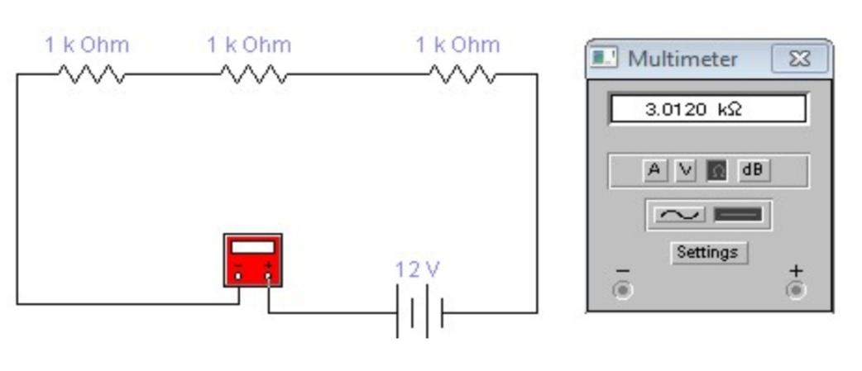

Equivalent resistance using formula:

Calculation of the total resistance of the circuit:

| **Resistor Symbol** | **Value(.)** | **Value to be used in calculations** |
| --- | --- | --- |
|  | **Multimeter** |  |
| **R1** | **3.0000kohm** | **3.0000kohm** |
| **R2** | **4.0004mA** | **4.0004mA** |
| **R3** | **3.0120kohm** | **3.0120kohm** |

| **S.**  **NO** | **Total resistance value(.)** | **Applied voltage**  **(V)** | **Current** | **Resistance Value (V/I)**  **(.)** |
| --- | --- | --- | --- | --- |
|  | | **Calculated using formula** | **Measured with voltmeter** | | --- | --- |   **R1+R2+R3. 3k ohm**  **=3kohm** | **12V** | **V=IReq**  **I=V/Req**  **I=12/3**  **I=4A** | **R=V/I**  **R=3kohm** |

**B. Parallel Circuit**:

Resistance of the parallel combination measured by multimeter:

Current flowing through the circuit measured by multimeter :

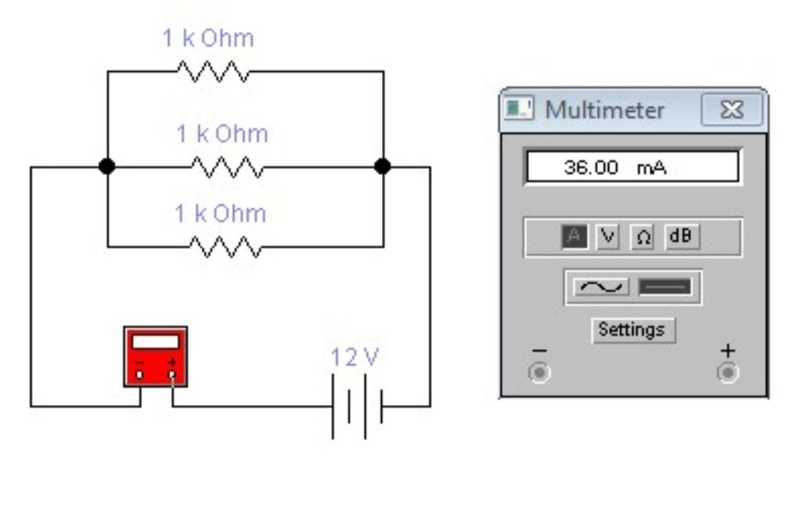

Total resistance of the circuit by multimeter:

Equivalent resistance using formula:

Calculation of the total resistance of the circuit:

| **Resistor Symbol** | **Value(.)** | **Value to be used in calculations** |
| --- | --- | --- |
|  | **Multimeter** |  |
| **R1** | **333.3 ohms** | **333.3ohms** |
| **R2** | **36.00mA** | **36.00mA** |
| **R3** | **345.3 ohms** | **345.3 ohms** |

| **SO.**  **NO** | **Total resistance value(.)** | **Applied voltage**  **(V)** | **Current** | **Resistance value** **(V/I)**  **(.)** |
| --- | --- | --- | --- | --- |
|  | | **Calculated using formula** | **Measured with voltmeter** | | --- | --- |   **1/R1+1/R2+. 3kohms**  **1/R3=3kohm** | **12V** | **36.00mA** | **3 k ohms** |

C. **Series Parallel Circuit:**

Resistance of the series parallel combination measured by multimeter:

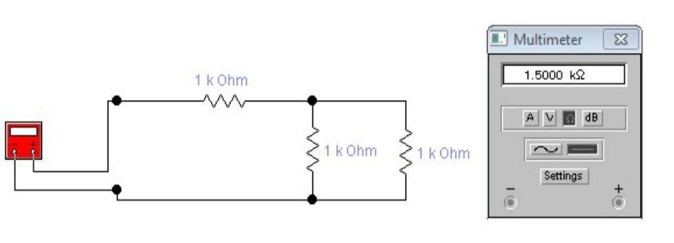

Current flowing through the circuit measured by multimeter:

Total resistance of the circuit by multimeter:

Equivalent resistance using formula:

Calculation of the total resistance of the circuit :

| **Resistor Symbol** | **Value(.)** | **Value to be used in calculations** |
| --- | --- | --- |
|  | **Multimeter** |  |
| **R1** | **1.5000 k ohm** | **1.5000k ohm** |
| **R2** | **18. 00mA** | **18.00mA** |
| **R3** | **1.4880 k ohm** | **1.4880 ohm** |

| **S.**  **NO** | **Total resistance value(.)** | **Applied voltage** (V) | **Current(A)** | **Resistance Value (V/I)**  **(.)** |
| --- | --- | --- | --- | --- |
|  | | **Calculated using formula** | **Measured with voltmeter** | | --- | --- |   **3 KOHM. 3K OHM** | **12 V** | **18.00mA** | **3 k ohm** |

D. **View point:**

Resistance of the circuit: At AB:

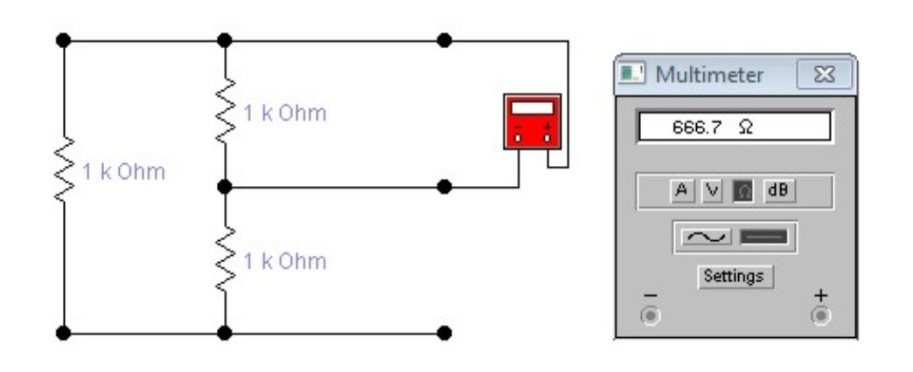

**At AC:**

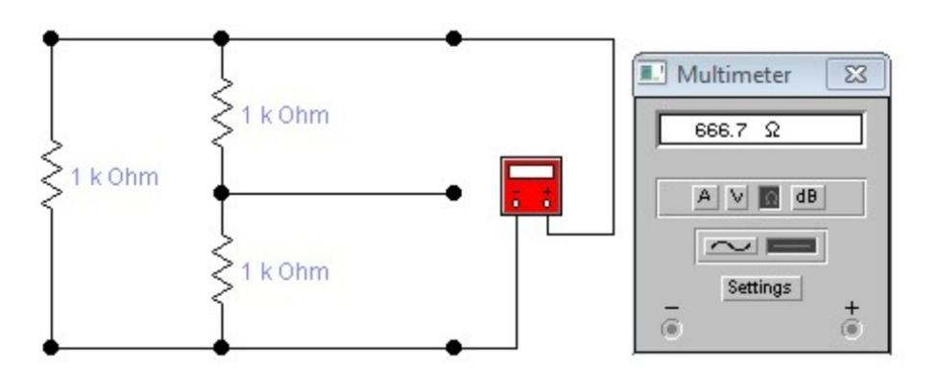

**At BC:**

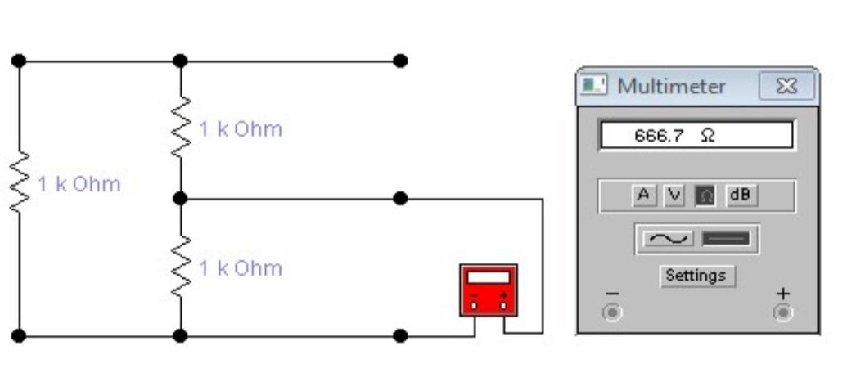

Current flowing through the circuit measured by multimeter :

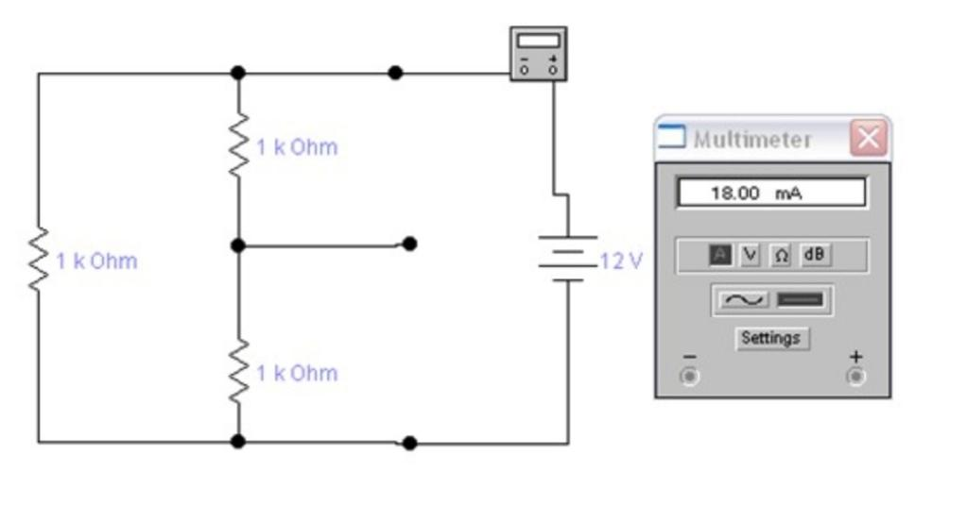

Calculate the resistance between points AB, BC and AC:

Calculation of the total resistance of the circuit :

| **Resistor Symbol** | **Value (.)** | **Value to be used in calculations** |
| --- | --- | --- |
|  | **Multimeter** |  |
| **R1** | **666.7 ohm** | **666.7 ohm** |
| **R2** | **666.7 ohm** | **666.7 ohm** |
| **R3** | **18.00 mA** | **18.00 mA** |

| **Total resistance value (.)** |
| --- |

| **So.**  **No** | **Calculated using formula** | **Measured with voltmeter** | **Applied voltage**  **(V)** | **Current** | **Resistance Value (V/I)**  **(.)** |
| --- | --- | --- | --- | --- | --- |
|  | **3 k ohm** | **3 kohm** | **12 V** | **18.00mA** | **666.7 K OHM** |
|  | **3 k ohm** | **3 k ohm** | **12 V** | **18.00mA** | **666.7k ohm** |
|  | **3 k ohm** | **3 k ohm** | **12 V** | **18.00mA** | **666.7 kohm** |