LIBRARY MANAGEMENT SYSTEM
Software Design & Architecture — Group Activity (Tasks 1–4)

Task 1: Candidate Conceptual Classes
We use both the noun-phrase technique and the category-list technique to identify candidate classes in the Library Management System.
No. | Candidate Class | Purpose
1 | Member | Person who registers with the library and borrows books.
2 | Librarian | Staff member who manages library operations.
3 | Book | A publication available in the library collection.
4 | BookCopy | An individual physical or digital copy of a book.
5 | Author | Person who writes a book.
6 | Loan | Record of a book borrowed by a member.
7 | Reservation | Request to hold a book for a member.
8 | Fine | Record of a charge for an overdue or damaged book.
9 | Publisher | Organization that publishes a book.
10 | LibraryCatalog | Collection used to search and organize library books.

Noun-phrase technique: Member, Librarian, Book, BookCopy, Author, Loan, Reservation, Fine, Publisher, and LibraryCatalog.
Category-list technique: People (Member, Librarian, Author), resources (Book, BookCopy), transactions (Loan, Reservation), charges (Fine), organizations (Publisher), and collections/search (LibraryCatalog).

Task 2: UML Class Diagram
The diagram should include all 10 candidate classes. Each class separates attributes (state/data) from methods (behavior/a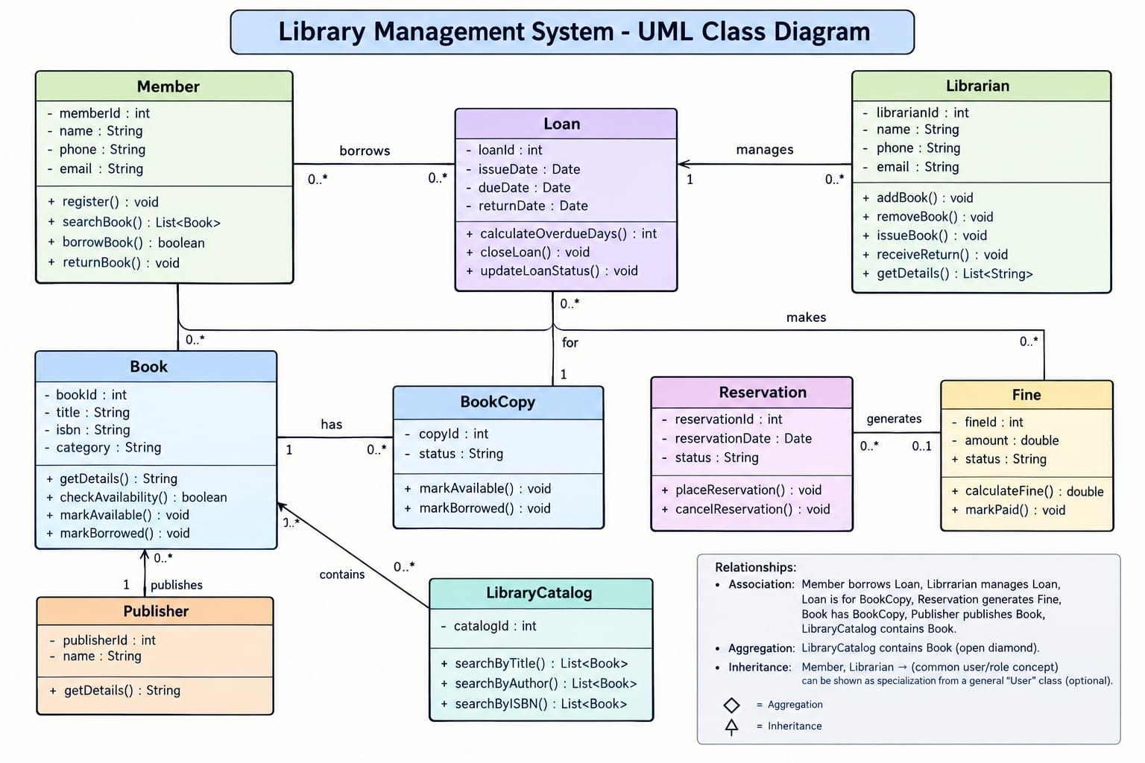ctions). The following text-based UML overview presents the main classes and relationships.

Relationships: One Member can have many Loans and Reservations. A Book can have multiple BookCopies and may be written by one or more Authors. A Publisher can publish many Books. A Loan is associated with a BookCopy and may generate a Fine. The LibraryCatalog organizes Books for searching.
UML notation: means a private attribute; + means a public method. Relationships show how objects interact in the system.

Task 2: Three Important Classes in Detail

1. Member
Attributes (State) | Methods (Behavior)
memberId: int | register()
name: String | searchBook()
phone: String | borrowBook()
email: String | returnBook()

2. Loan
Attributes (State) | Methods (Behavior)
loanId: int | calculateOverdueDays()
issueDate: Date | closeLoan()
dueDate: Date | updateLoanStatus()
returnDate: Date

3. BookCopy
Attributes (State) | Methods (Behavior)
copyId: int | markAvailable()
status: String | markBorrowed()
shelfLocation: String | updateLocation()

Task 3: Abstraction Decisions
Abstraction means showing only the important information and hiding unnecessary real-world details. In our Library Management System, we store a member’s name, contact information, and borrowing records, but we do not need to store details such as height, eye colour, or clothing. For a book, we store its title, ISBN, author, and availability status, while ignoring irrelevant physical details. This makes the system simpler, easier to manage, and more efficient.

Task 4: One Invented Software Object
Invented object: BookAvailabilityChecker
BookAvailabilityChecker is a software object that checks whether a requested book copy is available before a member borrows or reserves it. It verifies the book’s current status and checks whether all required information has been provided. If the book is unavailable or information is missing, it displays a suitable message. This object is invented for software purposes because it is not a physical object in the real world.

Short Presentation Summary
“Our group selected the Library Management System. We identified 10 candidate classes using the noun-phrase and category-list techniques. We described the classes through their attributes and methods and explained their relationships. We applied abstraction by keeping only relevant information and identified BookAvailabilityChecker as an invented software object that helps check book availability.”

