**ASSIGNMENT-1**

**Write a Java program to create a class called Vehicle with a method called drive().**

**\* Vehicle should have attributes such as make (String), model (String), year (int) and maximum Speed (int).**

**\* Create a constructor in Vehicle with all fields as constructor parameters.**

**\* Create a subclass called Car and override constructor. Call super().**

**\*Write a function that overrides the drive() method to print (make + " "+ model +**

**" Car is driving".)**

**\* Also create another subclass Bike extending the vehicle class.**

**•Override the drive() method to print (make + " "+ model + " Bike is driving".)**

**\* Instantiate both Bike and Car class. Print their attributes.**

**PROGRAM:**

**package** tanzeela;

**class** Vehicle{

**string** make;

**string** model;

**int** year;

**int** maximumSpeed;

**public** Vehicle(String make,String model,**int** year,**int** maximumSpeed) {

**this**.make=make; **this**.model=model; **this**.year=year;

**this**.maximumSpeed=maximumSpeed;

}

**public void** drive() {

System.***out***.println("Vehicle is driving");

}

}

**Class** Car **extends** Vehicle{

**public** Car(String make,String model,**int** year,**int** maximumSpeed) {

**super**(make,model,year,maximumSpeed);

}

**public void** drive() {

System.***out***.println(make + " " + model + "Car is driving.");

}

}

**class** Bike **extends** Vehicle{

**public** Bike(String make,String model,**int** year,**int** maximumSpeed) {

**super**(make,model,year,maximumSpeed);

}

**public void** drive() {

System.***out***.println(make + " " +model + "Bike is driving.");

}

**public class** Demo {

**public static void** main(String[] args) {

Car car=**new** Car("Toyata","Corolla",2020,120); System.***out***.println("Car

Details:"+car.make+","+car.model+","+car.year+","+car.maximumSpeed+"km/h"); car.drive();

Bike bike=**new** Bike("Honda","CBR500R",2020,150); System.***out***.println("Bike

Deatils:"+bike.make+","+bike.model+","+bike.year+","+bike.maximumSpeed+"km/h"); bike.drive();

}

}

**OUTPUT:**

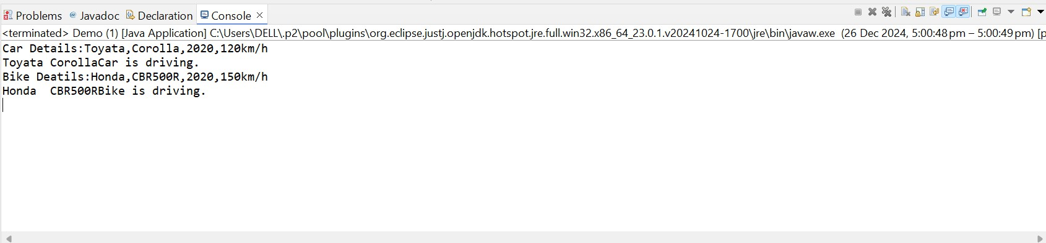

**ASSIGNMENT-2**

**Write a Java program to create a class called Shape with a method called getArea().**

**\* Create a subclass called Circle and create a constructor that takes the value of radius(int) as input parameter.**

**\* Override the getArea() method.**

**\* Create a class called square that takes an attribute length. Create a constructor that takes length as input.**

**\* Override the getArea() method.**

**\* Create a subclass of Shape called Rectangle that takes width and height as input to the constructor.**

**\* Override the getArea() method to calculate the area of a rectangle.**

**Instantiate and call getArea() method.**

**PROGRAM:**

**package** tanzeela;

**abstract class** Shape{

**public abstract double** getArea();

}

**class** Circle **extends** Shape{

**private int** radius;

**public** Circle(**int** radius) {

**this**.radius=radius;

}

**public double** getArea() {

**return** Math.***PI***\*radius*radius;

}

}

**class** Square **extends** Shape{

**private int** length;

**public** Square(**int** length) {

**this**.length=length;

}

**public double** getArea() {

**return** length*length;

}

}

**class** Rectangle **extends** Shape{

**private int** width,height;

**public** Rectangle(**int** width,**int** height) { **this**.width=width; **this**.height=height;

}

**public double** getArea() {

**return** width*height;

}

}

**public class** ShapeTest {

**public static void** main(String[] args) {

Shape circle=**new** Circle(7);//radius=7 Shape square=**new** Square(5);//length=5 Shape rectangle=**new** Rectangle(4,8);

System.***out***.println("Area of Circle:"+circle.getArea()); System.***out***.println("Area of Square:"+square.getArea()); System.***out***.println("Area of Rectangle:"+rectangle.getArea());

}

}

**OUTPUT:**

