CISPR/D/WG2/N316
2015-05

The preliminary observations were provided by the CISPR/D chairman, the WG2 convenor and the CISPR/D secretary to allow WG2 to focus on these comments, where more discussion is expected.
Comments marked in blue color will be addressed during the WG2 respective JTF meeting.
Experts, who feel, that the observations in black are not acceptable or incorrect, should indicate it during the discussion in WG2/JTF.

Voting Result on CIS/D/425A/CDV
Circulation Date: 2015-02-20 | Closing Date: 2015-05-15
CISPR 25 Ed. 4.0 CISPR 25: Vehicles, boats and internal combustion engines - Radio disturbance characteristics - Limits and methods of measurement for the protection of on-board receivers

Country | Status | Vote | Comments | Received
Australia | P | Y | - | 2015-05-12
Austria | P | Y | Y | 2015-05-11
Belarus | O | Y | - | 2015-05-14
Belgium | P | N | Y | 2015-05-04
China | P | Y | Y | 2015-05-14
Croatia | O | Y | - | 2015-05-15
Czech Republic | P | Y | - | 2015-05-13
Denmark | O | Y | - | 2015-05-06
Estonia | - | Y | - | 2015-05-12
Finland | P | Y | - | 2015-04-30
France | P | N | Y | 2015-04-30
Germany | P | Y | Y | 2015-05-13
Greece | O | A | - | 2015-05-14
Ireland | O | Y | - | 2015-04-21
Italy | P | Y | - | 2015-05-13
Japan | P | Y | Y | 2015-05-15
Korea, Republic of | P | Y | Y | 2015-05-06
Mexico | O | Y | - | 2015-05-14
Poland | O | Y | - | 2015-05-11
Portugal | O | A | - | 2015-05-15
Qatar | - | A | - | 2015-05-14
Romania | P | Y | - | 2015-04-30
Russian Federation | P | Y | - | 2015-05-15
Slovenia | - | Y | - | 2015-05-15
Spain | O | A | - | 2015-05-08
Sweden | P | Y | Y | 2015-05-13
Switzerland | P | Y | Y | 2015-05-13
Turkey | O | Y | - | 2015-05-15
United Kingdom | P | Y | Y | 2015-05-14
United States of America | P | Y | Y | 2015-04-29

 |  | Approval Criteria | Result
P-Members voting: 17
P-Members in favour: 15 = 88.2% |  | >=66.7% | APPROVED
Total votes cast: 26 | Total against: 2 = 7.7% | <=25% | APPROVED
Final Decision: |  |  | APPROVED

Notes
Vote: Does the National Committee agree to the circulation of the draft as a FDIS:
Y = In favour; N = Against; A = Abstention.
Only votes received before the closing date are counted in determining the decision.
Late Votes: (0).
Abstentions are not taken into account when totalizing the votes.
P-members not voting: (0).

*Comments rejected because they were not submitted in the IEC Comment form.
**Vote rejected due to lack of justification statement.

Date | Document | Project Nr.
 | CIS/D/425A/CDV

MB/NC | Line number  (e.g. 17) | Clause/ Subclause  (e.g. 3.1) | Paragraph/ Figure/ Table/  (e.g. Table 1) | Type of comment | Comments | Proposed change | Observations of the secretariat
AT |  |  |  |  | The Austrian NC casts a positive vote with following comments: |  | noted
BE1 |  | General |  | ge | The BE NC votes NEGATIVELY with the following comments. |  | noted
FR-01 |  |  |  | ge | The French NC cast a negative vote with the following comments |  | noted
GB1 |  |  |  | ge | Left alignment is generally considered to be more suitable to fully justified text because of unusually large spacing sometimes e.g. line 433, 434, and for ease of use for dyslexic readers. | Consult with head office to see if left alignment is possible and appropriate. | will be discussed with CO
GB2 |  |  |  | ge | Has the information sheet regarding the status of the CISPR 25 limits been incorporated into Edition 4? |  | to be discussed in WG2
DE-01 | 51 | Foreword |  | Ed | EV and PHEV are not defined nor explained in the document | Add defintions of EV and PHEV to section 3 | will be changed to electric vehicles (EV) and plug-in hybrid electric vehicles (PHEV)
DE-02 | 95 | Title |  | Ed | Why there is the same clause than in line 7 to 10? What’s the use for? | If no use, delete it | The title is part of the IEC standard template and used in the same way in every IEC standard.
GB3 | 113 | 1 | Para 2 | ed | Add Wi-Fi | "...(GPS etc.),Wi-Fi and Bluetooth" | agreed
GB4 | 123 | 1 | Para 4 | ed | Clarification of immunity scenario. | change "(RF) emissions" to "(RF) transmissions" | could also be RF emissions, e.g. near to ISM equipment
GB5 | (118) | 1 | Para 3, 4, 5 | ed | Paragraphs 3 and 5 are related to each other, and are split by paragraph 4 which is not related to them. | Swap paragraphs 3 and 4 | agreed
GB6 | (156) | 2 |  | te | ISO 7637-3 is referenced in line 2226, but not in the normative references. | Add a bibliographic reference to the current version of 7637-3. | agreed
DE-03 | 189 | 2 |  | Ed | ISO 11452-4:2011, Road vehicles — Component test methods for electrical disturbances from narrowband radiated electromagnetic energy — Part 4: Bulk current injection (BCI)  Why an accordance to BCI??  A useful relation is to part 2 Antenna | Delete this or change to ISO 1145-2 | Line 2225 refers to the probe defined in ISO 11452-4
DE-04 | 193 | 3 |  | Ge | Chapter 3 Definitions is not in alphanumerical order. Paginations/page breaks are confusing. | Re-order definitions in alphanumerical order. Delete unnecessary paginations/page breaks | definitions will be re-arranged in alphabetical order
FR-02 |  | 3 |  | ge | The definitions in clause 3 are not in alphabetical order | Re-arrange the definitions in alphabetical order | see DE-04
DE-05 | 193 | 3 |  | Ed | Definitions of Detectors are over the whole section (definition of AV detector at the beginning, PK and QP detector more to the end). | Restructure the definitions for the detectors in the following order:  3.xx detector, average  3.xx detector, peak  3.xx detector, quasi-peak  Like this, all three definitions could be found close to each other. | according to the IEC drafting rules the structure would be:  3.xx  detector  <average>  definition  <peak>  definition  Normally this syntax is used, if the meaning of the term (in our case “detector”) depends on the context, see for example our definition of “bandwidth” (3.12)  Proposal: leave the definitions as they are.
DE-06 | 195 | 3.1 |  | Ed | absorber lined shielded enclosure (ALSE)  shielded enclosure/screened room with radio frequency-absorbing material on its internal ceiling and walls  What’s the difference of a shielded enclosure and a screened room?  There is non! | Better wording:  shielded enclosure/room with …. | could be agreed
DE-07 | 199 | 3.2 |  | Ed | Two definitions for antenna topic in 3.2 and 3.3 | Better:  3.2 antenna  - antenna factor  - antenna matching unit | According to the proposal the term would be “antenna” and the subclauses would specify the context in which the term is to be used. In the definitions we explain antenna factor and antenna matching unit and not antenna. Proposal: no change
DE-08 | 210 | 3.5 |  | Ed | “component continuous conducted emission”  This term is not used in the entire document! | Delete it | correct,  agreed
US-1 | 218 | 3 |  | ed | It appears that a “page break” is here. | Page Break should be removed | will be part of the final editing
DE-09 | 225 | 3.8 |  | Ed | “receiver terminal voltage(antenna voltage)  This term is not used in the entire document! | Delete it | correct,  agreed
DE-10 | 234 | 3.10 |  | Ed | There are three definitions for artificial networks in 3.10 + 3,23 + 3.24 | Better:  3.2 (alphabetic order) artificial network (AN)  - line impedance stabilisation network  - artificial mains network  - asymmetric artificial network | see DE-07.  AN, AMN and AAN are different networks.  proposal: no change
FR-03 | 235 | 3 |  | ed | There is no definition of HV-AN | Add a definition of HV-AN :  "High Voltage Artificial Network (HV-AN)  a network inserted in the high voltage d.c. lead of apparatus to be tested which provides, in a given frequency range, a specified load impedance for the measurement of disturbance voltages and which may isolate the apparatus from the supply in that frequency range" | agreed,  wording to be discussed in the WG2 meeting
DE-11 | 266 | 3.14 |  | Ed | “disturbance suppression”  is not used in the entire document | Delete it | correct,  agreed
DE-12 | 270 | 3.15 |  | Ed | “disturbance voltage; interference voltage”  is not used in the entire document | Delete it | disturbance voltage is used several times in the document  not agreed
DE-13 | 276 | 3.16 |  | Ed | “electromagnetic environment”  is not used in the entire document | Delete it | correct,  agreed
DE-14 | 302 | 3.21 |  | Ed | shielded enclosure; screened room  a mesh or sheet metallic housing designed expressly for the purpose of electromagnetically separating the internal and the external environment  Same term than 3.1 See DE-06  absorber lined shielded enclosure (ALSE)  shielded enclosure/screened room with radio frequency-absorbing material on its internal ceiling and walls | Delete it and – if necessary – modify clause 3.1 | a shielded room is not necessarily equipped with absorber material.  not agreed
DE-15 | 313 + 323 | 3.23 + 3.24 |  | Ed | artificial mains network (AMN)  See DE-10 | Move it to clause 3.2 | see DE-10
FR-04 | 329 | 3.25 |  | te | The definition of measurement time is new and has never been discussed and decided in WG 2 | Delete this definition until any official proposal and discussion in WG 2 | it was officially proposed in CISPR/D/WG2/N258, discussed at the WG2-meeting in Munich (see CISPR/D/WG2/N278, 5.2.3), included in the working draft (CISPR/D/WG2/N286) and included already in CISPR/D/419/CD.
DE-16 | 350 | 3.28 |  | Ed | The note refers to low voltage. Copy/paste typo from definition of low voltage. The note in 3.28 should read: “The term high voltage may be defined…” | Replace “low voltage” by “high voltage” | agreed
US-2 | 352 | 3 |  | ed | It appears that a “page break” is here. | Page Break should be removed | will be part of the final editing
DE-17 | 354 | 4.1 | Headline | Ed | Headline reads “General test requirements and test plan” but not all sub chapters are dealing with test plan, but includes for example also sub-clause to test report. | Delete test plan in the headline. Headline should be shortened to “General test requirements” | could be agreed
GB7 | 377, 378, 382 - 384, 388-390 | 4.1.2, 4.1.3, 4.1.4 |  | te | Can the users of the standard be guided as to when either or these two alternatives (average & peak) or (average & quasi-peak) is specified in the test plan? |  | comment is valid,  to be discussed in Kyoto
DE-18 | 469 | 4.4 | Note 2 | Ed/Te | The requirement “ambient noise level shall be 6dB below limit” is not only required for the shielded enclosure, but also for the ALSE. | Add requirement of “ambient noise level shall be 6dB below limit” also for ALSE. | An ALSE is an absorber lined shielded enclosure and has therefore to fulfil the requirements for a shielded enclosure.
DE-19 | 469 | 4.4 | Note 2 | Ed/Te | If 469 is accepted, the reference should not only be to sub-clause 4.2 but also to 4.3 | Add reference to sub-clause 4.3 | see DE-18
GB8 | 496 | 4.4.2 |  | te | As the 4th edition now references CISPR16-1-1- 2010 FFT test receivers are now allowed although Section 4.4.2 receiver parameters makes no reference to this | Include reference to FFT receivers along with suggested scan rates etc | It is already in, see CISPR/D/WG2/N258 and CISPR/D/WG2/N278.
DE-20 | 511 | 4.4.2 | Table 1 | Ed | Textbox is on right side of table | Move textbox below table 1 | to be discussed in WG2
FR-05 | 511 | 4.4.2 | Table 1 | ed | Table 1 concerns spectrum analyser | Table 1 and line 512/513 should be moved at the end of 4.4.1 | agreed
US-3 | (511) | 4.4.2 | Table 1 & 2 | ed | The “11” for Bluetooth 802.11 is broken in the tables. | Try to adjust the Table Size and Column size to show “Bluetooth 802.11” as a single line. | will be part of the final editing
US-4 | 515 | 4.4.2 | Table 2 | ed | Line 515 has Table 2-Scanning Receiver Parameters has no table below it. Line 514 is where the table is found. | Move Table 2-Scanning Receiver Parameters to Line 514. | agreed
JP1 | 514 |  | Table 2 | ed | The location of the title is incorrect. | Correct it. | see US-4
FR-06 | 515 | 4.4.2 | Table 2 | ed | Title should be before the Table | Move the title | see US-4
GB9 | 515 |  | Table 2 | te | Clarification - some lab practices or software may not conform exactly to the stated step size, particularly FFT, where the apparent step size is 25% of a bandwidth. | Replace "Step Size" with "Max Step Size" | could be agreed
GB10 | 515 |  | Table 2 | ed | Table 2 heading should be moved to line 514 ie above the table | Move Table 2 Title | see US-4
AT | 539 | 4.5 Power supply / Vehicle tests: Charging mode |  | te | The d.c. supply voltage for the charging mode of systems with a nominal voltage of 24V is defined to be 24 +4/-2 V  This 24V seems to be too low in comparison to the other supply voltage given in this clause. | Rise the d.c. supply voltage in charging mode to a more appropriate value. | It is consistent with the voltage for 12V systems. The value was provided by manufacturer’s of such vehicles.
DE-21 | 550 | 4.5 |  | Ed | Wording is not consistent with rest of document. | Change wording to: “If a vehicle battery is used in parallel to the power supply, it shall be documented in the test plan.” | If so, the right place to document it is the test report.
US-5 | 561 | 5.1.1 | Table 3 | ed | Table 3 is broken up onto two pages. | Final formatting should try to get this small table onto one page | will be part of the final editing
GB11 | 567 | 5.1.2.1.1 |  | te | With 50 ohm AM band antennas now common should this section be modified? |  | to be discussed in WG2  this is a major technical change, which may be postponed for the next maintenance
GB12 | 570 | 5.1.2.1.1 |  | te | Does the stated SW band cover DRM appropriately? | Change "6.2" to "30" | to be discussed in WG2  this is a major technical change, which may be postponed for the next maintenance
GB13 | 571 | 5.1.2.1.1 | Para 2 | te | Modify to accomodate 50 ohm output antenna amplifiers. | put "(optional)" before "antenna matching unit" | see GB-11
GB14 | 575 | 5.1.2.1.1 | Bullets after "Antenna Matching Unit" | te | Additional information about use of matching unit | Add "- some AM broadcast antennas are fitted with antenna pre-amplifiers having an output impedance of 50 ohms. If such pre-amplifiers are fitted to the vehicle, the antenna matching unit is not required for the measurement." | see GB-11
GB15 | 588 | 5.1.2.1.2 | Title | ed | Does this include DAB, DTTV and Analogue TV? Or has analogue TV disappeared now? | Suggest heading is "FM, Analogue TV, Digital Audio and Digital TV Broadcast" | to be discussed in WG2
DE-22 | 654-656 | 5.3.1.2 |  | Ed | Whole sentence is dealing with power charging cable, but not with Artificial mains network which is the headline of this sub-clause. Almost the same sentence can be found in 5.3.1.3 lines 681+682 | Move sentence to 5.3.1.3 | agreed in principle:  New 2nd sentence of 1st par of 5.3.1.3: “It shall be routed perpendicularly to the vehicle longitudinal axis as shown in Figure 4 and 5.
FR-07 | 654 - 656 | 5.3.1.2 |  | ed | This sentence concerns the power charging cable and should be moved in 5.3.1.3 in replacement of the first sentence | Replace First sentence in 5.3.1.3 by the sentence in line 654 to 656 | see DE-22
GB16 | 654 | 5.3.1.2 | Para 4 | ed | Paragraph 4 " The power charging cable shall be placed in a straight line between the AMN(s) and the vehicle charging plug......" should be removed as this is duplicated in 5.3.1.3 | Merge information from Paragraph 4 with lines 661-662. | see DE-22
FR-08 | 657 | 5.3.1.2 |  | ed | Placement of AMN is not precise for vehicle with plug located side of the vehicle | Add after line 659 the following wording "For vehicles with plug located side of the vehicle, the AMN shall be placed on one side of the vehicle and aligned with the vehicle power charging plug and shall be aligned with the vehicle charging cable. " | agreed
FR-09 | 674 |  | Figures 3, 4, 5, 6 and 7 | ge | All dimensions in mm shall be placed in the heading of the figures | Modify figures consequently and add a sentence "dimensions in millimetres – not to scale" | agreed
JP2 | 686 | 5.3.1.4 | Figure.5 | ed | Dotted line between Key4 and key5 is different from Figure 4. | Unified in the same line type. | agreed to use the line style from Fig 5
US-6 | 694 | 5.3.1.4 | Fig. 5 | ed | Figure 5 verbiage on page 35 has no setup diagram associated with it. The diagram is on the previous page. | Move Figure 5 verbiage from page 35 to page 34. | will be part of the final editing
GB17 | 707 | 5.3.2.2 | Para 3 | ed | Paragraph 3 "In both case" | In both cases | agreed
DE-23 | 715 | 5.3.2.2 |  | Ed | Should read “…test location then the harness” | Add “the” | agreed
FR-10 | 722 - 723 | 5.3.2.3 |  | te | To be consistent with what has been decided in Annex E (E.2.4), a AN should be used | Replace "HV-AN" by "AN" and adapt the wording | to be discussed in WG2  FR-10 in CISPR/D/423/CC on CISPR 12:  “For DC power charging an HV-AN shall be used.”, “Replace “AN(s)” by “High Voltage Artificial Networks (HV-AN(s))”  which was agreed in Frankfurt
FR-11 | 724 - 728 | 5.3.2.3 |  | te | See FR-10 | Replace "HV-AN" by "AN" | see FR-10
FR-12 | 728 | 5.3.2.3 |  | ed | Consistency with FR-20 on CD comment accepted in Frankfort | Replace lines 728 and 729 by "For vehicles with plug located front/rear of the vehicle, the AMN/AN shall be placed on one side of the vehicle and perpendicularly to the vehicle power charging plug and shall be aligned with the vehicle charging cable." | FR-20 in CISPR/D/424/CC deals with charging cable.  agreed
FR-13 | 729 | 5.3.2.3 |  | ed | Placement of AMN/AN is not precise for vehicle with plug located side of the vehicle | Add after line 729 the following wording "For vehicles with plug located side of the vehicle, the AMN/AN shall be placed on one side of the vehicle and aligned with the vehicle power charging plug and shall be aligned with the vehicle charging cable." | agreed
FR-14 | 736 | 5.3.2.4 |  | te | See FR-10 | Replace "HV-AN" by "AN" | see FR-10
FR-15 | 736 - 738 | 5.3.2.4 |  | ed | This sentence concerns the power charging cable and should be moved in 5.3.2.5 with modification of the first sentence | Delete lines 736 and 738  Modify the first sentence in line 740 as follow "The power charging / communication or signal cable shall be placed in a straight line between the AMN(s) / AN(s) / AAN(s) and the vehicle charging plug and shall be routed perpendicularly to the vehicle longitudinal axis as shown in figure 6 and 7" | agreed in principle:  New 2nd sentence of 1st par in 5.3.2.5: It shall be routed perpendicularly to the vehicle longitudinal axis as shown in Figure 6 and 7.
GB18 | 736 | 5.3.2.4 | Para 5 | ed | Paragraph 5 " The power charging cable shall be placed in a straight line between the AMN / AAN or HV-AN/AAN and the vehicle charging plug......" should be removed as this is duplicated in 5.3.2.5 line 740 | Combine 736-738 with 740-742. | see FR-15
FR-16 | 738 | 5.3.2.4 |  | ed | Consistency with FR-20 on CD comment accepted in Frankfort | Add after line 738 "For vehicles with plug located front/rear of the vehicle, the AAN shall be placed on one side of the vehicle and perpendicularly to the vehicle power charging plug and shall be aligned with the vehicle charging cable." | agreed
FR-17 | 738 | 5.3.2.4 |  | ed | Placement of AAN is not precise for vehicle with plug located side of the vehicle | Add after line 738 the following wording "For vehicles with plug located side of the vehicle, the AAN shall be placed on one side of the vehicle and aligned with the vehicle power charging plug and shall be aligned with the vehicle charging cable." | agreed
FR-18 | 741 | 5.3.2.5 |  | te | See FR-10 | Replace "HV-AN" by "AN" | see FR-10
FR-19 | 743 | 5.3.2.5 |  | ed | Consistency with comment AU-4 accepted in Frankfort, additional wording should be placed at the end of this sentence | Add at the end of line 744 "If it is impractical to do so because of cable bulk or stiffness, or because the testing is being done at a user installation, the disposition of the excess cable shall be precisely noted in the test report" | agreed
US-7 | 764 | 5.3.2.6 | Fig. 6 | ed | Figure 6 verbiage on page 38 has no setup diagram associated with it. The diagram is on the previous page. | Move Figure 6 verbiage from page 38 to page 37. | will be part of the final editing
FR-20 | 760 - 773 | 5.3.2.6 | Figures 6 and 7 | te | See FR-10 | Replace "HV-AN" by "AN" in key 4 | see FR-10
US-8 | 777 | 5.3.2.6 | Fig. 7 | ed | Figure 7 verbiage on page 40 has no setup diagram associated with it. The diagram is on the previous page. | Move Figure 7 verbiage from page 40 to page 39. | will be part of the final editing
US-9 | 786 | 5.4 |  | ed | It appears that a “page break” is here. | Page Break should be removed if the partial table on the following page can be on this page. | will be part of the final editing
SE1 | 787, | 5.4 , | Table 4 | te | CISPR 25 component/vehicle test parameters and limits  To change the recommend RBW and detector for measurements of digital service bands, and add additional new communication bands  We are missing limits for WIFI 4915-5825 MHz, and ITS 5875-5905 MHz. | CISPR 25 component/vehicle test parameters and limits  To change the recommend RBW and detector for measurements of digital service bands  This recommendation should be reviewed in conjunction with the Swedish comments to N296 UK CISPR25 Digital Test Parameters. | to be discussed in WG2  this is a major technical change and may be postponed for the next maintenance
DE-24 | 793  1215 | 5.4  6.5.4 | Fig. 8b  Fig. 21b | Te | Today, all active GLONASS satellites are using L1-channels in the range from –7 to +6, The values in the figures represent L1-channels –7, +8, where the limit line (ramp area) cut the constant limit line on the center frequency of the lowest and the highest channel. Modern GLONASS-Receiver-Chips are designed to receive all L1-channels (-7..+13) | Modify the limit line figures to cover the latest GLONASS receiver technology and change figure title accordingly.  (see annex) | could be agreed
US-10 | 804 | 5.4 |  | ed | It appears that a “page break” is here. | Page Break should be removed | will be part of the final editing
GB19 | 810-811 | 6.1 | Para 3 | te | Is there a reason that Conducted Emission (Current Method) is not specified for LV/HV components? | Add another bullet regarding current method as appropriate. | to be discussed in WG2
CN-01 | 811 | 6.1 | 3th  paragraph | E | According to the content of the standard, the clause I.3 is for current probe method, and requirement in 6.2.3 is Load Simulator. | The sentence should be ’Conducted emission (voltage method) on LV lines shall be performed according to setup defined in clause I.2 and requirement in 6.3.3’ | agreed
CN-11 | 812 | 6.1 | 3rd paragraph | E | According to the content of the standard, the clause I.3 is for current probe method, and the requirement in I.3.3 is limits for conducted emission – current probe method. | The sentence should be ‘Conducted emission (voltage method) on HV lines shall be performed according to setup defined in clause I.2 and requirements in I.2.3 | agreed
DE-25 | 819-825 | 6.2.1 |  | Ed | This definition of diverse reference ground planes makes workers in the lab dizzy.  Why such differences? | Better: show one setup that can be used for all measurements and give hints for use smaller ground planes.  For better understanding say:  To cover all measurements of components and modules on the same test bench use a reference ground plane with 2000 x 1000 mm.  If only conducted voltage is measured a minimum ground plane of 1000 x 400 mm is adequate  For the current setup a ground plane with 2.500mm length is required!  This makes troubles when a setup by radiation is used.  Why not the same decision as in ISO 11452-4 BCI?  A U-shaped setup is also usable!! | to be discussed in WG2
DE-26 | 823 | 6.2.1 |  | Ed | The minimum length of the reference ground plane for radiated emissions shall be 2000 mm, or underneath the entire equipment plus 200 mm, whichever is larger.  This is often misunderstood. | Better wording:  …..or underneath the entire equipment plus 100 mm at each side, whichever is larger. | to be discussed in WG2
DE-27 | 827 | 6.2.1 |  | Ge | Through the whole document different descriptions for ground straps or bond(ing) straps are used. To be consistent only one single word should be used. | Remove “bond strap” by “ground strap” | could be agreed, WG2 to decide, which term is best
DE-28 | (861)  821 | 6.2.4 |  | Ed | The wording “The minimum attenuation shall be more than 40 dB…” is redundant. | Remove either “minimum” or “more than” | agreed … “shall be more than”
JP3 | 834 | 6.2.2 |  | ed | TEM cell test method has moved to informative Annex F. So, next sentence is not required in this position.  ‘For the TEM cell emissions tests of 6.6, an AN with a coaxial connector will facilitate connection to the TEM cell EUT power connector.’ | Delete this sentence and describe the necessary requirements in Annex F | agreed,  new clause F.2.3 Power supply and AN  Am AN with a coaxial connector will facilitate connection to the TEM cell EUT power connector.
JP4 | 857-879 | 6.2.4 | Whole | ed | TEM cell test method moved to informative Annex F. So, 6.2.4 should move to Annex F. | Move to Annex F. | agreed,  new clause F.2.4: old 6.2.4
GB20 | 859 | 6.2.4 | Para 1 | ed | TEM Cell test method refers to "AN defined above" should be changed to reference Annex E | In the TEM cell test method using the coaxial connectors for the EUT leads each lead shall pass through a filter which has impedance characteristics similar to that of the AN defined in Annex E | see JP-3
GB21 | 883 | 6.3.1 | General | ed | Grammatical change. | Replace "is not usable" with "cannot be used" | agreed
DE-29 | 887 | 6.3.2 | Headline | Ed | Headline “Reference ground plane arrangement” is not the correct title for this chapter. The sub-clauses below are dealing with the test setup in general. | Remove headline “6.3.2 Reference ground plane arrangement”. Move headlines below one level up. E.g. 6.3.2.1 Test setup → 6.3.2 Test setup | to be discussed in WG2
BE2 | (892) | 6.3.2.1.1 |  | te | It is mentioned in section 6.3.2.1.1 (“Location of the EUT”) that “The case of the EUT shall not be grounded to the reference ground plane unless it is intended to simulate the actual vehicle configuration.” This means that this connection is optional (depending on the actual configuration and the test plan). However, it is not clearly visible In Figures 11, 12 and 13 that the connections between the EUT (3) and the reference ground plane (5) are dotted lines (i.e. that these are optional connections). One would rather think that these are solid lines (i.e. fixed connections). |  | The connections in Figs 11, 12 and 13 are represented by dashed lines. If it is not clearly visible the figures will be edited.
DE-30 | 898 | 6.3.2.1.2 |  | Ed | If the technical sign lp should represent the standard length of the power supply lines, it should not be after EUT. | ove “(lp)” to “…shall have a standard length (lp) of (200…” | agreed:  l_{p} = (200…)
GB22 | 898 | 6.3.2.1.2 | Para 1 | ed | Replace "EUT (Ip)" with "EUT" | "of the EUT shall...." | see DE-30
GB23 | 900 | 6.3.2.1.2 | Para 2 | te | Clarify the intended setup of power and signal harnesses | "The power harness" rather than "The harness". | could be agreed
BE4 | (902) | 6.3.2.1.2 |  | te | In section 6.3.2.1.2 (“Location of the test harness”) and in Figures 11, 12 and 13 it is mentioned that the test harness (i.e. the connection between the EUT and the load simulator) should not contain power lines (i.e. no power supply line and no power return line) because they have to be connected to an AN. However, it should be made clear in the text and/or the figures that the test harness should still contain all other return lines (e.g. signal, input or output return lines). This can be easily forgotten as in many vehicle wire harnesses all return lines (power and other) are combined in a single ground line which then will be routed to an AN. If that is the case, the non-power return currents can only return to the EUT in an unpredictable way whereby they will leave the RF boundary during part of their path and so cause erroneous results with sometimes high resonances at specific frequencies. |  | to be discussed in WG2
GB24 | 904 | 6.3.2.1.2 | Para 3 | te | Clarify the intended setup of power and signal harnesses | The signal harness should be placed touching the reference groundplane. | to be discussed in WG2
GB25 | 906 | 6.3.2.1.2 | Para 4 | ed | Replace "system" with "EUT" | "the actual EUT application...." | agreed
BE3 | (910) | 6.3.2.1.3 |  | te | It is mentioned in section 6.3.2.1.3 (“Location of the load simulator”) that “Preferably, the load simulator shall be placed directly on the reference ground plane. If the load simulator has a metallic case, this case shall be bonded to the reference ground.” This means that this is also an optional connection (depending on the kind of load simulator that is used). However, it is not clearly visible In Figures 11, 12 and 13 that the connections between the load simulator (4) and the reference ground plane (5) are dotted lines (i.e. that these are optional connections). One would rather think that these are solid lines (i.e. fixed connections). |  | The connections in Figs 11, 12 and 13 are represented by dashed lines. If it is not clearly visible the figures will be edited.
DE-31 | 918 | 6.3.2.2 |  |  | Wording might confuse | Improve wording by replacing the lines by the following sentence:  “Any deviations from the standard test setup (e.g. test harness length), shall be agreed upon prior to testing and recorded in the test report.” | agreed
GB26 | 918 | 6.3.2.2 | Para 1 | ed | Remove "disturbance source" | " "arrangement of the EUT, connecting ...." | see DE-31
GB27 | 926 | 6.3.2.2 | Para 3 | ed |  | "AN, with the measuring port of the AN on the other supply lines terminated with a 50 ohm load | agreed
FR-21 | 943 - 970 | 6.3.2.2 | Figures 11 to 14 | ed | It is not clear on figures when lines are connected or not | Add connection points for the lines which are concerned | The figures will be edited to show the connections with a dot.
DE-32 | 947 | 6.3.2.2 | Fig. 11 | Ed | It might be confusing to the reader of this standard that although the component has a remotely grounded power return, there is still a direct ground strap from the housing of the EUT to the ground plane | Add a second note to the figure, for example:  “Note 2: The power return line might be of different potential than the housing ground lead.” | to be discussed in WG2
FR-22 | 951 | 6.3.2.2 | Figure 12 | ed | The connection of the EUT negative line to the ground plane represented with 2 bullets may lead to confusion with the EUT housing ground connection | Move the EUT negative line between the positive EUT line and the test harness and suppress the bullet on the EUT side | agreed
DE-33 | 954 | 6.3.2.2 | Fig. 12 | Ed | See DE-32 | See DE-32 | see DE-32
DE-34 | 954 | 6.3.2.2 | Fig. 12 | Ed | Key 6 is not only power supply line, but it is positive power supply line in particular.  Key for power return line is missing. | Key 6 should read: “positive power supply line”  Add Key for power return line. | see FR-21, see key “6” will also be used on this line to be consistent with Fig 11
GB28 | 960 | 6.3.2.2 | Fig 13 | te | No low relative permittivity support shown, why? | Modify Figure 13 | to be discussed in WG2, A support may be added below the power harness
US-11 | 964 | 6.3 | Fig. 13 | ed | Figure 13 verbiage on page 52 has no setup diagram associated with it. The diagram is on the previous page. | Move Figure 13 verbiage from page 52 to page 51. | will be part of the final editing
FR-23 | 966 - 970 | 6.3.2.2 | Figure 14 | ed | The grounding connections are not represented with 2 bullets as in figures 11 to 13 | Make consistency in figure 14 for the ground connection | agreed
FR-24 | 966 | 6.3.2.2 | Figure 14 | ed | The negative line connection to the ground plane is not correctly represented (connected to box 2) | Make a vertical line connection between negative line and ground plane with 2 bullets. | to be discussed in WG2  Understanding could be that the negative supply line is not connected to the ground plane by intention.
US-12 | 970 | 6.3 | Fig.14 | ed | Figure 14 verbiage on page 54 has no setup diagram associated with it. The diagram is on the previous page. | Move Figure 14 verbiage from page 54 to page 53. | will be part of the final editing
DE-35 | 994 | 6.4.1.1 |  | Ed | Wording of the following sentence is not correct.  “The test plan shall simulate the actual vehicle configuration and shall specify” | Sentence should read:  “The test setup shall simulate the actual vehicle configuration. The following information on the test setup shall be specified and documented in the test plan:” | agreed, bullet list will be used
GB29 | 994 | 6.4.1.1 | Para 1 | ed | Remove ":" | " shall specify remote versus..." | see DE-35
DE-36 | 997 | 6.4.1.1 |  | Ed | Wording not consistent | Sentence should read:  “The test setup is described in figure 15.” | agreed in principle: The test setup is shown in Figure 15.
DE-37 | 1004 | 6.4.2 |  | Ed | The probe (see CISPR 16-1-2) shall be mounted | Add “current” probe | agreed
DE-38 | 1013-1015 | 6.4.2 |  | Ed | Sentence is dealing with location of the EUT and is already in section 6.4.1.1 lines 993+994 | Delete sentence in this paragraph | agreed
DE-39 | 1015-1017 | 6.4.2 |  | Ed | See DE-35 | See DE-35 | see DE-35
US-13 | 1027 | 6.4 | Fig.15 | ed | Figure 15 verbiage on page 59 has no setup diagram associated with it. The diagram is on the previous page. | Move Figure 15 verbiage from page 59 to page 58. | will be part of the final editing
DE-40 | 1037 | 6.4.3 | Table 6 | Ed/Te | Headline of table (control/signal lines) is in contradiction to 1024 (all lines) | Remove “control/signal lines” in headline of table 6 | to be discussed in WG2
JP5 | 1037 |  | Table. 6 | ed | DAB 3 and VHF142-175 shall be ‘not applicable’. | Move to ‘Not applicable’ zone. | to be discussed in WG2
US-14 | 1039 | 6.4 |  | ed | Note 3 on page 61 doesn’t appear to be associated with any table | Move Note 3 up to page 60 to be included in Table 6. | will be part of the final editing
GB30 | 1054-1058 | 6.5.1 | Para 2 | ed | Looks outdated. | Remove these lines. | to be discussed in WG2
US-15 | 1075 | 6.5.2.1 |  | ed | Line 1075 states “The method used for characterization of a monopole (Rod) Antenna is given in CISPR 16-1-4”. | Should state what section of CISPR 16-1-4 as well as what revision of the standard. | If it is the version defined in clause 2 (normative references) a revision code is not necessary. But it will be checked.
DE-41 | 1077 | 6.5.2.1 |  | Te | SAE ARP 958 is listed in Normative References, but here it is referred to inside of a note (informative). Should this be a normative requirement like the reference to CISPR 16 for the monopol antenna? | Either remove standard from Normative Reference list, or move requirement from note to the main body of the text. | The editing team of CO did not ask to change that note.
FR-25 | 1079 and 1085  And 1262 | 6.5.2.1 and 6.5.2.2 and B.3 |  | ed | The term "VSWR" should be used | Replace "SWR" by "VSWR" | agreed
DE-42 | 1101 | 6.5.2.4 |  | Ed | Care shall be taken with the power lines that these are also not exceeding 2 000 mm. Where the power is taken separately from the load box, the AN shall be located such that the power lines can be maintained at less than 2 000 mm. If the power is derived from the load box, the line between the load box and the AN shall be kept as short as is practically possible to avoid excessive length being added to the power lines.  A setup deviation by diverse power supplies for the load simulation is not useful. | Better wording:  If a separate power supply for the load simulation is not possible – e.g. when same ground system is necessary – supply the power through the ANs and keep the lines between the AN and load simulator as short as possible to avoid excessive length being added to the cable harness. | to be discussed in WG2
FR-26 | 1146 | 6.5.2.6 |  | ed | Wording is not precise enough | Replace "The height of the counterpoise of the rod antenna shall be (+10 / -20) mm relative to the reference ground plane and shall be bonded to the reference ground plane."  By " The height of the counterpoise of the rod antenna shall be (+10 / -20) mm relative to the reference ground plane and shall be bonded (counterpoise full width) to the reference ground plane." | could be agreed
GB31 | 1153 | 6.5.2.6 | Para 4 | ed | Biconilogs are not described in 6.5.2.1 | Change "For a biconical or other antenna (e.g. biconilog)" to "For a biconical antenna" | to be discussed in WG2
GB32 | 1159 | 6.5.2.6 | Para 5 | ed | Biconilogs are not described in 6.5.2.1 | Remove "(including biconilog antennas)" | see GB-31
JP6 | 1159 |  |  | te | There is no information about biconilog antenna in 6.5.2.1.  6.5.2.6 includes some information about biconilog antena setup. | Add biconilog antena information to Note 1 of 6.5.2.1. | see GB-31
DE-43 | 1163 | 6.5.2.6 |  | Te | Why is the calibration for all antennas (except for the rod antenna) normative, but for the rod antenna it is inside of an informative note? |  | to be discussed in WG2
DE-44 | 1174 | 6.5.3 |  | Ed | The general arrangement of the disturbance source and connecting harnesses, etc. represents a standardised test condition. Any deviations from the standard test harness length, etc. shall be agreed upon prior to testing and recorded in the test report.  This paragraph belongs to the test setup description in 6.5.2  Test setup  For radiated emissions measurements, the arrangement of the EUT, test harness, load simulator and measuring equipment shall be equivalent to the examples shown in Figures 17 to 20. | Delete first sentence and move the second to clause 6.5.2 | agreed, but hanging paragraph in 6.5.2 will be changed to 6.5.2.1 General
DE-45 | 1175 + 1176 | 6.5.3 |  | Ed | See DE-31 | See DE-31 | see DE-31
DE-46 | 1183 | 6.5.3 |  | Ed | For radiated emission measurements, the arrangement of the EUT and measuring equipment shall be functionally equivalent to the examples shown in Figures 17 to 20.  This topic is already mentioned in line 1009 6.5.2 Test setup  For radiated emissions measurements, the arrangement of the EUT, test harness, load simulator and measuring equipment shall be equivalent to the examples shown in Figures 17 to 20. | Delete this sentence | agreed
US-16 | 1188 | 6.5.3 | Fig.17 | ed | The key for Figure 17 and Fig.17 verbiage are separated on pages 66 and 67. | The key and Fig.17 verbiage should all be included on page 66. | will be part of the final editing
US-17 | 1195 | 6.5.3 | Fig. 19 | ed | The key for Figure 19 and Fig.19 verbiage are separated on pages 69 and 70. | The key and Fig.19 verbiage should all be included on page 69. | will be part of the final editing
US-18 | 1198/1199 | 6.5.3 | Fig. 20 | ed | The key and Fig. 20 aren’t on the same page as the diagram | Move the key and Fig. 20 verbiage from page 71 to page 70. | will be part of the final editing
GB33 | 1206 | 6.5.4 | Para 1 | ed | Include Figures 21a and 21b | "This is shown in Figures 21a and 21b" | agreed
SE2 | 1208 | 6.5.4 | Table 7 | te | CISPR 25 component/vehicle test parameters and limits  To change the recommend RBW and detector for measurements of digital service bands, and add additional new communication bands  We are missing limits for WIFI 4915-5825 MHz, and ITS 5875-5905 MHz. | CISPR 25 component/vehicle test parameters and limits  To change the recommend RBW and detector for measurements of digital service bands  This recommendation should be reviewed in conjunction with the Swedish comments to N296 UK CISPR25 Digital Test Parameters. | to be discussed in WG2  this is a major technical change, which may be postponed for the next maintenance
DE-47 | 1227 | Annex A | Flowchart | Ed/Te | There is no path for components which are intended to be installed inside a vehicle for example | Add to first box:  “(Component which is intended to be installed inside) Road vehicle, or boat or machine…” | to be discussed in WG2
GB34 | 1309 | Annex D |  | te | Should the annex be expanded to include other bands ie DAB, TV bands |  | to be discussed in WG2  this is a major technical change, which may be postponed for the next maintenance.
US-19 | 1337/1338 | Annex D | Fig. D.1 | ed | The key and Fig. D.1 aren’t on the same page as the diagram | Move the key and Fig. D.1 verbiage from page 82 to page 81. | will be part of the final editing
US-20 | 1354/1355 | Annex D | Fig D.2 | ed | The key and Fig. D.2 aren’t on the same page as the diagram | Move the key and Fig. D.2 verbiage from page 84 to page 83. | will be part of the final editing
JP7 | 1368 | E.1 |  | ed | It is stated that AAN is used only for communication/signal lines.  In line 326 in clause 3, it is defined that AAN is network used to measure asymmetric voltage on unshielded symmetric signal (e.g. telecommunication) lines.  AAN is applicable to symmetric signal lines only, not applicable to the other communication/signal lines. | Replace by  AAN: used only for unshielded symmetric signal lines. | the comment is very valid, but the term AAN is used in the test setup for the charging mode in a generic way.  A solution could be to return to the term “impedance stabilization” IS and have an AAN as a specific type of an IS.
KR19 | (1389) | Annex E.2.2 |  | te | The HV-AN impedance values should be specified. But Figure E.4 is not enough to be specified. | The table of HV-AN impedance is needed like Table. E.1 | see GB-35
FR-27 | 1390 | E.2.2 |  | ed | It is not necessary to redefine the HV range because already define in 3.28 | Supress the parenthesis with voltage range | agreed
DE-48 | 1398 | E.2.2 | Fig. E.3 | Ed/Te | In this section the HV AN is described. If someone wants to build a HV AN on his own or wants to check if a AN is suitable, there should be an additional note to give advice for the special requirements of HV. | Add a note, e.g.:  “Note: elements inside HV AN should be capable of bearing the maximum supply voltage (HV)” | could be done
KR20 | (1398) | Annex E.2.2 | Figure E.3 | te | There are no P, B, A, B and 50 Ω load on Figure E.3 | The missing items should be marked on Figure E.3  See Figure Annex | the proposal does also not show the missing items.  The figure will be edited
GB35 | 1406 |  | Figure E.4 | ed | This appears to be exactly the same graph as Figure E.2 | Remove Figure E.4 and refer to Figure E.2 | will be checked
US-21 | 1428/1429 | Annex E | Fig E.6 | ed | The key and Fig. E.6 aren’t on the same page as the diagram | Move the key and Fig. E.6 verbiage from page 90 to page 89. | will be part of the final editing
DE-49 | 1431 | E.2.3 |  | Ed/Te | When a component is involved in charging mode connected to d.c. power mains, the reference to LV AN is not correct | Reference should be to E.2.2 (HV AN) | see FR-10
DE-50 | 1434 | E.2.4 |  | Ed/Te | When a vehicle is involved in charging mode connected to d.c. power mains, the reference to LV AN is not correct | Reference should be to E.2.2 (HV AN) | see FR-10
FR-28 | 1438 and 1444 | E.3.1 and E.3.2 |  | ed | wording | Suppress the "a" before "a a.c. power mains" | agreed
JP8 | 1453 | E.4.1 |  | te | Conducted emission measurement is required only on the communication lines defined in CISPR32.  Similar note described in the part of PLC on power lines and on control pilot should be necessary in sub clause E.4.1 | Add the following note:  This AAN is not intended for any conducted emission measurement if the communication lines is limited to be used between vehicle and charging station, but only to ensure a controlled impedance of the communication lines seen from the component or vehicle side. | to be discussed in WG2  could be agreed
JP9 | 1461 | E.4.1 |  | te | ANN can be used for CAN lines with high probability. If, by any chance, CAN communication should fail, inductance (and capacitance) shown in Figure E.7 may be changed to ensure proper communication. | Add the following note:  ANN may be applicable to CAN lines but if ANN shown in Figure E.7 induces malfunctions of communication, it may adapt (optimize) these values to ensure proper communication. | to be discussed in WG2,  could be agreed
FR-29 | 1463 | E.4.1 | Figure E.7 | ed | In figure E.7, there are 2 keys for Rx | Suppress the key "Rx= Receiver input" | agreed
FR-30 | 1476 - 1480 | E.4.1 |  | ed | There is no requirement in CISPR 25 to make emission measurement on PLC therefore this paragraph can be suppressed | Delete lines 1476 to 1480 | to be discuss in WG2  could be agreed
FR-31 | 1481 - 1482 | E.4.1 |  | ed | There is no requirement in CISPR 25 to make emission measurement on PLC therefore this paragraph can be suppressed | Delete the second sentence in the paragraph : "For emission testing …should be measured" | the intention is that during charging mode only that PLC modem on the vehicle and not the counterpart in the charging station should contribute to the disturbance voltage at the antenna terminal.  The sentence may be reworded to make the intention more clear.
JP10 | 1522-1659 | Annex F  F.1 to F.5 |  | ge / te | Those sub-clause moved from main body shall be normative. | Be divided into independent Annex. | to be discussed in WG2  This would be a major technical change and may be postponed for the next maintenance.
US-22 | 1554-1567 | Annex F | Fig F.2 | ed | It would be nice to have all the keys and figure title on the same page. | If the text from 1542 to 1546 is moved to the previous page, this may make room to have everything for Figure F.2 on one page. | will be part of the final editing
US-23 | 1678/1679 | Annex F | Fig F.5 | ed | The key and Fig. F.5 aren’t on the same page as the diagram | Move the key and Fig. F.5 verbiage from page 101 to page 100. | will be part of the final editing
US-24 | 1763 | Annex G | Fig. G.1 | ed | Figure G.1 verbiage on page 105 has no setup diagram associated with it. The diagram is on the previous page. | Move Figure G.1 verbiage from page 105 to page 104. | will be part of the final editing
US-25 | 1846 | Annex G | Fig. G.3 | ed | Figure G.3 verbiage on page 110 has no setup diagram associated with it. The diagram is on the previous page. | Move Figure G.3 verbiage from page 110 to page 109. | will be part of the final editing
GB36 | (1963) | Annex I |  | ed | There are references to "The main part", "The body" etc. in this Annex. Suggest that wording is changed before publication. | Use "Clause 6" when referring to the non-HV CISPR 25 tests. | will be part of the final editing
FR-32 | 1969 - 1972 | I.1 |  | ed | The paragraph is a little confusing with some no necessary wording | Replace "Components/modules used in electric vehicles are electronic components connected with LV network and/or HV power supply systems in the sense of CISPR 25. Therefore the requirements regarding emissions apply to them in their functions. The test methods, procedures and limit lines are defined in accordance with CISPR 25 requirements for vehicles." By " Components/modules used in electric vehicles are electronic components connected with LV network and/or HV power supply systems." | to be discussed in WG2
FR-33 | 1973 | I.1 |  | ed | Wording is in an annex | Replace "This document …" by "This annex …" | agreed
FR-34 | 1982 and 1983 | I.1 |  | ed | The sentence is more an explanation of how the TF has determined the table I.1 requirements than a specific requirement. Moreover, it refers to I.5.3.5 in which there are five different decoupling factors inducing different possible derivation limits | Suppress lines 1982 to 1983 | to be discussed in WG2
FR-35 | 1984 | I.1 |  | ed/te | This sentence is not at the good place and may lead to confusion because it refers only to limit  Furthermore it is not clear if this sentence applies only for conducted emission –voltage method or all measurements defined in Annex I (including decoupling factors) | Modify the sentence as follow "For unshielded systems test methodologies and setup defined in this annex apply with the limits defined in the main body of this standard." And move this sentence after line 1974  Or  Reword the sentence to avoid any misunderstanding | The title of the annex is: “Test methods for shielded power supply systems for high voltages in electric and hybrid vehicles”.  Sentence (after line 1974) could be:  “For unshielded systems the test methodologies, test setups and limits defined in clause 6 apply.”
FR-36 | 1985 to 1987 | I.1 |  | ed | This sentence is general about technologies and should be moved at the beginning of I.1 | Move lines 1985 to 1987 after line 1972 | agreed
CN-02 | 1988 | I.1 | 7th  paragraph | E | The phrase ‘the coupling factor’ in this sentence can cause confusion by the user of this standard. According to the description of this standard, it should be ‘the decoupling factor’. | The phrase ‘the coupling factor’ should be replaced by ‘the decoupling factor’. | agreed
FR-37 | 1988 to 1989 | I.1 |  | ed/te | This sentence is not clear and can be confusing (see FR-34) and is not consistent with lines 1982 and 1983 | A clear statement should be include in this annex to specify for each test methodologies, setups and limits defined in annex I what is applicable depending if the HV systems are shielded or unshielded | to be discussed in WG2
JP11 | 1997 | I.2 |  | te / ed | There are many ports in section I.2 (Figure I.1, I.2 and I.3). And, it is not clear which of ports shall be measured. | Add information about the port that to be measured. | to be discussed in WG2
GB37 | 1999-2001 | I.2.1 |  | ed | Consistent terminology. | Use "reference ground plane" rather than "ground plane" | agreed
CN-03 | 2013 | I.2.2 | 2^{cd}  paragraph | T | The three phase lines of some electric bus vehicles can be very long, even more than 3m, if these were shortened to 1m, the real situation of the bus cannot be reflected, and you may miss some low frequency interference. | Suggest adding a note: if the actual three-phase lines are greater than 1m, such as for electric bus, the lines could be extended according to the requirement of the test plan, or change the setup, but would need to consider that the test site be large enough, satisfy the distance requirement of the DUT to the absorbing material, and everything changed in the setup needs to be recorded. | to be discussed in WG2,  This is a major technical change, which may be postponed for the next maintenance.
GB38 | 2014-2015 | I.2.2 | Para 3 | te | Impractical requirement, because HV cables are not flexible. | Soften the requirement using "Unless physically impossible" or widening the tolerance, or saying that the insulating material has to meet that tolerance, but not the harnesses. | to be discussed in WG2
FR-38 | 2023 | I.2.2 |  | te | It is stated that the electric motor shall be mounted on an insulated support which means that the test cannot be done with electric motor directly placed on the ground plane  What is the reason for this restriction? | If no technical reasons, the placement of the electric motor directly on the ground plane should allowed as an alternative | to be discussed in WG2  This is a major technical change, which may be postponed for the next maintenance.
DE-51 | 2024-2025 | I.2.2 |  | Te | When a load simulation is used, it or at least a part of it should replace the electrical machine in the setup shown in figure I.2. It will then be within the shielded room. | Either change from “shall” to “should” in the sentence:  The load machine emulation shall should be placed outside the shielded room.  or delete the sentence as in I.3 (lines starting at 2099) and I.4 (lines starting at 2164) | to be discussed in WG2
FR-39 | 2033 to 2035 | I.2.2 |  | ed | The paragraph is a little confusing | Replace by "Figure I.3 shows an example of setup for systems with inverter/charger device" | to be discussed in WG2
FR-40 | 2041 | I.2.2 |  | ed | There is no wording concerning which measurement should be done as in I.3.2 | Add : "Voltage measurements have to be performed successively on HV+ and HV- power supply lines by connecting the measuring instrument on the measuring port of the related HV-AN, the measuring port of the HV-AN in the other supply line being terminated with a 50 Ω load" | could be agreed
FR-41 | 2042 – 2043  2046 – 2047  2052 - 2053 | I.2.2 | Figure I.1  Figure I.2  Figure I.3 | ed | The side view has no added value because a lot of items are missing or wrongly represented | Suppress the side view  Or  At least add key 3 and key 6 on the side view and key 31 for Figure I.3 | agreed
FR-42 | 2042 – 2043  2046 – 2047  2052 - 2053 | I.2.2 | Figure I.1  Figure I.2  Figure I.3 | te | The LV harness between EUT and LV load simulator shall be place on insulating support (see line 2014) | Modify the figure consequently | agreed
FR-43 | 2042 – 2043  2046 – 2047  2052 - 2053 | I.2.2 | Figure I.1  Figure I.2  Figure I.3 | ed | The LV power supply is represented on the ground plane | In key 13 replace "Should be placed on the bench" by "Should be placed on the ground plane" | agreed  ..reference ground plane
FR-44 | 2042 – 2043  2046 – 2047  2052 – 2053 | I.2.2 | Figure I.1  Figure I.2  Figure I.3 | ed | There is no specific requirements for the ground plane connection to the shielded enclosure | Add in key 23 after ground strap : "(See 6.2.1)" | agreed
US-26 | 2043/2044 | Annex I | All Figures (I.1-I.13 & I.15) | ed | The key and Fig. title aren’t on the same page as the diagram | Move the keys and Titles to all be on the same page if possible. | will be part of the final editing
JP12 | 2053 |  | figure I.3 | ed | KEY 6 shall be 1500mm ± 75mm. (Not KEY 31) | Correct it. | agreed
KR1 | (2053)  2073 | I.2.2 | Figure I.3 | ed | Missed “100 min” requirement between edge of ground plane and the closest EUT W/H. | Add “100 min” to Figure I.3 | this dimension is shown in figure I.3
FR-45 | 2058 to 2065 | I.2.3 |  | te | All the wording seems to explain that limits in Table I.1 have been "calculated" from Table 5 and one of the decoupling factor (A.1 to A.5) of Table I.4.  A comparison between Table I.1 and Table 5 for class 5 gives the following differences :  LW : 37 dB  MW : 32 dB  SW : 28 dB  FM : 19 dB  TV band I : 19 dB  CB : 23 dB  VHF 1 : 21 dB  VHF 2 : 19 dB  The differences in LW is close to the value isolation A.5 (40 dB) when the difference in FM is close to the value isolation A.4 (21 dB). Therefore the consistency is not valid for the whole frequency range.  This may come from the fact that during the TF discussions there has been various proposals for isolation curves (the HV limit table in this document may have issued from a previous TF document isolation curves).  For example the curve A.5 of TF_doc_031 is very close to the above calculated differences.  Furthermore it is not clear if all HV classes have been derivated from 12 V classes with the same isolation curve (Ax) or if class 5 of HV table has been derivated from class 5 of 12 V table with one isolation curve Ax and then class 1 to 4 from HV table correspond to the differences between the various isolation curves (A1 to A5) | Consistency between wording and Table 5, Table I.1 and Table I.4 should be checked and then wording and/or Tables should be updated consequently.  See Annex on FR-45 at the end of the document after the table of comments | to be discussed in WG2
KR2 | (2059)  2079 | I.2.3 | 1st | ed | “HV-“ could be considered as “HV (-)” | Delete “-“ | agreed
CN-04 | 2061 | I.2.3 | 1st  paragraph | E | There is only Tables I.1 in the part of this standard. | The sentence should be’ HV limit classes from Tables I.1 is determined by the OEM based on his overall HV system knowledge.’ | agreed
KR3 | (2064)  2084 | I.2.3 | 3rd | ed | For the better understanding, insert a formula to describe relation HV CEV limit and LV CEV limit. | Add,  HV CEV limit = LV CEV limit + Decoupling Factor | to be discussed in WG2. If a formula is included, appropriate symbols need to be defined
GB39 | 2065 | I.3.2 | Para 3 | te | Impractical requirement, because HV cables are not flexible. | Soften the requirement using "Unless physically impossible" or widening the tolerance, or saying that the insulating material has to meet that tolerance, but not the harnesses. | see GB-38
KR4 | (2067)  2087 | I.2.3 | Table I.1 | ed | Differences between two classes are not constant except for FM band.  For example, LW 10, 10, 9, 10. | All difference between two classes should be constant at the same freq. band like a Table 5 in the main body. | to be discussed in WG2
FR-46 | 2077 to 2079 | I.3.2 |  | ed | The 3 first lines are not consistent with the equivalent one in I.2.2 | Replace "The setup shall be as described in 6.4.1 with the extensions according to Figure I.4. The shielding configuration shall be according to the vehicle series configuration. Generally all shielded HV parts shall be properly connected with low impedance to ground (e.g. AN, cables, connectors etc.)."  By  "The set-up is adapted from 6.4.1 and is shown in Figure I.4. The shielding configuration and any protective ground connection should be representative of the vehicle application and shall be defined in the test plan. The battery charger ground connection shall also be defined in the test plan." | to be discussed in WG2
GB40 | 2088-2089 | I.3.2 | Para 3 | te | Impractical requirement, because HV cables are not flexible. | Soften the requirement using "Unless physically impossible" or widening the tolerance, or saying that the insulating material has to meet that tolerance, but not the harnesses. | see GB-38
CN-05 | 2089 | I.3.2 | 3th  Paragraph  Figure I.4  Figure I.5  Figure I.6 | E | According to Figure I.4. Figure I.5 and Figure I.6, LV lines not HV lines shall be placed at a minimum distance of 200 mm from the edge of the reference ground plane. | The sentence should be ’LV lines shall be placed at a minimum distance of 200 mm from the edge of the reference ground plane.’ | to be discussed in WG2
FR-47 | 2091 to 2092 | I.3.2 |  | ed | Inconsistent with I.2.2 | Replace "Shielded supply lines for HV+ and HV- lines and three phase lines may be coaxial cables or in a common shield depending on the plug system used"  by  "Shielded supply lines for the positive HV d.c. terminal line (HV+), the negative HV d.c. terminal line (HV-) and three phase HV a.c. lines may be separate coaxial cables or in a common shield depending on the connector system used." | agreed
FR-48 | 2094 | I.3.2 |  | ed | Inconsistent with I.2.2 | Replace "Unless otherwise specified in the test plan the case shall be connected to the ground plane either directly or via defined impedance."  By  "Unless otherwise specified in the test plan the EUT case shall be connected to the ground plane either directly or via defined impedance." | agreed
FR-50 | See FR-48 | I.3.2 |  | te | It is stated that the electric motor shall be mounted on an insulated support which means that the test cannot be done with electric motor directly placed on the ground plane  What is the reason for this restriction? | If no technical reasons, the placement of the electric motor directly on the ground plane should allowed as an alternative | see FR-38
FR-51 | See FR-48 | I.3.2 |  | ed | The paragraph is a little confusing | Replace by "Figure I.6 shows an example of setup for systems with inverter/charger device" | it is not clear, where this sentence is to be added.
FR-49 | 2096 to 2103 | I.3.2 |  | ed | Inconsistent with I.2.2 | Replace "The electric motor may be placed on a separate ground plane. In this case, the test plan shall define the connection configuration between this separate motor ground plane and the EUT ground plane (representing the vehicle grounding configuration). The electric motor shall be mounted on a non-conductive insulating support and its housing bonded to the ground plane, if applicable. In case of using a load machine emulation, the test plan shall define the connection conditions between the EUT and the load machine emulation and also the necessary grounding conditions. The load machine emulation will replace the “electric motor”, the “mechanical connection”, the “filtered mechanical bearing” and the “brake or propulsion motor”. The three phase motor supply lines will be fed through a power line filter."  By  "Figure I.5 shows a more complex configuration adding an electric motor or load machine emulation to the setup, e.g. in case the EUT is an electric power unit. The electric motor shall be mounted on a non-conductive insulating support and its housing bonded to the ground plane, if applicable. The load machine emulation shall be placed outside the shielded room. In case of using a load machine emulation, the test plan shall define the connection conditions between the EUT and the load machine emulation and also the necessary grounding conditions. The load machine emulation will replace the “electric motor”, the “mechanical connection”, the “filtered mechanical bearing” and the “brake or propulsion motor”. The three phase motor supply lines will be fed through a power line filter.  The electric motor may be placed on a separate ground plane. In this case, the test plan shall define the connection configuration between this separate motor ground plane and the EUT ground plane (representing the vehicle grounding configuration).  The setup in Figure I.6 is an example for further HV- and LV load simulators and supplies attached to the EUT like e.g. for testing an on-board charger and its communication links. Various combinations of the shown setups are possible based on the true application of the HV component under study (EUT)." | agreed in principle, but decision on DE-51 needs to be considered.
FR-52 | 2116 – 2117  2119 – 2120  2125 - 2126 | I.3.2 | Figure I.4  Figure I.5  Figure I.6 | ed | The side view has no added value because a lot of items are missing or wrongly represented | Suppress the side view  Or  At least add key 3 and key 6 on the side view and key 25 for Figure I.5 and key 31 for Figure I.6 | agreed
FR-53 | 2116 – 2117  2119 – 2120  2125 - 2126 | I.3.2 | Figure I.4  Figure I.5  Figure I.6 | ed | The LV power supply is represented on the ground plane | In key 13 replace "Should be placed on the bench" by "Should be placed on the ground plane" | agreed, but use term reference ground plane
FR-54 | 2116 – 2117  2119 – 2120  2125 - 2126 | I.3.2 | Figure I.4  Figure I.5  Figure I.6 | ed | There is no specific requirements for the ground plane connection to the shielded enclosure | Add in key 23 after ground strap : "(See 6.2.1)" | agreed
KR5 | (2117)  2137 | I.3.2 | Figure I.4 | te | Why the distance between edge of ground plane and the closest should be “200 min”? It makes more change CEC test set-up from RE and CEV which distance is 100±10 and 100 min. | Change “200 min” to “100 min”, if there is no critical influence to the CEC test result. | to be discussed in WG2  The distance of 200 mm originates from the main part (Figure 15).
KR6 | (2120)  2140 | I.3.2 | Figure I.5 | te | Why the distance between edge of ground plane and the closest should be “200 min”? It makes more change CEC test set-up from RE and CEV which distance is 100±10 and 100 min. | Change “200 min” to “100 min”, if there is no critical influence to the test result. | see KR-5
KR7 | (2126)  2146 | I.3.2 | Figure I.6 | te | Why the distance between edge of ground plane and the closest should be “200 min”? It makes more change CEC test set-up from RE and CEV which distance is 100±10 and 100 min. | Change “200 min” to “100 min”, if there is no critical influence to the test result. | see KR-5
FR-55 | 2137 to 2141 | I.4.2 |  | ed | Inconsistent with I.2.2 | Replace  "The setup shall be as described in 6.5.2, Figures 17, 18, 19 and 20 with the extensions according to Figures I.7, I.8 and I.9. The shielding configuration shall be according to the vehicle series configuration. Generally all shielded HV parts shall be properly connected with low impedance to ground (e. g. AN, cables, connectors etc.). EUTs and loads shall be connected to ground using impedance as defined in the test plan. The external HV power supply shall be connected via feed-through-filtering."  By  "The set-up is adapted from 6.5.2 and is shown in Figure I.7. The shielding configuration and any protective ground connection should be representative of the vehicle application and shall be defined in the test plan. The battery charger ground connection shall also be defined in the test plan." | could be agreed
GB41 | 2148-2149 | I.4.2 | Para 3 | te | Impractical requirement, because HV cables are not flexible. | Soften the requirement using "Unless physically impossible" or widening the tolerance, or saying that the insulating material has to meet that tolerance, but not the harnesses. | see GB-38
CN-06 | 2153 | I.4.2 | 4th  Paragraph  Figure I.7  Figure I.8  Figure I.9 | E | According to Figure I.7. Figure I.8 and Figure I.9, the long segment of LV test harness but not test harness HV is at a distance of (100 ± 10) mm from the edge. | The sentence should be’ Unless otherwise specified in the test plan, the configuration with the long segment of LV test harness at a distance of (100 ± 10) mm from the edge and the LV test harness located at 100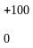mm from the HV lines shall also be tested. | It is the intention to perform two tests:  1) LV line 100mm from the RGP edge and HV line 100mm from LV line. (lines 2148-2152 and the figures)  2) HV line 100mm from the RGP edge and LV line 100mm from HV line (lines 2153-2155), if it is defined in the test plan.
FR-56 | 2156 to 2158 | I.4.2 |  | ed | Inconsistent with I.2.2 | Replace "Shielded supply lines for HV+ and HV- lines and three phase lines may be coaxial cables or in a common shield depending on the plug system used"  By  "Shielded supply lines for the positive HV d.c. terminal line (HV+), the negative HV d.c. terminal line (HV-) and three phase HV a.c. lines may be separate coaxial cables or in a common shield depending on the connector system used." | agreed
FR-57 | 2161 to 2168 | I.4.2 |  | ed | Inconsistent with I.2.2 | Replace "The electric motor may be placed on a separate ground plane. In this case, the test plan shall define the connection configuration between this separate motor ground plane and the EUT ground plane (representing the vehicle grounding configuration). The electric motor shall be mounted on a non-conductive insulating support and its housing bonded to the ground plane, if applicable. In case of using a load machine emulation, the test plan shall define the connection conditions between the EUT and the load machine emulation and also the necessary grounding conditions. The load machine emulation will replace the “electric motor”, the “mechanical connection”, the “filtered mechanical bearing” and the “brake or propulsion motor”. The three phase motor supply lines will be fed through a power line filter."  By  "Figure I.8 shows a more complex configuration adding an electric motor or load machine emulation to the setup, e.g. in case the EUT is an electric power unit. The electric motor shall be mounted on a non-conductive insulating support and its housing bonded to the ground plane, if applicable. The load machine emulation shall be placed outside the shielded room. In case of using a load machine emulation, the test plan shall define the connection conditions between the EUT and the load machine emulation and also the necessary grounding conditions. The load machine emulation will replace the “electric motor”, the “mechanical connection”, the “filtered mechanical bearing” and the “brake or propulsion motor”. The three phase motor supply lines will be fed through a power line filter.  The electric motor may be placed on a separate ground plane. In this case, the test plan shall define the connection configuration between this separate motor ground plane and the EUT ground plane (representing the vehicle grounding configuration).  The setup in Figure I.9 is an example for further HV- and LV load simulators and supplies attached to the EUT like e.g. for testing an on-board charger and its communication links. Various combinations of the shown setups are possible based on the true application of the HV component under study (EUT)." | agreed in principle, but decision on DE-51 needs to be considered.
FR-58 | See FR-56 | I.4.2 |  | te | It is stated that the electric motor shall be mounted on an insulated support which means that the test cannot be done with electric motor directly placed on the ground plane  What is the reason for this restriction? | If no technical reasons, the placement of the electric motor directly on the ground plane should allowed as an alternative | see FR-38
FR-59 | (2196?)  See FR-56 | I.4.2 |  | ed | The paragraph is a little confusing | Replace by "Figure I.9 shows an example of setup for systems with inverter/charger device" | see FR-39
CH-01 | 2168 | I.4.2 |  | te | Depending on the mechanical bearing and the treatment of the axle, the motor axle may act as exit path for the high frequency noise. | Add on after line 2168:  Depending on the mechanical bearing of the electric motor and the high frequency treatment of the axle, the motor axle may act as exit path for the high frequency noise. | to be discussed in WG2
KR8 | (2169)  2189 | I.4.2 | 9th | te | Why shall AC power lines of OBC be placed the furthest from the antenna always? It should depend on actual vehicle condition or test plan. | Change or delete the sentence. | to be discussed in WG2
FR-60 | 2182 – 2183  2185 – 2186  2192 - 2193 | I.4.2 | Figure I.7  Figure I.8  Figure I.9 | ed | The side view has no added value because a lot of items are missing or wrongly represented | Suppress the side view  Or  At least add key 3, key 5 and key 6 on the side view and key 26 for Figure I.8 and key 31 for Figure I.9 | agreed
FR-61 | 2182 – 2183  2185 – 2186  2192 - 2193 | I.4.2 | Figure I.7  Figure I.8  Figure I.9 | ed | The LV power supply is represented on the ground plane | In key 13 replace "Should be placed on the bench" by "Should be placed on the ground plane" | agreed, but use the term reference ground plane
FR-62 | 2182 – 2183  2185 – 2186  2192 - 2193 | I.4.2 | Figure I.7  Figure I.8  Figure I.9 | ed | There is no specific requirements for the ground plane connection to the shielded enclosure | Add in key 4 after ground strap : "(See 6.2.1)" | agreed
FR-64 | 2182 – 2183  2185 – 2186  2192 - 2193 | I.4.2 | Figure I.7  Figure I.8  Figure I.9 | ed | Inconsistent with Figure 18 to Figure 20 | Add after top view : "(horizontal polarisation)" | agreed
CH-02 | 2186 |  | I.7. | te | The mechanical connection (27) is leaving the electric motor behind the setup. The antenna will not catch up HF noise from the axle  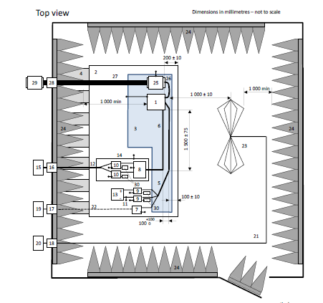 | Modify the setup that the mechanical axle (27) has at least 1 m metallic length before it is decoupled (non-conductive).  The axle (27) shall exit the setup on the side thus radiation direction is at least parallel to the antenna. | to be discussed in WG2  this would be a major technical change, which may be postponed for the next maintenance
CH-03 | 2189 |  |  | te | 27 Mechanical connection (e.g. non-conductive)  is only valid if the mechanical bearing is insulated or the axle is grounded at the motor. | Add comment that non-conductive axle may be only applicable if electric motor has e.g. an insulated bearing or grounded axle. In other configuration the axle may lead to an exceeded noise level | to be discussed in WG2
FR-63 | 2192 to 2193 | I.4.2 | Figure I.9 | ed | Why do we need a shielded box including AMN and a.c. charging load simulator when a.c. main lines are unshielded? | Suppress the shielded box 14 around box 26 and 27  NOTE : If proposal accepted, same modification should be done on Figure I.3 and Figure I.6 | to be discussed in WG2
JP13 | 2192 |  | figure I.9 | ed | The dimension line (KEY 1 to KEY 24) is incorrect. | Correct it. | agreed
CN-07 | 2199 | I.5.1 | 2^{cd}  paragraph | T | If the LV system can’t fulfill the LV-EMC requirements (failed by CE - Class1) the coupling test is unnecessary to perform. | Adding a general requirement  ——If the LV system failed by CE - Class1, the coupling test is unnecessary to perform. | to be discussed in WG2
KR9 | (2199)  2219 | I.5.1 |  | te | Basically, each decoupling factor from two test methods should be same. Some test results show it is even not similar, which might be caused by different test set-up between two test methods: EUT W/H, ANs and/or adaptors, etc.. It means OLD “scattering parameter” set-up could be more suitable. | Korea delegation proposes that we need more test results(Action Item) to make it sure which “scattering parameter” test set-up is more suitable by comparing test result with that of “CISPR25 method”. Before do this, we need to decide detail configuration HV and LV adaptor to RF cables. (See KR16) | to be discussed in WG2,  this would be a major technical change, which may be postponed for the next maintenance.
JP14 | 2210 | I.5.2 |  | te / ed | To measure the coupling factor, The EUT should not be in operational mode. If EUT is in an operational mode, in many cases it is difficult to separate the signal from EUT. | Change "The EUT shall be in an operational mode as defined in the test plan." to "The EUT shall be in a power on mode or in an operational mode, as defined in the test plan." | to be discussed in WG2
KR10 | (2210)  2230  (2226)  2246  (2279)  2299 | I.5.2  I.5.2.1  I.5.3.1 | 1st para  1st para  4th para | te | EUT mode for two methods is not in line with each other.  1. CISPR Method  I.5.2 Line 2230 : as defined in the test plan  I.5.2.1 Line 2246 : unpowered  2. Scattering Parameter  I.5.3.1 Line 2299 : unpowered | EUT mode for decoupling factor measurement should be the same between two methods. Change “as defined in the test plan” to “unpowered”.  And, add sentence: Decoupling factor does not depend on EUT operating mode. | to be discussed in WG2
FR-65 | 2212 to 2213 | I.5.2 |  | ed | The second sentence does not specify which class of Table I.1 requirements should be used | Replace :  "The test level is set to meet the specified HV limits from Table I.1 (average)."  By  "The test level is set to meet the specified HV average limits from Table I.1 defined by the vehicle manufacturer." | to be discussed in WG2
FR-66 | 2214 | I.5.2 |  | ed | The wording "On the LV side" at the beginning of the second sentence is confusing for radiated emission | Suppress " On the LV side" at the beginning of the second sentence | agreed
KR11 | (2224)  2244 | I.5.2.1 | 1st | te | The purpose of “optional impedance matching network” is not described. | Add which case needs “impedance matching network” and how to configure it. | to be discussed in WG2
FR-67 | 2230 | I.5.2.1 |  | ed | Use of AV or PK detector is allowed when in other parts in I.5.2, only AV is specified | Suppress PK | average in I.5.2 refers to the limits. Here a CW-signal is fed into the setup. Thus, PK and AV detector should give the same indication.
FR-68 | 2230 | I.5.2.1 |  | te | The bandwidth to be used is 9kHz in the whole frequency range, when CISPR 16 requires 9 kHz up to 30 MHz and 120 kHz above | Replace :  "… with a bandwidth of 9 kHz …"  By  "… with a bandwidth of 9 kHz (for frequencies between 150 kHz and 30 MHz) and a bandwidth of 120 kHz (for frequencies between 30 MHz and 108 MHz) …" | Here, only a transfer function is measured. The injected signal is a CW signal. Therefore, the bandwidth has no relevance.
FR-69 | 2235 to 2236 | I.5.2.1 | Figure I.10 | te | In all figures, EUT is placed on an insulating support and this may influence the test calibration | Add on Figure I.10 an insulated support below the EUT and add the optional EUT case grounding connection | agreed
FR-70 | 2235 to 2236 | I.5.2.1 | Figure I.10 | te | The use of shielded box (key 7) is necessary for this calibration because the HV line should be unshielded in order to induce the required disturbance.  But for all other measurements of clauses I.2, I.3 and I.4, all the Figures also include a shielded box enclosing the HV-AN.  This shielded box is not specified as optional; is-it really necessary to use this shielded box in clauses I.2, I.3 and I.4 if individual shielded HV-AN are used.  Furthermore, Annex E (§ E.2) does not specify that the shielded box is mandatory. | If use of shielded box is not mandatory, update consequently all Figures and wording of clause I.2, I.3 and I.4 to allow the use of individual shielded HV-AN without additional Shielded. | to be discussed in WG2,  This would be a major technical change, which may be postponed for the next maintenance.
KR12 | (2236)  2256 | I.5.2.1 | Figure I.10 | te | Basically, test set-up for calibration and EUT coupling factor measurement should be same.  But, Figure I.10 looks like calibration set-up is totally different from EUT coupling factor measurement set-up(Figure I.11). | Change Figure I.10 to show EUT bonding and EUT W/H layout, etc. by using Figure I.11 | to be discussed in WG2  This would be a major technical change, which may be postponed for the next maintenance.
FR-71 | 2243 | I.5.2.2 |  | ed | It is not clearly stated that the LV emission limit requirement class should be consistent with HV injected level of the same class used during calibration phase | Replace :  "The measured level shall not exceed the corresponding LV emission limits defined in 6.3, Table 5 (average)."  By  "The measured level shall not exceed the corresponding LV emission limits (same class than the one defined for HV level in § I.5.2.1) defined in 6.3.3, Table 5 (average)." | to be discussed in WG2
FR-72 | 2245– 2246  2255 – 2256  2267 - 2268 | I.5.2.2  I.5.2.3  I.5.2.4 | Figure I.11  Figure I.12  Figure I.13 | ed | The side view has no added value because a lot of items are missing or wrongly represented | Suppress the side view  Or  At least add key 3 and key 6 on the side view and key 5 for Figure I.12 and Figure I.13 | agreed
FR-73 | 2245– 2246 | I.5.2.2 | Figure I.11 | ed | The LV harness between EUT and LV load simulator shall be place on insulating support | Modify the figure consequently | agreed
FR-74 | 2245– 2246  2255 – 2256  2267 - 2268 | I.5.2.2  I.5.2.3  I.5.2.4 | Figure I.11  Figure I.12  Figure I.13 | ed | The LV power supply is represented on the ground plane | In key 13 replace "Should be placed on the bench" by "Should be placed on the ground plane" | agreed, but use the term “reference ground plane”
FR-75 | 2245– 2246  2255 – 2256  2267 - 2268 | I.5.2.2  I.5.2.3  I.5.2.4 | Figure I.11  Figure I.12  Figure I.13 | ed | There is no specific requirements for the ground plane connection to the shielded enclosure | Add in key 23 after ground strap : "(See 6.2.1)" | agreed
KR13 | (2245)  2265 | I.5.2.2 | 1st | ed | For the better understanding, insert a formula to describe relation decoupling factor and test result | Add,  Decoupling Factor = Calibration Level(HV CEV Limit) – Measured Level | see KR-3
KR14 | (2246)  2266 | I.5.2.2 | Figure I.11 | ed | Missed “100 min” requirement between edge of ground plane and the closest EUT W/H. | Add “100 min” to Figure I.3 | agreed
JP15 | 2250 | I.5.2.3 |  | te | The requirement of ‘d’ is missing. | Add the requirement of ‘d’. | to be discussed in WG2
FR-76 | 2252 to 2253 | I.5.2.3 |  | ed | It is not clearly stated that the LV emission limit requirement class should be consistent with HV injected level of the same class used during calibration phase | Replace :  "The measured level shall not exceed the corresponding LV emission limits defined in 6.4, Table 6 (average)."  By  "The measured level shall not exceed the corresponding LV emission limits (same class than the one defined for HV level in § I.5.2.1) defined in 6.4.3, Table 6 (average)." | see FR-71
FR-77 | 2261 to 2262 | I.5.2.4 |  | ed | It is not clearly stated that the LV emission limit requirement class should be consistent with HV injected level of the same class used during calibration phase | Replace :  "The measured level shall not exceed the corresponding LV emission limits defined in 6.5.4, Table 7 (average)."  By  "The measured level shall not exceed the corresponding LV emission limits (same class than the one defined for HV level in § I.5.2.1) defined in 6.3, Table 5 (average)." | see FR-71
JP16 | 2279 | I.5.2.4 |  | te | In I.5.2.1, calibration has done from 0.15MHz to 108MHz.  I.5.2.4 refers to section 6.5 and table 7.  Section 6.5 is for the measurement from 0.15MHz to 2500MHz.  So, required measure frequency is not clear. | Clarify the measure frequency by additional information. | to be discussed in WG2
KR15 | (2288)  2308 | I.5.3.3 | 1st | ed | There is no figure for “Test set-up for calibration” | Add, “Test set-up for calibration” by modifying Figure I.14 | to be discussed in WG2  see also FR-78
FR-78 | 2288 | I.5.3.4 |  | ed | Wording is not precise enough | Replace "A full-port calibration shall be performed including only the network analyser coaxial measuring cables."  By  "A SOLT (short open load through) calibration shall be performed including only the network analyser coaxial measuring cables (keys 5 and 6 of Figure I.14)." | to be discussed in WG2,  see KR-15
FR-79 | 2294 | I.5.3.4 |  | ed | Wording is not precise enough | Replace "Unless otherwise specified in the test plan the EUT case shall be bonded to the ground plane with a copper strap (maximum length to width ratio of 4:1)."  By  "Unless otherwise specified in the test plan the EUT case shall be bonded to the ground plane with a copper, brass, bronze or galvanized steel strap (maximum length to width ratio of 4:1)." | to be discussed in WG2
KR16 | (2296)  2316 | I.5.3.4 | 4th para | te | Not clear how to configure the HV side and LV side of each adapter to each RF connector, which might make a different test set-up. | Add new figure and requirement for the adapter | to be discussed in WG2
KR17 | (2300)  2320 | I.5.3.4 | Figure I.14 | te | There is no description for the bonding condition between network analyser and ground plane which could make a different test result. | Add direct bonding connection between network analyser and ground plane which impedance shall be below 2.5mΩ. | to be discussed in WG2
JP17 | 2301 | I.5.3.4 | Figure I.14 | te | If KEY 7 is single line, there is no information about the connection for outer conductor of KEY 6. | Add some instructions about this.  e.g. by using L shaped plate at KEY 9 position and connect it directly to KEY 2. | to be discussed in WG2
CN-08 | 2302 | I.5.3.4 | 5th  Paragraph | T | - This clause does not also define how to test the decoupling factor of EUT with more than one HV lines or LV lines.  - This clause does not define how to deal with the coupling attenuation factors from different configuration. | Added:  For EUT with more than one HV lines and LV lines the coupling attenuation factor should be tested separately for each HV line and each LV line。  For the coupling attenuation factor from different configuration the minimum factor should be selected as final coupling attenuation factor. | to be discussed in WG2,  this information is given in tables I.2 and I.3.
KR18 | (2303)  2323 | I.5.3.4 | 5th | ed | For the better understanding, insert a formula to describe relation decoupling factor and test result | Add,  Decoupling Factor = S21CAL – S21EUT | agreed in principle, an appropriate symbol needs to be defined
FR-80 | 2319 | Annex J |  | ge/te | The present Annex J includes two different test methods for chamber validation :  - the reference measurement method  - the modelled long wire antenna method.  For each method, the principle is to compare a measurement in the chamber to be validated with a "reference" (which is a measurement in the first method and a table of values from simulation in the second method).  The possible use of these two methods leads to an increase of "references" and therefore may lead to wider criteria of acceptation for the chamber.  Examples of "references" for the first method are given in annex of this document and show differences which can reach from 3 to 16 dB depending of the frequency range.  Considering that these data are only for 4 laboratories, it can be considered that the differences may be larger with a higher number of laboratories. | To keep in Annex J a single "reference" to avoid too large acceptance criteria.  One way could be to keep only the modelled long wire antenna method in Annex J which includes a single "reference" in Table J.1.  If comment FR-80 is accepted, delete all wording concerning reference measurement method. | to be discussed In the JTF,  This would be a significant technical change, which may be considered for the next maintenance
CN-09 | 2325 | J1 | 1st  paragraph | T | This annex contains two procedures, either of which can be used for validation of the ALSE (both methods are not required) .  First, if the two methods are used, it might be possible that one method will pass and the other will fail. The how to judge the outcome ? Which result is the correct one ?  Second, different method use different transmit antennas, one is rod antenna, another is long wire antenna. The measurement is carried out at the 1 meter distance and 150kHz ~ 30MHz frequency range for the near field. The different transmitting antenna is used will lead to different distribution of fields at the receive antenna position even for the same site is likely to get a different result. | It is recommended that the long-wire antenna is used as transmitting antenna in both methods. | see FR-80
FR-81 | 2330 | J.1 |  | ed | Wording refers to requirements of CISPR 16-1-4 without precise reference of the applicable requirement. | Replace "… which meets the requirements of CISPR 16-1-4."  By  "… which meets the requirements of CISPR 16-1-4 (Clauses 5.2 and 5.3). | agreed
GB42 | 2367-2381 | J.1 | Figure J.1 and associated text | ed | It seems appropriate to add a reference to M. Lafon's paper to justify the addition of these words and the graph. | Add a sentence here, then a bibliographic reference to the paper at the end of Annex J. | agreed, based on the decision on JP-18
JP18 | 2367-2381 | J.1 |  | te | - The requirement for the absorber is defined from 70 MHz and above, at section 4.3.3.2.  Figure J.1 includes the effect of the absorber between 10 MHz and 70MHz.  Figure J.1 shows the effect of the performance of the absorber, so it is necessary to show the requirement to the absorber.  - If those effects are coming out in the case where it is satisfy the requirements of the ground strap connection in 6.2.1, it is necessary to update the requirement in 6.2.1.  - There is no information about '0 dB influence'. | Add more information about Figure J.1 (e.g. simulation model, ideal or reference model and so on.)  Or  Delete line 2367-2381. | to be discussed in the JTF
FR-82 | 2370 | J.1 |  | ed | The value given in Figure J.1 are examples of typical values | Replace "Figure J.1 summarizes the influence levels of these parameters over the particular 10 – 100 MHz frequency range."  By  "Figure J.1 presents examples of typical influence levels of these parameters over the particular 10 – 100 MHz frequency range." | agreed, depending on the decision on JP-18
FR-83 | 2389 | J.1 | Fig J.2 | ed | Wrong reference in Fig J.2 | In the right box of long wire method replace Fig J.11 by J.12 | agreed
FR-84 | 2391 | J.1.1 |  | ed | The whole wording of clause J.1.1 should be moved in Introduction. | Move all wording of J.1.1 to the beginning of clause J.1. | to be discussed in the JTF
FR-85 | 2397 | J.1.2 |  | ed | It is under the responsibility of the test laboratories to define the repetition period. | Delete all J.1.2 | to be discussed in the JTF
FR-86 | 2427 | J.2.2.2 |  | te | In order to reduce deviations between reference measurements, the height of the monopole should be defined with more restrictions. | Replace "Overall height of monopole, including drive unit < 500 mm"  By  "Overall height of monopole, including drive unit = (200 ± 50) mm with maximum height of drive unit of 30 mm" | to be discussed in JTF,  this would be a major technical change, which may be postponed for the next maintenance
FR-87 | 2431 | J.2.2.2 | NOTE | ed | The possibility to terminate or not the 3rd port with 50 Ω load will generate extraneous deviations. | Replace "During use as a radiator, the third port may be terminated with 50 Ω or may be unterminated."  By  "During use as a radiator, the third port should be unterminated." | to be discussed in the JTF,  the experience gained during the project show that there is mainly a constant deviation, which due to the fact that finally a comparison is made, only yield to a negligible influence.
FR-88 | 2461 and 2462 | J.2.3.1.2 |  | ed | Frequency step size is mandatory. | Replace in second sentence "will be" by "shall be".  Replace in third sentence "are used" by "shall be used". | agreed
FR-89 | 2466 to 2468 | J.2.3.1.3 |  | ed | Noise floor measurement is mandatory. | Replace in first sentence "will be" by "shall be".  Replace in second sentence and third sentence "will be" by "shall be". | agreed
FR-90 | 2473 | J.2.3.2 |  | ed | Reference measurement is mandatory. | Replace in first sentence "will be" by "shall be". | agreed
JP19 | 2478 | J.2.3.2.1 |  | te | In some ALSEs cavity resonance phenomenon is observed in the frequency range below 30 MHz caused by the different absorber technologies and/or chamber size. | Add a following note at the end of J.2.3.2.1  In some ALSEs, there is possibility that the resonance will be occurred below 30MHz. It is recommended to compare the reference value with other ALSE or OATS. | to be discussed in the JTF
CN-10 | (2486) | J2.3.2.1 |  | T | In the reference measurements below 30 MHz, if we must carry out a reference measurement on the open site, since the transmitting and receiving antennas are both on the ground, but the confirmation measurement on the site has to be elevated to a height of 90 cm, this will lead to a big difference, and it will introduce a resonance generation, and will inevitably lead to a deviation about the reference measurements and confirmation measurements, since the deviation caused by resonance will be large, leading to the site does not meet the requirements. | It is recommended to destroy the resonance conditions, so as to achieve to meet the site requirements. Specific methods may differ, such as applying an absorbing material to the bottom of the receiving antenna, or adding a 10cm wide bonding strap at two angular positions of the receiving antenna counterpoise, etc. | To be discussed in the JTF,  this would be a major technical change also to the main part of the standard. Nevertheless, there is ongoing work in WG2 concerning the resonance effect.
FR-91 | 2487 and 2492 | J.2.3.2.1 |  | ed | The sequence is mandatory. | Replace in line 2487 "will be" by "shall be".  Replace in line 2492 "must then be" by "shall then be". | agreed
FR-92 | 2493 | J.2.3.2.1 |  | ed | Editorial | Replace "#2" by "2)" | agreed
FR-93 | 2494 - 2495 | J.2.3.2.1 | Figure J.4 | ed/te | The Figure has no keys and the distance tolerances are not defined. | Update the Figure with keys.  Replace "1 m" by "(1000 ± 10) mm". | agreed to add tolerances
JP20 | 2495 | J.2.3.2.1 | Figure J.4 | ed | There are no requirements for the bonding method of counterpoise. | Add the requirements for bonding. | to be discussed in the JTF
FR-94 | 2497, 2501, 2503, 2510 | J.2.3.2.2 |  | ed | The setup is mandatory. | Replace in the 4 lines "will be" by "shall be". | agreed
FR-95 | 2496 | J.2.3.2.2 |  | ed | Precise the frequency range. | Replace " Reference measurements at 30 MHz and above"  By  " Reference measurements from 30 MHz to 1 GHz"  And also in line 2497 and line 2501. | agreed
FR-96 | 2499 | J.2.3.2.2 |  | ed | There is no 5.6.2 in CISPR 16-1-4. | Replace "5.6.2" by "5.2.6". | agreed
FR-97 | 2513 and 2516 | J.2.3.2.2 | Figure J.5  and  Figure J.6 | ed/te | The Figures have no keys and the distances tolerances are not defined. | Update the Figures with keys.  Replace "1000 mm" by "(1000 ± 10) mm".  Replace "2500 mm" by "(2500 ± 25) mm".  Replace "100 mm" by "(100 ± 10) mm".  Replace "900 mm" by "(900 ± 100) mm".  Replace "250 mm" by "(250 ± 10) mm".  Update title of Figures (See FR-95) | agreed to add tolerances
FR-98 | 2519, 2525, 2530,  2531 | J.2.3.3.3 |  | ed | The setup is mandatory. | Replace in the 4 lines "are", "will be", "should be" by "shall be". | agreed
FR-99 | 2529 | J.2.3.3 | Figure J.7 | ed/te | The Figure has no keys and the distance tolerances are not defined. | Update the Figure with keys.  Replace "100 mm" by "(100 ± 10) mm".  Add the arrows for 100 mm distance.  Update title of Figure (See FR-95).  Add the value of the distance between the two antennas with tolerance. | agreed to add tolerances
JP21 | 2529 | J.2.3.3 | Figure J.7 | ed | The bonding strap is missing. | Add bonding straps.  Or, Change to ‘Reference ground plane with bonding straps’ from 'Reference ground plane’. | to be discussed in the JTF
JP22 | 2529 | J.2.3.3 | Figure J.7 | ed | Several lines and arrows are missing. | Update correctly. | agreed
FR-100 | 2536, 2540 | J.2.3.4 |  | ed | The calculation is mandatory. | Replace in the 2 lines "will be" by "shall be". | agreed
FR-101 | 2575 | J.3.2.2 |  | ed | Unnecessary word. | Suppress "of" in the first sentence. | replace by “between”
FR-102 | 2587 to 2588 | J.3.2.2 |  | ed | The connection of metallic sheet angle to the ground reference plane is not precise enough. | Replace "The metallic sheet angles are mounted on the ground reference plane to establish a low inductive, low resistive connection between angle and ground (see Figure J.10)."  By  "The metallic sheet angles shall be bounded on the ground reference plane to establish a low inductive, low resistive connection between angle and ground with a maximum d.c. resistance of 2,5 mΩ (see Figure J.10)." | to be discussed in the JTF
FR-103 | 2611 to 2612 | J.3.2.2 | Figure J.11 | ed | Modify title.  The y-axis reference is missing. | Add "attenuator" after "10 dB" in the title.  Add "1" at the lower part of the y-axis. | agreed
FR-104 | 2614 | J.3.2.3 |  | ed | Editorial | Replace "must be" by "shall be". | agreed
FR-105 | 2620 | J.3.2.4 |  | ed | Editorial | Replace "are made" by "shall be made". | agreed
FR-106 | 2640 | J.3.3.2 |  | te | When using a network analyser, it is not possible to deliver the 1 Vrms value. | Move 2638 to 2641 after 2635.  Add after 2637 : "when using a network analyser, the amplitude of signal generation equipment may be set to a value lower than 1 Vrms (120 dBµV) allowing to fulfill the noise floor requirement." | agreed
JP23 | 2642 |  | figure J.12 | ed | There are no Keys about the bulkhead connector. | Add Key about the bulkhead connector. | agreed
US-27 | 2642-2644 | Annex J | Fig. J.12 | ed | Figure J.12 verbiage on page 158 has no setup diagram associated with it. The diagram is on the previous page. | Move Figure J.12 verbiage from page 158 to page 157. | will be part of the final editing
FR-107 | 2657 to 2659 | J.3.3.2 |  | te | The 10 dB requirement may be difficult to be achieved in the lower frequency range when disconnecting the signal source from the radiation source. | Adapt the wording and/or the noise floor requirements (e.g. 80% of frequency point). | to be discussed in the JTF
JP24 | 2668  2678 | J.3.3.3 |  | te / ed | There are no computer model between 200 MHz and 1000MHz. | Add the following calculation model.  1). 0.15MHz to 30MHz  2). 200MHz to 1000MHz | to be discussed in the JTF,  proposal, add “as an example” to the sentence in line 2668.
FR-108 | 2669 | J.3.3.3 | Note | ed | The Note is no more necessary. | Delete the Note. | agreed
FR-109 | 2678 | J.3.3.3 | Figure J.13 | ed | Editorial | Replace in the title "MoM-Modell" by "MoM-Model". | agreed
FR-110 | 2705 to 2706 | J.3.4 |  | ed | Consistency with J.2.4. | Replace line 2705 – 2706 by lines 2560 – 2562. | to be discussed in the JTF,  an antenna factor can principally not derived from the long-wire-method.

Annex of DE.doc

Annex to the comment of the German NC on CISPR/D/425A/CDV

Limit for the protection of GLONASS receivers

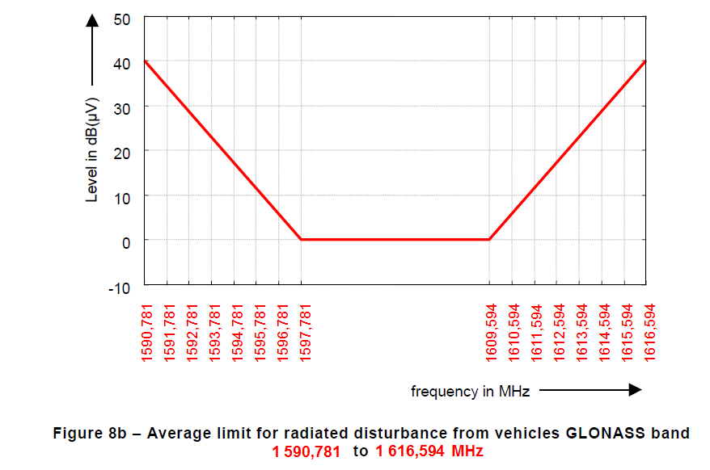

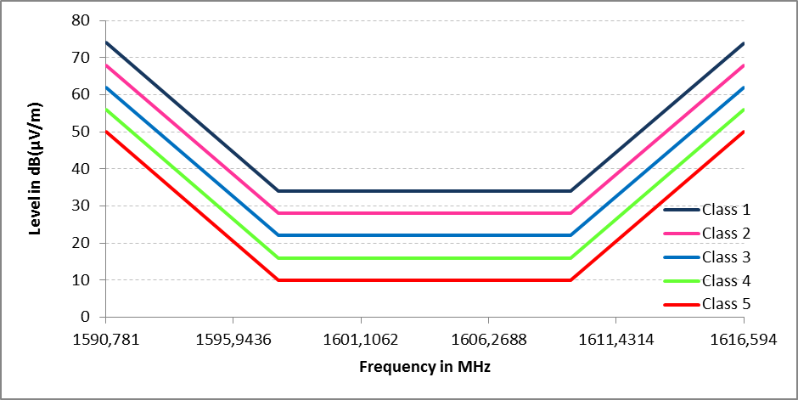
Figure 21b – Example of average limit for radiated disturbances from components GLONASS band 1590,781 to 1616,594 MHz

Annex of FR.doc

Annex on FR-45 :

The following figure presents the differences between the values of :
- Conducted emission on LV power lines – voltage method (table 5 of CISPR 25 CDV)
- Conducted emission on HV power lines – voltage method (table I.1 of CISPR 25 CDV)

This figure presents the differences for PK detector and all 5 classes

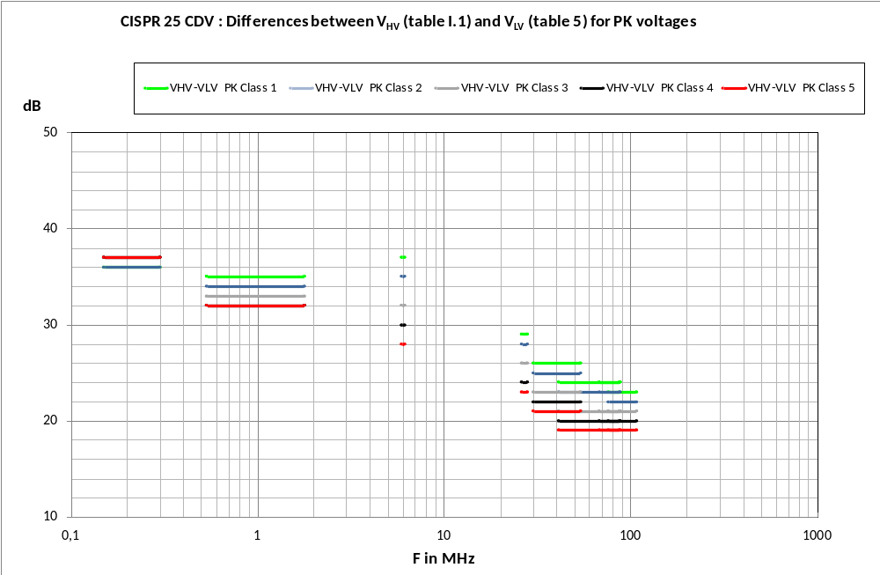

This figure shows that the differences are not identical for the 5 classes and that the differences are also not consistent for the various sub-bands

The following figure presents the previous data (differences between Conducted emission on LV power lines – voltage method (table 5 of CISPR 25 CDV) and Conducted emission on HV power lines – voltage method (table I.1 of CISPR 25 CDV)) with additionnal data
- Interpolation curves

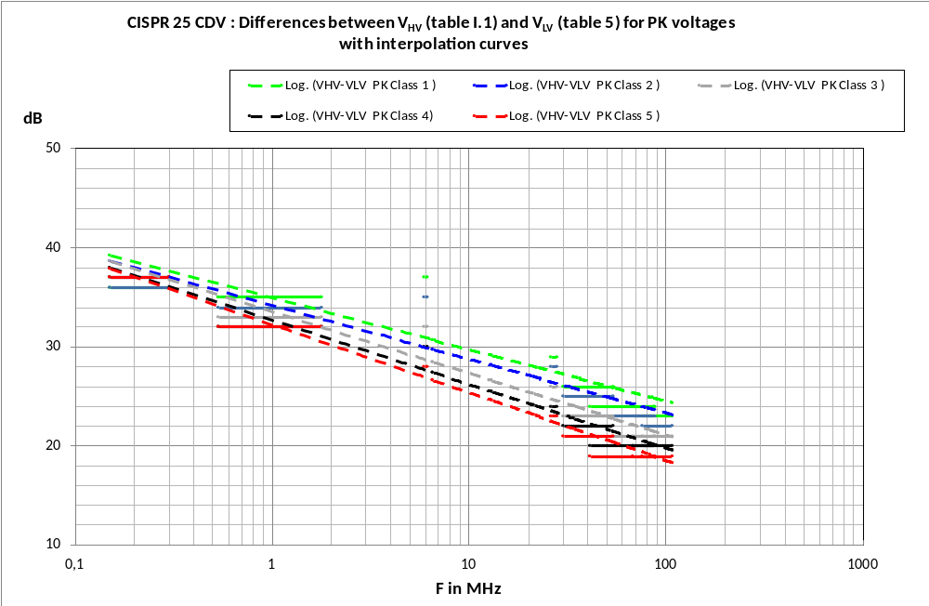

This figure shows that the differences for the various classes are not identical (rough data) and furthermore that the interpolated data are not identical and do not have the same slope.

The following figure presents the CISPR 25 CDV S₂₁ data

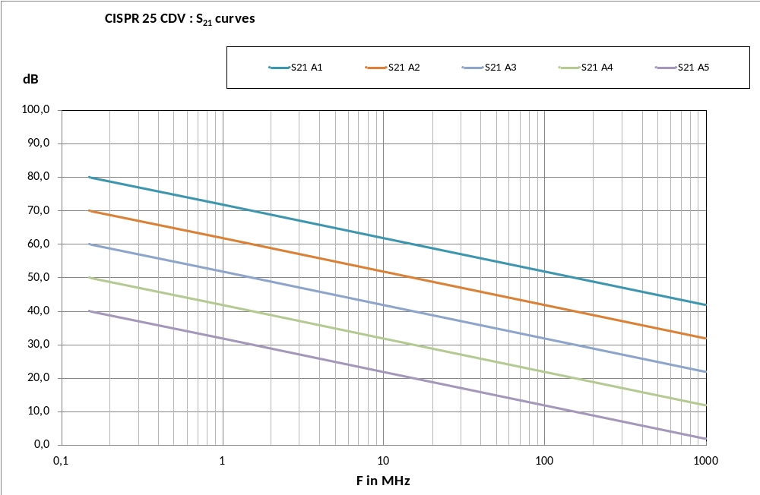

The differences and the slopes of the various CISPR 25 CDV S₂₁ data are consistent.

The following figure presents the previous data (differences between Conducted emission on LV power lines and Conducted emission on HV power lines, Interpolation curves) associated with S₂₁ curves

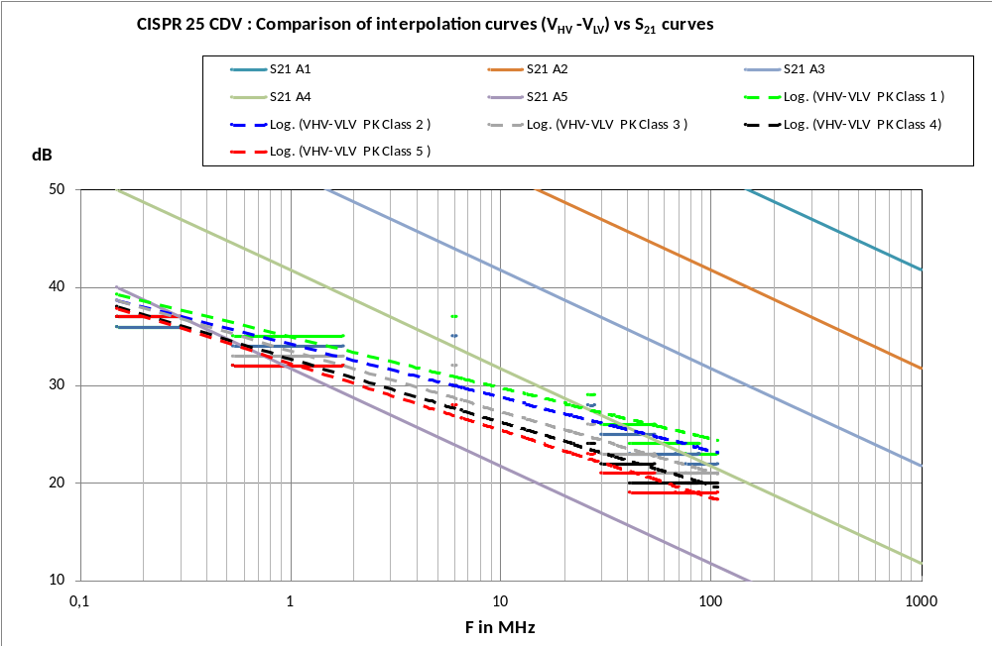

This figure shows that the S₂₁ data proposed in CISPR 25 CDV and the interpolated differences between Conducted emission on LV power lines and Conducted emission on HV power lines are not consistent in terms of values and of slopes (interpolation is close to S₂₁ A5 at 150 kHz when it is close to S₂₁ A4 at 108 MHz)

The following figure presents the previous data (differences between Conducted emission on LV power lines and Conducted emission on HV power lines, Interpolation curves, S₂₁ curves) with an additionnal previous S₂₁ curve (the A5 S₂₁ from document TF_DOC_031_CISPR25_4_HV_part_V2285_2012_09_05) :

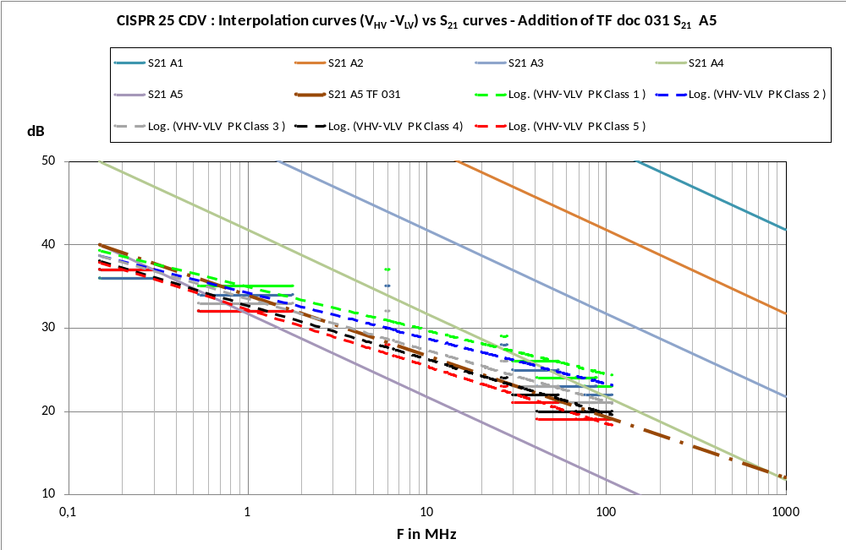

This figure shows that the slopes of interpolated differences data and of the TF_031 S₂₁ A5 data seem quite identical. Therefore the present CISPR 25 table I.1 (for HV lines) may has been issued from CISPR 25 table 5 (for LV lines) using a previous version of S₂₁ from an earlier TF document which may explains some of the questions raised in this French comment about Table I.1 and S₂₁ values in the present CDV document.
Annex on FR-80

Annex J Reference Measurement Method - Comparison of « reference » measurement

Frequency range 150 kHz – 30 MHz
The following graph presents the « reference » measurements for 3 different laboratories

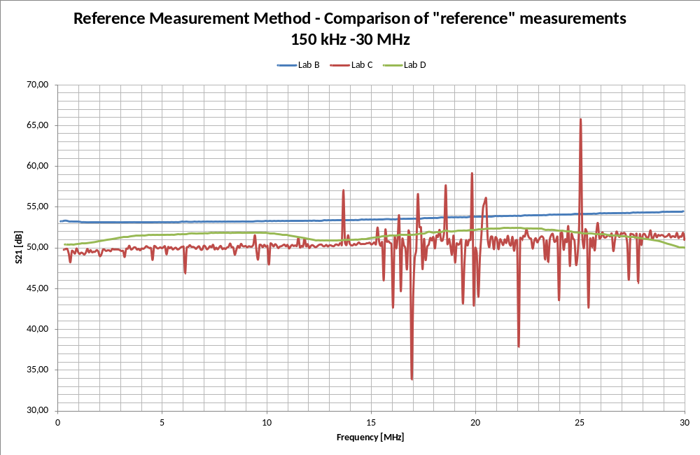

These measurements show that for only 3 different laboratories, differences up to 3 dB can be observed (variation shown for Lab C due to noise environment are not considered for deviation evalutation

Frequency range 30 MHz – 1000 MHz Vertical polarisation
The following graph presents the « reference » measurements for 3 different laboratories

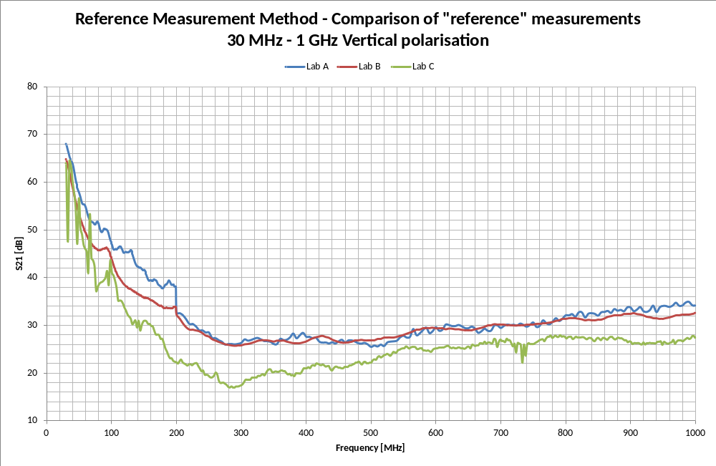

These measurements show that for only 3 different laboratories, differences from 3 to 10 dB can be observed

Frequency range 30 MHz – 1000 MHz Horizontal polarisation
The following graph presents the « reference » measurements for 3 different laboratories

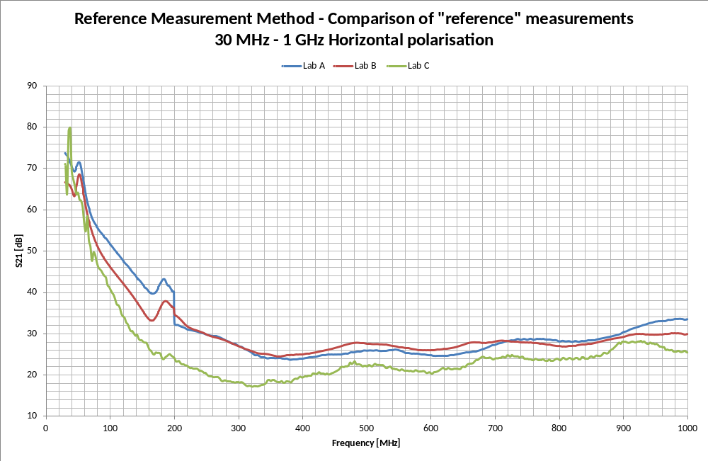

These measurements show that for only 3 different laboratories, differences from 4 to 16 dB can be observed

Annex of KR.doc
