INTRODUCTION.

BHOJPATRA : THE HERBAL TREE

Bhojpatra is also known as Betula utilis D. Don (Betulaceae) is a moderate- sized tree that grows up to 20 m in height. Betula utilis common name bhojpatra used in traditional medicine and is known for its beneficial and medicinal value.

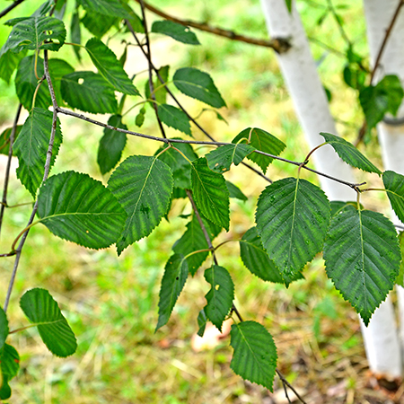

***Betula utilis***, the **Himalayan birch** (***bhojpatra***, [Sanskrit](https://en.wikipedia.org/wiki/Sanskrit_language): भूर्ज *bhūrjá*), is a [deciduous](https://en.wikipedia.org/wiki/Deciduous) tree native to the [Western Himalayas](https://en.wikipedia.org/wiki/Western_Himalayas), growing at elevations up to 4,500 m (14,800 ft). The Latin [specific epithet](https://en.wikipedia.org/wiki/Specific_epithet) *utilis* means "useful", and refers to the many uses of the different parts of the tree. The white, paper-like bark was used in ancient times as a writing surface for manuscripts of [Sanskrit](https://en.wikipedia.org/wiki/Sanskrit) literature. It is still used as paper for the writing of mantras, with the bark placed in an amulet and worn for protection. Selected varieties are used for landscaping throughout the world, even while some areas of its native habitat are being lost due to overuse of the tree for firewood.

SCIENTIFIC CLASSIFICATION :

|  |  |
| --- | --- |
| Kingdom: | [Plantae](https://en.wikipedia.org/wiki/Plant) |
| *Clade*: | [Tracheophytes](https://en.wikipedia.org/wiki/Vascular_plant) |
| *Clade*: | [Angiosperms](https://en.wikipedia.org/wiki/Flowering_plant) |
| *Clade*: | [Eudicots](https://en.wikipedia.org/wiki/Eudicots) |
| *Clade*: | [Rosids](https://en.wikipedia.org/wiki/Rosids) |
| Order: | [Fagales](https://en.wikipedia.org/wiki/Fagales) |
| Family: | [Betulaceae](https://en.wikipedia.org/wiki/Betulaceae) |
| Genus: | [*Betula*](https://en.wikipedia.org/wiki/Birch) |
| Subgenus: | [*Betula*subg.*Neurobetula*](https://en.wikipedia.org/wiki/Betula_subg._Neurobetula) |
| Species: | ***B. utilis*** |

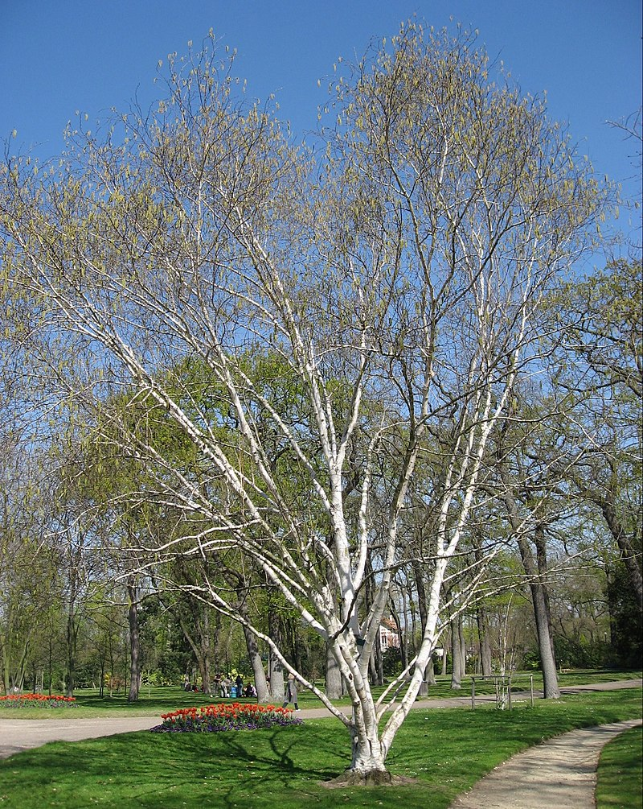

IMPORTANCE :

* Ecological importance:

The Bhojpatra tree helps preserve the Himalayan ecosystem by

reducing soil erosion and creating a bio-shield for the forests and

meadows below.

* Cultural significance:

  Bhojpatra is important in Indian culture and spirituality.

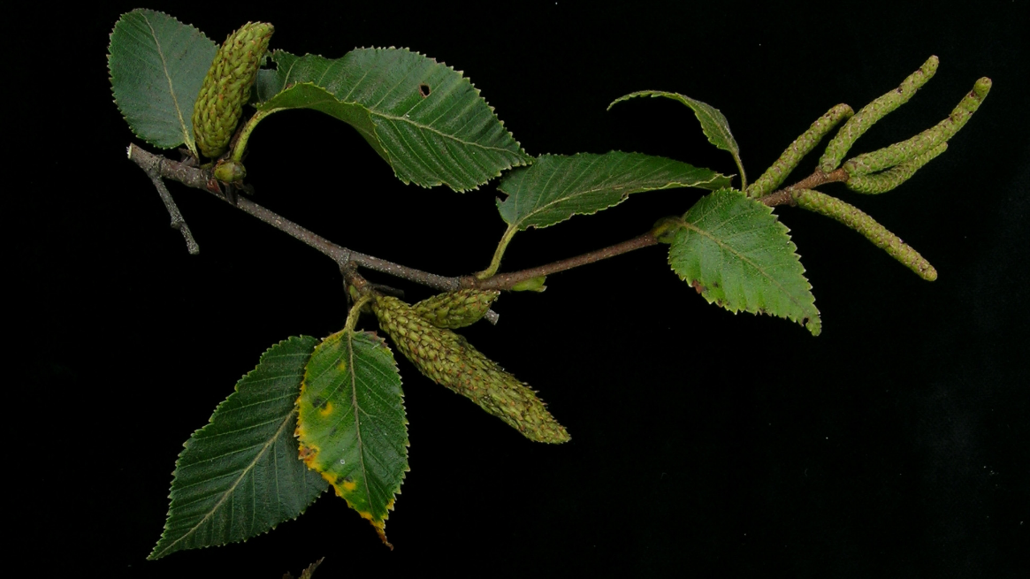

.

USES AND APPLICATIONS.

* Medicinal uses:

The bark, leaves, and sap of the Bhojpatra tree are used to make herbal remedies for a variety ailments. The bark contains betulin and other essential oils that have medicinal properties.

* Traditional crafts:

The leaves of the Bhojpatra tree are used in traditional crafts like painting, calligraphy, and manuscript illumination.