**NORTH SOUTH UNIVERSITY**

**CSE 499A Section 21**

**Paperless** Thesis Submission

Project Proposal

**Instructor**DR. MD SHAHRIAR KARIM

**Due Date  
13th** November 2019, **Wednesday**

Group: **Bright Sparks**

SUMAIYA NOORJAHAN SHAHADAT HOSSAIN PAVEL **151 2065 642 161 2332 042**

FAREHA ALAMGIR TANZIM AL DIN AHMED **152 1464 642 162 1203 042**

FAHAD BIN BARI SHOVO **161 0162 042**

# Abstract

Every year a huge amount of paper is being used in Thesis/Report Submission in the Universities. Interestingly, a huge portion of these bulky paper works are simply discarded because it contained errors or due to inappropriate formatting. And the resubmission process is not only time consuming but also wastes a huge amount of paper. Moreover, storing them also requires large amount of space, and therefore, even after a successful submission, only a few proportions is kept.

In this world of growing technology, it has now become more meaningful to store a digital version of these documents. This not only makes it easier to store these documents, but also reduces the chance of losing them and more importantly contributes towards a Greener Environment as less paper is wasted. Day by day more and more organizations are incorporating “Go Paperless” concepts and our project is also pivoted around this idea.

The purpose of this project would be to provide with a convenient, secure and more efficient, “Greener” solution to the problem mentioned above. This system would allow online submission and storage of these important documents like Thesis and Reports and would also check the formatting and other aspects of the documents prior to submission and would let the user know if a particular document requires certain changes.

# Introduction and Motivation

A large amount of papers is being used up in the thesis submission process in Universities in Bangladesh every year. Most of these papers are either discarded due to errors, become obsolete over time, or are lost. Storing these large amounts of papers also requires quite huge amount of space, and are also inconvenient to carry around.

Papers are made from trees and trees are inevitable for living beings to survive on earth. So, for making papers human being are cutting down valuable trees causing deforestation. Besides deforestation, paper industries are producing carbon-dioxide which plays a vital role in Global Warming. If we can build a system that will reduce the paper consumption in Educational Institutions like Universities resulting in less paper production, we might be able contribute towards a “Greener” and more sustainable environment, and help prevent climatic changes that are now taking place. The following chart (in the next page) is the increased emission of CO2 from the year 1970 to 2004 where, the paper consumption of universities and offices is playing a great role.



According to the American Forest & Paper Association, paper manufacturing is the third largest user of fossil fuels worldwide. Although recycling and using tree-free paper can reduce the environmental impact of paper, most paper still ends up in landfills. Paper production also leads to air pollution, as paper manufacturing releases nitrogen dioxide (NO2), sulfur dioxide (SO2), and carbon dioxide (CO2). Nitrogen dioxide and sulfur dioxide are major contributors to acid rain, whereas CO2 is a greenhouse gas responsible for climate change. Waste water discharged from pulp and paper mills contains solids, nutrients, and dissolved organic matter that are classified as pollutants.

There are around **143** Universities in Bangladesh. Approximately thousands of Thesis papers are submitted by these students every year. Most of these papers are, as mentioned earlier, wasted. The purpose of our project would be to reduce this wastage of papers, reducing paper consumption and thus contributing to a Greener Environment.

This system would allow the students to submit and store their papers online. The system would let the students know if their written documents violate any formatting rule provided by their teachers. Once submitted the teacher can view these papers online. Not only this would help reduce paper wastage but would also make the document submission process more convenient and also the students would be able to find their documents in one place pretty easily without worrying of losing them. And moreover, teachers could also use this system for all their document submissions, and thus would be able to keep track of all of them very easily.

# Carbon Foot Print

A carbon footprint is the set of greenhouse gas emissions caused by something. It can be calculated for a product, service, person, even a country, and is used to understand the impact human activity is having on the earth’s climate. The carbon footprint of paper products is defined as GHG emissions emitted during the life-cycle of paper.

Here is an approximate number of students in the following universities in Bangladesh and the number of papers used to submit thesis paper by each student in each year and an approximate Carbon footprint of it is calculated:

|  |  |
| --- | --- |
| National University | 297182 |
| KU | 6,965 |
| AUST | 6,843 |
| University of Barisal | 7,786 |
| Dhaka City College | 5,000 |
| University of Asia Pacific | 6,488 |
| Southeast University | 12,000 |
| Jagannath University | 17,134 |
| Jahangirnagar University | 16,781 |
| North South University | 13,990 |
| Bangladesh Open University | 433,413 |
| University of Rajshahi | 38,495 |
| American International University | 100 |
| Shahjalal University of Science and Technology | 7,662 |
| BRACU | 9,839 |
| EWU | 10,400 |
| DIU | 35790 |
| Total | 890078 |

A complete Thesis paper contains **60-70 pages**. If each student has to submit one thesis paper each containing **60 pages**, then 890078 students will submit **890078 thesis papers** containing 60*890078 pages = **53,404,680 pages** every year.

An **A4** paper measures **0.21m by 0.297m**. Therefore, a paper of **80GSM A4** weighs **5grams** and **53,404,680 pages** weighs **267.02 tonnes**. In producing **1000** papers, it has a carbon footprint of **6,000kg** (from energy required to create the paper and dispose of it in landfill eight times).

Thus, in producing **53,404,680 pages**, approximate carbon footprint is **(53404680*6000)/1000 kg = 320428.08 tonnes**.

Volume of a paper = **length*width*thickness = 0.21**\* **0.297 * 5*10^-3** cubic metres   
= **0.00031185** cubic metres.

So, **53,404,680 pages** will occupy space of, **53,404,680 * 0.00031185** cubic metres  
= **16654.25 cubic metres.**

Meanwhile, a typical database contains **5,500 carbon** footprint data items for materials, energy, transport etc. which is less than paper production.

# Background and Significance

Still now, the most common process of Thesis or Paper Submission requires a printed copy of the document to be submitted. Though more teachers are now moving towards the digital submission systems that are available like online classroom services or emails. But it is quite hard to keep track of the documents submitted using those, and also the teachers have to use separate plagiarism or spell-checking services, and still there is no other way to check the formatting of the document or other rules defined by the teacher without visually inspecting it. This service would incorporate all these features in one place, allowing them to create certain rules for the documents and provide with respective dashboards for easy maintenance of the submitted files.

Go green means to pursue knowledge and practices that can lead to more environmentally friendly and ecologically responsible decisions and lifestyles, which can help protect the environment and sustain its natural resources for current and future generations. Our environment is polluted day by day and on the other hand our environment getting warmer.

The aim of going green is to:

* Reduce pollution.
* Reduce resources consumption and eliminate wastes.
* Conserve natural resources and forests.
* Maintain the natural ecological balance on earth so that all living things can survive and thrive in their natural habitat.
* Reduce energy costs and consumption through the use of renewable energy alternatives like wind, solar, hydroelectric, and geothermal energy among others
* Buy and use energy star and saving appliances and plumbing systems
* Purchase eco-friendly items and cars
* Recycling and create DIY items
* Eat green and organic foods
* Choose a green mode of transportation like carpooling and telecommuting
* Use green cleaning and skin products
* Reduce paper consumption in offices and so much more

Making the earth go green first of all we should stop burning carbon. Because this is very much harmful not only our country but also the world. Our water level will raise, our environment will be polluted. It will be tough to breath for us. So, making our existence stable for this world we should stop burning carbon and try to make our earth “Greener”.

# **Paper Reviews**

# Integrated Cloud Storage on Paperless Thesis Examination

The advancements in technology has digitized almost all aspects of the present world. And the Internet is one of the most influential advancements in technology. And cloud computing has become one of the trends now. Many organizations are now incorporating cloud computing systems to provide a seamless, efficient and “Greener” management systems.

Paper consumptions results in increased cutting of trees and thus contributes to Global Warming. And with the advancements in technology it is now possible to think about alternative to help reduce the usage of paper, and make a “Greener” and sustainable environment. As people are becoming more aware, more and more organizations are trying to help contribute towards a solution to this issue.

The paperless thesis examination system is one of the systems developed in cloud computing. Nowadays, there are universities which developed and implemented paperless thesis examination system. The thesis documents are saving on the university's internal servers. The development of cloud storage can use as a storage media for thesis documents. Therefore, this paper discusses the design of paperless thesis examination information systems integrated with cloud storage. As a result, not only the systems are becoming more efficient but are also contributing towards reducing the carbon foot-print.

Many researchers have developed a paperless thesis examination system to improve the quality of the system to be better for use in universities. Based on a review of existing systems, the popularity of cloud storage has not been implemented in the system.

The proposed system to be designed will focus on student activities in the process of uploading the thesis document. The system to be designed will be integrated with academic information system account. So that every student can login without register first. The proposed system focuses only on the registration of a paperless thesis examination. Student activities on this system consist of access to information and thesis examination requirements, filling out forms and uploading requirements, uploading documents and viewing thesis examination schedules and examiners. In details, student activities can be illustrated in Fig. 1.

Each student is required to have a cloud storage account to gain access uploading documents.

Coordinator or Staff is the admin that manage all of students and lecturers activities. These activities can be seen in Fig. 2

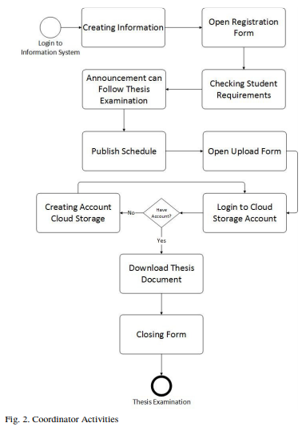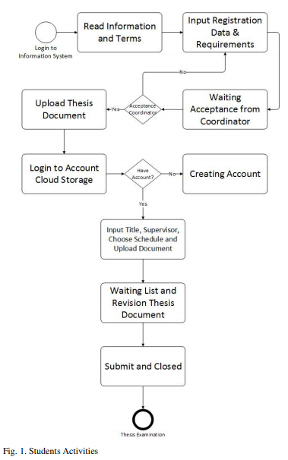

Divergent the students and staff, the lecturer's activity only sees the thesis examination schedule and downloads the student thesis document to be examined by the examiner lecturer, and the supervisor is a carbon copy. It can be seen in Fig. 3

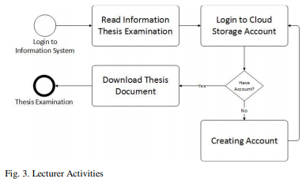

The proposed method in this paper focuses more on the use of cloud storage as a data storage to reduce the use of storage capacity on university server. Table II describes the data to easily highlight the advantages.

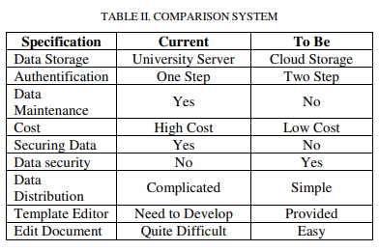

# Conclusion

In conclusion, since a long time ago, the paperless thesis has been developed to require in the educational scope. There are many researchers who research in this scope which have an impact on improving the system.

This research specification focuses on storing documents stored in cloud storage. Based on the results of the comparison of both business processes, there is a difference in the authentication process between the document storage processes on the internal server with the document storage process in cloud storage. The paperless thesis examination system not integrated with cloud storage requires user’s login to information systems for uploading or downloading thesis documents. While the systems that integrated with cloud storage, users login to information systems and cloud storage accounts. If the user has not a cloud storage account, the system will direct the user to create an account for uploading or downloading the document thesis.

# Paper Reference

<https://ieeexplore.ieee.org/document/8528573>

# Journal Review

A research on paper waste management was conducted by U. Arena on paper title “Environmental Assessment of Paper Waste Management Options by Means of LCA Methodology”.

In this paper, they had used to assess and compared the environmental performances of three alternative options (land-filling, recycling, and combustion with energy recovery) that could be used in Italy to manage paper and board packaging wastage. In this specific case, they showed that paper use should be viewed in the context of the international trade in bio-fuels.

Scenario on Waste Management: In the recycling scenario three represents the reference case, with the other two scenarios defined by their differences from this scenario. Scenarios a and c were represented by the best available technologies, to represent a possible new investment in alternatives to scenario b. In each scenario, the paper waste management sites (land-filling, recycling, combustion with energy recovery) are located in Italy. Paper production from virgin fiber is located in Sweden (where most of the fiber used in Italy is produced) and includes sericulture and harvesting, debarking, and chipping. The burdens related to the transportation of virgin fiber, from Stockholm to Rotterdam by ship and from there to central Italy by train, are also incorporated.

**a. Landfilling.** This situation covers the collection of 1.17 t of paper waste and its transport to a landfill, as nicely as the traditional manufacturing of 1 t of packaging paper from virgin fiber to provide the product made by recycling in situation b. A trendy landfill is considered, with excessive integrity bottom and top membranes for leachate containment, leachate therapy with the aid of reverse osmosis, high effectivity (55%) of biogas collection, and 60% of the accrued biogas burned in a fuel engine with an electrical conversion efficiency of 35%. The ultimate 40% of amassed biogas is flared to convert hydrocarbons to carbon dioxide and for this reason reduce its greenhouse warming effect. sixteen The amount of leachate produced used to be estimated to be 400 dm3/t of paper waste landfilled over a duration of 30 years: the price basically depends on local rainfall, the integrity of the sealing of the landfill, and the

Original water content of the buried waste. The conservative assumption was once made that the composition of the liquid effluent just met regulatory requirements. Biogas production was estimated to be a hundred and twenty standard cubic meters (at a reference temperature of 20 °C and 1 atm) per ton of paper waste. 15 The primary components of the landfill gasoline are methane, usually 50-55%, with the balance being often carbon dioxide plus less than 1% of hydrogen sulfide and different natural compounds. The time scale for quantifying the leachate and biogas

Emissions is related to the time required for the landfill to end up wholly mineralized, that is, 30 years.

**b. Fiber Recycling.** The recovered paper processing system varies in accordance to the paper grade to be produced and the kind of waste paper used. Recycled fiber (RCF) approaches can be divided into two main categories: (1) techniques with mechanical cleaning and deinking, which produce recycled products such as newsprint, tissue, printing and replica paper, magazine paper, lined board and carton board, and (2) processes with solely mechanical cleaning, i.e., without deinking, which produce down-cycled products such as test liner, corrugated medium, uncoated board, and carton board. All the strategies intention to separate paper fibers from impurities and contaminants by way of deliberation, deflating, and elimination of impurities. The procedure waft layout of the RCF mill, devoted to the coaching of secondary fiber packaging paper and board (i.e. recycled product), which has been used as the reference system for this study.

During the pulping stage, coarse rejects are separated, while in the successive multistage cleansing and screening tiers heavy particles, flat contaminants, stickiest, and exceptional sand are removed, main to deflating of the stock to supply suitable optical homogeneity. The review by EIPPC1 small print all the direct environmental burdens associated with this type of mill (Figure 6). The operations from entry to the foreground up to the RCF mill differ between distinct kinds of waste. For example, carton boards accrued from supermarkets and process scrap from paper manufacture require no sorting, only packing and transportation. However, some aspects are

Common to all wastes and products: all solid waste from sorting stations is routed to landfill (modeled as in scenario a), whereas waste from reprocessing is taken as 50% landfilled and 50% burned with power recovery (as in state of affairs c).As stated above, the complete recycling chain was once modeled for every of the most important Italian commercial products with the particular waste used for its production.

**c. Combustion with Energy**. Recovery This situation covers dedicated combustion of 1.17 t of accumulated paper waste with recuperation of electrical energy dispatched virtue distribution grid and consists of traditional manufacturing of 1 t of packaging paper in Sweden (Figure 4). A net calorific fee (LHV) of thirteen MJ/t has been evaluated on the groundwork of the composition of the accumulated waste. The waste-to-energy unit consists of three sections: combustion, strength recovery, and flue fuel treatment. A cellular grate furnace is the predominant factor of the combustion section. The strength recuperation section is assumed to have a conversion effectivity of 27.7%, which is high however possible with a modern day plant. A semidry scrubber for acid treatment, a fabric filter for casting off fly ashes, and selective catalytic reduction to reduce NOx and organic micro pollutants comprise the flue gasoline treatment. Final gasoline emissions are assumed to be those conceivable with perfect operation of these best available technologies and are well within regulatory limits. The inventory additionally takes into account all the environmental burdens associated to the conditioning of ashes and their disposal.

# Paper Reference

(1) Reference Document on Best Available Techniques in the

Pulp and Paper Industry; European Integrated Pollution Prevention and Control Bureau: Seville, Spain, July 2000 (http://eippcb.jrc.es).

(2) Handling of Packaging and Paper and Board Packaging

Waste; Comieco Report 2003; Comieco: Milan, Italy, July 2003 (http://www. comieco.org).

(3) McKay, H., Ed. Woodfuel Resource in Britain; The Forestry Commission: Edinburgh, Scotland, 2003.

(4) Finnveden, G.; Ekvall, T. Life Cycle Assessment as a Decision-Support Tool: The Case of Recycling versus Incineration of Paper. Resour., Conserv. Recycl. 1998, 24, 235-256.

(5) Arena, U.; Mastellone, M. L.; Perugini, F. Life Cycle Assessment of a Plastic Packaging Recycling System. Int. J. LCA 2003, 8 (2), 92-98.

(6) Ekvall, T.; Finnveden, G. The Application of Life Cycle

Assessment to Integrated Solid Waste Management. Part 2s

Perspectives on Energy and Material Recovery from Paper. Trans.

Inst. Chem. Eng. B 2000, 78, 288-296.

# Review paper

The paperless thesis examination system is one of the systems developed in cloud computing. Nowadays, there are universities which developed and implemented paperless thesis examination system. The thesis documents are saving on the university's internal servers. The development of cloud storage can use as a storage media for thesis documents. Therefore, this paper discusses the design of paperless thesis examination information systems integrated with cloud storage.

The proposed system to be designed will focus on student activities in the process of uploading the thesis document. The system to be designed will be integrated with academic information system account. So that every student can login without register first. The proposed system focuses only on the registration of a paperless thesis examination. Student activities on this system consist of access to information and thesis examination requirements, filling out forms and uploading requirements, uploading documents and viewing thesis examination schedules and examiners. In details, student activities can be illustrated in Fig. 1.

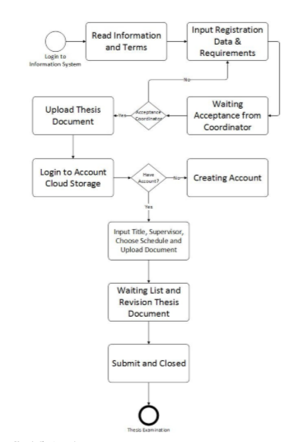

Each student is required to have a cloud storage account to gain access uploading documents. In the process of document submission, the system will direct the student to login the cloud storage account. If do not have an account, it will be directed to register first. Student uploaded documents can be accessed by supervisor, advisor and thesis coordinator. The uploaded thesis document can be changed until the thesis coordinator closes the registration of the thesis session.

Coordinator or Staff is the admin that manage all of students and lecturers activities. Coordinator activity consists of making information, opening registration forms, checking student requirements, making announcements for students and lecturers, updating thesis examination schedule and downloading thesis documents as university archives. These activities can be seen in Fig. 2.

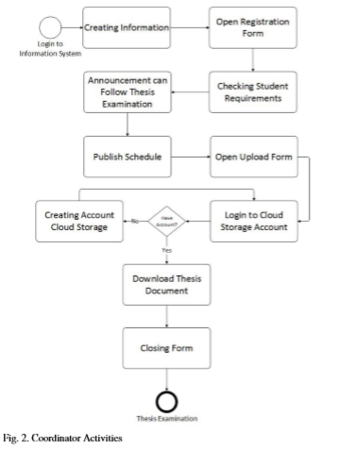

The Coordinator has many activities compared to students and lecturers. All coordinator activities are concerned with managing, creating information, and distributing student thesis documents for advisor and supervisor. As well as students and lecturers, the account coordinator needs to have an account on cloud storage for downloading the student thesis document. To maintain data security and order, the coordinator only can accessed by one account, even though there are many staff who take care of the thesis session.

Divergent the students and staff, the lecturer's activity only sees the thesis examination schedule and downloads the student thesis document to be examined by the examiner lecturer, and the supervisor is a carbon copy. It can be seen in Fig. 3.

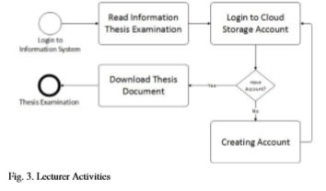

In conclusion, since a long time ago, the paperless thesis has been developed to require in the educational scope. There are many researchers who research in this scope which have an impact on improving the system. As well as with cloud storage, the development of cloud storage is so significant. Each of cloud storage service provider offers free or paid facilities. Some of cloud storage providers provide API services as a service that can be used to integrate with paperless thesis examination information systems. Of both products, this paper discusses the integration of cloud storage with the information system of paperless thesis examination using API service as a central to both products.

# Paper Reference

[1] M. G. C. E. Sicat, J. M. Flor, A. A. Hernandez, dan M. A. T. Subion, “iPad: Integrated Paperless Document Checking and Template-Based Editor for Electronic Thesis Compilation,” 2009, hal. 189–193.

[2] G. R. L. Franco dan C. Y. C. De Guzman, “Design and implementation of a web-based thesis coordinator system (TCS),” in Region 10 Conference (TENCON), 2016 IEEE, 2016, hal. 2726–2729. [3] W.-P. Chen dan C.-M. Liu, “Performance Comparison on the Heterogeneous File System in Cloud Storage Systems,” 2016, hal. 694– 701.

<https://sci-hub.tw/https://ieeexplore.ieee.org/document/8528573>

Method and Design

Payment Verification

Data, Files and Templates Storage

User Authentication

Layout comparison of the submitted files with the stored templates and other data processing

Back-End

User Interface / Front-End

Students

Teachers

Submit Thesis or Report

View submitted Thesis or Report **subsequent** to payment

View Submitted Thesis / Report

Add Templates for Thesis / Report

**Request to submit thesis**

Authenticate user

Perform file checks

Perform verification

**View Thesis files or add templates**

Authenticate user

Allow view / print

**Verify Submission**

Authenticate user

Complete verification

**Students**

**Thesis Verification Module**

Request teacher for approval

Add Digital Signature after verification

Save to Database

**File Checking Module**

Upload the file to temporary storage

Match format with a stored template

Check plagiarism score

Other checks

**User Authentication Module**

Create new Teacher’s account

Create new Student’s account

Login User

**Generate Responses**

Static HTML pages

Students’ Dashboard

Teachers’ Dashboard

Error Responses

**Request to create account**

Verify Identity

Create new account

**View Thesis files**

Authenticate user

Confirm Payment after free period

Allow view / print

**Application Server**

**Teachers**

**Database and File Storage**

Record Tables

File Storage

Temporary Storage

# Bibliography

<https://fisheri.com/images/features/Fisher_Analysis_Carbon_and_its_Impact_on_Global_PPI.pdf>

<http://www.bangladeshstudies.org/files/WPS_no10.pdf>

<https://en.wikipedia.org/wiki/Paperless_office>

<https://ghgprotocol.org/life-cycle-databases>

<https://www.goodenergy.co.uk/good-stats-on-carbon-saving/>

<https://get-thesis.com/blog/thesis-length>

<https://www.google.com/search?q=number%20of%20university%20students%20in%20bangladesh&oq=nuber%20&aqs=chrome.2.69i57j35i39l2j0.3456j0j7&client=ms-android-huawei-rev1&sourceid=chrome-mobile&ie=UTF-8&fbclid=IwAR3Qp2WwV0-Hs8bvPHA3Bz4gZw44Rn9dgaCgCQPI0qpLnW0LJbJOQlMiYkQ#pi=number%20of%20university%20students%20in%20bangladesh&sbfbu=0>

<http://shrinkthatfootprint.com/what-is-a-carbon-footprint>