Lab assignment 1:

network devices:

lspci

sudo lshw -C network

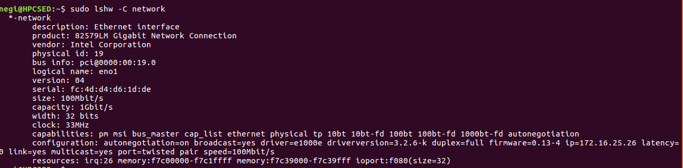

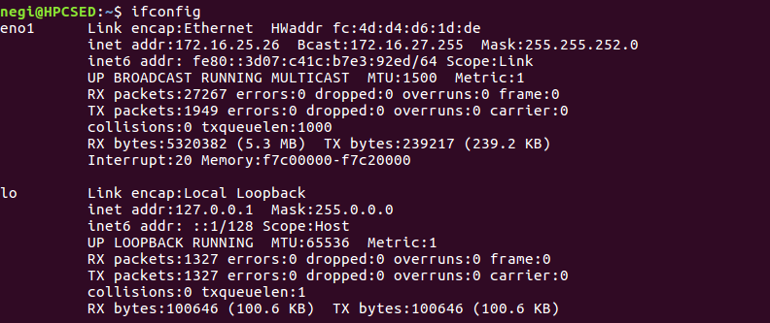
ifconfig

arp

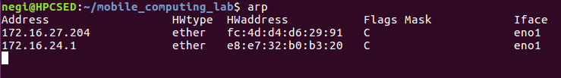

traceroute 172.16.30.30
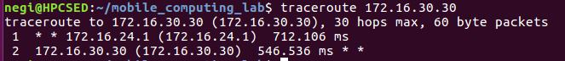

nslookup

