Iterative Model Optimization and
Systematic Analysis of Domain Adaptation
for Off-Road Semantic Segmentation
Duality AI Offroad Autonomy Segmentation Challenge
February 2026
Dataset: 2,857 Training | 317 Validation | 1,002 Test Images
Architecture: DINOv2-small + ConvNeXt Segmentation Head

Part 1: Iterative Model Optimization
This section documents our systematic approach to improving the baseline model through three key optimization steps, achieving validation IoU of 0.355.

Iteration 1: Extended Training (10 → 25 Epochs)
Observation: Initial 10-epoch training showed IoU curves still increasing without plateau, indicating insufficient training time.
Change: Increased training from 10 to 25 epochs
Results:
- Loss smoothly decreased throughout training
- Train and validation curves remained close (minimal overfitting)
- IoU steadily increased until ~epoch 23
- Validation IoU: 0.294 → 0.311 (+0.017)
Key Insight: Training longer provided modest improvement, but the model was reaching its capacity limit. Further gains would require optimizer or architecture changes, not just more epochs.

Iteration 2: Optimizer Switch (SGD → AdamW)
Observation: For transformer backbones like DINOv2, SGD is suboptimal. Adam/AdamW performs significantly better due to adaptive learning rates.
Change:
- Switched from SGD (lr=1e-4) to AdamW (lr=5e-4)
- Added weight decay of 1e-4 to AdamW for regularization
Results:
- Validation IoU: 0.31 → 0.3548 (+0.043)
- Significantly faster convergence in early epochs
- Better handling of the frozen DINOv2 backbone
Key Insight: AdamW unlocked the model's potential by properly optimizing the segmentation head parameters. This was the single largest performance gain.

Iteration 3: Learning Rate Scheduling
Observation: With constant learning rate, validation IoU plateaued around 0.35. Transformer models benefit from higher LR early and lower LR for fine-tuning later epochs.
Change:
- Added Cosine Annealing LR scheduler (T_max=25)
- LR decays from 5e-4 to near-zero following cosine curve
Final Results (After All Three Iterations):
Metric | Training | Validation
Loss | 0.685 | 0.716
IoU | 0.393 | 0.355
Dice Score | 0.526 | 0.509
Pixel Accuracy | 0.7368 | 0.7292

Training Dynamics Analysis
Training Stability:
- Smooth loss decrease with no sudden divergence
- No exploding gradients or training instability
- Train-val gap of 0.038 IoU indicates mild, expected overfitting
Convergence:
- Validation IoU plateaued around epoch 18-23
- Further training showed diminishing returns
- Model reached its capacity limit - architectural changes needed for further gains

Test Set Evaluation (Optimized Model)
Test IoU: 0.2323
Critical Observation: Validation IoU (0.355) vs Test IoU (0.232) represents a
34% performance drop, indicating strong domain shift between training and test environments.
Class | Test IoU
Sky | 0.9463
Landscape | 0.5606
Dry Grass | 0.1818
Rocks | 0.1050
Dry Bushes | 0.0951
Trees | 0.0851
Logs | 0.0653
Ground Clutter | 0.0599
Lush Bushes | 0.0156
Pattern Identified:
- Strong performance: Sky (0.946) and Landscape (0.561) - large, color-consistent classes
- Weak performance: Trees, Bushes, Logs, Ground Clutter - texture-heavy, small object classes
- Conclusion: Model is overfitting to training domain style and relying on color/texture cues rather than robust features

Part 2: Augmentation Strategy Experiments
Motivated by the severe validation-test gap (0.355 → 0.232), we hypothesized that aggressive data augmentation would improve generalization to the novel test environment. This section documents three experimental conditions testing this hypothesis.

Experimental Design
Model | Augmentation | Val IoU | Test IoU
Baseline | Standard (from Part 1) | 0.355 | 0.232
Aggressive | Jitter 0.5, Rotation 20°, Blur, Grayscale | 0.232 | 0.163
Moderate | Jitter 0.3, Rotation 10° | 0.257 | 0.176
Shocking Result: Both augmentation strategies degraded test performance. The hypothesis was wrong.

Training Curves Comparison

Baseline Model (Best Performance)
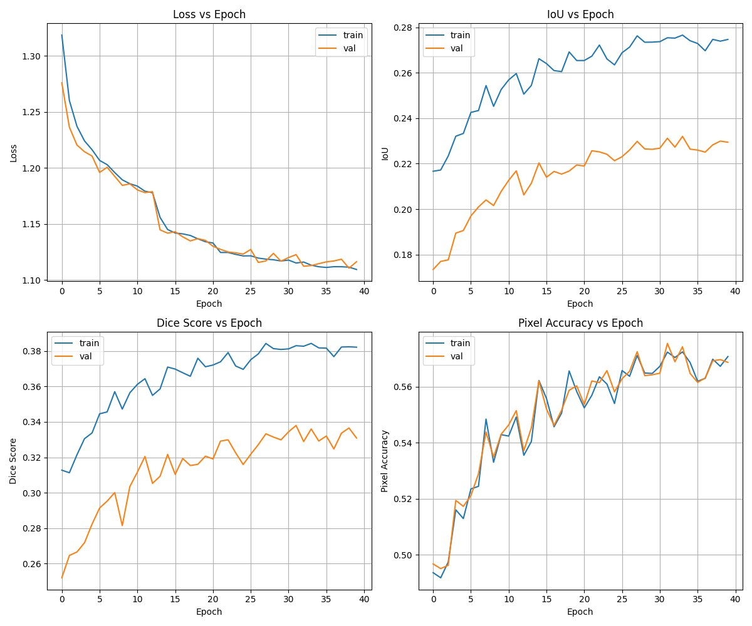
Figure 1: Baseline training curves - Val IoU 0.355, Test IoU 0.232

Moderate Augmentation Model
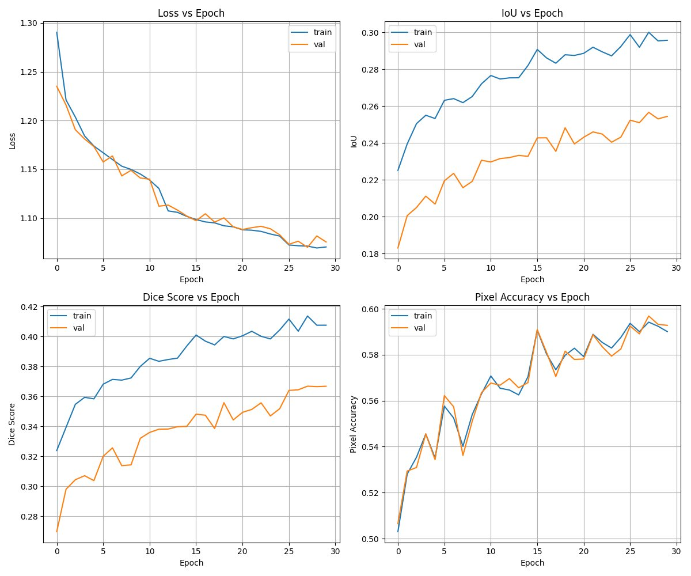
Figure 2: Moderate augmentation curves - Val IoU 0.257, Test IoU 0.176

Conclusion & Final Submission
This report documents two distinct phases of model development:
Phase 1: Iterative Optimization successfully improved validation IoU from 0.294 to 0.355 through systematic improvements (extended training, AdamW optimizer, LR scheduling).
Phase 2: Augmentation Experiments revealed that aggressive augmentation
degraded performance when source and target domains share visual characteristics (both desert environments).
Final Submission:
Model: Optimized baseline from Phase 1 (AdamW + LR scheduling)
Validation IoU: 0.355
Test IoU: 0.232
Key Learnings:
- Optimizer choice is critical: AdamW provided +0.043 IoU gain over SGD for transformer backbones
- Domain similarity ≠ no domain shift: 34% val-test gap despite both being deserts
- Augmentation can harm: Destroyed domain-specific features (desert color palette), degrading performance
- Systematic experimentation matters: Understanding WHY approaches fail is as valuable as finding what works

