## -Fruits (per 1cup , unless specified)

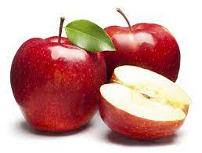

* **APPLES :**

Calories: 95

Carbohydrates: 25g

Fiber: 4g

Vitamin C: 14%DV (Daily Value)

* **APRICOTS :**

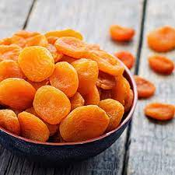

Calories: 74

Carbohydrates: 19g

Fiber: 3g

Vitamin A: 60% DV

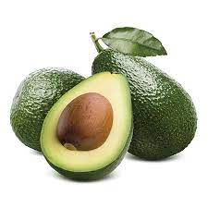

* **AVOCADOES (1 MEDIUMM AVOCADO)**

Calories: 234

Carbohydrates: 12g

Fiber: 10g

Healthy Fats: 21g

Vitamin K: 26% DV

Folate: 20% DV

Vitamin C: 17% DV

* 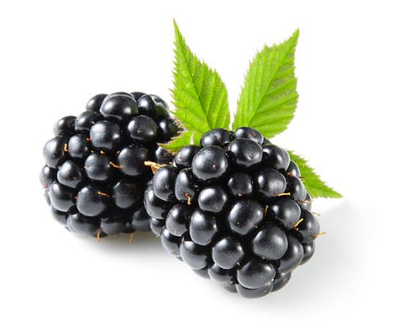**BLACKBERRIES:**

Calories: 62

Carbohydrates: 14g

Fiber: 8g

Vitamin C: 50% DV

* **BLUEBERRIES :**

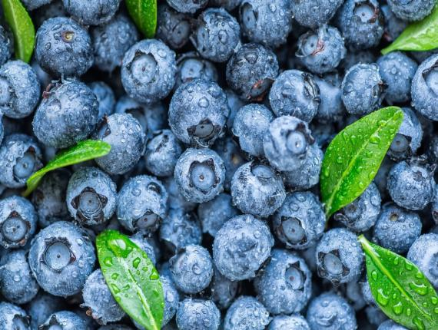

Calories: 85

Carbohydrates: 21g

Fiber: 4g

Vitamin C: 24% DV

Vitamin K: 36% DV

* **GRAPEFRUIT : (1 medium grapefruit)**

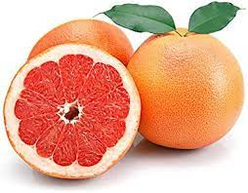

Calories: 52

Carbohydrates: 13g

Fiber: 2g

Vitamin C: 64% DV

Vitamin A: 28% DV

* **GRAPES : (1 CUP , seedless):**

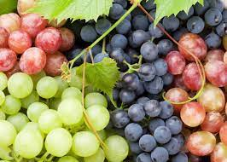

Calories: 104

Carbohydrates: 27g

Fiber: 1g

Vitamin C: 27% DV

* **PEACHES :**

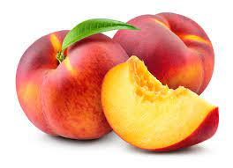

Calories: 58

Carbohydrates: 14g

Fiber: 2g

Vitamin C: 17% DV

Vitamin A: 10% DV

* 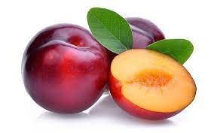**PLUMS :**

Calories: 46

Carbohydrates: 11g

Fiber: 2g

Vitamin C: 10% DV

Vitamin K: 10% DV

* **RASPBERRIES :**

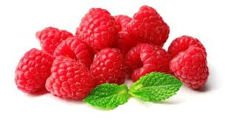

Calories: 64

Carbohydrates: 15g

Fiber: 8g

Vitamin C: 54% DV

* 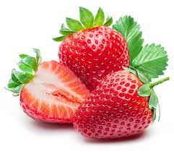**STRAWBERRIES :**

Calories: 49

Carbohydrates: 12g

Fiber: 3g

Vitamin C: 149% DV

* **FRUITS TO ENJOY IN MODERATION (PER 1 CUP , UNLESS SPECIFIED) :**

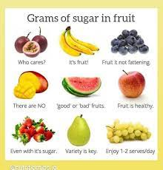

* **DRIED FRUITS ( RAISINS , DATES , ETC. )**

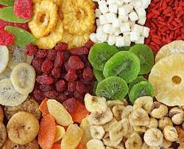

Calories: Varies based on the type and portion size.

Carbohydrates: Varies based on the type

Fiber: Varies based on the type.

* **WATERMELON** :

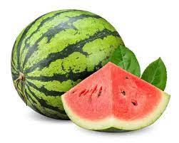

Calories: 46

Carbohydrates: 11g

Fiber: 1g

Vitamin C: 20% DV

* 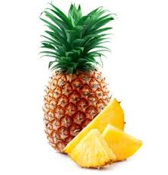**PINEAPPLE** :

Calories: 82

Carbohydrates: 21g

Fiber: 2g

Vitamin C: 131% DV

* **FRUIT JUICE (100% UNSWEETENED):**

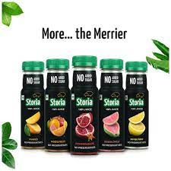

Calories: Varies based on the type and portion size

Carbohydrates: Varies based on the type

Vitamin C: Varies based on the type

* **OVERRIPE BANANAS :**

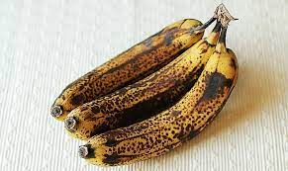

Calories: Varies based on the size and ripeness.

Carbohydrates: Varies based on the size and ripeness.

Fiber: Varies based on the size and ripeness.

* **Potatoes (per 1 medium-sized potato, unless specified):**
* **SWEET POTATOES :**

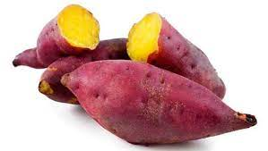

Calories: 103

Carbohydrates: 24g

Fiber: 4g

Vitamin A: 438% DV

Vitamin C: 37% DV

* **YAMS :**

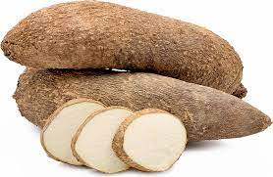

Calories: 158

Carbohydrates: 37g

Fiber: 5g

Vitamin C: 18% DV

* **WHITE POTATOES :**

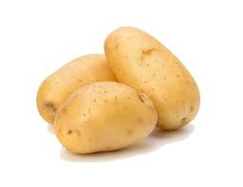

Calories: 168

Carbohydrates: 38g

Fiber: 4g Vitamin C: 48% DV

* **OATS (PER 1/2 CUP , COOKED)**

* **STONE GROUND OATS ( STEEL-CUT , OATS):**

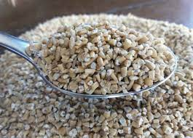

Calories: 150

Carbohydrates: 27g

Fiber: 4g

Protein: 5g

* ROLLED OATS :

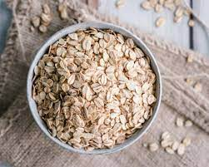

Calories: 150

Carbohydrates: 27g

Fiber: 4g

Protein: 5g

* **OATS PRODUCTS TO LIMIT (PER SERVING , UNLESS SPECIFIED):**

* PROCESSED OATS :

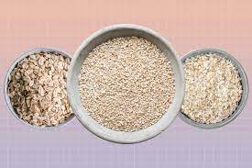

Calories: Varies based on the type and portion size

Carbohydrates: Varies based on the type

Fiber: Varies based on the type

* CEREAL BARS :

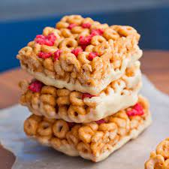

Calories: Varies based on the type and portion size

Carbohydrates: Varies based on the type

Fiber: Varies based on the type

* **NUT PRODUCTS (PER 1 ONCE, UNLESS SPECIFIED)**
* RAW ALMONDS :

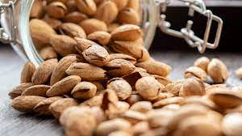

Calories: 160

Carbohydrates: 6g

Fiber: 3.5g

Protein: 6g

* RAW CASHEWS :

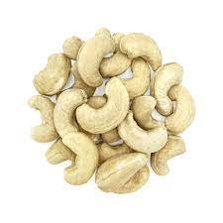

Calories: 157

Carbohydrates: 9g

Fiber: 1g

Protein: 5g

* 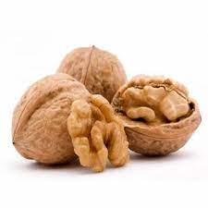RAW WALNUTS :

Calories: 185

Carbohydrates: 4g

Fiber: 2g

Protein: 4g

* RAW PECANS :

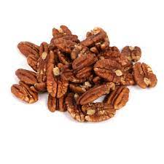

Calories: 196

Carbohydrates: 4g

Fiber: 3g

Protein: 3g

* **Other Tree Nuts (hazelnuts, pistachios, etc.):**
* **Calories, Carbohydrates, Fiber, and Protein vary by type**

* RAW PEANUTS :

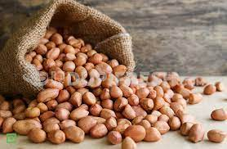

Calories: 160

Carbohydrates: 6g

Fiber: 2.5g

Protein: 7g

* PEANUT BUTTER (2 TABLESPOONS):

Calories: 188

Carbohydrates: 6g

Fiber: 2g

Protein: 8g

* **Nuts with Higher GI Scores (per 1 ounce, unless specified):**
* 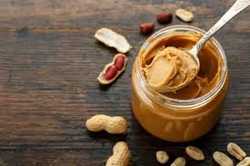CASHEWS :

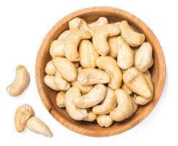

Calories: 157

Carbohydrates: 9g

Fiber: 1g

Protein: 5g

* **GI Score: 22 (low glycemic index)**

* MACADAMIA NUTS :

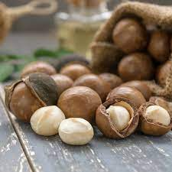

Calories: 204

Carbohydrates: 4g

Fiber: 2g

Protein: 2g

* **GI Score: 0 (low glycemic index)**

* ROASTED OR SALTED NUTS ( VARIES BY TYPE AND PREPARATIONS):

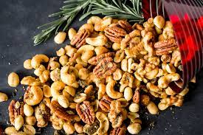

**Calories, Carbohydrates, Fiber, Protein, and GI Score vary by type and preparation.**

* CANDIED NUTS (VARIES BY TYPE AND PREPARATION):

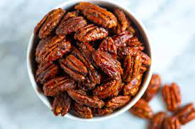

**Calories, Carbohydrates, Fiber, Protein, and GI Score vary by type and preparation.**

* **Fish Products (per 3-ounce cooked serving, unless specified):**
* 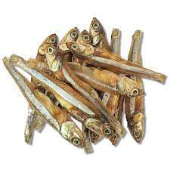ANCHOVIES :

Calories: 131

Protein: 20g

Omega-3 Fatty Acids: 1.5g

* 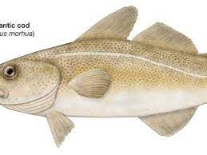COD :

Calories: 89

Protein: 20g

Omega-3 Fatty Acids: 0.2g

* 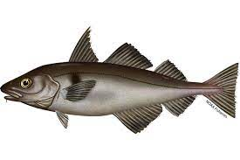HADDOCK :

Calories: 94

Protein: 20g

Omega-3 Fatty Acids: 0.2g

* HERRING :

Calories: 210

Protein: 19g

Omega-3 Fatty Acids: 1.7g

* POLLOCK :

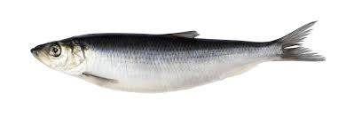

Calories: 94

Protein: 20g

Omega-3 Fatty Acids: 0.2g

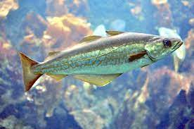

* SAITHE (POLLOCK) :

Calories: 82

Protein: 18g

Omega-3 Fatty Acids: 0.2g

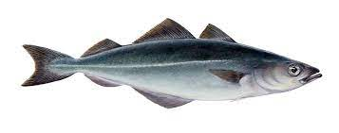SALMON :

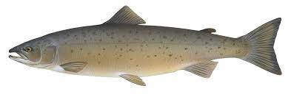

Calories: 177

Protein: 24g

Omega-3 Fatty Acids: 1.2g

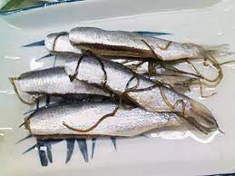

* SARDINES ( CANNED IN OIL, DRAINED):

Calories: 191

Protein: 22g

Omega-3 Fatty Acids: 1.3g

* FISH OIL CAPSULES ( PER CAPSULE, TYPICALLY 1,000 MG):

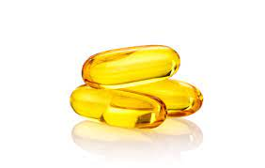

Calories: Varies based on the brand and concentration

Omega-3 Fatty Acids: Varies based on the brand and concentration.

* **Fish to Limit (per 3-ounce cooked serving, unless specified):**
* BIGEYE TUNA :

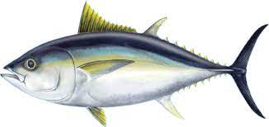

Calories: 135

Protein: 29g

Omega-3 Fatty Acids: 0.4g

* 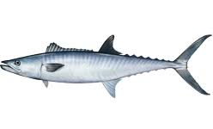KING MACKEREL :

Calories: 232

Protein: 21g

Omega-3 Fatty Acids: 0.4g

* MARLIN :

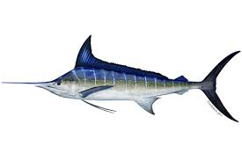

Calories: 184

Protein: 23g

Omega-3 Fatty Acids: 0.2g

* SHARK :

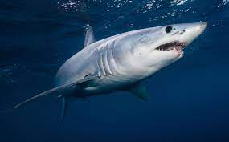

Calories: 164

Protein: 24g

Omega-3 Fatty Acids: 0.6g

* SWORDFISH :

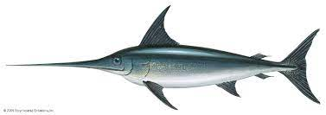

Calories: 177

Protein: 24g

Omega-3 Fatty Acids: 0.5g

* 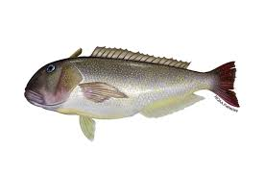TILEFISH :

Calories: 132

Protein: 26g

Omega-3 Fatty Acids: 0.2g

* **Yogurt (per 1 cup, unless specified):**

* GREEK YOGURT :

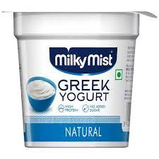

Calories: 100

Carbohydrates: 7g

Protein: 17g

Calcium: 18% DV

* 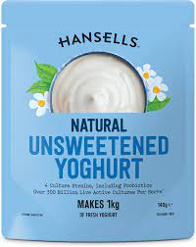UNSWEETENED YOGURT :(PLAIN, NON-FAT):

Calories: 137

Carbohydrates: 17g

Protein: 14g

Calcium: 49% DV

**Yogurt to Avoid (per 1 cup, unless specified):**

* SWEETENED YOGURT (FLAVORED,SWEETENED):

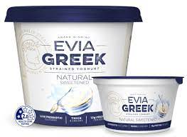

Calories: Varies based on the type and brand

Carbohydrates: Varies based on the type

Protein: Varies based on the type.

* FLAVORED YOGURT (FRUITY OR DESERT-STYLE):

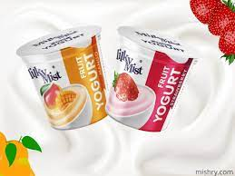

Calories: Varies based on the type and brand

Carbohydrates: Varies based on the type

Protein: Varies based on the type