* 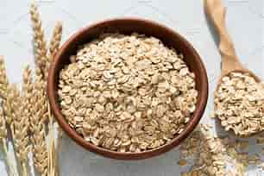 Oats:

Carbohydrates(g): 27

Protein(g): 5

Fat(g): 2

Fiber(g): 4

Sugar(g): 1

* Whole wheat bread

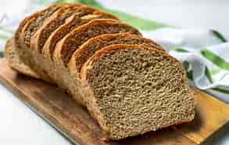 Carbohydrates(g): 12

Protein(g): 2

Fat(g):1

Fiber(g): 2

Sugar(g): 1

* Quinoa

Carbohydrates(g): 20

Protein(g): 4

Fat(g): 2

Fiber(g): 3

Sugar(g): 0

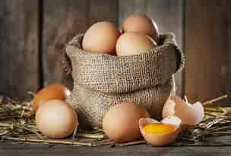 Protein

* Eggs

Carbohydrates(g): 1

Protein(g): 6

Fat(g): 5

Fiber(g): 0

Sugar(g): 0

* 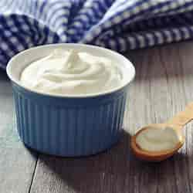 Greek yogurt

Carbohydrates(g): 6

Protein(g): 10

Fat(g): 0

Fiber(g): 0

Sugar(g): 6

* Nuts

 Carbohydrates(g): 5

Protein(g): 6

Fat(g): 14

Fiber(g): 3

Sugar(g): 1

* 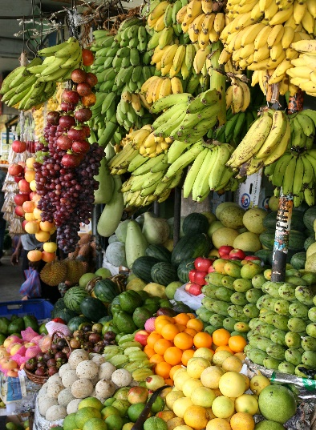Fruits
* Berries

Carbohydrates(g): 15

Protein(g): 1

Fat(g): 0

Fiber(g): 5

Sugar(g): 10

* Apples

 Carbohydrates(g): 25

Protein(g): 0

Fat(g): 0

Fiber(g): 4

Sugar(g): 1

*  Citrus fruits

Carbohydrates(g): 15

Protein(g): 1

Fat(g): 0

Fiber(g): 3

Sugar(g): 9

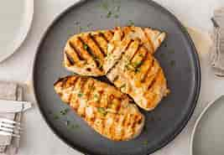 2 lunch

* Lean protein
* Grilled chicken

Carbohydrates(g): 0

Protein(g): 31

Fat(g): 3

Fiber(g): 0

Sugar(g): 0

* 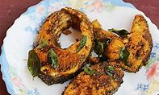Fish

Carbohydrates(g): 0

Protein(g): 20

Fat(g): 5

Fiber(g): 0

Sugar(g): 0

* Tofu

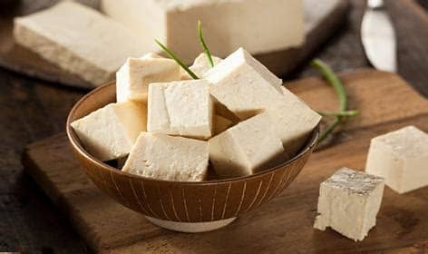 Carbohydrates(g): 2

Protein(g): 8

Fat(g): 4

Fiber(g): 1

Sugar(g): 0

* 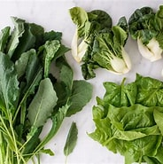 Non-starchy vegetables
* Leafy greens

Carbohydrates(g): 2

Protein(g): 2

Fat(g): 0

Fiber(g): 2

Sugar(g): 0

* 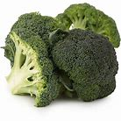 Broccoli

Carbohydrates(g): 6

Protein(g): 3

Fat(g): 0

Fiber(g): 2

Sugar(g): 1

* 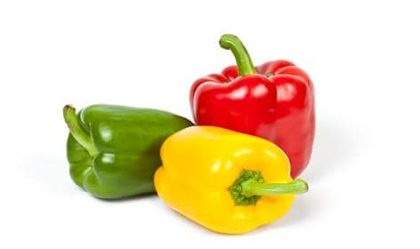 Bell peppers

Carbohydrates(g): 6

Protein(g): 1

Fat(g): 0

Fiber(g): 2

Sugar(g): 4

* 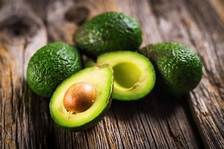Healthy fats
* Avocado

Carbohydrates(g): 9

Protein(g): 2

Fat(g): 15

Fiber(g): 7

Sugar(g): 1

* Olive oil

Carbohydrates(g): 0

Protein(g): 0

Fat(g): 14

Fiber(g): 0

Sugar(g): 0

* Nuts

Carbohydrates(g): 5

Protein(g): 6

Fat(g): 14

Fiber(g): 3

Sugar(g): 1

* dinner:

Lean protein

* Grilled chicken

Carbohydrates(g): 0

Protein(g): 31

Fat(g): 3

Fiber(g): 0

Sugar(g): 0

* Fish

Carbohydrates(g): 0

Protein(g): 20

Fat(g): 5

Fiber(g): 0

Sugar(g):0

* Tofu

Carbohydrates(g):2

Protein(g): 8

Fat(g): 4

Fiber(g): 1

Sugar(g)": 0

 Non-starchy vegetables

* Leafy greens

Carbohydrates(g): 2

Protein(g): 2

Fat(g): 0

Fiber(g): 2

Sugar(g): 0

* Broccoli

Carbohydrates(g): 6

Protein(g): 3

Fat(g): 0

Fiber(g): 2

Sugar(g): 1

* Bell peppers

Carbohydrates(g): 6

Protein(g): 1

Fat(g): 0

Fiber(g): 2

Sugar(g): 4

* Healthy fats
* Avocado

Carbohydrates(g): 9

Protein(g): 2

Fat(g): 15

Fiber(g): 7

Sugar(g): 1

* Olive oil

 Carbohydrates(g): 0

Protein(g): 0

Fat(g): 14

Fiber(g): 0

Sugar(g): 0

* Nuts

Carbohydrates(g): 5

Protein(g): 6

Fat(g): 14

Fiber(g): 3

Sugar(g): 1