User Manual

for Banking System

*（a tentative initial draft for TA team to test and may be modified later）*

c

Team 5 Project 2

Made by : Yang Runkang

Introduction

System Overview

Welcome to the Python-based Banking System, a versatile platform designed to facilitate both ATM and mobile banking activities. This system integrates a user-friendly interface built with PyQt5, providing a seamless experience for conducting a variety of banking transactions. Our system enables you to manage accounts, perform deposits and withdrawals, transfer funds, change passwords, and query transaction histories efficiently and securely.

Target Audience

This manual is intended for all users of the banking system, including bank customers using the ATM and mobile app for personal banking, as well as bank employees who manage and maintain the banking system. Whether you are a first-time user or an experienced operator, this manual will help you navigate and utilize the system effectively.

Document Purpose

The purpose of this document is to provide comprehensive guidance on using the Python-based Banking System. It contains detailed instructions on how to operate the system, troubleshoot common issues, and understand the security measures in place to protect your financial information. This manual ensures that all users can fully leverage the features and functionalities of the banking system.

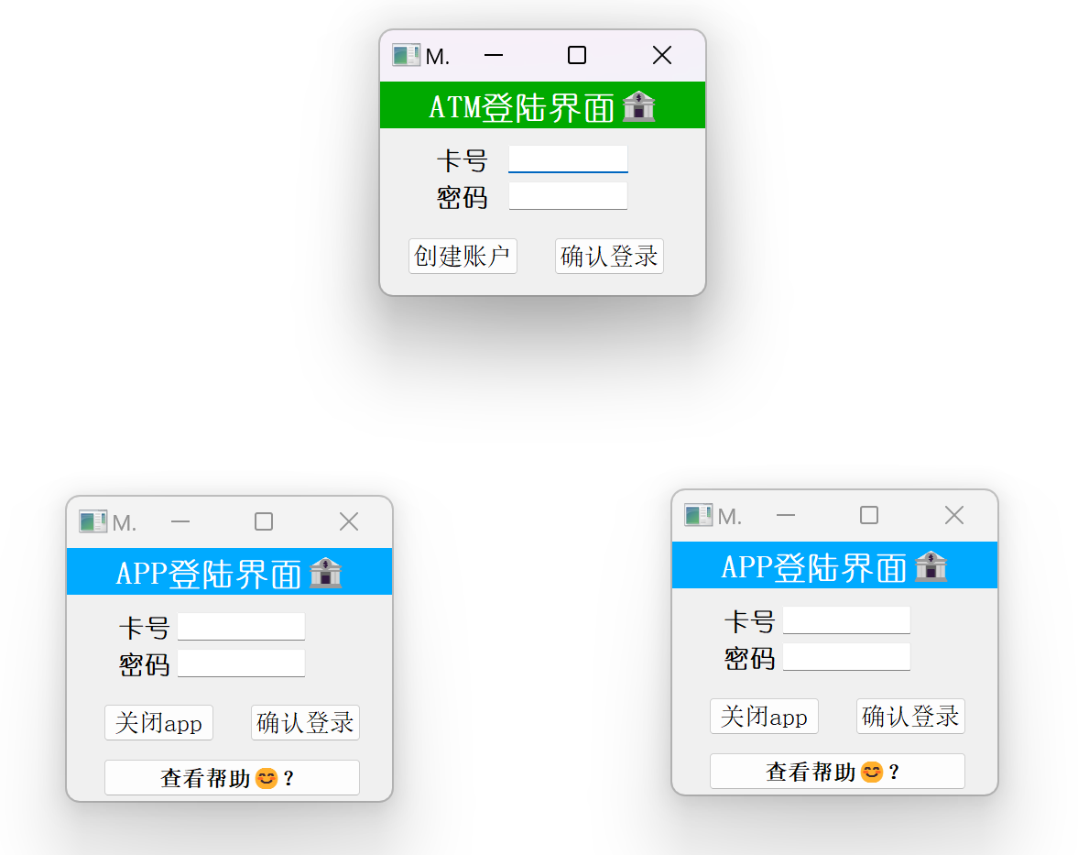

* Table of Contents
* Getting Started
* System Requirements
* Installation Guide
* Initial Setup and Configuration for Administrator*
* Manual Testing
* Backend String Testing
* First-Time User Login
* Using the Banking System
* How to Access the System
* Overview of the User Interface
* ATM Operations
* App Operations
* Troubleshooting
* Overview
* Common Issues and Solutions

Getting Started

System Requirements

Before you begin using the Python-based Banking System, ensure your system meets the following requirements:

* **Operating System:** Windows 10 or higher, MacOS 10.14 or higher, Linux Ubuntu 18.04 or higher.
* **Python Version:** Python 3.8 or higher.
* **Required Libraries:** PyQt5, zmq for networking capabilities. Make sure all dependencies are installed using pip or a similar package manager.

Installation Guide

To install the Python-based Banking System, follow these steps:

* **Download the Software:** Obtain the latest version of the software from gitlab.
* **Install Python and PyQt5:** If not already installed, download and install Python from python.org and install PyQt5 using the command pip install PyQt5.
* **Set Up the Environment:**
* Clone the repository into your desired location.
* Navigate to the project directory in your terminal or command prompt.

Initial Setup and Configuration for Administrator*

To get started or test with the Python-based Banking System, you need to configure the initial settings and start the application.

* **Launching the Application**
* **Open the Code Folder:**
* Navigate to the Code folder where the Launch.py file is located. This file is the entry point for the application.
* **Modify Initial Settings (Optional for administrator):**
* If you need to adjust the initial state of the system, such as predefined account balances and passwords, edit the **Database.py** file. For example, to change account details:
* # Modify account balances
* account_balance = {'11111': '20000', '22222': '15000'}
* # Modify account passwords
* account_password = {'11111': 'newpassword1', '22222': 'newpassword2'}

Manual Testing

* **Configure the Number of Apps:**
* By default, the system starts with one application instance. To start additional instances, modify the **Launch.py** file:
* # Start the first app instance
* app1 = applog(100, 700)
* app1.show()
* # To start a second app instance
* app2 = applog(700, 700)
* app2.show()
* Repeat the process for as many app instances as required, adjusting the position parameters to avoid overlap.
* **Start the System:**
* Run the Launch.py file by executing the command:
* python Launch.py
* This will launch the ATM and any configured app instances, making them ready for use.

Backend String Testing

* **Comment Out the Configuration of Apps:**
* For the backend string testing, software developer assume that no app is available during the system startup phase. Therefore, all code related to setting up the app needs to be commented out to enable the backend to start automated string testing.:
* # from app import applog
* # app1 = applog(100,700)
* # app1.show()
* # app2 = applog(700,700)
* # app2.show()
* **Start the System:**
* Run the Launch.py file by executing the command:
* python Launch.py
* This will launch the ATM and any configured app instances, making them ready for use.
* **Using the ATM**

The system includes one ATM interface, which is automatically started with the Launch.py script. It is ready for transactions immediately upon system startup.

First-Time User Login

Upon launching the system for the first time:

* Open the ATM or one of the app instances.
* Use one of the pre-configured accounts to log in, or create a new account using the ATM interface.
* The functionalities such as checking balances, making deposits, or transferring funds will be discussed in detail below.

This section ensures that all users can successfully set up and start using the Python-based Banking System with minimal setup. Detailed instructions and configurations provided here are designed to help both new and experienced users efficiently navigate the initial setup and start engaging with the system right away.

Using the Banking System

How to Access the System

ATM and Mobile App: Access to the banking system is available through ATM interfaces and a mobile application. Both platforms are designed for ease of use and are accessible directly upon running the Launch.py script as previously described in the "Getting Started" section.

Overview of the User Interface

* **ATM Interface:** The ATM provides options for card insertion, account creation, cash deposits, withdrawals, and viewing account balances.
* **Mobile App Interface:** The app allows for logging in, account management, money transfers, password changes, and transaction queries.

ATM Operations

The ATM interface of the Python-based Banking System is designed to handle typical banking transactions securely and efficiently. This section provides detailed instructions on how to perform ATM-specific operations, including card management and cash transactions.

* Inserting / Ejecting Card & Creating Account
* **Inserting a Card**

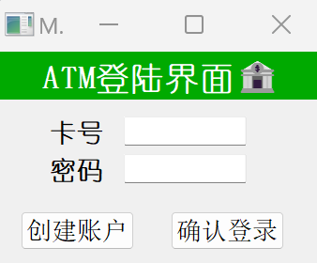

* **Operation:** insert_card@id
* **Steps:**
* Enter your account number and password. This acts as the equivalent of inserting a physical card into the machine.
* Enter “确认登陆”. The system will validate the account number, and if correct, you will gain access to perform other transactions.
* **System Response:** The ATM will display a confirmation message, card_inserted@id, indicating that the card insertion has been recognized and you can proceed with transactions.

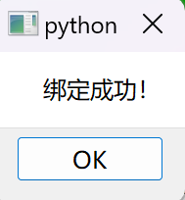

* **Troubleshooting:** If you fail to log in successfully, please check if the account and password input is incorrect, or if the account has been deactivated.
* **Ejecting a Card**

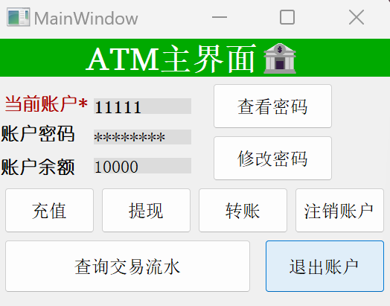

* **Operation:** return_card
* **Steps:**
* Once you have completed your transactions, select the "退出账户" option.
* The ATM will process the request and log you out of the system, ensuring that your account remains secure.
* Then you can safely leave the ATM.
* **System Response:** The ATM will display card_returned@id, confirming that the card (i.e., your session) has been securely closed.
* **Creating Account**

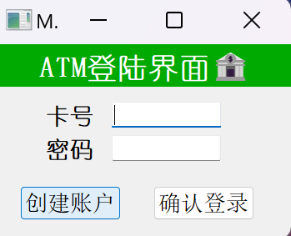

* **Operation:** create_account
* **Steps:**
* Please click the "创建账户" button on the ATM login screen.
* Please enter the password you want to set for this new account.

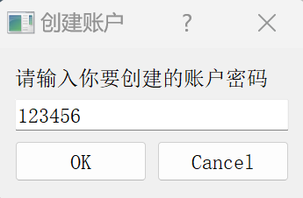

* **Password requirements: must be** 5 to 12 digits.
* After clicking OK, the system will automatically assign you a new account and take you to the ATM main screen.
* **System Response:** The ATM will display account_created@id, this means you have been assigned a new card, and the ATM will display the new card number and password.

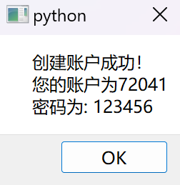

* Performing Transactions via ATM

The ATM provides a safe and convenient way to conduct several types of banking transactions, detailed below.

* **Depositing Cash**

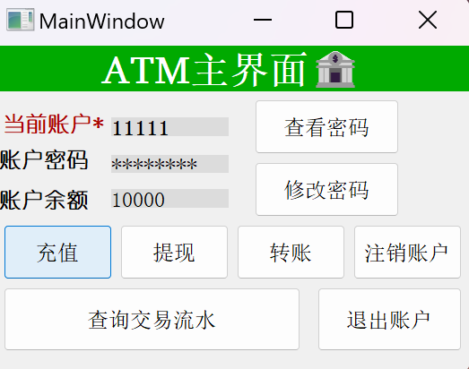

* **Operation:** deposit_cash@num
* **Steps:**
* After inserting your card, select the "充值" option.
* Enter the amount of cash you wish to deposit and confirm.

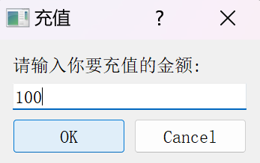

* Confirm the total amount as displayed on the screen.

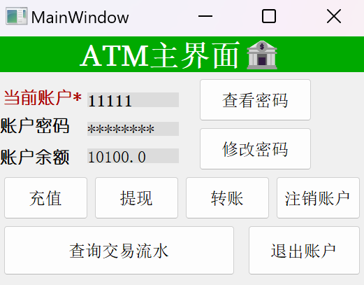

* **System Response:** Upon successful deposit, the ATM updates your account balance and displays cash_deposited@num from backend.
* **Troubleshooting:** If you fail to successfully complete the recharge (deposit), please check if the amount entered for the recharge is correct. Each recharge amount should be no less than ¥0.01, with a precision up to ¥0.01. If these requirements are not met, the recharge amount will be deemed invalid, and the recharge operation will be automatically terminated.

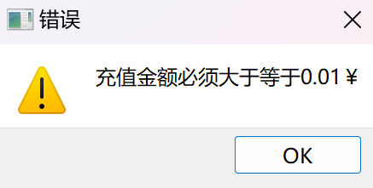 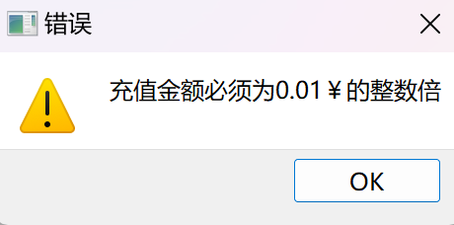 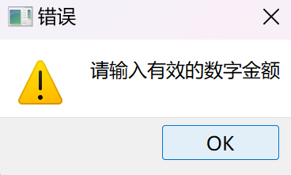

* **Withdrawing Cash**

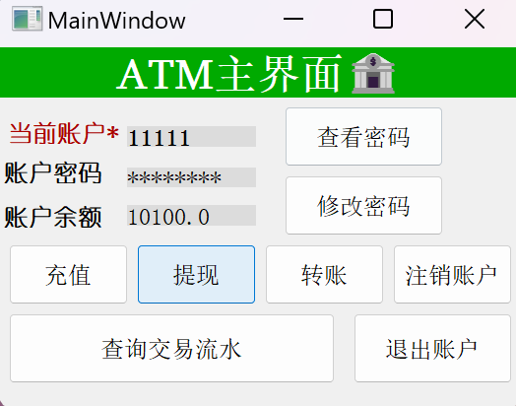

* **Operation:** withdraw_cash@num@password
* **Steps:**
* Enter the amount of cash you wish to withdraw and confirm.

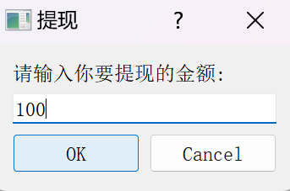

* The ATM processes the request and if the balance is sufficient, dispenses the specified amount of cash.

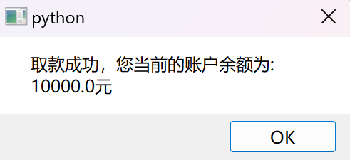

* **System Response:** The ATM will display cash_withdrawn@num, updating your balance.
* **Troubleshooting:** If you fail to successfully complete the withdrawal, similarly like the deposit operation, please check if the amount entered for the withdrawal is correct. Each withdrawal amount should be no less than ¥0.01, with a precision up to ¥0.01. Additionally, the withdrawal amount must not exceed the current account balance. If these requirements are not met, the withdrawal amount will be deemed invalid, and the withdrawal operation will be automatically terminated.

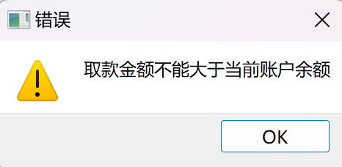

* **Money Transfers**

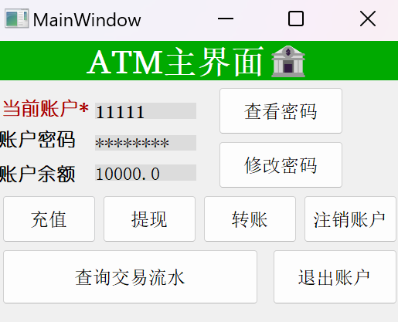

* **Steps:**
* Navigate to "转账" from the main menu.
* Enter the recipient's account number and the amount to transfer.

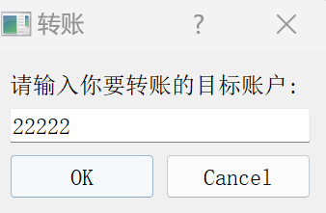 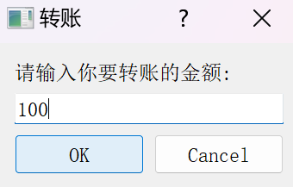

* Confirm the transaction details and authorize the transfer.
* **System Response:** Deducts the amount from your account, credits it to the recipient's account, and displays money_transfered@num(#app_id).

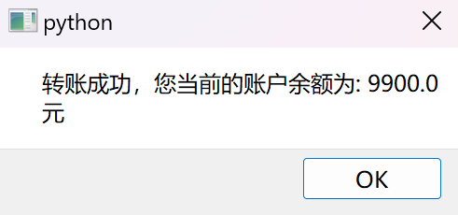

* **Troubleshooting:** If you fail to successfully complete the transfer, please check if the amount entered for the transfer is correct. The amount requirements are similar to those for deposits and withdrawals. Additionally, the transfer should ensure that the target account exists and should not transfer to yourself. If the target account does not exist in the database or you transfer to yourself, the transfer will also fail. If these requirements are not met, the system will display the transfer as invalid and automatically terminate the transfer operation.

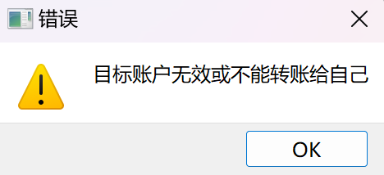

* Managing Account Settings
* **Viewing Password:**

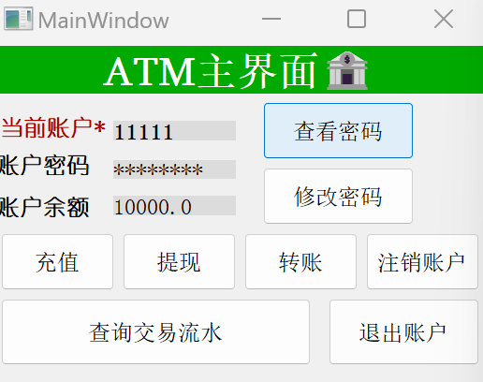

* **Steps:**
* In the menu, select "查看密码."
* **System Response:** Show your current password.

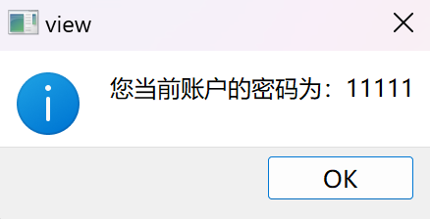

* **Changing Password:**

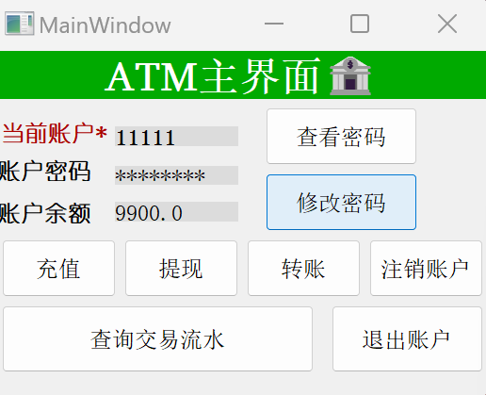

* **Steps:**
* In the menu, select "修改密码."
* Enter your new password.
* Submit the changes.

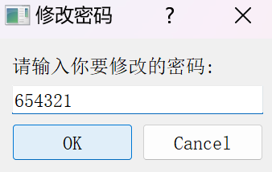

* **System Response:** Updates your password and displays a confirmation message, logging password_changed(#app_id).

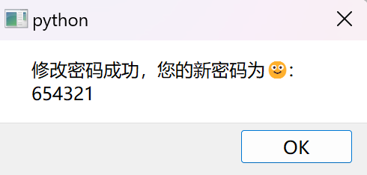

* **Troubleshooting:** If you fail to complete the password modification, please first check if your password meets the requirements, which should consist of 5 to 12 digits. Additionally, ensure that the new password is not the same as the original one. If these requirements are not met, the system will display a failure to modify the password and exit the password modification operation.

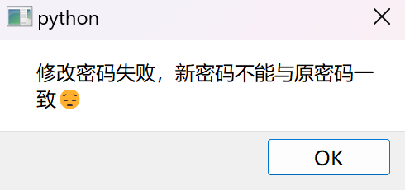 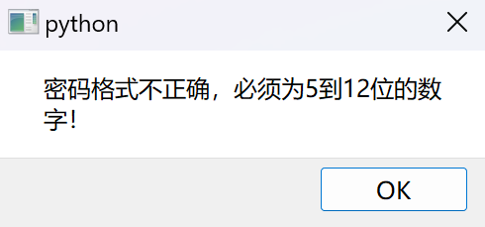

* **Close account:**

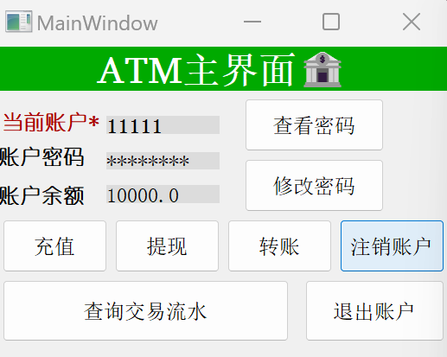

* **Steps:**
* From the main menu, select "注销账户."
* **System Response:** Removing your account from the database means you will no longer have access to it.

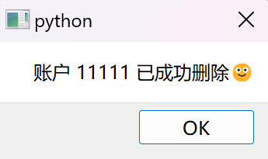

* **Troubleshooting**: If you fail to complete the account closure, please first check if the balance of your current account is zero. Only when the account balance is zero can it be safely closed. If this requirement is not met, the system will display a failure to close the account and exit the account closure operation.

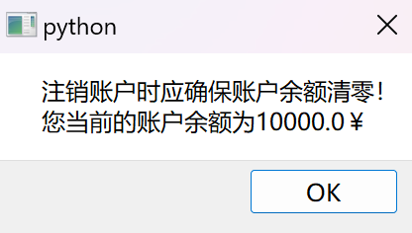

* Querying Transaction History
* **Viewing Transactions:**

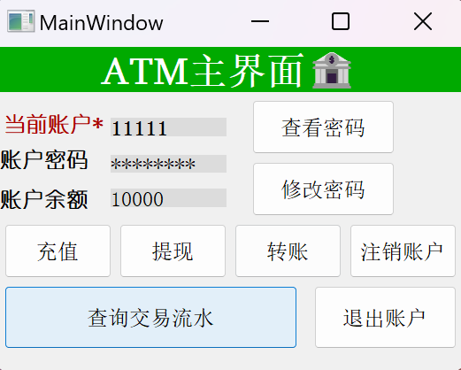

* **Steps:**
* From the main menu, select "Transactions."
* **System Response:** Displays a detailed list of transactions, facilitating easy tracking of financial activities.

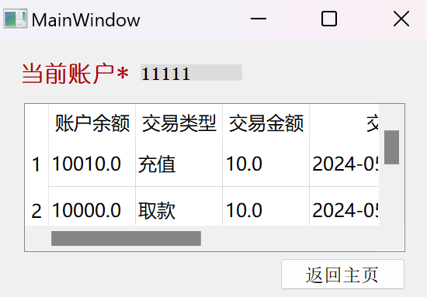

App Operations

The mobile application component of the Banking System offers a convenient and secure platform for managing personal banking directly from your smartphone or tablet. This section details the specific functionalities available through the app, including exclusive features not available on the ATM.

* Logging In and Out
* **Logging In:**

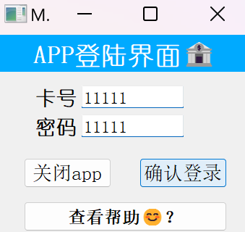

* **Steps:**
* Open the app and navigate to the login screen.
* Enter your account number and password.
* Tap "确认登陆" to access your account.
* **System Response:** Displays your account dashboard and logs logged_in@id#app_id.

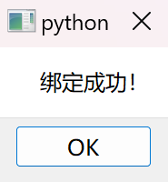

* **Logging Out:**

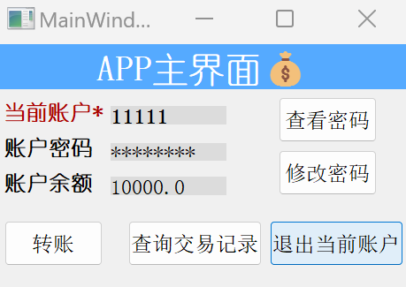

* **Steps:**
* From any screen, access the menu and select "退出当前账户."
* **System Response:** Closes your session and returns to the login screen, logging logged_out@id#app_id.
* Managing Account Settings
* **Viewing Password:**

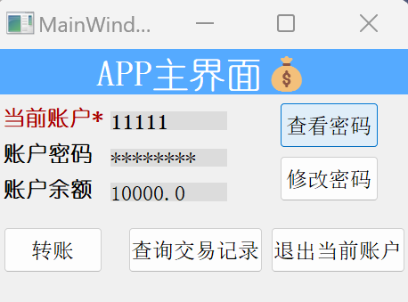

* **Steps:**
* In the menu, select "查看密码."
* **System Response:** Show your current password.



* **Changing Password:**

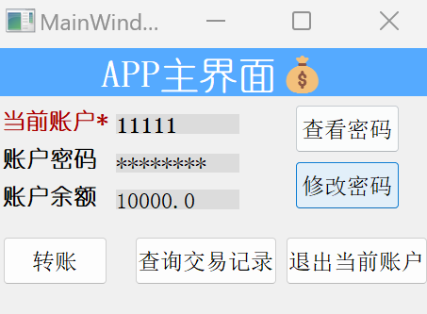

* **Steps:**
* In the menu, select "修改密码."
* Enter your new password.
* Submit the changes.



* **System Response:** Updates your password and displays a confirmation message, logging password_changed(#app_id).



* **Troubleshooting:** If you fail to complete the password modification, please first check if your password meets the requirements, which should consist of 5 to 12 digits. Additionally, ensure that the new password is not the same as the original one. If these requirements are not met, the system will display a failure to modify the password and exit the password modification operation.

 

* Performing Transactions via ATM

The app provides a safe and convenient way to conduct transfering transaction, detailed below.

* **Money Transfers**

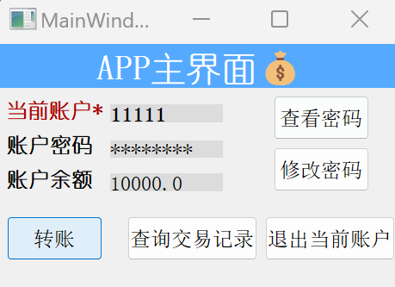

* **Steps:**
* Navigate to "转账" from the main menu.
* Enter the recipient's account number and the amount to transfer.

 

* Confirm the transaction details and authorize the transfer.
* **System Response:** Deducts the amount from your account, credits it to the recipient's account, and displays money_transfered@num(#app_id).



* **Troubleshooting:** If you fail to successfully complete the transfer, please check if the amount entered for the transfer is correct. The amount requirements are similar to those for deposits and withdrawals. Additionally, the transfer should ensure that the target account exists and should not transfer to yourself. If the target account does not exist in the database or you transfer to yourself, the transfer will also fail. If these requirements are not met, the system will display the transfer as invalid and automatically terminate the transfer operation.



* Querying Transaction History
* **Viewing Transactions:**

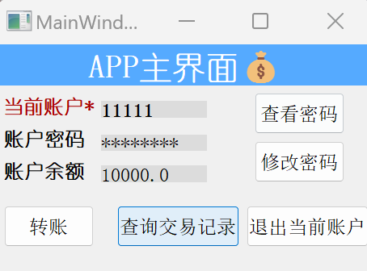

* **Steps:**
* From the main menu, select "Transactions."
* **System Response:** Displays a detailed list of transactions, facilitating easy tracking of financial activities.



Troubleshooting

Overview

Even with a robust and user-friendly banking system, users may occasionally encounter issues. The previous section has described the possible failure operations for each scenario. This section will classify the aforementioned failure operations for user awareness. This section provides detailed troubleshooting steps to resolve common problems that may arise while using the ATM or mobile app.

Common Issues and Solutions

* Logging problem
* **Problem Description:** Error message to indicate that the user may not enter the main page of the ATM or app.
* Please check if the account and password input is incorrect, or if the account has been deactivated.
* Transaction problem
* **Problem Description:** Error message to indicate that the user may not complete transactions.
* **Basic requirement:**

The amount of money of each transaction must be a number.

The amount of money of each transaction should be no less than ¥0.01.

The amount of money of each transaction should be consist with a precision up to ¥0.01.

* **Additional requirement:**
* **For withdraw:**
* the withdrawal amount must not exceed the current account balance
* **For transfer:**
* the transfer should ensure that the target account exists
* Account setting problem
* **Problem Description:** Error message to indicate that the user can not create account due to the incorrect password input.
* Password requirements: must be 5 to 12 digits.
* **Problem Description:** Error message to indicate that the user can not change the password.
* New password requirements: must be 5 to 12 digits and should not be same with the previous one.
* **Problem Description:** Error message to indicate that the user can not close the account on ATM.
* Only when the account balance is zero can it be safely closed.
* App Crashes Unexpectedly
* **Problem Description:** The app closes suddenly.
* Restart the app.