1. (1) Can you specify the different features of electrification and informatization?

Electrification is the process of using electricity to power some equipment, which is often related to the conversion of the kind of power source. While informatization refers to the extension of the force of information in today’s information-based life in society, economy, work and so on.

(2) Besides the winners of the five Nobel Prize winner, tell us another one pioneering scientist or engineer who has made significant contributions towards electrification or informatization.

Nikola Tesla.

(3) Point out one of his/her most representative discoveries or inventions. Briefly explain the working principle of such discovery or invention and its relation to electrical engineering.

He invented the Tesla coil, which produced high voltage, low-current, high frequency AC electricity, which is the basis of wireless electricity.

This coil uses a specialized transformer called a resonant transformer. The primary coil is connected to the power source and the secondary coil of a transformer is coupled loosely to ensure that it resonates. The capacitor connected in parallel with the transformer circuit acts as a tuning circuit to generate signals at a specific frequency. The primary of the transformer steps up to generate very high levels of voltage ranging between 2kv to 30 kV, which in turn charges the capacitor. With the accumulation of massive amounts of charge in the capacitor, eventually, breaks down the air of the spark gap. The capacitor emits a huge amount of current through the Tesla Coil, which in turn generates a high voltage at the output.

1. (1) I-V characteristics is the relationship between voltage and current of a circuit element. Use Multisim simulation to study the I-V characteristics of a current source and a voltage source (hint: connect a resistor and change its value, mark down the current and voltage history, draw the I-V characteristic with excel or by hand).

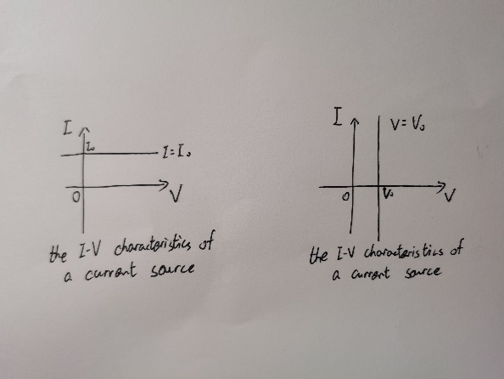

(2) Determine the value of i1 in the following circuit using Multisim simulation tool (show the circuit schematic and simulation results).

-200mA

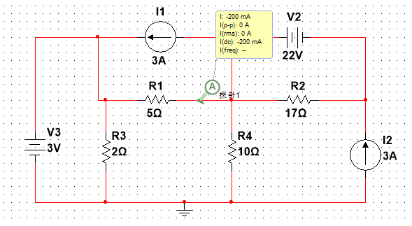

(3) Determine the value of i1 in the following circuit using Superposition principle 叠加原理. Search the Internet for more information about superposition in circuit analysis.

-200mA

1. （1）Select an NMOS model in Multisim. If you don’t know which one

to use, you can use 2N7000. Build a simple single-MOSFET circuit, as shown below. Generate the characteristic curves under different vGS (as Figure 12.6 did in the EE textbook).

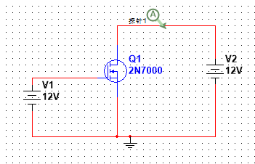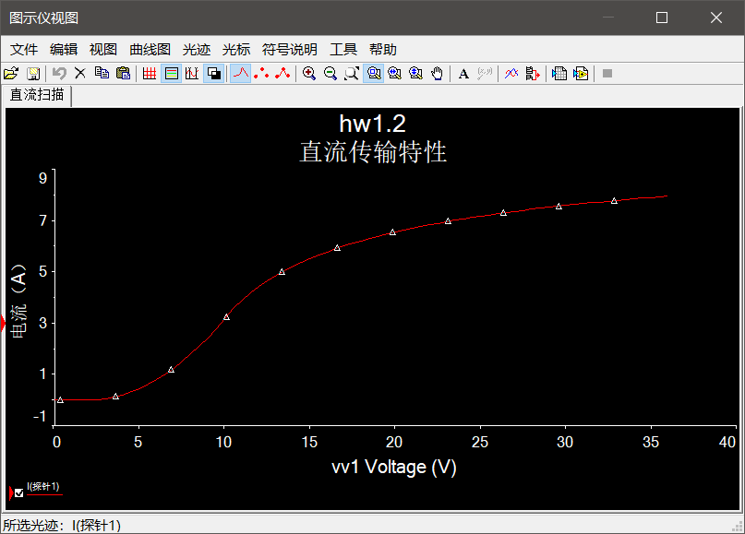

（2） Describe how to turn on the NMOS, and how to turn off the NMOS.

To turn on the NMOS, just increase the VGS to a special value Vt0. Similarly, to turn off the NMOS, reduce it below Vt0.