Detailing Site Features Team18, 03.04.17

|  |  |  |  |
| --- | --- | --- | --- |
| **As a….. (SITUATION)** | **I want to (MOTIVATION)** | **So I can (EXPECTED OUTCOME)** | **Priority** |
| As a basic user, | I want to see a google map of Dublin | So I can click on a station for bike availability and address information | 1 |
| As a daily user | I want to have a search function for a station | So I can quickly access my regular station. | 6 |
| As a daily user, | I want to see the average occupancy time around my search | So I can plan my imminent trip | 3 |
| As a basic user, | I want to see available stations from adequate glance | So that I can see where I should get a bike | 2 |
| As a basic user, | I want to access the website on my smartphone and provide my locational details | So I can see the availability of bike stands in my proximity. | 7 |
| As a commuter, | I want to view weather info | So I can decide whether or not I want to get the bus. | 4 |
| As a future user, | I want to see daily and weekly averages | So I can plan a future trip | 5 |

*Feature:*

*Function:*

*Input:*

*Output:*

*User choices:*

*Implementation:*

***FEATURES***

***Feature: interactive map***

*Function: display stations*

*Input: station location, name.*

*Output:*

*User choices: clickable station icons, scrollable map change view of map*

*Implementation:*

***Feature:* station detail**

*Function: show info for each station in infowindow*

*Input: static, dynamic*

*Output:*

*User choices:*

*Implementation:*

***Feature: time search***

*Function: give info about station at a certain time i.e. bikes available at station 1 at 13:00*

*Input: user chooses time, must consider user interface*

*Output: show info box or chart with average hourly values with chosen hour higlighted*

*User choices:*

*Implementation:*

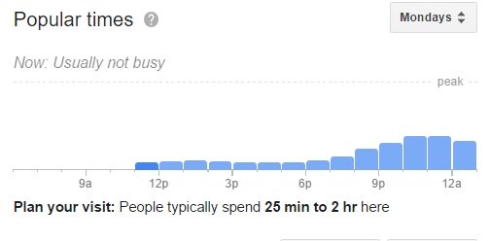

***Feature:* search function**

*Function: find info on chosen station*

*Input: pull station names from db*

*Output: search box that predicts user choice based on their keyboard input i.e. daw -> dawson street*

*User choices: the station names, dropdown or make user type in station name*

*Implementation:*

***Feature:* charts (Availability, occupancy, hourly, weekly)**

*Function: onclick station from search function or map icon, display charts showing availability + occupancy on weekly/hourly basis. How time*

*Input:*

*Output: readable charts based on user input*

*User choices: station, time,*

*Implementation: queries sent to db, json objects returned. Parsed into googlechart function()*