南京邮电大学通达学院
专业课程设计I报告
（ 2013 / 2014 学年 第 二 学期）

题目： | 图书馆管理系统

专 业 | 软件工程
学 生 姓 名 | 李志
班 级 学 号 | 11003117
指 导 教 师
指 导 单 位 | 计算机学院软件工程系
日 期 | 2014.06.09～06.20

- 类图及其关系
VS2012自动生成的类图关系：
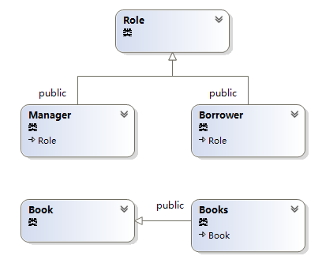
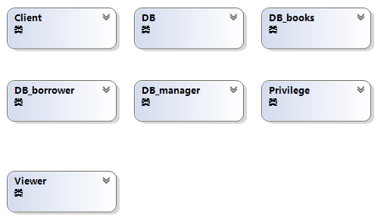
Viso下类的设计俯瞰图：
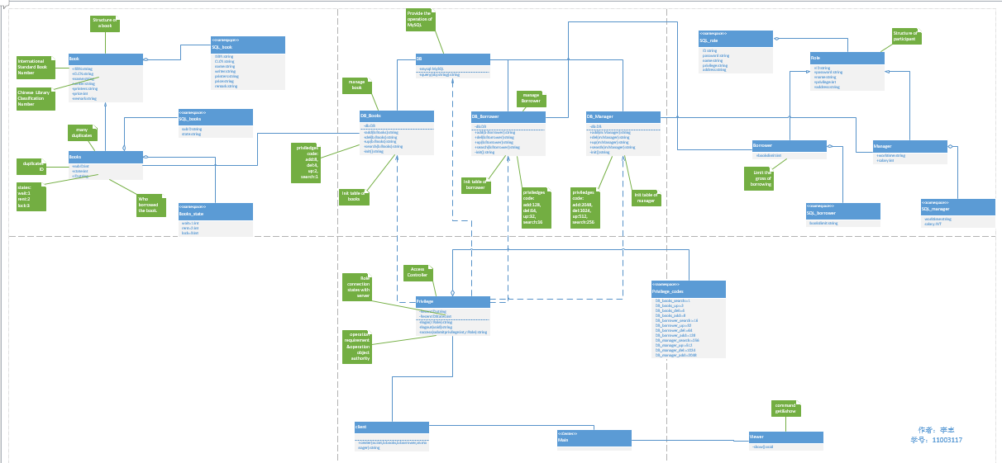
- 类的详细定义
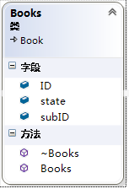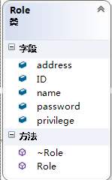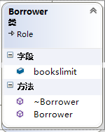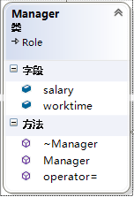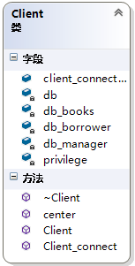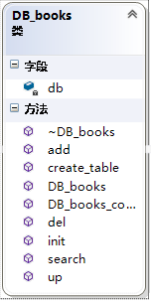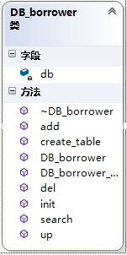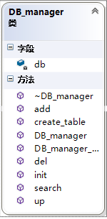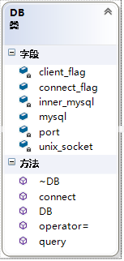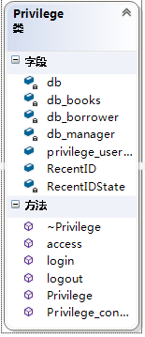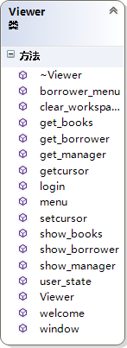

三．关键源文件及分析
Book,Books,Role,Borrower,Manager类是图书馆信息的数据结构定义，DB类是链接数据库的基本函数，DB_books,DB_Borrower,DB_manager是对应Books,Borrower,Manager对数据库的操作函数定义提供增删改查功能。
Client类是对DB_books,DB_Borrower,DB_manager提供统一的外部接口，Privilege是对用户权限认证类，没有对应的权限码就没有相应的操作权。有了Privilege和Client类就可以提供统一接口，无论是界面程序还是命令行界面都可以进行调用，这些是后台操作。由于时间关系我只设计了Viewer类提供命令行界面及其操作状态转换。

- DB_books.cpp
#include "DB_books.h"
DB_books::DB_books(void)
{
}
void DB_books::DB_books_connect(DB db)
{
this->db=db;
}

DB_books::~DB_books(void)
{
}

string DB_books::add(Books b)
{
string temp="library";
mysql_select_db(db.mysql,temp.c_str());
temp.clear();
temp+=mysql_error(db.mysql);
if(!temp.empty())
return temp;

char trans_price[32];
_itoa_s(b.price,trans_price,10);
string str_price=trans_price;
char trans_subID[32];
_itoa_s(b.subID,trans_subID,10);
string str_subID=trans_subID;
char trans_state[32];
_itoa_s(b.state,trans_state,10);
string str_state=trans_state;

temp.clear();
temp+="INSERT INTO";
temp+=" Books";
temp+=" (";
temp+=" "+SQL_book::SQL_ISBN;
temp+=","+SQL_book::SQL_CLCN;
temp+=","+SQL_book::SQL_name;
temp+=","+SQL_book::SQL_writer;
temp+=","+SQL_book::SQL_printers;
temp+=","+SQL_book::SQL_price;
temp+=","+SQL_book::SQL_remark;
temp+=","+SQL_books::SQL_subID;
temp+=","+SQL_books::SQL_state;
temp+=","+SQL_books::SQL_ID;
temp+=")";
temp+="VALUES (";
temp+=" '"+b.ISBN+"'";
temp+=",'"+b.CLCN+"'";
temp+=",'"+b.name+"'";
temp+=",'"+b.writer+"'";
temp+=",'"+b.printers+"'";
temp+=","+str_price;
temp+=",'"+b.remark+"'";
temp+=","+str_subID;
temp+=","+str_state;
temp+=",'"+b.ID+"'";
temp+=")";

//cout<<temp<<endl;

db.query(temp);
temp.clear();
temp+=mysql_error(db.mysql);
if(!temp.empty())
return temp;

return string("");
}

string DB_books::del(Books b)
{
string temp="library";
mysql_select_db(db.mysql,temp.c_str());
temp.clear();
temp+=mysql_error(db.mysql);
if(!temp.empty())
return temp;

Books b_temp=b;
if(!search(b_temp).empty())
return string("<DB_Books.del> row isn't exist");

char trans_subid[32];
_itoa_s(b.subID,trans_subid,10);
string str_subID=trans_subid;

temp.clear();
temp+="DELETE FROM";

temp+=" Books";

temp+=" WHERE";
temp+=" books."+SQL_book::SQL_ISBN+" = '"+b.ISBN+"'";
temp+=" AND";
temp+=" books."+SQL_books::SQL_subID+" = "+str_subID;

//cout<<temp<<endl;

db.query(temp);
temp.clear();
temp+=mysql_error(db.mysql);
return temp;
}

string DB_books::up(Books b)
{
string temp="library";
mysql_select_db(db.mysql,temp.c_str());
temp.clear();
temp+=mysql_error(db.mysql);
if(!temp.empty())
return temp;

Books b_temp=b;
if(!search(b_temp).empty())
return string("<DB_Books.up> row isn't exist");

char trans_subid[32];
_itoa_s(b.subID,trans_subid,10);
string str_subid=trans_subid;

temp.clear();
temp+="UPDATE Books";
temp+=" SET";

temp+=" "+SQL_book::SQL_ISBN+" ='"+b.ISBN+"'";
if(!b.CLCN.empty())
temp+=","+SQL_book::SQL_CLCN+" ='"+b.CLCN+"'";
if(!b.name.empty())
temp+=","+SQL_book::SQL_name+" ='"+b.name+"'";
if(!b.writer.empty())
temp+=","+SQL_book::SQL_writer+" ='"+b.writer+"'";
if(!b.printers.empty())
temp+=","+SQL_book::SQL_printers+" ='"+b.printers+"'";
if(b.price)
{
char trans_price[32];
_itoa_s(b.price,trans_price,10);
string str_price=trans_price;
temp+=","+SQL_book::SQL_price+" ="+str_price;
}
if(!b.remark.empty())
temp+=","+SQL_book::SQL_remark+" ='"+b.remark+"'";
if(b.state)
{
char trans_state[32];
_itoa_s(b.state,trans_state,10);
string str_price=trans_state;
temp+=","+SQL_book::SQL_price+" ="+str_price;
}
if(!b.ID.empty())
temp+=","+SQL_books::SQL_ID+" ='"+b.ID+"'";

temp+=" WHERE";
temp+=" books."+SQL_book::SQL_ISBN+" = '"+b.ISBN+"'";
temp+=" AND books."+SQL_books::SQL_subID+" = "+str_subid;

//cout<<temp<<endl;

db.query(temp);
temp.clear();
temp+=mysql_error(db.mysql);
return temp;
}

//search a book by its ISBN and subID
string DB_books::search(Books &b)
{
//cout<<"fuck 0"<<endl;

string temp="library";
mysql_select_db(db.mysql,temp.c_str());
temp.clear();
temp+=mysql_error(db.mysql);
if(!temp.empty())
return temp;

//cout<<"fuck 1"<<endl;

char trans_subid[32];
_itoa_s(b.subID,trans_subid,10);
//cout<<trans_subid<<endl;
string str_subid=trans_subid;

//cout<<str_subid<<endl;
//cout<<"fuck 2"<<endl;

temp.clear();
temp+="SELECT";
temp+=" "+SQL_book::SQL_ISBN;
temp+=","+SQL_book::SQL_CLCN;
temp+=","+SQL_book::SQL_name;
temp+=","+SQL_book::SQL_writer;
temp+=","+SQL_book::SQL_printers;
temp+=","+SQL_book::SQL_price;
temp+=","+SQL_book::SQL_remark;
temp+=","+SQL_books::SQL_subID;
temp+=","+SQL_books::SQL_state;
temp+=","+SQL_books::SQL_ID;

temp+=" FROM";
temp+=" books";
temp+=" WHERE";
temp+=" books."+SQL_book::SQL_ISBN+" = '"+b.ISBN+"'";
temp+=" AND books."+SQL_books::SQL_subID+" = "+str_subid;

//cout<<temp<<endl;

//cout<<"fuck 3"<<endl;
db.query(temp);
temp.clear();
temp+=mysql_error(db.mysql);
if(!temp.empty())
return temp;

//cout<<"fuck 4"<<endl;

MYSQL_RES *mysql_res=mysql_store_result(db.mysql);
MYSQL_ROW row=mysql_fetch_row(mysql_res);
temp.clear();
temp+=mysql_error(db.mysql);
if(!temp.empty())
return temp;

//cout<<"cao 1"<<endl;
if(mysql_num_rows(mysql_res))
{
//cout<<"cao 98"<<endl;
b.ISBN=row[0];
//cout<<"cao 99"<<endl;
b.CLCN=row[1];
//cout<<"cao 100"<<endl;
b.name=row[2];
b.writer=row[3];
//cout<<"cao 200"<<endl;
b.printers=row[4];
b.price=atoi(row[5]);
//cout<<"cao 400"<<endl;
b.remark=row[6];
b.subID=atoi(row[7]);
//cout<<"cao 800"<<endl;
b.state=atoi(row[8]);
b.ID=row[9];
//cout<<"cao 1000"<<endl;
return string("");
}
else
return string("<DB_books.Search> row isn't exist");
//cout<<"cao 2"<<endl;
}

//whether the books table is exist;
string DB_books::init(void)
{
//cout<<"fuck 0"<<endl;

string temp="information_schema";
mysql_select_db(db.mysql,temp.c_str());
temp.clear();
temp+=mysql_error(db.mysql);
if(!temp.empty())
return temp;

//cout<<"fuck 1"<<endl;

temp.clear();
temp+="SELECT TABLE_NAME FROM information_schema.tables WHERE TABLE_NAME='Books'";
db.query(temp);
temp.clear();
temp+=mysql_error(db.mysql);
if(!temp.empty())
return temp;

//cout<<"fuck 2"<<endl;

MYSQL_RES *mysql_res=mysql_store_result(db.mysql);
MYSQL_ROW row=mysql_fetch_row(mysql_res);

//cout<<"fuck 3"<<endl;

if(NULL==row)
return string("<DB_books.init> TABLE:[ Books ] isn't exist");
else
return string("");

}

string DB_books::create_table(void)
{
string temp="library";
mysql_select_db(db.mysql,temp.c_str());
temp.clear();
temp+=mysql_error(db.mysql);
if(!temp.empty())
return temp;

temp.clear();
temp+="CREATE TABLE Books (";
temp+=SQL_book::SQL_ISBN+" CHAR(16)";
temp+=","+SQL_book::SQL_CLCN+" CHAR(64)";
temp+=","+SQL_book::SQL_name+" CHAR(64)";
temp+=","+SQL_book::SQL_writer+" CHAR(64) NOT NULL";
temp+=","+SQL_book::SQL_printers+" CHAR(64)";
temp+=","+SQL_book::SQL_price+" INTEGER";
temp+=","+SQL_book::SQL_remark+" VARCHAR(64)";
temp+=","+SQL_books::SQL_subID+" INTEGER";
temp+=","+SQL_books::SQL_state+" INTEGER NOT NULL CHECK(state BETWEEN 1 AND 3)";
temp+=","+SQL_books::SQL_ID+" CHAR(64)";

temp+=",PRIMARY KEY(";
temp+=" "+SQL_book::SQL_ISBN;
temp+=","+SQL_books::SQL_subID;
temp+=" )";

//temp+=",FOREIGN KEY("+SQL_books::SQL_ID+")REFERENCES borrower("+SQL_books::SQL_ID+")";

temp+=")";
db.query(temp);

temp.clear();
temp+=mysql_error(db.mysql);
return temp;
}

- DB_Borrower.cpp

#include "DB_borrower.h"
DB_borrower::DB_borrower(void)
{
}

void DB_borrower::DB_borrower_connect(DB db)
{
this->db=db;
}

DB_borrower::~DB_borrower(void)
{
}

string DB_borrower::add(Borrower b)
{
string temp="library";
mysql_select_db(db.mysql,temp.c_str());
temp.clear();
temp+=mysql_error(db.mysql);
if(!temp.empty())
return temp;

char trans_privilege[32];
_itoa_s(b.privilege,trans_privilege,10);
string str_privilege=trans_privilege;

char trans_bookslimit[32];
_itoa_s(b.privilege,trans_bookslimit,10);
string str_bookslimit=trans_bookslimit;

temp.clear();
temp+="INSERT INTO";
temp+=" Borrower";
temp+=" (";
temp+=" "+SQL_role::SQL_ID;
temp+=","+SQL_role::SQL_password;
temp+=","+SQL_role::SQL_name;
temp+=","+SQL_role::SQL_privilege;
temp+=","+SQL_role::SQL_address;
temp+=","+SQL_borrower::SQL_bookslimit;

temp+=")";
temp+="VALUES (";
temp+=" '"+b.ID+"'";
temp+=",'"+b.password+"'";
temp+=",'"+b.name+"'";
temp+=","+str_privilege;
temp+=",'"+b.address+"'";
temp+=","+str_bookslimit;
temp+=")";

//cout<<temp<<endl;

db.query(temp);
temp.clear();
temp+=mysql_error(db.mysql);
if(!temp.empty())
return temp;

return string("");
}

string DB_borrower::del(Borrower b)
{
string temp="library";
mysql_select_db(db.mysql,temp.c_str());
temp.clear();
temp+=mysql_error(db.mysql);
if(!temp.empty())
return temp;

Borrower b_temp=b;
if(!search(b_temp).empty())
return string("<DB_Borrower.del> row isn't exist");

temp.clear();
temp+="DELETE FROM";

temp+=" Borrower";

temp+=" WHERE";
temp+=" borrower."+SQL_role::SQL_ID+" = '"+b.ID+"'";

cout<<temp<<endl;

db.query(temp);
temp.clear();
temp+=mysql_error(db.mysql);
return temp;
}

string DB_borrower::up(Borrower b)
{
string temp="library";
mysql_select_db(db.mysql,temp.c_str());
temp.clear();
temp+=mysql_error(db.mysql);
if(!temp.empty())
return temp;

Borrower b_temp=b;
if(!search(b_temp).empty())
return string("<DB_Borrower.up> row isn't exist");

temp.clear();
temp+="UPDATE borrower";
temp+=" SET";

temp+=" "+SQL_role::SQL_ID+" ='"+b.ID+"'";
if(!b.password.empty())
temp+=","+SQL_role::SQL_password+" ='"+b.password+"'";
if(!b.name.empty())
temp+=","+SQL_role::SQL_name+" ='"+b.name+"'";
if(b.privilege)
{
char trans_privilege[32];
_itoa_s(b.privilege,trans_privilege,10);
string str_privilege=trans_privilege;
temp+=","+SQL_role::SQL_privilege+" ="+str_privilege;
}
if(!b.address.empty())
temp+=","+SQL_role::SQL_address+" ='"+b.address+"'";
if(b.bookslimit)
{
char trans_bookslimit[32];
_itoa_s(b.bookslimit,trans_bookslimit,10);
string str_bookslimit=trans_bookslimit;
temp+=","+SQL_borrower::SQL_bookslimit+" ="+str_bookslimit;
}

temp+=" WHERE";
temp+=" borrower."+SQL_role::SQL_ID+" = '"+b.ID+"'";

//cout<<temp<<endl;

db.query(temp);
temp.clear();
temp+=mysql_error(db.mysql);
return temp;
}

string DB_borrower::search(Borrower &b)
{
string temp="library";
mysql_select_db(db.mysql,temp.c_str());
temp.clear();
temp+=mysql_error(db.mysql);
if(!temp.empty())
return temp;

temp.clear();
temp+="SELECT";
temp+=" "+SQL_role::SQL_ID;
temp+=","+SQL_role::SQL_password;
temp+=","+SQL_role::SQL_name;
temp+=","+SQL_role::SQL_privilege;
temp+=","+SQL_role::SQL_address;
temp+=","+SQL_borrower::SQL_bookslimit;

temp+=" FROM";
temp+=" borrower";
temp+=" WHERE";
temp+=" borrower."+SQL_role::SQL_ID+" = '"+b.ID+"'";

//cout<<temp<<endl;

db.query(temp);
temp.clear();
temp+=mysql_error(db.mysql);
if(!temp.empty())
return temp;

//cout<<"fuck 4"<<endl;

MYSQL_RES *mysql_res=mysql_store_result(db.mysql);
MYSQL_ROW row=mysql_fetch_row(mysql_res);
temp.clear();
temp+=mysql_error(db.mysql);
if(!temp.empty())
return temp;

//cout<<"cao 1"<<endl;
if(mysql_num_rows(mysql_res))
{
//cout<<"cao 98"<<endl;
b.ID=row[0];
//cout<<"cao 99"<<endl;
b.password=row[1];
//cout<<"cao 100"<<endl;
b.name=row[2];
b.privilege=atoi(row[3]);
//cout<<"cao 200"<<endl;
b.address=row[4];
b.bookslimit=atoi(row[5]);
return string("");
}
else
return string("<DB_borrower.Search> row isn't exist");
}

string DB_borrower::init(void)
{
//cout<<"fuck 0"<<endl;

string temp="information_schema";
mysql_select_db(db.mysql,temp.c_str());
temp.clear();
temp+=mysql_error(db.mysql);
if(!temp.empty())
return temp;

//cout<<"fuck 1"<<endl;

temp.clear();
temp+="SELECT TABLE_NAME FROM information_schema.tables WHERE TABLE_NAME='Borrower'";
db.query(temp);
temp.clear();
temp+=mysql_error(db.mysql);
if(!temp.empty())
return temp;

//cout<<"fuck 2"<<endl;

MYSQL_RES *mysql_res=mysql_store_result(db.mysql);
MYSQL_ROW row=mysql_fetch_row(mysql_res);

//cout<<"fuck 3"<<endl;

if(NULL==row)
return string("<DB_Borrower.init> TABLE:[ Borrower ] isn't exist");
else
return string("");
}

string DB_borrower::create_table(void)
{
string temp="library";
mysql_select_db(db.mysql,temp.c_str());
temp.clear();
temp+=mysql_error(db.mysql);
if(!temp.empty())
return temp;

temp.clear();
temp+="CREATE TABLE Borrower (";
temp+=SQL_role::SQL_ID+" CHAR(64)";
temp+=","+SQL_role::SQL_password+" CHAR(64) NOT NULL";
temp+=","+SQL_role::SQL_name+" CHAR(64)";
temp+=","+SQL_role::SQL_privilege+" INTEGER";
temp+=","+SQL_role::SQL_address+" CHAR(64)";
temp+=","+SQL_borrower::SQL_bookslimit+" INTEGER";
temp+=",PRIMARY KEY (ID)";

temp+=")";
db.query(temp);

temp.clear();
temp+=mysql_error(db.mysql);
return temp;
}

- DB_manager.cpp

#include "DB_manager.h"
DB_manager::DB_manager(void)
{
}
void DB_manager::DB_manager_connect(DB db)
{
this->db=db;
}

DB_manager::~DB_manager(void)
{
}

string DB_manager::add(Manager m)
{
string temp="library";
mysql_select_db(db.mysql,temp.c_str());
temp.clear();
temp+=mysql_error(db.mysql);
if(!temp.empty())
return temp;

char trans_privilege[32];
_itoa_s(m.privilege,trans_privilege,10);
string str_privilege=trans_privilege;

char trans_salary[32];
_itoa_s(m.salary,trans_salary,10);
string str_salary=trans_salary;

temp.clear();
temp+="INSERT INTO";
temp+=" Manager";
temp+=" (";
temp+=" "+SQL_role::SQL_ID;
temp+=","+SQL_role::SQL_password;
temp+=","+SQL_role::SQL_name;
temp+=","+SQL_role::SQL_privilege;
temp+=","+SQL_role::SQL_address;
temp+=","+SQL_manager::SQL_worktime;
temp+=","+SQL_manager::SQL_salary;

temp+=")";
temp+="VALUES (";
temp+=" '"+m.ID+"'";
temp+=",'"+m.password+"'";
temp+=",'"+m.name+"'";
temp+=","+str_privilege;
temp+=",'"+m.address+"'";
temp+=",'"+m.worktime+"'";
temp+=","+str_salary;
temp+=")";

//cout<<temp<<endl;

db.query(temp);
temp.clear();
temp+=mysql_error(db.mysql);
if(!temp.empty())
return temp;

return string("");
}

string DB_manager::del(Manager m)
{
string temp="library";
mysql_select_db(db.mysql,temp.c_str());
temp.clear();
temp+=mysql_error(db.mysql);
if(!temp.empty())
return temp;

Manager m_temp=m;
if(!search(m_temp).empty())
return string("<DB_Manager.del> row isn't exist");

temp.clear();
temp+="DELETE FROM";

temp+=" Manager";

temp+=" WHERE";
temp+=" manager."+SQL_role::SQL_ID+" = '"+m.ID+"'";

cout<<temp<<endl;

db.query(temp);
temp.clear();
temp+=mysql_error(db.mysql);
return temp;
}

string DB_manager::up(Manager m)
{
string temp="library";
mysql_select_db(db.mysql,temp.c_str());
temp.clear();
temp+=mysql_error(db.mysql);
if(!temp.empty())
return temp;

Manager m_temp=m;
if(!search(m_temp).empty())
return string("<DB_Manager.up> row isn't exist");

temp.clear();
temp+="UPDATE Manager";
temp+=" SET";

temp+=" "+SQL_role::SQL_ID+" ='"+m.ID+"'";
if(!m.password.empty())
temp+=","+SQL_role::SQL_password+" ='"+m.password+"'";
if(!m.name.empty())
temp+=","+SQL_role::SQL_name+" ='"+m.name+"'";
if(m.privilege)
{
char trans_privilege[32];
_itoa_s(m.privilege,trans_privilege,10);
string str_privilege=trans_privilege;
temp+=","+SQL_role::SQL_privilege+" ="+str_privilege;
}
if(!m.address.empty())
temp+=","+SQL_role::SQL_address+" ='"+m.address+"'";
if(m.salary)
{
char trans_salary[32];
_itoa_s(m.salary,trans_salary,10);
string str_salary=trans_salary;
temp+=","+SQL_manager::SQL_salary+" ="+str_salary;
}
if(!m.worktime.empty())
temp+=","+SQL_manager::SQL_worktime+" ='"+m.worktime+"'";

temp+=" WHERE";
temp+=" manager."+SQL_role::SQL_ID+" = '"+m.ID+"'";

//cout<<temp<<endl;

db.query(temp);
temp.clear();
temp+=mysql_error(db.mysql);
return temp;
return string();
}

string DB_manager::search(Manager &m)
{
string temp="library";
mysql_select_db(db.mysql,temp.c_str());
temp.clear();
temp+=mysql_error(db.mysql);
if(!temp.empty())
return temp;

temp.clear();
temp+="SELECT";
temp+=" "+SQL_role::SQL_ID;
temp+=","+SQL_role::SQL_password;
temp+=","+SQL_role::SQL_name;
temp+=","+SQL_role::SQL_privilege;
temp+=","+SQL_role::SQL_address;
temp+=","+SQL_manager::SQL_worktime;
temp+=","+SQL_manager::SQL_salary;

temp+=" FROM";
temp+=" manager";
temp+=" WHERE";
temp+=" manager."+SQL_role::SQL_ID+" = '"+m.ID+"'";

//cout<<temp<<endl;

db.query(temp);
temp.clear();
temp+=mysql_error(db.mysql);
if(!temp.empty())
return temp;

//cout<<"fuck 4"<<endl;

MYSQL_RES *mysql_res=mysql_store_result(db.mysql);
MYSQL_ROW row=mysql_fetch_row(mysql_res);
temp.clear();
temp+=mysql_error(db.mysql);
if(!temp.empty())
return temp;

if(mysql_num_rows(mysql_res))
{
m.ID=row[0];
m.password=row[1];
m.name=row[2];
m.privilege=atoi(row[3]);
m.address=row[4];
m.worktime=row[5];
m.salary=atoi(row[6]);
/*
cout<<SQL_role::SQL_ID<<":"<<m.ID<<endl;
cout<<SQL_role::SQL_password<<":"<<m.password<<endl;
cout<<SQL_role::SQL_name<<":"<<m.name<<endl;
cout<<SQL_role::SQL_privilege<<":"<<m.privilege<<endl;
cout<<SQL_role::SQL_address<<":"<<m.address<<endl;
cout<<SQL_manager::SQL_worktime<<":"<<m.worktime<<endl;
cout<<SQL_manager::SQL_salary<<":"<<m.salary<<endl;
*/
return string("");
}
else
return string("<DB_manager.Search> row isn't exist");
}

string DB_manager::init(void)
{
string temp="information_schema";
mysql_select_db(db.mysql,temp.c_str());
temp.clear();
temp+=mysql_error(db.mysql);
if(!temp.empty())
return temp;

//cout<<"fuck 1"<<endl;

temp.clear();
temp+="SELECT TABLE_NAME FROM information_schema.tables WHERE TABLE_NAME='Manager'";
db.query(temp);
temp.clear();
temp+=mysql_error(db.mysql);
if(!temp.empty())
return temp;

//cout<<"fuck 2"<<endl;

MYSQL_RES *mysql_res=mysql_store_result(db.mysql);
MYSQL_ROW row=mysql_fetch_row(mysql_res);

//cout<<"fuck 3"<<endl;

if(NULL==row)
return string("<DB_Manager.init> TABLE:[ Manager ] isn't exist");
else
return string("");
return false;
}

string DB_manager::create_table(void)
{
string temp="library";
mysql_select_db(db.mysql,temp.c_str());
temp.clear();
temp+=mysql_error(db.mysql);
if(!temp.empty())
return temp;

temp.clear();
temp+="CREATE TABLE Manager (";
temp+=SQL_role::SQL_ID+" CHAR(64)";
temp+=","+SQL_role::SQL_password+" CHAR(64) NOT NULL";
temp+=","+SQL_role::SQL_name+" CHAR(64)";
temp+=","+SQL_role::SQL_privilege+" INTEGER";
temp+=","+SQL_role::SQL_address+" CHAR(64)";
temp+=","+SQL_manager::SQL_worktime+" CHAR(64)";
temp+=","+SQL_manager::SQL_salary+" INTEGER";
temp+=",PRIMARY KEY (ID)";

temp+=")";
db.query(temp);

temp.clear();
temp+=mysql_error(db.mysql);
return temp;
return string();
}
- Privilege.cpp
#include "Privilege.h"
Privilege::Privilege(void)
{
privilege_user_flag=false;
RecentID=string("");
RecentIDState=privilege_id_states::OUTLINE;
}

void Privilege::Privilege_connect(DB db)
{
this->db=db;
db_books.DB_books_connect(this->db);
db_manager.DB_manager_connect(this->db);
db_borrower.DB_borrower_connect(this->db);
}

Privilege::~Privilege(void)
{
}

string Privilege::login(string ID,string password)
{
Borrower b;
Manager m;
b.ID=ID;
m.ID=ID;
db_borrower.search(b);
db_manager.search(m);

//cout<<SQL_role::SQL_ID<<":"<<b.ID<<endl;
//cout<<SQL_role::SQL_password<<":"<<b.password<<endl;
//cout<<SQL_role::SQL_privilege<<":"<<b.privilege<<endl;

//cout<<SQL_role::SQL_ID<<":"<<m.ID<<endl;
//cout<<SQL_role::SQL_password<<":"<<m.password<<endl;
//cout<<SQL_role::SQL_privilege<<":"<<m.privilege<<endl;

if(b.password==password)
{
privilege_user_flag=true;
RecentID=ID;
RecentIDState=privilege_id_states::ONLINE;
return string("");
}
else if(m.password==password)
{
privilege_user_flag=true;
RecentID=ID;
RecentIDState=privilege_id_states::ONLINE;
return string("");
}
else
return string("Login [FALSE]");
}

string Privilege::logout(void)
{
RecentID.clear();
RecentIDState=privilege_id_states::OUTLINE;
privilege_user_flag=false;
return string("");
}

string Privilege::access(int sutmitprivilege)//just submit one kind of privilege_codes;
{
//cout<<"------------->>>>>>sutmitprivilege:"<<sutmitprivilege<<endl;
if(RecentID.empty())
return string("Login Requirement");
Borrower b;
Manager m;
b.ID=RecentID;
m.ID=RecentID;
db_borrower.search(b);
db_manager.search(m);

int real_privilege=0;
if(b.privilege>m.privilege)
real_privilege=b.privilege;
else
real_privilege=m.privilege;
int identified=real_privilege & sutmitprivilege;

if(identified)
return string("");
else
return string("Access denied");
}
- 实验分析
(1).主界面
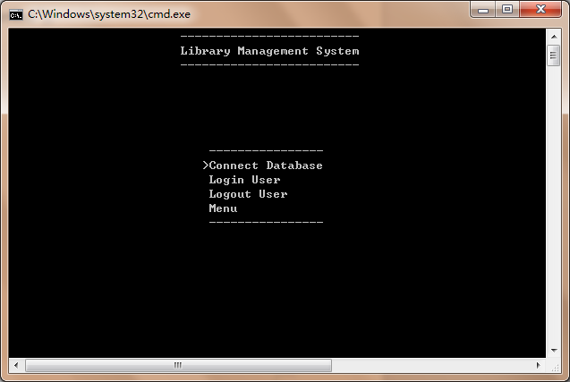
- 主菜单Menu
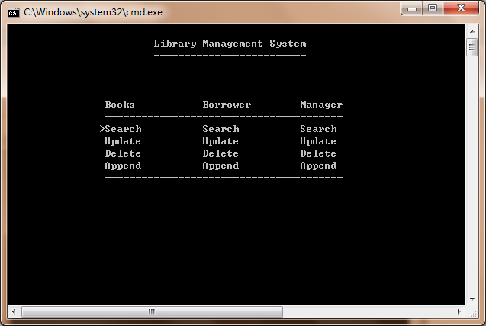

(3)用户登陆
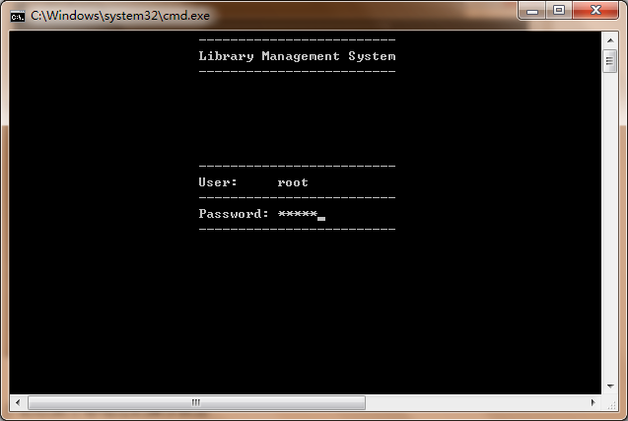

在链接了数据库，登陆了用户之后就可以进入主菜单进行操作，如果当前用户的权限不够相应的操作就会提示ACCESS DEYNIED,操作就会失效。

- 实验心得
实验中类图的设计很重要，尤其是类比较多的时候，他们的关系非常复杂，所以实验开始我用Viso设计了这几个类，在编码的时候按照类图去编码。类在设计之初我也学了很多，开始设计不好后面编码就会偏离系统规格说明书，带来维护困难。MYSQL数据库都用string返回错误信息，正确的话就不返回信息，所以这一点被我学习，我在设计函数时候也统一用string作为返回值，调试起来也方便。在cpp文件里面我用过了大量的namespace定义统一的局部变量，使更变变得方便。MYSQL也研究了一段时间，MYSQL的查询结果都是以结果集展示返回的，在以后的编码中可以学习这一点，对结果也用char*返回，方便了返回。
指导教师成绩评定表
学生姓名 |  |  | 班级学号 |  |  | 专业 |  | 软件工程
评分内容 | 评分标准 |  |  |  |  |  | 优秀 |  | 良好 |  | 中等 | 差
平时成绩 | 认真对待课程设计，遵守实验室规定，上机不迟到早退，不做和设计无关的事
设计成果 | 设计的科学、合理性
设计成果 | 功能丰富、符合题目要求
设计成果 | 界面友好、外观漂亮、大方
设计成果 | 程序功能执行的正确性
设计成果 | 程序算法执行的效能
设计报告 | 设计报告正确合理、反映系统设计流程
设计报告 | 文档内容详实程度
设计报告 | 文档格式规范、排版美观
验收答辩 | 简练、准确阐述设计内容，能准确有条理回答各种问题，系统演示顺利。
评分等级
指导教师
简短评语
指导教师签名 |  |  |  |  | 日期 |  |  |  |  | 06月20日
备注 | 评分等级有五种：优秀、良好、中等、及格、不及格

