**Cell-Cell Communication Analysis Report**

**Candidate:** Tao Sun  
**Task:** Question 3 – Cell-Cell Communication/Interaction Analysis  
**Submission Date:** [Insert submission date]  
**GitHub Link:** <https://github.com/Samuel700712/Bulk_RNAseq_ATF3_KO_Report>

**Objective**

To explore the cell-cell communication landscape among spatial clusters using spatial transcriptomics data from GSE283269. The analysis identifies and visualizes ligand-receptor signaling networks based on the Seurat and CellChat pipelines.

**Dataset**

* **GEO Accession:** GSE283269
* **Sample Analyzed:** GSM8658911 (Sample1a1)
* **Technology:** Spatial transcriptomics

**Methods and Workflow**

**Preprocessing and Clustering (Seurat)**

* Loaded expression matrix from matrix.mtx, features.tsv, barcodes.tsv
* Created a Seurat object
* Normalized data, identified variable genes, performed PCA
* Computed clusters and visualized using UMAP

*Figure 1. UMAP plot of clusters from Sample1a1*

**CellChat Analysis**

* CellChat v1.6.1 was used with CellChatDB.human
* Clusters were renamed (C0, C1, etc.) for compatibility
* Computed overexpressed ligands, receptors, and interaction probabilities
* Aggregated signaling network and visualized global communication

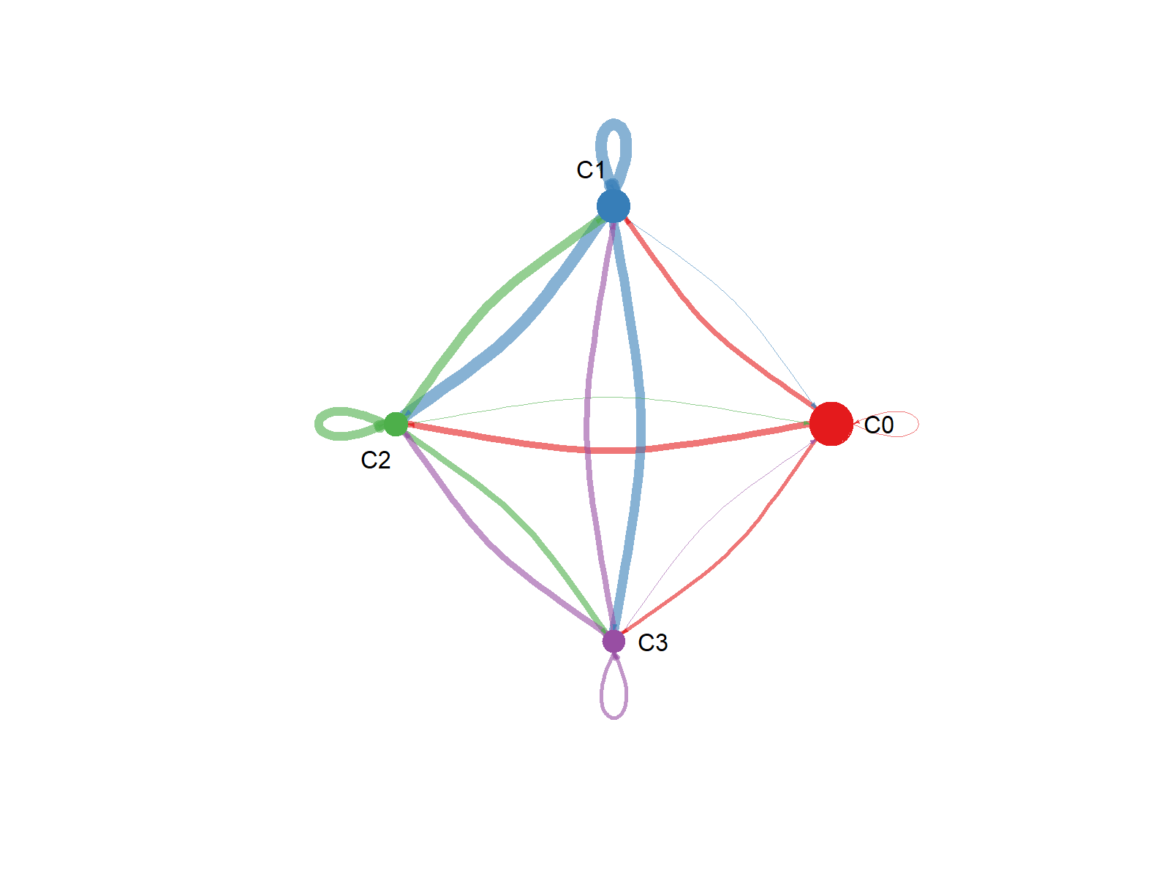

*Figure 2. Overall communication network among clusters*

*Figure 3. Dot plot of top 2 signaling pathways*

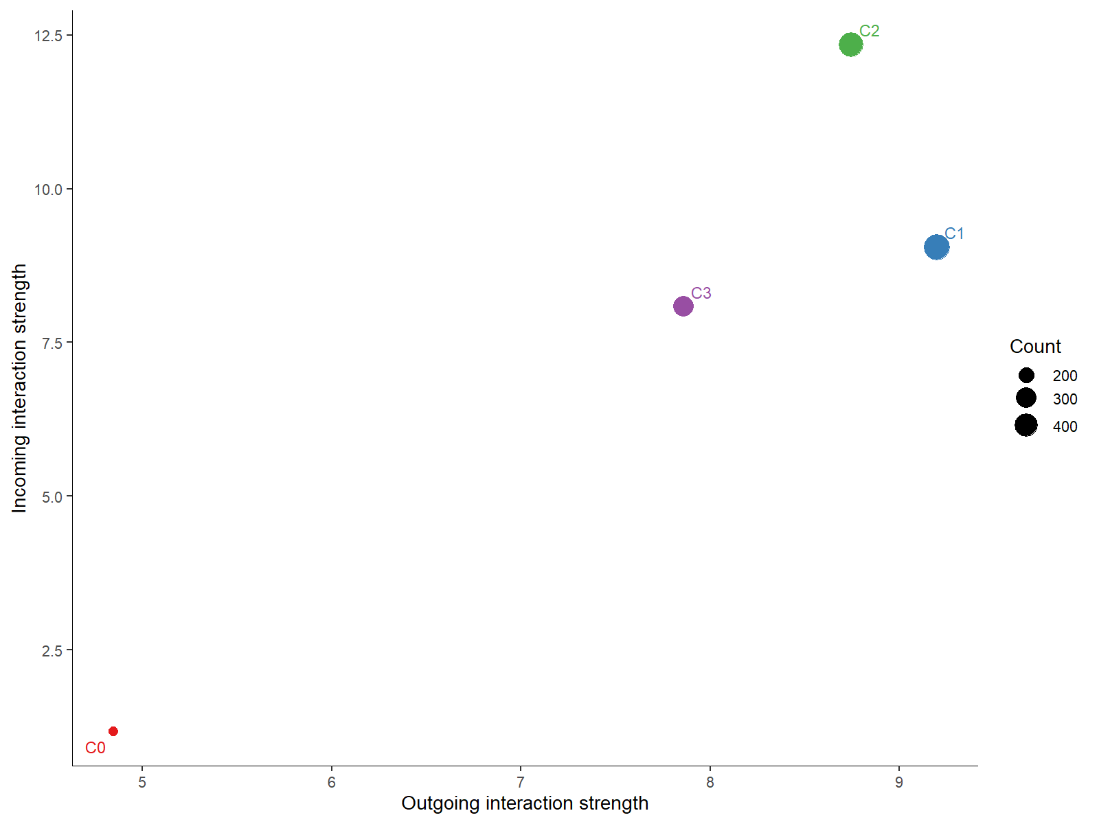

*Figure 4. Cluster role scatter plot (Sender/Receiver/Mediator/Influencer)*

*Figure 5: Signaling role heatmap (outgoing patterns)*

**Top 10 Signaling Pathways**

| **Rank** | **Pathway** | **Interaction Count** |
| --- | --- | --- |
| 1 | COLLAGEN | 257 |
| 2 | LAMININ | 171 |
| 3 | THBS | 89 |
| 4 | FN1 | 54 |
| 5 | TENASCIN | 41 |
| 6 | ANGPTL | 36 |
| 7 | SPP1 | 18 |
| 8 | NOTCH | 15 |
| 9 | VISFATIN | 11 |
| 10 | GAS | 11 |

**Output Files**

Located in E:/UBC_wang_qn3/ or GitHub archive:

* sample1a1_umap_clusters.png
* sample1a1_cellchat_circle.png
* sample1a1_cellchat_dotplot_top10_pathways.png
* sample1a1_cellchat_role_scatter.png
* sample1a1_cellchat_all_communications.csv
* sample1a1_cellchat_cluster_roles.csv
* sample1a1_cellchat_[Pathway]_interactions.csv (per pathway)

**Conclusion**

Using Seurat and CellChat, we inferred meaningful cell-cell communication networks among clusters in spatial transcriptomic data. Dominant signaling pathways such as COLLAGEN and LAMININ drove inter-cluster interactions. Functional roles such as senders, receivers, and mediators were identified, offering biological insight into tissue-level coordination and microenvironmental interactions.