Manual Test Record

Contents

1. GET /products 2

2. GET /products?name={name} 2

3. GET /products/{id} 3

4. POST /products 3

5. PUT /products/{id} 4

6. DELETE /products/{id} 4

7. GET /products/{id}/options 5

8. GET /products/{id}/options/{optionId} 5

9. POST /products/{id}/options 6

10. PUT /products/{id}/options/{optionId} 6

11. DELETE /products/{id}/options/{optionId} 7

# 1. GET /products

Gets all products.

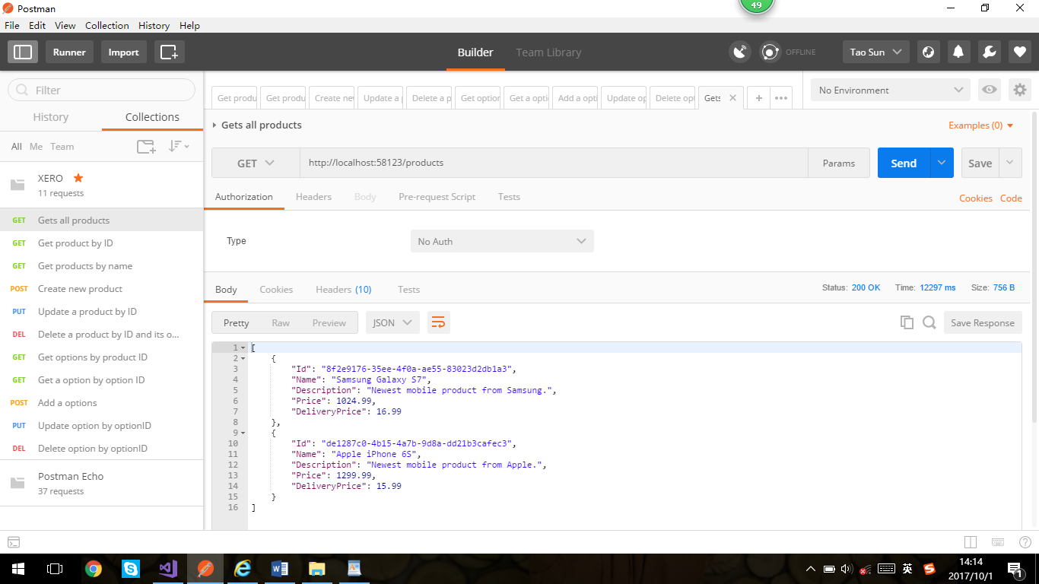

# 2. GET /products?name={name}

Finds all products matching the specified name.

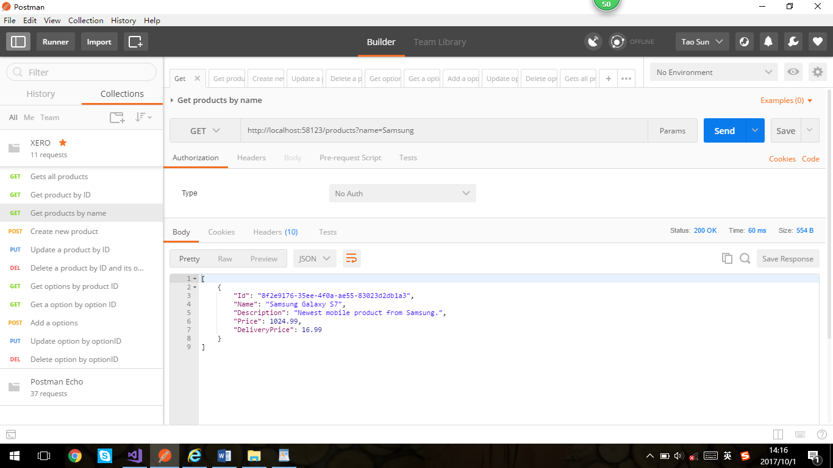

# 3. GET /products/{id}

Gets the project that matches the specified ID - ID is a GUID.

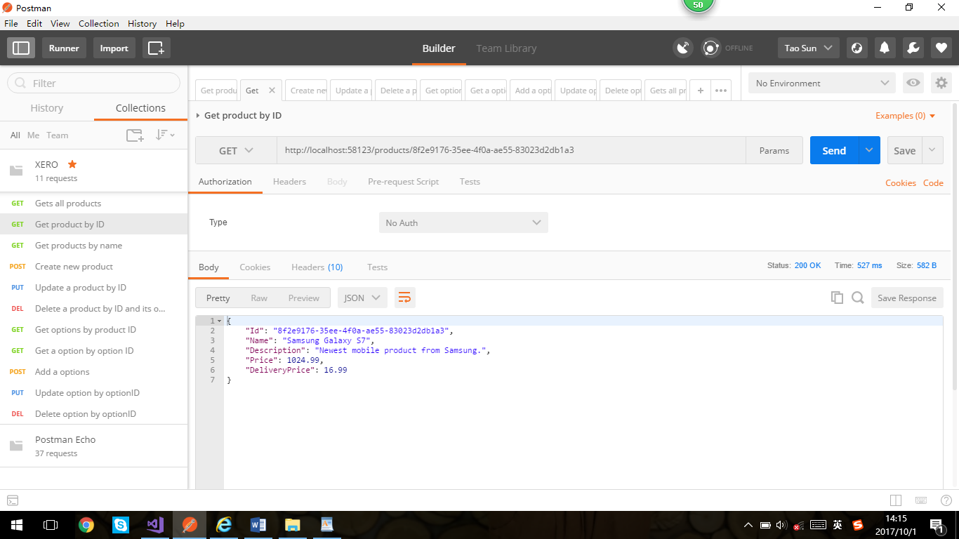

# 4. POST /products

Creates a new product.

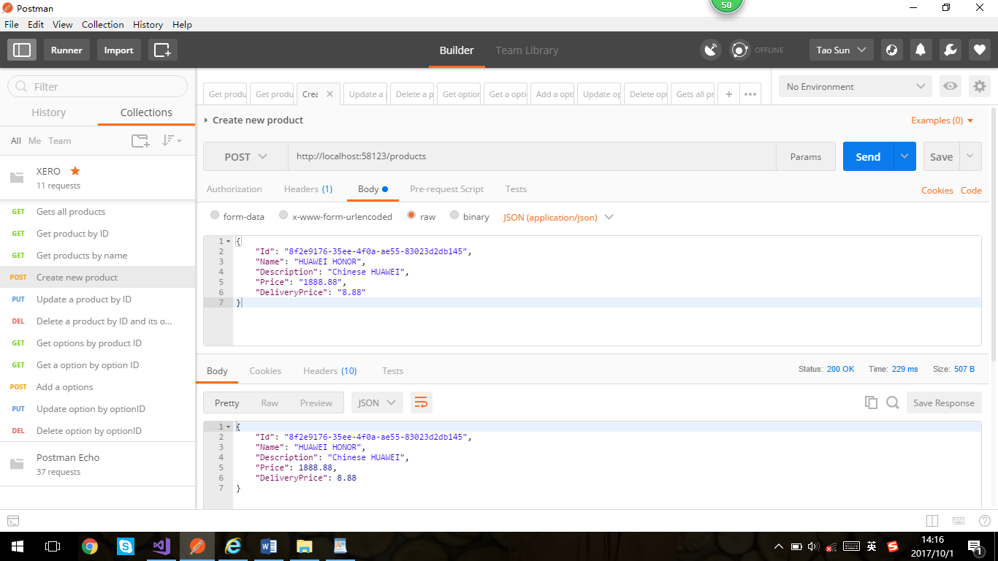

# 5. PUT /products/{id}

Updates a product.

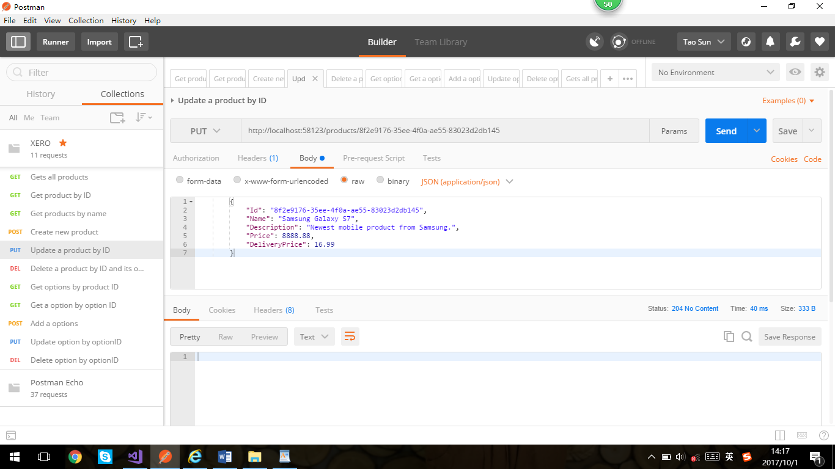

# 6. DELETE /products/{id}

Deletes a product and its options.

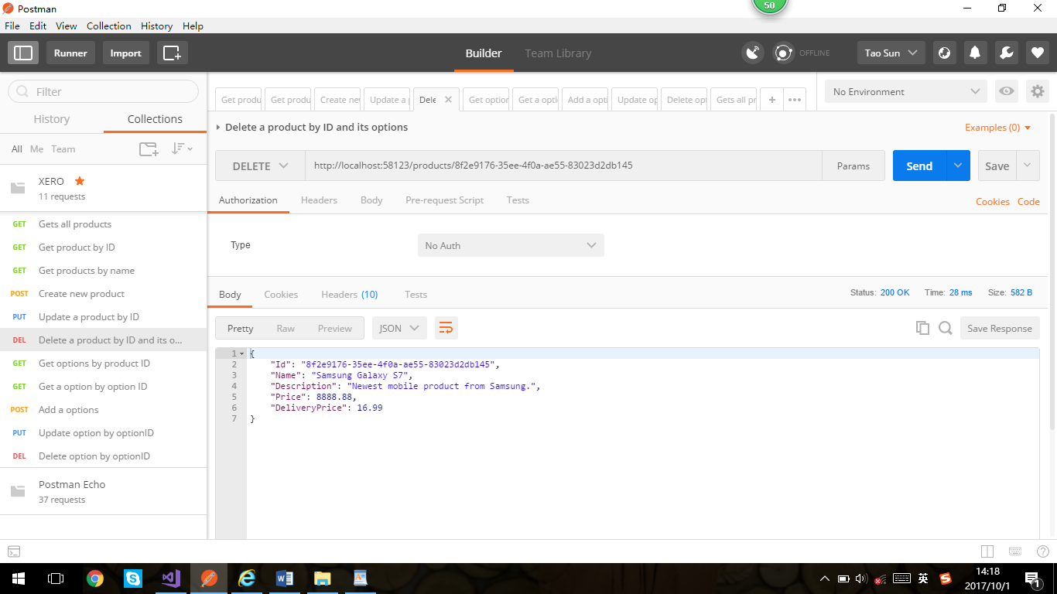

# 7. GET /products/{id}/options

Finds all options for a specified product.

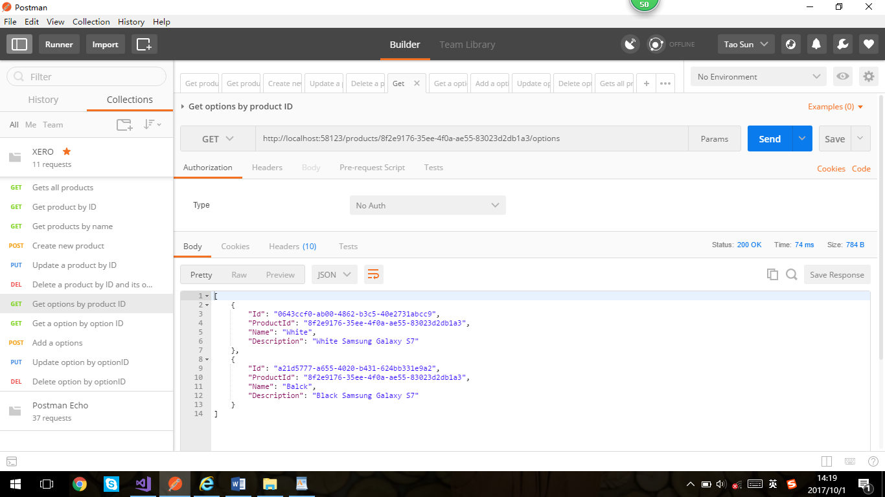

# 8. GET /products/{id}/options/{optionId}

Finds the specified product option for the specified product.

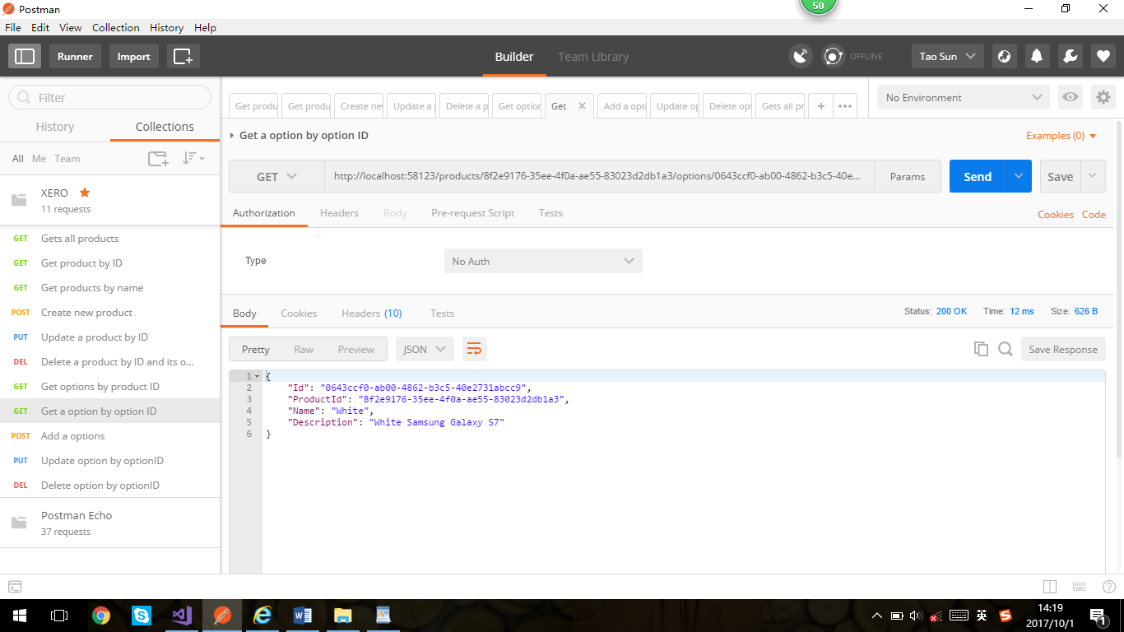

# 9. POST /products/{id}/options

Adds a new product option to the specified product.

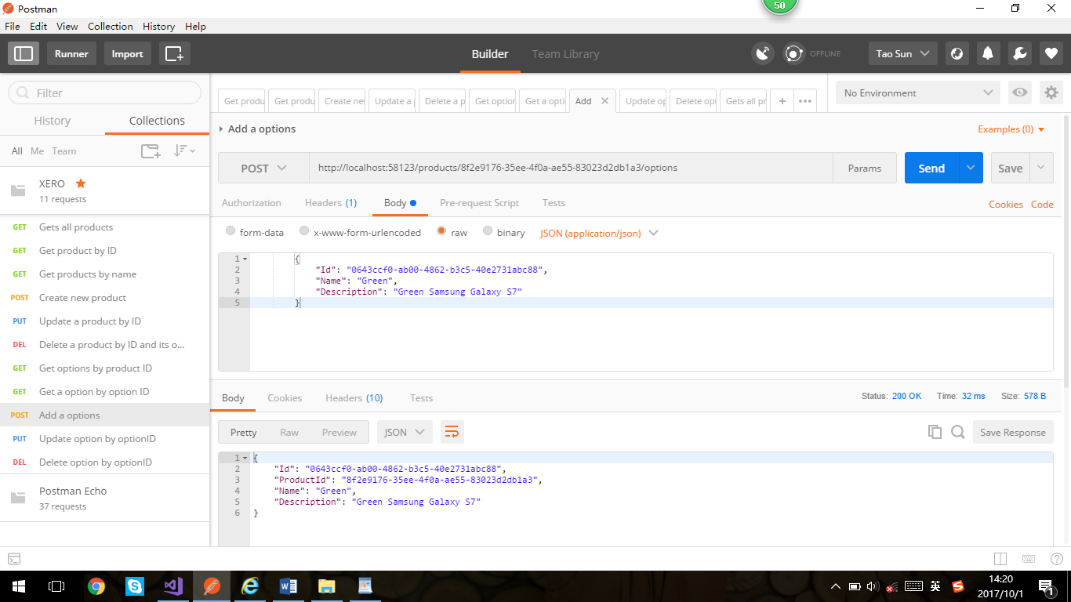

# 10. PUT /products/{id}/options/{optionId}

Updates the specified product option.

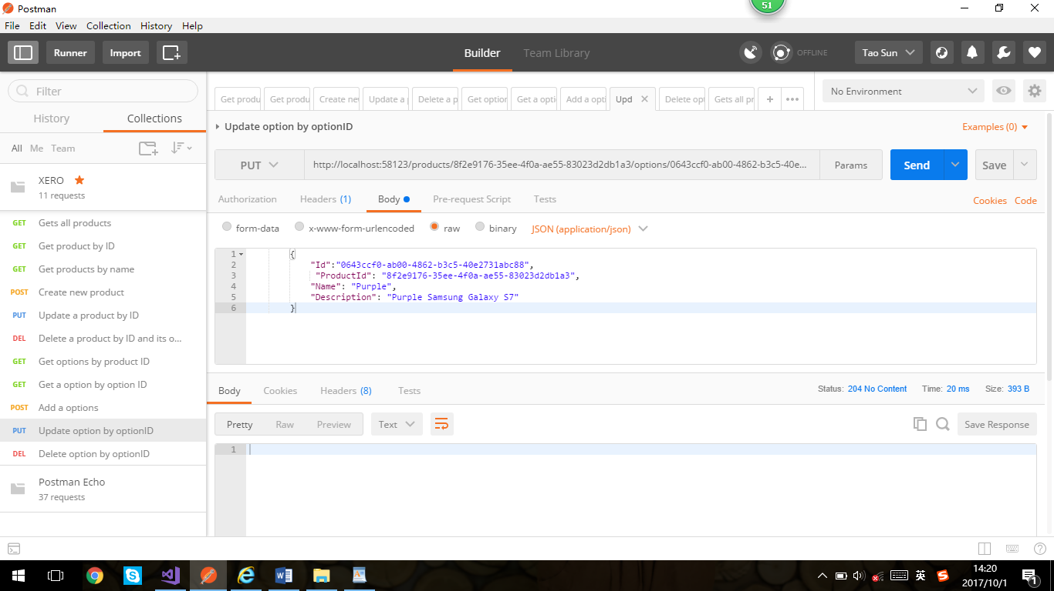

# 11. DELETE /products/{id}/options/{optionId}

Deletes the specified product option.

