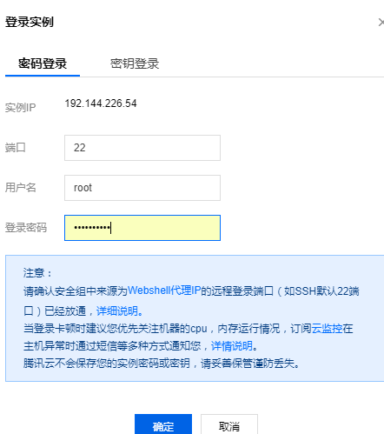

centos 卸载 docker

首先查看Docker版本  
# yum list installed | grep docker  
docker-ce.x86_64  18.05.0.ce-3.el7.centos @docker-ce-edge  
   
执行卸载  
# yum -y remove docker-ce.x86_64  
   
删除存储目录  
   
# rm -rf /etc/docker  
# rm -rf /run/docker  
# rm -rf /var/lib/dockershim  
# rm -rf /var/lib/docker

如果发现删除不掉，需要先 umount，如  
# umount /var/lib/docker/devicemapper