Teacher logs into the system: Information module, Appointment module

The teacher logs in to the account.
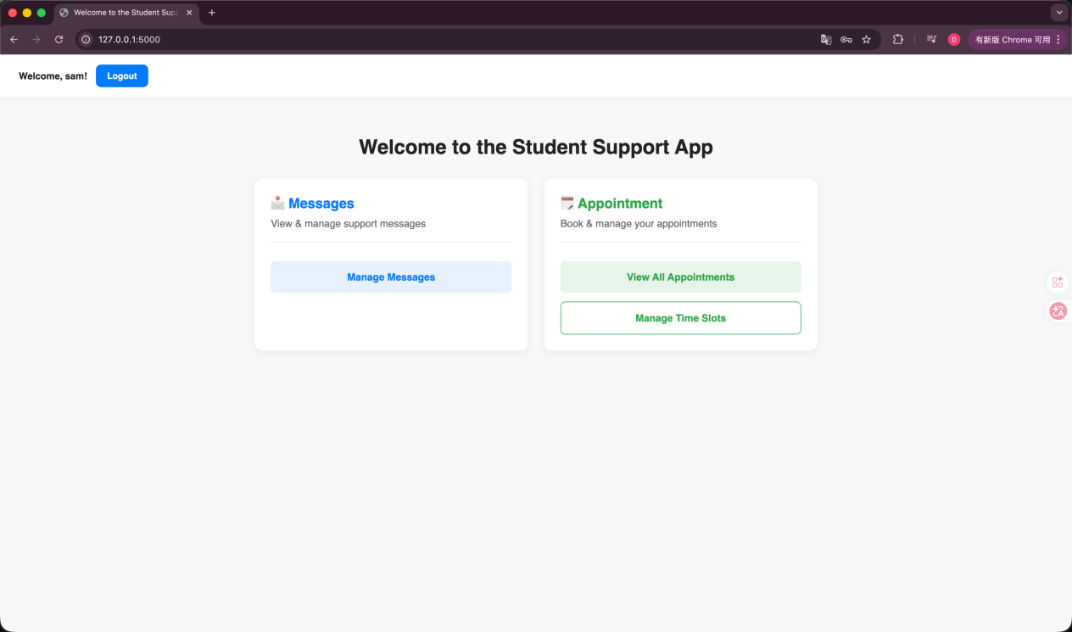

Information module：
The teacher posted a message.
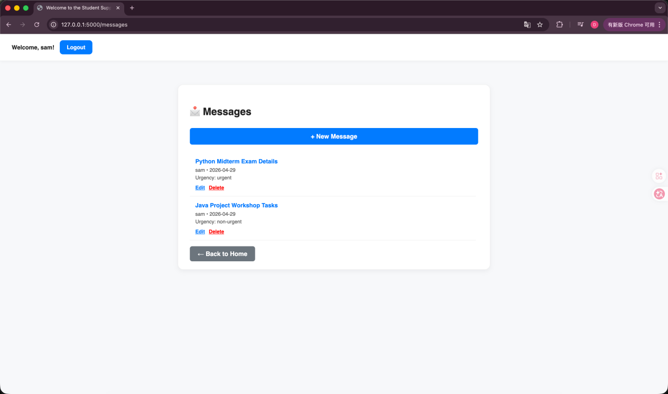

Appointment module：
The teacher posts the available appointment time slots.
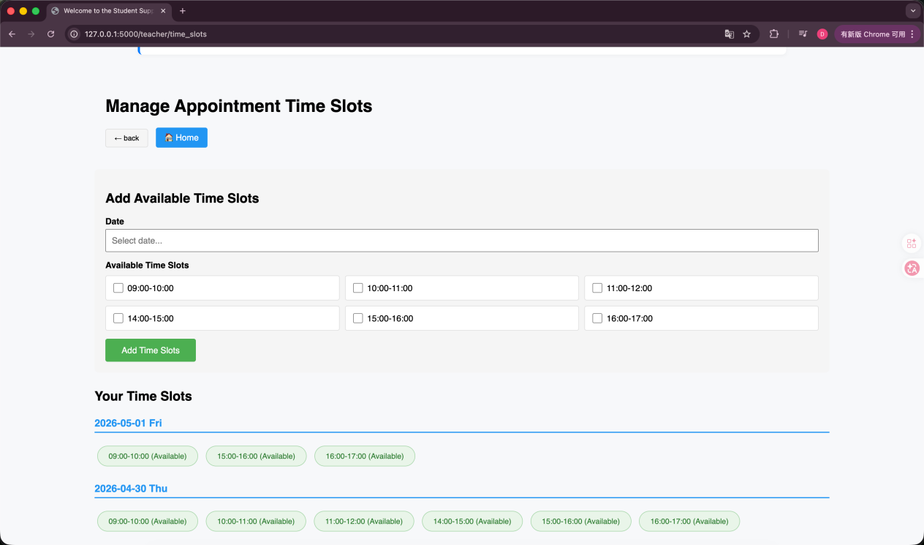

Student login system: Information module, Survey module, Appointment module

Student login account.
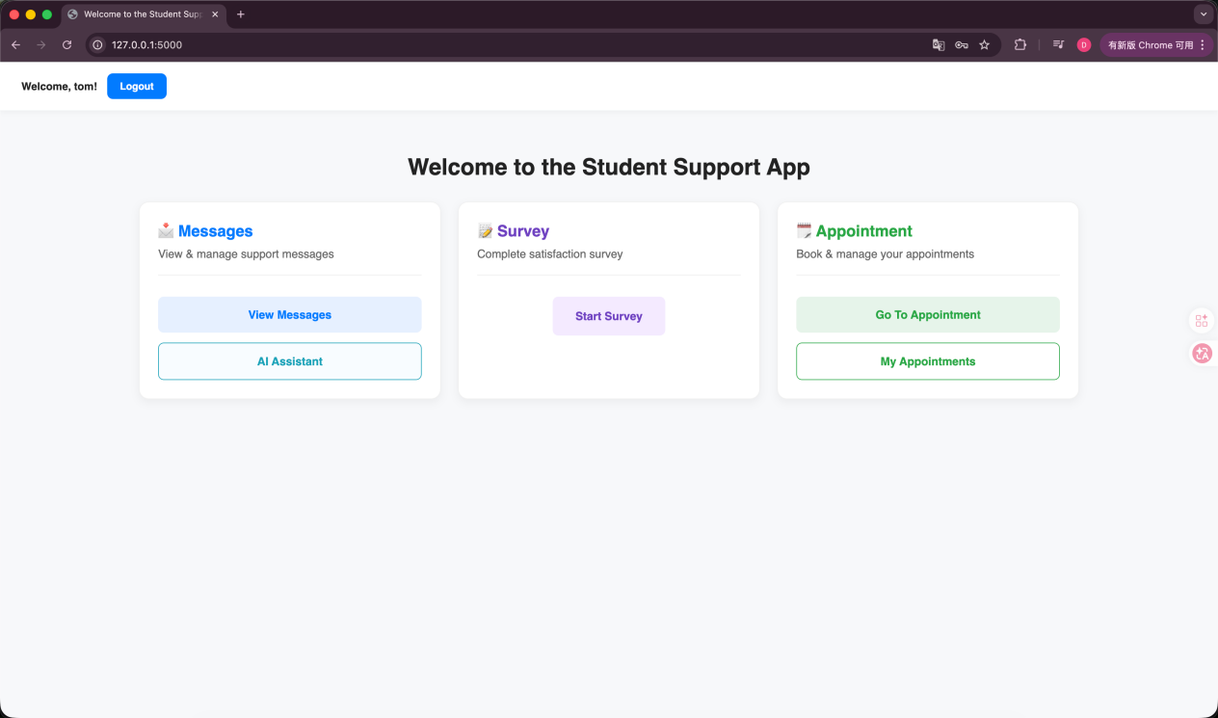

Information module：
Students view the information overview.
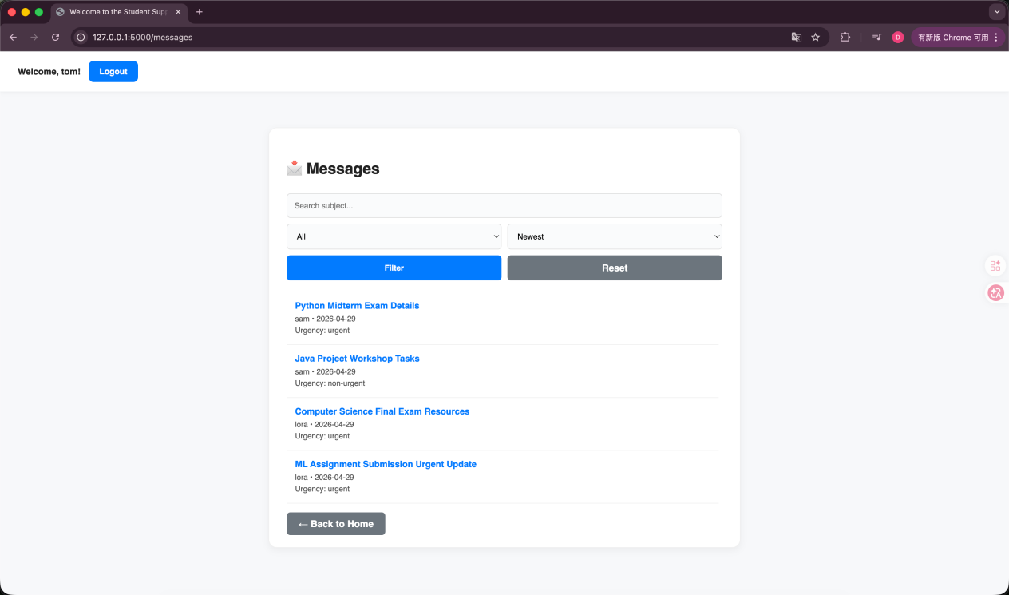

Students view the detailed information.
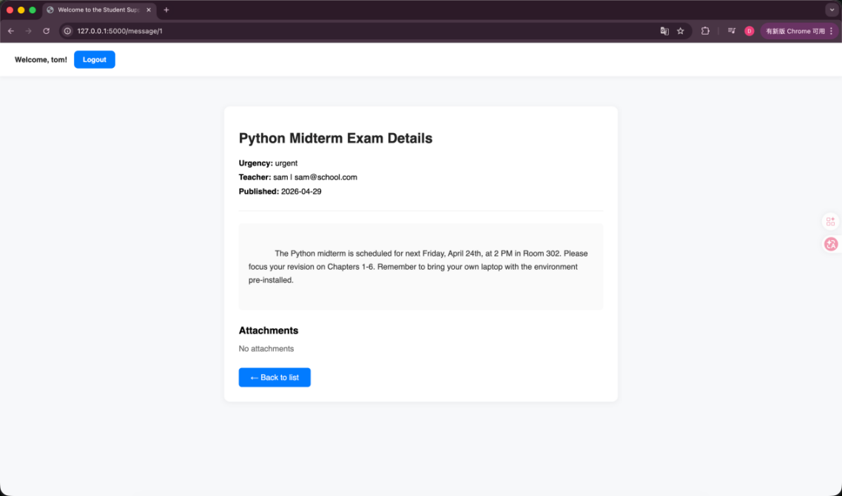

Students conduct information screening.
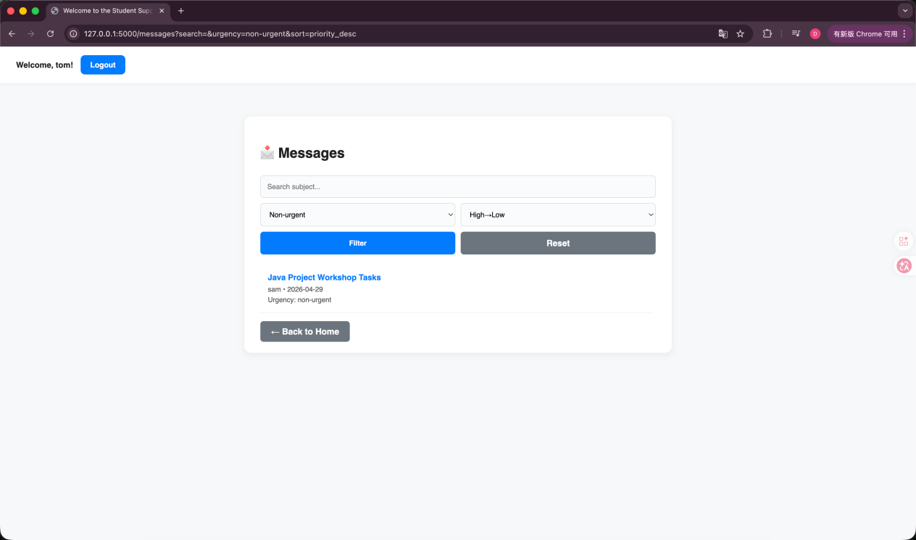

Students use the AI assistant to categorize and summarize the information.
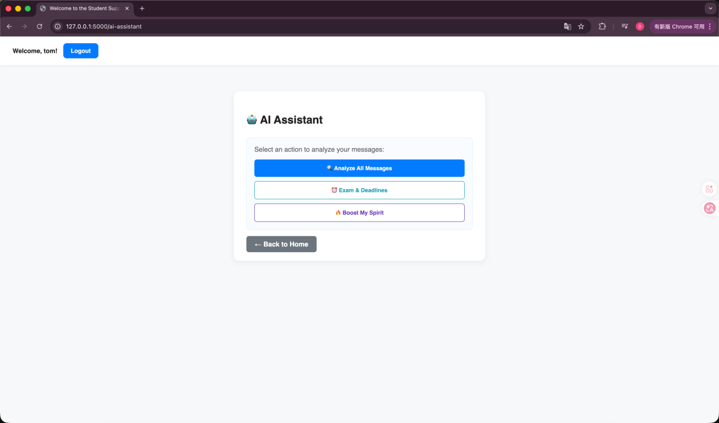

The three AI analysis modes that students can choose from。
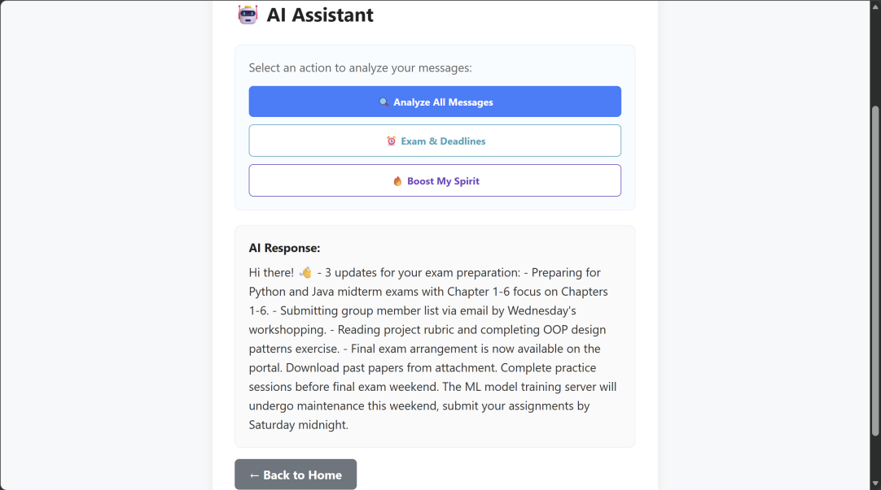
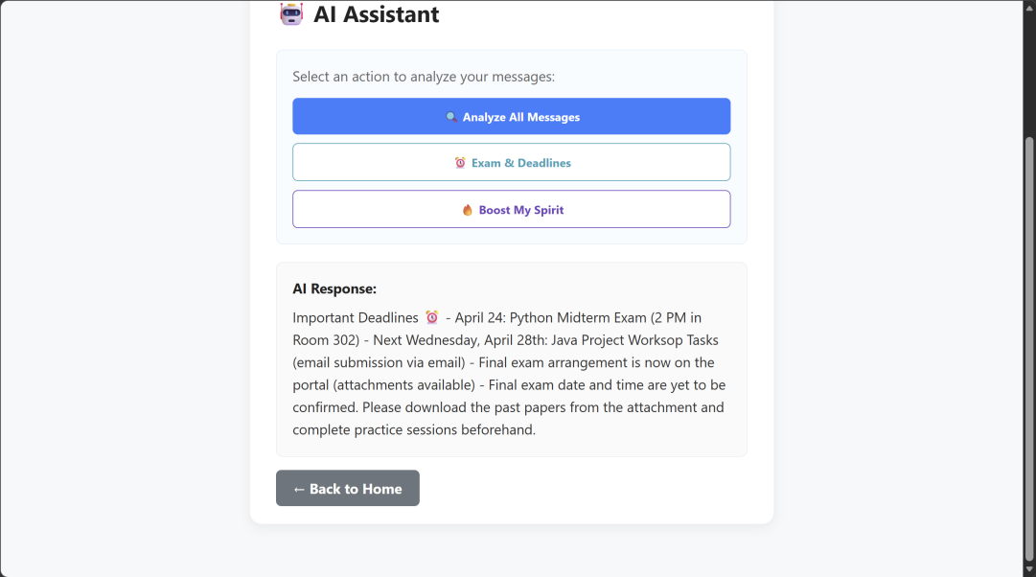

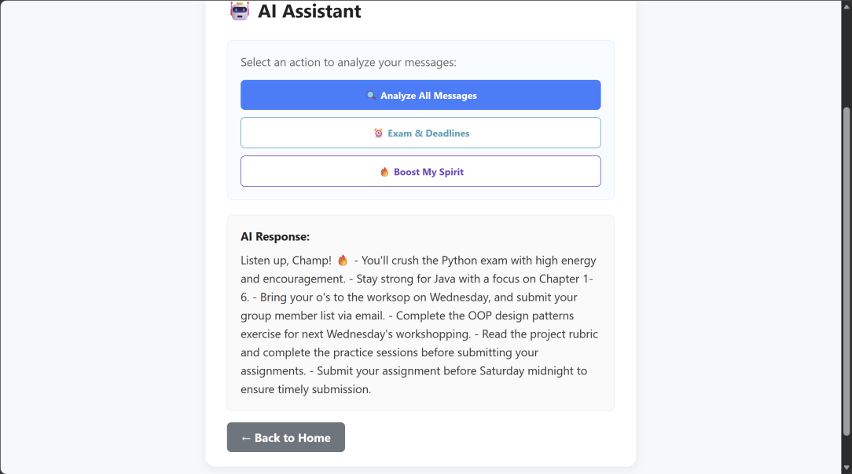

Survey module：
The students began to fill out the questionnaire and select their grade.
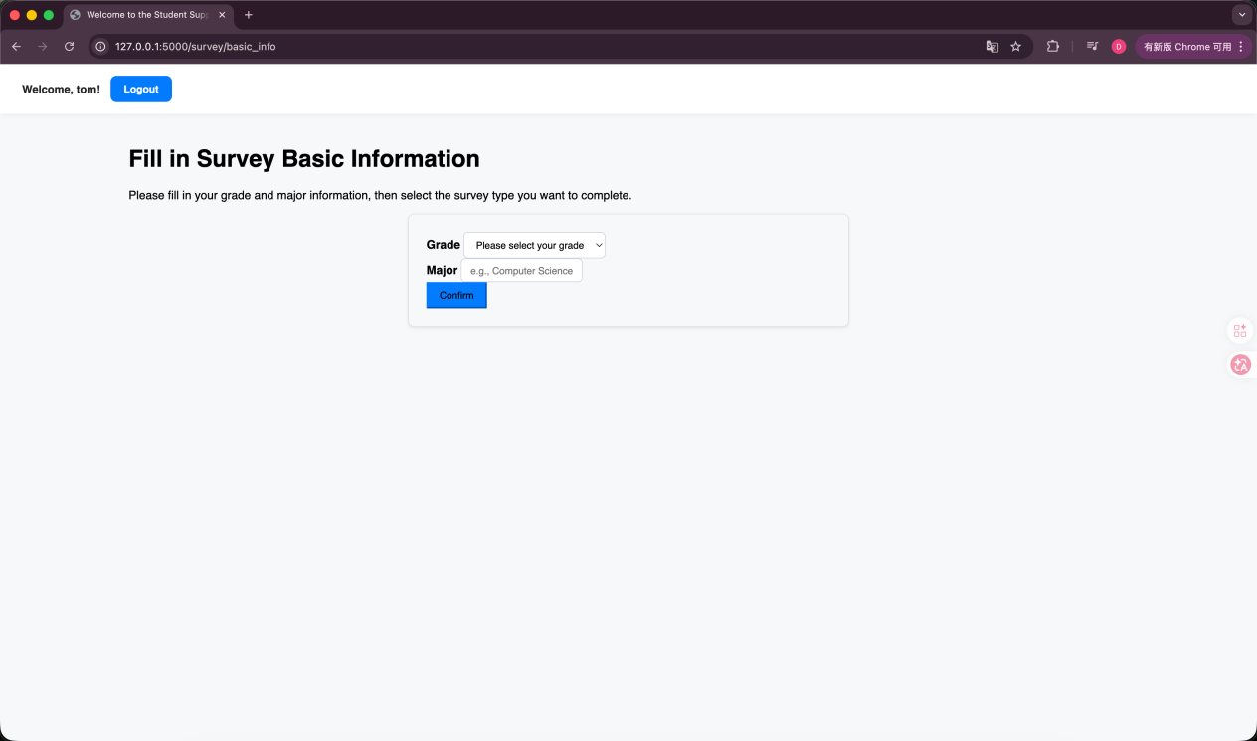

Students choose the type of questionnaire: Learning Situation Survey、School Management Satisfaction Survey、Teacher Teaching Satisfaction Survey
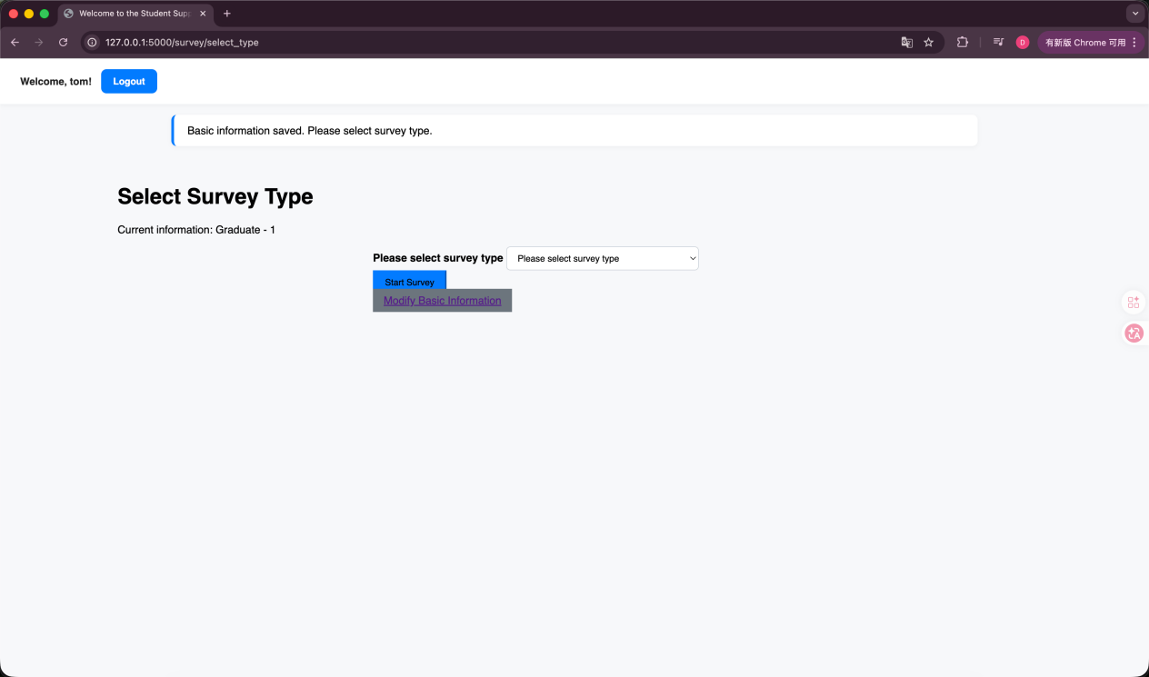

Students fill in the relevant information。
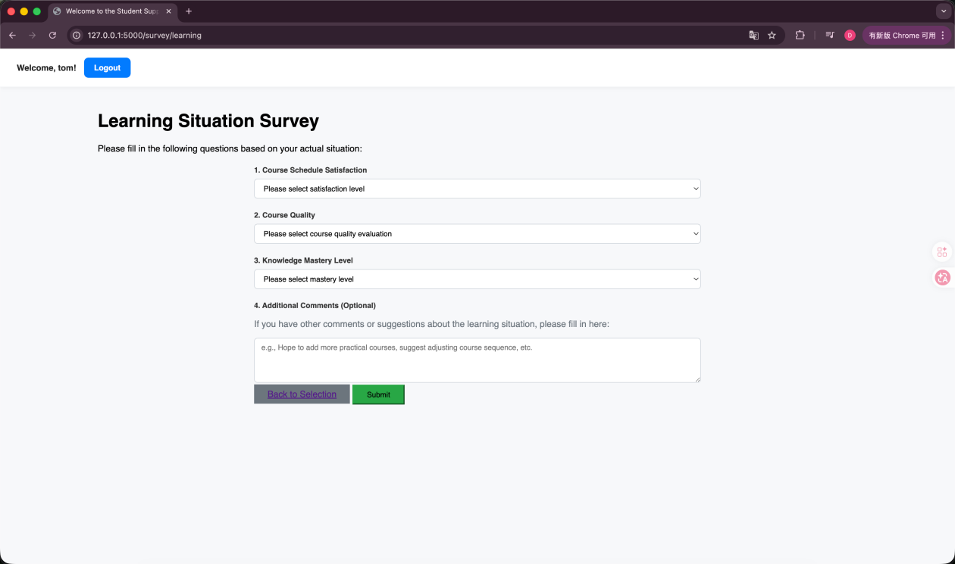
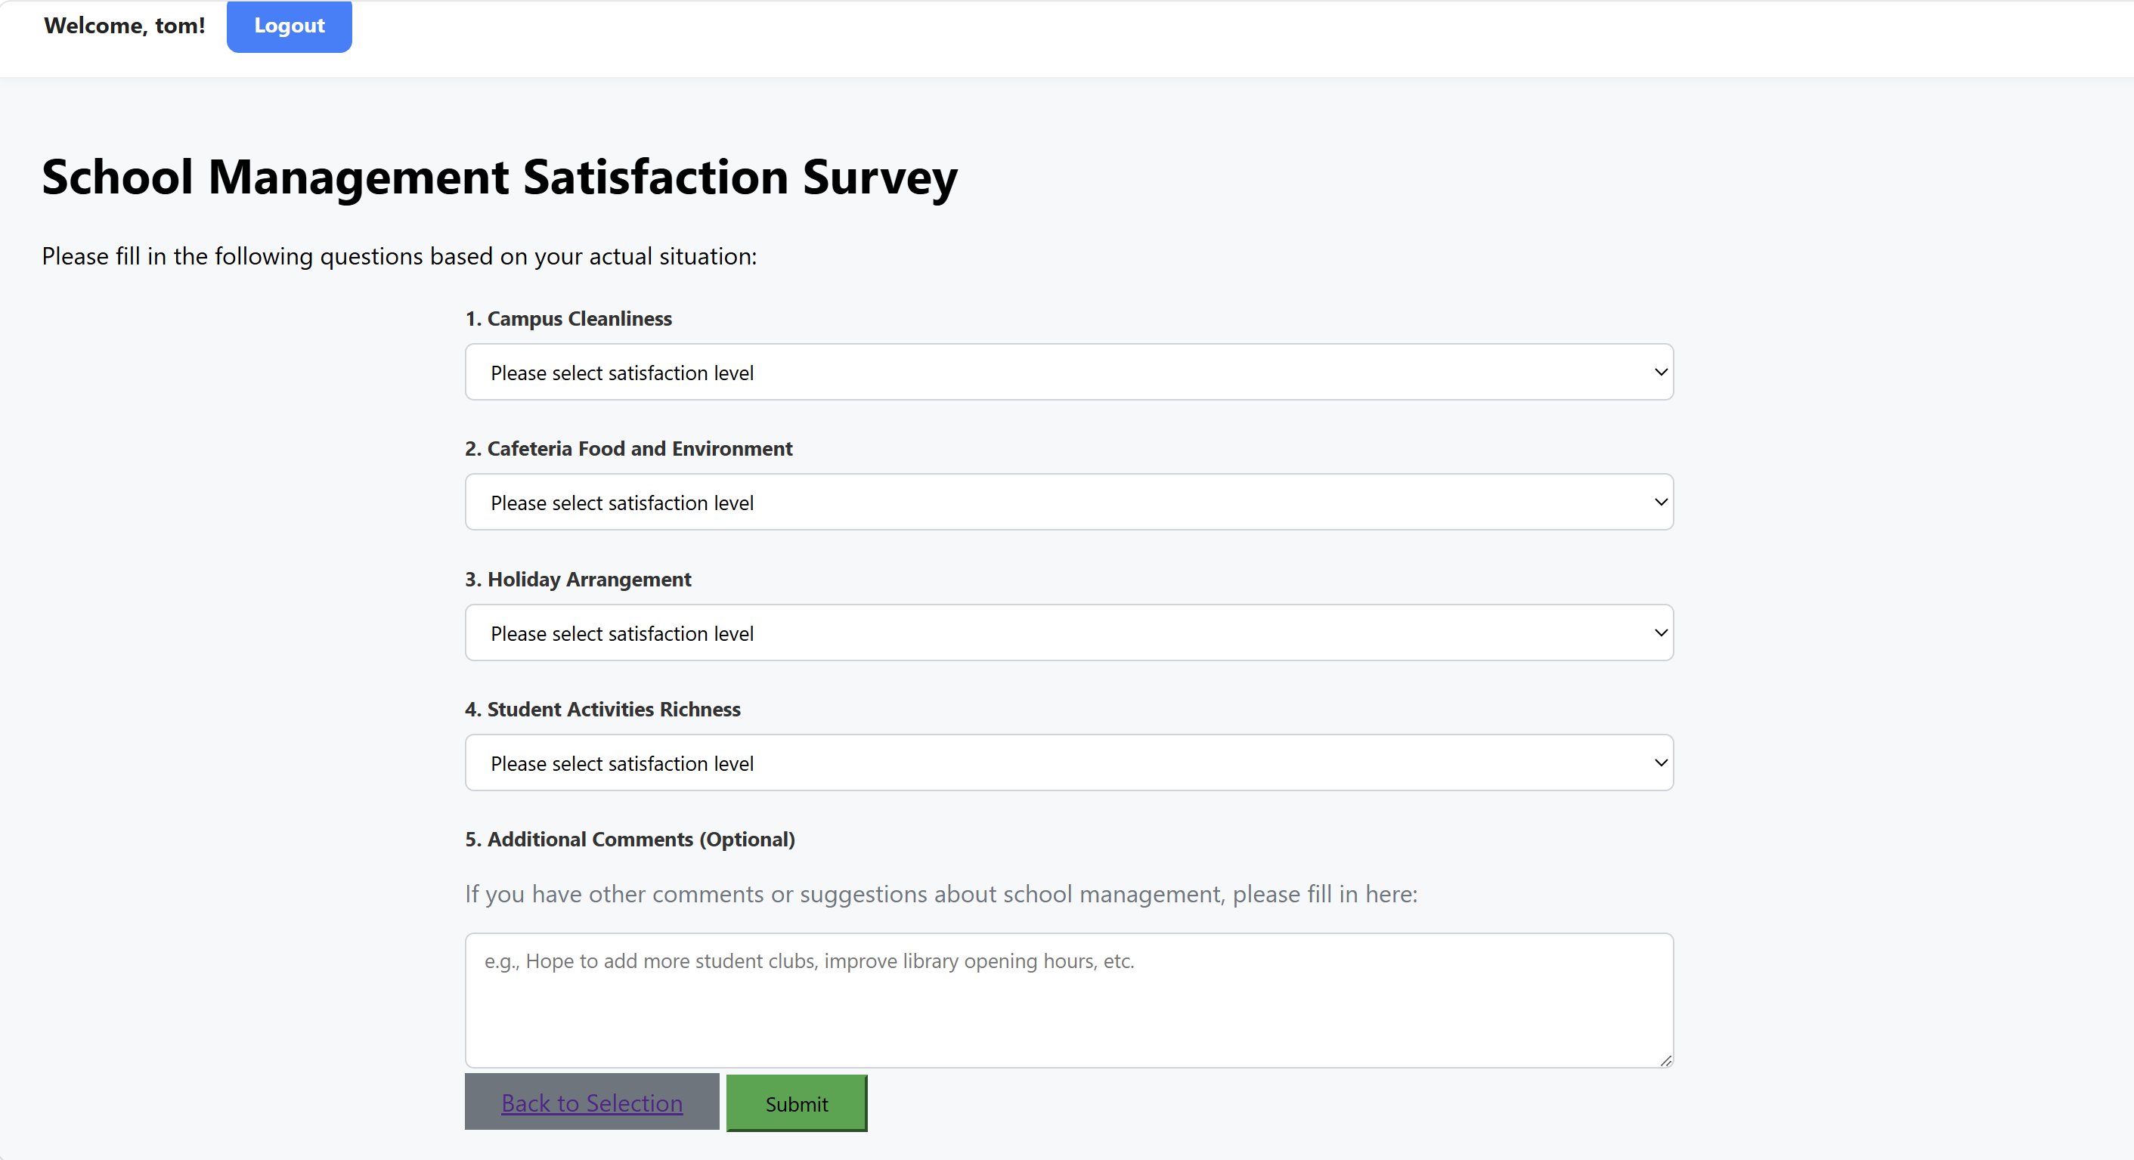
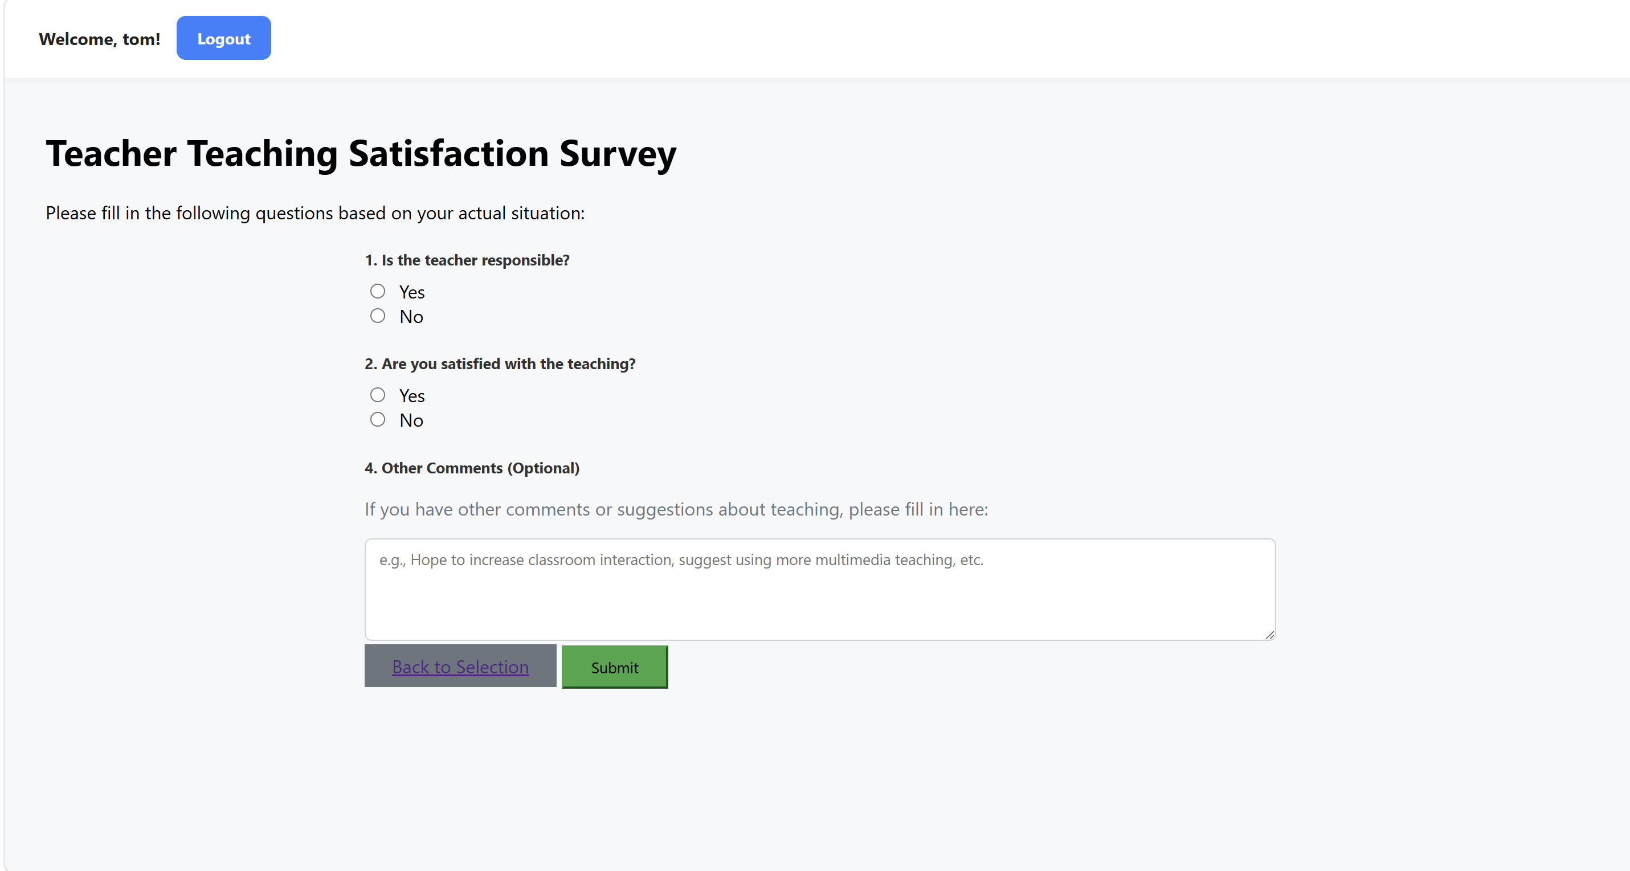

Submission successful.

Appointment module：
Students make appointments with their teachers and select the courses they wish to take.
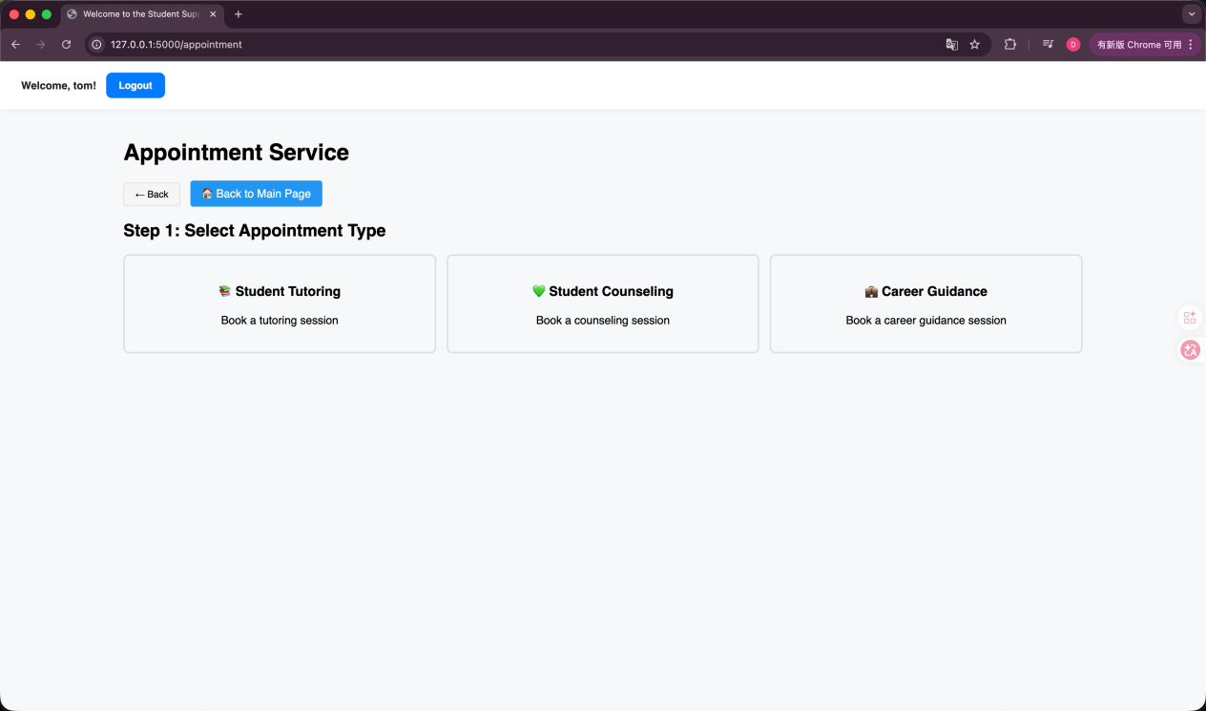

Students make appointments with teachers.
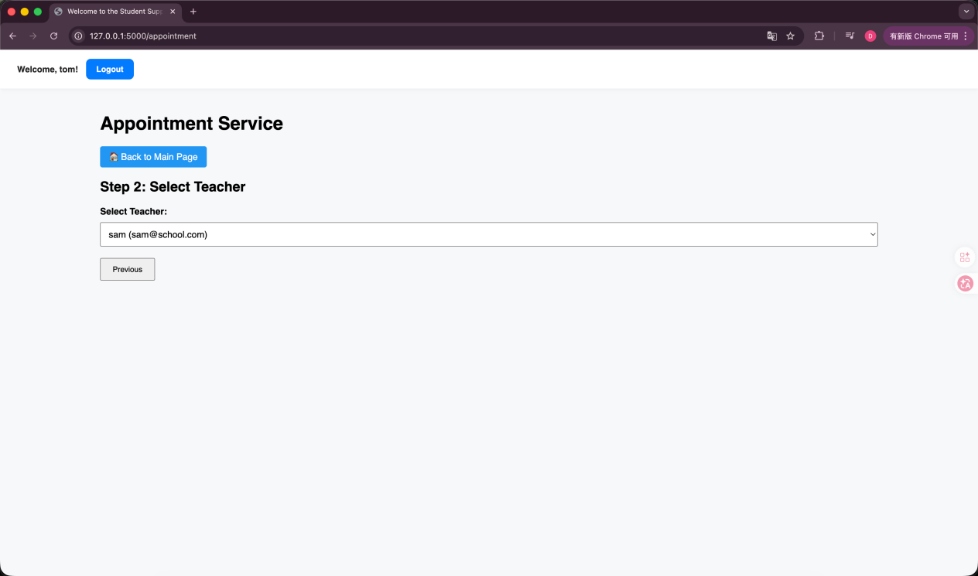

Students select the appointment date.
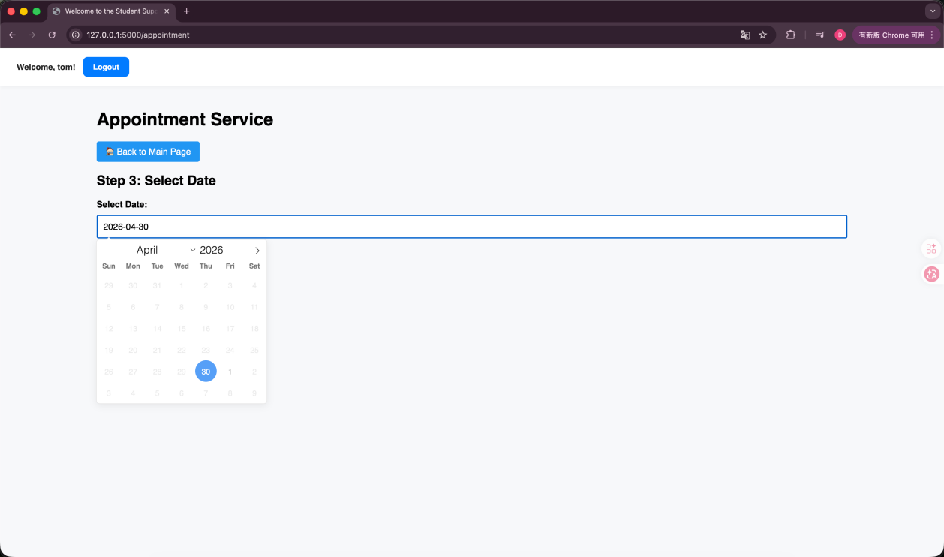

If the selected teacher has no available appointment dates, a message will be displayed indicating that there are no suitable dates.
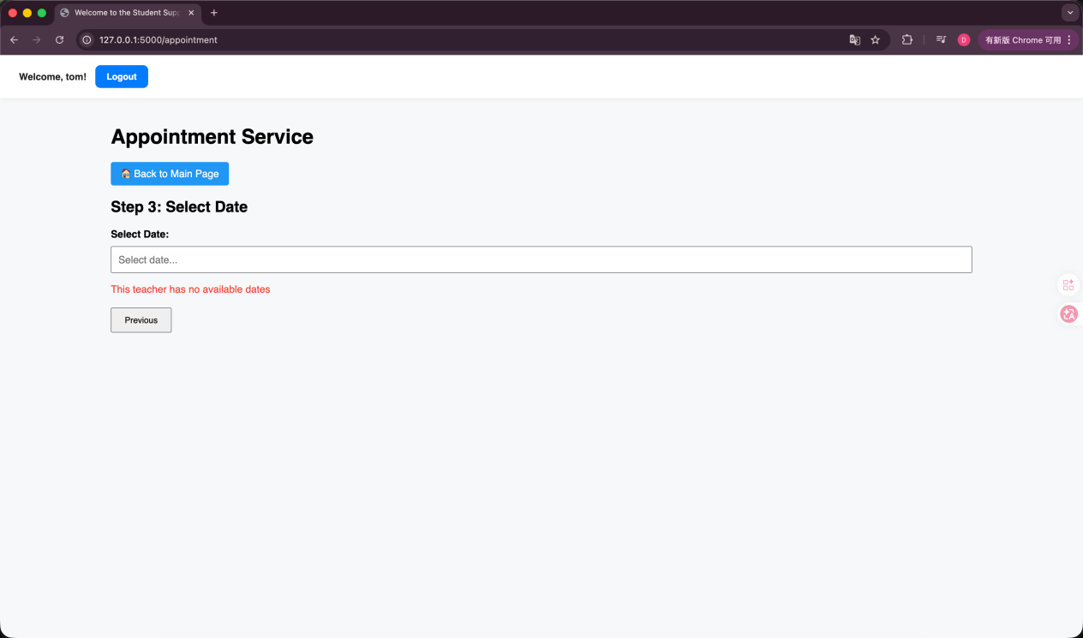
Students select the appointment time slot.
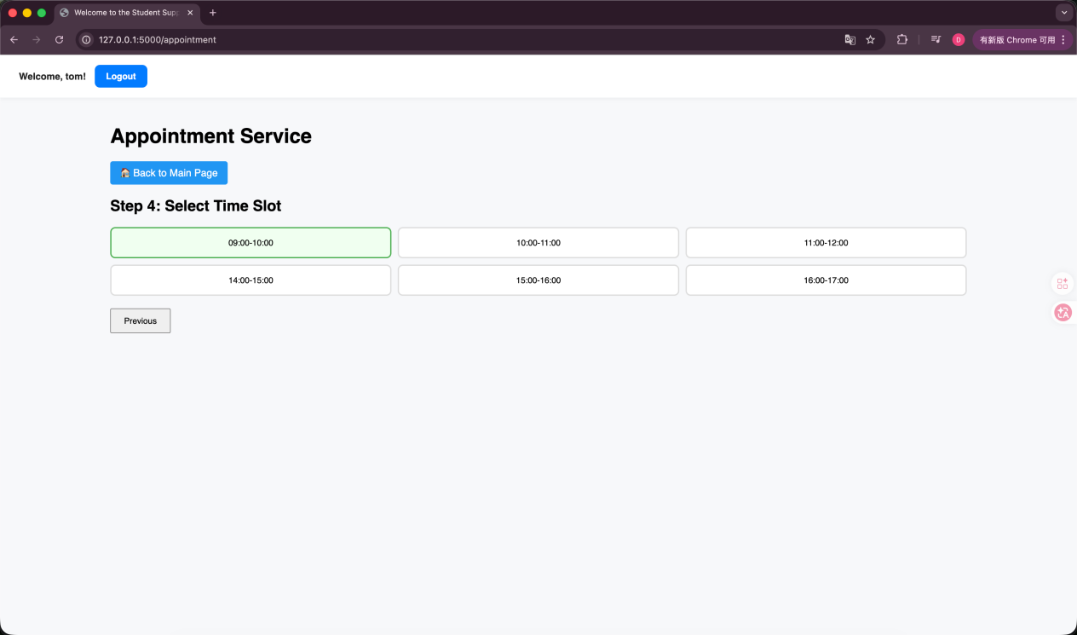

Students fill in the remarks for the reservation details (optional) and confirm the reservation.
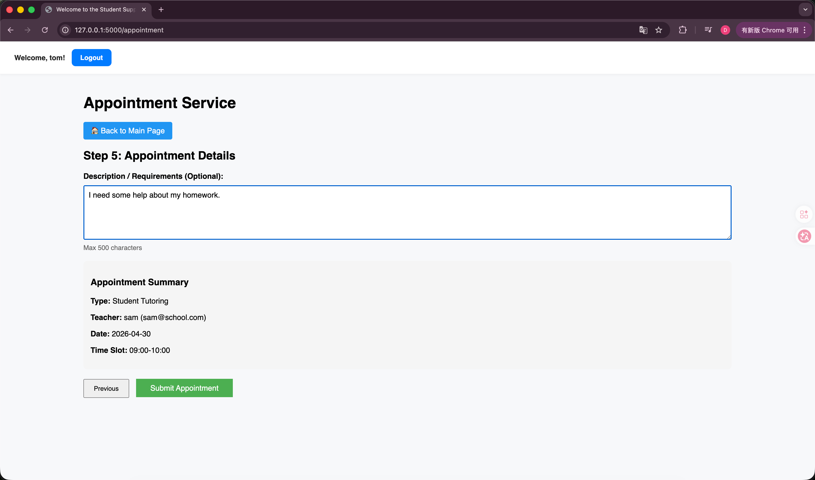
Book successfully.
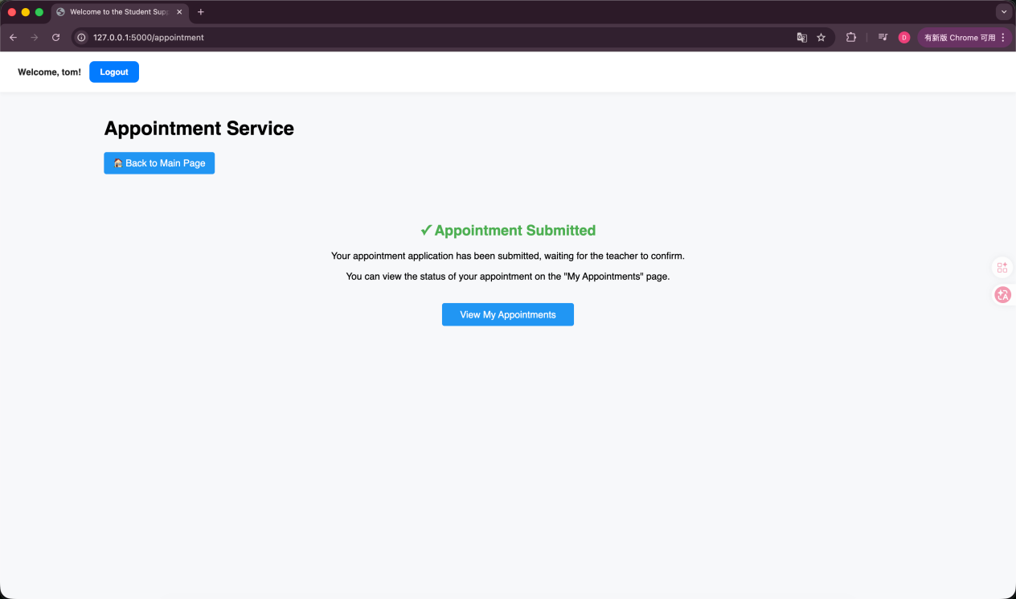

Students can view their personal reservations and cancel them.
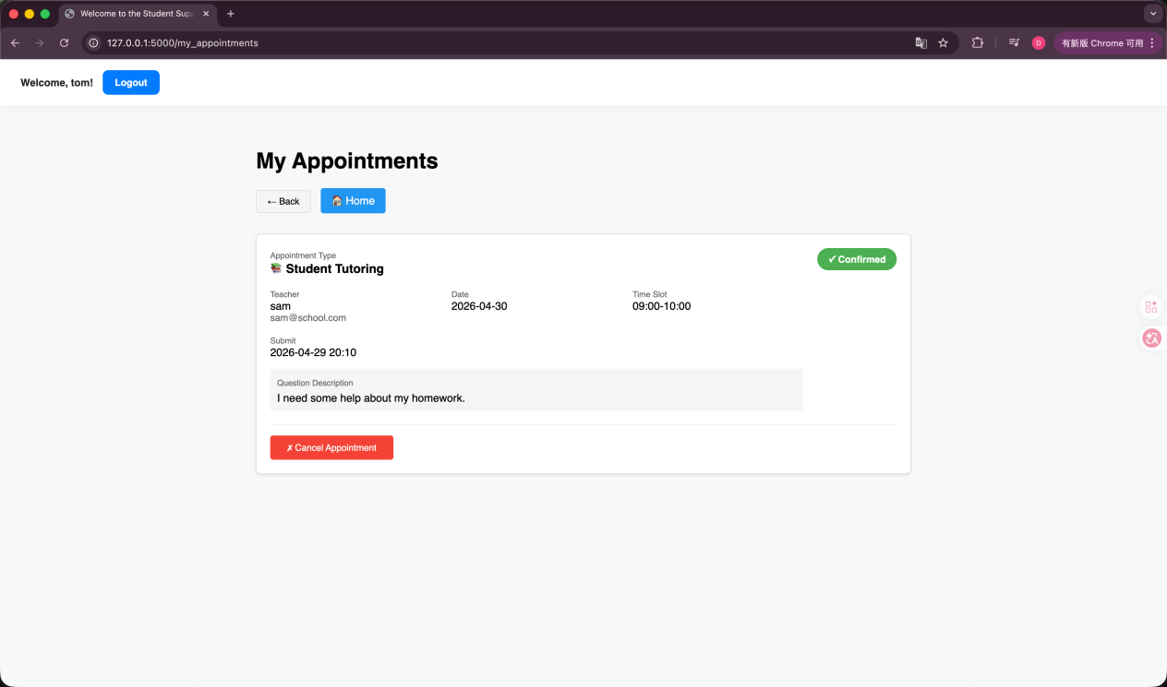
Teacher logs into the system: Information module, Appointment module

Information module：
Teacher modifies or deletes the published information.
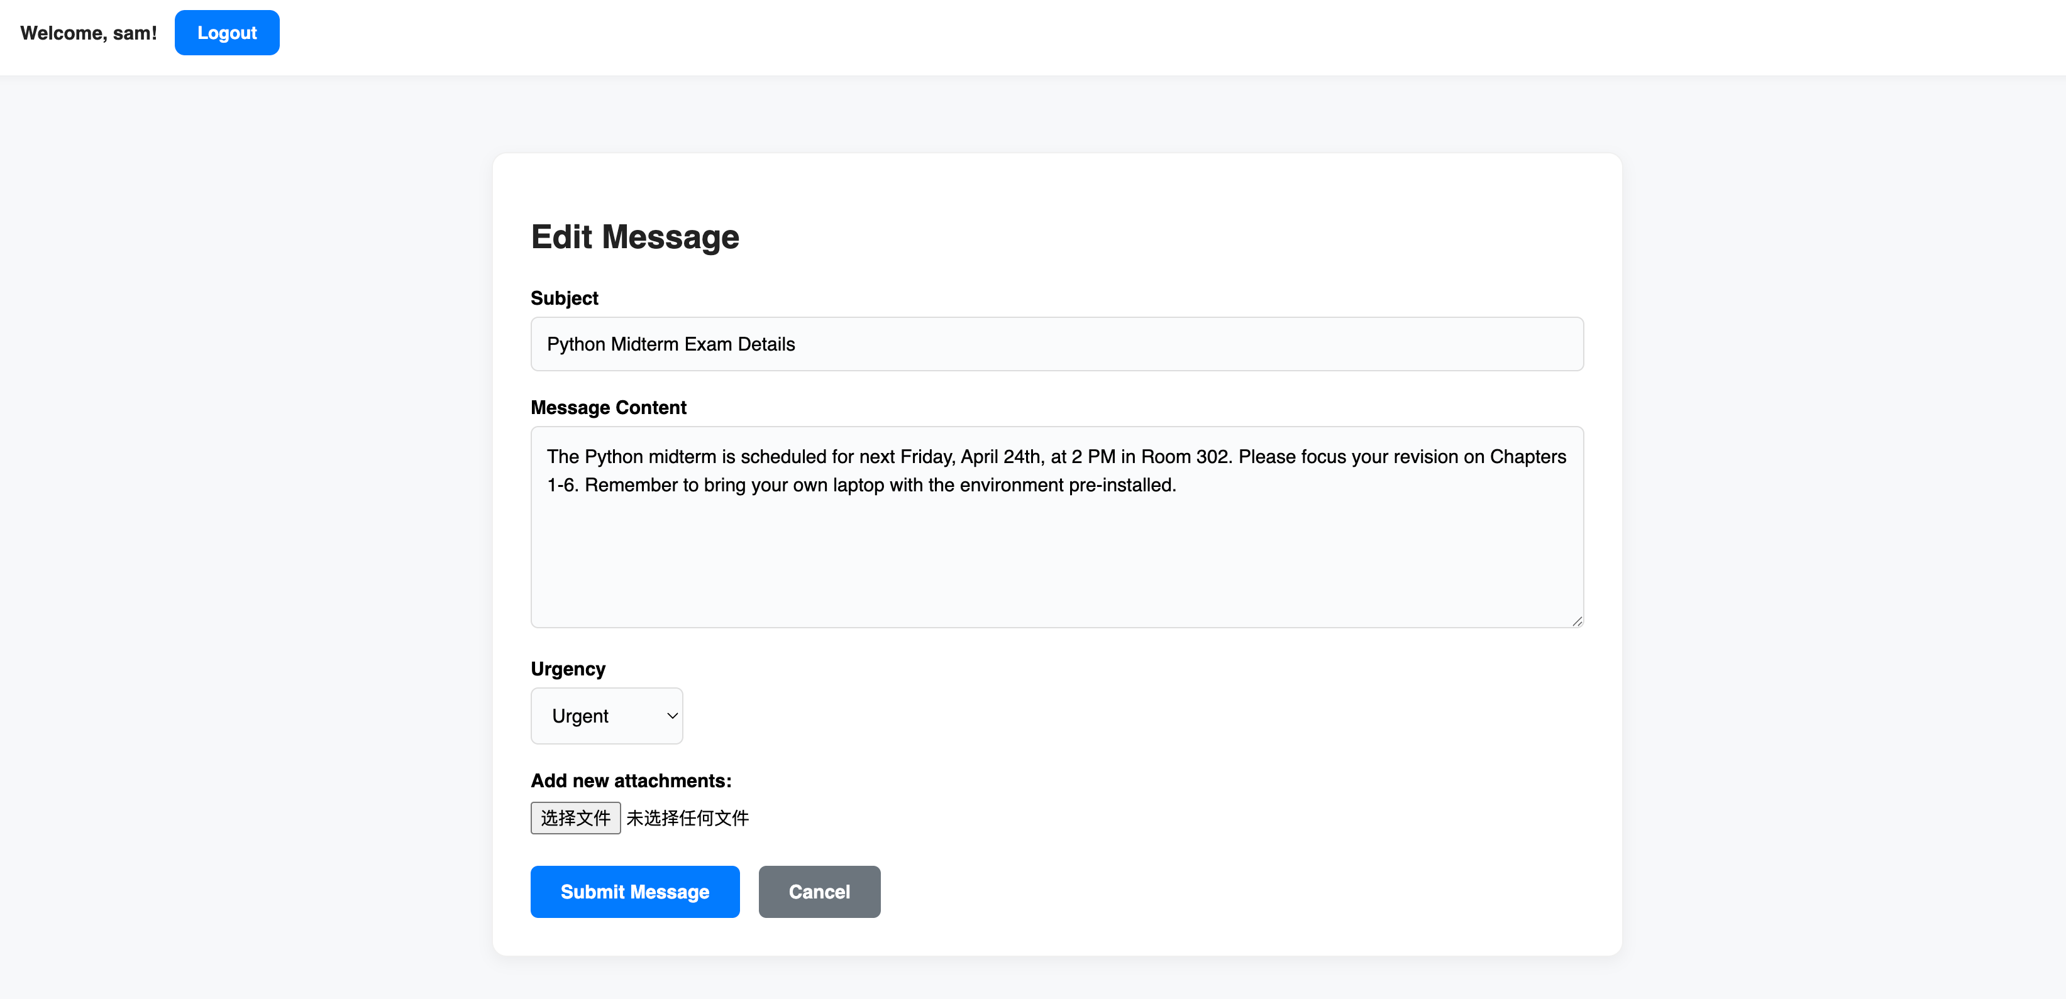

Appointment module：
The teacher checks the students' reservation status.
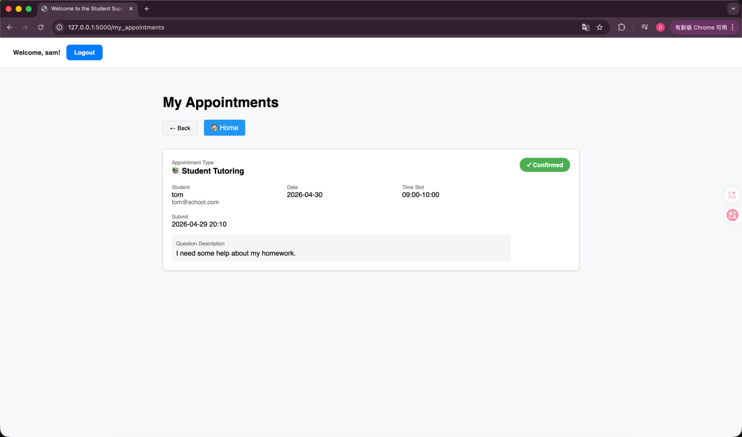

Administrator login: Survey module
Administrator login account.
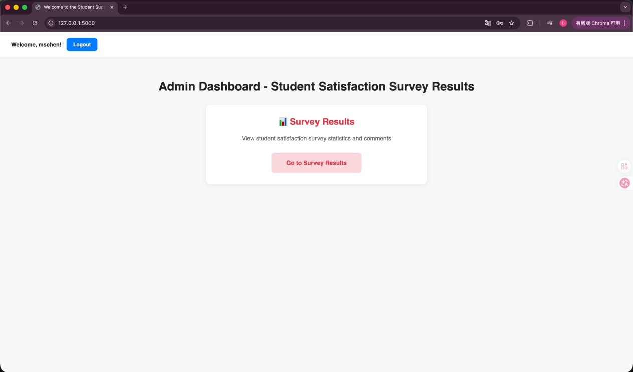

Survey module:
The administrator reviews the questionnaire results.
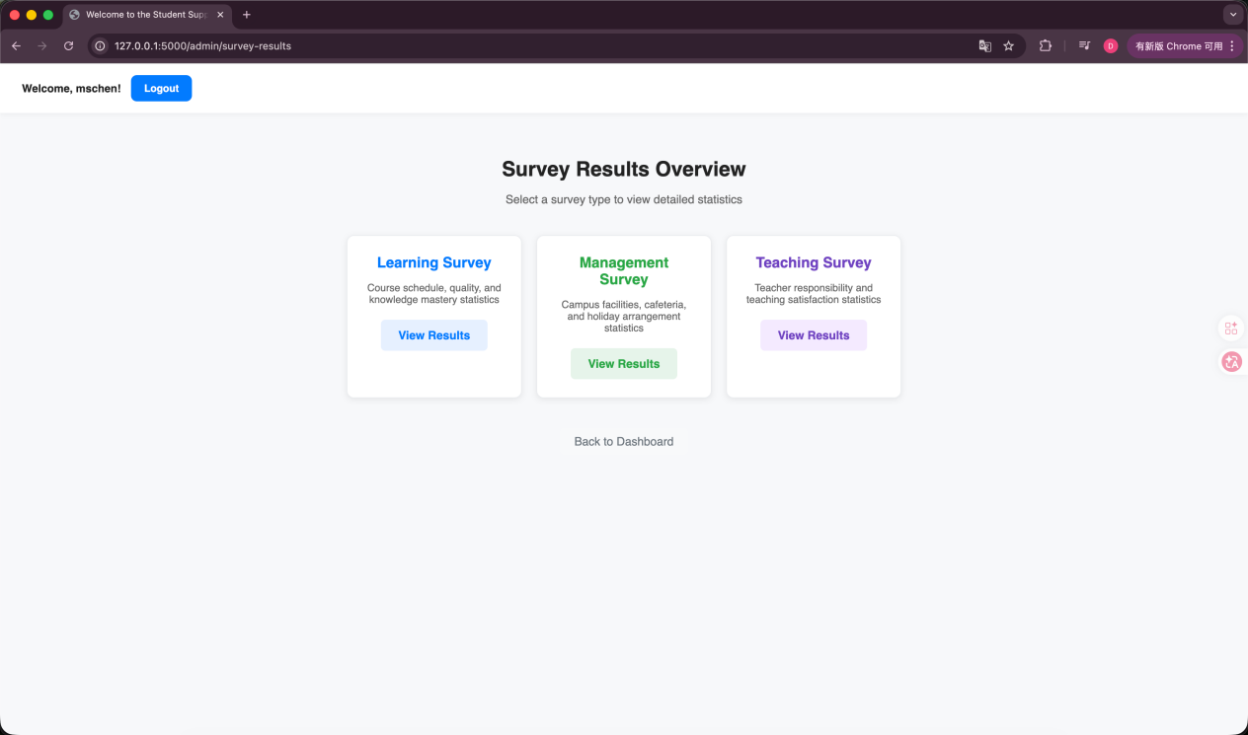

Display of questionnaire statistics results.
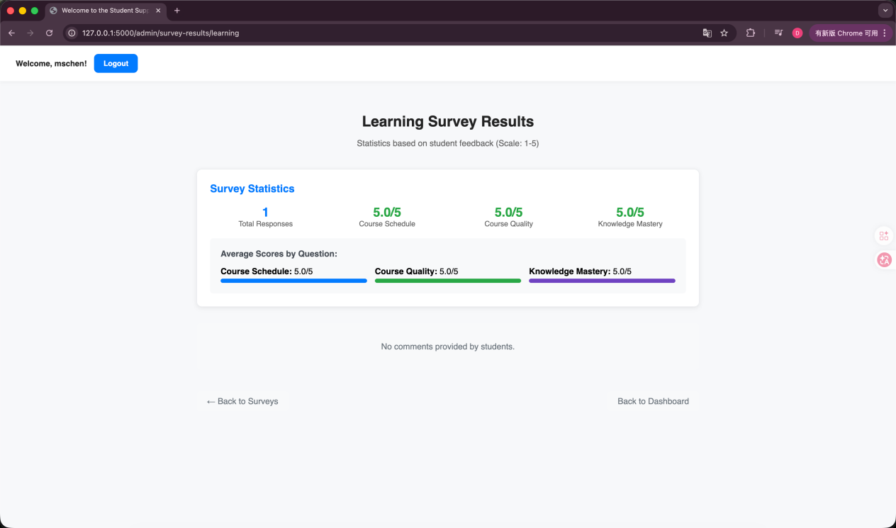

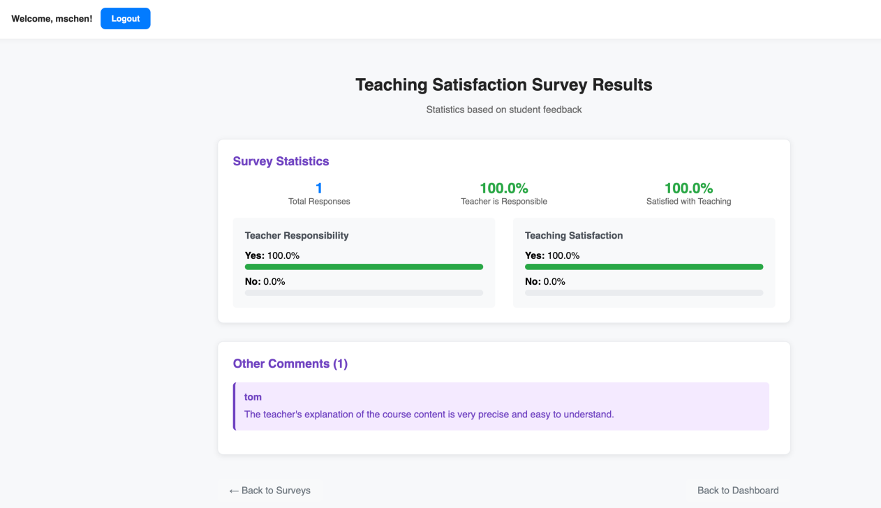

If there is no corresponding questionnaire data, it will prompt that there are no relevant data.
