## Report for week6,7

**Software defined measurement**

* **Goal:** create a software measurement system which can be used to analysis the data from the database in which there is bandwidth,aggregate and latency of the network. We create our algorithm to make decision of the source host and destination host for migration.
* **Process:**

Target host sets statistics

With different frequency

Preliminary

migration decision:

Source host set

Destination host set

Customized mode

Data analysis

(algorithm1)

Migration System:

Do migration

Send command to migration system

Data analysis

(algorithm2)

Database

(data collection as default mode)

Final migration decision:

Source host

Destination host

* **Current Achievement:**

Database, statistics collection in default mode, statistics collection in Customized mode, migration System

* **Results**
* **Out put log**

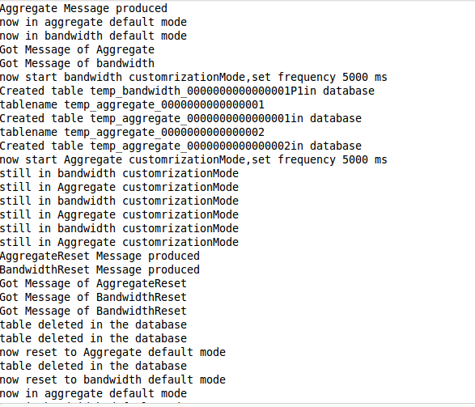

* **Temporary generated table(set the frequence 5s, one table correspond to one switch in customized mode )**

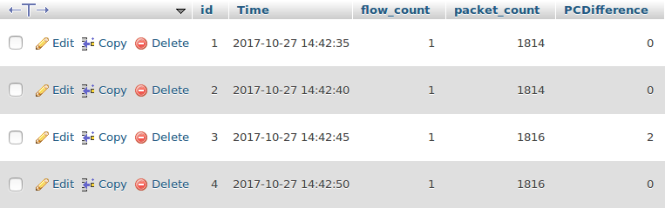

* **Reset Message**

The system will delete the temporary table from the database

* **Customized mode implementation details(in gray block):**

