## Report for week3

**Architecture:(logic of prototype of the thesis)**

measurement

**FloodLight**

**VIB**

**Migration**

**(VIRSH,CRIU)**

**Decision Brain**

**MININET**

**VIB:**

**The statistics got from the floodlight,such as bandwidth,latency,aggregate transmission packets number.**

**Floodlight:**

**The SDN controller which can manege the network,and provide the northbound API to get the statistics of the network.**

**Decision Brain:**

**The logic of the architecture which can use the statistics to make brain decision.**

**Option1:**

**Leave it for users to decide.**

**Option2:**

**Do research or finding a good method based on measurements collected.**

**Migration:**

**The tools can be used to do the migration,VIRSH for migrating the VMs, CRIU for migrating LVMS.**

**Different migration can be done according to the configuration file,migrate VMs or LVMs.**

**What can I do based on the Architecture?**

1. Create a system that can use SDN to perform monitoring operations on my mininet network

Such as software defined traffic measurement(openscretch).

1. Use the measurements info to manege the network better,such as routing,migration,repair.

Build an application that can use VIB data structure queues as input of network management,make migration or routing decisions.

1. As use case we will show better to use my Software Defined system to perform migration

* Node migration
* Link migration (routing)
* VM migration
* LVM migration

**Paper readings:**

* **Software Defined Traffic Measurement with OpensSketch**

**why?**

* Flexible measurement data plane

Classify flows(different resource/accuracy)

* Picking the packets to measure

Hashes to represent a compact set of flows

* storing and exporting the data,diverse mappings between counters and flows

**Insights:**

**Select count(*) from * where dstip=10.10.20.3 group by srcip**

Groupby: can be accomplished by a hash

Where :can be accomplished by a classifier

Count:by a count primitive

**A three-stage pipeline**

counting

classifier

Hashing

**prt**

Eg.

#bytes from 23.43.12.1

|  |  |  |  |  |
| --- | --- | --- | --- | --- |
| 3 | 0 | **5** | 1 | 9 |

|  |  |  |  |  |
| --- | --- | --- | --- | --- |
| 1 | 2 | 0 | 3 | 4 |

|  |  |  |  |  |
| --- | --- | --- | --- | --- |
| 0 | 1 | 9 | **3** | 0 |

H

Hash1

Hash2

Hash3

* Automatic configure with a task
* Resource collection cross tasks

**Conclusion:**

* **Sketches accuracy memory trade-off**
* **Making sketches easy to implement and use**

**-> different measurement task**

**-> easy to implement with commodity switch hardware**

**-> modularized library for easy programming**

* **MOZART:Temporal Coordination of Measurement**

**MOZART: MOnitor flowZ At the Right Time**

**Temporal coordination of measurement**

**Why?**

It is useful for one device to tell another one which flows to monitor at which time,rather than monitoring all the flows all the time.

**How?**

Two key components:

* Selectors which capture networks events and select related flows
* Monitors which collect flow-level statistics of the selected flows

**Architecture:**

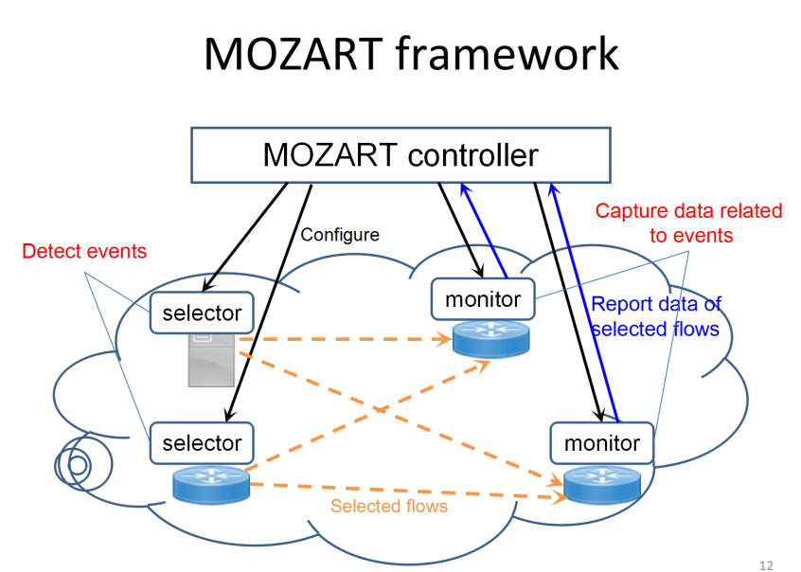

**Conclusion:**

* **Temporal coordination is important**

**--collect data related to events**

**--Different views/abilities of devices**

* **MOZART design highlights**

**--Coordination algorithms**

**--Placement algorithm for maximizing tasks to run**

* **Benefits**

**--High measurement accuracy**

**--Support more tasks**

**--Meet memory constraints in devices**

* **Re-evaluating Measurement Algorithms in Software**

**Why?**

Measurement is Critical for NFVs, make decisions based on measurement input

Firewall,loading balancing,intrusion detection systems(IDS)

Measurement for managing NFVs

Profiling NFV usage,resource scheduling..

Nowadays,the software switch is popular,so the concern is not as the same as traditional switch,network device,before memory is a critical part.now there are plenty of memory for measurement.

**Conclusion:**

* NFV is the new trend in data-center and ISPs
* Measurement is a key component for NFV
* Simple hash table works best

For many tasks,the working set fits in the cache

Especially when the traffic is skewed