VM consumption of run-time dynamic linking
Tao Zhang

Abstract
A process can use the same DLL file in both load-time and run-time dynamic linking. This article will talk about the VM (virtual memory) consumption of run-time dynamic linking. In addition, this article will cover how to analyze and avoid Dll file loading failure issues.

Keywords
VM: Virtual memory

TOC

1. Introduction 3
2. VM consumption of a Dll file 3
3. Check VM layout of a process 5
4. Potential problem 5
5. Best practice 6
6. Reference 6

Introduction
Usually there are 4GB VM totally for a 32-bit Windows application. 2GB VM is for kernel mode (0x80000000 to 0xffffffff), another 2GB VM is for user mode (0x00000000 to 0x7fffffff). That is to say an application can only have 2GB VM usually (It is possible to get 3GB VM by using on /3GB switch). However, any DLLs that needed b y the application are loaded into this 2GB address space as well. Every executable and DLL module has a preferred base address, which identifies the ideal memory address where the module should get mapped into a process' address space.
When a process dynamically loads one Dll file directly or indirectly using LoadLibrary/LoadLibraryEx the first time, it needs a certain size of continuous VM. The loading may fail due to lack of continuous VM since the process may have many fragments at that time.

VM consumption of a Dll file
Dumpbin.exe which locates in Visual Studio installation folder can help us get the exactly size of continuous VM when we load a Dll file the first time. We can use /header option and check “size of image” field as shown in following figure:
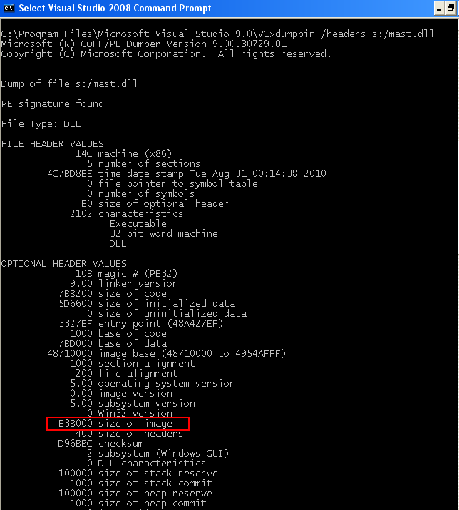

The above case, we need about 14.9M (E3B00 in Hex) continuous VM when we load mast.dll file the first time.
In addition, dumpbin command can get more useful data of a DLL file. Refer to this link to get more detail about DLL file format.
The global or static variables will contribute to the size of “size of image”. In addition, incremental linking option also will contribute to it. That is to say usually debug version Dll needs more continuous VM than release one.

Check VM layout of a process
VMMap is a process virtual and physical memory analysis utility with good GUI. It can distinguish different type of memory (Image, Mapped file, Heap, Managed Heap, thread stack, Free etc.) as different color with their address range.
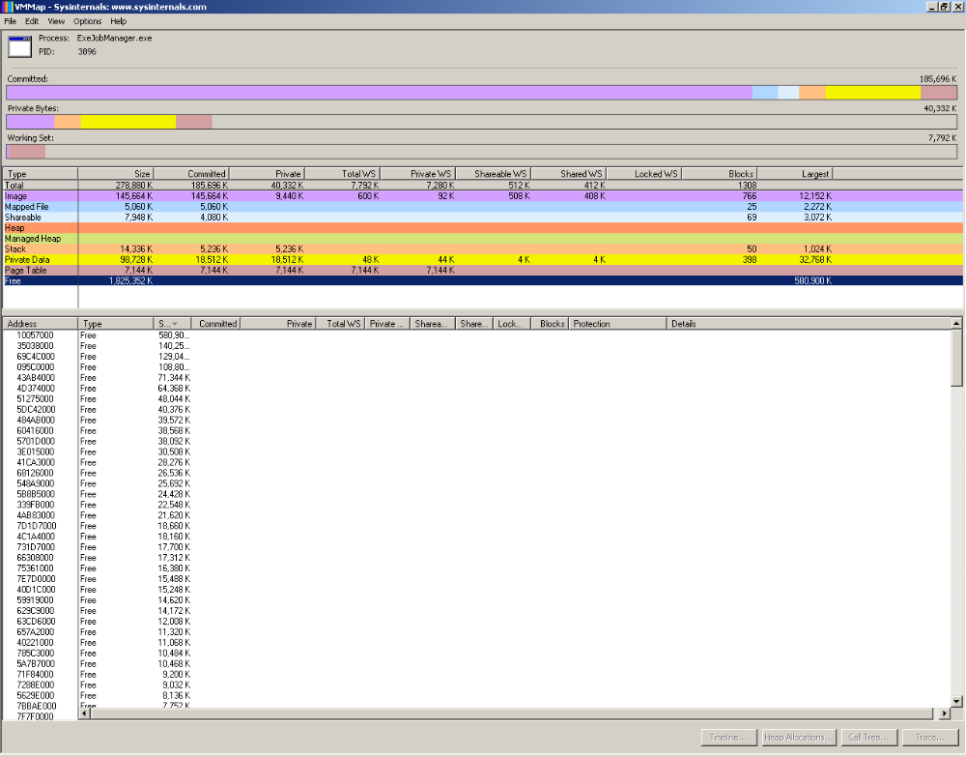

If you are experiencing out of memory errors, the first thing to check is the largest free block size. As you can see at the figure, it is easy to find the largest continuous VM size for a specific process in VMMap. With this largest free block size and the “size of image” field of the DLL file which we already acquired in section 2, we can find out whether we have enough space to load DLL file.
In addition, VMMap can provide more other useful information such as: Heap information, Managed Heap information, Mapped file information and loaded DLL file information etc. For loaded DLL file information we can get following: Started address, consumed VM size and other DLL file section: header, code (.text), resources (.rsrc), relocations (.reloc) etc. Go to View→Fragmentation View, we can get VM layout in UI with different color

For other tools such as Windbg, we use command “!address -summary” can also find the largest continuous VM size after attach the process.

Potential problem
Since run-time dynamic linking can happen at any stage during process running, we should be very cautious to this kind of issues especially for “Huge” Dll files. While process running, the free VM becomes less and memory fragment becomes more. It is more likely failed to load a Dll file due to lack of continuous VM if the Dll file has large “size of image” size.
If this failure happens when we call LoadLibrary, we can get clear error message and it is easy to find out the root cause.
Trickier thing happens in COM application. As CoCreateInstance calls LoadLibraryEx internally, it may fail due to lack of continuous VM as well. Even more badly, the error message returned by CoCreateInstance is something like “Class not registered” for this situation.

Best practice
To avoid the loading failure issue, we can do following things:
- Avoid declaring large size of global or static variables as much as possible. In one word, change the initialization of variable from loading time to run time.
To achieve this we can do following things:
- Define the member variable rather than global variable
- Define non-static variable rather than static variable
- If we have to define static or global variable, consider to declare a pointer variable rather than a huge array. For example:
static int intArray[1000]; //Will consume 8K memory during loading time;
static int *p_IntArray; //Will consuem only 8 bytes memory during loading time.
- Turn off the “incremental linking” build option which is already disabled in default configuration of release build. (Open Property page and then go to Linker→General as following figure)
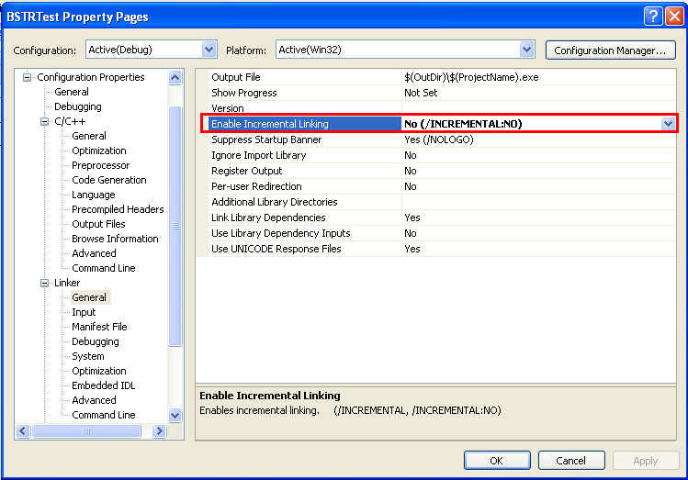
To disable this “incremental linking” build option, we usually can save 20-30% VM during DLL loading compare to enable this build option.
- Split the huge DLL file into several small DLL files.
- If we have to load large “size of image” size Dll file as run-time dynamic linking manner, move the Dll loading as earlier as possible. The reason is: The less time that process runs the fewer fragments in VM.
- Use the VM more effectively.
This is a big topic and can improve overall performance of the application. There are several approaches:
    - Avoid performing dynamic memory allocation and de-allocation frequently.
    - Try to allocate large chunks rather than small ones.
    - Choose correct and smart rebase address for all the DLL files.
That way the memory fragment between two DLL files can be controlled and decreased a lot. At the same time, it can avoid DLL file relocation.

Reference
http://msdn.microsoft.com/en-us/magazine/cc301727.aspx
http://www.microsoft.com/msj/0698/hood0698.aspx
http://www.microsoft.com/msj/0999/hood/hood0999.aspx
http://msdn.microsoft.com/en-us/magazine/bb985992.aspx
http://msdn.microsoft.com/en-us/magazine/bb985994.aspx

